Doraemon

Doraemon is a Cartoon Character.

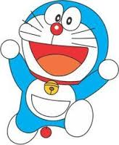

|  |  |
| --- | --- |
| Character | Quality |
| Nobita | Lazy |