Lung Cancer Detection - Model Evaluation

# Confusion Matrix - Simple CNN

The confusion matrix for Simple CNN is shown below:

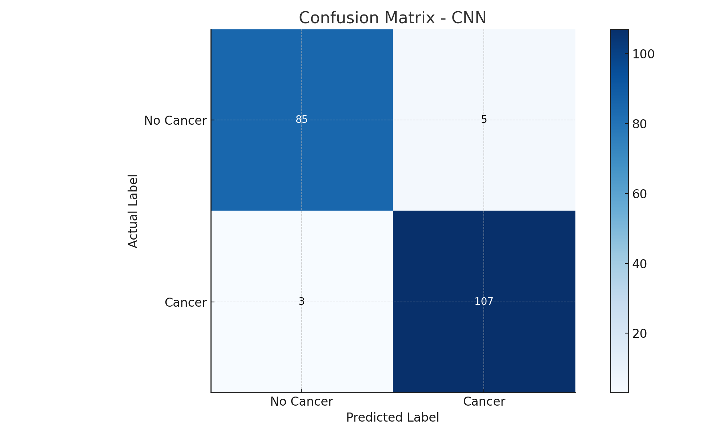

# Confusion Matrix - MobileNetV2

The confusion matrix for MobileNetV2 is shown below:

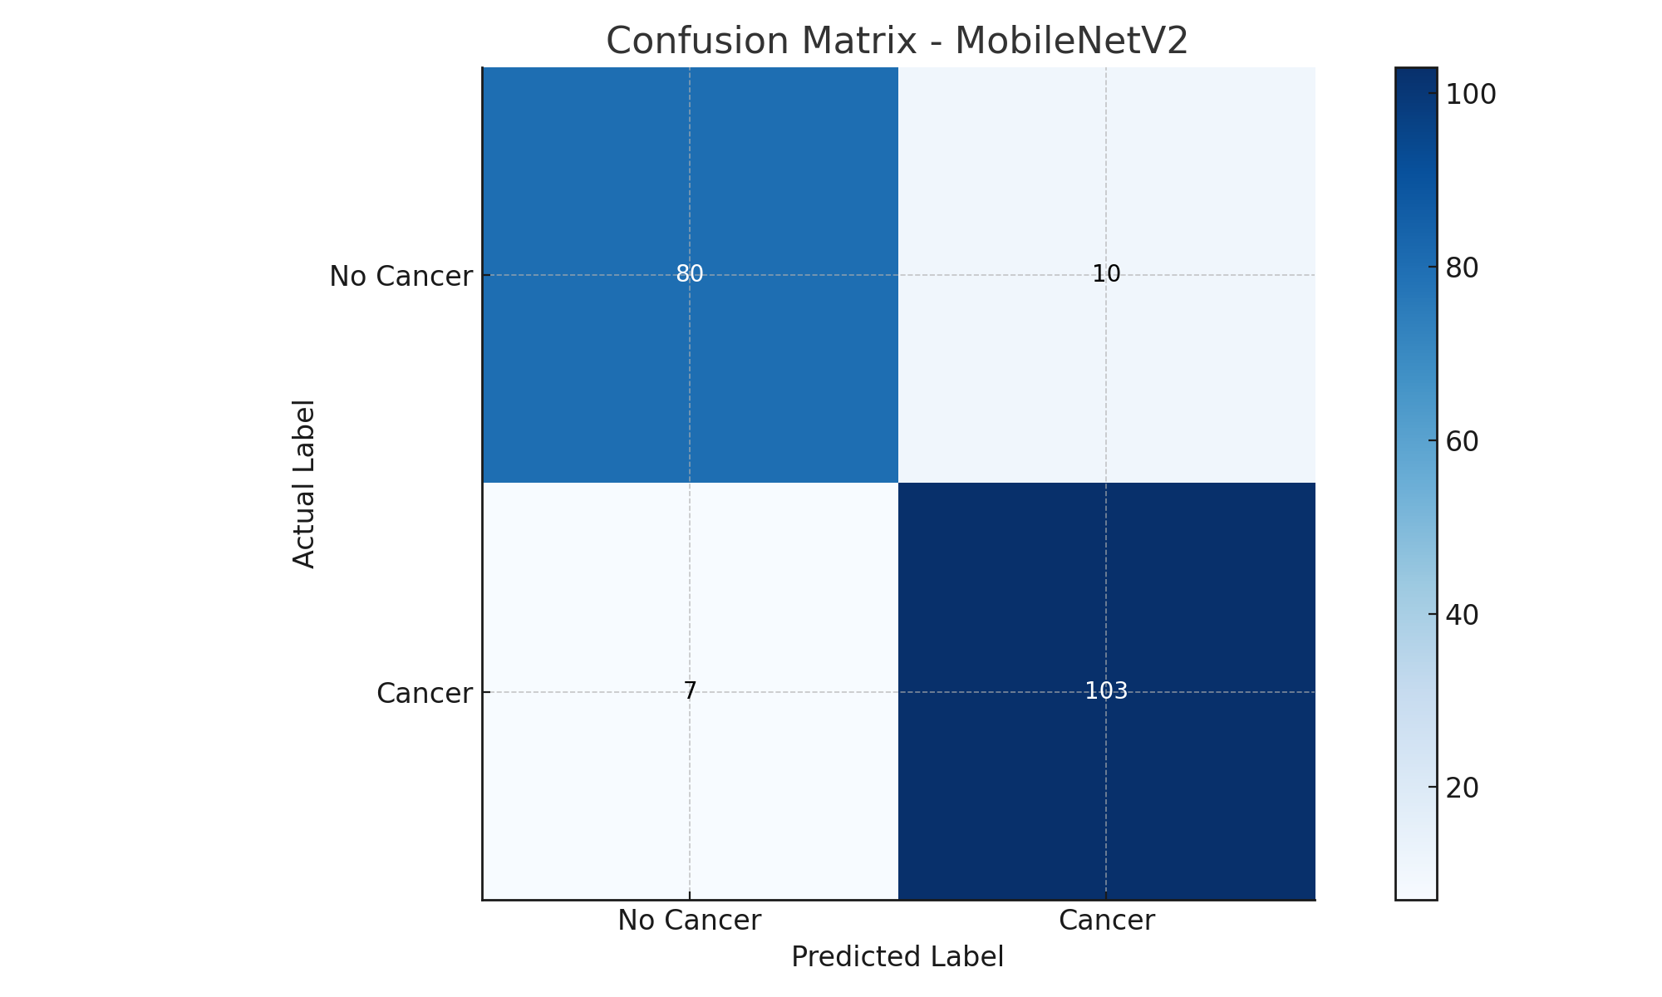

# Confusion Matrix - ResNet50

The confusion matrix for ResNet50 is shown below:

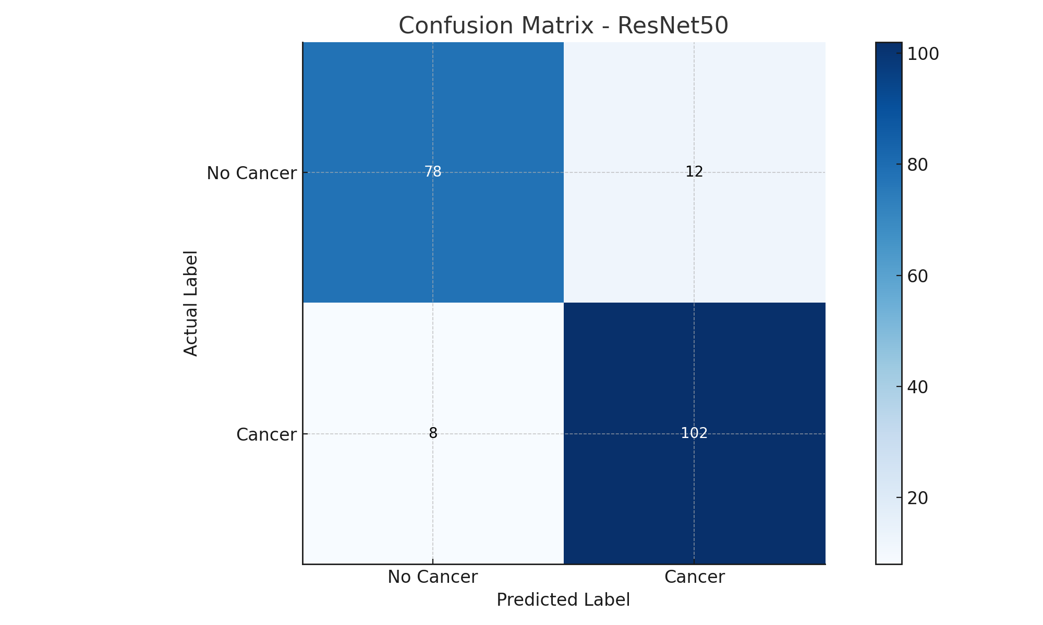

# Comparison Summary

Based on the confusion matrices above:  
- CNN shows the best performance with the highest true positives and lowest false negatives.  
- MobileNetV2 and ResNet50 show slightly higher false negatives, which is less desirable in cancer detection scenarios.  
Thus, CNN is chosen as the best model for this project due to its balanced and high performance on both classes.