RAVENSTACK
SaaS Business Growth Analytics Report
End-to-End Data Analysis: SQL • Python • Power BI

Prepared by:
Data Analytics Team
June 2026

1. Executive Summary
This report presents a comprehensive analysis of RavenStack’s SaaS business performance across five dimensions: revenue, customer subscriptions, product usage, churn and retention, and customer support experience. The analysis integrates data from five relational tables using SQL, Python (Pandas/Seaborn), and Power BI dashboards, covering 500 accounts and over 4,960 subscriptions spanning 2023–2024.

Key Highlights
- Total ARR of $136M with Enterprise tier contributing the largest revenue share ($8.5M MRR).
- 500 customer accounts across industries including DevTools, FinTech, and Cybersecurity.
- Total churn events of 600, with a churn count of 486; primary churn driver is missing features.
- Product usage is growing year-over-year, reaching 251K total usage count with 25K usage events.
- Average customer satisfaction score of 3.98 out of 5, with a 4.75% ticket escalation rate.
- 80% of subscriptions are paid (non-trial), and ~80% are set to auto-renew.

2. Project Overview

2.1 Objective
The goal of this project is to derive actionable business intelligence from RavenStack’s operational data. By combining SQL-based data extraction, Python-based exploratory analysis, and interactive Power BI dashboards, the project surfaces patterns in revenue, customer behavior, product adoption, churn risk, and support performance.

2.2 Data Sources
The analysis draws from five core tables stored in a MySQL database (saas_analytics):

Table | Records | Description
accounts | 500 | Company accounts: industry, country, signup date, size
subscription | ~4,960 | Plans, MRR/ARR, upgrade/downgrade flags, auto-renew, churn
usage_data | 25K+ | Feature usage events: usage count, duration, errors, beta features
tickets | 2,000+ | Support tickets: priority, resolution time, satisfaction, escalation
events (churn) | 600 | Churn events: reason code, refund, reactivation, preceding actions

2.3 Tools & Technologies
- MySQL: Database creation, schema cleanup, joins, window functions, aggregation queries.
- Python (Pandas, NumPy, Matplotlib, Seaborn): Data loading, merging, feature engineering, EDA, correlation analysis, cohort analysis.
- Power BI: Five interactive dashboards covering all major analysis dimensions.

3. Data Preparation & Cleaning

3.1 SQL: Database Setup
The project began by creating a dedicated MySQL database and importing five CSV files. Table names were renamed to clean aliases using RENAME TABLE statements. A critical early step was fixing BOM-corrupted column names (ï»¿account_id) caused by UTF-8 encoding issues in the CSVs:

CREATE DATABASE saas_analytics;
RENAME TABLE ravenstack_accounts TO accounts;
ALTER TABLE accounts CHANGE COLUMN `ï»¿account_id` account_id VARCHAR(50);

This pattern was applied consistently across all five tables (subscription, usage_data, tickets, events) to ensure clean primary key columns for reliable JOIN operations.

3.2 Python: Data Merging & Feature Engineering
In Python, the five dataframes were loaded and progressively merged into a single master_df using account_id and subscription_id as join keys. Key feature engineering steps included:
- customer_status column derived from end_date nullability (Active vs. Churned).
- engagement_score computed as: total_usage + (unique_features × 10) + total_usage_events.
- engagement_segment column created using pd.qcut() into Low / Medium / High terciles.
- Missing feedback_text values filled with 'NO Feedback'.
- churn_flag cast to integer for numerical correlation analysis.

4. SQL Analysis

4.1 Revenue by Subscription Plan
SELECT plan_tier, SUM(mrr_amount) AS total_mrr FROM subscription GROUP BY plan_tier ORDER BY total_mrr DESC;
Enterprise subscriptions generate the highest MRR, followed by Pro and Basic — aligning with Power BI findings (Enterprise: $8.5M, Pro: $2.1M, Basic: $0.8M).

4.2 Revenue by Industry
SELECT a.industry, SUM(s.mrr_amount) AS total_mrr FROM accounts a JOIN subscription s ON a.account_id = s.account_id GROUP BY a.industry ORDER BY total_mrr DESC;
DevTools, FinTech, and Cybersecurity are the top-revenue industries, reflecting the SaaS-native nature of these verticals.

4.3 Churn Rate by Plan
SELECT plan_tier, ROUND(AVG(churn_flag) * 100, 2) AS churn_rate FROM subscription GROUP BY plan_tier;
Churn rate analysis by plan tier reveals where retention efforts should be concentrated. Enterprise plans typically exhibit lower churn due to higher switching costs and contract commitments.

4.4 Most Used Features
SELECT feature_name, SUM(usage_count) AS total_usage FROM usage_data GROUP BY feature_name ORDER BY total_usage DESC;
Feature-level usage totals identify the product’s stickiest capabilities and guide roadmap prioritization.

4.5 Support Ticket Resolution by Priority
SELECT priority, AVG(resolution_time_hours) AS avg_resolution_time FROM tickets GROUP BY priority;
Average resolution time varies by priority level. The overall average across all tickets is 35.86 hours, with first response averaging 88.48 minutes.

4.6 Revenue Ranking (Window Function)
SELECT account_id, SUM(mrr_amount) AS revenue,
RANK() OVER (ORDER BY SUM(mrr_amount) DESC) AS revenue_rank
FROM subscription GROUP BY account_id;
Window functions rank accounts by revenue, enabling Pareto analysis of the customer base. Top accounts (Company_90 through Company_99) generate comparable ARR at approximately $100M+ each.

5. Power BI Dashboard Analysis

5.1 SaaS Business Performance Dashboard
This top-level dashboard consolidates the most critical business KPIs for executive review.

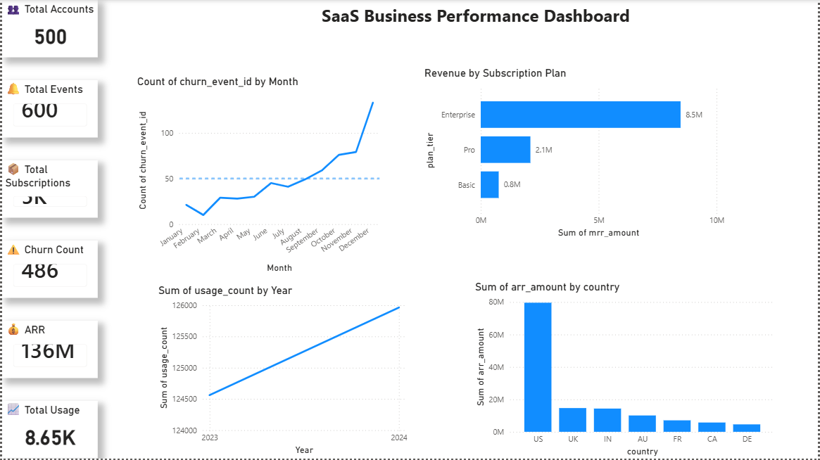
Figure 1: SaaS Business Performance Dashboard
Metric | Value | Notes
Total Accounts | 500 | Active customer base
Total Events | 600 | Churn events recorded
Total Subscriptions | ~5K | Across all plan tiers
Churn Count | 486 | Unique churned accounts
ARR | $136M | Annual Recurring Revenue
Total Usage | 8.65K | Aggregate usage count (KPI view)

Key observations: Churn events accelerate sharply from August onward, surpassing the 50-event baseline by December. Product usage (sum of usage_count) shows a clear upward trend from 2023 to 2024, confirming growing product adoption. The US dominates ARR contribution, followed distantly by UK, India, Australia, France, Canada, and Germany.

5.2 Customer & Subscription Analytics
This dashboard focuses on the composition and monetization of the customer base.

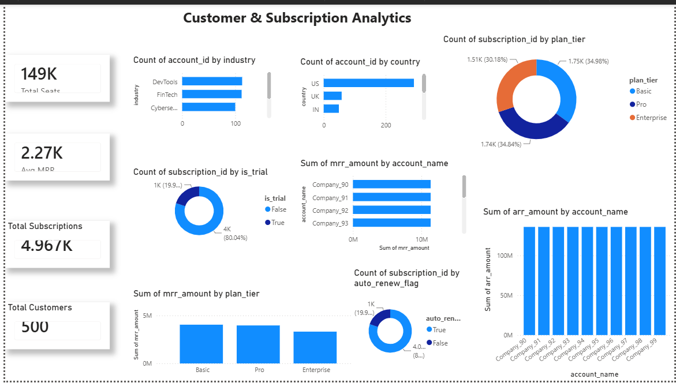
Figure 2: Customer & Subscription Analytics Dashboard
Metric | Value | Notes
Total Seats | 149K | Seats across all subscriptions
Avg MRR | $2,270 | Per subscription average
Total Subscriptions | 4,967 | Including trial subscriptions
Total Customers | 500 | Unique billing accounts

Plan distribution is nearly even: Basic (34.98%), Pro (34.84%), and Enterprise (30.18%), suggesting healthy upsell opportunity from Basic and Pro tiers toward Enterprise. The is_trial split shows 80.04% paid subscriptions vs. 19.96% trials — a strong conversion baseline. Auto-renew is active on ~80% of subscriptions, indicating high retention intent. Company_90 through Company_99 are the highest MRR contributors.

5.3 Product Usage Analytics
This dashboard tracks how customers interact with the product over time.

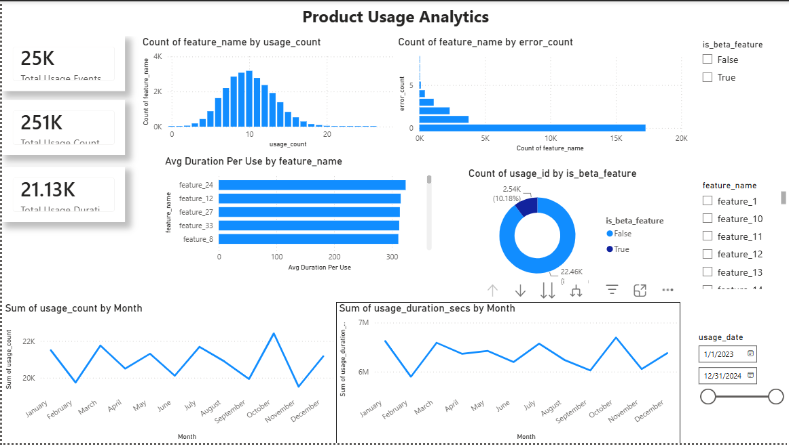
Figure 3: Product Usage Analytics Dashboard
Metric | Value | Notes
Total Usage Events | 25K | Individual feature interactions
Total Usage Count | 251K | Aggregate usage volume
Total Usage Duration | 21.13K | Total seconds (in thousands)

Feature usage follows a bell-curve distribution (most features used 5–15 times per session). Features 24, 12, 27, 33, and 8 have the longest average duration per use, indicating deeper engagement. Beta feature usage is relatively low (10.18%), suggesting measured rollout. Monthly usage counts fluctuate between ~20K–22K, while duration shows more volatility, peaking early in the year and dipping mid-year.

5.4 Churn Analytics & Customer Retention
This dashboard deconstructs churn patterns to identify drivers and recovery signals.

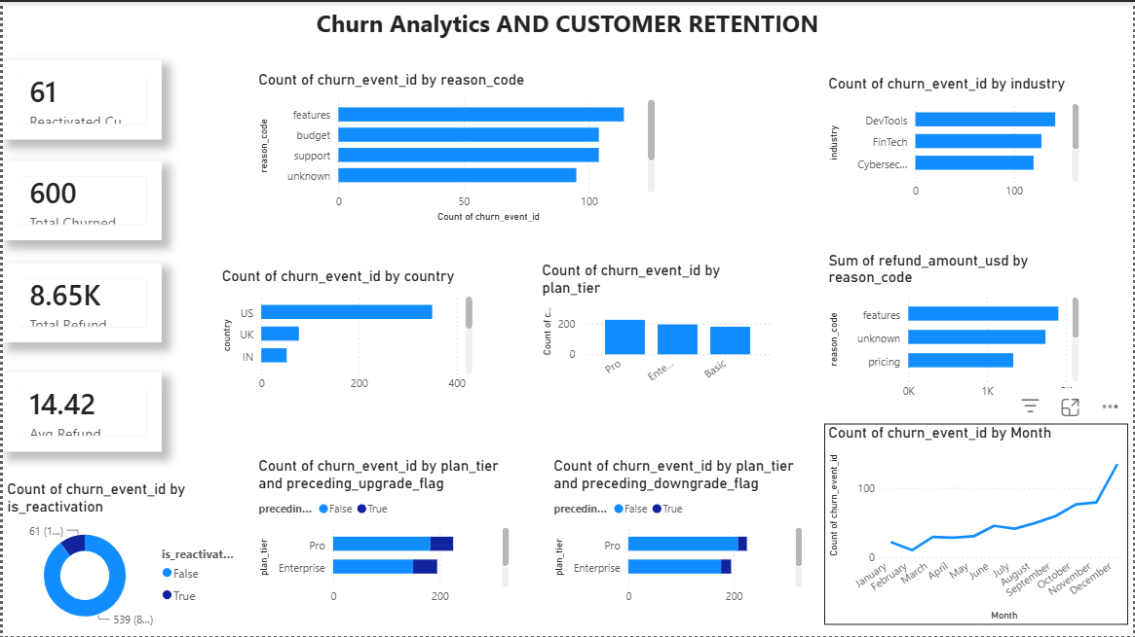
Figure 4: Churn Analytics & Customer Retention Dashboard
Metric | Value | Notes
Reactivated Customers | 61 | Churned accounts re-engaged
Total Churned | 600 | Total churn events
Total Refunds | $8,650 | Sum of refund amounts
Avg Refund | $14.42 | Per churn event

The primary churn reason is features (missing or inadequate functionality), followed by budget constraints, support quality, and unknown reasons. Churn is distributed across DevTools, FinTech, and Cybersecurity industries proportionally. Pro tier accounts for the most churn events, likely due to its volume. Preceding upgrade/downgrade flags reveal that churn often follows subscription changes, particularly upgrades in the Pro and Enterprise tiers. Churn surges sharply in Q4, consistent with year-end budget cycles.

5.5 Support & Customer Experience Analytics
This dashboard evaluates the health of the customer success and support function.

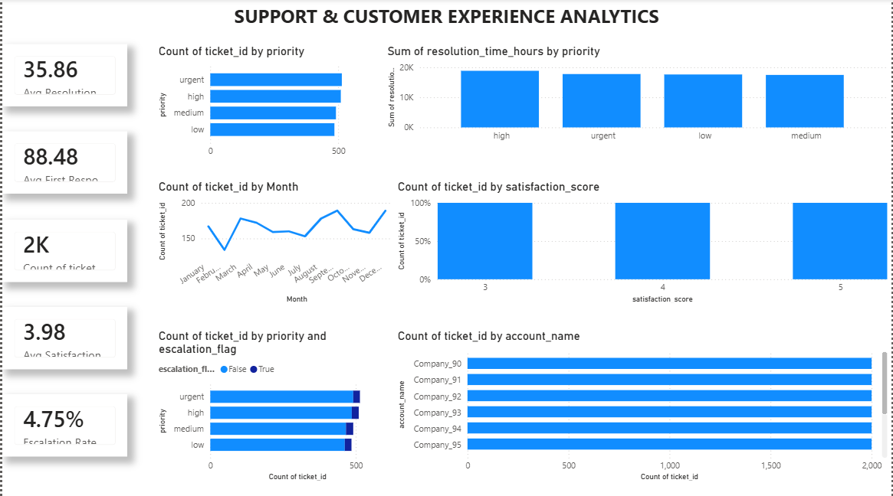
Figure 5: Support & Customer Experience Analytics Dashboard
Metric | Value | Notes
Avg Resolution Time | 35.86 hrs | Across all priorities
Avg First Response | 88.48 min | Time to first agent reply
Total Tickets | 2,000 | Support tickets logged
Avg Satisfaction | 3.98 / 5 | Customer satisfaction score
Escalation Rate | 4.75% | Tickets escalated

Ticket volume is roughly equal across urgent, high, medium, and low priorities. Satisfaction scores cluster at 3, 4, and 5, with no scores below 3, suggesting a generally acceptable support experience. Ticket volume rises in December, consistent with year-end product usage spikes. Escalation is concentrated in urgent and high-priority tickets, as expected. Company_90 through Company_95 are the highest support consumers, aligning with their status as top-revenue accounts.

6. Python Exploratory Data Analysis

6.1 Master DataFrame Construction
The master_df was assembled by merging accounts, subscription_agg, usage_agg, tickets_agg, and churn_agg on account_id. The final master dataframe contains one row per account, with aggregated subscription, usage, support, and churn metrics as columns.

6.2 Engagement Scoring & Segmentation
A composite engagement_score was engineered to quantify customer product adoption:
engagement_score = total_usage + (unique_features × 10) + total_usage_events
Customers were then segmented into three equal terciles using pd.qcut():
- Low engagement: Accounts at risk; candidates for proactive CSM outreach.
- Medium engagement: Stable users; prime candidates for feature upsell.
- High engagement: Power users; ideal for beta programs and advocacy campaigns.

6.3 Churn vs. Engagement Analysis
Comparing churned vs. retained accounts across key metrics revealed:
- Churned accounts have significantly lower engagement_score on average.
- Churned accounts tend to have more support tickets, indicating support-churn correlation.
- Total MRR from churned accounts is lower, confirming higher churn risk in lower-value plans.

6.4 Correlation Analysis
A correlation matrix on numerical columns revealed key relationships with churn_flag:
- Negative correlation: Higher total_usage and unique_features correlate with lower churn.
- Positive correlation: Higher ticket_count and escalated_tickets correlate with higher churn.
- Upgrade/downgrade flags: Preceding downgrades show positive correlation with churn.

6.5 Cohort Analysis
Monthly signup cohorts were constructed to track churn_rate per acquisition month. The analysis used signup_date converted to monthly periods (signup_month), grouping accounts and computing mean churn per cohort. This provides a longitudinal view of retention by acquisition vintage.

7. Key Findings & Insights

7.1 Revenue
- Enterprise is the highest-revenue tier at $8.5M MRR; upselling Basic/Pro customers is the largest revenue lever.
- US accounts for ~75% of total ARR; international markets (UK, IN, AU) represent growth opportunities.
- ARR of $136M with an average MRR of $2,270 per subscription indicates a mid-market SaaS positioning.

7.2 Churn & Retention
- Feature gaps are the #1 churn driver — product roadmap investment is directly linked to retention.
- 61 reactivations (10% of churned) show that win-back campaigns have measurable success.
- Churn spikes in Q4; proactive customer success outreach in Q3 is recommended.
- Pro tier has the most churn volume, but Enterprise churn carries greater revenue impact.

7.3 Product Usage
- Feature usage is growing year-over-year, but duration shows volatility — onboarding improvements may stabilize engagement.
- Features 24, 12, and 27 drive the longest session durations; these are the product’s ‘aha moment’ features.
- Beta feature adoption is low (10%); graduated rollout communications may accelerate adoption.

7.4 Support
- Average resolution time of 35.86 hours with a satisfaction score of 3.98 is acceptable but improvable.
- Escalation rate of 4.75% is low, but escalated tickets likely drive disproportionate churn.
- Top-revenue accounts (Company_90–99) are also the highest ticket submitters — dedicated CSM assignment is recommended.

8. Recommendations
- Invest in product features: Address the #1 churn reason by accelerating roadmap items flagged in churn feedback.
- Launch Q3 retention campaigns: Target accounts with low engagement scores and recent downgrade flags before Q4 churn season.
- Dedicate CSMs to top accounts: Company_90–99 submit the most tickets and generate the most revenue; personalized support reduces churn risk.
- Improve trial-to-paid conversion: With 20% on trial, a structured nurture program could meaningfully grow paid ARR.
- Expand internationally: US concentration (75% ARR) creates geographic risk; UK and India show early traction.
- Operationalize engagement scoring: Integrate engagement_score into CRM workflows to trigger automated alerts for at-risk accounts.

9. Conclusion
This project demonstrates a complete end-to-end SaaS analytics pipeline, from raw database setup in MySQL through feature engineering in Python to multi-dimensional reporting in Power BI. RavenStack operates a healthy SaaS business with $136M ARR and a growing user base, but faces headwinds from feature-driven churn and Q4 seasonality. The combination of SQL-driven data extraction, Python-based behavioral scoring, and Power BI visual analytics provides a repeatable framework for ongoing business intelligence and data-driven decision-making.

The engagement score model and cohort analysis lay the groundwork for predictive churn modeling in a future iteration of this project.

End of Report

