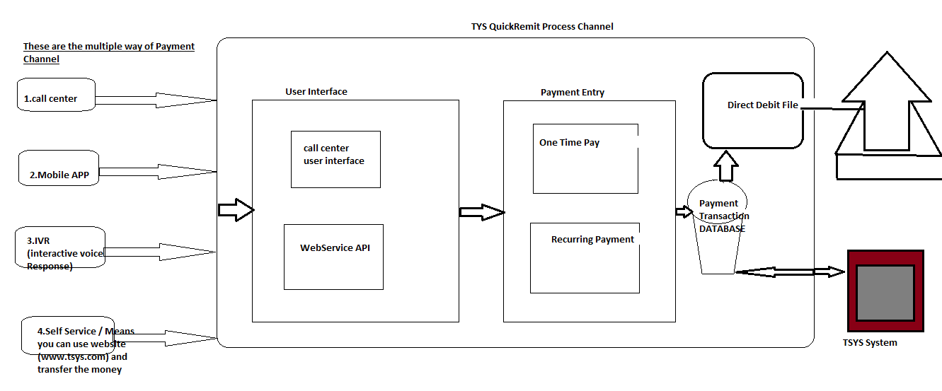

Pic 1.1

If we look above picture there are certain actors playing the role while transfering payment from sender to recevier .

There are multiple ways to interact with Payment Channel.

* Call Center
* Mobile APP
* IVR
* Self Service (Self By using website of payment gateway we can transfer)

**Features and Functionality Involved in Payment Channels**

* **Payment Channel:**

Once by using any one of the channel which is listed above if we are trying to transfer pay to the Recevier end then first user interface with interact by UI

UI will call to API for webservice call .

* **UserInterface:**

Like that define all process Priya …by looking at Above picture