Predict Gas Guzzlers using a Neural Net Model on the MPG Data Set

Priya

Loading libraries needed

library(neuralnet)

Create a Data Frame We will use the dataset mtcars. We’re going to create a new variable called mpg2. If the car has greater than 22 mpg that it’s a one. If less than 0. This creates a binary variable, which we can use in the NN.

hist(mtcars$mpg)

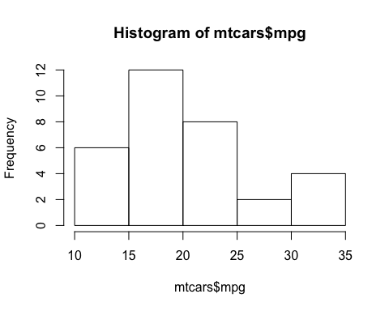

mtcars$mpg2 <- ifelse(mtcars$mpg > 22,1,0)  
data <- mtcars  
rows <- sample(1:nrow(data), nrow(data) * .7, replace = F)  
train <- data[rows,]  
test <- data[-rows,]

Creating a neural net model We are going to use all the variables. It is also a logistic neural net model.

set.seed(222)  
model <- neuralnet(mpg2 ~ ., train,  
 act.fct = "logistic", linear.output = F )  
?neuralnet

We can also plot the model to see the structure of neuralnet

plot(model)

Testing the model We call the compute method to test the model on our test set.

predict <- neuralnet::compute(model, test)  
predict

## $neurons  
## $neurons[[1]]  
## mpg cyl disp hp drat wt qsec vs am gear carb  
## Hornet Sportabout 1 18.7 8 360.0 175 3.15 3.440 17.02 0 0 3 2  
## Duster 360 1 14.3 8 360.0 245 3.21 3.570 15.84 0 0 3 4  
## Merc 450SL 1 17.3 8 275.8 180 3.07 3.730 17.60 0 0 3 3  
## Merc 450SLC 1 15.2 8 275.8 180 3.07 3.780 18.00 0 0 3 3  
## Dodge Challenger 1 15.5 8 318.0 150 2.76 3.520 16.87 0 0 3 2  
## AMC Javelin 1 15.2 8 304.0 150 3.15 3.435 17.30 0 0 3 2  
## Fiat X1-9 1 27.3 4 79.0 66 4.08 1.935 18.90 1 1 4 1  
## Porsche 914-2 1 26.0 4 120.3 91 4.43 2.140 16.70 0 1 5 2  
## Ford Pantera L 1 15.8 8 351.0 264 4.22 3.170 14.50 0 1 5 4  
## Maserati Bora 1 15.0 8 301.0 335 3.54 3.570 14.60 0 1 5 8  
##   
## $neurons[[2]]  
## [,1] [,2]  
## Hornet Sportabout 1 4.983105e-44  
## Duster 360 1 5.953512e-42  
## Merc 450SL 1 2.596518e-28  
## Merc 450SLC 1 4.856959e-28  
## Dodge Challenger 1 1.204269e-37  
## AMC Javelin 1 9.736825e-35  
## Fiat X1-9 1 9.999784e-01  
## Porsche 914-2 1 1.993641e-04  
## Ford Pantera L 1 2.669313e-38  
## Maserati Bora 1 2.824040e-27  
##   
##   
## $net.result  
## [,1]  
## Hornet Sportabout 0.1164533  
## Duster 360 0.1164533  
## Merc 450SL 0.1164533  
## Merc 450SLC 0.1164533  
## Dodge Challenger 0.1164533  
## AMC Javelin 0.1164533  
## Fiat X1-9 0.9898095  
## Porsche 914-2 0.1165888  
## Ford Pantera L 0.1164533  
## Maserati Bora 0.1164533

Creating Confusion matrix

results <- ifelse(predict$net.result > .5, 1,0)  
  
table(results, test$mpg2)

##   
## results 0 1  
## 0 8 1  
## 1 0 1