E-COMMERCE SALES & CUSTOMER BEHAVIOUR ANALYSIS USING IBM COGNOS ANALYTICS
A
PROJECT REPORT
SUBMTTED BY
PRIYANSHI
ROLLNO: 25050020013
in partial fulfilment of Summer Internship for the award of the degree
Of
MASTER OF BUSINESS ADMINISTRATION
IN

SESSION 2026-2027
UNDER THE GUIDANCE OF
MR. Ferhan Ahmed
IBM Trainer
Rawatpur, Prayagraj,
Uttar Pradesh 211012

ACKNOWLEDGEMENT

I would like to express my sincere gratitude to United University, Prayagraj, Uttar Pradesh, for providing me with the opportunity to undertake this project titled “E-commerce Sales & Customer Behaviour Analysis Using IBM Cognos Analytics” as part of my MBA – IBM programme for the academic session 2026–2027.

First and foremost, I would like to express my heartfelt thanks to my IBM Trainer, Mr. Ferhan Ahmed, for his valuable guidance, support, and encouragement throughout the project. His guidance helped me understand the practical application of IBM Cognos Analytics and the importance of data visualization in business decision-making. His support motivated me to explore the concepts of data analysis and dashboard development in a structured manner.

I am also grateful to the Faculty of Commerce and Management at United University for providing the academic environment and learning opportunities necessary for completing this project. The knowledge and skills gained during my MBA programme helped me understand the relationship between business management, sales analysis, and customer behaviour.

This project provided me with an opportunity to develop practical knowledge of data preparation, data visualization, dashboard creation, and the interpretation of business data using IBM Cognos Analytics. It also enhanced my analytical thinking and helped me understand how data-driven insights can support better business decisions in the e-commerce industry.

I would also like to thank my teachers, classmates, and everyone who directly or indirectly supported and encouraged me during the completion of this project.
Finally, I am deeply thankful to my parents for their continuous encouragement, motivation, and support throughout my academic journey. Their belief in me has always inspired me to learn new skills and work towards my goals with dedication.
This project has been a valuable learning experience, and I am grateful to everyone who contributed to its successful completion.

PRIYANSHI
MBA – IBM
United University, Prayagraj
ABSTRACT

The project entitled “E-commerce Sales & Customer Behaviour Analysis Using IBM Cognos Analytics” focuses on analyzing e-commerce sales data to understand sales performance and customer purchasing patterns.

The main objective of this project is to transform raw sales data into meaningful information through data visualization and descriptive analytics. The project uses Microsoft Excel for dataset preparation and IBM Cognos Analytics for creating interactive visualizations and a dashboard.

The dataset consists of 300 order records containing information such as product categories, sales revenue, customer details, geographical regions, payment methods, devices, order status, and customer ratings.

Various visualizations have been developed to analyze net sales by product category, sales trends, regional sales performance, repeat and new customers, payment methods, order status, and device usage. Key Performance Indicators (KPIs), including total net sales and total orders, have also been included in the dashboard.

The project demonstrates how business intelligence and data visualization tools can help organize sales information, identify patterns, and support data-driven decision-making. The findings can help businesses better understand their sales performance and customer behaviour.

Keywords: E-commerce, Sales Analysis, Customer Behaviour, Descriptive Analytics, IBM Cognos Analytics, Data Visualization, Dashboard, KPI.

TABLE OF CONTENT

S.No | Content
1 | Title Page
2 | Acknowledgement
3 | Abstract
4 | Table Of Content
5 | Introduction
6 | Objective of the study
7 | Problem Statement
8 | Data Discussion
9 | Method, Tools& Technologies Used
10 | Project Workflow
11 | Results and Dashboard Analysis
12 | Insights / Observation
13 | Recommendations / Suggestions
14 | Conclusion
15 | References

1.INTRODUCTION

1.1 Introduction

In today's digital era, e-commerce has become an important part of the modern business environment. It allows customers to purchase products and services online through websites and mobile applications. The rapid growth of online shopping has generated large amounts of data related to sales transactions, customer preferences, payment methods, product categories, and purchasing behaviour.

Analyzing this data helps businesses understand their performance, identify customer preferences, and make informed decisions. However, raw data alone does not provide meaningful insights unless it is properly organized, analyzed, and presented in an understandable format.

Business Intelligence (BI) tools play an important role in converting raw data into useful information through reports, charts, dashboards, and key performance indicators (KPIs). These tools help users identify patterns, compare performance, and monitor important business metrics.

This project, “E-commerce Sales & Customer Behaviour Analysis Using IBM Cognos Analytics,” focuses on analyzing e-commerce sales data using descriptive analytics and data visualization techniques. Microsoft Excel is used to prepare and organize the dataset, while IBM Cognos Analytics is used to create visualizations and develop a dashboard.

The project analyzes different aspects of e-commerce operations, including sales by product category, regional sales performance, customer purchasing patterns, payment methods, order status, and device usage. It also includes key performance indicators such as total net sales and total orders to provide a summarized view of business performance.

The overall purpose of this project is to demonstrate how data visualization and business intelligence can help transform sales data into meaningful insights and support data-driven business decisions.

1.2 Background of the Study

The e-commerce industry operates in a highly competitive environment where understanding customer behaviour and sales performance is essential for business growth. Online businesses collect transaction data that can reveal information about popular products, customer purchasing patterns, regional demand, and preferred payment methods.

Descriptive analytics helps summarize historical data and identify patterns using measures such as totals, counts, averages, and comparisons. When combined with visual representations, it becomes easier for users to interpret complex information.

IBM Cognos Analytics is a business intelligence and analytics platform that supports data exploration, reporting, and dashboard development. It enables users to present business information through visualizations that make comparisons and trends easier to understand.

This project applies these concepts to an e-commerce dataset containing 300 order records created for academic and analytical purposes.

1.3 Importance of the Study

The study is important for the following reasons:

1. Sales Performance Analysis: It helps examine net sales across different product categories and regions.
2. Customer Behaviour Analysis: It provides an overview of repeat and new customers.
3. Payment Method Analysis: It helps compare the number of orders associated with different payment methods.
4. Order Status Analysis: It presents the distribution of orders across different statuses.
5. Device Usage Analysis: It helps understand the devices customers use to place orders.
6. Data Visualization: It presents information through charts and dashboard components that are easier to interpret.
7. Business Decision-Making: It demonstrates how summarized data can support business planning and performance monitoring.

1.4 Overview of the Project

The project involves preparing an e-commerce dataset, importing it into IBM Cognos Analytics, and developing a dashboard using suitable visualizations.

The dataset includes variables such as order date, customer details, product category, quantity, unit price, discount, net sales, payment method, region, device, order status, and customer rating.

The dashboard presents different views of the dataset, including:

- Net Sales by Product Category
- Net Sales by Order Date
- Net Sales by Region
- Repeat vs New Customer Orders
- Orders by Payment Method
- Order Status Distribution
- Orders by Device

The dashboard also includes KPI cards for summarizing important metrics, such as total net sales and total orders. These visualizations collectively provide an overview of the sales data and selected customer behaviour indicators.

1.5 Scope of the Study

The scope of this project is limited to descriptive analysis of the selected e-commerce dataset. It focuses on summarizing sales transactions and exploring customer-related patterns using IBM Cognos Analytics.

The study covers product category performance, sales across regions and dates, repeat customer indicators, payment methods, order statuses, and device usage.

The project uses a synthetic dataset containing 300 order records. Therefore, the results demonstrate analytical techniques for academic purposes and should not be treated as verified findings about an actual e-commerce company or the entire e-commerce industry.

1.6 Structure of the Report

This project report is organized into chapters covering the introduction, objectives, research methodology, dataset description, dashboard development, analysis and interpretation, findings, limitations, recommendations, conclusion, and references. Each section explains a different stage of the project and demonstrates the application of business intelligence techniques to e-commerce sales data.

2.OBJECTIVES OF THE PROJECT

2.1 Introduction

The objectives of this project define the main purpose of analyzing e-commerce sales data using IBM Cognos Analytics. The project focuses on understanding sales performance, examining customer-related patterns, and presenting useful information through data visualization.

The study applies descriptive analytics techniques to summarize the dataset and develop a dashboard that provides a clear overview of important business metrics.

2.2 Primary Objective

The primary objective of this project is to analyze e-commerce sales and selected customer behaviour indicators using IBM Cognos Analytics and develop a visual dashboard that presents meaningful information to support data-driven decision-making.

2.3 Specific Objectives

The specific objectives of the project are as follows:

1. To analyze sales performance: To examine net sales across different product categories and identify variations in sales performance.

2. To examine sales trends: To visualize sales across different dates and observe changes in sales performance over the selected period.

3. To compare regional sales: To analyze net sales across different geographical regions and understand their relative contribution.

4. To study customer purchasing patterns: To compare orders associated with repeat customers and new customers.

5. To analyze payment methods: To examine the distribution of orders across different payment methods.

6. To evaluate order status: To understand the distribution of orders across statuses such as delivered, cancelled, and returned.

7. To analyze device usage: To examine the devices used by customers while placing orders.

8. To develop KPI indicators: To summarize important business metrics, including total net sales and total orders, using KPI cards.

9. To apply data visualization techniques: To present the analysis through suitable charts and dashboard components in IBM Cognos Analytics.

10. To support data-driven decision-making: To demonstrate how organized sales information and visual analytics can help users understand business performance.

2.4 Expected Outcomes

The expected outcomes of this project are:

- A dashboard presenting an overview of e-commerce sales data.
- A visual comparison of net sales across product categories and regions.
- An overview of sales performance across dates.
- A comparison of repeat and new customer orders.
- A summary of orders by payment method, order status, and device.
- KPI cards displaying key business metrics.
- Improved understanding of how business intelligence tools can be used for descriptive analytics.

2.5 Summary

This chapter outlines the primary and specific objectives of the project. By achieving these objectives, the project demonstrates the practical application of IBM Cognos Analytics in analyzing e-commerce sales data and presenting the results in a clear and understandable dashboard.

3. PROBLEM STATEMENT

3.1 Problem Statement

E-commerce businesses generate large amounts of data through online transactions, including sales records, product information, customer details, payment methods, and order statuses. However, raw data is often difficult to interpret without proper organization, analysis, and visualization.

Without a clear and structured presentation of sales information, it can be challenging to understand which product categories generate higher sales, how sales vary across geographical regions, which payment methods customers use, and how orders are distributed across different statuses.

Similarly, understanding repeat customer orders and device usage can help businesses explore customer purchasing patterns. Presenting these details in separate data tables may make it difficult to identify patterns and compare different business indicators efficiently.

Therefore, this project aims to organize and analyze an e-commerce dataset using IBM Cognos Analytics and present the results through a dashboard containing charts and key performance indicators (KPIs).

The project focuses on descriptive analytics rather than predicting future sales. Its purpose is to make the available data easier to understand and demonstrate how data visualization can support business performance monitoring and informed decision-making.

3.2 Key Problems Addressed

The project addresses the following problems:

1. Difficulty in understanding sales performance across different product categories.
2. Difficulty in comparing sales across geographical regions.
3. Need to visualize sales variations across dates.
4. Need to compare orders associated with repeat and new customers.
5. Difficulty in understanding the distribution of orders across payment methods.
6. Need to examine order statuses, including delivered, cancelled, and returned orders.
7. Need to understand the distribution of orders by device.
8. Need for a centralized dashboard that presents key sales metrics in a clear and understandable format.

3.3 Proposed Solution

To address these problems, the project uses Microsoft Excel to prepare the dataset and IBM Cognos Analytics to create visualizations and develop a dashboard.

The dashboard combines sales charts, customer-related comparisons, order analysis, and KPI cards. It provides a summarized view of the dataset and allows users to compare different business indicators without examining every individual record.

Since the dataset contains 300 synthetic order records created for academic purposes, the findings demonstrate the application of descriptive analytics techniques and should not be interpreted as verified results from a real e-commerce business.

4. DATA DISCUSSION

4.1 Overview of the Dataset

The dataset used in this project is an e-commerce sales dataset containing 300 order records. It has been prepared for academic and analytical purposes to demonstrate the application of descriptive analytics and data visualization using IBM Cognos Analytics.

The dataset contains information about customer demographics, product categories, sales transactions, geographical regions, payment methods, devices, order statuses, and customer ratings. These variables help analyze sales performance and explore selected customer purchasing patterns.

The dataset covers the period from January 2025 to December 2025. It is organized in Microsoft Excel and imported into IBM Cognos Analytics for visualization and dashboard development.

4.2 Data Source

The project uses a synthetic dataset created for educational purposes. It does not represent verified transactions from an actual e-commerce company.

Microsoft Excel was used to store and organize the data before it was imported into IBM Cognos Analytics. The dataset was then used to create charts and key performance indicator (KPI) cards.

4.3 Description of the Dataset

The dataset contains the following important variables:

S. No.| Variable| Description
1| Order ID| Unique identifier assigned to an order
2| Order Date| Date on which the order was recorded
3| Customer ID| Identifier assigned to a customer
4| Customer Age| Age of the customer
5| Gender| Gender category recorded in the dataset
6| City| City associated with the order
7| Region| Geographical region associated with the order
8| Product Category| Category to which the purchased product belongs
9| Product Name| Name of the product purchased
10| Quantity| Number of units ordered
11| Unit Price (INR)| Price per unit in Indian rupees
12| Discount (%)| Discount percentage applied to the order
13| Gross Sales (INR)| Sales amount before deducting the discount
14| Discount Amount (INR)| Monetary value of the discount
15| Net Sales (INR)| Gross sales after deducting the discount
16| Payment Method| Payment method recorded for the order
17| Device| Device associated with the order
18| Order Channel| Channel through which the order was placed
19| Delivery Days| Number of days recorded for delivery
20| Customer Rating| Customer rating recorded in the dataset
21| Order Status| Status of the order, such as delivered, cancelled, or returned
22| Repeat Customer| Indicator showing whether the customer is categorized as a repeat customer

4.4 Nature of the Data

The dataset contains both numerical and categorical variables.

Numerical data: Customer Age, Quantity, Unit Price, Discount Percentage, Gross Sales, Discount Amount, Net Sales, Delivery Days, and Customer Rating.

Categorical data: Gender, City, Region, Product Category, Product Name, Payment Method, Device, Order Channel, Order Status, and Repeat Customer.

Date and identifier fields: Order Date, Order ID, and Customer ID.

These different types of variables allow the project to examine sales amounts, compare categories, count orders, and visualize sales across dates.

4.5 Data Preparation

The dataset was maintained in Microsoft Excel and imported into IBM Cognos Analytics for analysis and visualization.

The main preparation activities included:

1. Organizing the dataset in a structured tabular format.
2. Identifying the relevant fields required for sales and customer analysis.
3. Using order dates to examine sales over time.
4. Using numerical fields, such as Net Sales (INR), for sales analysis.
5. Using categorical fields, such as Product Category and Region, to compare sales performance.
6. Using Order ID to count orders.
7. Selecting suitable fields and aggregations while developing dashboard visualizations.

4.6 Data Analysis Scope

The dataset was used to develop visualizations covering the following areas:

- Net sales by product category.
- Net sales by order date.
- Net sales by region.
- Repeat versus new customer orders.
- Orders by payment method.
- Order status distribution.
- Orders by device.
- Total net sales and total orders through KPI cards.

These visualizations provide a descriptive overview of the dataset and help present the information in an understandable format.

4.7 Limitations of the Dataset

The dataset has certain limitations that should be considered while interpreting the results:

1. The dataset contains 300 synthetic order records created for academic purposes.
2. The results do not represent verified sales or customer behaviour from a real business.
3. The analysis is limited to the fields available in the dataset.
4. The project focuses on descriptive analytics and does not include a trained predictive model.
5. Net Sales (INR) represents gross sales after deducting the discount amount. Returned and cancelled orders are not automatically deducted from this measure.

4.8 Summary

The dataset provides a structured foundation for analyzing e-commerce sales and selected customer behaviour indicators. By using Microsoft Excel and IBM Cognos Analytics, the data can be summarized and presented through visualizations and KPI cards. This supports the project's objective of demonstrating the practical use of descriptive analytics and dashboard development.

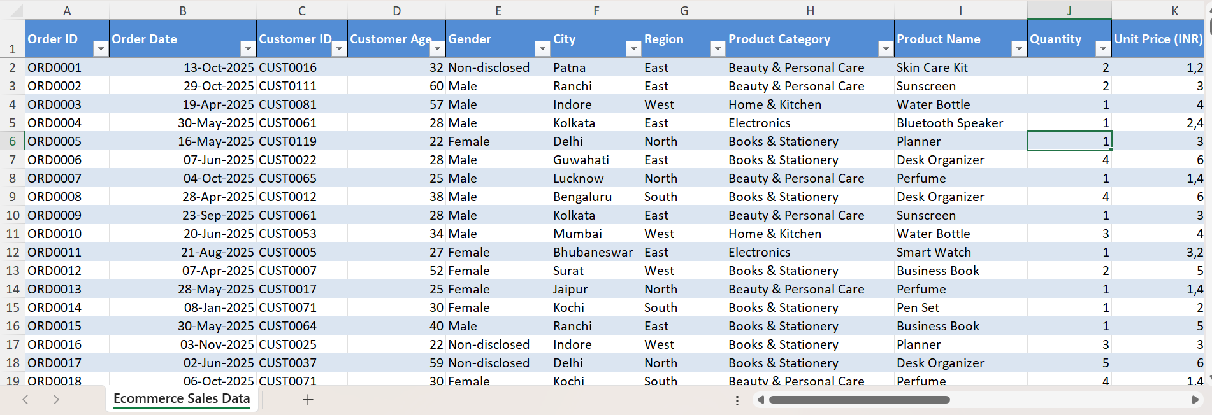

5. METHOD, TOOLS & TECHNOLOGIES USED

5.1 Methodology

This project follows a descriptive analytics methodology to analyze e-commerce sales data and present the results through visualizations. Descriptive analytics is used to summarize existing data, identify patterns, compare categories, and understand business performance.

The project methodology consists of the following stages:

1. Data Preparation: The e-commerce dataset containing 300 order records was organized in Microsoft Excel.
2. Data Import: The prepared dataset was imported into IBM Cognos Analytics.
3. Field Identification: Relevant numerical, categorical, and date fields were identified for analysis.
4. Data Aggregation: Measures such as net sales and order counts were used to summarize the data.
5. Data Visualization: Appropriate charts were developed to compare sales, customer-related indicators, payment methods, order statuses, and device usage.
6. KPI Development: KPI cards were created to display important metrics, including total net sales and total orders.
7. Dashboard Development: The visualizations were combined into a dashboard to provide an overall view of the dataset.
8. Interpretation: The charts and KPIs were examined to understand the patterns represented in the data.

5.2 Tools Used

5.2.1 Microsoft Excel

Microsoft Excel was used to store and organize the e-commerce dataset before it was imported into IBM Cognos Analytics.

Its role in the project includes:

- Maintaining the dataset in a tabular format.
- Organizing column names and data fields.
- Storing numerical, categorical, and date information.
- Preparing the data for use in the analytics platform.

5.2.2 IBM Cognos Analytics

IBM Cognos Analytics was the primary tool used for data visualization and dashboard development.

Its role in the project includes:

- Importing and exploring the dataset.
- Selecting relevant fields for analysis.
- Creating charts to compare sales and order-related information.
- Summarizing data using suitable aggregations.
- Developing KPI cards.
- Presenting the analysis through a dashboard.

5.3 Technologies and Techniques Used

The following techniques and technologies were applied in the project:

1. Business Intelligence (BI)

Business Intelligence refers to the use of tools and techniques to convert data into meaningful information. In this project, IBM Cognos Analytics was used to present e-commerce information through visualizations and KPI cards.

2. Descriptive Analytics

Descriptive analytics was used to summarize the available dataset and understand sales performance and customer-related patterns. The project focuses on existing data rather than forecasting future outcomes.

3. Data Visualization

Data visualization involves presenting information through graphical representations such as bar charts and line charts. It helps users compare categories and interpret data more easily.

4. Data Aggregation

Data aggregation was used to summarize records into meaningful measures. For example, net sales were aggregated to compare sales across product categories and regions, while order identifiers were counted to examine order distribution.

5. Key Performance Indicators (KPIs)

KPIs are measurable indicators used to summarize important aspects of business performance. The project includes KPI cards for total net sales and total orders, along with a customer rating visualization.

6. Dashboard Development

Dashboard development involves combining multiple charts and indicators into a single visual interface. The dashboard presents different aspects of the e-commerce dataset in one place.

5.4 Visualizations Developed

The following visualizations were developed using IBM Cognos Analytics:

1. Net Sales by Product Category.
2. Net Sales by Order Date.
3. Net Sales by Region.
4. Repeat vs New Customer Orders.
5. Orders by Payment Method.
6. Order Status Distribution.
7. Orders by Device.

The dashboard also includes KPI cards for Total Net Sales and Total Orders, along with a Customer Rating visualization.

5.5 Summary

Microsoft Excel and IBM Cognos Analytics were used to prepare, explore, analyze, and visualize the e-commerce dataset. Descriptive analytics, data aggregation, KPI development, and dashboard visualization formed the core methodology of the project. These techniques helped present the available information in a structured and understandable format.

6. PROJECT WORKFLOW

6.1 Introduction

The project workflow describes the sequence of activities followed to complete the E-commerce Sales & Customer Behaviour Analysis project using IBM Cognos Analytics. The workflow begins with dataset preparation and continues through data import, visualization, dashboard development, and interpretation of the results.

A systematic workflow helps ensure that the data is organized properly and that the visualizations address the objectives of the project.

6.2 Steps Involved in the Project Workflow

Step 1: Dataset Preparation

An e-commerce sales dataset containing 300 order records was prepared in Microsoft Excel. The dataset included order details, customer information, product categories, sales amounts, payment methods, devices, order statuses, and customer ratings.

Step 2: Data Understanding

The dataset was examined to understand the available columns and identify the fields required for analysis. Numerical fields, such as Net Sales (INR), and categorical fields, such as Product Category and Region, were identified for use in visualizations.

Step 3: Importing Data into IBM Cognos Analytics

The Excel dataset was imported into IBM Cognos Analytics. The imported data source was then used to access the fields required for creating the dashboard.

Step 4: Selecting Relevant Variables

Relevant variables were selected according to the analytical objectives. For example, Product Category and Region were used to compare sales, while Order ID was used to count orders.

Step 5: Creating Visualizations

Different visualizations were created to examine the dataset. These included charts for net sales by product category, sales by order date, sales by region, repeat versus new customer orders, payment methods, order status, and device usage.

Step 6: Developing KPI Cards

KPI cards were created to summarize important business metrics. Total Net Sales and Total Orders were displayed as key indicators. A separate Customer Rating visualization was also developed.

Step 7: Dashboard Development

The charts and KPI cards were added to the dashboard to present different aspects of the e-commerce dataset in one place.

Step 8: Reviewing the Dashboard

The visualizations were reviewed to check whether the selected fields, aggregation methods, titles, and displayed values were appropriate for the intended analysis.

Step 9: Interpreting the Results

The completed visualizations were examined to understand the sales distribution across product categories and regions, order patterns, payment methods, order statuses, and device usage.

Step 10: Documenting the Project

The project activities, tools, methodology, visualizations, results, observations, and recommendations were documented in the final project report.

6.3 Workflow Diagram

The overall project workflow can be represented as follows:

Dataset Preparation in Microsoft Excel
↓
Understanding the Dataset
↓
Importing Data into IBM Cognos Analytics
↓
Selecting Relevant Variables
↓
Creating Charts and Visualizations
↓
Developing KPI Cards
↓
Building the Dashboard
↓
Reviewing and Interpreting Results
↓
Preparing the Project Report

6.4 Summary

The project workflow provides a structured approach to analyzing e-commerce sales data. By following these steps, the dataset was organized, imported into IBM Cognos Analytics, and represented through charts and KPI cards. The resulting dashboard provides a consolidated visual overview of the available data and supports descriptive analysis of sales and customer-related indicators.

7. RESULTS AND DASHBOARD ANALYSIS

7.1 Introduction

This section presents the results obtained from the E-commerce Sales & Customer Behaviour Analysis project developed using IBM Cognos Analytics. The dashboard contains visualizations and key performance indicators (KPIs) that provide an overview of sales performance and selected customer behaviour indicators.

The analysis is based on a synthetic dataset containing 300 e-commerce order records created for academic purposes. Various charts were developed to summarize and compare the information available in the dataset.

7.2 Total Net Sales

The Total Net Sales KPI card displays the total sales amount after deducting discounts from gross sales.

Result: ₹5,86,921.05

This KPI provides a summarized view of the net sales recorded in the dataset. It helps users understand the overall sales value represented by the available records.

7.3 Total Orders

The Total Orders KPI card displays the number of unique orders included in the dataset.

Result: 300 orders

This indicator provides an overview of the total number of order records represented in the dataset and serves as a reference for order-related analysis.

7.4 Net Sales by Product Category

A bar chart was developed to compare net sales across different product categories.

The visualization helps identify differences in sales performance among the categories included in the dataset. Categories with higher net sales contribute more to the overall sales value, while categories with lower net sales contribute less.

Dashboard Output: Insert the screenshot of the Net Sales by Product Category chart here.

7.5 Net Sales by Order Date

A line chart was developed to visualize net sales across order dates.

The chart provides a visual representation of changes in sales over the selected period. It helps users observe variations in sales values across dates.

Dashboard Output: Insert the screenshot of the Net Sales by Order Date chart here.

7.6 Net Sales by Region

A bar chart was developed to compare net sales across different geographical regions.

The visualization provides a regional comparison of sales performance and helps identify differences in the sales amounts associated with the regions represented in the dataset.

Dashboard Output: Insert the screenshot of the Net Sales by Region chart here.

7.7 Repeat vs New Customer Orders

A chart was developed to compare orders associated with repeat customers and new customers.

The dashboard output displayed the following values:

- Repeat Customers (Yes): 137
- New Customers (No): 163
- Total Orders: 300

Based on these displayed values, new-customer orders account for approximately 54.33% of the total, while repeat-customer orders account for approximately 45.67%.

This comparison provides an overview of the distribution of orders across the two customer categories in the dataset.

Dashboard Output: Insert the screenshot of the Repeat vs New Customer Orders chart here.

7.8 Orders by Payment Method

A bar chart was developed to display the distribution of orders across different payment methods.

This visualization allows users to compare the number of orders associated with each payment method and observe which methods are more frequently represented in the dataset.

Dashboard Output: Insert the screenshot of the Orders by Payment Method chart here.

7.9 Order Status Distribution

A bar chart was developed to represent the distribution of orders by status, including Delivered, Cancelled, and Returned.

The visualization helps compare the number of orders in each status category. It provides an overview of the order statuses recorded in the dataset.

Dashboard Output: Insert the screenshot of the Order Status Distribution chart here.

7.10 Orders by Device

A bar chart was developed to compare orders associated with different devices.

The visualization helps examine the distribution of orders across the device categories available in the dataset. This information can provide a descriptive overview of device usage in the recorded transactions.

Dashboard Output: Insert the screenshot of the Orders by Device chart here.

7.11 Customer Rating

A separate visualization was created using the Customer Rating field.

The displayed output showed a value of 5. However, this value should not be interpreted as the average customer rating unless the Average aggregation is applied in IBM Cognos Analytics.

The customer rating visualization provides an additional view of the rating information available in the dataset.

Dashboard Output: Insert the screenshot of the Customer Rating visualization here.

7.12 Summary of Results

The dashboard combines sales-related charts, order distribution visualizations, customer-related comparisons, and KPI cards into a single analytical interface.

The main numerical results confirmed from the dashboard are:

Metric| Result
Total Net Sales| ₹5,86,921.05
Total Orders| 300
Repeat-Customer Orders| 137
New-Customer Orders| 163

The remaining charts provide visual comparisons of sales by product category, order date, and region, as well as orders by payment method, status, and device.

Overall, the project demonstrates how IBM Cognos Analytics can be used to summarize and visualize e-commerce data through descriptive analytics. Since the dataset is synthetic, the results are intended for academic demonstration rather than as verified evidence of an actual business's performance.

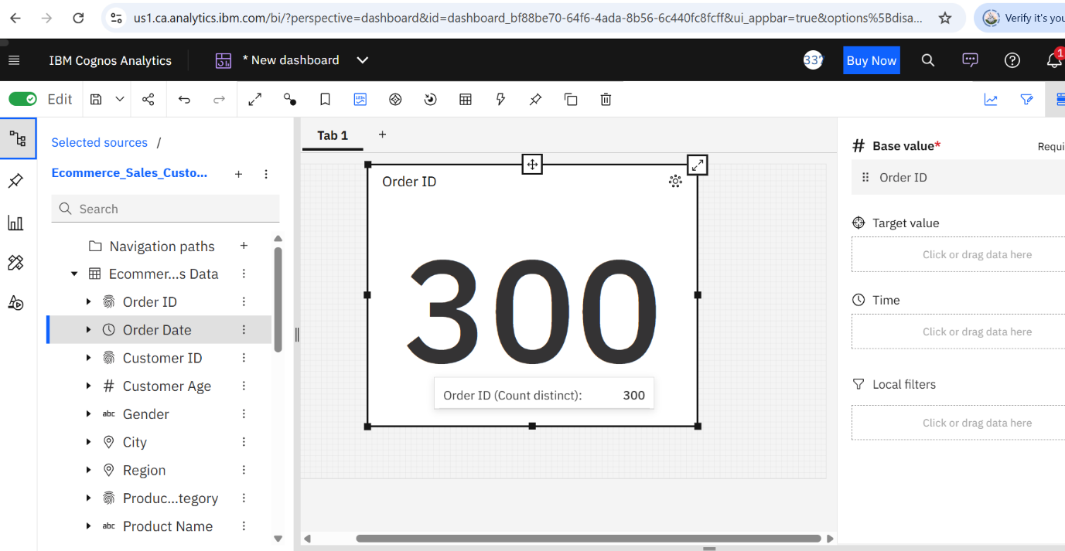

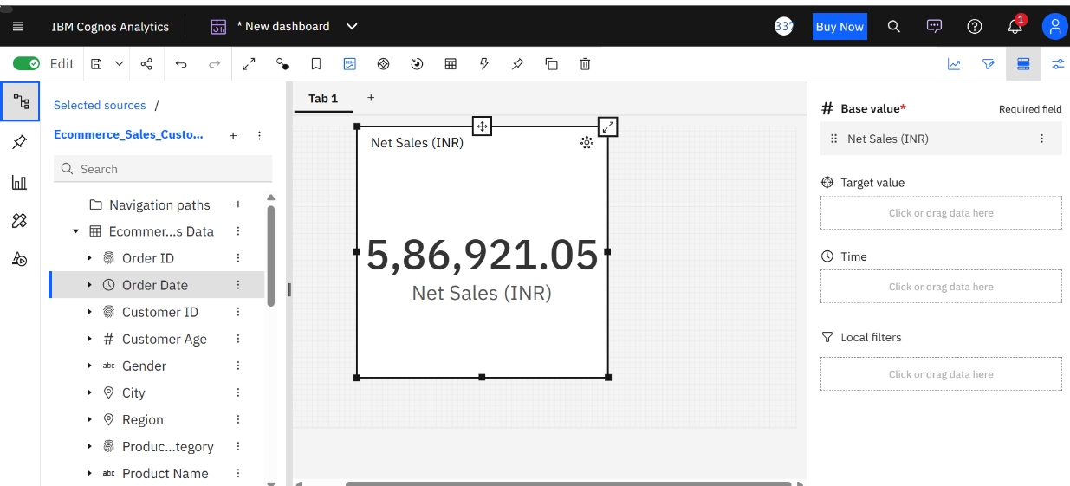

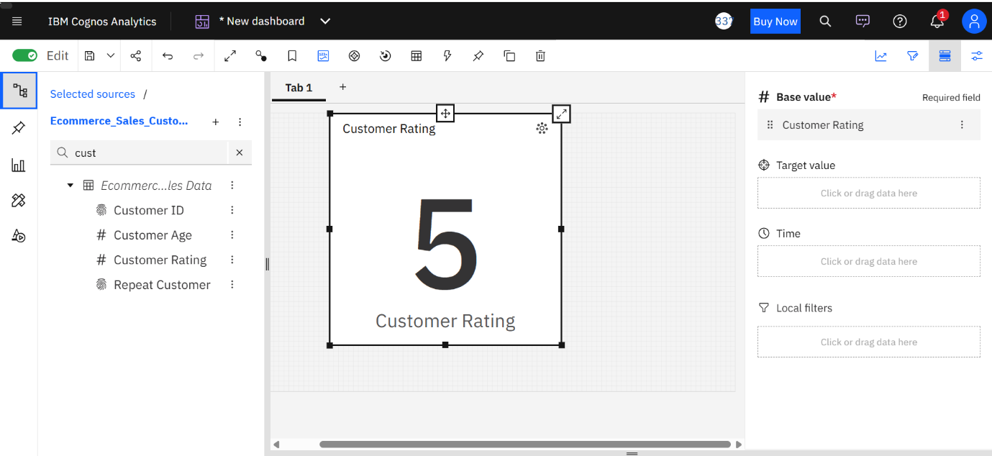
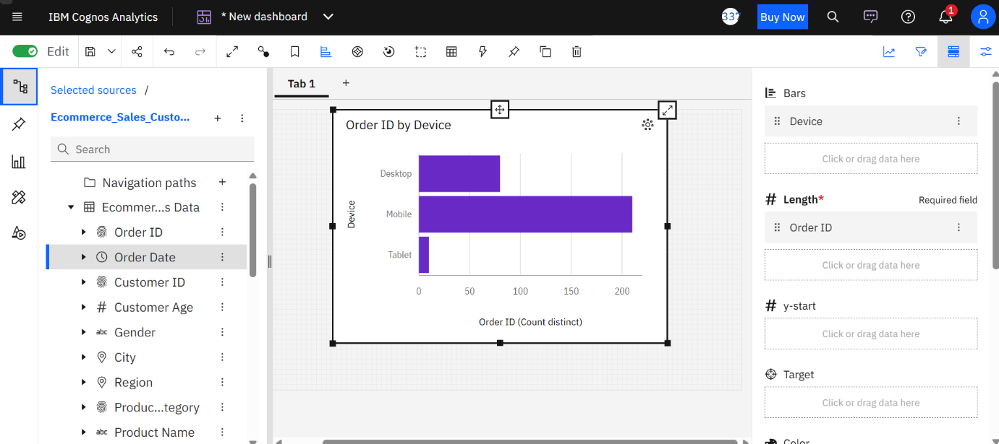

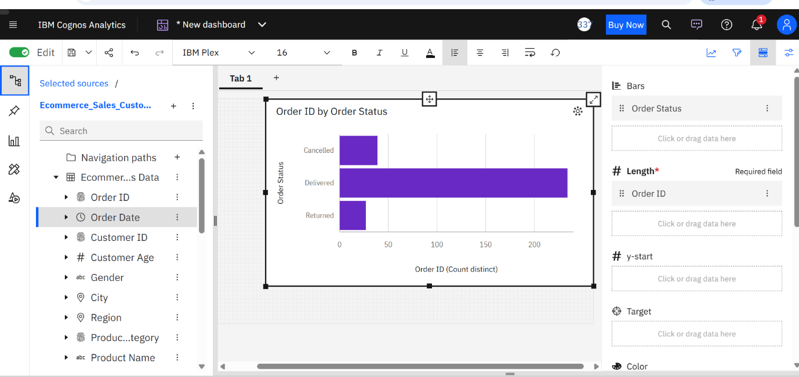

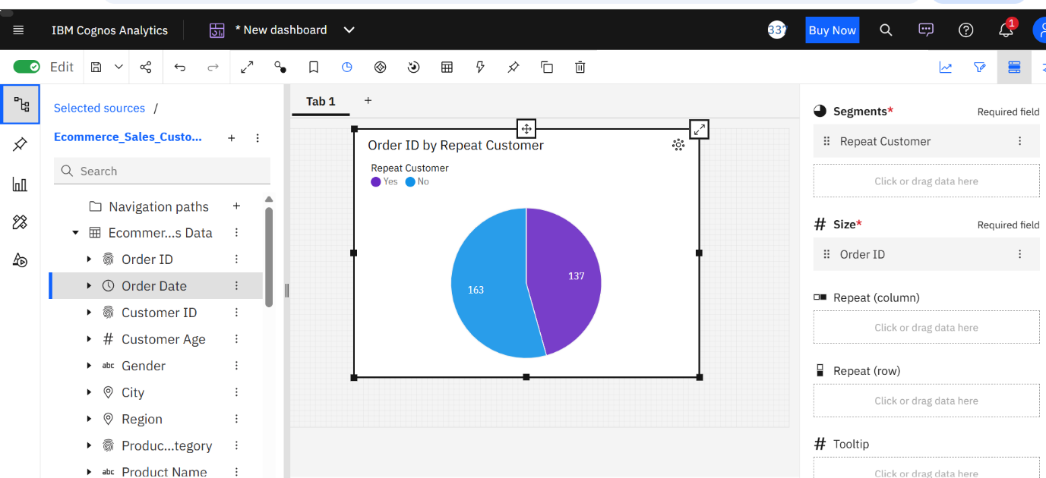
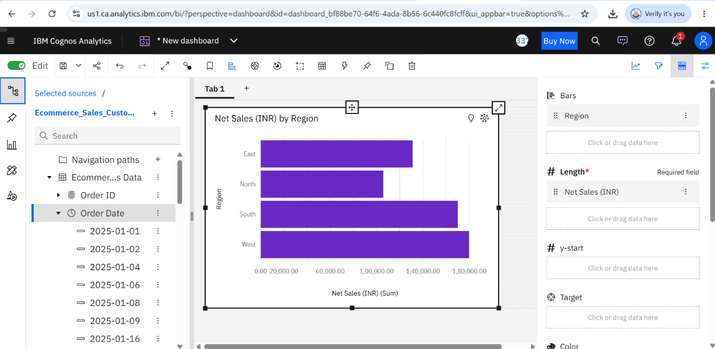

8. INSIGHTS (OBSERVATIONS)

The e-commerce sales and customer behaviour dashboard developed using IBM Cognos Analytics provides useful insights into sales performance, customer purchasing patterns, and order distribution. The analysis is based on 300 order records from the dataset.

8.1 Overall Sales Performance

The total net sales recorded in the dataset were ₹5,86,921.05 across 300 orders. These figures provide an overview of the sales performance during the selected period. The sales analysis helps in understanding the overall business performance and identifying areas that may require further investigation.

8.2 New and Repeat Customer Analysis

The dashboard shows that 163 orders were associated with new customers, while 137 orders were associated with repeat customers.

- New customer orders: 163 (54.33%)
- Repeat customer orders: 137 (45.67%)

The results indicate that new-customer orders represent a slightly larger share of the dataset. However, repeat-customer orders also account for a substantial proportion, highlighting the importance of customer retention and satisfaction.

8.3 Product Category Sales Analysis

The product category visualization helps compare sales across different categories. This analysis can help identify categories contributing to overall revenue and support decisions related to product promotion, inventory planning, and marketing activities.

8.4 Sales Trend Analysis

The sales trend visualization presents net sales across order dates. It helps examine changes in sales over time and identify periods of relatively higher or lower sales activity. These patterns can support future sales planning and promotional decisions.

8.5 Regional Sales Analysis

The regional sales visualization compares net sales across different regions. It helps identify geographical differences in sales performance and provides a basis for planning region-specific marketing campaigns and sales strategies.

8.6 Payment Method Analysis

The payment method visualization shows the distribution of orders across different payment options. Understanding customers' payment preferences can help businesses improve the checkout experience and provide suitable payment facilities.

8.7 Order Status Analysis

The order status visualization displays the distribution of orders across statuses such as delivered, cancelled, and returned. This analysis helps examine order fulfilment patterns and highlights the importance of monitoring cancellations and returns to improve operational efficiency.

8.8 Device-Based Order Analysis

The device analysis compares orders placed through different devices. It can help the business understand device usage patterns and assess whether its shopping experience is convenient across the available platforms.

8.9 Customer Rating Analysis

The customer rating visualization provides a view of the rating data available in the dataset. Customer ratings can help businesses understand customer feedback and identify opportunities to improve product quality, service, and the overall shopping experience.

8.10 Summary of Observations

Overall, the dashboard brings together important sales and customer-related metrics in a single view. The analysis highlights the total sales value, order volume, new and repeat customer distribution, and several operational dimensions. These insights can support data-driven decision-making in sales management, customer relationship management, and e-commerce operations.

Note: The dataset is prepared for academic demonstration. Category-wise, regional, payment-wise, device-wise, and order-status conclusions should be confirmed against the actual values displayed in the dashboard.

9. RECOMMENDATIONS / SUGGESTIONS

Based on the analysis of e-commerce sales and customer behaviour using IBM Cognos Analytics, the following recommendations are suggested to improve sales performance, customer satisfaction, and operational efficiency.

9.1 Improve Customer Retention

The analysis shows that 137 orders are associated with repeat customers, compared with 163 orders associated with new customers. The business should focus on encouraging first-time customers to make repeat purchases through loyalty programmes, personalised offers, discount coupons, and follow-up communication.

9.2 Strengthen Product Category Strategies

The business should regularly analyse sales across product categories to understand customer demand. Marketing campaigns and promotional offers can be designed according to category performance. Inventory levels should also be planned based on demand patterns to avoid overstocking or stock shortages.

9.3 Monitor Sales Trends

Sales should be monitored regularly using dashboard visualizations. Identifying periods of higher and lower sales activity can help the business plan promotional campaigns, manage inventory, and allocate resources more effectively.

9.4 Develop Region-Specific Marketing Strategies

The business should compare sales performance across regions and identify areas with growth opportunities. Regional preferences, customer needs, and purchasing patterns should be considered when designing marketing campaigns and promotional activities.

9.5 Improve the Payment Experience

The business should analyse customer preferences for different payment methods and ensure that commonly used payment options are convenient and reliable. A smooth and secure payment process can help improve the customer experience and reduce the possibility of abandoned transactions.

9.6 Reduce Order Cancellations and Returns

The business should regularly monitor cancelled and returned orders to identify possible reasons. Clear product descriptions, accurate product images, transparent return policies, timely delivery, and effective customer support may help reduce avoidable cancellations and returns.

9.7 Enhance the Shopping Experience Across Devices

The business should ensure that its website or application works smoothly on mobile phones, tablets, and computers. A user-friendly interface, simple navigation, fast loading speed, and a convenient checkout process can improve the overall shopping experience.

9.8 Focus on Customer Satisfaction

Customer feedback and ratings should be reviewed regularly. The business should identify common customer concerns and take corrective action to improve product quality, delivery services, and customer support.

9.9 Use Data Analytics for Decision-Making

The business should use IBM Cognos Analytics dashboards to monitor key performance indicators such as total sales, number of orders, customer behaviour, payment preferences, and order status. Regular analysis can help managers make informed decisions and identify potential business opportunities.

9.10 Update and Review the Dashboard Regularly

The dashboard should be updated with new sales and customer data at regular intervals. This will help the business monitor changes in performance, compare results across periods, and evaluate whether implemented strategies are producing the desired outcomes.

Summary

The recommendations focus on customer retention, sales improvement, effective inventory planning, regional marketing, order management, and customer satisfaction. By regularly analysing business data through IBM Cognos Analytics, e-commerce businesses can make more informed decisions and identify opportunities for continuous improvement.

10. CONCLUSION

The project, “E-commerce Sales & Customer Behaviour Analysis Using IBM Cognos Analytics,” was undertaken to understand sales performance and customer purchasing patterns through data visualization and analysis.

The project used a dataset containing 300 order records and analysed key metrics, including total net sales of ₹5,86,921.05, total orders, new and repeat customer orders, product category sales, regional performance, payment methods, order status, device usage, and customer ratings.

IBM Cognos Analytics helped transform the dataset into meaningful visualizations and a dashboard. The dashboard provides a consolidated view of important business metrics, making it easier to interpret sales performance and customer behaviour.

The analysis also highlights the importance of customer retention, sales monitoring, efficient order management, and customer satisfaction. The insights can help businesses identify areas for improvement and make informed decisions.

Overall, this project provided practical experience in data preparation, data visualization, dashboard creation, and business analysis using IBM Cognos Analytics. It also demonstrated how data analytics can support better decision-making in e-commerce.

Since the dataset was prepared for academic purposes, the findings are intended for demonstration and learning rather than representing the actual performance of a commercial e-commerce business.

REFERENCES

1. IBM. IBM Cognos Analytics Documentation. Available at: https://www.ibm.com/docs/en/cognos-analytics

2. IBM. IBM Cognos Analytics – Business Intelligence and Data Visualization. Available at: https://www.ibm.com/products/cognos-analytics

3. Microsoft. Microsoft Excel Documentation. Available at: https://support.microsoft.com/excel

4. Course Materials. MBA – IBM, United University, Prayagraj.

5. E-commerce Sales and Customer Behaviour Dataset. Dataset prepared for academic analysis and dashboard development as part of this project.

