

**Twilio**

Push notification

**Utility Provider**

Target customer list Dashboard

**IBM services**

Machine Learning Service

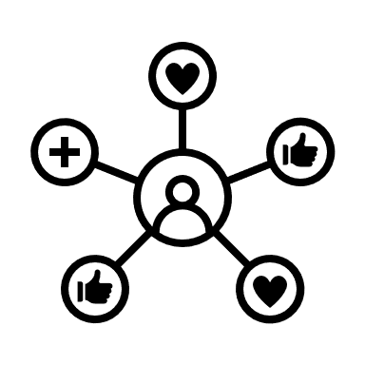



Cloud object storage

**Utility Provider**

Customer usage data

Energy

**User**