Infosys Springboard Virtual Internship 6.0
Completion Report

AgriFlow
Intelligent Agriculture Management System

Batch Number | Batch 13 – Group II
Start Date | 2nd February 2026
End Date | 11th April 2026
Duration | 8 Weeks

Team Members
S.No | Name
1 | P.K Priyanka
2 | Kondragunta Naveen
3 | Priyadharshini S
4 | Monika T
5 | Kunal Kumar

Project Title
AgriFlow – Intelligent Agriculture Management System

1. Project Objective
- Design and develop a centralized digital platform to manage agricultural products, warehouses, transactions, and user roles efficiently.
- Enable real-time inventory tracking for agricultural goods including crops, seeds, and produce, with accurate visibility of stock availability and movement.
- Implement role-based authentication for three user types — Farmer, Buyer, and Admin — ensuring secure and controlled access throughout the system.
- Minimize manual record-keeping errors and data redundancy through automated product management with SKU-based tracking and expiry date monitoring.
- Develop a transaction management module to record buy/sell operations between farmers and buyers with complete traceability and status tracking.
- Integrate an intelligent alert system to automatically notify users of low-stock, out-of-stock, and product expiry events with configurable severity levels.
- Support warehouse management with categorized storage types (Cold, Dry, General) and capacity tracking linked to agricultural product inventory.

2. Project Description in Detail
AgriFlow – Intelligent Agriculture Management System is a comprehensive digital platform developed to modernize and streamline traditional agricultural product management. In the agricultural sector, inventory and transaction management are often carried out through manual registers or fragmented spreadsheets, leading to stock mismatches, delayed updates, and lack of real-time visibility across the supply chain. AgriFlow addresses these challenges by providing a centralized, automated, and secure management solution tailored for the agriculture domain.

The system supports three distinct user roles: Admin, Farmer, and Buyer. Each role has a dedicated dashboard and access permissions aligned with their responsibilities. Farmers can list and manage their agricultural products — including crops, seeds, and produce — with detailed attributes such as product name, category, quantity, unit, price, SKU code, expiry date, and warehouse assignment. Buyers can browse available agricultural products and initiate purchase transactions, while Admins oversee all users, products, transactions, and system-level operations.

Authentication in AgriFlow is secured through JWT (JSON Web Tokens), with OTP-based email verification for new farmer registrations and a forgot password flow with secure reset links. Admin approval is required for newly registered farmers before they gain full access to the system, ensuring controlled onboarding. Failed login attempts are tracked to protect against unauthorized access.

The product management module enables farmers to add new agricultural products, update stock levels, assign categories, link to warehouses, and set minimum stock thresholds. Each product entry is uniquely identified by its SKU code, and expiry dates are tracked to ensure product freshness and compliance. The system validates stock values in real time and automatically reflects changes across all related modules.

The transaction management module records all buy and sell operations between farmers and buyers. Each transaction logs the product name, user details, quantity, price, transaction type (BUY/SELL), timestamp, notes, and status. This complete audit trail ensures transparency and accountability across all stock movements in the system.

AgriFlow includes a smart alert system that monitors product stock levels and expiry dates. Alerts are automatically triggered for LOW_STOCK, OUT_OF_STOCK, and EXPIRY conditions, each assigned a severity level (LOW, MEDIUM, HIGH). Users can view, filter, and acknowledge alerts to ensure timely action and prevent supply chain disruptions.

The frontend of AgriFlow is developed using Thymeleaf server-side templates, delivering separate, purpose-built dashboards for Farmers, Buyers, and Admins. These interfaces provide intuitive product listings, transaction histories, alert views, and admin controls — all rendered dynamically from the Spring Boot backend via RESTful APIs.

The system is built on a scalable full-stack architecture using Java Spring Boot for the backend, MySQL for relational data storage, and Spring Security with JWT for authentication. It is designed to be adaptable for use by individual farmers, agricultural cooperatives, warehouses, and agri-supply chain organizations.

3. Timeline Overview

Week | Activities Planned | Activities Completed
Week 1 | Requirement analysis, problem identification, technology stack selection, and system architecture design. | Conducted detailed study of agriculture management challenges, finalized system requirements, and designed overall architecture with module breakdown.
Week 2 | Database schema design, backend project setup, and API structure planning. | Designed normalized relational database schema for users, products, warehouses, transactions, and alerts; configured Spring Boot project with Maven.
Week 3 | Authentication system design and role-based access control implementation. | Implemented JWT-based login, OTP email verification for farmers, admin approval workflow, forgot password with reset link, and RBAC for Admin/Farmer/Buyer roles.
Week 4 | Product management module development. | Developed full product CRUD with SKU code generation, category management, warehouse assignment, expiry date tracking, minimum stock level configuration, and search/filter functionality.
Week 5 | Transaction management system development. | Implemented BUY/SELL transaction recording with full audit trail including user details, product info, quantity, price, timestamps, notes, and status tracking.
Week 6 | Alert system development and notification integration. | Built intelligent alert module for LOW_STOCK, OUT_OF_STOCK, and EXPIRY events with severity levels; integrated email notification service and alert filtering.
Week 7 | System testing, debugging, and performance optimization. | Performed unit and integration testing across all modules, resolved functional errors, optimized database queries, and improved overall system responsiveness.
Week 8 | Final integration, documentation, and deployment preparation. | Integrated all completed modules, prepared technical documentation and user guide, conducted final system demo, and submitted the project.

4. Key Milestones

4a. Milestone Summary

Milestone | Description | Date Achieved
Project Kickoff | Initial project briefing, requirement analysis, and technology stack finalization. | 2nd Feb 2026
Database & Backend Setup Completed | Designed MySQL schema and implemented core Spring Boot backend with API connectivity. | Week 1
Authentication Module Completed | JWT-based login, OTP verification, admin approval workflow, and RBAC for all three user roles. | Week 2
Product Management Module Ready | Full product CRUD with SKU tracking, expiry date management, warehouse linking, and stock thresholds. | Week 3
Transaction Module Completed | BUY/SELL transaction recording with complete audit trail, status tracking, and user traceability. | Week 4
Alert System Integration Completed | Intelligent alert engine for stock and expiry events with severity levels and email notifications. | Week 5
System Testing & Optimization Completed | Functional testing, bug fixes, query optimization, and performance improvements across all modules. | Week 6
Final Integration & Documentation | Full module integration, technical documentation, and successful project demonstration. | Week 7

4b. Project Execution Details
AgriFlow was developed using a structured full-stack architecture to ensure scalability, security, and maintainability across all modules. The system was organized into five key functional areas: Authentication, Product Management, Transaction Management, Alert System, and Warehouse Management.

The backend was implemented using Java 17 with Spring Boot 4.0, following a layered architecture comprising controllers, services, repositories, and entity classes. RESTful APIs were developed for each module, handling business logic, user requests, and database interactions. Spring Data JPA was used for data persistence, and the project was managed using Maven as the build tool.

A MySQL relational database was used to store all system data, including user accounts, product records, warehouse details, transaction logs, and alert entries. The database schema was designed with normalized tables and proper foreign key relationships to maintain data consistency and integrity.

Authentication and authorization were implemented using Spring Security combined with JWT (JSON Web Tokens). The system supports three roles — ADMIN, FARMER, and BUYER — each with distinct permissions and dashboards. Newly registered farmers undergo OTP-based email verification followed by admin approval before gaining system access. A secure forgot-password flow with email reset links was also implemented.

The product management module allows farmers to add agricultural products with complete details including name, category, quantity, unit, price, SKU code, expiry date, warehouse assignment, and minimum stock level. The system enforces SKU uniqueness and validates all stock operations in real time.

The transaction module captures every buy/sell operation between farmers and buyers with full details: product ID, product name, user ID, user email, user role, transaction type, quantity, price, timestamp, notes, and status. This creates a comprehensive audit trail that ensures accountability across all stock movements.

The alert system monitors product stock levels and expiry dates automatically. Alerts are classified into three types — LOW_STOCK, OUT_OF_STOCK, and EXPIRY — each assigned a severity level (LOW, MEDIUM, HIGH) and a status (ACTIVE, ACKNOWLEDGED, RESOLVED). An email notification service was integrated to proactively alert relevant users when threshold conditions are met.

The frontend was built using Thymeleaf server-side templates served by the Spring MVC layer. Separate dashboard views were created for Farmers, Buyers, and Admins, each tailored to their respective workflows. The admin panel provides comprehensive controls for user management, product oversight, transaction review, and system-wide monitoring.

Testing was conducted at multiple levels, including unit testing of service layer logic, API endpoint testing, and end-to-end integration testing across the frontend and backend. Performance was optimized through efficient SQL queries, proper indexing on key fields, and streamlined API response handling.

5. Snapshots / Screenshots



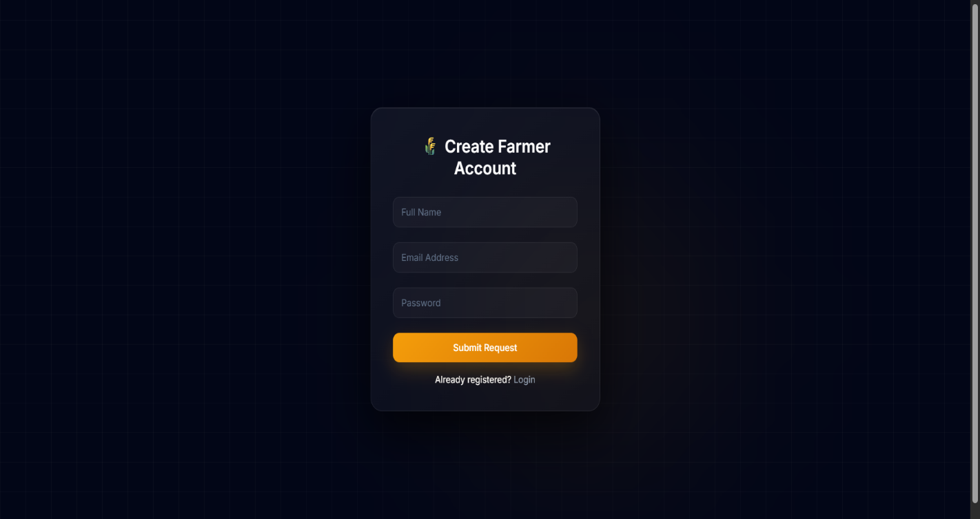

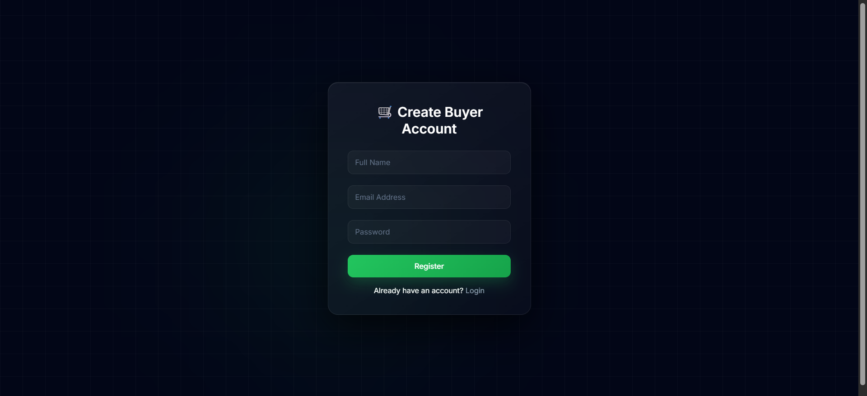

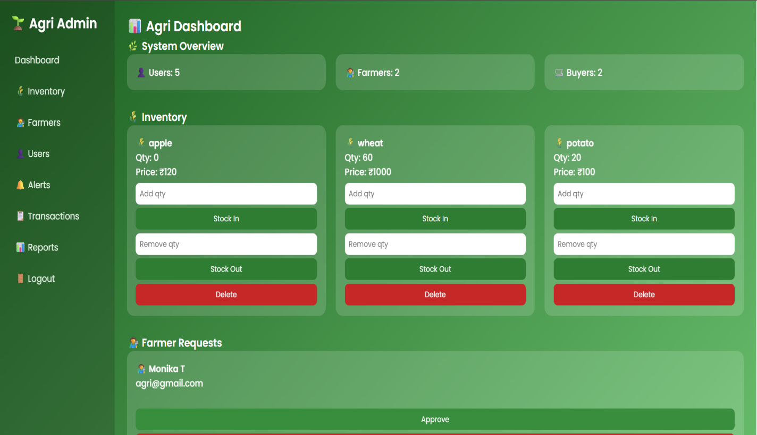

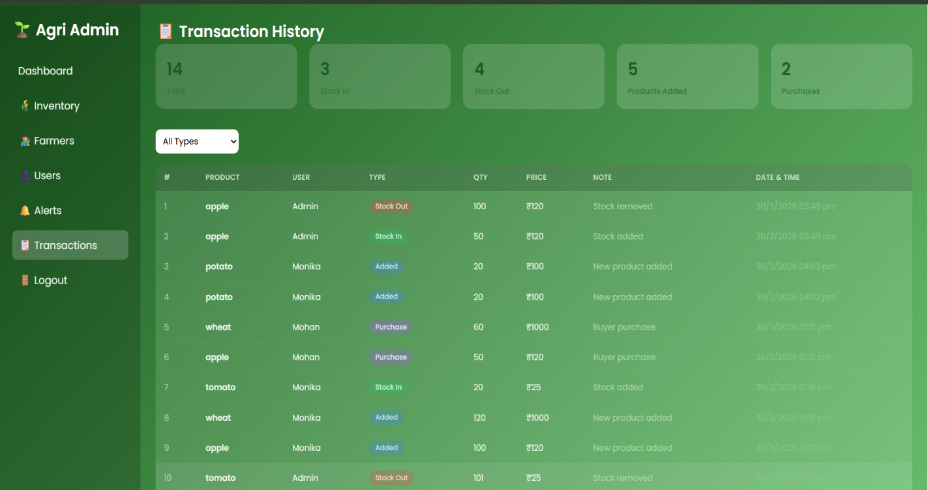

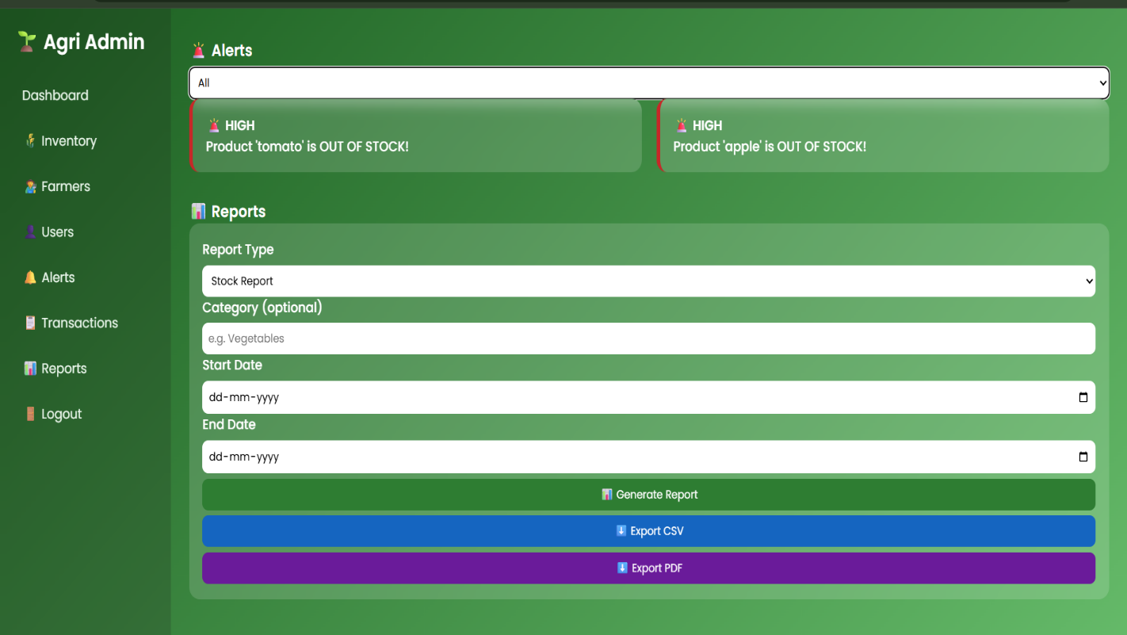

5. Technology Stack

Layer | Technology Used
Backend Framework | Java 17 with Spring Boot 4.0
Security | Spring Security + JWT (jwt 0.11.5)
Database | MySQL with Spring Data JPA (Hibernate)
Frontend / Templates | Thymeleaf (server-side rendering)
Email Service | Spring Boot Mail (SMTP integration)
Build Tool | Apache Maven
Utilities | Lombok (code generation), Spring Validation
Testing | Spring Boot Test, Spring Security Test

6. Learnings & Skills Acquired

- Gained practical experience in designing and managing relational databases using MySQL, including normalized schema design, foreign key relationships, and indexing strategies.
- Developed strong understanding of backend development using Java 17 and Spring Boot for building RESTful APIs with a layered architecture (Controller → Service → Repository).
- Learned to implement secure authentication using Spring Security with JWT, including OTP-based email verification, admin approval workflows, and role-based access control for three distinct user roles.
- Acquired knowledge of agricultural domain-specific inventory management concepts including SKU-based product tracking, expiry date monitoring, and warehouse capacity management.
- Learned to build and integrate an automated alert system with configurable severity levels and email notifications using Spring Boot Mail.
- Improved understanding of API integration and server-side rendering using Thymeleaf templates connected to a Spring MVC backend.
- Enhanced debugging, testing, and performance optimization skills through multi-level testing of APIs, business logic, and frontend-backend integration.
- Gained experience in full-stack application architecture and the practical integration of multiple independent modules into a cohesive system.
- Improved team collaboration, task distribution, documentation, and project presentation skills in a virtual internship setting.

7. Challenges Faced

Challenge 1: Designing a Multi-Role Authentication System
Problem: Managing three distinct user roles (Admin, Farmer, Buyer) with different access levels, registration workflows, and approval processes while maintaining security.
Solution: Implemented JWT-based authentication with Spring Security, OTP-based email verification for farmers, and an admin approval mechanism. Each role has its own access policies enforced at the API controller level.

Challenge 2: Maintaining Accurate Real-Time Stock Updates
Problem: Ensuring inventory quantities remain accurate after every transaction, particularly when multiple users interact with the same product records simultaneously.
Solution: Implemented transactional backend logic in Spring Boot to atomically update stock quantities after each buy/sell operation, with validation guards to prevent negative stock values.

Challenge 3: Building an Intelligent Alert Engine
Problem: Automatically detecting stock threshold violations and product expiry conditions across all products without degrading system performance.
Solution: Developed an AlertService with dedicated filtering logic and a NotificationService connected to Spring Boot Mail. Alerts are categorized by type (LOW_STOCK, OUT_OF_STOCK, EXPIRY) and severity (LOW, MEDIUM, HIGH) for targeted responses.

Challenge 4: Integrating Warehouse Management with Products
Problem: Linking agricultural products to specific warehouses with different storage types (Cold, Dry, General) while keeping capacity tracking synchronized with actual stock levels.
Solution: Designed a Warehouse entity with capacity and current stock fields, linked to products via a foreign key relationship, with backend validation ensuring warehouse assignments remain consistent with product data.

8. Testimonials from Team

Working on AgriFlow was an enriching and practically rewarding experience for the entire team. Each member contributed meaningfully to different system modules — backend development, authentication, alert engine design, database management, and frontend integration — which gave us a holistic understanding of how a real-world full-stack application is built and deployed.

Regular planning sessions, collaborative debugging, and consistent communication helped us overcome technical challenges efficiently. The project significantly improved our practical knowledge of Java, Spring Boot, MySQL, and Spring Security, while also deepening our understanding of domain-specific challenges in agricultural inventory management.

This internship experience enhanced our teamwork, problem-solving capabilities, and project documentation skills, making us more confident and industry-ready for software development roles.

9. Conclusion

AgriFlow – Intelligent Agriculture Management System successfully demonstrates how digital technology can transform traditional agricultural inventory and transaction management into a smart, efficient, and data-driven process. By integrating a Java Spring Boot backend, a MySQL relational database, JWT-based security, and Thymeleaf-powered frontend dashboards, the system delivers a complete full-stack solution for real-time agricultural stock monitoring and control.

The project effectively addressed common challenges in manual agricultural management — including stock mismatches, lack of role-based access control, and absence of automated alerts — through features such as multi-role authentication, SKU-based product tracking, expiry monitoring, BUY/SELL transaction recording, and an intelligent alert engine with email notifications.

While Module 5 (Reports and Analytics) remains planned for a future development phase, the four completed modules form a robust and fully functional core system. Developing AgriFlow provided hands-on experience in backend API development, secure authentication design, database schema engineering, alert system architecture, and frontend integration. It also reinforced our ability to work collaboratively on modular software systems under real-world project constraints.

Overall, AgriFlow stands as a practical and scalable solution that can be adapted for use by individual farmers, agricultural cooperatives, warehouses, and agri-supply chain organizations. The project not only met its technical objectives for the internship program but also enhanced our readiness to take on industry-level software development challenges.

10. Acknowledgements

We would like to express our sincere gratitude to Infosys Springboard for providing this virtual internship opportunity and the structured learning platform that enabled us to develop a real-world, production-oriented system.

We extend our heartfelt thanks to our project mentor and faculty members for their continuous guidance, technical insights, and constructive feedback throughout the development of AgriFlow. Their support played a crucial role in helping us navigate complex technical challenges and improve the quality of our work.

We also thank our institution for providing the necessary resources and encouraging an environment of hands-on learning. Finally, we appreciate the dedication, teamwork, and consistent contributions of all team members, whose collective efforts made the successful completion of this project possible.

