Tesla Full Self-Driving — Computer Vision Case Study

Student Name : Priya A
Roll No : 20252034
Subject: Computer Vision in Autonomous Vehicles Company: Tesla, Inc.
System: Full Self-Driving (FSD) — HydraNet Architecture
Sensors: 8 cameras, no radar or LiDAR
Introduction
Tesla's Full Self-Driving (FSD) system is one of the most ambitious applications of computer vision in the world today. Unlike most autonomous vehicle systems that rely on expensive LiDAR sensors and radar arrays, Tesla made a bold bet — cameras alone, combined with powerful neural networks, are sufficient to drive a car safely. This decision has shaped the entire architecture of the FSD system and distinguishes Tesla from every major competitor in the autonomous driving space.
The system processes approximately 2 GB of camera data every second, runs more than 50 parallel vision tasks simultaneously, and translates raw pixels into real-time steering, braking, and acceleration decisions — all on a custom chip inside a consumer vehicle. This case study examines how Tesla built this system, what makes it work, and what challenges it still faces.
Why Computer Vision?
Humans drive using only their eyes. We read road signs, judge distances, track moving vehicles, anticipate pedestrian behaviour, and navigate complex intersections — all from visual information alone. Tesla's core argument is that if humans can do this with biological vision, a sufficiently powerful artificial vision system should be able to do the same. This reasoning led to the removal of radar from Tesla vehicles in 2021 and the decision never to adopt LiDAR.
Radar was specifically problematic because it conflicted with camera inputs. A camera correctly ignores a stationary overhead bridge because context tells it the bridge is not on the road. Radar returns a strong reflection from the same bridge and can trigger phantom emergency braking. By removing radar, Tesla eliminated an entire category of sensor conflict and forced the neural network to get better at resolving ambiguity using vision alone.
The Camera System Architecture :
8 Cameras, 360-Degree Coverage
Tesla uses eight cameras placed around the vehicle, each designed for a specific role:
- Front wide-angle camera — 120-degree field of view. Covers nearby obstacles, pedestrians stepping off kerbs, and complex intersection geometry at close range.
- Front main camera — 45-degree field of view. The primary sensor for general highway and urban driving, object detection, and lane following.
- Front telephoto camera — 25-degree field of view. Designed for long-range detection on highways. At 100 metres, a traffic light occupies only about 10 pixels in a wide-angle feed; the telephoto resolves it clearly enough to distinguish red from green from a green arrow.
- Left and right pillar cameras — 90-degree field of view each. Mounted near the side mirrors, these handle lane changes, adjacent vehicles, and merging situations.
- Rear-left and rear-right cameras — 90-degree field of view each. Cover the blind spots and monitor vehicles overtaking from behind.
- Rear camera — 120-degree field of view. Handles reversing, parking, and vehicles cutting in from behind.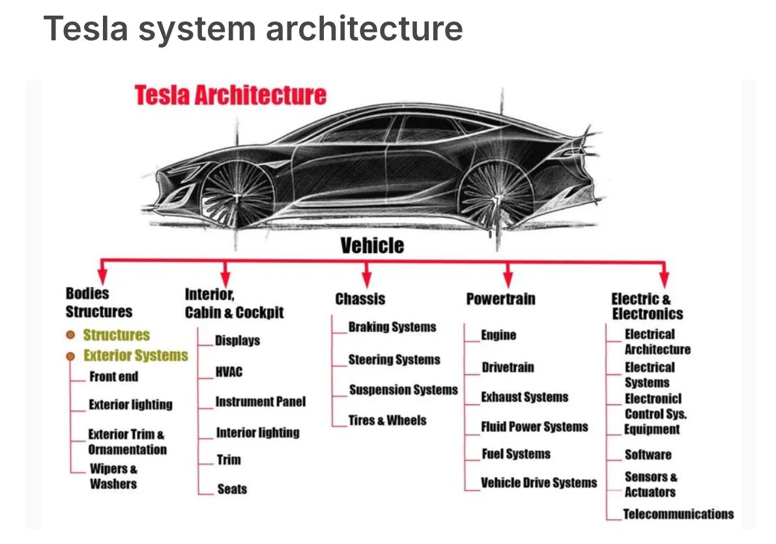
Why the Overlap Is Intentional :
Adjacent cameras share overlapping zones of coverage deliberately. When two cameras both observe the same object, the neural network gains stereo-like depth perception triangulating distance from the slight difference in viewpoint, exactly as your two eyes do. This is one of the primary ways Tesla estimates distance without LiDAR. Additional depth cues come from motion parallax (how fast an object moves across the frame as the car drives) and from temporal change in bounding box size (an approaching car grows larger each frame at a rate proportional to its closing speed).
The overlap also provides redundancy. If one camera is obscured by rain, mud, or direct sunlight, neighbouring cameras maintain coverage. And when an object moves from one camera's field of view into another's, its tracking history velocity, trajectory, identity carries over seamlessly because tracking happens in a unified world coordinate system, not in any individual camera's pixel space.
Traffic light recognition is fundamentally a resolution problem. A signal 150 metres ahead is barely visible in a wide-angle feed. The telephoto camera's narrow field of view means it dedicates far more pixels to distant objects, making colour classification reliable at highway speeds. This is the engineering reason Tesla uses three separate front cameras rather than one each is optimised for a different distance range, and all three run simultaneously.
HydraNet Neural Network Architecture :
HydraNet is Tesla's name for the multi-task neural network at the centre of the FSD system. Its defining feature is a shared backbone a single deep convolutional network that processes all eight camera feeds and produces a rich feature representation that is consumed by more than 50 specialised task heads running in parallel.
This architecture is far more efficient than running separate models for each task. If Tesla ran 50 independent models, each would need to execute its own full feature extraction pass paying the computational cost 50 times. HydraNet pays it once. More importantly, during training, gradients from all 50+ tasks flow back into the shared backbone simultaneously. Learning to detect lane lines makes the backbone better at detecting vehicles, and vice versa, because they share underlying weights. The tasks teach each other.

Stage 1 — Feature extraction: Each camera frame passes through the shared convolutional backbone (based on the RegNet architecture). The network identifies low-level features — edges, textures, colour gradients — and builds them into increasingly abstract representations across successive layers. The same weights process all eight cameras, so training data collected from any camera improves all the others.
Stage 2 — Multi-camera transformer fusion: A transformer layer runs attention across all eight feature maps simultaneously. It learns spatial correspondences between cameras — recognising that a feature in the left pillar camera and a feature in the telephoto camera belong to the same physical vehicle. This cross-camera attention is where reliable depth estimation emerges from pure geometry.
Stage 3 — Temporal fusion: A second transformer incorporates approximately half a second of frame history (roughly 18 frames at 36 fps). The network learns to track how features move over time, deriving velocity, heading, and acceleration from purely visual information. This is what allows Tesla to estimate that a car ahead is braking before its brake lights even activate.
Stage 4 — Task heads: More than 50 specialised sub-networks branch from the shared feature volume. Each head is trained for one task: object detection and tracking, lane geometry, road edge detection, depth estimation, traffic sign OCR, traffic light state classification, Bird's Eye View mapping, occupancy prediction, pedestrian intent classification, and many others.
Stage 5 — Planning: All head outputs feed into a unified world model that the planning module uses to determine speed, steering angle, and lane choice. The entire chain from raw pixels to driving commands is end-to-end learned — there are no manually written rules in the pipeline.

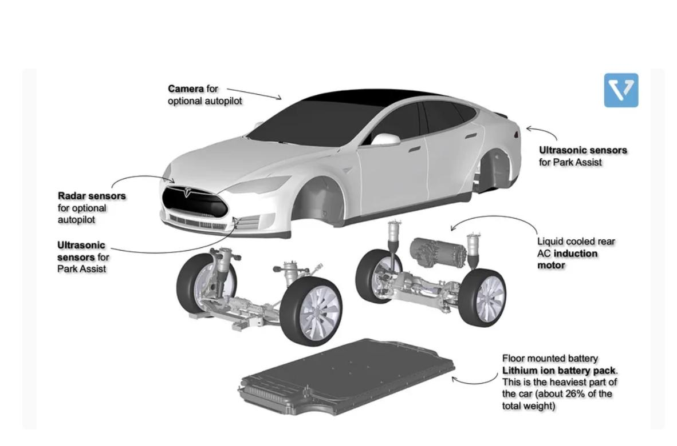
Bird's Eye View and Occupancy Networks
Two task heads produce outputs that represent a significant advancement over traditional object detection.
The Bird's Eye View head transforms the multi-camera feature volume into a top-down metric map centred on the vehicle. Every lane, vehicle, pedestrian, and obstacle is represented in real-world coordinates — metres from the car — rather than in camera pixel coordinates. This makes path planning dramatically simpler and more consistent, because the planner always works in the same coordinate space regardless of which camera originally detected each object.
The occupancy network head goes further. Instead of placing rectangular bounding boxes around detected objects, it divides the surrounding 3D space into a grid of small volume units called voxels, and classifies each voxel as free or occupied. This captures the true shape of irregular objects — construction debris, fallen cargo, unusually shaped vehicles — and explicitly models the driveable free space available to the car. Bounding boxes cannot do this; occupancy networks can.
________________________________________

Traffic Light Recognition
Reading traffic signals correctly is not simply a detection problem — it is a multi-stage pipeline:
Detection: HydraNet's object detection head localises the bounding box of each traffic light housing in every frame. The telephoto camera leads this task for forward-facing signals.
State classification: A dedicated classification head crops the detected bounding box and outputs the light state red, amber, green, green arrow, flashing red, or unknown. The model is trained on data collected under sun glare, rain, night conditions, and partial occlusion.
Temporal smoothing: A single ambiguous or misclassified frame does not trigger a decision. The system tracks light state across multiple consecutive frames and acts only when a confident, stable reading is sustained.
Map prior: GPS position and map data provide an expectation of what lies ahead whether there is an intersection, what type of signals are present, and what the expected state sequence should be. This prior helps resolve rare or unusual signal configurations.
Stop Sign and Speed Limit Recognition
Stop signs are verified using three independent checks that must all agree: the octagonal shape (unique to stop signs worldwide), the red colour verified in HSV colour space, and the text "STOP" read via optical character recognition. Requiring all three to agree eliminates false positives from red octagonal objects that are not stop signs.
Speed limit signs use a dedicated OCR task head trained specifically to read digits from the white rectangular sign patch. Once extracted, the number is cross-checked against map data to confirm the unit (mph versus km/h) and whether the value is plausible for the road type. The system maintains a speed limit memory it holds the most recently confirmed limit even after the sign has left the camera frame, until a new sign is detected.
Object Tracking Across Time
Detecting an object in a single frame is the beginning, not the end. Tesla's system maintains persistent tracks for every object across time this is what enables prediction of future positions rather than mere reaction to current ones.
Each confirmed object carries a state vector containing its position, velocity, heading, and bounding box dimensions in Bird's Eye View coordinates. A Kalman filter updates this state every frame with two steps: a predict step (where should this object be, given its velocity?) and an update step (a new detection arrived blend the prediction with the measurement, weighted by confidence). Objects that disappear temporarily hidden by a truck, for example are not deleted. Their position continues to be predicted until they reappear or go missing for too many consecutive frames.
Confirmed tracks generate probabilistic trajectory forecasts three to five seconds into the future. For vehicles this is primarily physics-based extrapolation. For pedestrians and cyclists an intent classifier adds behavioural reasoning — is this person about to step into the road? Time-to-collision computed from these forecasts initiates braking earlier than human reaction time would allow.
A critical design decision is that all tracking occurs in world coordinate space, not in any camera's pixel space. When a vehicle moves from the telephoto camera's field of view into the side camera's coverage zone, its track identity and entire velocity history are preserved without any special handoff logic. There is no handoff problem, because all objects exist in the unified 3D world model — the cameras are merely sensors feeding that model.
How the Model Gets Smarter — The Data Flywheel
Tesla's most significant competitive advantage is the scale and quality of its training data. Every Tesla vehicle on the road functions as a data collection device, and the training pipeline has five stages:
Fleet collection: Vehicles continuously record short video clips triggered by unusual events near-misses, sudden driver interventions, abrupt steering or braking. These edge cases are the most valuable training examples because they represent situations where the model is likely to be wrong or uncertain.
Shadow mode: The FSD system runs silently in the background on vehicles where it is not actively controlling the car. It predicts what it would do and compares those predictions to the human driver's actual actions. Every disagreement is flagged as a potential training example. This is how Tesla discovers failures without requiring a real accident.
Auto-labelling and human review: Collected clips are labelled using the existing model to produce initial annotations, which human annotators then verify and correct. Novel or rare scenarios are prioritised for human review. The labelled data is added to the training set.
Dojo supercomputer training: Tesla's custom training cluster, built around proprietary D1 chips connected with high-bandwidth interconnects, retrains the neural network on the expanded dataset. The system is designed to scale to exaflop-class compute, enabling much faster training iteration cycles than using commercial GPU clusters.
Over-the-air deployment: The improved model is pushed to the entire global fleet as an over-the-air software update. Every vehicle becomes smarter simultaneously, with no physical service visit required.
Key Technical Challenges
Depth estimation without LiDAR is inherently noisier than direct range measurement. Tesla compensates with stereo geometry from overlapping cameras, temporal parallax, and bounding box size change rate — but in poor lighting or featureless environments these cues degrade. Adverse weather reduces image quality through rain on lenses, snow obscuring lane markings, and glare from wet roads. The model is trained on diverse weather data from the fleet, but low-visibility conditions remain a harder problem for cameras than for radar.
Long-tail scenarios are rare events that appear too infrequently in normal driving data to train on reliably — a horse on a motorway, construction workers directing traffic with unusual gestures, or a malfunctioning traffic light. Shadow mode is Tesla's primary mechanism for finding and collecting these cases at scale.
Regional variation in road signs, lane markings, and driving conventions means the model must generalise across dozens of countries with meaningfully different visual environments. This requires either separate models per region or a single model trained on sufficiently diverse international data.
Critical Evaluation
Tesla's vision-only approach has genuine strengths. The system is cheaper to manufacture than LiDAR-equipped alternatives, scales to millions of vehicles at low marginal hardware cost, and benefits from a data flywheel that competitors deploying smaller fleets cannot easily replicate. The end-to-end learned pipeline eliminates the engineering burden of writing manual rules for every edge case — the model learns them from data.
The limitations are also real. Camera-based depth estimation will always be noisier than direct LiDAR measurement. Single-modality systems have less inherent redundancy than fused multi-sensor architectures. In conditions that severely degrade image quality, the system must rely heavily on temporal history and map priors rather than fresh sensor data.
Conclusion
Tesla's Full Self-Driving system demonstrates how far camera-based computer vision can go when paired with sufficient data, compute, and architectural innovation. The HydraNet multi-task architecture, Bird's Eye View world modelling, occupancy networks, Kalman-filter object tracking, and the shadow mode data flywheel are each significant achievements individually. Together they form a coherent system that has accumulated billions of autonomous miles and continues to improve with every software update. Whether the vision-only approach ultimately proves safer than multi-sensor alternatives remains an open question but Tesla has already shown that the question is worth asking seriously.
References
- Tesla AI Day 2021 — HydraNet and multi-task learning (Andrej Karpathy presentation)
- Tesla AI Day 2022 — Occupancy networks, BEV, and Dojo supercomputer
- Karpathy, A. (2021). "Building the Software 2.0 Stack." Tesla Engineering Blog.
- Geiger, A. et al. (2012). "Are We Ready for Autonomous Driving? The KITTI Vision Benchmark Suite." CVPR 2012.
- Zhou, X. et al. (2019). "Objects as Points." arXiv:1904.07850.
- Tesla FSD Beta release notes — ongoing software changelog, tesla

