INDEX
- Introduction
- Acknowledgement
- Problem Definition
- Gathering data requirements & functional requirements
  - Existing System
  - Proposed System
  - Hardware Requirement
  - Software Requirement
- Feasibility Study
  - Economic Feasibility
  - Technical Feasibility
  - Operational Feasibility
- Design the normalized database
- ER Diagram
- Data flow Diagram
  - Use-case Diagram
  - Class Diagram
  - Object Diagram
  - Sequence Diagram
  - Collaboration Diagram
  - Activity Chart Diagram
  - State chart Diagram
  - Component Diagram
- I/O Screens
- Bibliography

Introduction
The Smart Billing System is developed to simplify and computerize hotel management tasks. It replaces the traditional manual process of maintaining client records and generating bills, which often leads to errors and consumes extra time. By digitizing these operations, the system ensures accuracy, efficiency, and quick access to client information.
This project also reduces extensive paperwork and makes the overall process more user-friendly. With automated billing and organized record management, hotels can deliver faster service, improve customer satisfaction, and manage operations more effectively in a modern, scalable way.

Acknowledgement
It’s my esteemed pleasure to present the project report on hotel management system.
I would like to thanks to my beloved……for providing us all necessary facility to carry the project successfully. Last but not least we are thankful to my friends without whose support at various stages, this project wouldn’t have materialized…..I think to all the supporting friends who directly or indirectly helped me in completing this project.

Problem Definition

The project is developed based on distributed client-server computing technology. The main purpose of this system is to provide an efficient and accurate solution for managing billing operations.
The Smart Billing System is designed to handle billing activities such as product details, customer information, and transaction records. It helps in generating bills automatically, reducing manual calculations, and minimizing errors.
The system provides two levels of user access:
- Administrative User – Has full control over the system, including managing products, prices, and transaction records.
- Normal User – Has limited access, mainly for billing operations and viewing records.
This system helps in maintaining proper billing records, improving speed and accuracy, and ensuring smooth and efficient billing operations.

Existing System:
• It is a completely manual billing system.
• Due to manual calculations, it requires more time to generate bills.
• In this system, total amount and taxes are calculated manually, which may lead to errors.
• Product details and prices are checked manually through registers or written records.
• Each and every bill record has to be searched manually, which is time-consuming
- .

Need of the System:
• The manual billing system is time-consuming and inefficient.
• There is a high chance of calculation errors in manual billing.
• Managing and maintaining records manually is difficult and unorganized.
• Searching for old bills and records takes a lot of time.
• There is a need to improve accuracy and speed in billing operations.
• The system helps in automatic bill generation and proper record maintenance.
• It reduces human effort and ensures smooth and efficient billing process.

Scope of the Work
The proposed system is simple in design and easy to implement. The scope of the system defines its functions and operational range. The system requires very low resources and can work on almost all system configurations.
The system has the following features:
• Ensures high data accuracy.
• Records are efficiently maintained using DBMS.
• Billing and product details can be accessed easily.
• Provides better and faster service.
• Requires minimum time for billing operations.

Feasibility Study
A feasibility study is conducted to check the viability of the proposed system. It helps in understanding whether the project is practical and beneficial. There are different types of feasibility studies, but in this project, we have focused on three main types.

Economical Feasibility
In making recommendations, the economic aspects of the proposed system must be considered. The system should be cost-effective and provide good returns compared to the investment.
Cost-benefit analysis is difficult because some costs are not clearly defined and benefits may be qualitative. However, we estimate and evaluate the costs and benefits of the system.
The cost of the proposed system can be divided into two categories:
- Cost associated with the development of the system.
- Cost associated with operating and maintaining the system.

Top of Form
Bottom of Form

Technical Feasibility
Technical feasibility involves analyzing the technical aspects of the proposed system. It focuses on evaluating the performance, reliability, maintainability, and overall efficiency of the system.
The system is developed using commonly available technologies like Java and MySQL, which makes it easy to implement and maintain. It requires minimal hardware resources and can run smoothly on standard systems. Therefore, the proposed system is technically feasible.

Operational Feasibility
Operational feasibility checks whether the system will work effectively in the real environment and meet the organization’s requirements.
The Smart Billing System is user-friendly and easy to operate. It reduces manual work and increases accuracy and speed. Users can easily adapt to the system with minimal training. Hence, it fits well within existing operations and improves overall efficiency.

System Requirements

Hardware Requirements:
• Processor : Pentium IV (PI4) or above
• RAM : Minimum 256 MB
• Hard Disk : Minimum 20 GB

Software Requirements:
• Operating System : Windows
• Front End : Java
• Back End (Database) : MySQL

Bottom of Form

Functional Requirements:
• The details of product price list and customer information are maintained and controlled by the admin only.
• Calculation of total amount, taxes, and balance is performed automatically by the system as defined by the admin.
• Product details and availability are maintained and updated regularly by the admin.
• Billing form, product list, and customer details are maintained on separate pages.
• The system provides options for adding new records, updating, deleting, and searching data.

Fact Finding Techniques
While designing any system, preliminary investigation is very important. It helps in understanding the current system and gathering necessary information for development.
The following techniques were used:

1. Record Review
This technique helps in collecting system-related information by studying existing records.
In this system, record review was done on billing registers, product details, and transaction records. By analyzing database files, reports, and screen designs, required input/output and system design were identified.

2. Interview
In this method, we interacted with shop staff or billing operators to understand how they manage billing.
We asked how they maintain records, calculate bills, and handle transactions manually. The information collected was very useful for developing the system.

3. Observation
We observed how billing is done manually using registers.
This helped us understand how records are maintained, how reports are generated, and what format is used in real-world billing systems.
Normalized Database
User Table:-tbuser
Sr No | Attribute | Data Type | Constraint
1 | uid | Integer | Primary Key
2 | uname | Varchar(50) | Not Null
3 | upassword | Varchar(20) | Not Null
4 | urole | Varchar(20) | Not Null (e.g. Admin, Staff)
5 | contact | Char(10) | Not Null
Billing Table:-tbbill

Sr no |  | Attribute | DataType | Constraint
 | 1 | bno | Integer | Primary key
 | 2 | rno | Integer | Not Null
 | 3 | cno | Integer | Not Null
 | 4 | bdate | Char(10) | Not Null
 | 5 | rdate | Char(10) | Not Null
 | 6 | charges | Float | Not Null
 | 7 | breakfast | Char(1) | Not Null
 | 8 | lunch | Char(1) | Not Null
 | 9 | dinner | Char(1)

ER Diagram:-
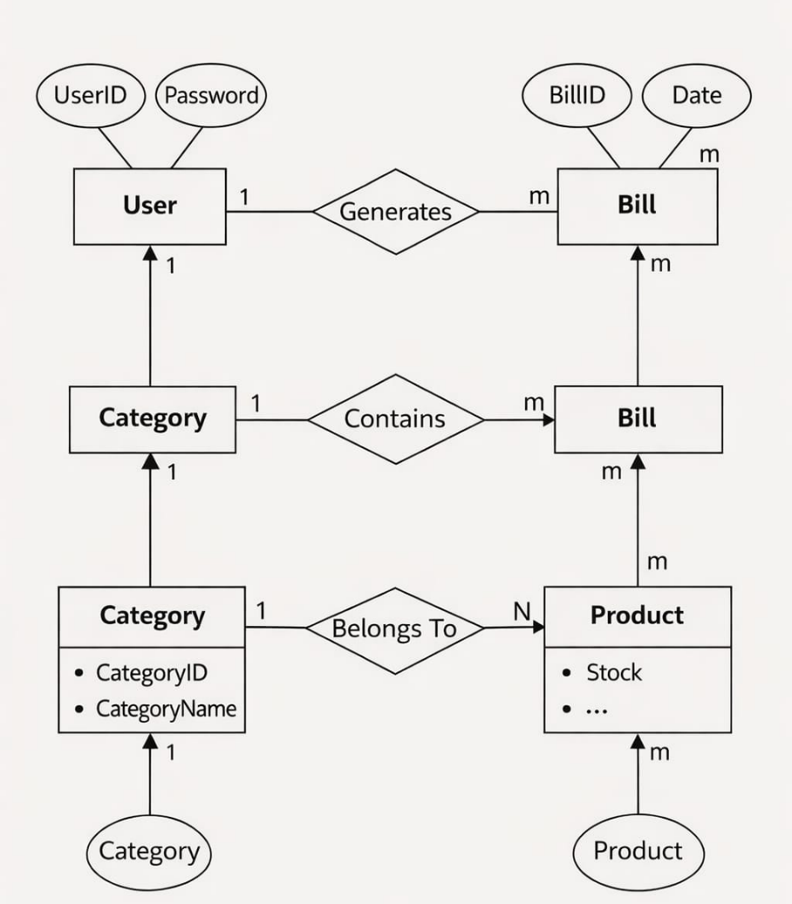
Class Diagram
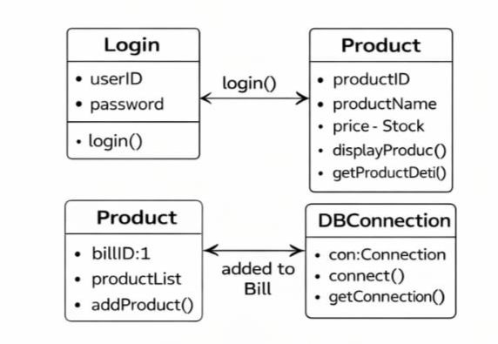

3)object daigram:-

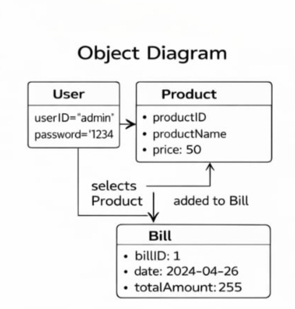

- Sequence Diagram:-
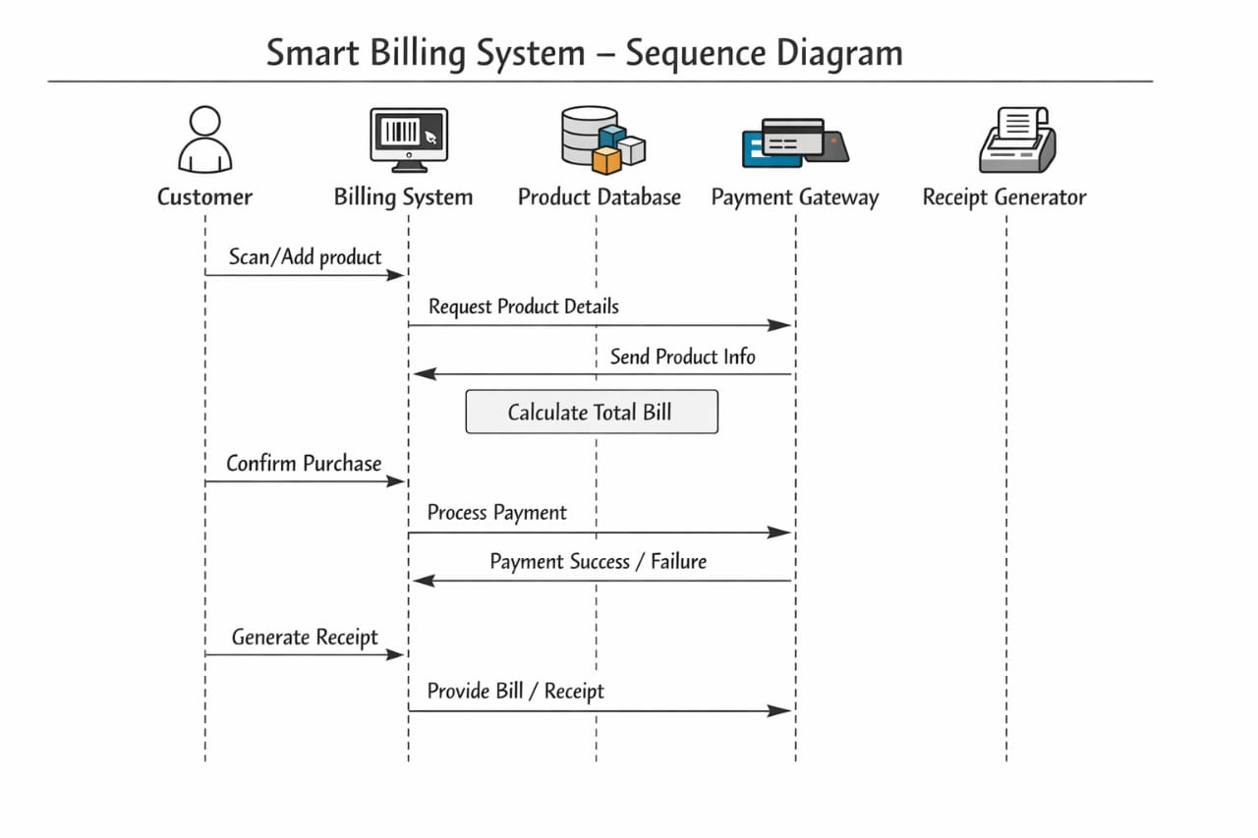

- Collaboration Diagram:-

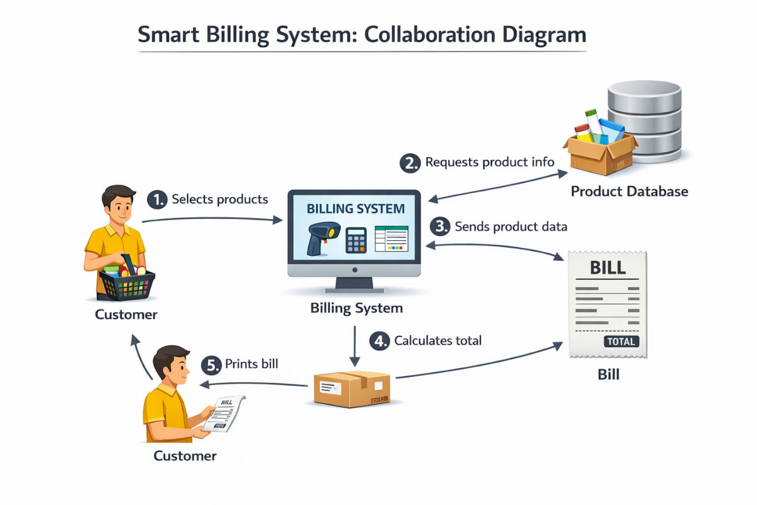
- Activity Diagram:-
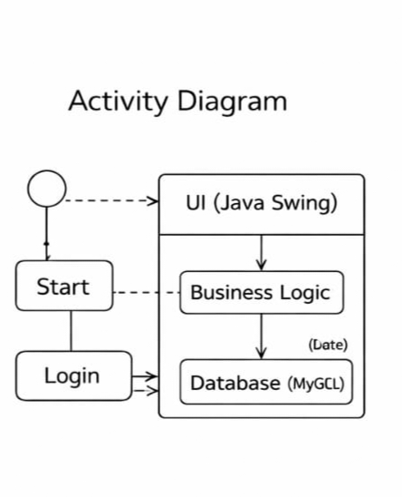
- Component Diagram:-
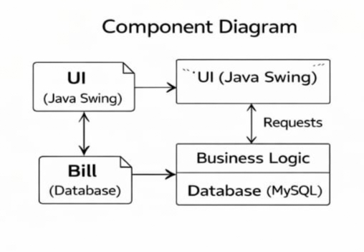

I/O Screenshots
Welcome page:
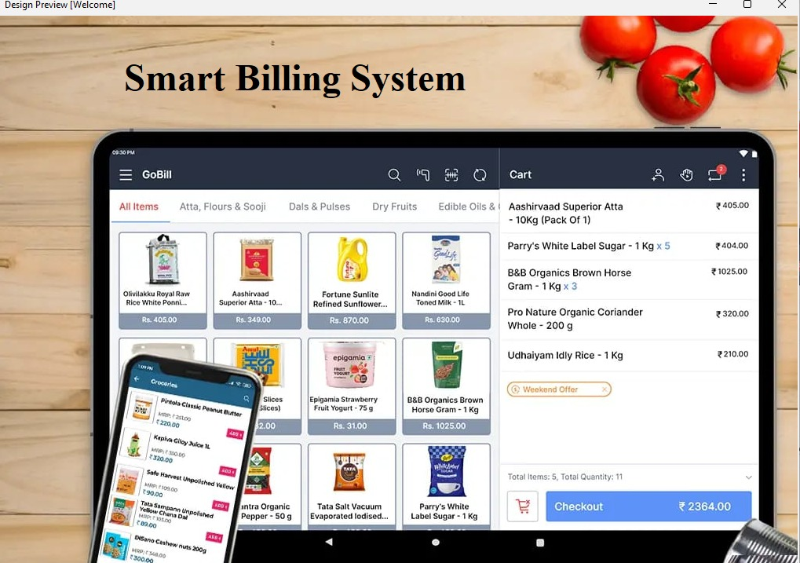

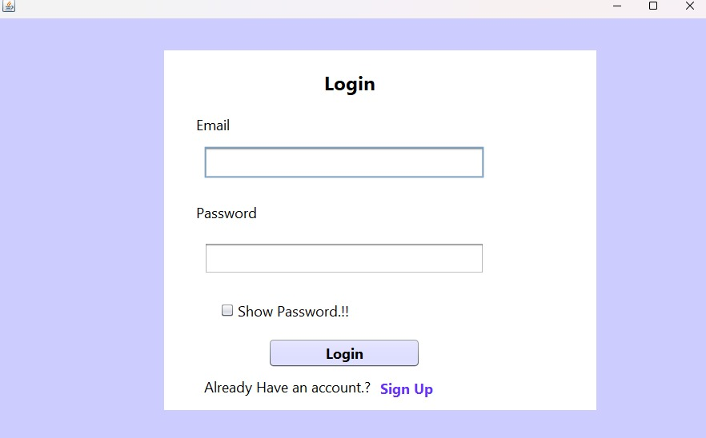

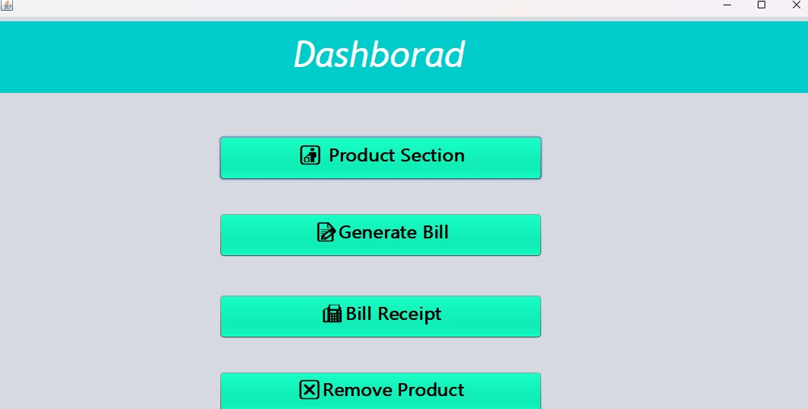

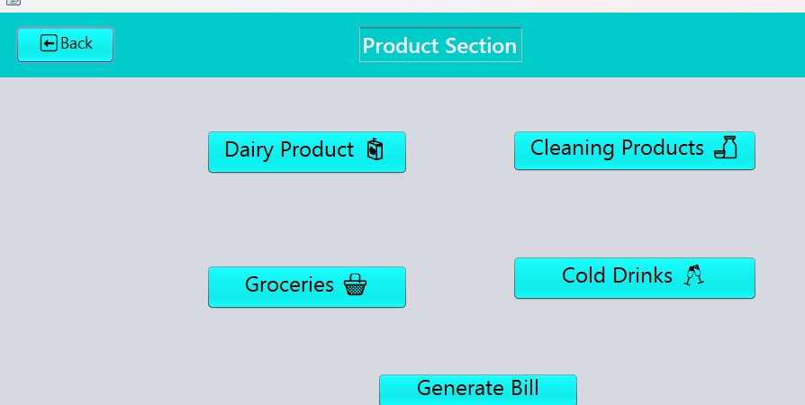

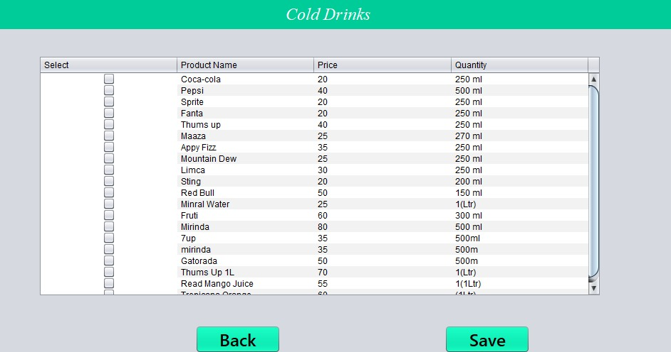

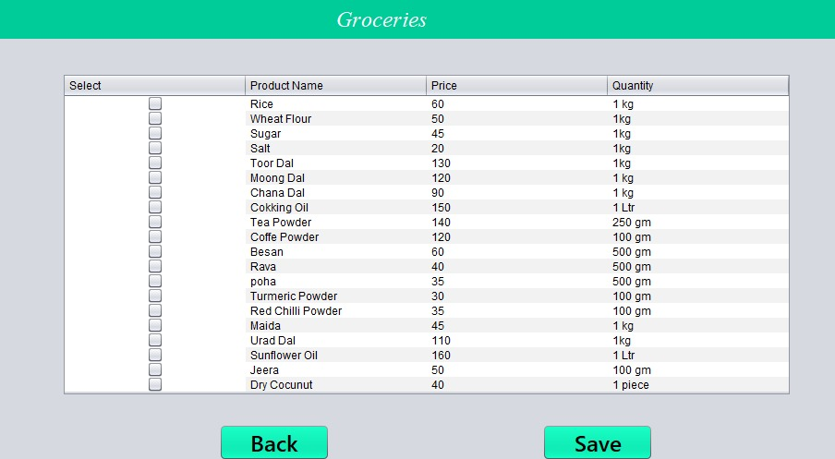
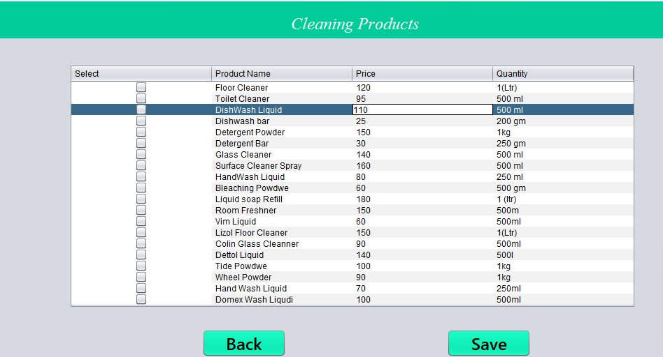

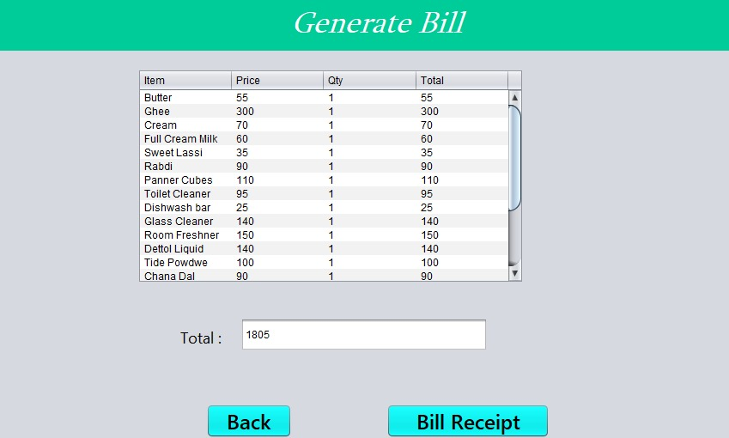
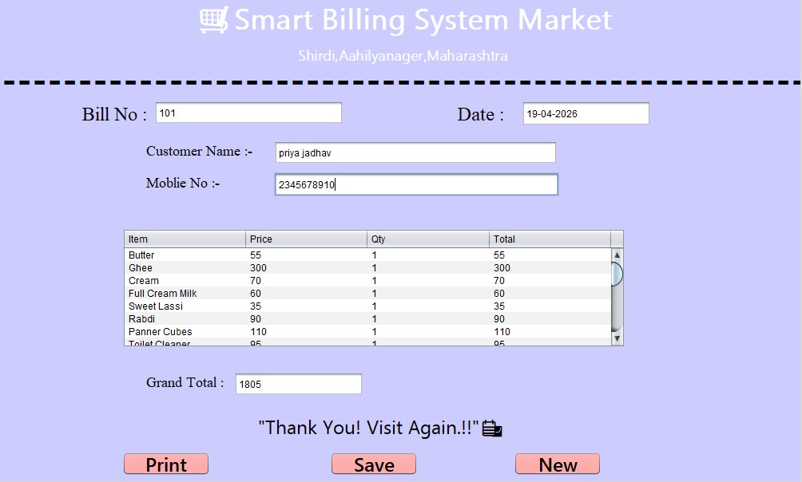

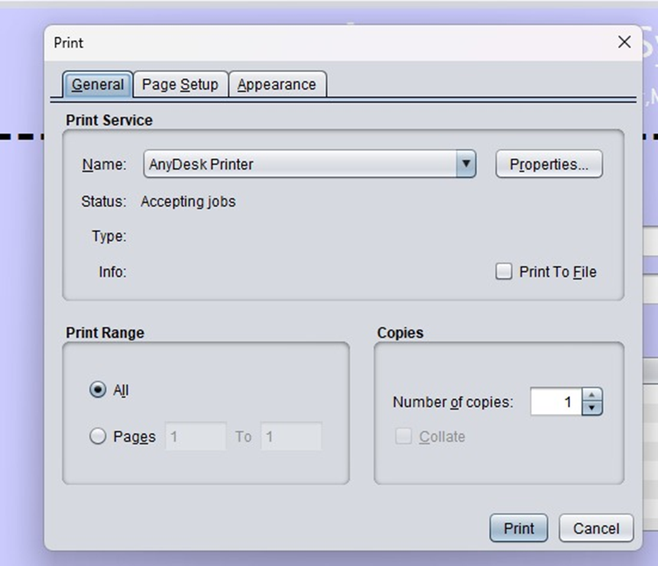

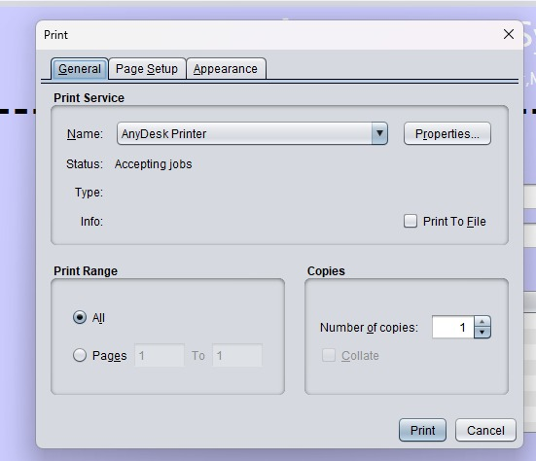
Biblography:
1)http://www.java.com/
- http://www.javaworld.com/javaworld.jw-01-1998/jw-01-bookreview.html
- Database Programming with JDBC and java by O’Reilly
http://java.sun.com

Biblography:
1)http://www.java.com/
- http://www.javaworld.com/javaworld.jw-01-1998/jw-01-bookreview.html
- Database Programming with JDBC and java by O’Reilly
- http://java.sun.com

