**PRIYA A**

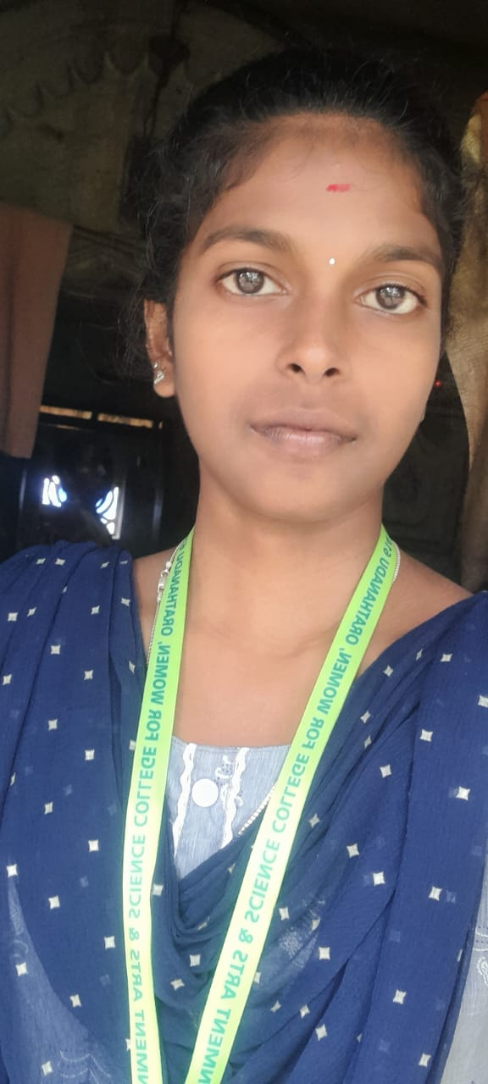

D/O,Anantharaj P

1174, Sankarn street, Avadanallavijayapuram,

Papanadu,Orathanadu,Thanjavur.

PINCODE:614626

Phone:9600850360

Email:apriyap4@gmail.com

**Objectives:**

* To obtain a position where my experiences and education can be utilized and expanded.

1. **Skill Sets:**
   * Through knowledge in accountancy.
   * Good knowledge about marketing management.
   * Good communication skills.
   * Analytical skills.
   * Reasoning ability.
   * Team player.
2. **Computer Skills:**
   * Programming language : JAVA, C, C++, Python
   * MS WORD.
   * MS EXCEL.
   * POWER POINT.
3. **Education Qualification:**

|  |  |  |  |
| --- | --- | --- | --- |
| Name of Exam | Name of Board | Passing year | Percentage (%) |
| 10th | SSLC | 2017-2018 | 70% |
| 12th | HSC | 2020-2021 | 75% |
| BCA(Bachelor of Computer Applications) | Bharathidhasan  University | 2023-2026 | 80% |

**Personal Details:**

Date of Birth : 30.05.2004

Nationality : Inadia

Marital status : Single

Religion : Hindu

Gender : Female

Place : Tamil Nadu