

**maBetter**

**Al**

**Global Terrorism Analysis**

Voice against Terrorism

**Participants: *Prince Priyadarshi Priyanka Gorkhe Pratibha Sanganmath Rahul Deshmukh***

Search…….. Let’s Begin From here!!!

Introduction

This point will introduce with the aim and agenda of this analysis..

Problem Statement

This point will brief you the problem..

ABSTRACT

This point will give you an insight to the analysis.

Exploratory

Analysis

This point will describe all the steps involved in the analysis with data visualisation..

 Conclusion

This point will conclude the analysis and put some interesting facts related with it..

Libraries used

This point will list up the libraries we used and their purpose..

**Abstract:**

The entire world in today’s time is highly undergoing through terrorism. This topic not only includes the incessant obstacles thrusting in the path of global progress but also a deep-down effect on development of every county.

Here we have an impactful dataset drawn from Global Terrorism Database which comprises of data of all the terrorist attacks taken place around the world from 1907 to 2017. It includes more than 180000 attacks and a big range of massacre. It has distressed the political and economic stabilities on worldwide level.



Here our study can help understand what are the basic factors riding behind this growing problem. And some core points are milestones to take a proper action to reduce this problem at some extent.

1. **Problem Statement**

Data provided here is big source of record of continuous terrorist activities. Here we have to provide a helpful data analysis for having multilateral initiatives in response to terrorism. The followingly depicted points are some major questions which we need to answer are:

1. The most active terrorist group
2. The most used weapon set
3. The most attacked country
4. The most attacked regions
5. The correlation of years and terrorist activities
6. The estimation of people and property loss in each country
7. The calculation of people wounded

And therefore we need to present a solid data analysis which help people in predicting which country needs more security ,which country is safer to live and which kind of weapons and strategies the terrorists use ,so that people can be alert.

### **Introduction**

### The International growing terrorist activities have laid off many arenas of serendipity of life and nature. It has badly affected tourism and weakened the economic sphere of the gross development. .

### This Exploratory data analysis is bringing a helpful report to understand in which aspects strong actions are needed to be taken. We can dig the ground deep to find a synthesized solution of this convulsing block.

1. ***Libraries* Used**

* **Pandas**

We have used pandas for data analysis and manipulation and of better data representation.

* **Matplolib**

We have used matplotlib for data visualization and graph plotations.

* **Seaborn**

We have added seaborn to make data visualisation more colourful and meaningful.

* **Folium**

Folium has been used for drawing world map to locate any desired location within no time.

* **Ipywidgets**

An interactive amazing library ‘Ipywidgets’ has been used to cater more dynamic representation of our graphs and plots.

1. **EXPLORATORY DATA ANALYSIS:**
2. **DATA LOADING**

We have loaded the data into our drive and then finally loaded it to google colab notebook using pandas library.

**Total we have a huge number of rows 18135 columns.**

1. **DATA CLEANING (Null value treatment)**

The major part of the dataset is null values which triggers many stumbling blockages in processing the necessary columns. Therefore its required to identify the columns containing lumpsum null values and then drop them.

Let’s remove the columns which have ‘Naan’ i.e. no values .Remember ,it’s something else than ‘0’!!

**3. DELETING UNWANTED COLUMNS**

In this step we will observe the columns of the dataset minutely and eliminate those columns which don’t have much to do with our topic. It will help to smoothen our analysis. We are almost near to get our final dataset!!

And the columns which may hamper your accuracy are:

extended,'region'specifity', 'vicinty', 'crit1', 'crit2', 'crit3', 'doubtterr', 'multiple','weaptype1','attacktype1','targtype1','targsubtype1','natlty1', 'natlty1_txt','guncertain1', 'individual','weaptype1','property', 'ishostkid', 'dbsource','INT_LOG','INT_IDEO', 'INT_MISC', 'INT_ANY'

***The number of columns is 20 !!! How sweet!!***

eventid', 'iyear', 'imonth', 'iday', 'country_txt', 'region_txt','provstate', 'city', 'latitude', 'longitude', 'success', 'suicide','attacktype1_txt', 'targtype1_txt', 'targsubtype1_txt', 'target1','gname', 'weaptype1_txt', 'nkill', 'nwound'

**4.Renaming The Columns**

Now finally we have set all the columns .And now its time to rename the column to make the study easier.

'eventid':'event_id',

'iyear':'year',

'imonth':'month',

'iday':'day',

'country_txt':'country',

'region_txt':'region',

'provstate':'state',

'attacktype1_txt':'attack_type',

'targtype1_txt':'targ_type',

'targsubtype1_txt':'targsub_type',

'target1':'main_target',

'gname':'gang_name',

'weaptype1_txt':'weapon_type',

'nkill':'number_of_kill',

'nwound':'number_of_wound'

1. **ANALYSIS OF MOST TYPE VARIABLES:**
2. Country
3. Region
4. City
5. Year
6. Month
7. Group
8. Attack types(Strategies / Weapon sets used for attack)

* Country with the most attacks: Iraq
* City with the most attacks: Unknown
* Region with the most attacks: Middle East & North Africa
* Year with the most attacks: 2014
* Month with the most attacks: 5
* **Group with the most attacks: Taliban**
* **Most Attack Types: Bombing/Explosion.**

*And here you go !! what can shake your head and make you say just ‘wow!’ is that what you have predicted has actually foregone in trends. Very recently we came across with overwhelming actions of the* ***TALIBAN*** *who had made many* ***BOMBING EXPLOSIONS*** *in* ***KABUL*** *and overpowered* ***AFGANISTAN.***

**6. DATA VISUALISATION:**

**6.1. PEOPLE KILLED EVERY YEAR:**

Here we have encarved that from year 1970 to 2017 how rapidly graph of peoples’ deaths has slayed the surface and in the year 2014 it reached at the topmost.

The maxima was more than 14000 a big number!!!

From above bar chart, we came to know about the total number of terrorist attacks with re-spect to different years. We can conclude that most attacks were done in the year 2014.

We can see here that attacks slowly started to increase from 1972 until about 1993 where by 2004 we can see a downward trend in the terrorist incidents. Then after 2014 the terrorist activities started increasing till 2014 then slowly decreased.

The lines striding upward show that how rapidly the attacks grew between 2010 to 2014.

And then submissively they decreased.

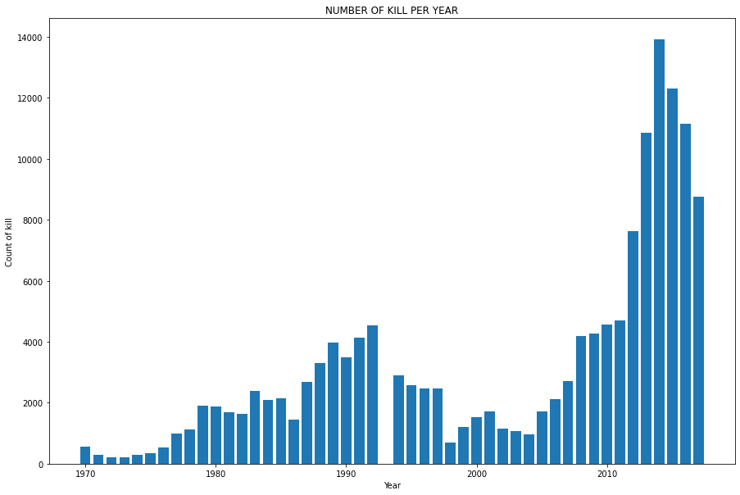



**6.2.NUMBER OF PEOPLE KILLED BY EACH TERRORIST GROUP**

### The increasing graph of peoples killed was reaching high as a resultant of terrorist attacks.

### As we analysed the data we figured out from the below bar graph which shows the number of people killed by different terrorist groups, we can say that most people were killed by terrorists which is unknown followed by ISIL and least number of people killed by Hutu ex-tremists group.

### 

* 1. **TERRORIST ACTIVITIES (NUMBER OF ATTACKS VS YEAR)**

The below graph is plotted using an area type of graph. It shows the total number of attacks in corresponding years and regions. Most attacks were made in 2014 on Australasia & Oceania.

In the 1970s we can see that most terrorist attacks occurred in Western Europe, followed by Latin and South America in the 1980s.But then there is an overall decline in the number of attacks between the mid-1990s and 2003.

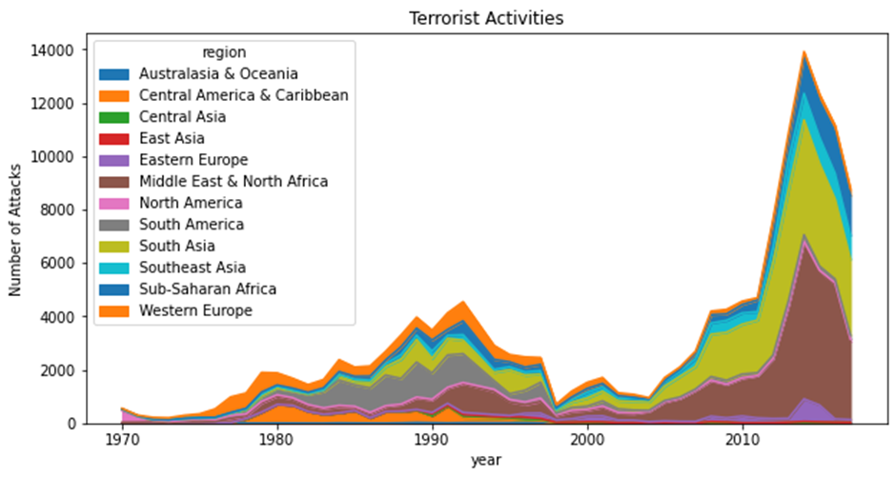

**6.4.PERCENTAGE OF ATTACKS BY EACH GANG.**

The following figure is plotted using a pie chart which shows the percentage of attacks made by different terrorist groups out of total attacks.

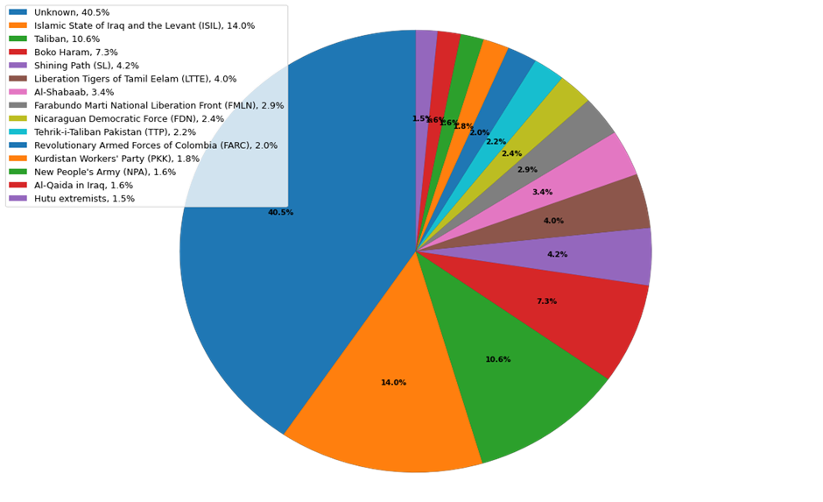

**6.5 THE MOST ACTIVE GANG IN THE ATTACKS**

From the below graph, which depicts the total number of attacks by different terrorist groups in respect to different years, we can say the most active terrorist gang was ***Taliban.***

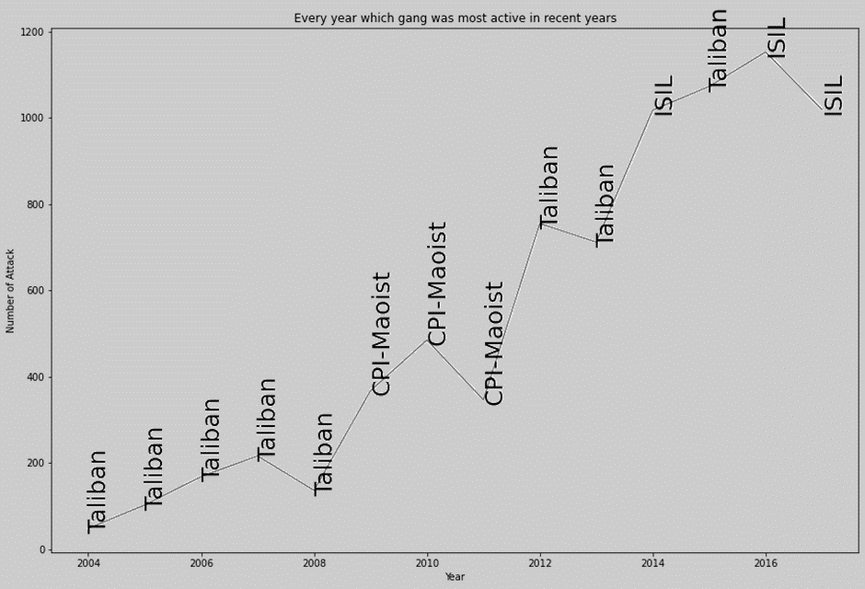

* 1. **MAXIMUM NUMBER OF KILL IN EACH COUNTRY WHICH IS GREATER THAN 200.**

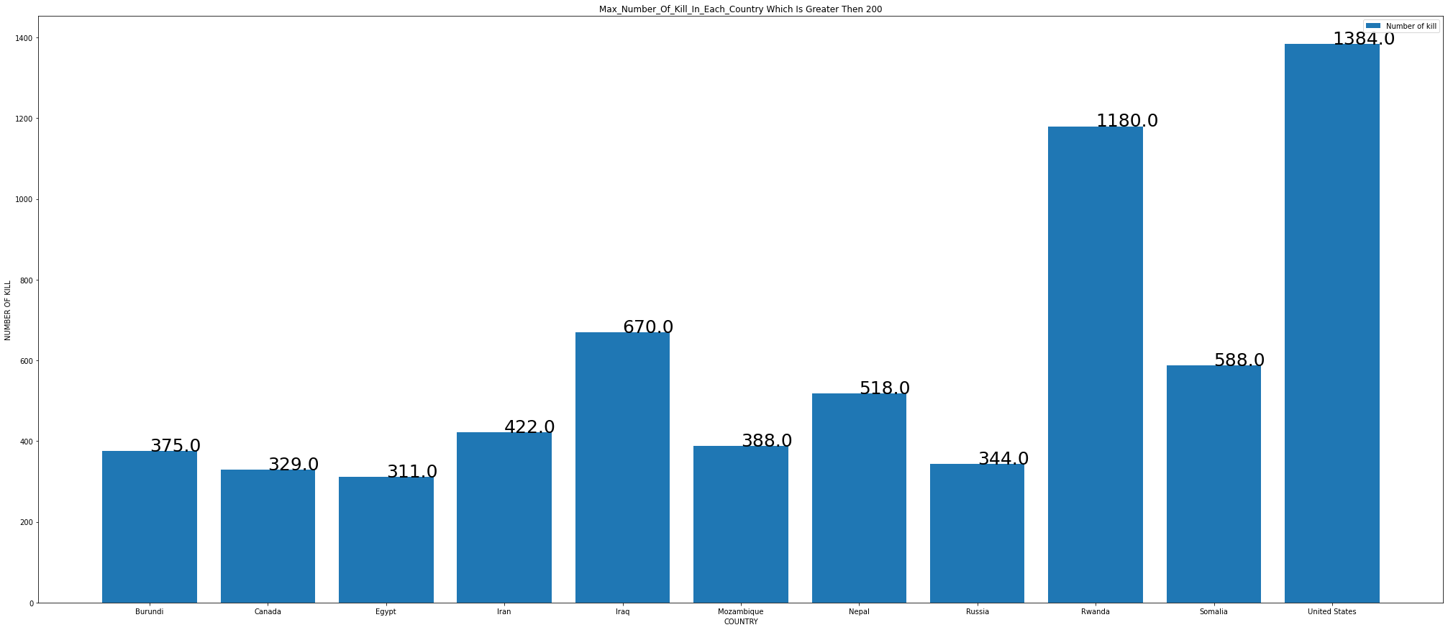

From the above bar graph, which displays the total number of people killed in different countries,we can say that **the most people** were **killed** in ***United States i.e.1384*** people were killed.

* 1. **TARGET VALUES**

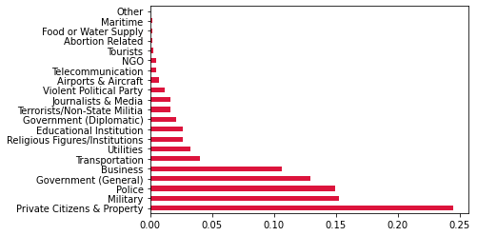

From above graph, which depicts that most of the terrorist gangs targeted the private citizens and property followed by military, police.

* 1. **NUMBER OF KILL VS NUMBER OF WOUNDED**

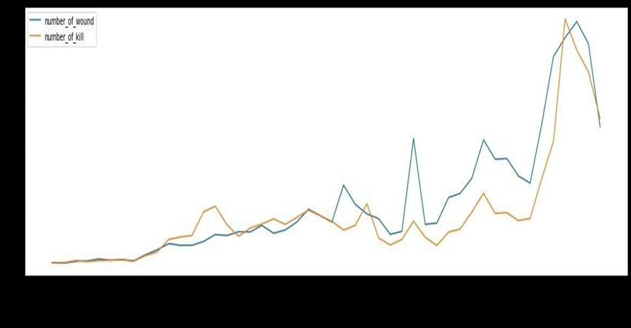

The above graph shows the graph of deaths and people wounded. With every year the rate of attacks increased and it resulted in increasing death rate and wounded peoples. In the begin-ning the kill rate was lower than wound rate but in the ending years the death rate rapidly made a big arch marking a big range of death rate in proportion to wound rate.

* 1. **CORRELATION BETWEEN ‘SUICIDE’ ‘KILLS’ AND ‘IYEAR’:-**

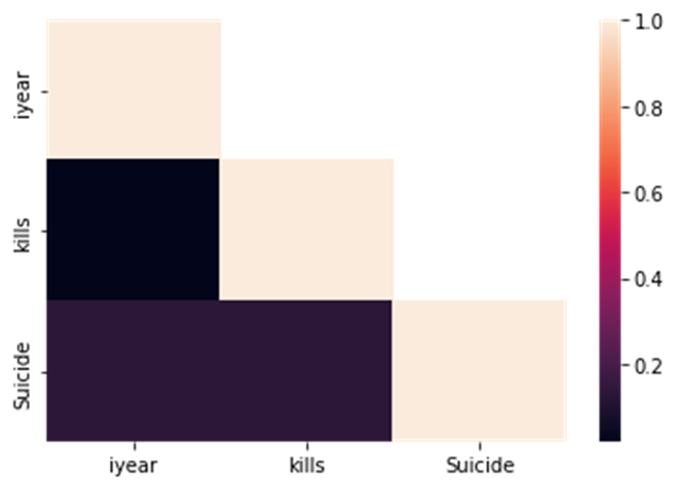

The above heatmap of correlation between the independent variables. The matrix shows the coefficients in the squared form coloured as per the intensity scale. The map has positive covariance as with increase in one variable another is also increasing. As per the increase in years suicides are also increasing . But with each increase of years number of deaths are intensively growing.

1. **CONCLUSION**

The data representation and visualization has played a big role to come to a solid report . Our thorough data studies helped us in understanding that with increase in technologies and weapons the kills have increased and the attacks have taken place very frequently. In the row of continuous attacks the countries which has the most attacks is ‘IRAQ’ and the one with most deaths is also Iraq in May 2014. The terrorists used Bombing/Explosions to kill the big mass at one time. Many people committed suicides to escape from the hardest deaths caused by Terrorists.

The gang which made maximum number of attacks is ‘TALIBAN’. This gang attacked at multiple places and the country which was mostly attacked by this group is ‘AFGANISTAN’.

The group which caused maximum deaths is ‘ISIL’

They used Bombing/Explosion, Armed Assault and Hostage Taking (Kidnapping) to kill the people.

Al_Qaida Most mischievous gang in early 20's and have done most number kill till date and

They used Explosives and vehicle-borne explosives for killing people.So if we control on the illegal tranportation of weapons, we can reduce the possibility of upcoming wars.

We can see that in only one year (2001) there were 2 attacks on the same day ,

So we can say that there might me some disput between USA and Al_Qaida which caused such a big massacre.

**The figure of kills made by each gang……**

**GANG_NAME VS NUMBER_OF_KILL**

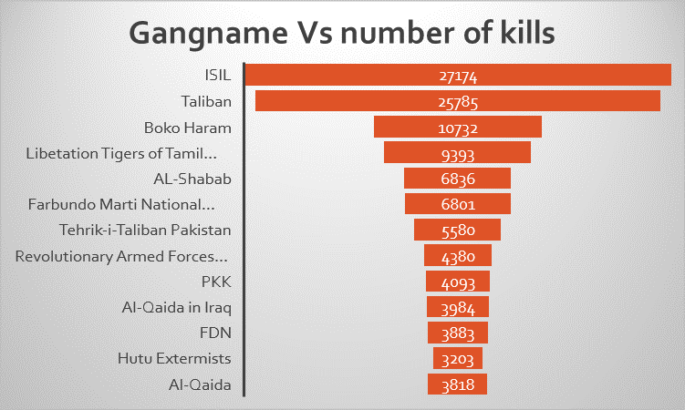

Overall the maximum number of people were killed by Al-Qaida but in 20’s this gang is not so active.

**EFFECTS ON INDIA AND NEIGHBOUR COUNTRIES:**

Our country India was also badly affected by this massacre. Total 10491 people were killed.

Whereas Pakistan stands on the second number in human loss. 12756 people were killed in these attacks. Whereas in Afghanistan 10871 people were killed.

Overall the middle east area was broadly affected and was looted. Whereas UK was the safest country.

To get rid of such huge problem its very important to understand key factors threshing to-wards this problem. As it has been a kind of dead lock which is pushing the developing countries down and making them handicapped from standing in the rows of the other developed countries.

**THE END**