**Abstract**

The Project titled “Attendance Management System” deal with

the maintainance of attendance details. It is for maintaining daily

The Project titled “Attendance Management System” deal with

the maintainance of attendance details. It is for maintaining daily

The Project titled “Attendance Management System” deal with

the maintainance of attendance details. It is for maintaining daily

The Project titled “Attendance Management System” deal with

the maintainance of attendance details. It is for maintaining daily

Over the years the manual attendance management has been carried across most of educational institutions.

**Student Attendance Management** deals with the maintenance of the student’s attendance details. It generates the attendance of the student on basis of presence in class. It is maintained on the daily basis of their attendance.

The staffs are responsible to mark the attendance for all students. Only if the student present on that particular day, the attendance will be calculated. The student’s attendance reports based on monthly.

**Introduction**

In educational instituitions, managing student attendance efficiently is crucial for maintaining discipline, monitoring student progress and ensuring compliance with regulations. Manual attendance tracking methods are prone to errors and can be time-consuming. To address these challenges, the Student Attendance Management System offers a comprehensive solution.

The Student Attendance Management System is a mini-project designed to automate the process of recording and managing student attendace in schools, colleges, or any educational organization. It provides an efficient and accurate way to monitor student attendance, saving time for teachers and administrators while improving overall attendance management.

Attendance Management System is a software developed for daily student attendance in schools, colleges and institutes. It facilitates to access the attendance information of a particular student in a particular class.

The purpose of developing attendance management system is to computerized the tradition way of taking attendance. This system will also help in evaluating attendance eligibility criteria of a student.

Here the staffs will be responsible will be responsible to mark the attendance of the students. It is cost effective in the sense that has eliminated the paper work completely.

**Flowchart**

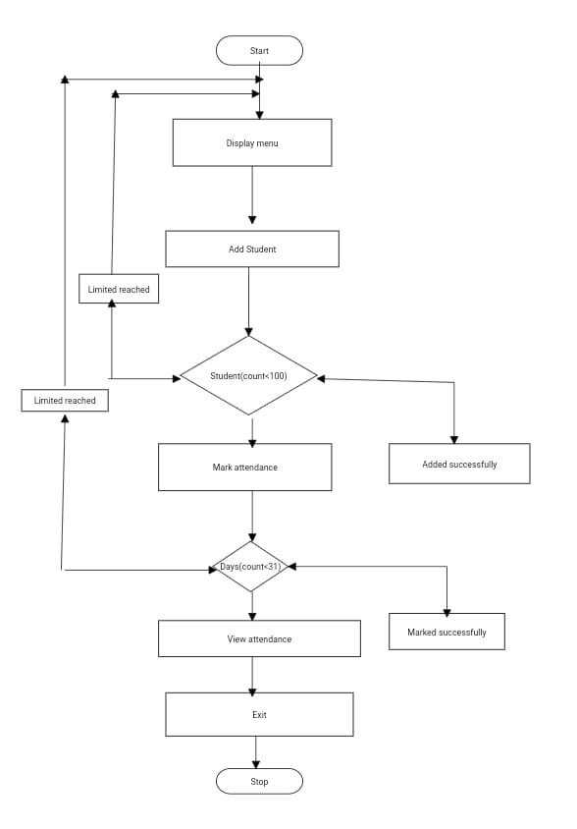



**Source Code**

import java.util.Scanner;

public class AttendanceManagement {

private static final int MAX_STUDENTS = 100;

private static final int MAX_DAYS = 31;

public static void main(String[] args) {

Scanner scanner = new Scanner(System.in);

String[] students = new String[MAX_STUDENTS];

boolean[][] attendance = new boolean[MAX_STUDENTS][MAX_DAYS];

int studentCount = 0;

int currentDay = 0;

System.out.println("Welcome to Attendance Marker");

while (true) {

System.out.println("\n1. Add student");

System.out.println("2. Mark attendance");

System.out.println("3. View attendance");

System.out.println("4. Exit");

System.out.print("Enter your choice: ");

int choice = scanner.nextInt();

switch (choice) {

case 1:

if (studentCount < MAX_STUDENTS) {

System.out.print("Enter student name: ");

String studentName = scanner.next();

students[studentCount++] = studentName;

System.out.println("Student added successfully!");

} else {

System.out.println("Maximum student limit reached!");

}

break;

case 2:

if (studentCount == 0) {

System.out.println("No students added yet!");

break;

}

if (currentDay >= MAX_DAYS) {

System.out.println("Maximum days limit reached for marking attendance!");

break;

}

System.out.println("Marking attendance for day " + (currentDay + 1));

for (int i = 0; i < studentCount; i++) {

System.out.print("Is " + students[i] + " present on day"+(currentDay+1) +" (Y/N): ");

String attendanceStatus = scanner.next().toUpperCase();

if (attendanceStatus.equals("Y")) {

attendance[i][currentDay] = true;

} else if (attendanceStatus.equals("N")) {

attendance[i][currentDay] = false;

} else {

System.out.println("Invalid input! Please enter Y or N.");

i--;

}

}

currentDay++;

break;

case 3:

if (studentCount == 0) {

System.out.println("No students added yet!");

break;

}

System.out.print("Name\t\t");

for (int days=0;days<31;days++)

{

System.out.print("Day-"+(days+1)+"\t\t");

}

System.out.println();

for (int i = 0; i < studentCount; i++) {

System.out.print(students[i] + "\t");

for (int j = 0; j < currentDay; j++) {

System.out.print(" ");

System.out.print(attendance[i][j] ? "\tPresent " : "\tAbsent ");

}

System.out.println();

}

break;

case 4:

System.out.println("Exiting");

return;

default:

System.out.println("Invalid choice! Please enter a valid option.");

}

}

}

}

**Output**

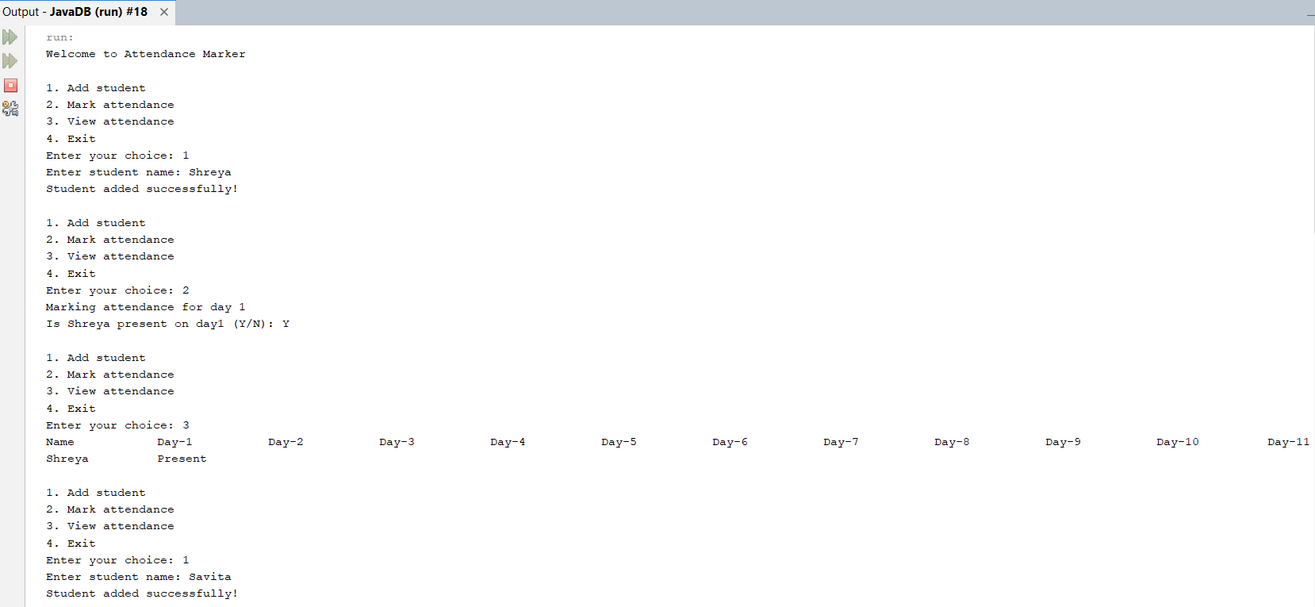

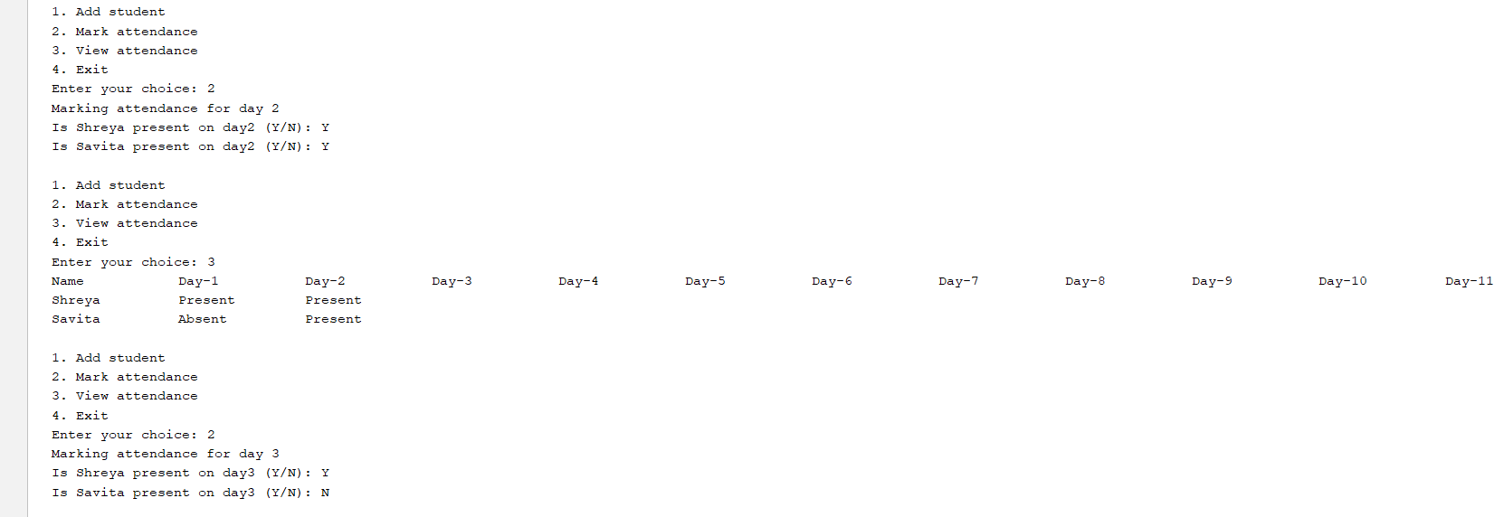

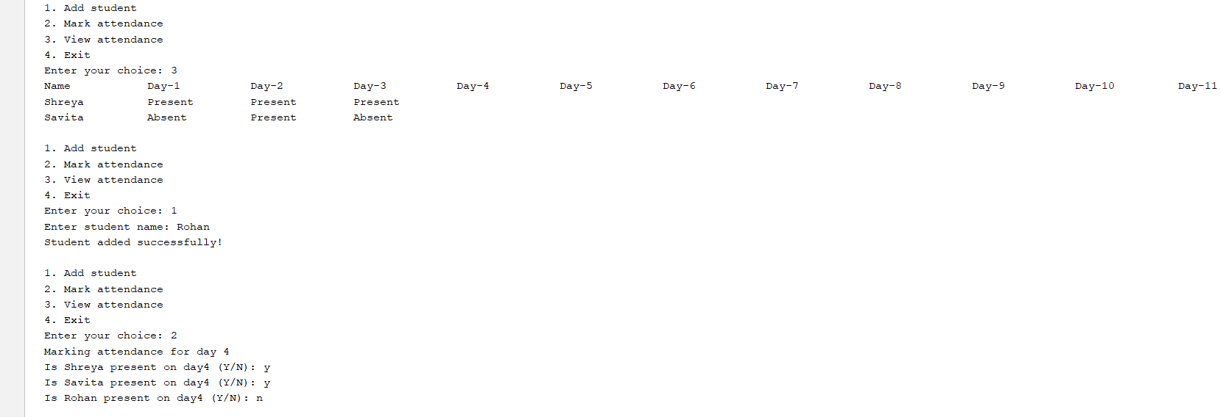

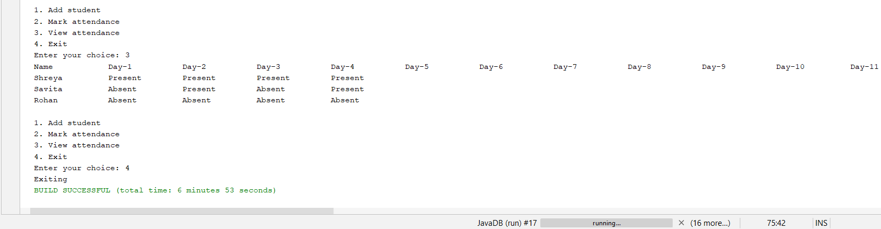

**Conclusion**

To conclude, project data grid works like a component which can add students, mark their attendance as monthly basis. The students that are added after few days are marked absent in the beginning days by default. Project of Student ttendance Management System is very easy to manage and can be grown furthermore in the future.. It overcomes the many limitations incorportaed in the attendance:

* Easy implementation environment
* Generate report flexibility

The project has a very vast scope in future. The project can be implemented on internet in future. Project can be updated in near future as and when requirement for the same arises, as it is very flexible in terms of expansion. With the proposed software of database. Space manage ready and fully functional the client will be able to run the entire work much better, accurate and error free manner. The following updations can be done on the project in the future:

* Discontiune of the particular student eliminate potential attendance
* Bar code reader based attendance system
* Individual attendance system with photo using student login