TC001: User able to create account using special symboll “@” in password field

BUG01: User not able to create account using special symboll “@” in password field

Steps:

1. Search Url in chrome driver
2. Insert Username
3. Insert Password
4. Click on login button

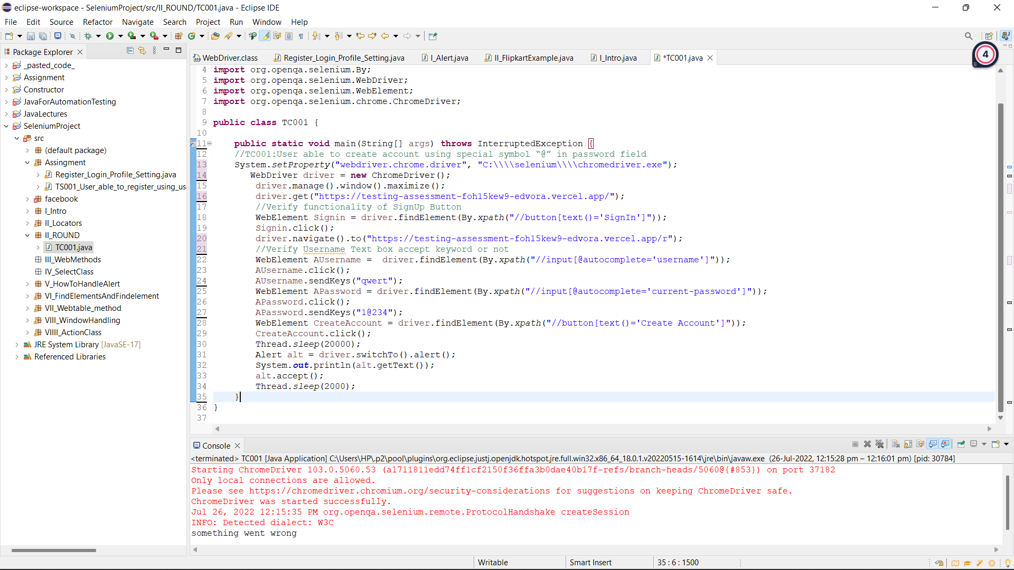

Observed Result: ‘Something went wrong’ message pop up on screen

Status: Fail

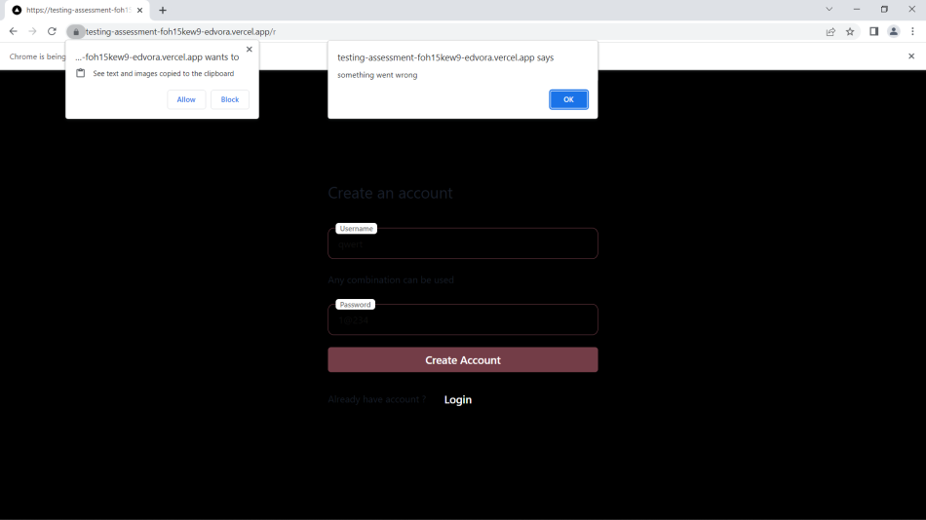

Expected Result: User able to create account using special symboll “@” in password field

Priority: High

Severity: High

==========================================================================

TC003: User able to change mobile no

BUG02: User not able to create account using special symboll “@” in password field

Steps:

1. Search Url in chrome driver
2. Insert valid Username
3. Insert valid Password
4. Click on login button
5. Click on Edit button
6. Enter Mobile Number
7. Click on save button
8. Click on Edit button
9. Clear previous Mobile Number
10. Enter Mobile Number
11. Click on save button

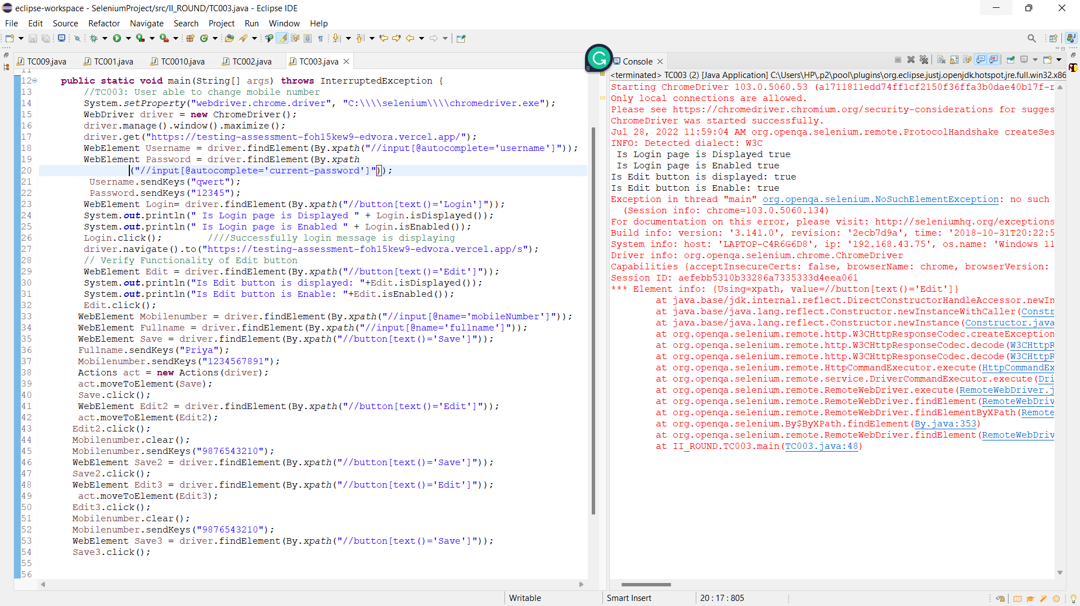

Observed Result: User unable to click on Save button

Status: Fail

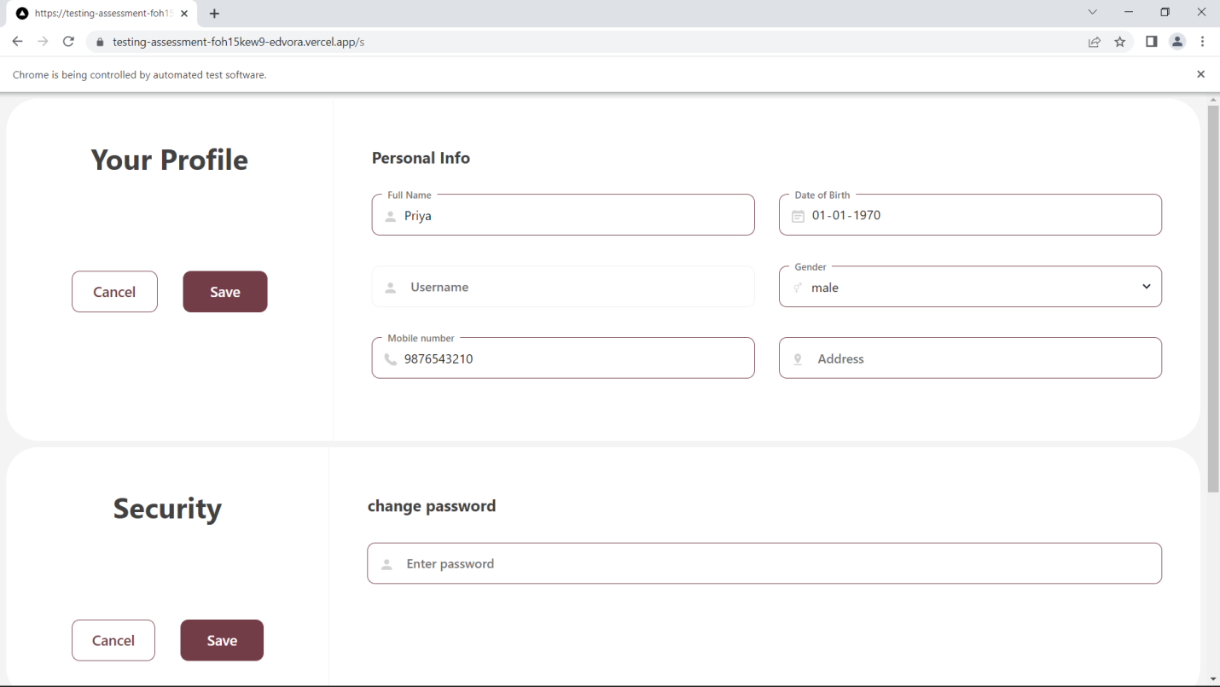

Priority: High

Severity: High

TC004: User able to give space in full name field inside setting page

BUG03: User not able to give space in full name field inside setting page

Steps:

1. Search Url in chrome driver
2. Insert Username
3. Insert Password
4. Click on login button
5. Insert full name

Observed Result:

Status: Fail

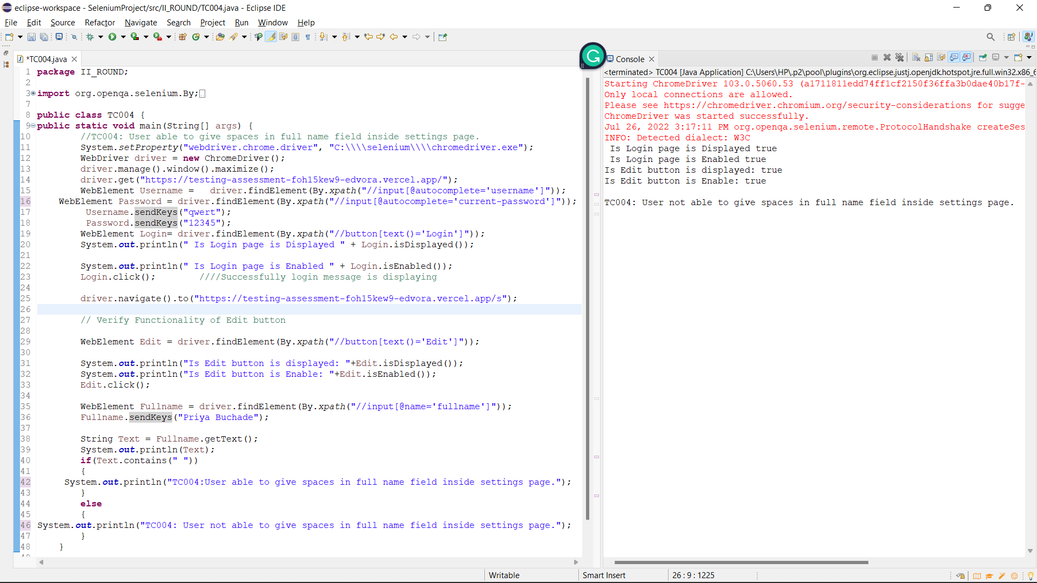

Expected Result: User able to give space in full name field inside setting page

Priority: High

Severity: Low

TC008 User gets a native popup saying “Some went wrong” when user tries to login with invalid creds.

BUG04: User do not gets a native popup saying “Some went wrong” when user tries to login with invalid creds.

Steps:

1. Search Url in chrome driver
2. Insert Invalid Username
3. Insert Invalid Password
4. Click on login button

Observed Result: User do not gets a native popup saying “Some went wrong” when user tries to login with invalid creds.

Status: Fail

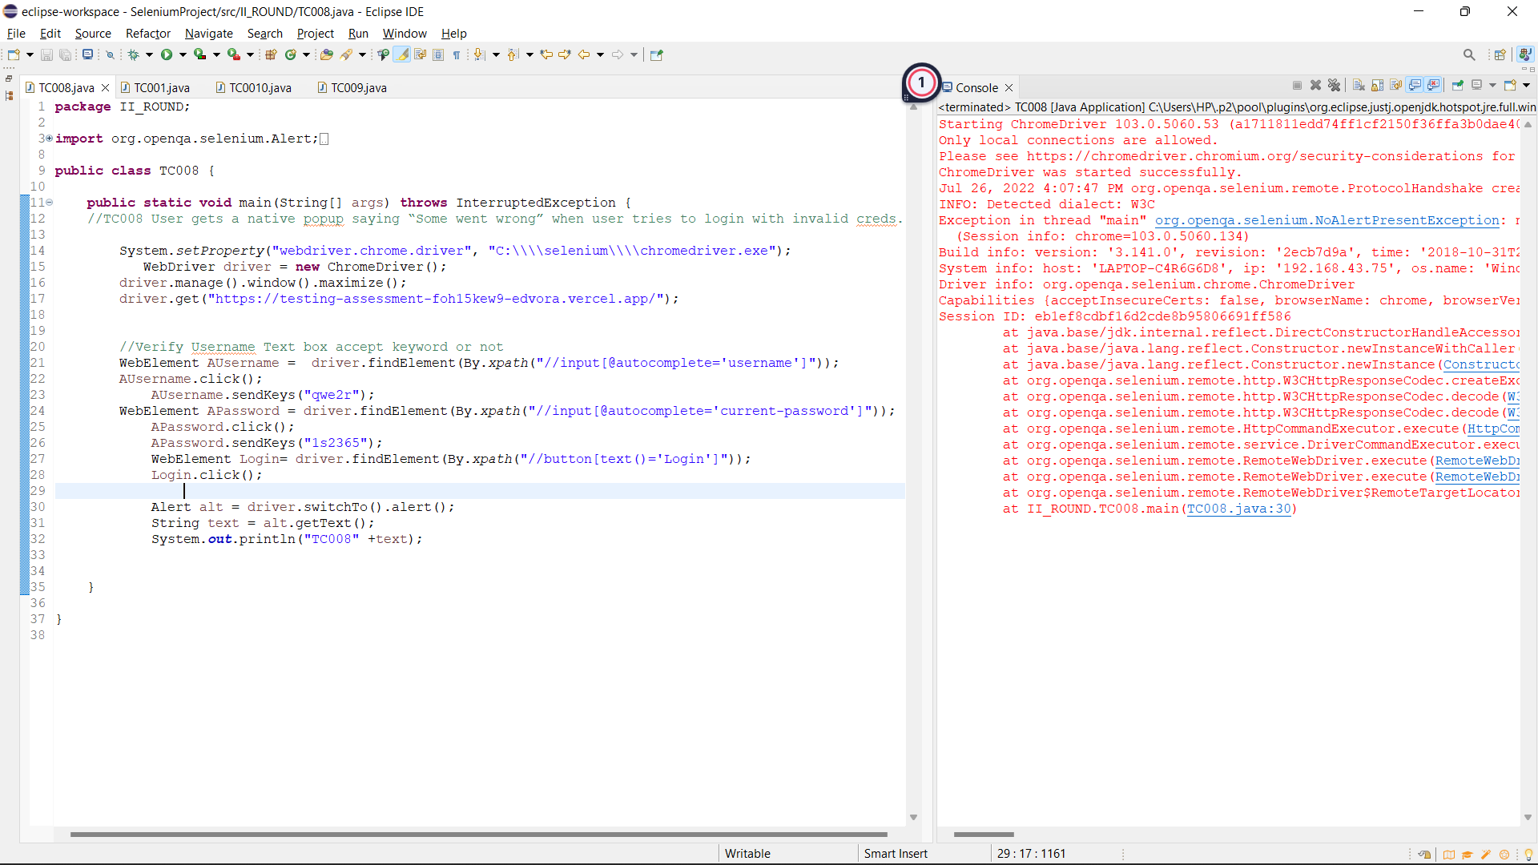

Expected Result: User gets a native popup saying “Some went wrong” when user tries to login with invalid creds.

Priority: High

Severity: High

TC009: Users should not be able to open the settings page after logging out by using the url.

BUG05: Users able to open the settings page after logging out by using the url.

Steps:

1. Search Url in chrome driver
2. Insert Invalid Username
3. Insert Invalid Password
4. Click on login button
5. Click on logout button
6. Search setting page Url in chrome drive

Observed Result: Users able to open the settings page after logging out by using the url.

Status: Fail

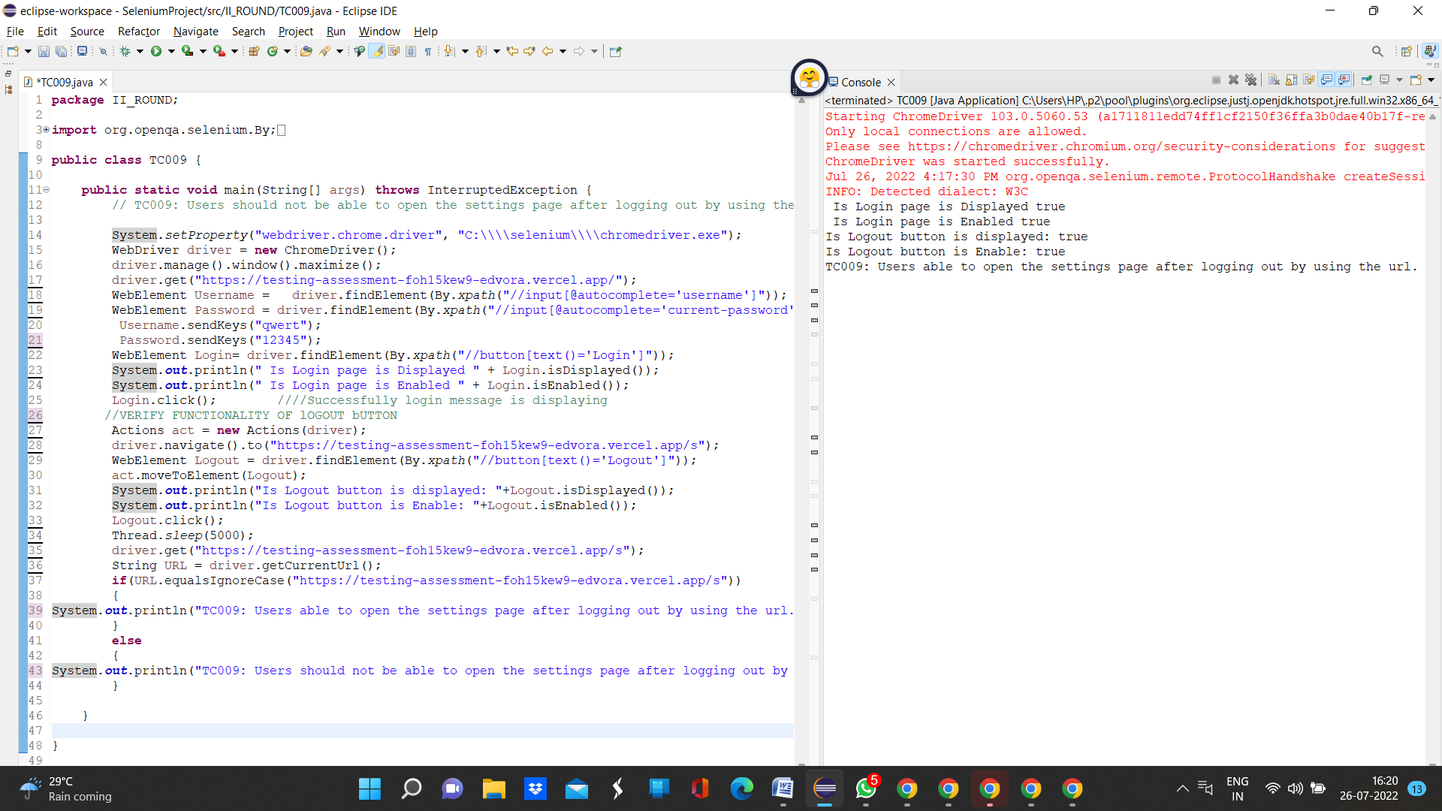

Expected Result: User should not able to open the settings page after logging out by using the url.

Priority: High

Severity: low

TC010: User able to go back after logging out using native browser back button.

BUG06: User not able to go back after logging out using native browser back button.

Steps:

1. Search Url in chrome driver
2. Insert Invalid Username
3. Insert Invalid Password
4. Click on login button
5. Click on backword arrow

Observed result

User not able to go back after logging out using native browser back button.

Staus: Fail

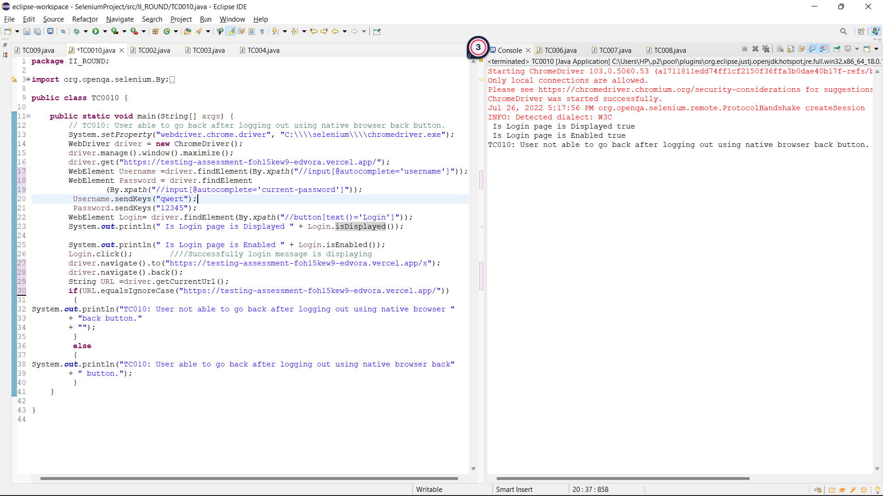

Expected Result: User able to open the settings page after logging out by using the url.

Priority: High

Severity: low

Extra Test cases

TC0013:Text written in username and password text boxes should be of visible color

BUG07: User is not to see text entered in usename and password text box

Steps:

1. Search Url in chrome driver
2. Insert Username
3. Insert Password

Observed Result: User is not to see text entered in usename and password text box

Status: Fail

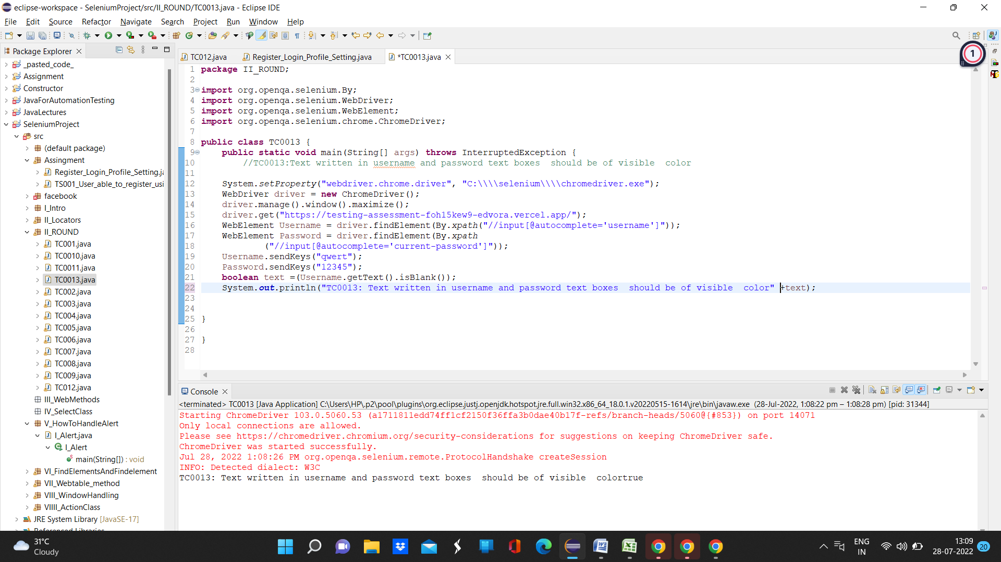

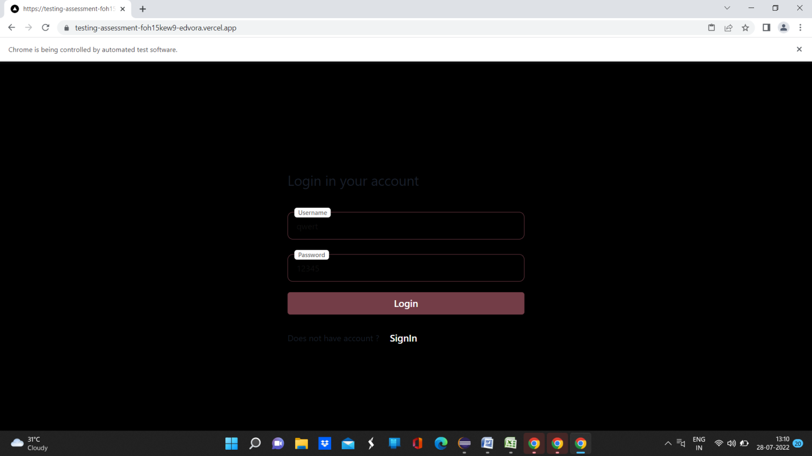  
Expected Result: User should able to read text entered in username and password textbox

Priority: High

Severity: High

TC0014:Text written in username and password text boxes should be of visible color during SignIn

BUG08: User is not to see text entered in usename and password text box

Steps:

1. Search Url in chrome driver
2. Click on SignIn button
3. Insert Username
4. Insert Password

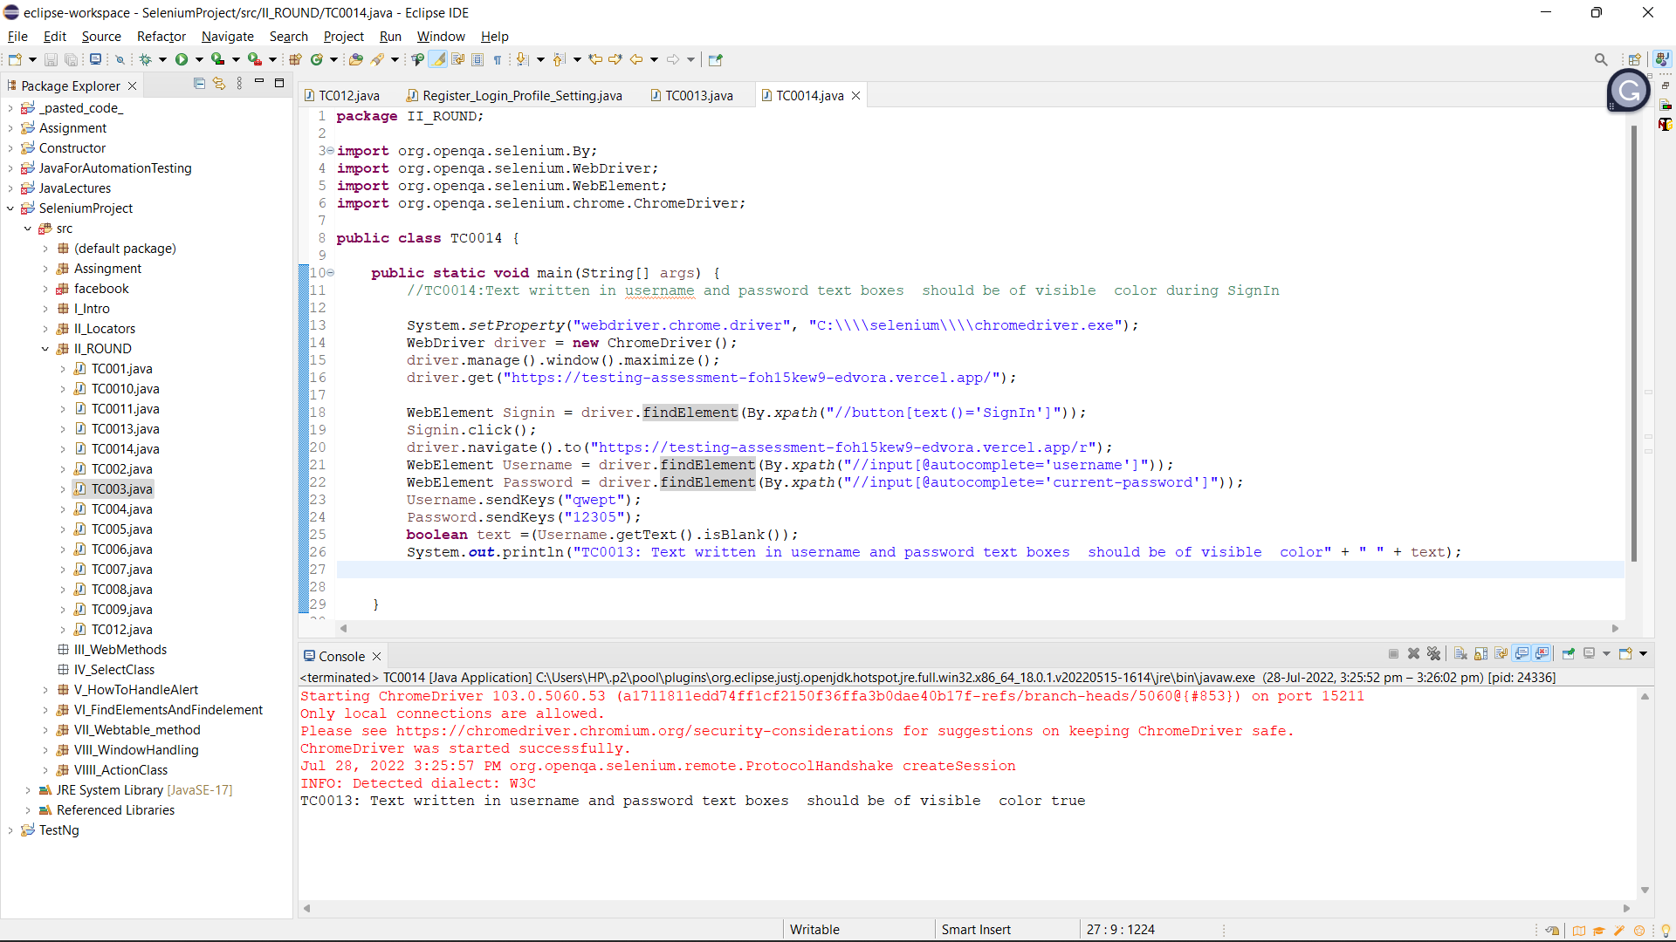

Expected Result: User should able to read text entered in username and password textbox

Priority: High

Severity: High

TC0020: User should not create account with empty username and password

BUG09: user can create account with empty username and password

Steps:

1. Search Url in chrome driver
2. Click on SignIn button
3. Click on create account button

Observed result

user can create account with empty username and password and get Account created successfully message

Staus: Fail

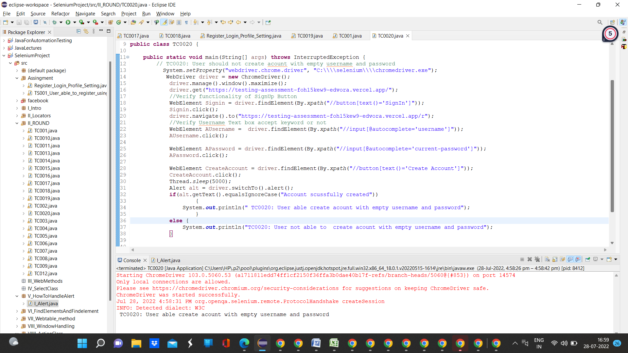

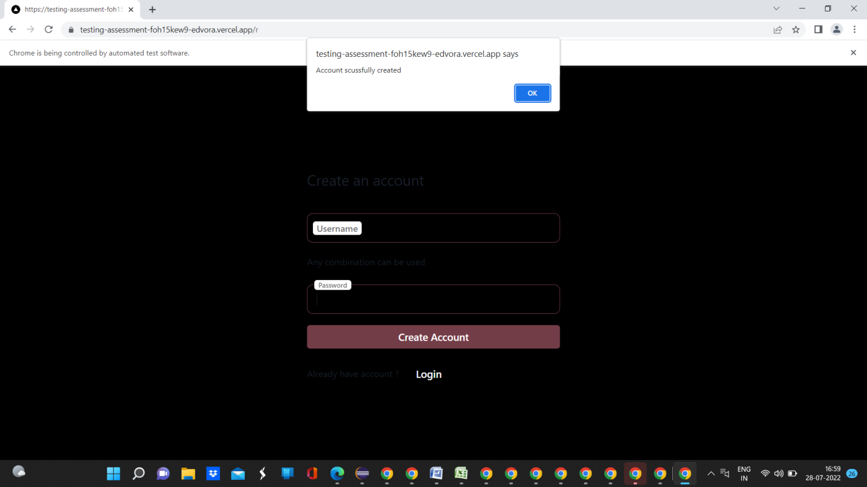

Expected Result: User should not able to create account with empty username and password filed

Priority: High

Severity: High