Real-time Drowsiness Detection System for Safe Driving using Machine Learning
NAME: Priyadharshini
REG.NO: CB.SC.P2AIE23010
SYSTEM ARCHITECTURE:
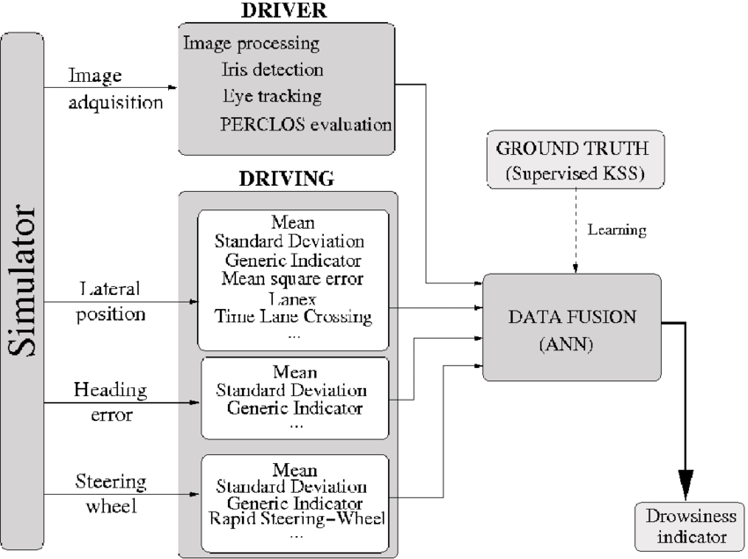

The simulator in this context is a software that simulates the driving environment of a vehicle. It uses image processing techniques to detect and track the driver's eyes and head movements. The simulator also measures the lateral position, heading error, and steering wheel error of the vehicle.

- The Mean Square Error (MSE) is a measure of the average squared difference between the estimated values and the actual values. In this case, it is used to evaluate the performance of the driver's eye tracking and head tracking indicators.

- The Generic Indicator (GI) is a measure that combines the Mean Square Error and the Standard Deviation to provide a single value that represents the overall performance of the driver's eye tracking and head tracking indicators.

- The Rapid Steering Wheel (RSW) is a steering wheel that allows the driver to rapidly change the steering angle of the vehicle. It is used in the simulator to simulate the driver's steering actions.

- The Ground Truth (GT) is the actual or true value of a particular quantity. In this case, it refers to the actual lateral position, heading error, and steering wheel error of the vehicle.

- The Supervised KSS (Knowledge-based System for Steering) is a learning system that uses the Ground Truth data to learn and predict the driver's eye tracking and head tracking indicators. It is used in the simulator to evaluate the performance of the driver's eye tracking and head tracking indicators.

- The Artificial Neural Network (ANN) is a type of machine learning algorithm that is used in the DATA FUSION part of the simulator. It is used to combine the outputs of the driver's eye tracking and head tracking indicators with the Ground Truth data to provide a more accurate and reliable evaluation of the driver's performance.

- The Drowsiness Indicator is a measure that evaluates the driver's alertness and attention during the driving task. It is used in the simulator to provide feedback to the driver about their level of alertness and attention.

In summary, the simulator uses image processing techniques to detect and track the driver's eyes and head movements. It measures the lateral position, heading error, and steering wheel error of the vehicle. The simulator also evaluates the performance of the driver's eye tracking and head tracking indicators using the Mean Square Error, Generic Indicator, and Ground Truth data. The simulator combines the outputs of the driver's eye tracking and head tracking indicators with the Ground Truth data using an Artificial Neural Network to provide a more accurate and reliable evaluation of the driver's performance. The Drowsiness Indicator is used to provide feedback to the driver about their level of alertness and attention during the driving task.

SYSTEM DESIGN:
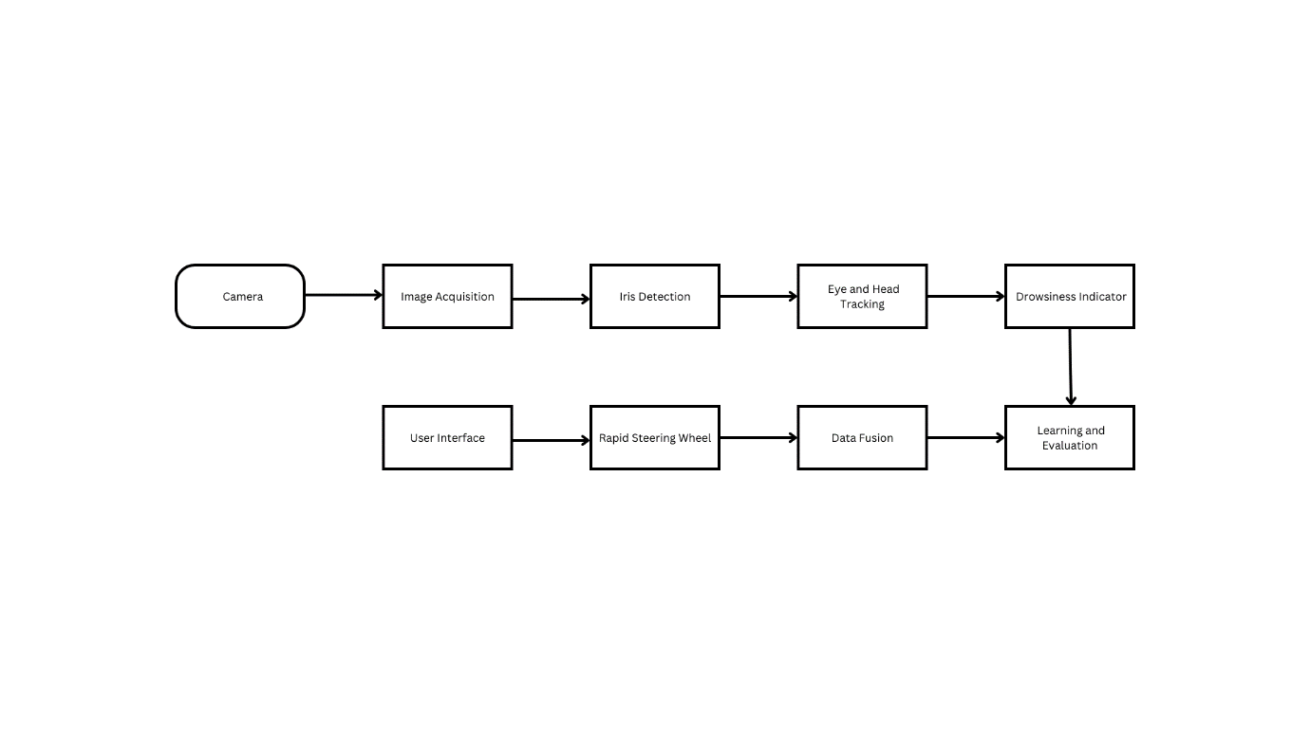

- Image Acquisition: The simulator captures images of the driver's face and head using a high-resolution camera.
- Iris Detection: The simulator uses image processing techniques to detect the driver's eyes and irises.
- Eye and Head Tracking: The simulator tracks the driver's eye and head movements in real-time. It measures the lateral position, heading error, and steering wheel error of the vehicle.
- Drowsiness Indicator: The simulator evaluates the driver's alertness and attention using a drowsiness indicator.
- Learning and Evaluation: The simulator uses a Supervised KSS learning system to learn and predict the driver's eye tracking and head tracking indicators. It evaluates the performance of the driver's eye tracking and head tracking indicators using the Mean Square Error, Generic Indicator, and Ground Truth data.
- Data Fusion: The simulator combines the outputs of the driver's eye tracking and head tracking indicators with the Ground Truth data using an Artificial Neural Network to provide a more accurate and reliable evaluation of the driver's performance.
- Rapid Steering Wheel: The simulator uses a rapid steering wheel to simulate the driver's steering actions.
- User Interface: The simulator provides a user interface that displays the driver's eye tracking and head tracking indicators, the drowsiness indicator, and the evaluation results.

