Driver Drowsiness Detection System

NAME: Priyadharshini. N
REG.NO: CB.SC.P2AIE23010

DATASET:
I collected dataset from Kaggle. In the dataset consists of two main folders: "train" and "test". Within each folder, there are subfolders labeled "openEye" and "closedEye". The "train" folder contains a total of 8412 images, with 4200 images labeled as openEye and 4212 images labeled as closedEye. Similarly, the "test" folder comprises 4474 images, split into 2340 openEye images and 2134 closedEye images.
- Training Set:
  - OpenEye - 4200
  - ClosedEye - 4212
  - Total: 8412 images.
- Test Set:
  - openEye - 2340
  - closedEye - 2134
  - Total: 4474 images.

PRE-PROCESSING
[1] Importing Libraries
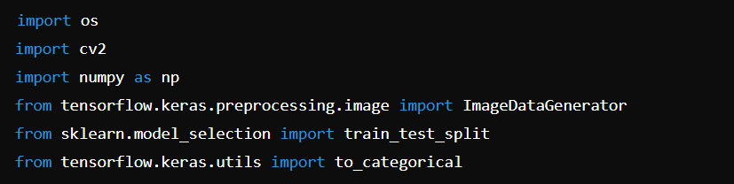
- Purpose: These are Python libraries and modules required for image processing, data manipulation, machine learning model training, and evaluation.
- Explanation:
  - os: Provides functions for interacting with the operating system, used here for directory and path operations.
  - cv2: OpenCV library for image processing, used to read and resize images.
  - numpy: Fundamental package for numerical computing in Python, used for array operations.
  - ImageDataGenerator: Part of Keras for real-time data augmentation and batch data generation during model training.
  - train_test_split: From scikit-learn, used to split the dataset into training and validation sets.
  - to_categorical: Converts class vector (integers) to binary class matrix (one-hot encoding).

[2] Define Paths:
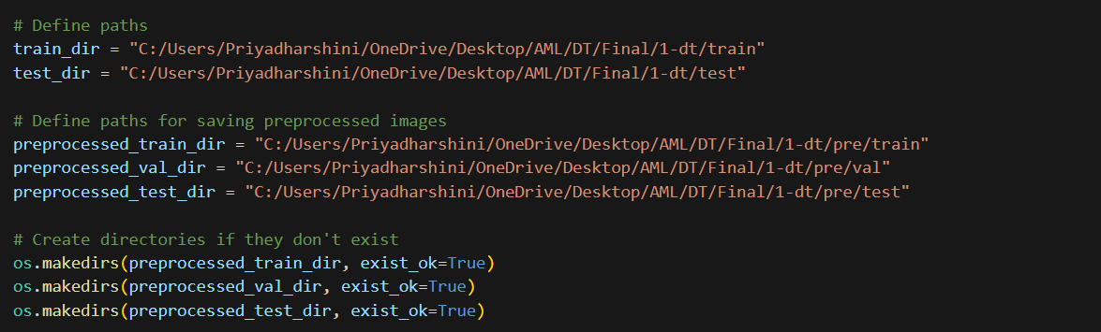
- Purpose: Specifies the directories where training and testing images are stored.
- Explanation: These variables define the paths to the original training (train_dir) and test (test_dir) image directories.
- preprocessed_train_dir, preprocessed_val_dir, and preprocessed_test_dir are directories where preprocessed images will be saved.
[3] Create Directories
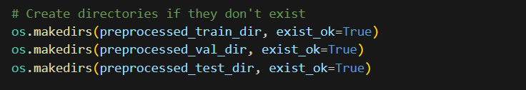

- Explanation:
  - Ensure that directories for saving preprocessed images exist. If they don't (exist_ok=True), create them.

[4] Load Images from Folder Function:
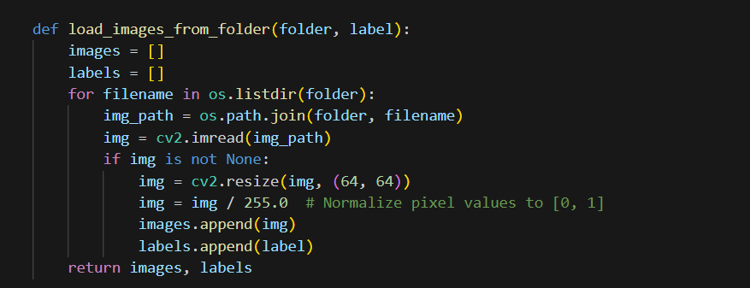
- Purpose: Loads images from a specified folder and assigns a label to each image.
- Explanation:
  - folder: Directory path containing the images.
  - label: Numeric label assigned to images (0 for closed eyes, 1 for open eyes).
  - Reads each image, resizes it to 64x64 pixels, normalizes pixel values, and appends it to images along with its corresponding label.

[5] Load Data Function:
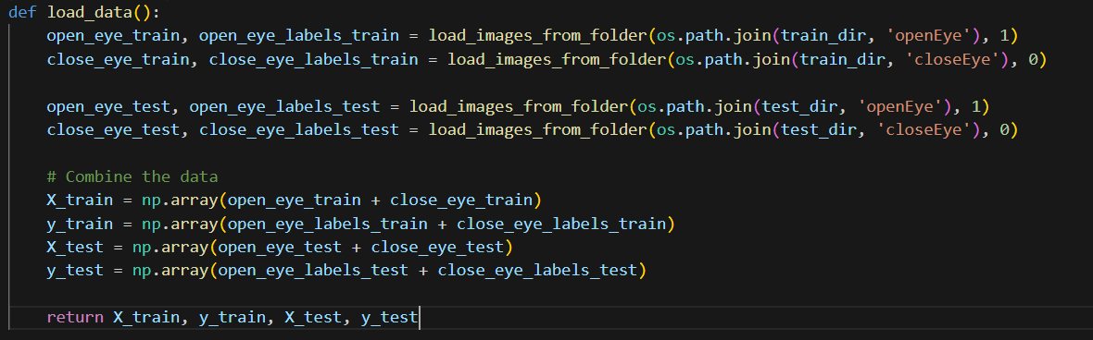
- Purpose: Loads and prepares training and testing datasets using the load_images_from_folder function.
- Explanation:
  - Calls load_images_from_folder function for both training and testing directories (openEye and closeEye).
  - Combines images and their labels into X_train, y_train, X_test, and y_test arrays.

[6] Split Data into Training and Validation Sets
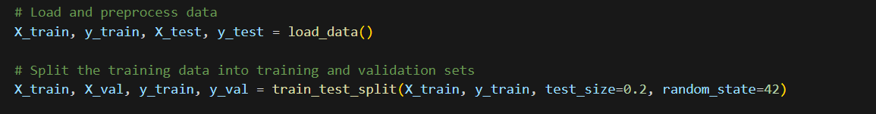
- Explanation:
  - train_test_split function splits X_train and y_train into training and validation sets (X_train, y_train, X_val, y_val).
  - test_size=0.2 indicates that 20% of the data will be used for validation.
  - random_state=42 ensures reproducibility of the split.

[7] Convert Labels to Categorical (One-Hot Encoding)
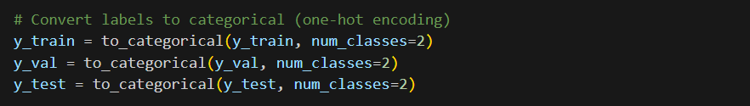
- Explanation:
  - to_categorical converts integer labels (y_train, y_val, y_test) to categorical matrices.
  - num_classes=2 specifies the number of classes for one-hot encoding (openEye and closeEye).

[8] Save Pre-processed Images
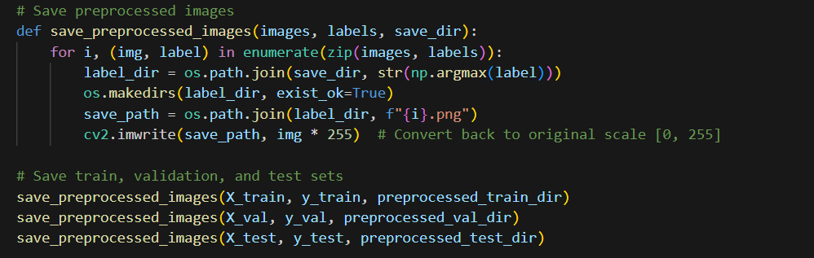
- Explanation:
  - save_preprocessed_images function saves preprocessed images (X_train, X_val, X_test) into directories (preprocessed_train_dir, preprocessed_val_dir, preprocessed_test_dir).
  - Images are saved under subdirectories based on their class label (0 for closeEye, 1 for openEye).

[9] Data Augmentation:
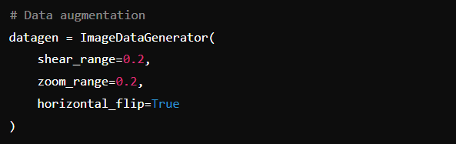
- Purpose: Augments the training data to improve model generalization.
- Explanation:
  - ImageDataGenerator: Generates batches of augmented data during model training.
  - Parameters (shear_range, zoom_range, horizontal_flip) specify transformations applied to training images to create new, altered images.

[10] Data Generators:
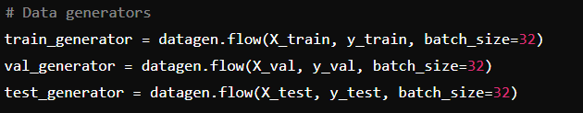
- Purpose: Provides a continuous flow of augmented data batches during model training and evaluation.
- Explanation:
  - flow: Generates batches of augmented data from X_train, y_train, X_val, y_val, X_test, y_test based on specified batch size (32 in this case).
  - These generators are used with Keras models to feed batches of data during training and evaluation.

[11] Print Shapes and Verify Data Augmentation:
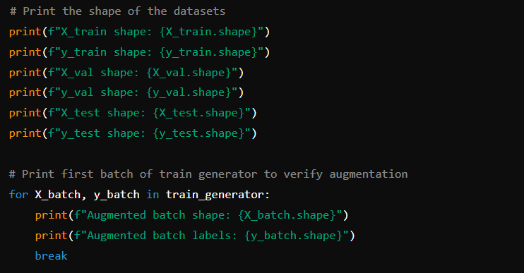
- Purpose: Confirms the shapes of the prepared datasets and verifies data augmentation.
- Explanation:
  - Prints the shapes (X_train, y_train, X_val, y_val, X_test, y_test) to ensure correct dimensions.
  - Iterates through the first batch of train_generator to verify that data augmentation (shear, zoom, flip) is applied correctly.

OUTPUT: [PRE-PROCESSING]
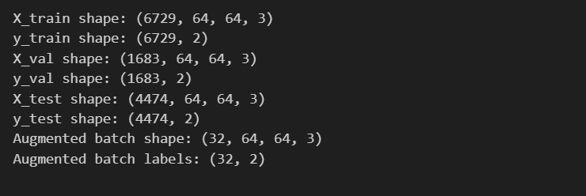

CHECKING THE NUMBER OF CLASSES [TO CHECK THE PRE-PRCESSING STEP DONE OR NOT]
[1] Importing ImageDataGenerator
This line imports the ImageDataGenerator class from TensorFlow Keras, which is used for real-time data augmentation during training and for loading images in batches.

[2] Setting up Data Generators
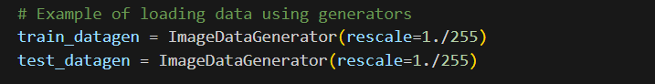
- train_datagen and test_datagen are instances of ImageDataGenerator.
- rescale=1./255 normalizes pixel values of the images to the range [0, 1]. This is a common preprocessing step to standardize input data for neural networks.

[3] Creating Data Generators
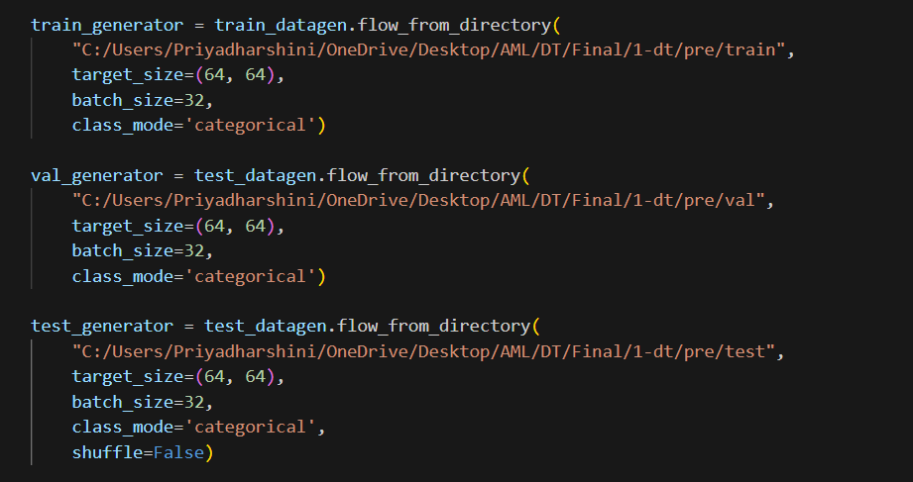
- flow_from_directory method generates batches of augmented data from images stored in a directory.
- val_generator and test_generator are similar to train_generator but load images from validation and test directories respectively.
- "C:/Users/Priyadharshini/OneDrive/Desktop/AML/DT/Final/1-dt/pre/train" specifies the path to the directory containing training images.
- target_size=(64, 64) resizes all images to 64x64 pixels during loading.
- batch_size=32 specifies the number of images in each batch.
- class_mode='categorical' indicates that the labels are represented as categorical vectors (one-hot encoded).
- shuffle=False for test_generator ensures that the order of images remains consistent during testing, which is important for evaluating model performance.

[4] Printing Generator Information
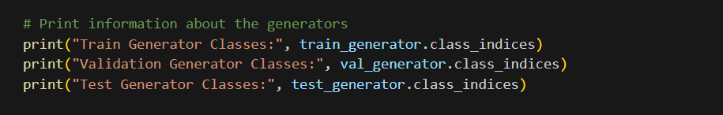
- class_indices attribute provides a dictionary mapping class names to their corresponding indices.
- This information is useful for interpreting model predictions and evaluating classification performance.

OUTPUT:
