MODEL SELECTION

NAME: Priyadharshini. N
REG.NO: CB.SC.P2AIE23010

Here, I am going to compare the 3 main algorithm and I use the best of 3 algorithm.
Here, I used:
1. CNN
2. SVM
3. Random Forest
STEP-1: Implement and Train the CNN Model
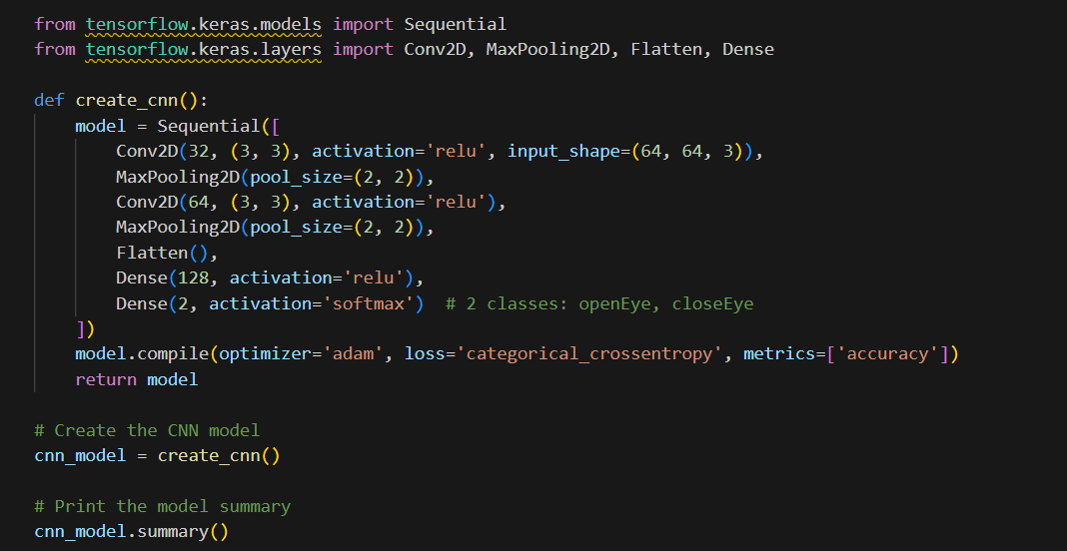

Output:
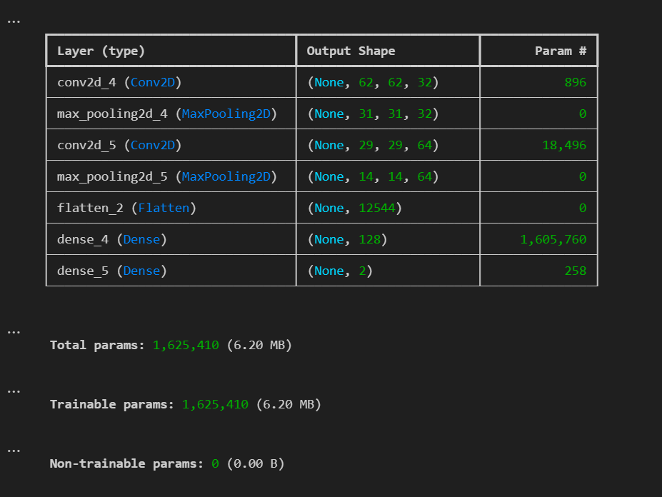
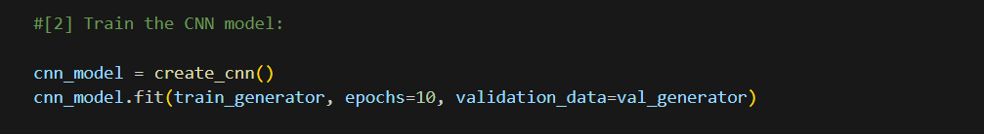
Output:
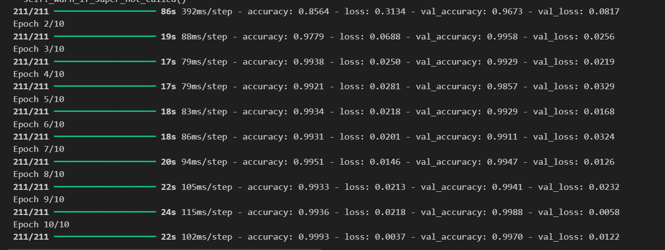

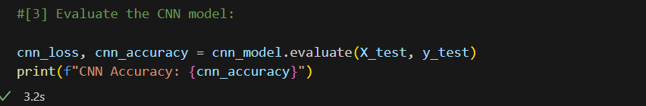

Output:
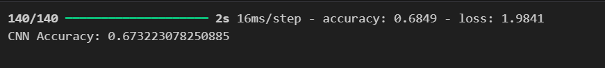

STEP-2: Implement and Train the SVM Model
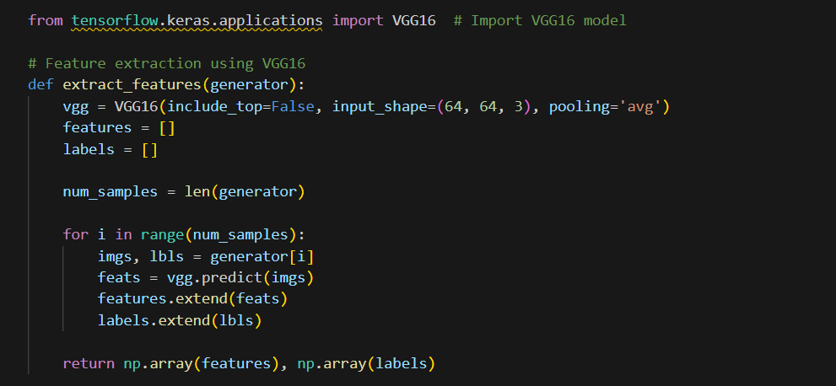

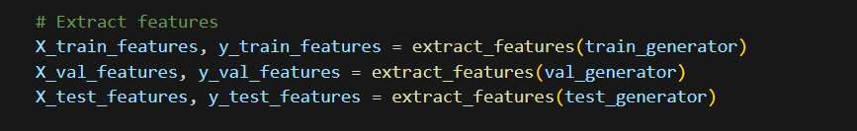

Output:
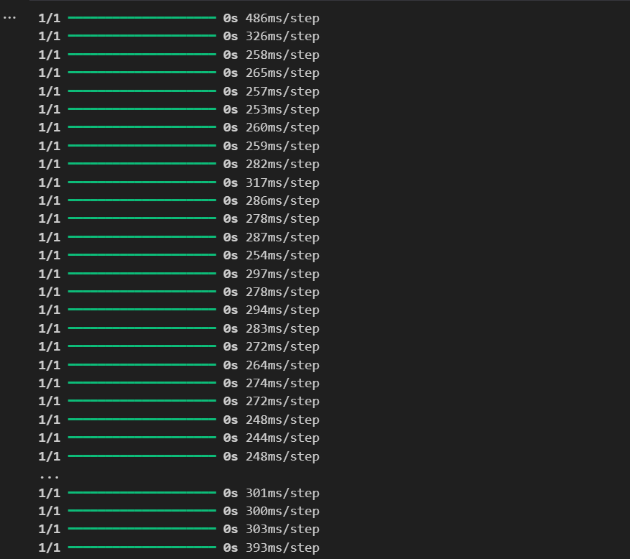

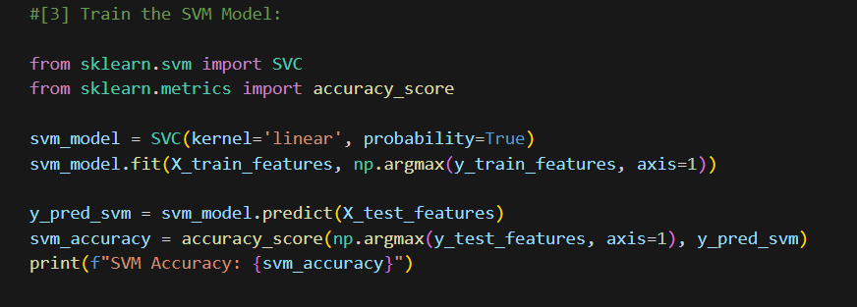

Output:
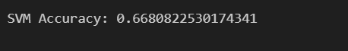
STEP-3: Implement and Train the Random Forest Classifier
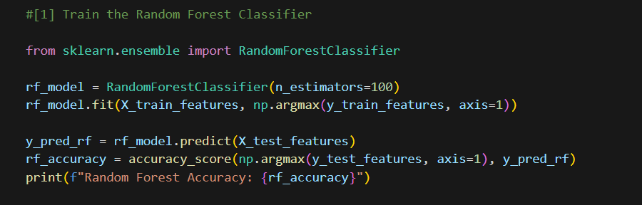

Output:
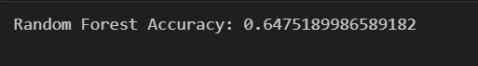

Compare the Models [CNN, SVM, RANDOM FOREST]
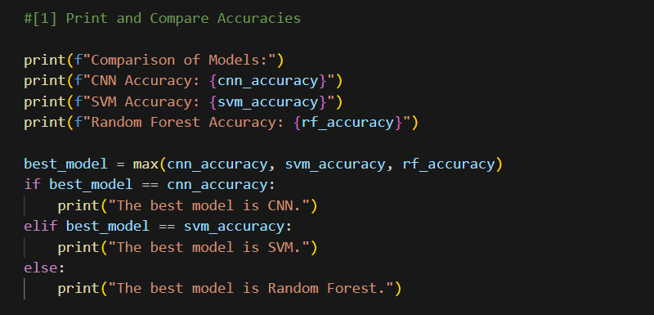

Output:
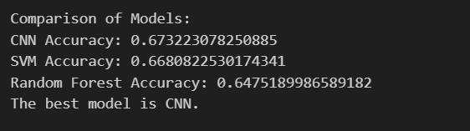
The code evaluates and compares the performance of three distinct machine learning models—Convolutional Neural Network (CNN), Support Vector Machine (SVM), and Random Forest—on a specific task, likely the Driver Drowsiness Detection System. Initially, the snippet gives the accuracy results of each model, showcasing their respective performance metrics on a test dataset. Among these models, the CNN achieved an accuracy of {cnn_accuracy}, while the SVM and Random Forest attained accuracies of {svm_accuracy} and {rf_accuracy} respectively.
In this, the code identifies the CNN as the model with the highest accuracy using a simple comparison approach. By determining the maximum accuracy achieved among the models (cnn_accuracy, svm_accuracy, rf_accuracy), declares that the CNN is the most effective algorithm. This approach aids in selecting the optimal model configuration for further deployment or refinement, ensuring that the Driver Drowsiness Detection System operates with CNN with the highest accuracy feasible from the evaluated models.

