MODEL EVALUTION
NAME: Priyadharshini. N
REG.NO: CB.SC.P2AIE23010
Imports:
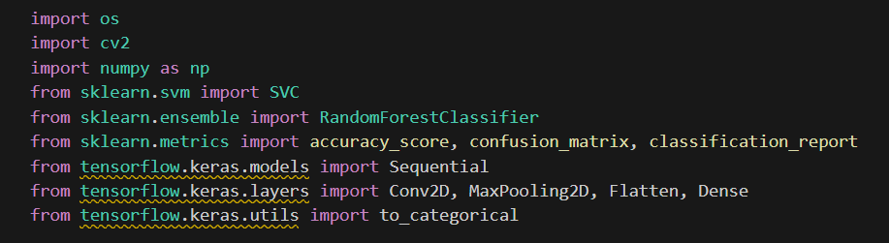
Define Paths:
Load Images from Folder:
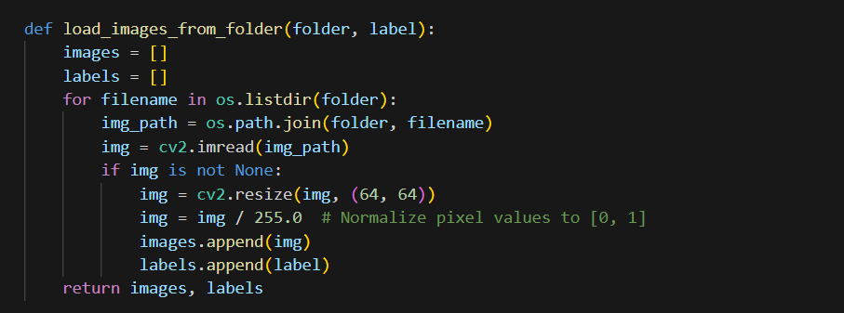
Load Data:
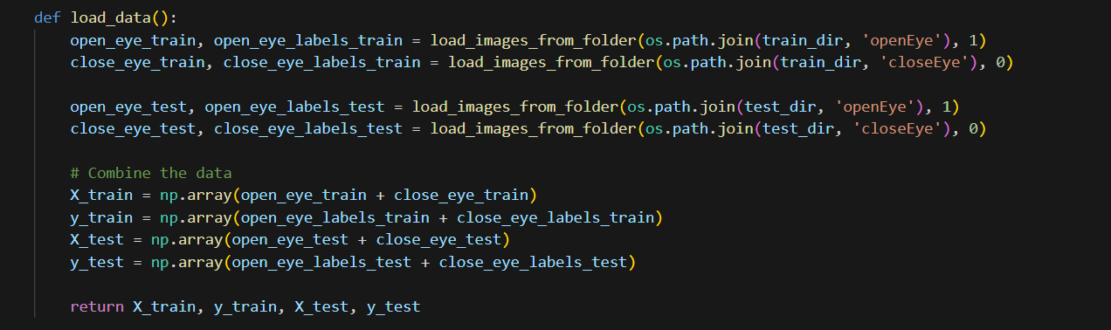
Preprocess Labels:
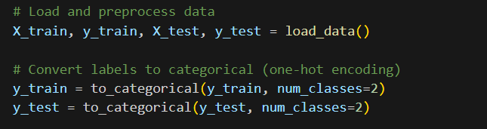
Define CNN Model:
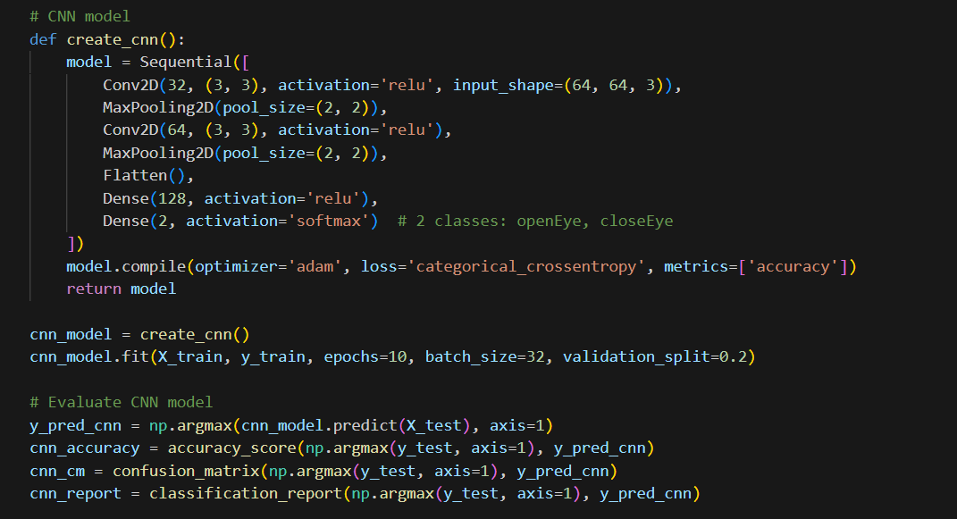
Define SVM Model:
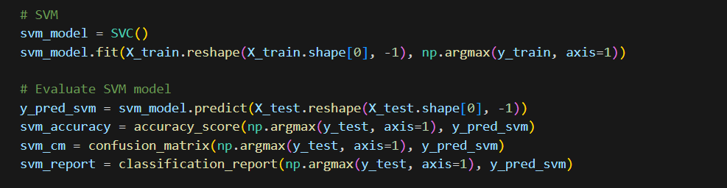
Define Random Forest Model:
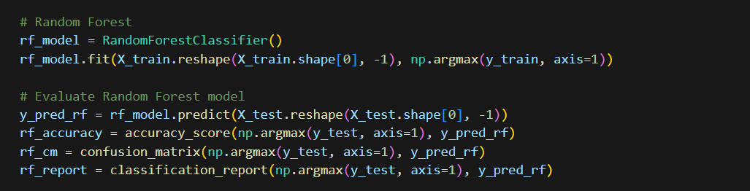

Print the classification Model:
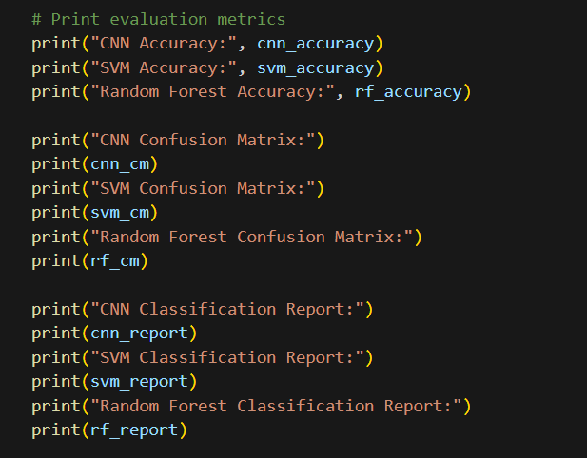

OUTPUT:
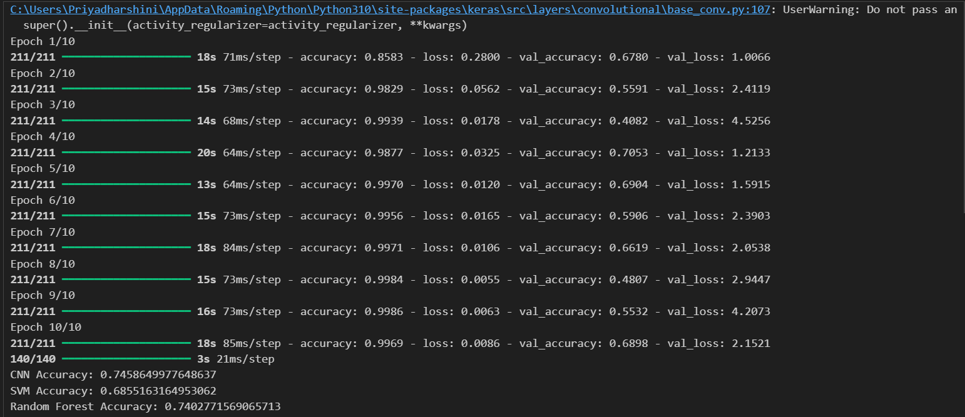

CONFUSION MATRIX:
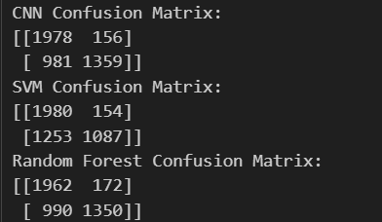

CNN
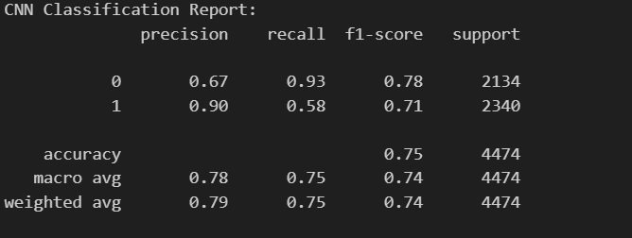

SVM
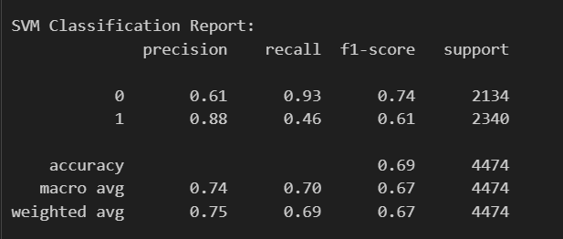

Random Forest:
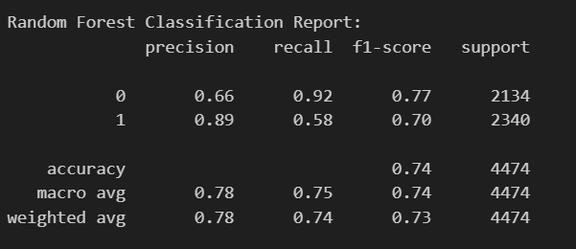

EXPLAINATION:
- Importing Libraries: The code begins by importing necessary libraries such as os for directory operations, cv2 for image processing, numpy for numerical operations, and various modules from sklearn for machine learning models (SVC, RandomForestClassifier) and metrics (accuracy_score, confusion_matrix, classification_report). It also imports components from tensorflow.keras for building a Convolutional Neural Network (CNN).
- Defining Paths and Loading Functions:
  - train_dir and test_dir are defined to specify paths where the training and testing images are stored.
  - load_images_from_folder function loads images from a specified directory (folder) and assigns them a given label (label). Images are resized to 64x64 pixels and normalized to the range [0, 1].
  - load_data function uses load_images_from_folder to load both training and testing data, separating images of "open eyes" and "closed eyes". It combines these into arrays X_train, y_train, X_test, and y_test.
- Preprocessing:
  - to_categorical is used to convert categorical labels (y_train and y_test) into one-hot encoded vectors, which are required for training neural networks.
- Creating a CNN Model:
  - create_cnn function defines a Sequential model using TensorFlow Keras. It consists of convolutional layers (Conv2D), max pooling layers (MaxPooling2D), and fully connected layers (Dense). The model is compiled with the Adam optimizer, categorical crossentropy loss function, and accuracy metric.
- Training the CNN Model:
  - The cnn_model is created using create_cnn and trained on X_train and y_train for 10 epochs with a batch size of 32. Validation data (X_val, y_val) is automatically split from X_train during training.
- Evaluating the CNN Model:
  - Predictions (y_pred_cnn) are made on X_test using the trained cnn_model. Metrics such as accuracy (cnn_accuracy), confusion matrix (cnn_cm), and classification report (cnn_report) are computed using accuracy_score, confusion_matrix, and classification_report.
- Training and Evaluating SVM and Random Forest Models:
  - SVM (svm_model) and Random Forest (rf_model) models are instantiated and trained using the flattened version of X_train. Predictions are made on X_test, and evaluation metrics (accuracy, confusion matrix, classification report) are computed similarly to the CNN model.
- Printing Evaluation Metrics:
  - Finally, the accuracy scores and detailed evaluation metrics (confusion matrix and classification report) for all three models (CNN, SVM, Random Forest) are printed to compare their performance on the test set.

