MODEL DEPLOYMENT
NAME: Priyadharshini. N
REG.NO: CB.SC.P2AIE23010

In this project involves creating a web application that detects the driver’s drowsiness detection (open or closed) in a video using a pre-trained Convolutional Neural Network (CNN). The application consists of two main pages: one for uploading a video and another for playing the video with real-time eye state detection.
Technology Stack
- Flask: A lightweight web framework for Python used to create the web application.
- OpenCV: An open-source computer vision library used for video processing and Haar cascades for face and eye detection.
- TensorFlow: An open-source machine learning framework used to load and run the pre-trained CNN model.
- Pygame: A set of Python modules designed for writing video games, used here to play an alarm sound.
- HTML: Used for creating the web pages.
- CSS: Used for basic styling of the web pages.

Steps to Create the Application
- Install Necessary Libraries: Install the required libraries using pip
- Pip install numpy
- Pip install pygame
- Pip install tensorflow
- Pip install opencv-python
- Pip install flask

- Setup Flask Application: Create a main application file app.py
from flask import Flask, render_template, request, redirect, url_for, Response
import cv2
import numpy as np
import tensorflow as tf
from pygame import mixer
import os

app = Flask(__name__)
app.config['UPLOAD_FOLDER'] = 'uploads/'

# Ensure the upload folder exists
if not os.path.exists(app.config['UPLOAD_FOLDER']):
os.makedirs(app.config['UPLOAD_FOLDER'])

# Initialize Pygame mixer for sound
mixer.init()
sound = mixer.Sound("C:/Users/Priyadharshini/OneDrive/Desktop/AML/New folder/alarm.wav")

# Load pre-trained Haar cascades for face and eyes detection
face_cascade = cv2.CascadeClassifier("C:/Users/Priyadharshini/OneDrive/Desktop/AML/New folder/haarcascade_frontalface_alt.xml")
leye_cascade = cv2.CascadeClassifier("C:/Users/Priyadharshini/OneDrive/Desktop/AML/New folder/haarcascade_lefteye_2splits.xml")
reye_cascade = cv2.CascadeClassifier("C:/Users/Priyadharshini/OneDrive/Desktop/AML/New folder/haarcascade_righteye_2splits.xml")

# Load CNN model for eye state classification
model = tf.keras.models.load_model('C:/Users/Priyadharshini/OneDrive/Desktop/AML/New folder/cnn_model.h5')

lbl = ['Close', 'Open']
score = 0
thicc = 2

video_path = ""

@app.route('/')
def index():
return render_template('index.html')

@app.route('/upload', methods=['GET', 'POST'])
def upload():
if request.method == 'POST':
if 'file' not in request.files:
return redirect(request.url)
file = request.files['file']
if file.filename == '':
return redirect(request.url)
if file:
global video_path
video_path = os.path.join(app.config['UPLOAD_FOLDER'], file.filename)
file.save(video_path)
return redirect(url_for('play'))
return render_template('upload.html')

@app.route('/play')
def play():
return render_template('play.html')

def generate_frames():
global score
cap = cv2.VideoCapture(video_path)

while True:
ret, frame = cap.read()
if not ret:
break

height, width = frame.shape[:2]
gray = cv2.cvtColor(frame, cv2.COLOR_BGR2GRAY)
faces = face_cascade.detectMultiScale(gray, minNeighbors=5, scaleFactor=1.1, minSize=(25, 25))

for (x, y, w, h) in faces:
cv2.rectangle(frame, (x, y), (x+w, y+h), (100, 100, 100), 1)
roi_gray = gray[y:y+h, x:x+w]
roi_color = frame[y:y+h, x:x+w]

left_eye = leye_cascade.detectMultiScale(roi_gray)
right_eye = reye_cascade.detectMultiScale(roi_gray)

for (lex, ley, lew, leh) in left_eye:
l_eye = roi_color[ley:ley+leh, lex:lex+lew]
l_eye_gray = roi_gray[ley:ley+leh, lex:lex+lew]
l_eye_rgb_resized = cv2.resize(l_eye_gray, (64, 64))
l_eye_rgb_resized = cv2.cvtColor(l_eye_rgb_resized, cv2.COLOR_GRAY2RGB)
l_eye_rgb_resized = l_eye_rgb_resized.astype(np.float32) / 255.0
l_eye_input = np.expand_dims(l_eye_rgb_resized, axis=0)
lpred = np.argmax(model.predict(l_eye_input), axis=-1)[0]

lbl_text = 'Open' if lpred == 1 else 'Closed'
cv2.putText(frame, lbl_text, (x + lex, y + ley), cv2.FONT_HERSHEY_SIMPLEX, 0.5, (0, 255, 0), 1)

if lpred == 0:
score += 1
else:
score -= 1

cv2.putText(frame, 'Score: ' + str(score), (10, height - 20), cv2.FONT_HERSHEY_SIMPLEX, 0.7, (0, 0, 255), 2)
cv2.rectangle(frame, (x, y), (x+w, y+h), (255, 0, 0), thicc)

ret, buffer = cv2.imencode('.jpg', frame)
frame = buffer.tobytes()
yield (b'--frame\r\n'
b'Content-Type: image/jpeg\r\n\r\n' + frame + b'\r\n')

@app.route('/video_feed')
def video_feed():
return Response(generate_frames(), mimetype='multipart/x-mixed-replace; boundary=frame')

if __name__ == "__main__":
app.run(debug=True)

- Create HTML Templates: Create an index.html template for the landing page

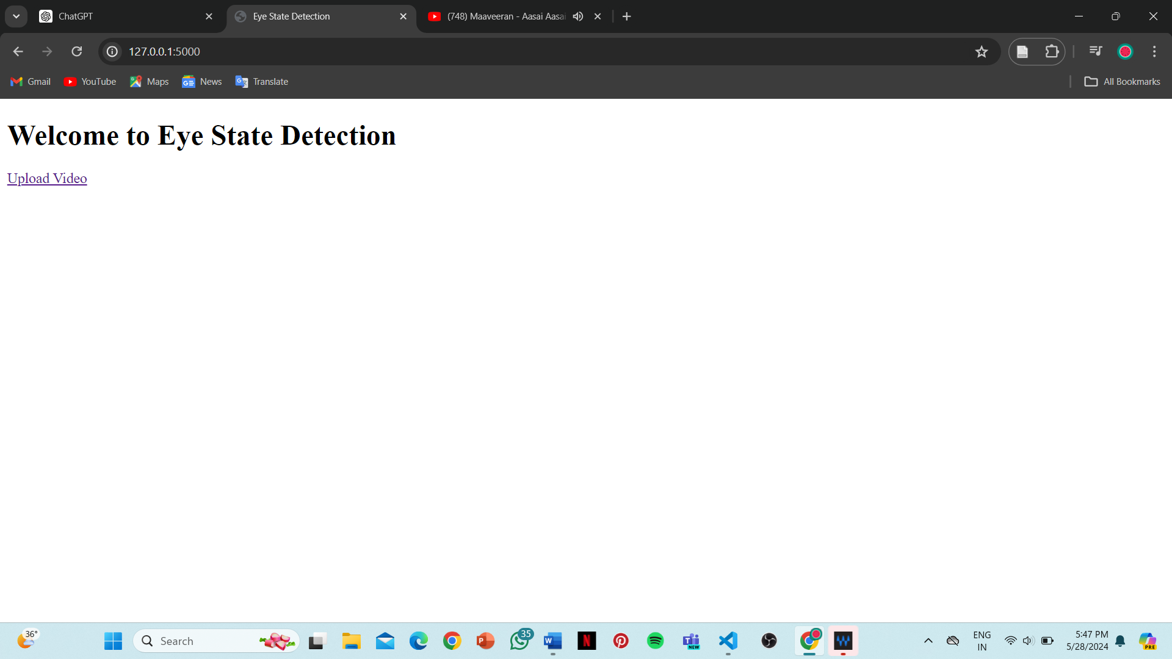
<!DOCTYPE html>
<html lang="en">
<head>
<meta charset="UTF-8">
<meta name="viewport" content="width=device-width, initial-scale=1.0">
<title>Eye State Detection</title>
</head>
<body>
<h1>Welcome to Eye State Detection</h1>
<a href="{{ url_for('upload') }}">Upload Video</a>
</body>
</html>

- Create HTML Templates: Create an upload.html template for the video upload page
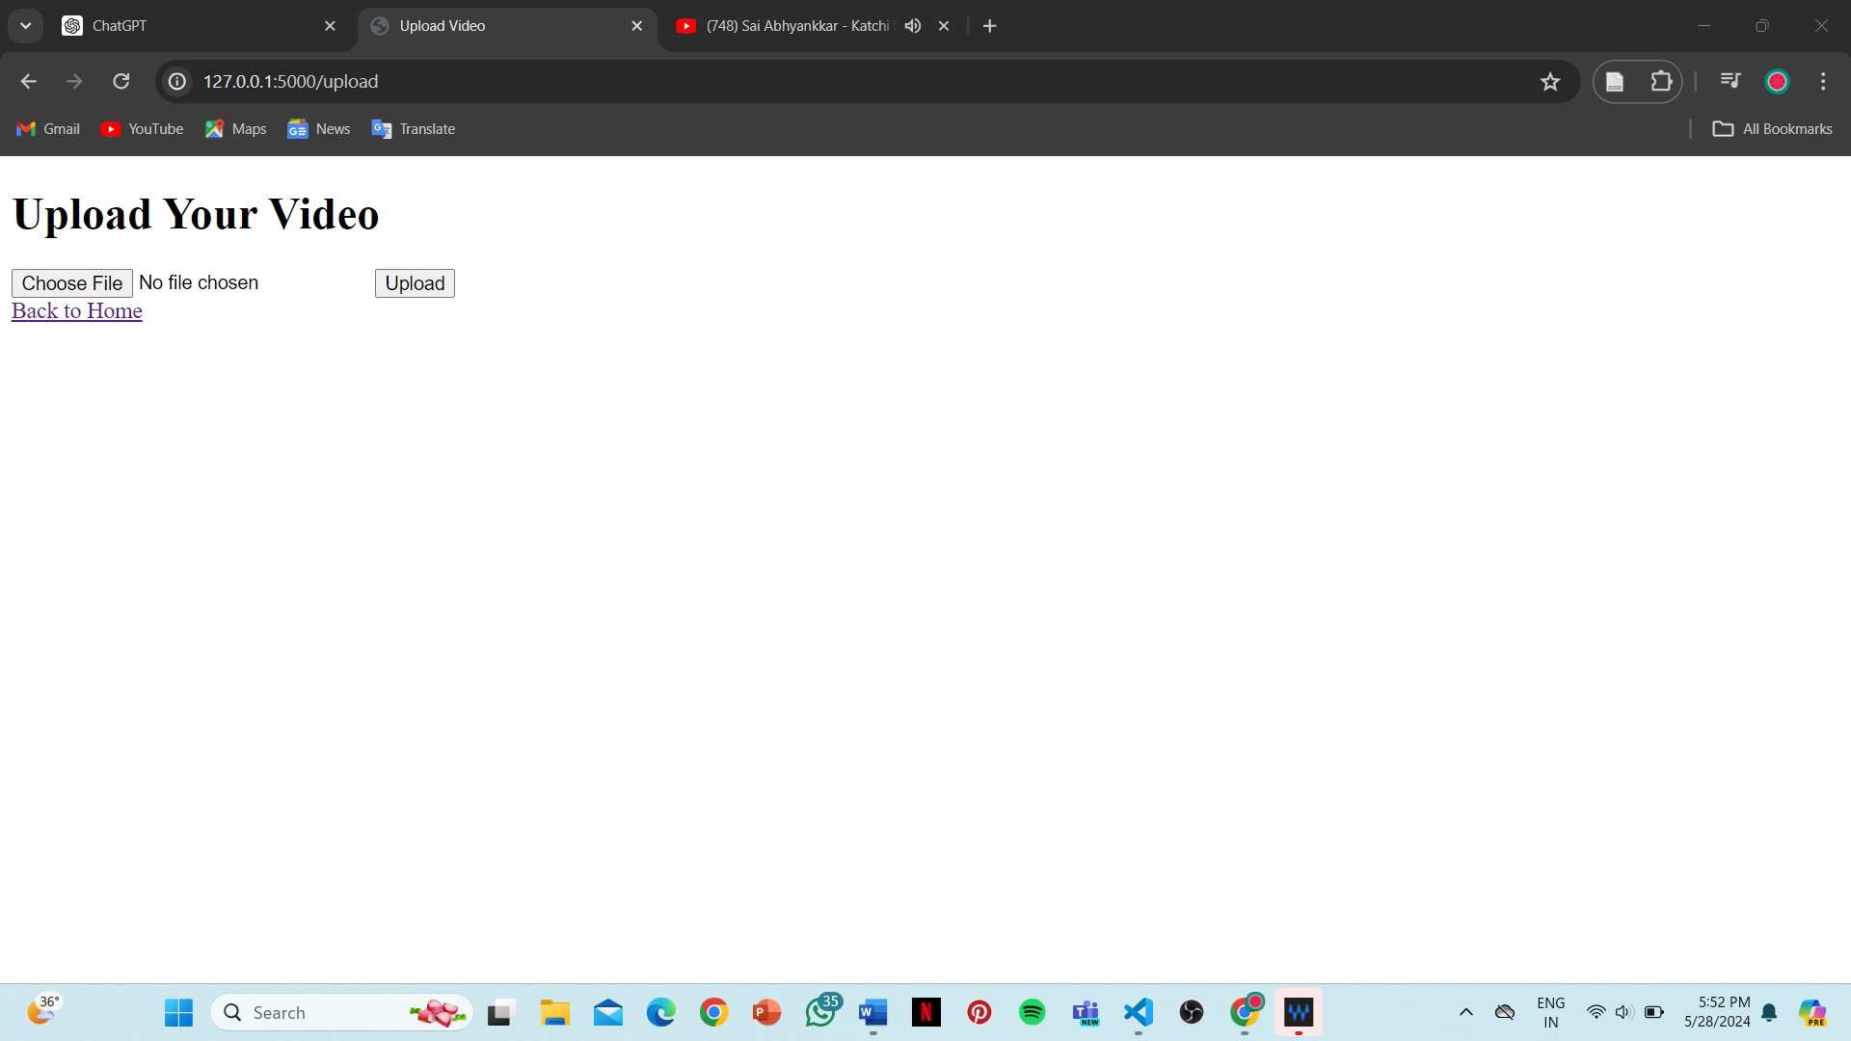

<!DOCTYPE html>
<html lang="en">
<head>
<meta charset="UTF-8">
<meta name="viewport" content="width=device-width, initial-scale=1.0">
<title>Upload Video</title>
</head>
<body>
<h1>Upload Your Video</h1>
<form action="{{ url_for('upload') }}" method="post" enctype="multipart/form-data">
<input type="file" name="file">
<input type="submit" value="Upload">
</form>
<a href="{{ url_for('index') }}">Back to Home</a>
</body>
</html>

- Create HTML Templates: Create a play.html template for the video playback page
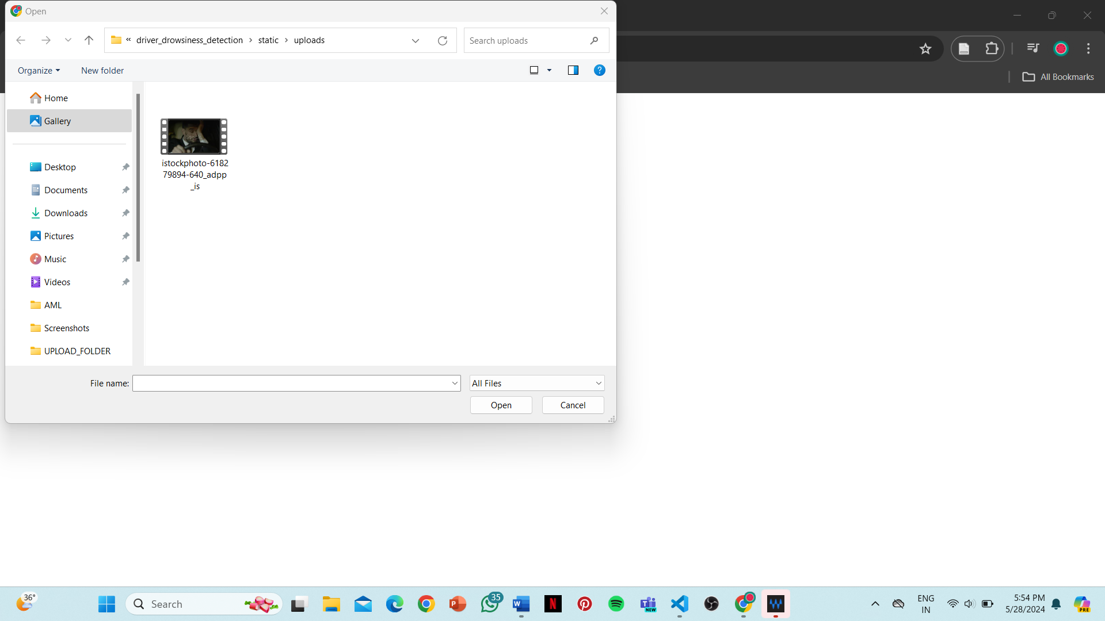
- On the landing page, click the "Upload Video" link.
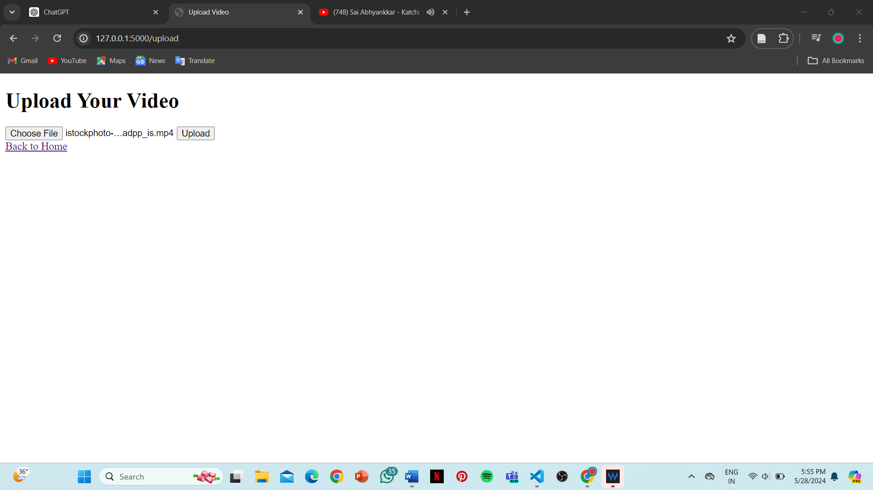
- On the upload page, upload your video file and submit.

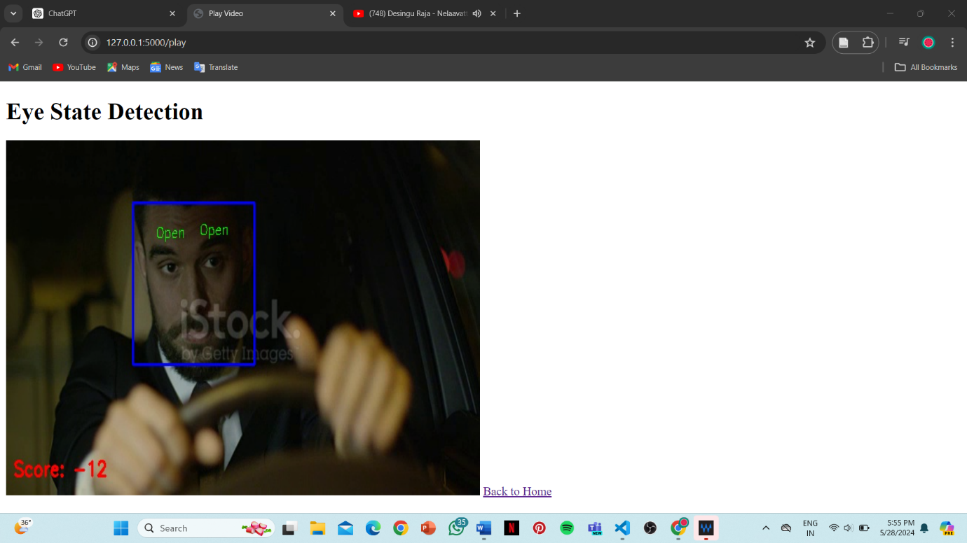

- After uploading, you will be redirected to the play page where you can see the video with the eye state detection output displayed in real-time.

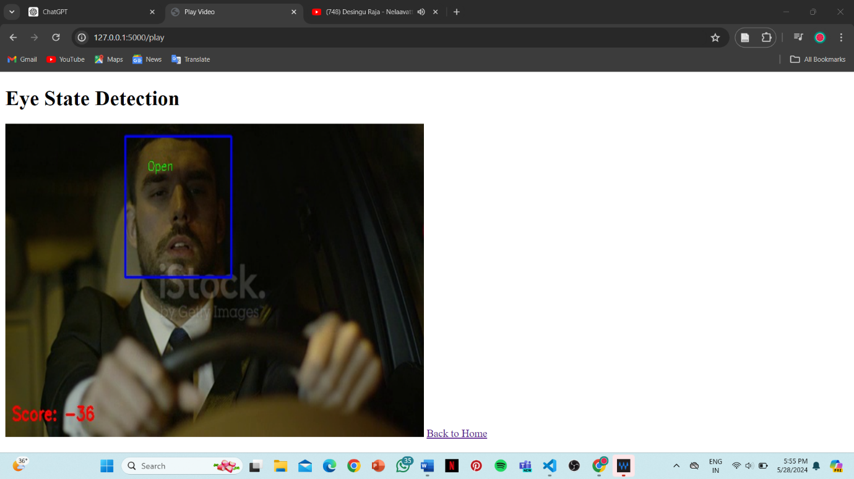

- Run the Application:
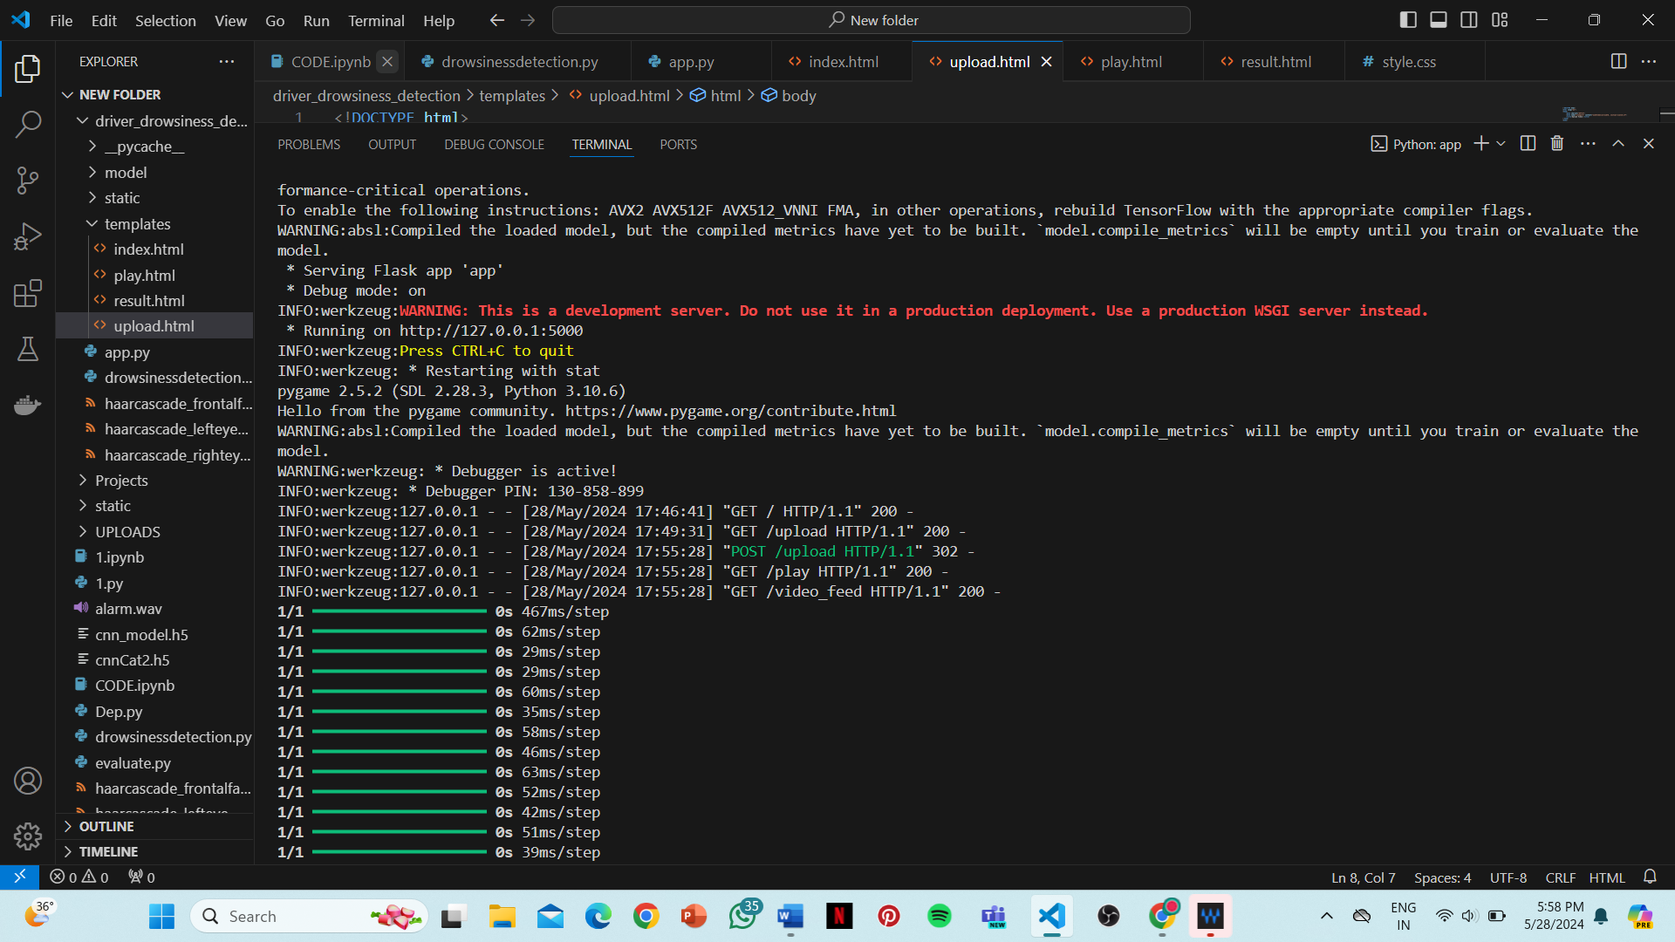

- Open a web browser and go to http://127.0.0.1:5000/.
- On the landing page, click the "Upload Video" link.
- On the upload page, upload your video file and submit.
- After uploading, you will be redirected to the play page where you can see the video with the eye state detection output displayed in real-time.

