RESTAURANT RATING

PREDICTION

Revision Number: 1.0

Last date of revision: 08/07/2022

The home page of this project looks similar to this :

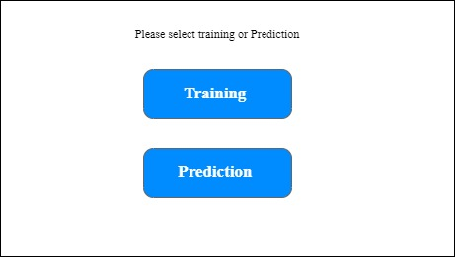

When the user choose training , training of the model takes place and the result completed message will be showed to the user

When user choose Prediction, the following page gets loaded :

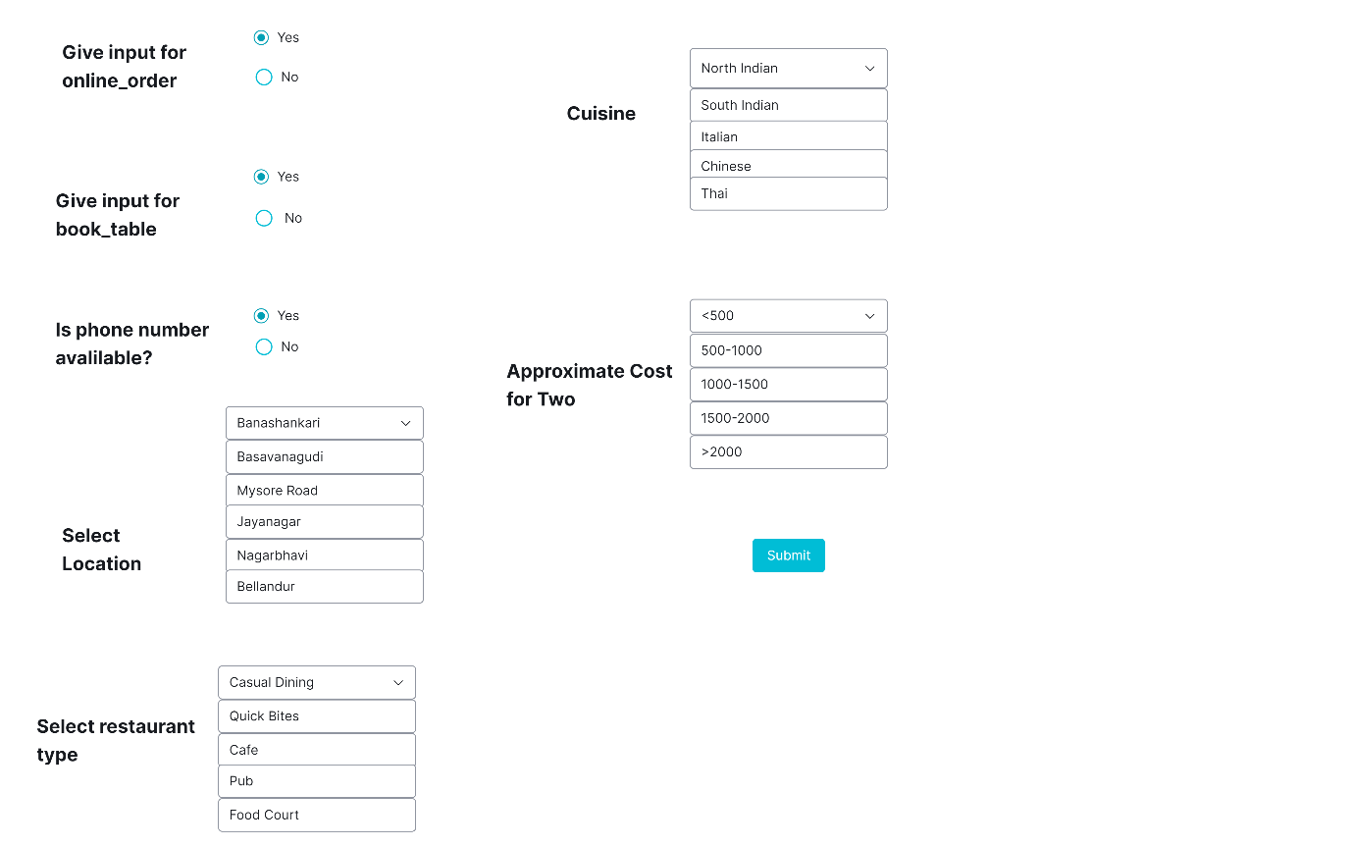

After clicking submit, the user can see the prediction for the input which they give :

The result page looks something like this :

