RESTAURANT RATING PREDICTION

Revision Number: 1.0

Last date of revision: 07/07/2022

# Document Version Control

|  |  |  |  |
| --- | --- | --- | --- |
| Date Issued | Version | Description | Author |
| 07/07/2022 | 1 | Initial HLD — V1.0 | Priya Ganesan |
|  |  |  |  |
|  |  |  |  |
|  |  |  |  |
|  |  |  |  |
|  |  |  |  |
|  |  |  |  |

Contents

Document Version Control 2

Abstract 2

1. Introduction 3

1.1 Why this High-Level Design Document? 3

1.2 Scope 3

2. General Description 3

2.1 Product Perspective 3

2.2 Problem statement 3

2.3 Proposed solution 3

2.4 Further improvements 4

2.5 Database 4

2.6 Data Requirements 4

2.7 Tools used 5

2.8 Constraints 5

2.9 Assumptions 5

3. Design Details 6

3.1 Process Flow 6

3.2 Model Training and Evaluation 6

3.3 Event log 7

3.4 Error Handling 7

3.5 Performance 7

3.6 Reusability 7

3.7 Deployment 7

4. Conclusion 8

# 

# Abstract

Food is something which everyone likes and look forward to try new cuisines, new places. Through food delivery app like Swiggy, Zomato etc, we are able to taste so many different types of food sitting in our home. After tasting the food, one thing we all do is giving rating to the restaurant so that it helps other people to try the options which we tried. The project is based on this and it will be useful for a new person who is thinking of starting a food business. When a person thinks of starting a new restaurant, there will be multiple doubts, he might have like location, cuisine, type of the restaurant, cost and everything. This model helps to solve the issue by predicting the rating when a person thinks of starting a new restaurant. The person can give different options and check which will improve the rating. This can also be used for the user who is already running the restaurant but wanted to improve the rating.

# Introduction

## 1.1 Why this High-Level Design Document?

This document acts as a reference manual in a high level. The purpose of this High Level Design Document is to add the details of the project so that everyone will be in the same page and avoid the contradictions while coding.

## 1.2 Scope

All the hardware and software requirements for the project. This document includes high level architecture diagram, hardware requirement, software requirement, database details and application flow

# General Description

## 2.1 Product Perspective

Restaurant Rating Prediction is a e-commerce machine learning project which predicts the rating of a restaurant and help the user to give insights about the location, cuisine, type of restaurant etc

## 2.2 Problem statement

To create regression model to:

* + Predict the rating of the restaurant with user input
  + The prediction can help the user to decide the location, cuisine and other data

## 2.3 Proposed solution

This solution predicts the rating of a restaurant with the given input, and this can be insights for user who is opening a new restaurant. The UI allows the user to select different inputs and based on those inputs, the rating is given to the user. The default training is made from Zomato data Bengaluru.

## 

## 2.4 Further improvements

By default model gives prediction for Bengaluru region restaurants. If the user wants prediction for other regions, the user need to pass the data, train it and then the model can be used for prediction for those regions.

## 2.5 Database

The database used in this case is Cassandra DB. Cassandra is a NOSQL database and each record for the training and for the prediction is stored in the DB for future reference. If re-training of the model is required , we can used the data from the same DB and re-train the data according to Business perspective. The data which is given by the user is also stored in DB and the prediction which has been given to the customer is also stored in the same DB for future reference.

## 2.6 Data Requirements

Zomato data has been used for building this prediction system. The data should contain the following information :

1. URL from which the data is crawled
2. Address of the particular restaurant
3. Name of the restaurant
4. Whether online order facility available in this restaurant
5. Whether booking table facility available in this restaurant
6. Number of votes of the restaurant
7. Phone number of the restaurant
8. Location of the restaurant
9. Type of the restaurant
10. The liked dishes in the restaurant
11. Cuisines available in that particular restaurant
12. Approximate cost for 2 people
13. List of the reviews
14. Menu
15. City
16. Rating

We need to predict the rating of a restaurant based on the details given by the customer

## 2.7 Tools used

Python programming language and framework such as Numpy, Pandas, Scikit-learn, Matplotlib are used to built this model



* Pycharm is used as IDE
* For visualization, Matplotlib and seaborn is used
* AWS is used for deployment of the model
* Cassandra is used as the database for the model
* Front end development is done using HTML/CSS
* Python flask is used for backend development
* GitHub is used as version contol system

## 2.8 Constraints

The training of the system is done with the restaurant running for years. But the prediction is done for not yet opened restaurant. So the prediction system should work well with newly opened restaurant and also for the restaurant which is yet to opened.

## 2.9 Assumptions

The predictive system will work well for all type of restaurant and gives close predictions so that user can get some good insights from the project

# Design Details

## 3.1 Process Flow

Below is the the process flow for the model

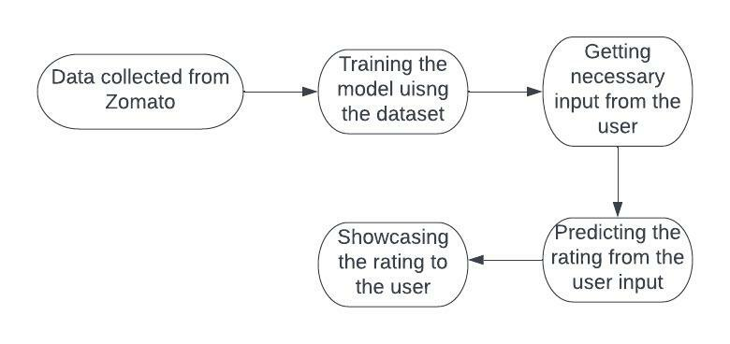

## 3.2 Model Training and Evaluation

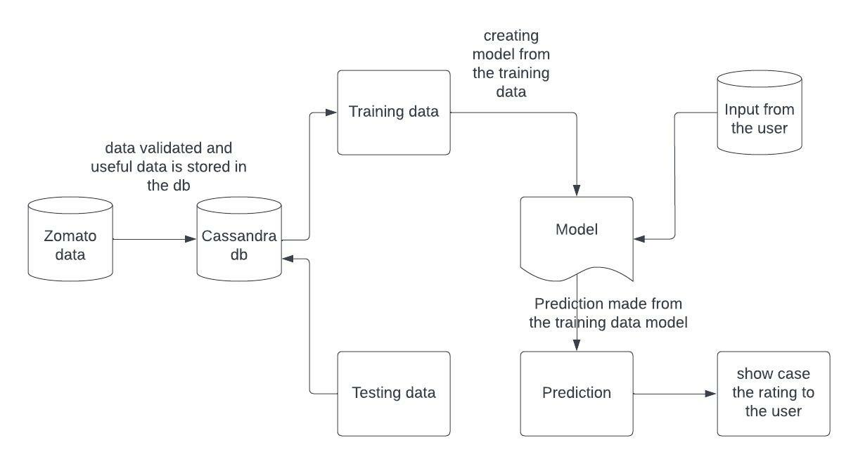

## 3.3 Event log

System will log each and every process so that it will be easy to check whether all the process are running as per expectation

1. Each and every step logging is required
2. We can choose the method of logging. Logging can be either file level logging or logging can be made using database
3. When there is any issue, we should be easily identify with the help of logs

## 3.4 Error Handling

If there is any error that occurs, the error should be explained in detail so that the customer can know the error and the support team can take care of the error

## 3.5 Performance

The Restaurant Rating Prediction should give very good accuracy so that it helps the user who thinks of creating his/own restaurant. This can also be used by the user who is already running the restaurant and wants to improve his rating. It gives suitable accuracy to improve the above mentioned points

## 3.6 Reusability

The same code can be also reused to train different region restaurant and it should be done with ease

## 3.7 Deployment

The deployment of this project is done in amazon web services

# 

# 4. Conclusion

This Restaurant Predictive model can be used to predict the rating and whenever someone thinks of opening a new restaurant, this model helps them in giving necessary insights needed for satisfying the customers. The user can also get their target audience and decide the location, cuisines through this project