**CHAPTER-1**

**INTODUCTION**

The current scenario point out that the role of using Robotic technology and Internet of things for the outbreak of Covid19 is very crucial and essential in hospital and societal sectors. This pandemic gave a huge disaster in all the countries leaving dangerous footprint for the next coming years. It is the time for engineers, scientists, and researchers to innovate new methodologies, concepts and ideas making the robots and IOT technology to stand in the front line to serve the virus affected people. As covid19 is a deadly disease like Ebola virus which affected many people lives all over the world. This created a need for developing new technology in the field of Robotics and IOT for serving people in various ways, as they are disinfectant to the coronavirus than human beings.

Today the entire world is facing a major epidemic with a wide spread of coronavirus originated from Wuhan, China. The majority of countries are under the lockdown facing a severe disaster of losing economy and people on a large scale. In order to reduce the severity of virus spread, there is huge need of deploying Robots and IOT technologies as they stand in the front line saving the human labor to get infected from the coronavirus as these are highly immune to coronavirus. In this view, different types of research and innovation works are to be carried out to safeguard the people and serve the corona affected patients. The main objectives of the study are: To know the evolution of virus. To get awareness about coronavirus. Use of Robotic and IoT technologies.

Artificial intelligence (AI), robotics, machine learning, and swarm technologies will provide the next phase of development of IoT applications. Robotics systems traditionally provide the programmable dimension to machines designed to be involved in labour intensive and repetitive work, as well as a rich set of technologies to make these machines sense their environment and act upon it, while artificial intelligence and machine learning allow/empower these machines to function using decision making and learning algorithms instead of programming. The combination of these scientific disciplines opens the developments of autonomous programmable systems, combining robotics and machine learning for designing robotic systems to be autonomous. Machine learning is part of an advanced state of intelligence using statistical pattern recognition, parametric/non-parametric algorithms, neural networks, recommender systems, swarm technologies etc. to perform autonomous tasks. In addition, the industrial IoT is a subset of the IoT, where edge devices, processing units and networks interact with their environments to generate data to improve processes [1]. It is in this area where autonomous functions and IoT can realistically allocate IoRT technology. The use of communication-centred robots using wireless communication and connectivity with sensors and other network resources has been a growing and converging trend in robotics. A connected or “networked robot” is a robotic device connected to a communications network such as the Internet or LAN. The network could be wired or wireless, and based on any of a variety of protocols such as TCP, UDP, or 802.11. Many new applications are now being developed ranging from automation to exploration [64]. IEEE Society of Robotics and Automation’s Technical Committee on Networked Robots [10] defines two subclasses of networked robots: • Tele-operated robots, where human supervisors send commands and receive feedback via the network. Such systems support research, education, and public awareness by making valuable resources accessible to broad audiences. • Autonomous robots, where robots and sensors exchange data via the network with minimum human intervention. In such systems, the sensor network extends the effective sensing range of the robots, allowing them to communicate with each other over long distances to coordinate their activity. The robots in turn can deploy, repair, and maintain the sensor network to increase its longevity, and utility. A common challenge in the two subclasses of networked robots is to develop a science base that connect communication for controlling and enabling new capabilities, normally a robot is a closed system(s) with high capacities and where upgrades in functionality and operation (remote and/or local) requires expertise and usually long maintenance periods and where usually there is no open interfaces nor open communication channels and this is a way to guarantee security and control of efficiency. Networked robots require wireless networks for sharing data among multiple robots, and to communicate with other, more powerful workstations used for computationally expensive and offline processing such as the creation of globally consistent maps of the robot’s environment. This connectivity has strong implications for the sharing of tasks among robots, e.g. allowing teleoperation, as well as for human-robot interaction (HRI) and for on-the-fly reprogramming and adaptation of the robots on the network [16]. The evolution of these systems has now reached the consumer market, for instance, to support remote meetings and as tele-presence health-care tools. Cloud robotic systems have also emerged, to overcome the limitations of networked robotics through the provision of elastic resources from cloud infrastructure [9], and to exploit shared knowledge repositories over the Internet, making robots able to share information and learn from each other.

**CHAPTER -2**

**LITERATURE REVIEW**

During the Ebola outbreak that began in 2014, the White house office of science and technology policy and National Science foundation, organized workshops to identify various ways in which robots could make a difference. Guang-zhong yang, [1] dean of the institute of medical robotics at Shanghai Jiao Tong University, said during the epidemic, we really need to ensure that we have a global orchestrated sustainable approach to robotics research. Robots could occupy the place of health workers in certain circumstances, like administering tests who are infected with coronavirus and silent infection is the biggest problem. It helps that robots don’t get sick and unless they run out of power, they do not sleep-Yang said. Russel Taylor, a roboticist at johns Hopkins University said sending a remotely operated robot to interact with the patient instead could dramatically reduce the risk. After all, robots are immune to biological pathogens and can be efficiently disinfected with harsh chemicals. In this scenario, engineers would not design a robot specifically for the COVID19 pandemic but the trick is to find solutions that can be broadly commercialized for the next system in the ways that they are economical to have around.

Bill Smart,[1] a roboticist at Oregon State University, explained “you’re not directly interacting with the patients where it could go really wrong if the robots breaks, and you’re also not denying the patient human contact. He also said robots could still help minimize the risk for front line medical staffers, use of drones by IOT to transport medicine within the hospitals or using robots to deliver meals. Robin Murphy, a roboticist at Texas A&M University, said today investing in robotics development is a lot like investing in a large snowplow. It is expensive and not put to use for much of the year, but when a big snowstorm hits, it proves it worth. It’s akin to a problem faced by the scientists who works on vaccines and treatments for emerging infectious diseases. If research into the coronavirus responsible for the outbreaks of SARS and MERS hadn’t dried up, options for fighting COVID19 would have been more readily available says many scientists[1]. Computer vision and technology has gotten better, IOT enablers like sensing capabilities, tracking capabilities, scanning capabilities, mobile apps capabilities has gone better, and artificial intelligence has gone even smarter and all this translates into more potential for putting robots into good usage.

CHAPTER -3

INTRODUCTION TO EMBEDDED SYSTEM

**3.1 INTRODUCTION OF EMBEDDED SYSTEM**

An embedded system is a combination of software and hardware to perform a dedicated task. Some of the main devices used in embedded products are Microprocessors and Microcontrollers.

Microprocessors are commonly referred to as general purpose processors as they simply accept the inputs, process it and give the output. In contrast, a microcontroller not only accepts the data as inputs but also manipulates it, interfaces the data with various devices, controls the data and thus finally gives the result.

An Embedded System is a combination of computer hardware and software, and perhaps additional mechanical or other parts, designed to perform a specific function. A good example is the microwave oven. Almost every household has one, and tens of millions of them are used every day, but very few people realize that a processor and software are involved in the preparation of their lunch or dinner.

This is in direct contrast to the personal computer in the family room. It too is comprised of computer hardware and software and mechanical components (disk drives, for example). However, a personal computer is not designed to perform a specific function rather; it is able to do many different things. Many people use the term general-purpose computer to make this distinction clear. As shipped, a general-purpose computer is a blank slate; the manufacturer does not know what the customer will do wish it. One customer may use it for a network file server another may use it exclusively for playing games, and a third may use it to write the next great American novel.

Frequently, an embedded system is a component within some larger system. For example, modern cars and trucks contain many embedded systems. One embedded system controls the anti-lock brakes, other monitors and controls the vehicle's emissions, and a third displays information on the dashboard. In some cases, these embedded systems are connected by some sort of a communication network, but that is certainly not a requirement.

At the possible risk of confusing you, it is important to point out that a general-purpose computer is itself made up of numerous embedded systems. For example, my computer consists of a keyboard, mouse, video card, modem, hard drive, floppy drive, and sound card-each of which is an embedded system. Each of these devices contains a processor and software and is designed to perform a specific function. For example, the modem is designed to send and receive digital data over analog telephone line. That's it and all of the other devices can be summarized in a single sentence as well.

**3.2 0VERVIEW OF EMBEDDED SYSTEMS**

Every embedded system consists of custom-built hardware built around a Central Processing Unit (CPU). This hardware also contains memory chips onto which the software is loaded. The software residing on the memory chip is also called the ‘firmware’.

The same architecture is applicable to any computer including a desktop computer. However, there are significant differences. It is not compulsory to have an operating system in every embedded system. For small appliances such as remote control units, air conditioners, toys etc., there is no need foran operating system and you can write only the software specific to that application.

For applications involving complex processing, it is advisable to have an operating system. In such a case, you need to integrate the application software with the operating system and then transfer the entire software on to the memory chip. Once the software is transferred to the memory chip, the software will continue to run *for* a long time you don’t need to reload new software. Now, let us see the details of the various building blocks of the hardware of an embedded system. As shown in Fig. the building blocks are:

1. Central Processing Unit (CPU)
2. Memory (Read-only Memory and Random Access Memory)
3. Input Devices
4. Output devices
5. Communication interfaces
6. Application-specific circuitry

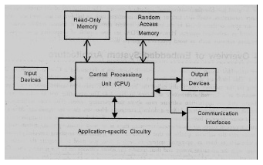

Fig: 3.1 Building blocks of the hardware of an embedded system

* **CENTRAL PROCESSING UNIT (CPU):**

The Central Processing Unit (processor, in short) can be any of the following: microcontroller, microprocessor or Digital Signal Processor (DSP). A micro-controller is a low-cost processor. Its main attraction is that on the chip itself, there will be many other components such as memory, serial communication interface, analog-to digital converter etc.

So, for small applications, a micro-controller is the best choice as the number of external components required will be very less. On the other hand, microprocessors are more powerful, but you need to use many external components with them. D5P is used mainly for applications in which signal processing is involved such as audio and video processing.

* **MEMORY:**

The memory is categorized as Random Access 11emory (RAM) and Read Only Memory (ROM). The contents of the RAM will be erased if power is switched off to the chip, whereas ROM retains the contents even if the power is switched off. So, the firmware is stored in the ROM. When power is switched on, the processor reads the ROM

* **INPUT DEVICES**:

Unlike the desktops, the input devices to an embedded system have very limited capability. There will be no keyboard or a mouse, and hence interacting with the embedded system is no easy task. Many embedded systems will have a small keypad-you press one key to give a specific command. A keypad may be used to input only the digits. Many embedded systems used in process control do not have any input device for user interaction; they take inputs from sensors or transducers 1’fnd produce electrical signals that are in turn fed to other systems.

* **OUTPUT DEVICES**:

The output devices of the embedded systems also have very limited capability. Some embedded systems will have a few Light Emitting Diodes (LEDs) to indicate the health status of the system modules, or for visual indication of alarms. A small Liquid Crystal Display (LCD) may also be used to display some important parameters.

* **COMMUNICATION INTERFACES**:

The embedded systems may need to, interact with other embedded systems at they may have to transmit data to a desktop. To facilitate this, the embedded systems are provided with one or a few communication interfaces such as RS232, RS422, RS485, Universal Serial Bus (USB), IEEE 1394, Ethernet etc.

* **APPLICATION-SPECIFIC CIRCUITRY:**

Sensors, transducers, special processing and control circuitry may be required fat an embedded system, depending on its application. This circuitry interacts with the processor to carry out the necessary work. The entire hardware has to be given power supply either through the 230 volts main supply or through a battery. The hardware has to design in such a way that the power consumption is minimized.

CHAPTER-4

**4.1 DRAWBACKS AND EXISTING SYSTEM**

This idea might provide older citizens living independently with a robot-assisted intelligent emergency system. Through a robot-sensing element system, it serves as an innovative senior freelancing living emergency assistance platform. the robot-assisted emergency system in brief Wearable sensors and emergency aid capabilities will be required. Motion sensors are often used to keep an eye on all of the senior citizen's activities. Emergency situations, such as falling to the ground, will be seen in advance. It will automatically certify that the incident is a falling accident rather than someone sitting on a sofa or sleeping on a bed since the acceleration rate of the person's postures exceeds a certain threshold, etc. We tend to successfully integrate the wearable device and mechanism together, resulting in a smooth hardware/software system integration. The wearable gadget is wirelessly (through Bluetooth or Wi-Fi) linked to the mechanism. When a wearable gadget triggers an alert, the mechanism may take a number of steps. For example, it may automatically choose a relative who will remotely tele-control the mechanism through video communication in order to investigate the situation and take appropriate action. In this instance, we will reduce the warning rate that restricts the efficacy of several remedies. In the event that a response is not obtained from the mechanism, the wearable gadget may also convey a warning to family members or physicians.

**4.2 PROBLEM STATEMENT**

Experts are often asked to appear at every hospital and crisis centre once in a great while. However, it is not feasible for every professional to be available at every location at the desired time. The challenge with video calling is that you have to be forced to use a computer or computer at a certain location. This limits the specialist's capacity to assess patients, go around emergency clinic rooms, or even be present in the activity theatre freely. The expert may make a lot of money with this mechanism:

Specialists will be able to walk about the patient easily, be at any location at any time, and see clinical reports remotely through video chats. Specialists will also be able to roam around activity theatres.

**CHAPTER -5**

**PROPOSED SYSTEM**

BLOCK DIAGRAM

LCD

ARDUINO

Power Supply

wifi

Driver

robot

CHARGER

Mobile PHONE

**FIG.**

This project's main objective is to effectively provide medical care to the underprivileged in mobile regions of the state. The main goal is to use less staff to care for the patients. People who reside in rural or mobile locations lack the option to get medical care from a doctor who practises in a city. A recorded voice and a show advise the patient to sit in front of the specialists and to disclose the nature of their sickness during a recorded consultation.

Sometimes, doctors are obliged to work at every hospital and urgent care facility simultaneously. However, it is impossible for every doctor to be available at all times or in all locations. With video business, it's necessary to do video calls from a laptop or laptop computer on a table. This restricts the doctor's ability to observe the patient, walk about the operating area, or maybe travel among the hospital rooms on a PRN basis.To assist in resolving this problem, we have ave created a virtual doctor automaton that enables a physician to virtually roam around in a distant country and even sit down with the patients there as needed. For physicians, this automaton has a tonne of advantages, including:

• The ability to be anywhere, at any time;

• The ability to easily move among patients and operating rooms;

• The capacity to see medical reports remotely through video chats;

• The ability to walk about in many rooms at once.

For simple navigation, the system uses a robotic car with four wheel drive. The automaton also comes with a mounting for a tablet or smartphone and a controller box for electrical devices. Live video calls are carried via a mobile device or a tablet. The doctor will control the automaton using a panel that is mostly based on IOT.

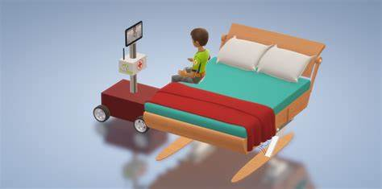

**Fig.**

**5.1 DESIGN OF HARDWARE**

**ARDUINO**

The most common version of Arduino is the Arduino Uno. This board is what most people are talking about when they refer to an Arduino. The Uno is one of the more popular boards in the Arduino family and a great choice for beginners. There are different revisions of Arduino Uno, below detail is the most recent revision (Rev3 or R3).

The Arduino Uno is a microcontroller board based on the ATmega328. It has 14 digital input/output pins (of which 6 can be used as PWM outputs), 6 analog inputs, a 16 MHz ceramic resonator, a USB connection, a power jack, an ICSP header, and a reset button. It contains everything needed to support the microcontroller; simply connect it to a computer with a USB cable or power it with an AC-to-DC adapter or battery to get started.

Microcontroller   : ATmega328

Operating Voltage     : 5V

Input Voltage (recommended)             : 7-12V

Input Voltage (limits)                           : 6-20V

Digital I/O Pins                                     : 14 (of which 6 provide PWM output)

Analog Input Pins                                 : 6

DC Current per I/O Pin                         : 40 mA

DC Current for 3.3V Pin                       : 50 mA

Flash Memory                              : 32 KB (ATmega328) of which 0.5 KB used by  bootloader

SRAM                                                  : 2 KB (ATmega328)

EEPROM                                             :  1 KB (ATmega328)

Clock Speed                                         : 16 MHz

Length                                                 :  68.6 mm

Width                                                    : 53.4 mm

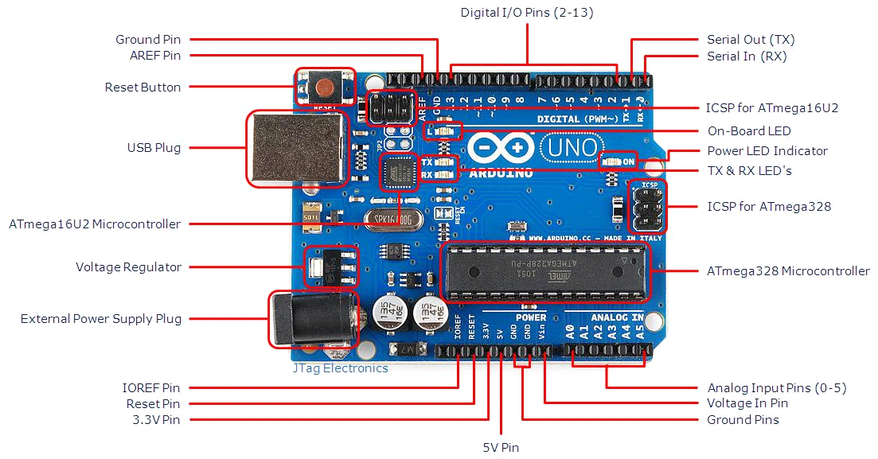

Arduino Uno R3 Board

* **USB Plug & External Power Supply Plug**

Every Arduino board needs a way to be connected to a power source. The Arduino Uno can be powered from a USB cable coming from your computer or a wall power supply that is terminated in a barrel jack. The power source is selected automatically. The USB connection is also how you will load code onto your Arduino board. Please on my other post on how to program with Arduino can be found in Installing and Programming Arduino.

NOTE: The board can operate on an external supply of 6 to 20 volts. If supplied with less than 7V,

however, the 5V pin may supply less than five volts and the board may be unstable.If using more than 12V, the voltage regulator may overheat and damage the board. The recommended range is 7 to 12 volts.

.

* **Voltage Regulator**

The voltage regulator is not actually something you can (or should) interact with on the Arduino. But it is potentially useful to know that it is there and what it’s for. The voltage regulator does exactly what it says – it controls the amount of voltage that is let into the Arduino board. Think of it as a kind of gatekeeper; it will turn away an extra voltage that might harm the circuit. Of course,it has its limits, so don’t hook up your Arduino to anything greater than 20 volts.

* **Power Pins**

Voltage In Pin – The input voltage to the Arduino board when it’s using an external power source(as opposed to 5 volts from the USB connection or other regulated power source). You can supply voltage through this pin, or, if supplying voltage via the power jack, access it through this pin.

5V Pin – This pin outputs a regulated 5V from the regulator on the board. The board can be supplied with power either from the DC power jack (7 – 12V), the USB connector (5V), or the VIN pin of the board (7-12V). Supplying voltage via the 5V or 3.3V pins bypasses the regulator, and can damage your board. It’s not recommended.3.3V Pin – A 3.3 volt supply generated by the on-board regulator. Maximum current draw is 50 mA.

* **Ground Pins**

There are several GND pins on the Arduino, any of which can be used to ground your circuit.

* **IOREF Pin**

This pin on the Arduino board provides the voltage reference with which the microcontroller operates. A properly configured shield can read the IOREF pin voltage and select the appropriate power source or enable voltage translators on the outputs for working with the 5V or 3.3V.

* **Input and Output Pins**

Each of the 14 digital pins on the Uno can be used as an input or output. They operate at 5 volts. These pins can be used for both digital input (like telling if a button is pushed) and digital output (like powering an LED). Each pin can provide or receive a maximum of 40 mA and has an internal pull-up resistor (disconnected by default) of 20-5k Ohms. In addition, some pins have specialized functions.

* **Serial Out (TX) & Serial In (RX)**

Used to receive (RX) and transmit (TX) TTL serial data. These pins are connected to the corresponding pins of the ATmega8U2 USB-to-TTL Serial chip.

* **External Interrupts**

Pins 2 and 3 can be configured to trigger an interrupt on a low value, a rising or falling edge, or a change in value.

PWM– You may have noticed the tilde (~) next to some of the digital pins (3, 5, 6, 9, 10, and 11). These pins act as normal digital pins, but can also be used for something called Pulse-Width Modulation (PWM).  Think of these pins as being able to simulate analog output (like fading an LED in and out).

SPI – Pins 10 (SS), 11 (MOSI), 12 (MISO), 13 (SCK). SPI stands for Serial Peripheral Interface. These pins support SPI communication using the SPI library.

Analog Input Pins – Labeled A0 through A5, each of which provide 10 bits of resolution (i.e. 1024 different values). These pins can read the signal from an analog sensor (like a temperature sensor) and convert it into a digital value that we can read. By default they measure from ground to 5 volts, though is it possible to change the upper end of their range using the AREF Pin(Stands for Analog Reference. Most of the time you can leave this pin alone). Additionally, some pins have specialized functionality:

TWI – Pins A4 or SDA pin and A5 or SCL pin. Support TWI communication using the Wire library.

* **Reset Pin**

Bring this line LOW to reset the microcontroller.Typically used to add a reset button to shields which block the one on the board.

* **LED Indicators**

Power LED Indicator – Just beneath and to the right of the word “UNO” on your circuit board, there’s a tiny LED next to the word ‘ON’. This LED should light up whenever you plug your Arduino into a power source. If this light doesn’t turn on, there’s a good chance something is wrong. Time to re-check your circuit!

On-Board LED – There is a built-in LED connected to digital pin 13. When the pin is HIGH value, the LED is on, when the pin is LOW, it’s off. This useful to quickly check if the board has no problem as some boards has a pre-loaded simple blinking LED program in it.

TX & RX LEDs – These LEDs will give us some nice visual indications whenever our Arduino is receiving or transmitting data (like when we’re loading a new program ontotheboard).

**Reset Button:**Pushing the reset button temporarily connect the reset pin to ground and restart any code that is loaded on the Arduino. This can be very useful if your code doesn’t repeat, but you want to test it multiple times.

**POWER SUPPLY:**

The power supplies are designed to convert high voltage AC mains electricity to a suitable low voltage supply for electronic circuits and other devices. A power supply can by broken down into a series of blocks, each of which performs a particular function. A d.c power supply which maintains the output voltage constant irrespective of a.c mains fluctuations or load variations is known as “Regulated D.C Power Supply”.

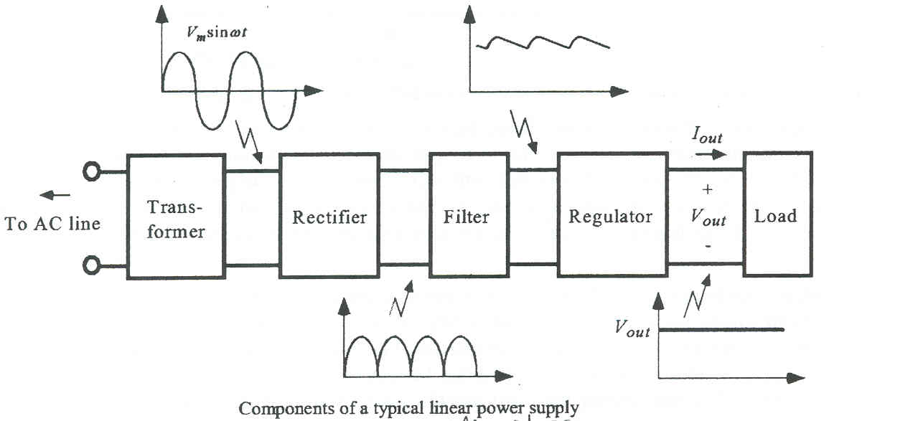

Fig:4.4. Block Diagram of Power Supply

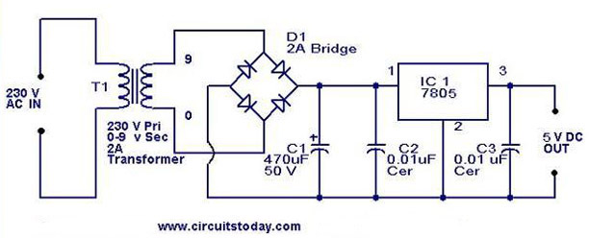

Fig:4.5. Schematic Diagram of Power Supply

**TRANSFORMER:**

A transformer is an electrical device which is used to convert electrical power from one Electrical circuit to another without change in frequency.

When AC is applied to the primary winding of the power transformer it can either be stepped down or up depending on the value of DC needed. In our circuit the transformer of 230v/12-0-12v is used to perform the step down operation where a 230V AC appears as 12V AC across the secondary winding.

**RECTIFIER:**

A circuit which is used to convert a.c to dc is known as RECTIFIER. The process of conversion a.c to d.c is called “rectification.

# Bridge Rectifier:

# 

Fig: 4.6 Bridge Rectifier

**OPERATION:**

During positive half cycle of secondary, the diodes D2 and D3 are in forward biased while D1 and D4 are in reverse biased. During negative half cycle of secondary voltage, the diodes D1 and D4 are in forward biased while D2 and D3 are in reverse biased.

**FILTER:**

A Filter is a device which removes the a.c component of rectifier output but allows the d.c component to reach the load.We have seen that the ripple content in the rectified output of half wave rectifier is **121%** or that of full-wave or bridge rectifier or bridge rectifier is **48%** such high percentages of ripples is not acceptable for most of the applications. Ripples can be removed by one of the following methods of filtering. A capacitor, in parallel to the load, provides an easier by –pass for the ripples voltage though it due to low impedance. At ripple frequency and leave the d.c.to appears the load.

**VOLTAGE REGULATOR:**

As the name itself implies, it regulates the input applied to it. A voltage regulator is an electrical regulator designed to automatically maintain a constant voltage level. In this project, power supply of 5V and 12V are required. In order to obtain these voltage levels,7805 and 7812 voltage regulators are to be used. The first number 78 represents positive supply and the numbers 05,12 represent the required output voltage.

**LCD:**

A model described here is for its low price and great possibilities most frequently used in practice. It is based on the HD44780 microcontroller (Hitachi) and can display messages in two lines with 16 characters each. It displays all the alphabets, Greek letters, punctuation marks, mathematical symbols etc. In addition, it is possible to display symbols that user makes up on its own. Automatic shifting message on display (shift left and right), appearance of the pointer, backlight etc. are considered as useful characteristics.

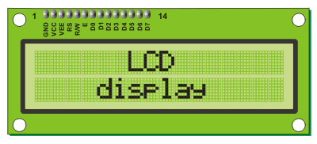Fig: 4.10. LCD

**PINS FUNCTIONS:**

There are pins along one side of the small printed board used for connection to the microcontroller. There are total of 14 pins marked with numbers (16 in case the background light is built in). Their function is described in the table below:

|  |  |  |  |  |
| --- | --- | --- | --- | --- |
| **Function** | **Pin Number** | **Name** | **LogicState** | **Description** |
| Ground | 1 | Vss | - | 0V |
| Power supply | 2 | Vdd | - | +5V |
| Contrast | 3 | Vee | - | 0 –Vdd |
| Controlof operating | 4 | RS | 0 1 | D0 – D7 are interpreted as commands D0 – D7 are interpreted as data |
| 5 | R/W | 0 1 | Write data (from controller to LCD) Read data (from LCD to controller) |
| 6 | E | 0 1 From 1 to 0 | Access to LCD disabled Normal operating Data/commands are transferred to LCD |
| Data / commands | 7 | D0 | 0/1 | Bit 0 LSB |
| 8 | D1 | 0/1 | Bit 1 |
| 9 | D2 | 0/1 | Bit 2 |
| 10 | D3 | 0/1 | Bit 3 |
| 11 | D4 | 0/1 | Bit 4 |
| 12 | D5 | 0/1 | Bit 5 |
| 13 | D6 | 0/1 | Bit 6 |
| 14 | D7 | 0/1 | Bit 7 MSB |

Table 4.2:LCD Pin Functions

**LCD SCREEN:**

LCD screen consists of two lines with 16 characters each. Each character consists of 5x7 dot matrix. Contrast on display depends on the power supply voltage and whether messages are displayed in one or two lines. For that reason, variable voltage 0-Vdd is applied on pin marked as Vee. Trimmer potentiometer is usually used for that purpose. Some versions of displays have built in backlight (blue or green diodes). When used during operating, a resistor for current limitation should be used (like with any LE diode).

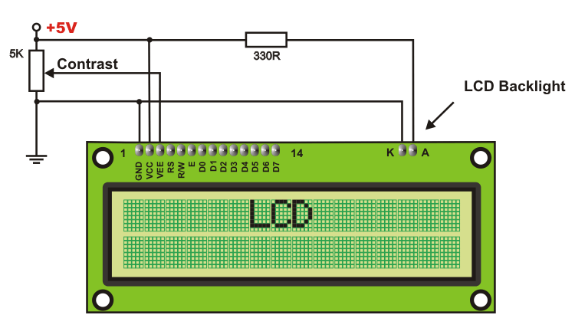

Fig: 4.11.LCD Screen Circuit Diagram

* **LCD Basic Commands:**

All data transferred to LCD through outputs D0-D7 will be interpreted as commands or as data, which depends on logic state on pin RS: RS = 1 - Bits D0 - D7 are addresses of characters that should be displayed. Built in processor addresses built in “map of characters” and displays corresponding symbols. Displaying position is determined by DDRAM address. This address is either previously defined or the address of previously transferred character is automatically incremented. RS = 0 - Bits D0 - D7 are commands which determine display mode. List of commands which LCD recognizes are given in the table below:

|  |  |  |  |  |  |  |  |  |  |  |  |
| --- | --- | --- | --- | --- | --- | --- | --- | --- | --- | --- | --- |
| **Command** | **RS** | **RW** | **D7** | **D6** | **D5** | **D4** | **D3** | **D2** | **D1** | **D0** | **Execution Time** |
| Clear display | 0 | 0 | 0 | 0 | 0 | 0 | 0 | 0 | 0 | 1 | 1.64mS |
| Cursor home | 0 | 0 | 0 | 0 | 0 | 0 | 0 | 0 | 1 | x | 1.64mS |
| Entry mode set | 0 | 0 | 0 | 0 | 0 | 0 | 0 | 1 | I/D | S | 40uS |
| Display on/off control | 0 | 0 | 0 | 0 | 0 | 0 | 1 | D | U | B | 40uS |
| Cursor/Display Shift | 0 | 0 | 0 | 0 | 0 | 1 | D/C | R/L | x | x | 40uS |
| Function set | 0 | 0 | 0 | 0 | 1 | DL | N | F | x | x | 40uS |
| Set CGRAM address | 0 | 0 | 0 | 1 | CGRAM address | | | | | | 40uS |
| Set DDRAM address | 0 | 0 | 1 | DDRAM address | | | | | | | 40uS |
| Read “BUSY” flag (BF) | 0 | 1 | BF | DDRAM address | | | | | | | - |

Table 4.3 Basic Commands Of LCD

**THEORY OF DC MOTOR**

The speed of a DC motor is directly proportional to the supply voltage, so if we reduce the supply voltage from 12 Volts to 6 Volts, the motor will run at half the speed. How can this be achieved when the battery is fixed at 12 Volts? The speed controller works by varying the average voltage sent to the motor. It could do this by simply adjusting the voltage sent to the motor, but this is quite inefficient to do. A better way is to switch the motor's supply on and off very quickly. If the switching is fast enough, the motor doesn't notice it, it only notices the average effect.

When you watch a film in the cinema, or the television, what you are actually seeing is a series of fixed pictures, which change rapidly enough that your eyes just see the average effect - movement. Your brain fills in the gaps to give an average effect.

Now imagine a light bulb with a switch. When you close the switch, the bulb goes on and is at full brightness, say 100 Watts. When you open the switch it goes off (0 Watts). Now if you close the switch for a fraction of a second, then open it for the same amount of time, the filament won't have time to cool down and heat up, and you will just get an average glow of 50 Watts. This is how lamp dimmers work, and the same principle is used by speed controllers to drive a motor. When the switch is closed, the motor sees 12 Volts, and when it is open it sees 0 Volts. If the switch is open for the same amount of time as it is closed, the motor will see an average of 6 Volts, and will run more slowly accordingly. The graph below shows the speed of a motor that is being turned on and off.

**H-BRIDGE**

An H-bridge is an electronic circuit which enables DC electric motors to be run forwards or backwards. These circuits are often used in robotics. H-bridges are available as integrated circuits, or can be built from discrete component

The H-Bridge arrangement is generally used to reverse the polarity of the motor, but can also be used to 'brake' the motor, where the motor comes to a sudden stop, as the motors terminals are shorted, or to let the motor 'free run' to a stop, as the motor is effectively disconnected from the circuit. The following table summarizes operation.

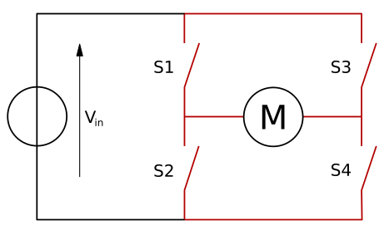

|  |  |  |  |  |
| --- | --- | --- | --- | --- |
| **S1** | **S2** | **S3** | **S4** | **Result** |
| 1 | 0 | 0 | 1 | Motor moves right |
| 0 | 1 | 1 | 0 | Motor moves left |
| 0 | 0 | 0 | 0 | Motor free runs |
| 0 | 1 | 0 | 1 | Motor FRONT |
| 1 | 0 | 1 | 0 | MOTOR BACK |

**H-Bridge Driver:**

An H-bridge is an electronic circuit which enables DC electric motors to be run forwards or backwards. These circuits are often used in robotics. H-bridges are available as integrated circuits, or can be built from discrete componentsThe switching property of this H-Bridge can be replace by a Transistor or a Relay or a Mosfet or even by an IC. Here we are replacing this with an IC named L293D as the driver whose description is as given below.

**Features:**

* 600mA OUTPUT CURRENT CAPABILITY
* PER CHANNEL
* 1.2A PEAK OUTPUT CURRENT (non repetitive)
* PER CHANNEL
* ENABLE FACILITY
* OVERTEMPERATURE PROTECTION
* LOGICAL "0" INPUT VOLTAGE UP TO 1.5 V
* (HIGH NOISE IMMUNITY)
* INTERNAL CLAMP DIODES

**DESCRIPTION**

The Device is a monolithic integrated high voltage, high current four channel driver designed to accept standard DTL or TTL logic levels and drive inductive loads (such as relays solenoides, DC and stepping motors) and switching power transistors. To simplify use as two bridges each pair of channels is equipped with an enable input. A separate supply input is provided for the logic, allowing operation at a lower voltage and internal clamp diodes are included. This device is suitable for use in switching applications at frequencies up to 5 kHz. The L293D is assembled in a 16 lead plastic packaage which has 4 center pins connected together and used for heatsinking The L293DD is assembled in a 20 lead surface mount which has 8 center pins connected together and used for heatsinking

**BLOCK DIAGRAM**



**ABSOLUTE MAXIMUM RATINGS**



**PIN CONNECTIONS**



**ESP8266 WIFI**

The **ESP8266** is a low-cost [Wi-Fi](https://en.wikipedia.org/wiki/Wi-Fi) microchip with full [TCP/IP stack](https://en.wikipedia.org/wiki/TCP/IP_stack) and [microcontroller](https://en.wikipedia.org/wiki/Microcontroller) capability produced by Shanghai-based Chinese manufacturer, Espressif Systems.[[1]](https://en.wikipedia.org/wiki/ESP8266#cite_note-Espressif_ESP8266-1)

The chip first came to the attention of western [makers](https://en.wikipedia.org/wiki/Maker_culture) in August 2014 with the **ESP-01** module, made by a third-party manufacturer, Ai-Thinker. This small module allows microcontrollers to connect to a Wi-Fi network and make simple TCP/IP connections using [Hayes](https://en.wikipedia.org/wiki/Hayes_command_set)-style commands. However, at the time there was almost no English-language documentation on the chip and the commands it accepted.[[2]](https://en.wikipedia.org/wiki/ESP8266#cite_note-2) The very low price and the fact that there were very few external components on the module which suggested that it could eventually be very inexpensive in volume, attracted many hackers to explore the module, chip, and the software on it, as well as to translate the Chinese documentation.[[3]](https://en.wikipedia.org/wiki/ESP8266#cite_note-3)

The **ESP8285** is an ESP8266 with 1 MiB of built-in flash, allowing for single-chip devices capable of connecting to Wi-Fi.[[4]](https://en.wikipedia.org/wiki/ESP8266#cite_note-esp8285-4)

The successor to these microcontroller chips is the [ESP32](https://en.wikipedia.org/wiki/ESP32).

|  |  |
| --- | --- |
| **ESP8266** | |
| ESP-8266 module by Ai-Thinker | |
| **Manufacturer** | Espressif Systems |
| **Power** | 12VDC |

* Processor: L106 32-bit [RISC](https://en.wikipedia.org/wiki/Reduced_instruction_set_computing) microprocessor core based on the [Tensilica](https://en.wikipedia.org/wiki/Tensilica) Xtensa Diamond Standard 106Micro running at 80 MHz†
* Memory:
  + 32 KiB instruction RAM
  + 32 KiB instruction cache RAM
  + 80 KiB user data RAM
  + 16 KiB ETS system data RAM
* External QSPI flash: up to 16 MiB is supported (512 KiB to 4 MiB typically included)
* [IEEE 802.11](https://en.wikipedia.org/wiki/IEEE_802.11) b/g/n [Wi-Fi](https://en.wikipedia.org/wiki/Wi-Fi)
  + Integrated [TR switch](https://en.wikipedia.org/wiki/Duplexer#Transmit-receive_switch), [balun](https://en.wikipedia.org/wiki/Balun), [LNA](https://en.wikipedia.org/wiki/Low-noise_amplifier), [power amplifier](https://en.wikipedia.org/wiki/RF_power_amplifier) and [matching network](https://en.wikipedia.org/wiki/Matching_network)
  + [WEP](https://en.wikipedia.org/wiki/Wired_Equivalent_Privacy) or [WPA/WPA2](https://en.wikipedia.org/wiki/Wi-Fi_Protected_Access) authentication, or open networks
* 16 [GPIO](https://en.wikipedia.org/wiki/General-purpose_input/output) pins
* [SPI](https://en.wikipedia.org/wiki/Serial_Peripheral_Interface_Bus)
* [I²C](https://en.wikipedia.org/wiki/I%C2%B2C) (software implementation)[[5]](https://en.wikipedia.org/wiki/ESP8266#cite_note-EspressifBBS_I2C-5)
* [I²S](https://en.wikipedia.org/wiki/I%C2%B2S) interfaces with DMA (sharing pins with GPIO)
* [UART](https://en.wikipedia.org/wiki/Universal_asynchronous_receiver/transmitter) on dedicated pins, plus a transmit-only UART can be enabled on GPIO2
* 10-bit [ADC](https://en.wikipedia.org/wiki/Analog-to-digital_converter) ([successive approximation ADC](https://en.wikipedia.org/wiki/Successive_approximation_ADC))

† Both the CPU and flash clock speeds can be doubled by overclocking on some devices. CPU can be run at 160 MHz and flash can be sped up from 40 MHz to 80 MHz.[[*citation needed*](https://en.wikipedia.org/wiki/Wikipedia:Citation_needed)] Success varies chip to chip.[[*citation needed*](https://en.wikipedia.org/wiki/Wikipedia:Citation_needed)]

## SDKs[[edit](https://en.wikipedia.org/w/index.php?title=ESP8266&action=edit&section=2)]

In late October 2014, Espressif Systems released a [software development kit](https://en.wikipedia.org/wiki/Software_development_kit) (SDK) that allowed the chip to be programmed, removing the need for a separate microcontroller.[[6]](https://en.wikipedia.org/wiki/ESP8266#cite_note-6)Since then, there have been many official SDK releases from Espressif; Espressif maintains two versions of the SDK – one that is based on [FreeRTOS](https://en.wikipedia.org/wiki/FreeRTOS) and the other based on callbacks.[[7]](https://en.wikipedia.org/wiki/ESP8266#cite_note-7)

An alternative to Espressif's official SDK is the open source ESP-Open-SDK[[8]](https://en.wikipedia.org/wiki/ESP8266#cite_note-8) that is based on the [GCC](https://en.wikipedia.org/wiki/GNU_Compiler_Collection) toolchain. ESP8266 uses the Cadence Tensilica L106 microcontroller and the GCC toolchain is open-sourced and maintained by Max Filippov.[[9]](https://en.wikipedia.org/wiki/ESP8266#cite_note-9) Another alternative is the "Unofficial Development Kit" by Mikhail Grigorev.[[10]](https://en.wikipedia.org/wiki/ESP8266#cite_note-10)[[11]](https://en.wikipedia.org/wiki/ESP8266#cite_note-11)

Other SDKs (mostly open source) include:

* [NodeMCU](https://en.wikipedia.org/wiki/NodeMCU) – A Lua-based firmware.
* [Arduino](https://en.wikipedia.org/wiki/Arduino) – A C++ based firmware. This core enables the ESP8266 CPU and its Wi-Fi components to be programmed like any other Arduino device. The ESP8266 Arduino Core is available through GitHub.
* PlatformIO (<https://platformio.org/platforms/espressif8266>) – A cross-platform IDE and unified debugger which sits on top of Arduino code and libraries.
* MicroPython – A port of [MicroPython](https://en.wikipedia.org/wiki/MicroPython) (an implementation of Python for embedded devices) to the ESP8266 platform.
* ESP8266 BASIC – An open source basic interpreter specifically tailored for the internet of things. Self hosting browser based development environment.
* Zbasic for ESP8266 – A subset of Microsoft's widely used Visual Basic 6 which has been adapted as a control language for the ZX microcontroller family and the ESP8266.
* Espruino – An actively maintained JavaScript SDK and firmware, closely emulating Node.js. Supports a few MCUs, including the ESP8266.
* [Mongoose OS](https://en.wikipedia.org/wiki/Mongoose_OS) – An open source Operating System for connected products. Supports ESP82666 and ESP32. Develop in C or JavaScript.[[12]](https://en.wikipedia.org/wiki/ESP8266#cite_note-12)
* ESP-Open-SDK – Free and open (as much as possible) integrated SDK for ESP8266/ESP8285 chips.
* ESP-Open-RTOS – Open source FreeRTOS-based ESP8266 software framework.
* Zerynth – [IoT](https://en.wikipedia.org/wiki/Internet_of_things) framework that allows programming ESP8266[[13]](https://en.wikipedia.org/wiki/ESP8266#cite_note-13) and other microcontrollers using [Python](https://en.wikipedia.org/wiki/Python_(programming_language)).

## Espressif modules[[edit](https://en.wikipedia.org/w/index.php?title=ESP8266&action=edit&section=3)]

This is the series of ESP8266-based modules made by Espressif:

|  |  |  |  |  |  |  |  |  |
| --- | --- | --- | --- | --- | --- | --- | --- | --- |
| **Name** | **Active pins** | **Pitch** | **Form factor** | **LEDs** | **Antenna** | **Shielded** | **Dimensions (mm)** | **Notes** |
| ESP-WROOM-02[[14]](https://en.wikipedia.org/wiki/ESP8266#cite_note-14) | 18 | 1.5 mm | 2×9 castellated | No | PCB trace | Yes | 18 × 20 | FCC ID 2AC7Z-ESPWROOM02. |
| ESP-WROOM-02D[[15]](https://en.wikipedia.org/wiki/ESP8266#cite_note-Espressif_ESPWROOM02DU_Datasheet-15) | 18 | 1.5 mm | 2×9 castellated | No | PCB trace | Yes | 18 × 20 | FCC ID 2AC7Z-ESPWROOM02D. Revision of ESP-WROOM-02 compatible with both 150-mil and 208-mil flash memory chips. |
| ESP-WROOM-02U[[15]](https://en.wikipedia.org/wiki/ESP8266#cite_note-Espressif_ESPWROOM02DU_Datasheet-15) | 18 | 1.5 mm | 2×9 castellated | No | U.FL socket | Yes | 18 × 20 | Differs from ESP-WROOM-02D in that includes an U.FL compatible antenna socket connector. |
| ESP-WROOM-S2[[16]](https://en.wikipedia.org/wiki/ESP8266#cite_note-16) | 20 | 1.5 mm | 2×10 castellated | No | PCB trace | Yes | 16 × 23 | FCC ID 2AC7Z-ESPWROOMS2. |
|  |  |  |  |  |  |  |  |  |
|  |  |  |  |  |  |  |  |  |

In the table above (and the two tables which follow), "Active pins" include the GPIO and ADC pins with which you can attach external devices to the ESP8266 MCU. The "Pitch" is the space between pins on the ESP8266 module, which is important to know if you are going to breadboard the device. The "Form factor" also describes the module packaging as "2 × 9 DIL", meaning two rows of 9 pins arranged "Dual In Line", like the pins of DIP ICs. Many ESP-xx modules include a small on-board LED which can be programmed to blink and thereby indicate activity. There are several antenna options for ESP-xx boards including a trace antenna, an on-board ceramic antenna, and an external connector which allows you to attach an external Wi-Fi antenna. Since Wi-Fi communications generates a lot of RFI (Radio Frequency Interference), governmental bodies like the FCC like shielded electronics to minimize interference with other devices. Some of the ESP-xx modules come housed within a metal box with an FCC seal of approval stamped on it. First and second world markets will likely demand FCC approval and shielded Wi-Fi devices.

## Ai-Thinker modules[[edit](https://en.wikipedia.org/w/index.php?title=ESP8266&action=edit&section=4)]

Ai-Thinker ESP8266 modules (ESP-12F, black color) soldered to breakout boards (white color)

These are the first series of modules made with the ESP8266 by the third-party manufacturer *Ai-Thinker* and remain the most widely available.[[17]](https://en.wikipedia.org/wiki/ESP8266#cite_note-17) They are collectively referred to as "ESP-xx modules". To form a workable development system they require additional components, especially a serial TTL-to-USB adapter (sometimes called a USB-to-UART bridge) and an external 3.3 volt power supply. Novice ESP8266 developers are encouraged to consider larger ESP8266 Wi-Fi development boards like the NodeMCU which includes the USB-to-UART bridge and a Micro-USB connector coupled with a 3.3 volt power regulator already built into the board. When project development is complete, these components are not needed anymore and it can be considered using these cheaper ESP-xx modules as a lower power, smaller footprint option for production runs.

Flash in notes; "512 KiB Flash" indicates for that & the ones after unless mentioned ie "(1 MiB)" in () means just this one)

| **Name** | **Active pins** | **Pitch** | **Form factor** | **LEDs** | **Antenna** | **Shielded** | **Dimensions (mm)** | **Notes** |
| --- | --- | --- | --- | --- | --- | --- | --- | --- |
| ESP-01 | 6 | 0.1 in | 2×4 DIL | Yes | PCB trace | No | 14.3 × 24.8 | 512 KiB Flash |
| ESP-01S | 6 | 0.1 in | 2×4 DIL | Yes | PCB trace | No | 14.4 × 24.7 | (1 MiB Flash ) |
| ESP-01M | 16 | 1.6 mm | 2×9 edge connector | No | PCB trace | Yes | 18.0 × 18.0 | Uses ESP8285 (1 MiB built-in flash) |
| ESP-02 | 6 | 0.1 in | 2×4 castellated | No | U.FL socket | No | 14.2 × 14.2 |  |
| ESP-03 | 10 | 2 mm | 2×7 castellated | No | Ceramic | No | 17.3 × 12.1 |  |
| ESP-04 | 10 | 2 mm | 2×4 castellated | No | None | No | 14.7 × 12.1 |  |
| ESP-05 | 3 | 0.1 in | 1×5 SIL | No | U.FL socket | No | 14.2 × 14.2 |  |
| ESP-06 | 11 | various | 4×3 dice | No | None | Yes | 14.2 × 14.7 | Not FCC approved. |
| ESP-07 | 14 | 2 mm | 2×8 pinhole | Yes | Ceramic + U.FL socket | Yes | 20.0 × 16.0 | Not FCC approved. |
| ESP-07S | 14 | 2 mm | 2×8 pinhole | No | U.FL socket | Yes | 17.0 × 16.0 | FCC and CE approved. |
| ESP-08 | 10 | 2 mm | 2×7 castellated | No | None | Yes | 17.0 × 16.0 | Not FCC approved. |
| ESP-09 | 10 | various | 4×3 dice | No | None | No | 10.0 × 10.0 |  |
| ESP-10 | 3 | 2 mm | 1×5 castellated | No | None | No | 14.2 × 10.0 |  |
| ESP-11 | 6 | 1.27 mm | 1×8 pinhole | No | Ceramic | No | 17.3 × 12.1 |  |
| ESP-12 | 14 | 2 mm | 2×8 castellated | Yes | PCB trace | Yes | 24.0 × 16.0 | FCC and CE approved.[[18]](https://en.wikipedia.org/wiki/ESP8266#cite_note-18) |
| ESP-12E | 20 | 2 mm | 2×8 castellated | Yes | PCB trace | Yes | 24.0 × 16.0 | 4 MiB flash. |
| ESP-12F | 20 | 2 mm | 2×8 castellated | Yes | PCB trace | Yes | 24.0 × 16.0 | FCC and CE approved. Improved antenna performance. 4 MiB flash. |
| ESP-12S | 14 | 2 mm | 2×8 castellated | Yes | PCB trace | Yes | 24.0 × 16.0 | 4 MiB flash. FCC approved.[[19]](https://en.wikipedia.org/wiki/ESP8266#cite_note-19) |
| ESP-13 | 16 | 1.5 mm | 2×9 castellated | No | PCB trace | Yes | W18.0 × L20.0 | Marked as ″FCC″. Shielded module is placed sideways, as compared to the ESP-12 modules. |
| ESP-14 | 22 | 2 mm | 2×8 castellated +6 | No | PCB trace | Yes | 24.3 × 16.2 |  |

#### Light-emitting diode (LED)

Light-emitting diodes are elements for light signalization in electronics. They are manufactured in different shapes, colors and sizes. For their low price, low consumption and simple use, they have almost completely pushed aside other light sources- bulbs at first place. They perform similar to common diodes with the difference that they emit light when current flows through them.

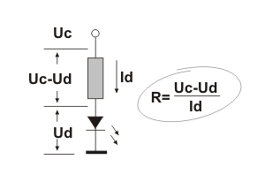

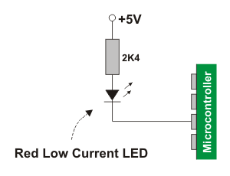It is important to know that each diode will be immediately destroyed unless its current is limited. This means that a conductor must be connected in parallel to a diode. In order to correctly determine value of this conductor, it is necessary to know diode’s voltage drop in forward direction, which depends on what material a diode is made of and what colour it is. Values typical for the most frequently used diodes are shown in table below: As seen, there are three main types of LEDs. *Standard* ones get ful brightness at current of 20mA. *Low Current* diodes get ful brightness at ten times lower current while *Super Bright* diodes produce more intensive light than Standard ones.

Since the 8051 microcontrollers can provide only low input current and since their pins are configured as outputs when voltage level on them is equal to 0, direct connectining to LEDs is carried out as it is shown on figure (*Low current* LED, cathode is connected to output pin).

#### Switches and Pushbuttons

There is nothing simpler than this! This is the simplest way of controlling appearance of some voltage on microcontroller’s input pin. There is also no need for additional explanation of how these components operate.

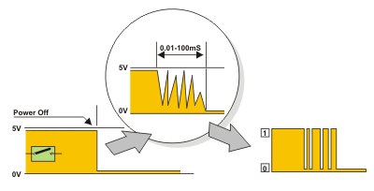

Nevertheless, it is not so simple in practice... This is about something commonly unnoticeable when using these components in everyday life. It is about contact bounce- a common problem with m e c h a n i c a l switches. If contact switching does not happen so quickly, several consecutive bounces can be noticed prior to maintain stable state. The reasons for this are: vibrations, slight rough spots and dirt. Anyway, whole this process does not last long (a few micro- or miliseconds), but long enough to be registered by the microcontroller. Concerning pulse counter, error occurs in almost 100% of cases!

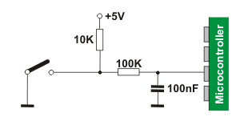

The simplest solution is to connect simple RC circuit which will “suppress” each quick voltage change. Since the bouncing time is not defined, the values of elements are not strictly determined. In the most cases, the values shown on figure are sufficient.

If complete safety is needed, radical measures should be taken! The circuit, shown on the figure (RS flip-flop), changes logic state on its output with the first pulse triggered by contact bounce. Even though this is more expensive solution (SPDT switch), the problem is definitely resolved! Besides, since the condensator is not used, very short pulses can be also registered in this way. In addition to these hardware solutions, a simple software solution is commonly applied too: when a program tests the state of some input pin and finds changes, the check should be done one more time after certain time delay. If the change is confirmed it means that switch (or pushbutton) has changed its position. The advantages of such solution are obvious: it is free of charge, effects of disturbances are eliminated too and it can be adjusted to the worst-quality contacts.

**BATTERY**

A **Lithium-ion** or **Li-ion battery** is a type of [rechargeable battery](https://en.wikipedia.org/wiki/Rechargeable_battery) which uses the reversible [reduction](https://en.wikipedia.org/wiki/Redox) of [lithium](https://en.wikipedia.org/wiki/Lithium) [ions](https://en.wikipedia.org/wiki/Ion) to store energy. It is the predominant battery type used in portable [consumer electronics](https://en.wikipedia.org/wiki/Consumer_electronics) and [electric vehicles](https://en.wikipedia.org/wiki/Electric_vehicle). It also sees significant use for [grid-scale energy storage](https://en.wikipedia.org/wiki/Battery_storage_power_station) and military and [aerospace](https://en.wikipedia.org/wiki/Aerospace) applications. Compared to other rechargeable battery technologies, Li-ion batteries have high [energy densities](https://en.wikipedia.org/wiki/Energy_density), low [self-discharge](https://en.wikipedia.org/wiki/Self-discharge), and no [memory effect](https://en.wikipedia.org/wiki/Memory_effect) (although a small memory effect reported in [LFP cells](https://en.wikipedia.org/wiki/Lithium_iron_phosphate_battery) has been traced to poorly made cells).[[9]](https://en.wikipedia.org/wiki/Lithium-ion_battery#cite_note-9)

Chemistry, performance, cost and safety characteristics vary across types of lithium-ion batteries. Most commercial Li-ion cells use [intercalation](https://en.wikipedia.org/wiki/Intercalation_(chemistry)) compounds as the active materials. The anode or negative electrode is usually [graphite](https://en.wikipedia.org/wiki/Graphite), although [silicon-carbon](https://en.wikipedia.org/wiki/Lithium%E2%80%93silicon_battery) is also being increasingly used. Cells can be manufactured to prioritize either energy or power density.[[10]](https://en.wikipedia.org/wiki/Lithium-ion_battery#cite_note-10) Handheld electronics mostly use [lithium polymer batteries](https://en.wikipedia.org/wiki/Lithium_polymer_battery) (with a polymer gel as electrolyte),a [lithium cobalt oxide](https://en.wikipedia.org/wiki/Lithium_cobalt_oxide) (LiCoO  
2) cathode material, and a [graphite](https://en.wikipedia.org/wiki/Graphite) anode, which together offer a high energy density.[[11]](https://en.wikipedia.org/wiki/Lithium-ion_battery#cite_note-11)[[12]](https://en.wikipedia.org/wiki/Lithium-ion_battery#cite_note-E-electric20200604-12) [Lithium iron phosphate](https://en.wikipedia.org/wiki/Lithium_iron_phosphate) (LiFePO4), [lithium manganese oxide](https://en.wikipedia.org/wiki/Lithium_ion_manganese_oxide_battery) (LiMn  
2O4 spinel, or Li2MnO3-based lithium rich layered materials, LMR-NMC), and [lithium nickel manganese cobalt oxide](https://en.wikipedia.org/wiki/Lithium_nickel_manganese_cobalt_oxide) (LiNiMnCoO  
2 or NMC) may offer longer lives and may have better rate capability. NMC and its derivatives are widely used in the [electrification of transport](https://en.wikipedia.org/wiki/Electrification_of_transport), one of the main technologies (combined with [renewable energy](https://en.wikipedia.org/wiki/Renewable_energy)) for reducing [greenhouse gas emissions from vehicles](https://en.wikipedia.org/wiki/Greenhouse_gas_emissions).[[13]](https://en.wikipedia.org/wiki/Lithium-ion_battery#cite_note-13)[[14]](https://en.wikipedia.org/wiki/Lithium-ion_battery#cite_note-14)

[M. Stanley Whittingham](https://en.wikipedia.org/wiki/M._Stanley_Whittingham) discovered the concept of [intercalation](https://en.wikipedia.org/wiki/Intercalation_(chemistry)) electrodes in the 1970s and created the first rechargeable lithium-ion battery, which was based on a [titanium disulfide](https://en.wikipedia.org/wiki/Titanium_disulfide) cathode and a lithium-aluminum anode, although it suffered from safety issues and was never commercialized.[[15]](https://en.wikipedia.org/wiki/Lithium-ion_battery#cite_note-rfsuny-15) [John Goodenough](https://en.wikipedia.org/wiki/John_Goodenough) expanded on this work in 1980 by using [lithium cobalt oxide](https://en.wikipedia.org/wiki/Lithium_cobalt_oxide) as a cathode.[[16]](https://en.wikipedia.org/wiki/Lithium-ion_battery#cite_note-nobel-16) The first prototype of the modern Li-ion battery, which uses a carbonaceous anode rather than lithium metal, was developed by [Akira Yoshino](https://en.wikipedia.org/wiki/Akira_Yoshino) in 1985, which was commercialized by a [Sony](https://en.wikipedia.org/wiki/Sony) and [Asahi Kasei](https://en.wikipedia.org/wiki/Asahi_Kasei) team led by Yoshio Nishi in 1991.[[17]](https://en.wikipedia.org/wiki/Lithium-ion_battery#cite_note-NAE-17)

Lithium-ion batteries can be a safety hazard if not properly engineered and manufactured since cells have flammable electrolytes and if damaged or incorrectly charged, can lead to explosions and fires. Much development has made progress in manufacturing safe Lithium-ion batteries batteries.[[18]](https://en.wikipedia.org/wiki/Lithium-ion_battery#cite_note-18) Lithium Ion All [Solid State Batteries](https://en.wikipedia.org/wiki/Solid-state_battery) are being developed to eliminate the flammable electrolyte. Improperly [recycled batteries](https://en.wikipedia.org/wiki/Battery_recycling) can create toxic waste, especially from toxic metals and are at risk of fire. Moreover, both [lithium](https://en.wikipedia.org/wiki/Lithium) and other key strategic minerals used in batteries have significant issues at extraction, with lithium being water intensive in often arid regions and other minerals often being [conflict minerals](https://en.wikipedia.org/wiki/Conflict_resource) such as [cobalt](https://en.wikipedia.org/wiki/Cobalt). Both [environmental issues](https://en.wikipedia.org/wiki/Environmental_impacts_of_lithium-ion_batteries) have encouraged some researchers to improve mineral efficiency and alternatives such as [iron-air batteries](https://en.wikipedia.org/wiki/Iron-air_battery).

Research areas for lithium-ion batteries include extending lifetime, increasing energy density, improving safety, reducing cost, and increasing charging speed,[[19]](https://en.wikipedia.org/wiki/Lithium-ion_battery#cite_note-19)[[20]](https://en.wikipedia.org/wiki/Lithium-ion_battery#cite_note-20) among others. Research has been under way in the area of non-flammable electrolytes as a pathway to increased safety based on the flammability and volatility of the organic solvents used in the typical electrolyte. Strategies include [aqueous lithium-ion batteries](https://en.wikipedia.org/wiki/Aqueous_lithium-ion_battery), ceramic solid electrolytes, polymer electrolytes, ionic liquids, and heavily fluorinated systems

## History

Research on rechargeable Li-ion batteries dates to the 1960s; one of the earliest examples is a CuF  
2/Li battery developed by [NASA](https://en.wikipedia.org/wiki/NASA) in 1965. The breakthrough that produced the earliest form of the modern Li-ion battery was made by British chemist [M. Stanley Whittingham](https://en.wikipedia.org/wiki/M._Stanley_Whittingham) in 1974, who first used [titanium disulfide](https://en.wikipedia.org/wiki/Titanium_disulfide) (TiS  
2) as a cathode material, which has a layered structure that can [take in lithium ions](https://en.wikipedia.org/wiki/Intercalation_(chemistry)) without significant changes to its [crystal structure](https://en.wikipedia.org/wiki/Crystal_structure). [Exxon](https://en.wikipedia.org/wiki/Exxon) tried to commercialize this battery in the late 1970s, but found the synthesis expensive and complex, as TiS  
2 is sensitive to moisture and releases toxic H  
2S gas on contact with water. More prohibitively, the batteries were also prone to spontaneously catch fire due to the presence of metallic lithium in the cells. For this, and other reasons, Exxon discontinued development of Whittingham's lithium-titanium disulfide battery.[[25]](https://en.wikipedia.org/wiki/Lithium-ion_battery#cite_note-:5-25)

In 1980 working in separate groups Ned A. Godshall et al.,[[26]](https://en.wikipedia.org/wiki/Lithium-ion_battery#cite_note-26)[[27]](https://en.wikipedia.org/wiki/Lithium-ion_battery#cite_note-27)[[28]](https://en.wikipedia.org/wiki/Lithium-ion_battery#cite_note-28) and, shortly thereafter, [Koichi Mizushima](https://en.wikipedia.org/wiki/Koichi_Mizushima_(scientist)) and [John B. Goodenough](https://en.wikipedia.org/wiki/John_B._Goodenough), after testing a range of alternative materials, replaced TiS  
2 with [lithium cobalt oxide](https://en.wikipedia.org/wiki/Lithium_cobalt_oxide) (LiCoO  
2, or LCO), which has a similar layered structure but offers a higher voltage and is much more stable in air. This material would later be used in the first commercial Li-ion battery, although it did not, on its own, resolve the persistent issue of flammability.[[25]](https://en.wikipedia.org/wiki/Lithium-ion_battery#cite_note-:5-25) The same year, [Rachid Yazami](https://en.wikipedia.org/wiki/Rachid_Yazami) demonstrated the reversible electrochemical intercalation of lithium in graphite,[[29]](https://en.wikipedia.org/wiki/Lithium-ion_battery#cite_note-29)[[30]](https://en.wikipedia.org/wiki/Lithium-ion_battery#cite_note-30) and invented the lithium graphite electrode (anode).[[31]](https://en.wikipedia.org/wiki/Lithium-ion_battery#cite_note-31)[[32]](https://en.wikipedia.org/wiki/Lithium-ion_battery#cite_note-ieee-32)

These early attempts to develop rechargeable Li-ion batteries used lithium metal anodes, which were ultimately abandoned due to safety concerns, as lithium metal is unstable and prone to [dendrite](https://en.wikipedia.org/wiki/Dendrite_(crystal)) formation, which can cause [short-circuiting](https://en.wikipedia.org/wiki/Short_circuit). The eventual solution was to use an intercalation anode, similar to that used for the cathode, which prevents the formation of lithium metal during battery charging. A variety of anode materials were studied; in 1987, [Akira Yoshino](https://en.wikipedia.org/wiki/Akira_Yoshino) patented what would become the first commercial lithium-ion battery using an anode of "[soft carbon](https://en.wikipedia.org/wiki/Hard_carbon)" (a charcoal-like material) along with Goodenough's previously reported LCO cathode and a [carbonate ester](https://en.wikipedia.org/wiki/Carbonate_ester)-based electrolyte. In 1991, using Yoshino's design, [Sony](https://en.wikipedia.org/wiki/Sony) began producing and selling the world's first rechargeable lithium-ion batteries. The following year, a [joint venture](https://en.wikipedia.org/wiki/Joint_venture) between [Toshiba](https://en.wikipedia.org/wiki/Toshiba) and [Asashi Kasei](https://en.wikipedia.org/wiki/Asahi_Kasei) Co. also released their lithium-ion battery.[[25]](https://en.wikipedia.org/wiki/Lithium-ion_battery#cite_note-:5-25)

Significant improvements in energy density were achieved in the 1990s by replacing the soft carbon anode first with hard carbon and later with graphite, a concept originally proposed by [Jürgen Otto Besenhard](https://en.wikipedia.org/w/index.php?title=J%C3%BCrgen_Otto_Besenhard&action=edit&redlink=1) in 1974 but considered unfeasible due to unresolved incompatibilities with the electrolytes then in use.[[25]](https://en.wikipedia.org/wiki/Lithium-ion_battery#cite_note-:5-25)[[33]](https://en.wikipedia.org/wiki/Lithium-ion_battery#cite_note-33)[[34]](https://en.wikipedia.org/wiki/Lithium-ion_battery#cite_note-34)

In 2012 [John B. Goodenough](https://en.wikipedia.org/wiki/John_B._Goodenough), Rachid Yazami and Akira Yoshino received the 2012 IEEE Medal for Environmental and Safety Technologies for developing the lithium-ion battery; Goodenough, Whittingham, and Yoshino were awarded the 2019 [Nobel Prize in Chemistry](https://en.wikipedia.org/wiki/Nobel_Prize_in_Chemistry) "for the development of lithium-ion batteries".

In 2010, global lithium-ion battery production capacity was 20 gigawatt-hours.[[35]](https://en.wikipedia.org/wiki/Lithium-ion_battery#cite_note-35) By 2016, it was 28 GWh, with 16.4 GWh in China.[[36]](https://en.wikipedia.org/wiki/Lithium-ion_battery#cite_note-36) Global production capacity was 767 GWh in 2020, with China accounting for 75%.[[37]](https://en.wikipedia.org/wiki/Lithium-ion_battery#cite_note-37) Production in 2021 is estimated by various sources to be between 200 and 600 GWh, and predictions for 2023 range from 400 to 1,100 GWh.[[38]](https://en.wikipedia.org/wiki/Lithium-ion_battery#cite_note-38)

## Design

[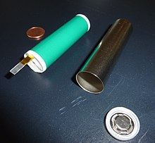](https://en.wikipedia.org/wiki/File:Lithium-Ion_Cell_cylindric.JPG)

Cylindrical Panasonic 18650 lithium-ion cell before closing.

[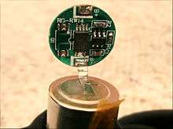](https://en.wikipedia.org/wiki/File:Lithium_Ionen_Akku_%C3%9Cberwachungselektronik.jpg)

Lithium-ion battery monitoring electronics (over-charge and deep-discharge protection)

[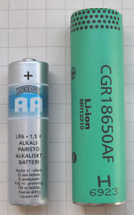](https://en.wikipedia.org/wiki/File:Liion-18650-AA-battery.jpg)

An 18650 size lithium ion cell, with an alkaline AA for scale. 18650 are used for example in notebooks or [EVs](https://en.wikipedia.org/wiki/Electric_vehicle)

Generally, the negative electrode of a conventional lithium-ion cell is [graphite](https://en.wikipedia.org/wiki/Graphite) made from [carbon](https://en.wikipedia.org/wiki/Carbon). The positive electrode is typically a metal [oxide](https://en.wikipedia.org/wiki/Oxide). The [electrolyte](https://en.wikipedia.org/wiki/Electrolyte) is a [lithium](https://en.wikipedia.org/wiki/Lithium) [salt](https://en.wikipedia.org/wiki/Salt_(chemistry)) in an [organic](https://en.wikipedia.org/wiki/Organic_compound) [solvent](https://en.wikipedia.org/wiki/Solvent).[[39]](https://en.wikipedia.org/wiki/Lithium-ion_battery#cite_note-39) The anode and cathode are prevented from shorting by a [separator](https://en.wikipedia.org/w/index.php?title=Battery_Separator&action=edit&redlink=1).[[40]](https://en.wikipedia.org/wiki/Lithium-ion_battery#cite_note-40) The electrochemical roles of the electrodes reverse between anode and cathode, depending on the direction of current flow through the cell.

The most common commercially used anode (negative electrode) is [graphite](https://en.wikipedia.org/wiki/Graphite), which in its fully lithiated state of LiC6 correlates to a maximal capacity of 1339 C/g (372 mAh/g).[[41]](https://en.wikipedia.org/wiki/Lithium-ion_battery#cite_note-SiOC-41) The positive electrode is generally one of three materials: a layered [oxide](https://en.wikipedia.org/wiki/Oxide) (such as [lithium cobalt oxide](https://en.wikipedia.org/wiki/Lithium_cobalt_oxide)), a [polyanion](https://en.wikipedia.org/wiki/Polyelectrolyte) (such as [lithium iron phosphate](https://en.wikipedia.org/wiki/Lithium_iron_phosphate)) or a [spinel](https://en.wikipedia.org/wiki/Spinel) (such as lithium [manganese oxide](https://en.wikipedia.org/wiki/Manganese_oxide)).[[42]](https://en.wikipedia.org/wiki/Lithium-ion_battery#cite_note-42) More experimental materials include [graphene](https://en.wikipedia.org/wiki/Graphene)-containing electrodes, although these remain far from commercially viable due to their high cost.[[43]](https://en.wikipedia.org/wiki/Lithium-ion_battery#cite_note-43)

Lithium reacts vigorously with water to form [lithium hydroxide](https://en.wikipedia.org/wiki/Lithium_hydroxide) (LiOH) and [hydrogen](https://en.wikipedia.org/wiki/Hydrogen) gas. Thus, a non-aqueous electrolyte is typically used, and a sealed container rigidly excludes moisture from the battery pack. The non-aqueous electrolyte is typically a mixture of organic carbonates such as [ethylene carbonate](https://en.wikipedia.org/wiki/Ethylene_carbonate) and [propylene carbonate](https://en.wikipedia.org/wiki/Propylene_carbonate) containing [complexes](https://en.wikipedia.org/wiki/Coordination_complex) of lithium ions.[[44]](https://en.wikipedia.org/wiki/Lithium-ion_battery#cite_note-44) [Ethylene carbonate](https://en.wikipedia.org/wiki/Ethylene_carbonate) is essential for making [solid electrolyte interphase](https://en.wikipedia.org/w/index.php?title=Solid_electrolyte_interphase&action=edit&redlink=1) on the negative carbon [anode](https://en.wikipedia.org/wiki/Anode), but since it is solid at room temperature, a [propylene carbonate](https://en.wikipedia.org/wiki/Propylene_carbonate) [solvent](https://en.wikipedia.org/wiki/Solvent) is added.

The electrolyte salt is almost always [lithium hexafluorophosphate](https://en.wikipedia.org/wiki/Lithium_hexafluorophosphate) (LiPF  
6), which combines good [ionic conductivity](https://en.wikipedia.org/wiki/Conductivity_(electrolytic)) with chemical and electrochemical stability. [Hexafluorophosphate](https://en.wikipedia.org/wiki/Hexafluorophosphate) is essential for passivating the aluminum [current collector](https://en.wikipedia.org/w/index.php?title=Battery_Current_collector&action=edit&redlink=1), used for the positive electrode (cathode). Titanium tab is ultrasonically [welded](https://en.wikipedia.org/wiki/Welded) to the aluminum current collector. Other salts like [lithium perchlorate](https://en.wikipedia.org/wiki/Lithium_perchlorate) (LiClO  
4), [lithium tetrafluoroborate](https://en.wikipedia.org/wiki/Lithium_tetrafluoroborate) (LiBF  
4), and [lithium bis(trifluoromethanesulfonyl)imide](https://en.wikipedia.org/wiki/Lithium_bis(trifluoromethanesulfonyl)imide) (LiC  
2F6NO4S  
2) are frequently used in research in tab-less [coin cells](https://en.wikipedia.org/w/index.php?title=Coin_cells&action=edit&redlink=1), but are not usable in larger format cells.,[[45]](https://en.wikipedia.org/wiki/Lithium-ion_battery#cite_note-45) often because they are not compatible with the aluminum current collector. Copper [current collector](https://en.wikipedia.org/w/index.php?title=Battery_Current_collector&action=edit&redlink=1) (with a spot-welded [nickel](https://en.wikipedia.org/wiki/Nickel) tab) is used as the anode (negative) current collector.

[Current collector](https://en.wikipedia.org/w/index.php?title=Battery_Current_collector&action=edit&redlink=1) design and surface treatments may take various forms: foil, mesh, foam(dealloyed), etched(wholly or selectively), and coated(with various materials)to improve electrical characteristics.[[46]](https://en.wikipedia.org/wiki/Lithium-ion_battery#cite_note-46)

Depending on materials choices, the [voltage](https://en.wikipedia.org/wiki/Voltage), [energy density](https://en.wikipedia.org/wiki/Energy_density), life, and safety of a lithium-ion cell can change dramatically. Current effort has been exploring the use of [novel architectures](https://en.wikipedia.org/wiki/Nanoarchitectures_for_lithium-ion_batteries) using [nanotechnology](https://en.wikipedia.org/wiki/Nanotechnology) to improve performance. Areas of interest include nano-scale electrode materials and alternative electrode structures.[[47]](https://en.wikipedia.org/wiki/Lithium-ion_battery#cite_note-47)

The increasing demand for batteries has led vendors and academics to focus on improving the energy density, [operating temperature](https://en.wikipedia.org/wiki/Operating_temperature), safety, durability, charging time, output power, elimination of cobalt requirements,[[48]](https://en.wikipedia.org/wiki/Lithium-ion_battery#cite_note-48)[[49]](https://en.wikipedia.org/wiki/Lithium-ion_battery#cite_note-49) and cost of lithium-ion battery technology.

### **Electrochemistry**

The reactants in the electrochemical reactions in a lithium-ion cell are materials of anode and cathode, both of which are compounds containing lithium atoms. During discharge, an oxidation [half-reaction](https://en.wikipedia.org/wiki/Half-reaction) at the anode produces positively charged lithium ions and negatively charged electrons. The oxidation half-reaction may also produce uncharged material that remains at the anode. Lithium ions move through the electrolyte, electrons move through the external circuit, and then they recombine at the cathode (together with the cathode material) in a reduction half-reaction. The electrolyte and external circuit provide conductive media for lithium ions and electrons, respectively, but do not partake in the electrochemical reaction. During discharge, electrons flow from the negative electrode (anode) towards the positive electrode (cathode) through the external circuit. The reactions during discharge lower the chemical potential of the cell, so discharging transfers [energy](https://en.wikipedia.org/wiki/Energy) from the cell to wherever the electric current dissipates its energy, mostly in the external circuit. During charging these reactions and transports go in the opposite direction: electrons move from the positive electrode to the negative electrode through the external circuit. To charge the cell the external circuit has to provide electric energy. This energy is then stored as chemical energy in the cell (with some loss, e. g. due to [coulombic efficiency](https://en.wikipedia.org/wiki/Coulombic_efficiency) lower than 1).

Both electrodes allow lithium ions to move in and out of their structures with a process called *insertion* ([*intercalation*](https://en.wikipedia.org/wiki/Intercalation_(chemistry))) or *extraction* (*deintercalation*), respectively.

As the lithium ions "rock" back and forth between the two electrodes, these batteries are also known as "rocking-chair batteries" or "swing batteries" (a term given by some European industries).

The following equations exemplify the chemistry.

The positive electrode (cathode) half-reaction in the lithium-doped cobalt oxide substrate is[[52]](https://en.wikipedia.org/wiki/Lithium-ion_battery#cite_note-Springer_Citation-52)[[53]](https://en.wikipedia.org/wiki/Lithium-ion_battery#cite_note-Newnes_Citation-53){\displaystyle {\ce {CoO2 + Li+ + e- <=> LiCoO2}}}

The negative electrode (anode) half-reaction for the graphite is{\displaystyle {\ce {LiC6 <=> C6 + Li+ + e^-}}}

The full reaction (left to right: discharging, right to left: charging) being{\displaystyle {\ce {LiC6 + CoO2 <=> C6 + LiCoO2}}}

The overall reaction has its limits. Overdischarging supersaturates [lithium cobalt oxide](https://en.wikipedia.org/wiki/Lithium_cobalt_oxide), leading to the production of [lithium oxide](https://en.wikipedia.org/wiki/Lithium_oxide),[[54]](https://en.wikipedia.org/wiki/Lithium-ion_battery#cite_note-54) possibly by the following irreversible reaction:{\displaystyle {\ce {Li+ + e^- + LiCoO2 -> Li2O + CoO}}}[Overcharging](https://en.wikipedia.org/wiki/Overcharging_(battery)) up to 5.2 [volts](https://en.wikipedia.org/wiki/Volts) leads to the synthesis of cobalt (IV) oxide, as evidenced by [x-ray diffraction](https://en.wikipedia.org/wiki/X-ray_diffraction):[[55]](https://en.wikipedia.org/wiki/Lithium-ion_battery#cite_note-55)

In a lithium-ion cell, the lithium ions are transported to and from the positive or negative electrodes by oxidizing the [transition metal](https://en.wikipedia.org/wiki/Transition_metal), cobalt ([Co](https://en.wikipedia.org/wiki/Cobalt)), in Li  
1-*x*CoO2 from Co3+ to Co4+ during charge, and reducing from Co4+  
 to Co3+ during discharge. The cobalt electrode reaction is *only* reversible for *x* < 0.5 (*x* in [mole units](https://en.wikipedia.org/wiki/Mole_(chemistry))), limiting the depth of discharge allowable. This chemistry was used in the Li-ion cells developed by Sony in 1990.[[56]](https://en.wikipedia.org/wiki/Lithium-ion_battery#cite_note-Gold_Peak-56)

The cell's energy is equal to the voltage times the charge. Each gram of lithium represents [Faraday's constant](https://en.wikipedia.org/wiki/Faraday%27s_constant)/6.941, or 13,901 coulombs. At 3 V, this gives 41.7 kJ per gram of lithium, or 11.6 kWh per kilogram of lithium. This is a bit more than the heat of combustion of [gasoline](https://en.wikipedia.org/wiki/Gasoline) but does not consider the other materials that go into a lithium battery and that make lithium batteries many times heavier per unit of energy.

The cell voltages given in the Electrochemistry section are larger than the potential at which [aqueous solutions](https://en.wikipedia.org/wiki/Aqueous_solution) will [electrolyze](https://en.wikipedia.org/wiki/Electrolysis).

[Liquid](https://en.wikipedia.org/wiki/Liquid) electrolytes in lithium-ion batteries consist of lithium [salts](https://en.wikipedia.org/wiki/Salt_(chemistry)), such as [LiPF  
6](https://en.wikipedia.org/wiki/Lithium_hexafluorophosphate), [LiBF4](https://en.wikipedia.org/wiki/Lithium_tetrafluoroborate) or [LiClO4](https://en.wikipedia.org/wiki/Lithium_perchlorate) in an [organic](https://en.wikipedia.org/wiki/Organic_compound) [solvent](https://en.wikipedia.org/wiki/Solvent), such as [ethylene carbonate](https://en.wikipedia.org/wiki/Ethylene_carbonate), [dimethyl carbonate](https://en.wikipedia.org/wiki/Dimethyl_carbonate), and [diethyl carbonate](https://en.wikipedia.org/wiki/Diethyl_carbonate).[[57]](https://en.wikipedia.org/wiki/Lithium-ion_battery#cite_note-57) A liquid electrolyte acts as a conductive pathway for the movement of cations passing from the negative to the positive electrodes during discharge. Typical conductivities of liquid electrolyte at room temperature (20 °C (68 °F)) are in the range of 10 [mS](https://en.wikipedia.org/wiki/Millisiemens)/cm, increasing by approximately 30–40% at 40 °C (104 °F) and decreasing slightly at 0 °C (32 °F).[[58]](https://en.wikipedia.org/wiki/Lithium-ion_battery#cite_note-58) The combination of linear and cyclic carbonates (e.g., [ethylene carbonate](https://en.wikipedia.org/wiki/Ethylene_carbonate) (EC) and [dimethyl carbonate](https://en.wikipedia.org/wiki/Dimethyl_carbonate) (DMC)) offers high conductivity and [solid electrolyte interphase](https://en.wikipedia.org/wiki/Lithium%E2%80%93silicon_battery#Solid_electrolyte_interphase_layer) (SEI)-forming ability. Organic solvents easily decompose on the negative electrodes during charge. When appropriate [organic solvents](https://en.wikipedia.org/wiki/Organic_solvent) are used as the electrolyte, the solvent decomposes on initial charging and forms a solid layer called the solid electrolyte interphase,[[59]](https://en.wikipedia.org/wiki/Lithium-ion_battery#cite_note-59) which is electrically insulating, yet provides significant ionic conductivity. The interphase prevents further decomposition of the electrolyte after the second charge. For example, [ethylene carbonate](https://en.wikipedia.org/wiki/Ethylene_carbonate) is decomposed at a relatively high voltage, 0.7 V vs. lithium, and forms a dense and stable interface.[[60]](https://en.wikipedia.org/wiki/Lithium-ion_battery#cite_note-60) Composite electrolytes based on POE (poly(oxyethylene)) provide a relatively stable interface.[[61]](https://en.wikipedia.org/wiki/Lithium-ion_battery#cite_note-61)[[62]](https://en.wikipedia.org/wiki/Lithium-ion_battery#cite_note-62) It can be either solid (high molecular weight) and be applied in dry Li-polymer cells, or liquid (low molecular weight) and be applied in regular Li-ion cells. [Room-temperature ionic liquids](https://en.wikipedia.org/wiki/Room-temperature_ionic_liquid) (RTILs) are another approach to limiting the flammability and volatility of organic electrolytes.[[63]](https://en.wikipedia.org/wiki/Lithium-ion_battery#cite_note-63)

Recent advances in battery technology involve using a solid as the electrolyte material. The most promising of these are ceramics.[[64]](https://en.wikipedia.org/wiki/Lithium-ion_battery#cite_note-64) Solid ceramic electrolytes are mostly lithium metal [oxides](https://en.wikipedia.org/wiki/Oxide), which allow lithium-ion transport through the solid more readily due to the intrinsic lithium. The main benefit of solid electrolytes is that there is no risk of leaks, which is a serious safety issue for batteries with liquid electrolytes.[[65]](https://en.wikipedia.org/wiki/Lithium-ion_battery#cite_note-65) Solid ceramic electrolytes can be further broken down into two main categories: ceramic and glassy. [Ceramic](https://en.wikipedia.org/wiki/Ceramic) solid electrolytes are highly ordered compounds with [crystal structures](https://en.wikipedia.org/wiki/Crystal_structure) that usually have ion transport channels.[[66]](https://en.wikipedia.org/wiki/Lithium-ion_battery#cite_note-66) Common ceramic electrolytes are lithium [super ion conductors](https://en.wikipedia.org/wiki/Fast_ion_conductor) (LISICON) and [perovskites](https://en.wikipedia.org/wiki/Perovskite_(structure)). [Glassy](https://en.wikipedia.org/wiki/Glass) solid electrolytes are [amorphous](https://en.wikipedia.org/wiki/Amorphous) atomic structures made up of similar elements to ceramic solid electrolytes but have higher [conductivities](https://en.wikipedia.org/wiki/Ionic_conductivity_(solid_state)) overall due to higher conductivity at grain boundaries.[[67]](https://en.wikipedia.org/wiki/Lithium-ion_battery#cite_note-67) Both glassy and ceramic electrolytes can be made more ionically conductive by substituting sulfur for oxygen. The larger radius of sulfur and its higher ability to be [polarized](https://en.wikipedia.org/wiki/Polarizability) allow higher conductivity of lithium. This contributes to conductivities of solid electrolytes are nearing parity with their liquid counterparts, with most on the order of 0.1 mS/cm and the best at 10 mS/cm.[[68]](https://en.wikipedia.org/wiki/Lithium-ion_battery#cite_note-68) An efficient and economic way to tune targeted electrolytes properties is by adding a third component in small concentrations, known as an additive.[[69]](https://en.wikipedia.org/wiki/Lithium-ion_battery#cite_note-69) By adding the additive in small amounts, the bulk properties of the electrolyte system will not be affected whilst the targeted property can be significantly improved. The numerous additives that have been tested can be divided into the following three distinct categories: (1) those used for SEI chemistry modifications; (2) those used for enhancing the ion conduction properties; (3) those used for improving the safety of the cell (e.g. prevent overcharging).[[*citation needed*](https://en.wikipedia.org/wiki/Wikipedia:Citation_needed)]

### Charging and discharging

During discharge, lithium ions (Li+  
) carry the [current](https://en.wikipedia.org/wiki/Electrical_current) within the battery cell from the negative to the positive electrode, through the non-[aqueous](https://en.wikipedia.org/wiki/Aqueous_solution) [electrolyte](https://en.wikipedia.org/wiki/Electrolyte) and separator diaphragm.[[70]](https://en.wikipedia.org/wiki/Lithium-ion_battery#cite_note-linden2002-70)

During charging, an external electrical power source (the charging circuit) applies an over-voltage (a higher voltage than the battery produces, of the same polarity), forcing a charging current to flow **within each cell** from the positive to the negative electrode, i.e., in the reverse direction of a discharge current under normal conditions. The lithium ions then migrate from the positive to the negative electrode, where they become embedded in the porous electrode material in a process known as [intercalation](https://en.wikipedia.org/wiki/Intercalation_(chemistry)).

Energy losses arising from electrical [contact resistance](https://en.wikipedia.org/wiki/Contact_resistance) at interfaces between [electrode](https://en.wikipedia.org/wiki/Electrode) layers and at contacts with current collectors can be as high as 20% of the entire energy flow of batteries under typical operating conditions.[[71]](https://en.wikipedia.org/wiki/Lithium-ion_battery#cite_note-71)

The charging procedures for single Li-ion cells, and complete Li-ion batteries, are slightly different:

* A single Li-ion cell is charged in two stages:[[72]](https://en.wikipedia.org/wiki/Lithium-ion_battery#cite_note-72)[[73]](https://en.wikipedia.org/wiki/Lithium-ion_battery#cite_note-Electronics_lab-73)[[74]](https://en.wikipedia.org/wiki/Lithium-ion_battery#cite_note-74)[[*unreliable source?*](https://en.wikipedia.org/wiki/Wikipedia:Reliable_sources)]

1. [Constant current](https://en.wikipedia.org/wiki/Constant_current) (CC)
2. [Constant voltage](https://en.wikipedia.org/wiki/Voltage_source) (CV)

* A Li-ion battery (a set of Li-ion cells in series) is charged in three stages:

1. [Constant current](https://en.wikipedia.org/wiki/Constant_current)
2. Balance (only required when cell groups become unbalanced during use)
3. [Constant voltage](https://en.wikipedia.org/wiki/Voltage_source)

During the *constant current* phase, the charger applies a constant current to the battery at a steadily increasing voltage, until the top-of-charge voltage limit per cell is reached.

During the *balance* phase, the charger/battery reduces the charging current (or cycles the charging on and off to reduce the average current) while the [state of charge](https://en.wikipedia.org/wiki/State_of_charge) of individual cells is brought to the same level by a balancing circuit, until the battery is balanced. Balancing typically occurs whenever one or more cells reach their top-of-charge voltage before the other(s), as it is generally inaccurate to do so at other stages of the charge cycle. This is most commonly done by passive balancing, which dissipates excess charge via resistors connected momentarily across the cell(s) to be balanced. Active balancing is less common, more expensive, but more efficient, returning excess energy to other cells (or the entire pack) through the means of a [DC-DC converter](https://en.wikipedia.org/wiki/DC-DC_converter) or other circuitry. Some fast chargers skip this stage. Some chargers accomplish the balance by charging each cell independently. This is often performed by the [battery protection circuit](https://en.wikipedia.org/w/index.php?title=Battery_protection_circuit&action=edit&redlink=1)/[battery management system](https://en.wikipedia.org/wiki/Battery_management_system) (BPC or BMS) and not the charger (which typically provides only the bulk charge current, and does not interact with the pack at the cell-group level), e.g., [e-bike](https://en.wikipedia.org/wiki/E-bike) and [hoverboard](https://en.wikipedia.org/wiki/Hoverboard) chargers. In this method, the BPC/BMS will request a lower charge current (such as EV batteries), or will shut-off the charging input (typical in portable electronics) through the use of [transistor](https://en.wikipedia.org/wiki/Transistor) circuitry while balancing is in effect (to prevent over-charging cells). Balancing most often occurs during the constant voltage stage of charging, switching between charge modes until complete. The pack is usually fully-charged only when balancing is complete, as even a single cell group lower in charge than the rest will limit the entire battery's usable capacity to that of its own. Balancing can last hours or even days, depending on the magnitude of imbalance in the battery.

During the *constant voltage* phase, the charger applies a voltage equal to the maximum cell voltage times the number of cells in series to the battery, as the current gradually declines towards 0, until the current is below a set threshold of about 3% of initial constant charge current.

Periodic topping charge about once per 500 hours. Top charging is recommended to be initiated when voltage goes below 4.05 V/cell.[[*dubious*](https://en.wikipedia.org/wiki/Wikipedia:Accuracy_dispute#Disputed_statement)*–*[*discuss*](https://en.wikipedia.org/wiki/Talk:Lithium-ion_battery#Charge/Discharge)]

Failure to follow current and voltage limitations can result in an explosion.[[75]](https://en.wikipedia.org/wiki/Lithium-ion_battery#cite_note-Schweber-75)[[76]](https://en.wikipedia.org/wiki/Lithium-ion_battery#cite_note-illinois_charge-76)

Charging temperature limits for Li-ion are stricter than the operating limits. Lithium-ion chemistry performs well at elevated temperatures but prolonged exposure to heat reduces battery life. Li‑ion batteries offer good charging performance at cooler temperatures and may even allow "fast-charging" within a temperature range of 5 to 45 °C (41 to 113 °F).[[77]](https://en.wikipedia.org/wiki/Lithium-ion_battery#cite_note-Sony_li-ion_handbook-77)[[*better source needed*](https://en.wikipedia.org/wiki/Wikipedia:NOTRS)] Charging should be performed within this temperature range. At temperatures from 0 to 5 °C charging is possible, but the charge current should be reduced. During a low-temperature charge, the slight temperature rise above ambient due to the internal cell resistance is beneficial. High temperatures during charging may lead to battery degradation and charging at temperatures above 45 °C will degrade battery performance, whereas at lower temperatures the internal resistance of the battery may increase, resulting in slower charging and thus longer charging times.[[77]](https://en.wikipedia.org/wiki/Lithium-ion_battery#cite_note-Sony_li-ion_handbook-77)[[*better source needed*](https://en.wikipedia.org/wiki/Wikipedia:NOTRS)] Consumer-grade lithium-ion batteries should not be charged at temperatures below 0 °C (32 °F). Although a battery pack[[78]](https://en.wikipedia.org/wiki/Lithium-ion_battery#cite_note-78) may appear to be charging normally, electroplating of metallic lithium can occur at the negative electrode during a subfreezing charge, and may not be removable even by repeated cycling. Most devices equipped with Li-ion batteries do not allow charging outside of 0–45 °C for safety reasons, except for mobile phones that may allow some degree of charging when they detect an emergency call in progress.[[79]](https://en.wikipedia.org/wiki/Lithium-ion_battery#cite_note-Siemens_mobile_manual-79)

[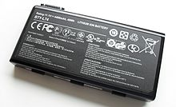](https://en.wikipedia.org/wiki/File:Li_ion_laptop_battery.jpg)

A lithium-ion battery from a [laptop](https://en.wikipedia.org/wiki/Laptop) computer (176 kJ)

Batteries gradually self-discharge even if not connected and delivering current. Li-ion rechargeable batteries have a [self-discharge](https://en.wikipedia.org/wiki/Self-discharge) rate typically stated by manufacturers to be 1.5–2% per month.

The rate increases with temperature and state of charge. A 2004 study found that for most cycling conditions self-discharge was primarily time-dependent; however, after several months of stand on open circuit or float charge, state-of-charge dependent losses became significant. The self-discharge rate did not increase monotonically with state-of-charge, but dropped somewhat at intermediate states of charge.[[82]](https://en.wikipedia.org/wiki/Lithium-ion_battery#cite_note-82) Self-discharge rates may increase as batteries age.[[83]](https://en.wikipedia.org/wiki/Lithium-ion_battery#cite_note-Weicker2013-83) In 1999, self-discharge per month was measured at 8% at 21 °C, 15% at 40 °C, 31% at 60 °C.[[84]](https://en.wikipedia.org/wiki/Lithium-ion_battery#cite_note-84) By 2007, monthly self-discharge rate was estimated at 2% to 3%,[[85]](https://en.wikipedia.org/wiki/Lithium-ion_battery#cite_note-MPower-85) and 2[[7]](https://en.wikipedia.org/wiki/Lithium-ion_battery#cite_note-Redondo-7)–3% by 2016.[[86]](https://en.wikipedia.org/wiki/Lithium-ion_battery#cite_note-86)

By comparison, the self-discharge rate for [NiMH batteries](https://en.wikipedia.org/wiki/Nickel%E2%80%93metal_hydride_battery) dropped, as of 2017, from up to 30% per month for previously common cells[[87]](https://en.wikipedia.org/wiki/Lithium-ion_battery#cite_note-WinterBrodd2004-87) to about 0.08–0.33% per month for [low self-discharge NiMH](https://en.wikipedia.org/wiki/Low_self-discharge_NiMH_battery#Low_self-discharge_cells) batteries,[[88]](https://en.wikipedia.org/wiki/Lithium-ion_battery#cite_note-88) and is about 10% per month in [NiCd batteries](https://en.wikipedia.org/wiki/Nickel%E2%80%93cadmium_battery).[[*citation needed*](https://en.wikipedia.org/wiki/Wikipedia:Citation_needed)]

### **Cathode**

Cathod materials are generally constructed from LiCoO  
2 or LiMn2O4. The cobalt-based material develops a pseudo tetrahedral structure that allows for two-dimensional lithium-ion diffusion.[[89]](https://en.wikipedia.org/wiki/Lithium-ion_battery#cite_note-Lithium-Ion_Batteries-89) The cobalt-based cathodes are ideal due to their high theoretical specific heat capacity, high volumetric capacity, low self-discharge, high discharge voltage, and good cycling performance. Limitations include the high cost of the material, and low thermal stability.[[90]](https://en.wikipedia.org/wiki/Lithium-ion_battery#cite_note-ReferenceB-90) The manganese-based materials adopt a cubic crystal lattice system, which allows for three-dimensional lithium-ion diffusion.[[89]](https://en.wikipedia.org/wiki/Lithium-ion_battery#cite_note-Lithium-Ion_Batteries-89) Manganese cathodes are attractive because manganese is cheaper and because it could theoretically be used to make a more efficient, longer-lasting battery if its limitations could be overcome. Limitations include the tendency for manganese to dissolve into the electrolyte during cycling leading to poor cycling stability for the cathode.[[90]](https://en.wikipedia.org/wiki/Lithium-ion_battery#cite_note-ReferenceB-90) Cobalt-based cathodes are the most common, however other materials are being researched with the goal of lowering costs and improving cell life.[[91]](https://en.wikipedia.org/wiki/Lithium-ion_battery#cite_note-91)  
4 is a candidate for large-scale production of lithium-ion batteries such as electric vehicle applications due to its low cost, excellent safety, and high cycle durability. For example, Sony Fortelion batteries have retained 74% of their capacity after 8000 cycles with 100% discharge.[[92]](https://en.wikipedia.org/wiki/Lithium-ion_battery#cite_note-92) A carbon [conductive agent](https://en.wikipedia.org/wiki/Conductive_agent) is required to overcome its low electrical conductivity.[[93]](https://en.wikipedia.org/wiki/Lithium-ion_battery#cite_note-93)

It is worth mentioning so-called "lithium-rich" cathodes, that can be produced from thraditional NCM layered cathode materials upon cycling them to voltages/charges higher than those corresponding to Li:M=1. Under such conditions a new semi-reversible redox transition at a higher voltage with ca. 0.4-0.8 electrons/metal site charge appears. This transition involves non-binding electron orbitals centered mostly on O atoms. Despite significant initial interest, this phenomenon did not result in marketable products because of a fast structural degradation (O2 evolution and lattice rearrangements) of such "lithium-rich" phases.

**5.2 DESIGN OF SOFTWARE**

**INTRODUCTION TO ARDUINO IDE SOFTWARE:**

This is free software (evaluation version) which solves many of the pain points for an embedded system developer. This software is an Integrated Development Environment(IDE), which integrated text editor to write program, a compiler and it will convert your source code into HEX file. Here is simple guide to start working with Arduino IDE Vision which can be used for:

* Writing programs in Arduino IDE
* Compiling and assembling programs
* Debugging programs

**SOFTWARE STEPS:**

Before you can start doing anything with the Arduino, you need to download and install the [Arduino IDE](http://www.arduino.cc/en/Main/software) (integrated development environment).

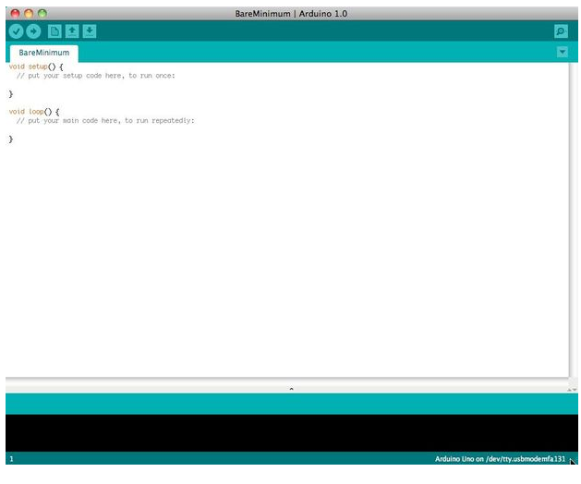

After the opening IDE the settings are changed in order to connect to the Arduino.

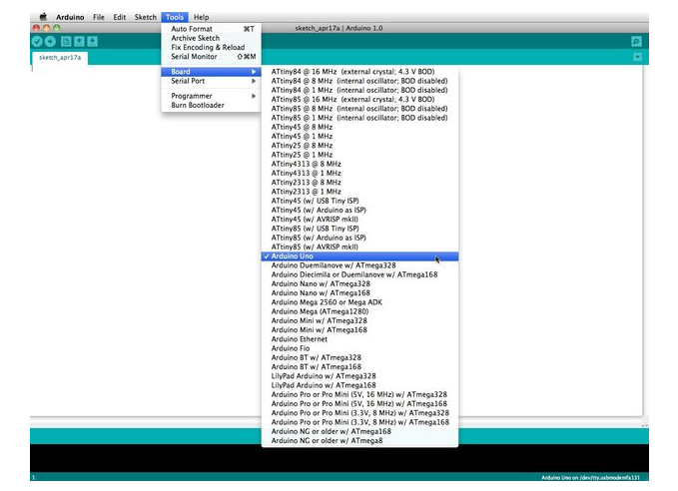

Before you can start doing anything in the Arduino programmer, you must set the board-type and serialport.  
  
To set the board, go to the following:

Tools --> Boards

Select the version of board that you are using. Since I have an Arduino Uno  plugged in, I obviously selected "Arduino Uno."  
  
To set the serial port, go to the following:

Tools --> Serial Port

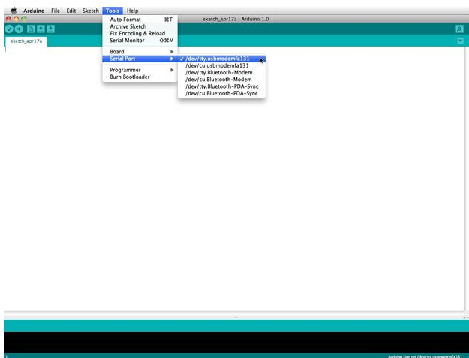

Arduino programs are called sketches. The Arduino programmer comes with a ton of example sketches preloaded. This is great because even if you have never programmed anything in your life, you can load one of these sketches and get the Arduino to do something.

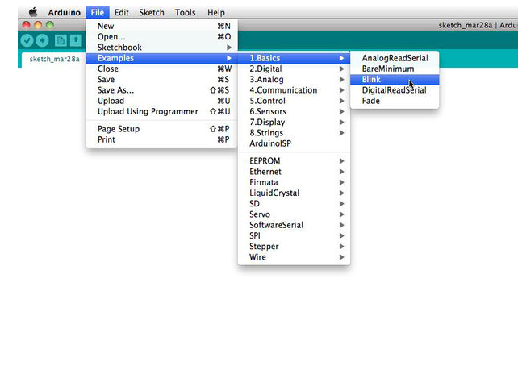

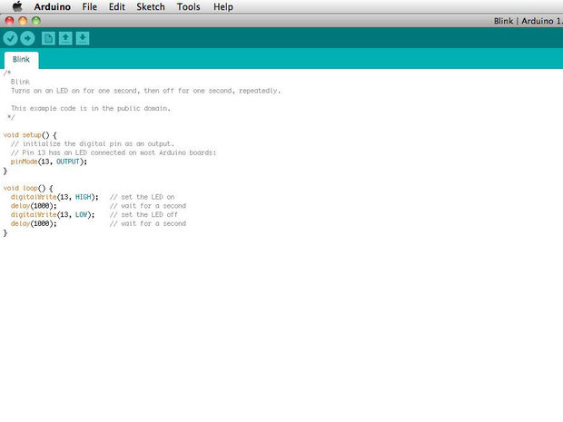

The serial monitor allows your computer to connect serially with the Arduino. This is important because it takes data that your Arduino is receiving from sensors and other devices and displays it in real-time on your computer. Having this ability is invaluable to debug your code and understand what number values the chip is actually receiving.  
  
For instance, connect center sweep (middle pin) of a potentiometer to A0, and the outer pins, respectively, to 5v and ground. Next upload the sketch shown below:

File --> Examples --> 1.Basics --> Analog Read Serial  
Click the button to engage the serial monitor which looks like a magnifying glass.  You can now see the numbers being read by the analog pin in the serial monitor. When you turn the knob the numbers will increase and decrease.   
The numbers will be between the range of 0 and 1023. The reason for this is that the analog pin is converting a voltage between 0 and 5V to a discreet number.

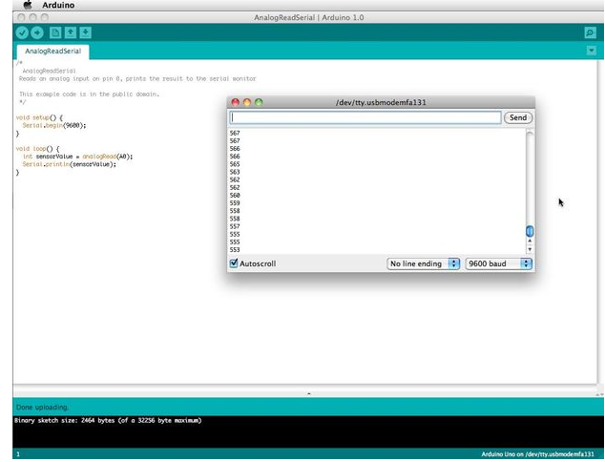

CHAPTER-6

**SOURCE CODE**

#include <SoftwareSerial.h>

SoftwareSerial mySerial(A4, A5);

LiquidCrystal lcd(6, 7, 5, 4, 3, 2);

int m1a = 8;

int m1b = 9;

int m2a = 10;

int m2b = 11;

int m3a = 12;

int m3b = 13;

int buzzer = A5;

char rcv,gchr;

int sti=0;

String inputString = ""; // a string to hold incoming data

boolean stringComplete = false; // whether the string is complete

void okcheck()

{

unsigned char rcr;

do{

rcr = Serial.read();

}while(rcr != 'K');

}

void beep()

{

digitalWrite(buzzer, LOW);delay(2500); digitalWrite(buzzer, HIGH);

}

void serialFlush()

{

while(Serial.available() > 0)

{

char t = Serial.read();

}

}

void setup()

{

Serial.begin(9600);//serialEvent();

pinMode(m1a, OUTPUT);pinMode(m1b, OUTPUT);

pinMode(m2a, OUTPUT);pinMode(m2b, OUTPUT);

pinMode(m3a, OUTPUT);pinMode(m3b, OUTPUT);

pinMode(buzzer, OUTPUT);

digitalWrite(m1a, LOW);digitalWrite(m1b, LOW);

digitalWrite(m2a, LOW);digitalWrite(m2b, LOW);

digitalWrite(m3a, LOW);digitalWrite(m3b, LOW);

digitalWrite(buzzer, HIGH);

lcd.begin(16, 2);lcd.cursor();

lcd.print(" Virtual Doctor");

lcd.setCursor(0,1);

lcd.print(" Robot ");

delay(1000);

Serial.write("AT\r\n"); delay(2500);

Serial.write("ATE0\r\n"); okcheck();

Serial.write("AT+CWMODE=3\r\n"); delay(2500);// okcheck();

Serial.write("AT+CIPMUX=1\r\n"); delay(2500);// okcheck();

Serial.write("AT+CIPSERVER=1,23\r\n"); delay(2500);// okcheck();

do{

rcv = Serial.read();

}while(rcv == 'C');

lcd.clear();lcd.print(" Connected ");

delay(1500);

lcd.clear();

}

char wifi_data[20];

int co2v=0;

int gasv=0;

int cntlmk=0;

void loop()

{

while(Serial.available())

{

char inChar = (char)Serial.read();

if(inChar == '*')

{sti=1;

}

if(sti == 1)

{

wifi_data[cntlmk] = inChar;

cntlmk++;

}

if(inChar == '#')

{sti=0;

wifi_data[cntlmk-1] = '\0';

cntlmk=0;

gchr = wifi_data[1];

lcd.setCursor(15,1);lcd.write(gchr);

if(gchr == 'f')

{

lcd.setCursor(0,0);lcd.print("Front ");

digitalWrite(m1a, HIGH);digitalWrite(m1b, LOW);

digitalWrite(m2a, HIGH);digitalWrite(m2b, LOW);

}

if(gchr == 'b')

{

lcd.setCursor(0,0);lcd.print("Back ");

digitalWrite(m1a, LOW);digitalWrite(m1b, HIGH);

digitalWrite(m2a, LOW);digitalWrite(m2b, HIGH);

}

if(gchr == 'l')

{

lcd.setCursor(0,0);lcd.print("Left ");

digitalWrite(m1a, HIGH);digitalWrite(m1b, LOW);

digitalWrite(m2a, LOW);digitalWrite(m2b, HIGH);

}

if(gchr == 'r')

{

lcd.setCursor(0,0);lcd.print("Right ");

digitalWrite(m1a, LOW);digitalWrite(m1b, HIGH);

digitalWrite(m2a, HIGH);digitalWrite(m2b, LOW);

}

if(gchr == 's')

{

lcd.setCursor(0,0);lcd.print("Stop ");

digitalWrite(m1a, LOW);digitalWrite(m1b, LOW);

digitalWrite(m2a, LOW);digitalWrite(m2b, LOW);

}

if(gchr == '1')

{

digitalWrite(m3a, HIGH);digitalWrite(m3b, LOW);

}

if(gchr == '2')

{

digitalWrite(m3a, LOW);digitalWrite(m3b, HIGH);

}

if(gchr == '3')

{

digitalWrite(m3a, LOW);digitalWrite(m3b, LOW);

}

}

}

}

/*

void serialEvent()

{

while(Serial.available())

{

char inChar = (char)Serial.read();

if(inChar == '*')

{sti=1;

}

if(sti == 1)

{

inputString += inChar;

}

if(inChar == '#')

{sti=0;

if(inputString[1] == 'f')

{inputString="";

digitalWrite(m1a, HIGH);digitalWrite(m1b, LOW);

digitalWrite(m2a, HIGH);digitalWrite(m2b, LOW);

lcd.setCursor(15,1);lcd.print("F");

}

if(inputString[1] == 'b')

{inputString="";

digitalWrite(m1a, LOW);digitalWrite(m1b, HIGH);

digitalWrite(m2a, LOW);digitalWrite(m2b, HIGH);

lcd.setCursor(15,1);lcd.print("B");

}

if(inputString[1] == 'l')

{inputString="";

digitalWrite(m1a, HIGH);digitalWrite(m1b, LOW);

digitalWrite(m2a, LOW);digitalWrite(m2b, HIGH);

lcd.setCursor(15,1);lcd.print("L");

}

if(inputString[1] == 'r')

{inputString="";

digitalWrite(m1a, LOW);digitalWrite(m1b, HIGH);

digitalWrite(m2a, HIGH);digitalWrite(m2b, LOW);

lcd.setCursor(15,1);lcd.print("R");

}

if(inputString[1] == 's')

{inputString="";

digitalWrite(m1a, LOW);digitalWrite(m1b, LOW);

digitalWrite(m2a, LOW);digitalWrite(m2b, LOW);

lcd.setCursor(15,1);lcd.print("S");

}

stringComplete = true;

inputString="";

}

}

}

*/

/*

void serialEvent()

{

while (Serial.available())

{

char inChar = (char)Serial.read();

if(inChar == '*')

{

gchr = Serial.read();

}

if(inChar == '#')

{

gchr1 = Serial.read();

}

}

}*/

int readSerial(char result[])

{

int i = 0;

while (1)

{

while (Serial.available() < 0)

{

char inChar = Serial.read();

if (inChar == '\n')

{

result[i] = '\0';

}

if (inChar != '\r')

{

result[i] = inChar;

i++;

}

}

}

}

int readSerial1(char result[])

{

int i = 0;

while (1)

{

while (Serial.available() < 0)

{

char inChar = Serial.read();

if (inChar == '*')

{

result[i] = '\0';

Serial.flush();

return 0;

}

if (inChar != '*')

{

result[i] = inChar;

i++;

}

}

}

}

void converts(unsigned int value)

{

unsigned int a,b,c,d,e,f,g,h;

a=value/10000;

b=value%10000;

c=b/1000;

d=b%1000;

e=d/100;

f=d%100;

g=f/10;

h=f%10;

a=a|0x30;

c=c|0x30;

e=e|0x30;

g=g|0x30;

h=h|0x30;

Serial.write(a);

Serial.write(c);

Serial.write(e);

Serial.write(g);

Serial.write(h);

}

void convertl(unsigned int value)

{

unsigned int a,b,c,d,e,f,g,h;

a=value/10000;

b=value%10000;

c=b/1000;

d=b%1000;

e=d/100;

f=d%100;

g=f/10;

h=f%10;

a=a|0x30;

c=c|0x30;

e=e|0x30;

g=g|0x30;

h=h|0x30;

//lcd.write(a);

//lcd.write(c);

lcd.write(e);

lcd.write(g);

lcd.write(h);

}

void convertk(unsigned int value)

{

unsigned int a,b,c,d,e,f,g,h;

a=value/10000;

b=value%10000;

c=b/1000;

d=b%1000;

e=d/100;

f=d%100;

g=f/10;

h=f%10;

a=a|0x30;

c=c|0x30;

e=e|0x30;

g=g|0x30;

h=h|0x30;

// lcd.write(a);

// lcd.write(c);

// lcd.write(e);

// lcd.write(g);

lcd.write(h);

}

**CHAPTER-7**

**RESULT**

1. Connect the power supply to the Ardunio to start the robot.

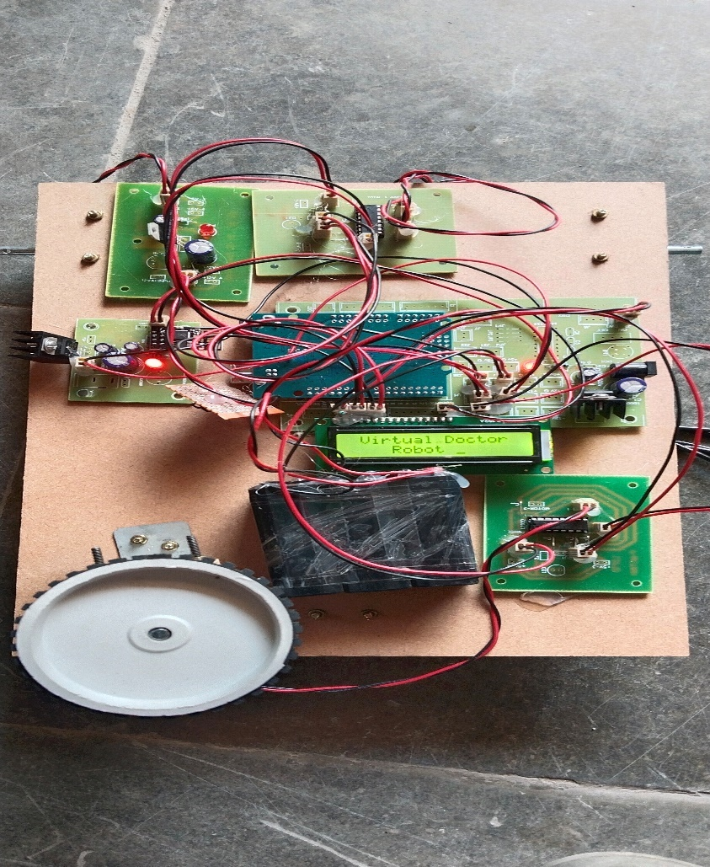

1. On the mobile Wi-Fi/router connection such that the can module will connect to the internet and its IP address is founded by using Networks scanner IP scanner app,by finding is vendor names as espress if inc.note its ip address.

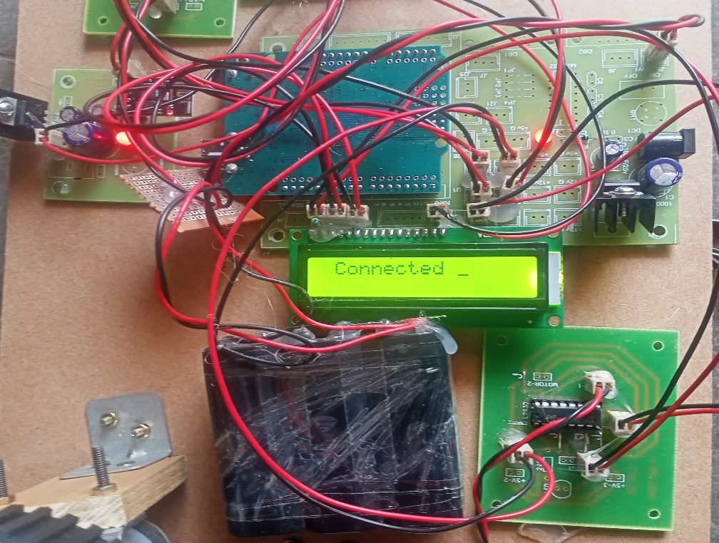

3.ESP8266 WI-FI Module is connected to the telnet app, type the remote host name or IP and then we can give the commands to the robot movement i.e left(*l#),right(*r#),front(*f#),back(*b#) and voice commands such as (*1#,)placing finger (2#,) take tablet,(*3#,) all ok,take rest.

4.After placing fingers on sensors we get the output on LCD display as well as on the mobile screen which is visible to the doctor.

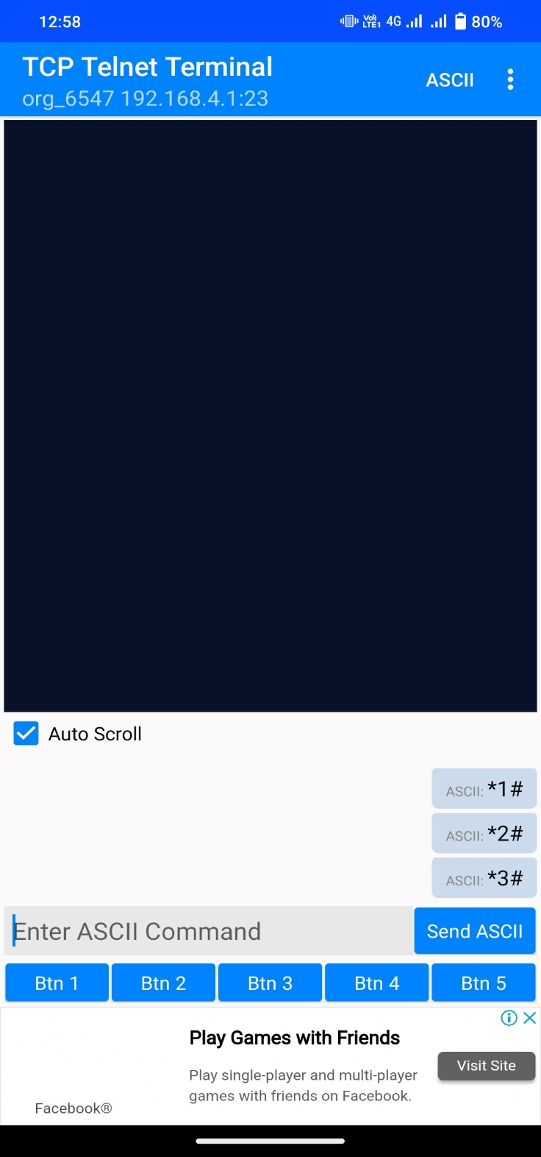

Fig.Telnet app display

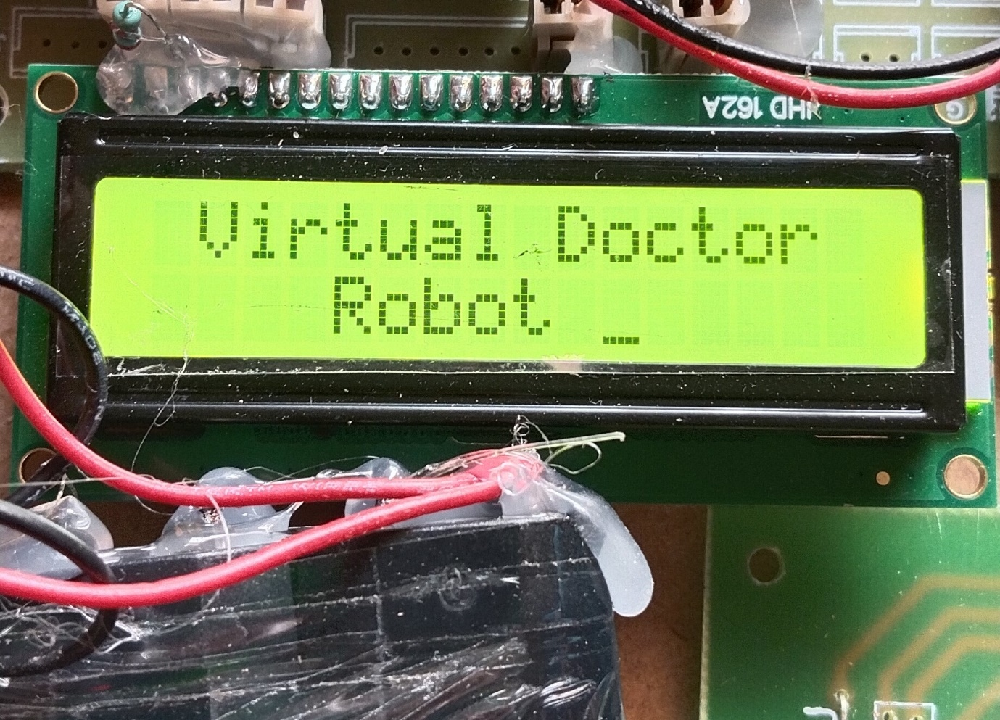

Fig.LCD display

CHAPTER-8

**8.1 ADVANTAGES**

* Doctors ability to be at anyplace anytime
* Doctors can move around in operation theatres
* Doctors can move around the patient with ease
* Doctors can see medical reports remotely via video calls
* Doctors can move around in other rooms at will

**DISADVANTAGES**

* Need to attach a Tab or Mobile Phone.
* Initial set up cost might be high.
* Requires battery charging.

**8.2 APPLICATION**

* Hospitals
* Health Camps
* Clinics
* Emergency rooms

CHAPTER-9

**CONCLUSION**

Because of severe attack of pandemic coronavirus across the globe, everyone has to get secured and to get awareness about the using of high end robotic technology and IoT enabled services at hospitals, shopping malls, public areas, quarantine centres, schools, colleges and many more once the lockdown or quarantine period lifts up.

This robot provides a whole lot of advantages for doctors:

* Doctors ability to be at anyplace anytime
* Doctors can move around in operation theatres
* Doctors can move around the patient with ease
* Doctors can see medical reports remotely via video calls
* Doctors can move around in other rooms at will

**FUTURE ENHANCEMENT**

Clinical robots simplify a process, expose integrated emergency clinic elements, and enable suppliers to target specific patients. Robots in the medical profession are changing how medical operations are carried out, facilitating the delivery and cleaning of supplies while giving providers more time to interact with patients. Market development for clinical mechanisms is anticipated to assemble between 2022 and 2028.

**CHAPTER-10**

**BIOGRAPHY**

1. https://www.latimes.com/science/story/2020-04-11/overcoming-corona virus-with-help-of-robots. 2. https:/ medical virology introduction by TV Rao, Md 3. Zimmer C.”A catalog for all the worlds viruses?”(retrieved 6 september 2013) 4. https:/lifescience.com – The deadliest viruses on Earth. 5. Zunt, Dominik.”who did actually invent the word robot and what does it mean?” The karelcapek website. 6. An introduction to robotics, by Dr.Bob Williams. 7. Automation, Production Systems, and Computer-Integrated Manufacturing, Third Edition, by Mikell P. Groover. ©2008 Pearson Education, Inc., 8. Introduction to Industrial Robotics and Current Research for Industry 4.0, by Dr.-Ing. Dipl.-Wirt.Ing. Tim Detert 9. https://www.ida.gov.sg/~/media/Files/Infocomm%20Landscape/Techno logy/TechnologyRoadmap/Internet OfThings.pdf 10. Dr. Ovidiu Vermesan SINTEF, Norway, Dr. Peter FriessEU, Belgium, “Internet of Things: Converging Technologies for Smart Environments and Integrated Ecosystems”, river publishers’ series in communications, 2013. (1,2) 11. http://www.reloade.com/blog/2013/12/6characteristics-within-interne t-things-iot.php. 12. https://www.ida.gov.sg/~/media/Files/Infocomm%20Landscape/Tech nology/TechnologyRoadmap/InternetOfThings.pdf 13. https://www.justcreative.com/blog/files/benifits-internet-things-iot.ph p. 14. https://tblocks.com/internet-of-things-source 15. https://packtpub.com/ applications-internet-of-things- source 16. https://news.virginia.edu/cotent/robot-allows-uva-health-resue-thousa nds-masks-covid-19-fight. 17. https://straitstimes.com/singapore/uv-disinfecting-robots-to-be-deplo yed--in-fighting-covid-19. 18. https://www.healthcarepackaging.com/covid-19/article/21126536/cov id19-provides-use-cases-for-mobile-robots. 19. https://www.germfalcon.com/ 20. https://technology.inquirer.net/96449/disinfection-robots-make-medic al-magic-in-china. 21. https://www.businessinsider.com/robots-fighting-coronavirus-in-chin a-us-and-europe-2020-3 22. https://www.eurekalert.org/pub_releases/2020-04/ntu-nrs041420.php 23. https://www.theguardian.com/world/2020/apr/04/show-me-ur-id-tuni sia-deploys-robocop-to-enforce-coronavirus-lockdown. 24. https://www.forbes.com/sites/bernardmarr/2020/03/18/how-robots-an d-drones-are -helping-to-fight-coronavirus/ 25. Donald D.Hearn, M.Pauline Baker, “ Computer Graphics, C Version”, Second Edition, Pearson 26. https://www.drkmm.com/resources/INTRODUCTION_TO_IMAGE_ PROCESSING_29aug06.pdf 27. Dempsey,Jhon S.(2008).Introduction to private security:Thompson Wadsworth.p.78 28. "App" voted 2010 word of the year by the American Dialect Society (UPDATED) American Dialect Society" Americandialect.org. 2011-01-08. Retrieved 2012-01-28. 29. Yetisen, Ali Kemal; Martinez-Hurtado, J. L; Da Cruz Vasconcellos, Fernando; Simsekler, M. C. Emre; Akram, Muhammad Safwan; Lowe, Christopher R (2014). "The regulation of mobile medical applications". LabonaChip. 14 (5):833–40. doi:10.1039/C3LC51235 E. PMID 24425070. 30. Strehle EM, Shabde N. One hundred years of telemedicine: does this new technology have a place in pediatrics?Archives of Disease in Childhood, 2006, 91(12):956–9