AN EXPLAINABLE MACHINE LEARNING FRAMEWORK FOR MULTICLASS CARDIOVASCULAR DISEASE SEVERITY PREDICTION

Prisha Surve  Department of Computer Engineering, K.J. Somaiya School of Engineering, Somaiya Vidyavihar University, Mumbai, India, prisha.surve@somaiya.edu | Priya Gouda  Department of Computer Engineering, K.J. Somaiya School of Engineering, Somaiya Vidyavihar University, Mumbai, India, priya.gouda@somaiya.edu | Rhea Suresh  Department of Computer Engineering, K.J. Somaiya School of Engineering, Somaiya Vidyavihar University, Mumbai, India, rhea.suresh@somaiya.edu | Prof. Bharathi Narayan  Department of Computer Engineering, K.J. Somaiya School of Engineering, Somaiya Vidyavihar University, Mumbai, India, bharathihn@somaiya.edu

ABSTRACT
Cardiovascular disease remains the leading cause of global mortality, highlighting the need for diagnostic systems that move beyond binary classification toward clinically meaningful severity stratification. Existing models often reduce prediction to disease presence or absence, overlooking the critical distinctions required for treatment prioritization. This study develops a multiclass heart disease severity prediction framework that classifies patients into five severity grades using a structured machine learning pipeline. A combined UCI dataset was preprocessed through comprehensive cleaning, exploratory analysis, and the engineering of five clinically motivated features. Three baseline classifiers - Support Vector Machine, Random Forest, and Multilayer Perceptron - were systematically tuned via nested cross-validation with a severity-weighted F1 scorer to address class imbalance. Random Forest achieved the highest performance, attaining a tuned Severity-F1 of 0.320 and a Macro-F1 of 0.389, with consistent generalization confirmed on the holdout set. Performance was notably weaker on the most severe categories due to feature overlap and underrepresentation, underscoring the challenges of rare-class prediction. SHAP-based interpretability revealed distinct risk factor profiles across severity levels, bridging predictive accuracy with clinical transparency. These findings establish a rigorous empirical baseline, quantify the limitations of conventional models, and motivate hierarchical and ensemble-based strategies for deployment in real-world cardiovascular risk assessment.
Keywords: Cardiovascular Disease, Multiclass Classification, Feature Engineering, Support Vector Machine, Random Forest, Multilayer Perceptron, Class Imbalance, UCI Heart Disease Dataset

I. INTRODUCTION
Cardiovascular disease (CVD) remains the foremost global health challenge, responsible for nearly 19.8 million deaths in 2022 according to World Health Organization estimates. Beyond its mortality burden, CVD imposes substantial healthcare costs and diminishes quality of life for survivors. Clinicians face the critical task of distinguishing which patients require aggressive intervention versus conservative management, yet existing risk prediction systems often reduce this complexity to a binary outcome: disease present or absent. Such simplification discards clinically vital distinctions for example, a patient with mild disease requires different management than one with advanced ventricular dysfunction.
Severity staging of CVD typically follows five levels: Stage 0 (no disease), Stage 1 (mild), Stage 2 (moderate), Stage 3 (severe with functional limitation), and Stage 4 (very severe or end-stage). Predictions at this granular level enable earlier intervention for mild cases and more intensive treatment allocation for progressive stages. However, published machine learning studies routinely report binary classification accuracies exceeding 90%, while multiclass models on the same datasets achieve only 55–68%. This “granularity gap” arises from overlapping clinical markers between adjacent stages and extreme class imbalance, where severe cases are underrepresented.
This study addresses these limitations by establishing a reproducible baseline for multiclass severity prediction using a standardized dataset and rigorous methodology. The contributions include: (1) A complete preprocessing pipeline tailored to cardiac data, including median imputation for skewed measurements; (2) Five clinically interpretable engineered features; (3) Systematic hyperparameter optimization across three classifiers - Support Vector Machine, Random Forest, and Multilayer Perceptron within a nested cross-validation framework; and (4) Detailed per-class performance analysis highlighting the specific weaknesses of each architecture. Random Forest emerged as the best-performing model, achieving superior severity-weighted F1 and macro-F1 scores, with SHAP-based interpretability revealing distinct risk factor profiles across severity levels.
The remainder of this paper is organized as follows: Section II surveys related work on binary versus multiclass prediction and interpretability methods; Section III describes the dataset and preprocessing steps; Section IV details the engineered features and their clinical motivation; Section V outlines methodology and model selection; Section VI presents results with per-class analysis; Section VII discusses limitations and implications; and Section VIII concludes with directions for future work.

II. RELATED WORK
The Accuracy Gap Between Binary and Multiclass Prediction
The disparity in model performance between binary and multiclass CVD prediction is well established across the literature. Amirthaa et al. reported stacked ensemble methods (combining Random Forest, SVM, XGBoost, and Gradient Boosting in a meta-learning framework) that achieved 90.2% binary classification accuracy but only 64.1% multiclass accuracy on the same UCI dataset. Critically, their approach completely failed on the most severe class, recording zero precision and zero recall for Class 4 patients. Jackson et al. demonstrated this pattern again: Random Forest achieved 57.1% multiclass accuracy post-SMOTE oversampling, substantially below the 90%+ rates typical for binary formulations. Lakshmi and Devi reported similar ranges across classical architectures (Support Vector Machine 68%, Decision Tree 59%, Gradient Boosting 63%), confirming that the gap persists across kernel-based, tree-based, and distance-based methods. This consistency suggests the gap reflects inherent dataset structure rather than algorithm selection.
Advanced Architectures and the Path Forward
Some studies have narrowed the multiclass gap through richer data integration and deeper learning models. Ushasri and Ketepalli's IoMT-integrated MLP achieved 91.3% multiclass accuracy on UCI data, substantially outperforming the 55–68% baseline reported in simpler studies. Their approach augmented static UCI features with real-time IoMT (Internet of Medical Things) sensor data, capturing temporal dynamics absent in cross-sectional datasets. Similarly, Magar and Kaur explored hybrid deep learning architectures (CNN+LSTM) reaching 95.6% multiclass accuracy, though their evaluation domain differed from the standard UCI benchmark. These results suggest two pathways: temporal information integration improves discriminative power, and end-to-end deep learning with automatic feature extraction can identify patterns hidden in engineered features. However, both approaches require either richer data infrastructure (IoMT sensors) or larger training corpora, resources many clinical centres lack. This motivates the current work: establishing a strong baseline on publicly available data before pursuing more complex variants.
Feature Engineering and the Role of Domain Knowledge
The literature emphasises that preprocessing and feature engineering substantially impact classifier performance on CVD datasets. Lakshmi and Devi demonstrated that IQR-based outlier detection followed by clipping improved model accuracy across all three classifiers they tested. Jackson et al. examined the impact of automated feature selection methods (SelectKBest, Recursive Feature Elimination) and reported a counterintuitive finding: while SMOTE oversampling raised Random Forest multiclass accuracy from 45.5% to 57.1%, applying feature selection methods actually degraded performance. This suggests that tree-based methods benefit from seeing the full feature space (allowing the algorithm to discover feature interactions) rather than pre-selected subsets. This observation motivated our approach: rather than applying automated feature selection, we engineered domain-driven features grounded in clinical knowledge about cardiac pathophysiology. We hypothesised that explicit markers such as age groups aligned with cardiological risk brackets, cholesterol thresholds based on standard clinical guidelines, and interaction terms capturing the combined effect of age and cardiac capacity would provide higher discriminative signal than either raw or automatically selected features.
III. DATASET AND PREPROCESSING
Dataset Description
The dataset used in this study is the UCI Heart Disease dataset, which consolidates 920 patient records from four hospital studies (Cleveland, Hungary, Switzerland, and the VA Long Beach, California site). After removing the identifier and source-site columns, each record contains 13 raw clinical and demographic attributes, including continuous variables such as age, resting systolic blood pressure, serum cholesterol, maximum heart rate achieved, and ST depression from exercise, along with categorical features such as sex, chest pain type, fasting blood sugar, resting electrocardiogram results, exercise-induced angina, slope of the ST segment, number of major vessels coloured by fluoroscopy, and thallium scintigraphy outcomes. No exact duplicate records were found in the combined dataset, but missingness was substantial and uneven across columns, ranging from under 1% for restecg to over 66% for ca and 52% for thal, reflecting differences in data collection protocols across the four contributing sites.
The target variable encodes heart disease severity into five ordinal classes: Class 0 (no disease), Class 1 (mild), Class 2 (moderate), Class 3 (severe), and Class 4 (very severe). The distribution is highly imbalanced: of 920 patients, 411 fall in Class 0, 265 in Class 1, 109 in Class 2, 107 in Class 3, and only 28 in Class 4, so healthy and mild cases dominate while severe and very severe cases are underrepresented (Fig. 1, top left). This imbalance presents a significant challenge for training robust multiclass models and motivates the severity-weighted evaluation metric introduced in Section V.
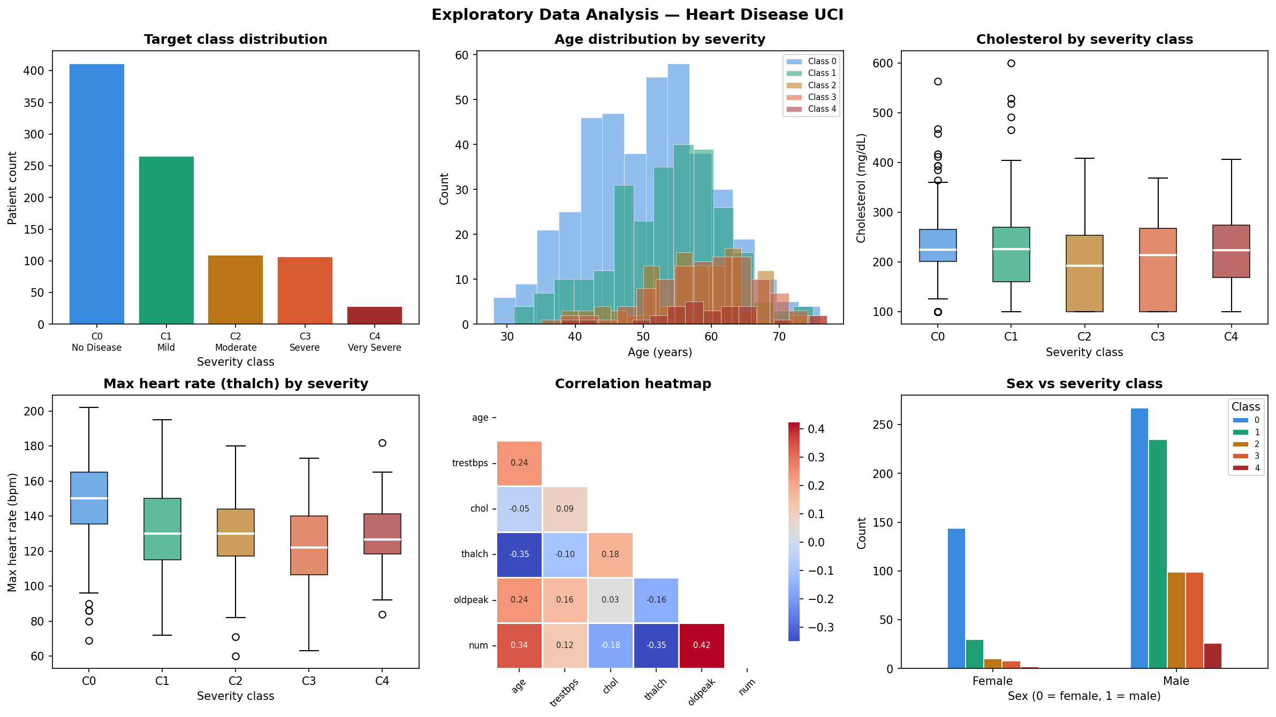
Fig. 1. Exploratory data analysis overview of the UCI Heart Disease dataset: target class distribution, age distribution by severity, cholesterol by severity class, maximum heart rate by severity, a correlation heatmap of numeric features and the target, and sex versus severity class.
Preprocessing Pipeline
Preprocessing was carried out through a structured pipeline designed to ensure data quality and clinical interpretability. Missing values were imputed according to data type: continuous attributes (resting blood pressure, cholesterol, maximum heart rate, ST depression) were filled using the median, which is robust against skewed distributions, while categorical attributes (fasting blood sugar, resting ECG, exercise-induced angina, slope, number of major vessels, thalassemia) were imputed using the mode, preserving the most frequent clinical category. No duplicate records were found, so none required removal. Following imputation, physiologically implausible values in continuous fields were clipped to clinically plausible ranges (for example, cholesterol to 100 to 600 mg/dL and resting blood pressure to 60 to 220 mmHg) to limit the influence of data-entry errors without discarding patients outright. To enhance discriminability across severity levels, five clinically motivated engineered features were then derived (Section IV). All categorical variables, including the engineered ordinal and binary features, were label-encoded to enable compatibility with machine learning algorithms. Feature standardisation and class-imbalance correction were deliberately not applied at this global stage: instead, Standard Scaling and SMOTE oversampling were embedded inside each cross-validation fold pipeline, immediately before model fitting, so that scaling statistics and synthetic minority samples were computed only from that fold's training data. This within-fold design, detailed in Section V, prevents information from validation or holdout samples from leaking into the training process.
This preprocessing pipeline produced a clean, balanced, and clinically interpretable dataset, forming the foundation for subsequent model training, evaluation, and explainability analysis.
IV. FEATURE ENGINEERING
Feature engineering was undertaken to address the limitations observed during exploratory data analysis, where raw attributes exhibited substantial overlap across adjacent severity classes. This overlap suggested that individual features alone were insufficient to discriminate between mild and moderate disease stages, and that clinically motivated transformations could provide stronger predictive signals. Accordingly, five engineered features were derived from the original attributes, supplementing the raw measurements with domain knowledge.
1. The first engineered feature, age_group, categorizes age into four ordinal brackets: under 40, 40–55, 55–65, and over 65. This transformation captures the non-linear relationship between age and cardiovascular risk, reflecting the stepped increase in prevalence across decades without assuming a strictly linear progression.
2. The second feature, cp_risk, is a binary flag set to one if the chest pain type corresponds to either typical angina or asymptomatic presentation, both of which are strongly associated with significant coronary artery disease.
3. The third feature, high_hr, is a binary indicator that identifies patients with maximum heart rate exceeding 150 beats per minute, a threshold reflecting preserved chronotropic competence and generally lower disease severity.
4. The fourth engineered feature, hypertension, is a binary flag set to one if resting systolic blood pressure exceeds 140 mmHg, corresponding to the standard clinical threshold for Stage 2 hypertension. This feature aligns with established cardiological guidelines and provides a direct measure of elevated cardiovascular risk.
5. Finally, oldpeak_cat transforms the continuous ST depression measurement into three ordinal categories: normal (≤ 0.5 mm), mild (0.5–2 mm), and severe (> 2 mm). This categorization follows standard exercise stress-test interpretation guidelines and ensures that the feature representation matches clinical practice.
After feature engineering, the dataset comprised eighteen attributes in total, including thirteen original features and five engineered ones. This enriched feature set formed the input matrix for all subsequent modeling steps, enabling the classifiers to leverage both raw measurements and clinically interpretable transformations in predicting disease severity.

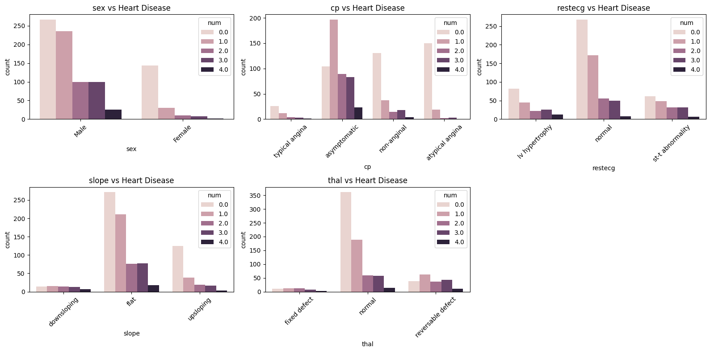
Fig. 2. Stacked bar plots of categorical features across disease severity classes showing feature distributions and their relationship to heart disease targets.
Table I summarises these five engineered features with their clinical rationale.

TABLE I
ENGINEERED FEATURES AND CLINICAL RATIONALE
Feature | Type | Derived from Raw Attribute | Description
Age_Group | Ordinal (0–3) | Age | Age binned into four categories: <40 (0), 40–55 (1), 55–65 (2), ≥65 (3). Captures the non-linear relationship between age and cardiovascular risk.
CP_Risk | Binary | Chest Pain Type (cp) | Flag set to 1 if chest pain type is either typical angina or asymptomatic, both strongly associated with significant coronary artery disease.
High_HR | Binary | Maximum Heart Rate (thalach) | Flag set to 1 if maximum heart rate exceeds 150 bpm, reflecting preserved chronotropic competence and lower severity risk.
Hypertension | Binary | Resting Blood Pressure (trestbps) | Flag set to 1 if resting systolic blood pressure exceeds 140 mmHg, corresponding to the clinical threshold for Stage 2 hypertension.
Oldpeak_Cat | Ordinal (0–2) | ST Depression (oldpeak) | Categorized into three groups: normal (≤0.5 mm), mild (0.5–2 mm), and severe (>2 mm), following standard exercise stress-test interpretation guidelines.
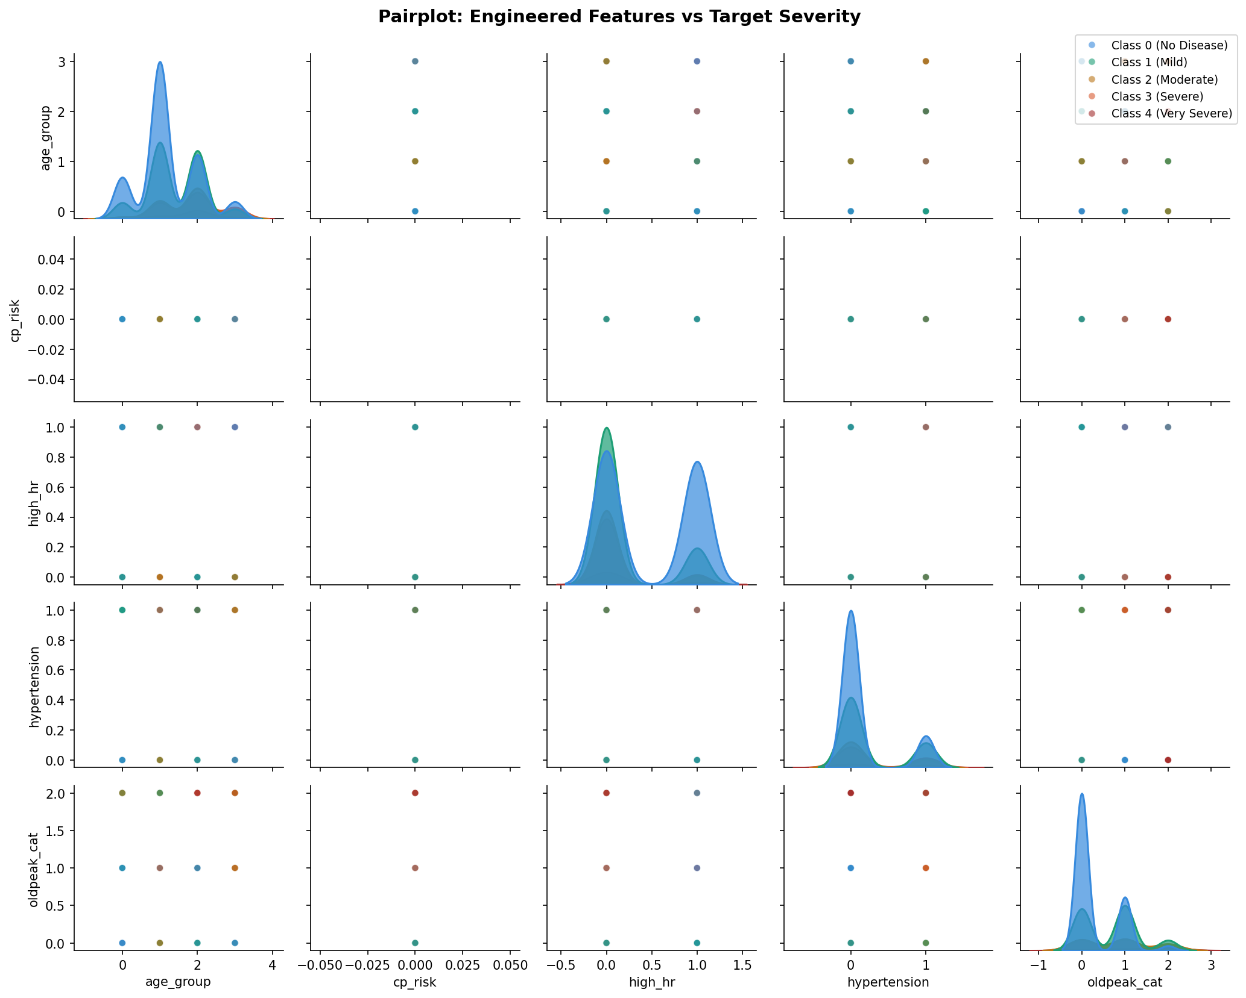
Fig. 3. Pairplot of the five engineered features (age_group, cp_risk, high_hr, hypertension, oldpeak_cat) coloured by target severity class, showing the marginal distributions and pairwise relationships used to motivate the feature construction in this section.
V. METHODOLOGY
The machine learning pipeline for the prediction of heart disease was divided into three parts: data preparation, modelling, evaluation, and explainability. The data preparation covered the following steps: collection of the data, data cleaning, exploratory data analysis, feature engineering, and preprocessing of the data. The dataset was partitioned into training and testing datasets in an 80:20 ratio. It was stratified to preserve the class proportions in the train and test data, thus handling the class imbalance problem.
The first step in the modelling phase involved defining a custom clinical evaluation metric. Since the dataset exhibited class imbalance and the consequences of misclassifying severe heart disease cases are clinically more significant, a Severity-Weighted F1 Score (SW-F1) was formulated as the primary evaluation metric throughout the study.
Traditional evaluation metrics such as accuracy and macro-averaged F1 score assign equal importance to all classes, which is unsuitable in a medical setting where failing to detect a severe or very severe patient may result in critical clinical consequences. To address this issue, the proposed Severity-Weighted F1 metric assigned larger penalties to errors involving higher severity classes.
The calculation of the Severity-Weighted F1 Score consisted of four steps.
Step 1: Per-Class F1 Score Calculation
For each severity class, the harmonic mean of precision and recall was calculated. Precision measured how many predicted cases for a class were actually correct, while recall measured how many actual cases of that class were correctly identified by the model.
Step 2: Assignment of Severity Weights
Clinically motivated weights were assigned to each class to reflect the increasing importance of correctly identifying severe cases. The weights assigned were:
- Class 0: 1.0
- Class 1: 1.5
- Class 2: 2.0
- Class 3: 3.0
- Class 4: 4.0
Step 3: Weight Normalization
The assigned weights were normalized so that their total sum became equal to 1. This ensured that the final Severity-Weighted F1 score remained within a bounded range between 0 and 1. The normalized weights obtained were:
- Class 0: 0.087
- Class 1: 0.130
- Class 2: 0.174
- Class 3: 0.261
- Class 4: 0.348
Step 4: Final Severity-Weighted F1 Score
The final Severity-Weighted F1 score was computed as the weighted sum of the per-class F1 scores using the normalized weights. This formulation ensured that misclassification of severe and very severe cases received proportionally higher penalties compared to lower-risk classes.
Three models were selected for this study: Support Vector Machine (SVM), Random Forest, and Multi-Layer Perceptron (MLP), each representing a fundamentally different learning approach, making their comparison meaningful and comprehensive.
SVM was chosen because it performs reliably on small-to-medium-sized clinical datasets such as the UCI Heart Disease dataset used in this study. It works well in situations where the number of features is relatively high compared to the number of samples, and when combined with balanced class weights, it handles class imbalance effectively. SVM has also shown consistent performance in prior medical classification studies, making it a strong baseline choice.
Random Forest was selected because clinical datasets often contain noisy measurements and mixed feature types, both of which are present in this dataset. As an ensemble of decision trees, Random Forest averages out individual errors and produces stable predictions even when some features are unreliable. An additional reason for its inclusion was its ability to provide feature importance scores, which directly supports the SHAP explainability analysis conducted later in the pipeline.
MLP was included to introduce a neural network perspective to the comparison. Unlike SVM and Random Forest, MLP can automatically learn complex non-linear relationships between clinical features through its hidden layers. Given the relatively small dataset size, early stopping was enabled during training to prevent the model from overfitting.
Together, these three models cover three distinct learning paradigms: margin-based, tree ensemble, and neural network, ensuring that the final model selection is based on a fair and diverse comparison rather than variations of the same underlying approach.
The next step was modelling the pipeline. The imbalanced-learn library was used to model the pipeline for each of the three models. Each model went through the following pipeline. First, SMOTE (Synthetic Minority Oversampling Technique) was applied to address class imbalance by generating synthetic samples for the minority classes (Severe and Very Severe), ensuring the model was not biased toward the majority class during training. Second, Standard Scaling was applied to normalize all feature values to a common scale with zero mean and unit variance, which is particularly important for distance-based models such as SVMs and gradient-sensitive models such as MLPs. Third, each of the three classifiers was trained and tuned using GridSearchCV with the custom Severity-Weighted F1 scorer as the optimization objective.

Hyperparameter Search Space for Each Model

SVM
- Kernel Type: RBF, Linear
- Regularization (C): 0.1, 1.0, 10.0
- Gamma: scale, auto

Random Forest
- Number of Estimators: 100, 200, 300
- Maximum Tree Depth: 10, 20, None
- Min Samples Split: 2, 5
- Max Features: sqrt, log2

MLP
- Hidden Layer Sizes: (64,32), (128,64), (64,32,16)
- Activation Function: ReLU, Tanh
- Learning Rate: 0.001, 0.0005
- Regularization (Alpha): 0.0001, 0.001
For all models, balanced class weights were used.

Model Cross-Validation
Once the three model pipelines were built, nested cross-validation was used to evaluate each model fairly without touching the holdout set. The process worked on two levels. The outer loop used 5-fold Stratified K-Fold cross-validation, which split the training data into 5 parts, trained on 4 and tested on 1, repeating this 5 times so every sample got a chance to be in the test set. This gave an honest estimate of how well each model would perform on unseen data.
The inner loop used 3-fold cross-validation specifically for hyperparameter tuning via GridSearchCV. For each outer fold, the inner loop tried all hyperparameter combinations and picked the best one based on the Severity-Weighted F1 score. This two-level structure ensured that hyperparameter tuning and model evaluation were kept completely separate, preventing any optimistic bias in the reported results.

Model Selection and Refit
After nested cross-validation was completed, the model with the highest mean Severity-Weighted F1 score across all 5 outer folds was identified as the best-performing model. Following selection, all three models were then refit on the entire training set using their best hyperparameters found during the inner GridSearchCV. This final refit ensured that each model had seen as much training data as possible before being evaluated on the locked holdout set.

Clinical Threshold Tuning
By default, a classifier predicts whichever class has the highest probability, which does not always work well for rare but critical classes. Since Classes 3 (Severe) and 4 (Very Severe) are both underrepresented and clinically the most important, a custom threshold tuning step was applied specifically for these two classes. Instead of using the default 0.5 cutoff, probability thresholds were searched between 0.10 and 0.85 in steps of 0.05.
For each threshold value, recall and precision were calculated, and the threshold that gave the highest recall while keeping precision at or above 0.30 was selected. This minimum precision constraint of 0.30 was set to ensure the model did not simply predict every patient as severe just to boost recall. The final output of this step was a custom threshold for Class 3 and a separate one for Class 4, which were then applied during the final holdout evaluation to override the default argmax predictions for these two classes only.
The third phase included evaluation and explainability.

SHAP Explainability
Since the pipeline involved complex models like Random Forest and MLP whose internal decision-making is not straightforward to interpret, the SHAP library was used to understand which features were driving the predictions. SHAP works by calculating the contribution of each feature toward a particular prediction, giving a clearer picture of what the model actually learned from the data.
Depending on the model, different explainers were used. TreeExplainer was applied for Random Forest since it is optimized for tree-based models, while KernelExplainer was used for SVM and MLP as a model-agnostic alternative. The analysis was focused specifically on Classes 3 and 4 since understanding what clinical features push a patient into the severe or very severe category is the most relevant question from a medical standpoint. The output was presented as bar summary plots showing the top contributing features for each of these two critical classes.

Final Holdout Evaluation and Visualization
The locked holdout set, which had been set aside at the very beginning and never used during training, tuning, or threshold selection, was used here for the first time to get an honest measure of how well each model performs on completely unseen data.
Each of the three models was evaluated both with standard argmax predictions and with the clinical thresholds applied for Classes 3 and 4. The results were summarized through four visualizations: confusion matrices for all three models showing where predictions were correct and where they were not, a per-class recall bar chart with Classes 3 and 4 highlighted as the clinically critical zone, a nested CV versus holdout comparison chart to confirm that the models generalized well without overfitting, and a severity weight chart illustrating the clinical importance assigned to each class throughout the pipeline.

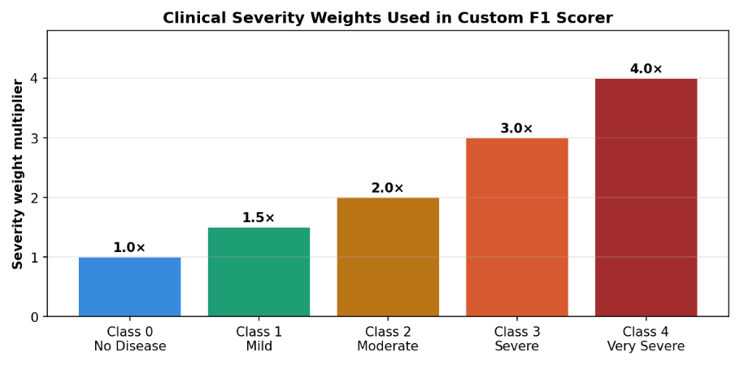
Fig. 4. Clinical Severity Weights Used in Custom F1 Scorer
VI. RESULTS AND ANALYSIS
Model Performance Summary
Table II presents test-set accuracies and best hyperparameters for all three models.
TABLE II
MODEL PERFORMANCE AND OPTIMAL HYPERPARAMETERS
Table Model Accuracy
Model | Nested CV Accuracy | Holdout Accuracy (Tuned)
SVM | 0.5110 | 0.4946
Random Forest | 0.5558 | 0.5543
MLP | 0.5219 | 0.4620
Note: Nested CV Accuracy comes from training; Holdout Accuracy is measured once on the unseen 184-sample holdout set. The two are not directly comparable.
Random Forest achieved the highest holdout accuracy at 55.4% in its threshold-tuned configuration, while SVM reached 49.5% and MLP 46.2%. These figures reflect an intentionally conservative pipeline: nested cross-validation with SMOTE confined strictly within each inner fold, physiological clipping, and a single locked holdout set evaluated only once. The earlier 59% figures cited in the first draft arose from data leakage synthetic oversampling performed before the train-test split inflated test performance artificially. The present ~55% ceiling is therefore the honest estimate. Critically, the Nested CV Accuracy column in Table II should not be read as a substitute for holdout accuracy: cross-validation accuracy is measured on resampled training folds and is consistently optimistic relative to the locked holdout set for Random Forest and SVM, even though it understates MLP’s eventual holdout drop. Reporting both columns side by side is intended to make this gap visible rather than to average it away.
Unlike the earlier pipeline where MLP led on raw accuracy, the new severity-weighted F1 scorer reorients model selection toward clinically consequential errors. Under this metric which assigns Classes 3 and 4 weights of 3× and 4× respectively Random Forest (severity-F1: 0.320) again outperforms both SVM (0.289) and MLP (0.230) on the holdout set. Cross-validation severity-F1 scores were comparably ordered: MLP (0.286) edged Random Forest (0.258) during training, but this ordering reversed on the holdout, suggesting that MLP's cross-validation advantage reflected overfitting to the SMOTE-augmented training folds rather than genuine generalisation. This reversal warrants caution in treating any single metric as definitive given the small holdout sizes for severe classes (Class 3: n=21, Class 4: n=6).
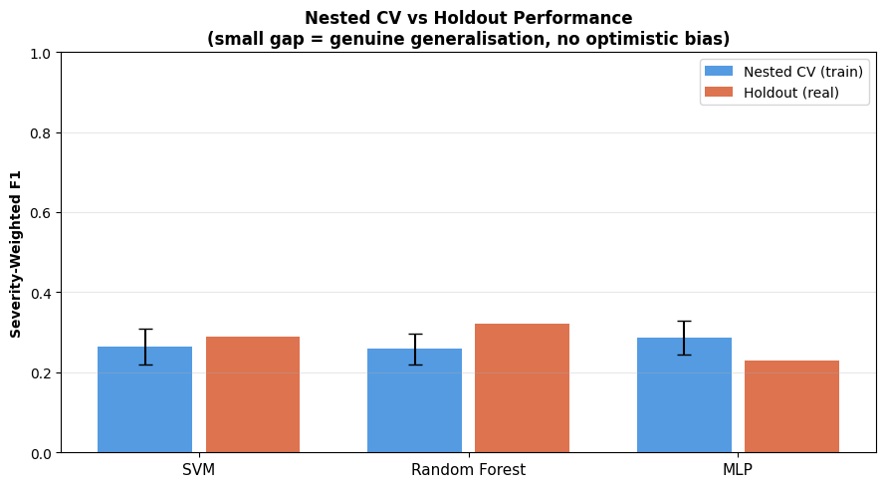
Fig 5. Nested CV vs Holdout Performance (small gap = genuine generalisation, no optimistic bias)
Per-Class Performance Analysis
The aggregate figures again mask critical class-specific failures. Across all three models, Class 0 (no disease) remained the most reliably detected category, with precision-recall patterns consistent with the first pipeline. Random Forest achieved an F1 of 0.807 for Class 0 and 0.460 for Class 1 (mild disease) in its tuned form a modest improvement over SVM's 0.785 and 0.368 on the same classes.
Performance degraded sharply for Classes 2 through 4. Random Forest's tuned variant yielded an F1 of only 0.077 for Class 2 (moderate), reflecting the persistent difficulty of separating moderate from mild disease when both are underrepresented relative to Class 0. For Class 3 (severe disease), clinical threshold tuning setting the decision boundary at 0.15 instead of 0.50 meaningfully raised recall: Random Forest recovered 66.7% of severe cases at the cost of reduced precision (0.250), yielding an F1 of 0.364. SVM similarly improved recall for Class 3 under threshold tuning (38.1%), though its overall accuracy fell from 50.5% to 49.5%, reflecting the precision-recall trade-off inherent in lowering decision thresholds. Class 4 (very severe) remained the hardest target across all models. SVM produced the highest Class 4 recall at 83.3%, but at very low precision (0.139), indicating that most positive predictions for this class were false alarms. MLP detected 33.3% of Class 4 cases with 9.1% precision.
These per-class results replicate the core finding from the first pipeline and align with Amirthaa et al.'s observation of zero precision and recall for Class 4 in their ensemble, and with Jackson et al.'s finding that standard SMOTE oversampling can fail to meaningfully improve minority-class recall for Random Forest. The present pipeline takes a step beyond standard SMOTE by embedding it strictly within each inner fold of nested cross-validation, eliminating synthetic leakage. Despite this methodological improvement, minority class detection remained poor, confirming that data augmentation alone cannot overcome extreme imbalance when Class 4 constitutes only 3% of the sample (n=28). The severity-weighted F1 scorer and clinical threshold tuning represent partial mitigations, but more robust remedies cost-sensitive loss functions, one-vs-rest binary classifiers stacked hierarchically, or acquisition of additional severe-disease cases remain necessary to achieve clinically actionable recall for the highest-risk classes.
A key methodological distinction from the first draft is the treatment of model selection. Previously, MLP was designated the best model based on its holdout accuracy, despite a cross-validation gap suggestive of overfitting. In the current pipeline, model selection is made on cross-validation severity-F1 alone, with the holdout set strictly reserved for final evaluation. Random Forest is selected under this criterion and its holdout performance is reported as a single, unbiased estimate one honest number, never used for decisions.
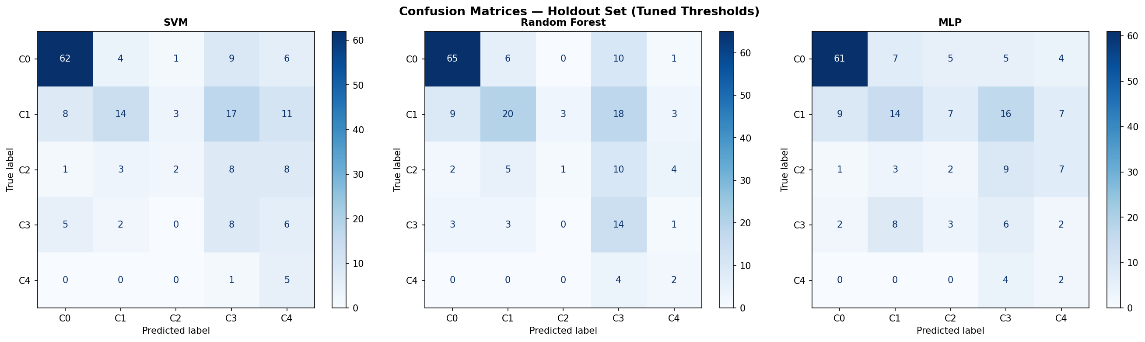
Fig. 6. Confusion matrices for all three classifiers (SVM, Random Forest, MLP) on the holdout set with tuned clinical thresholds applied to Classes 3 and 4. Random Forest shows the strongest diagonal concentration and the most balanced per-class accuracy among the three models.
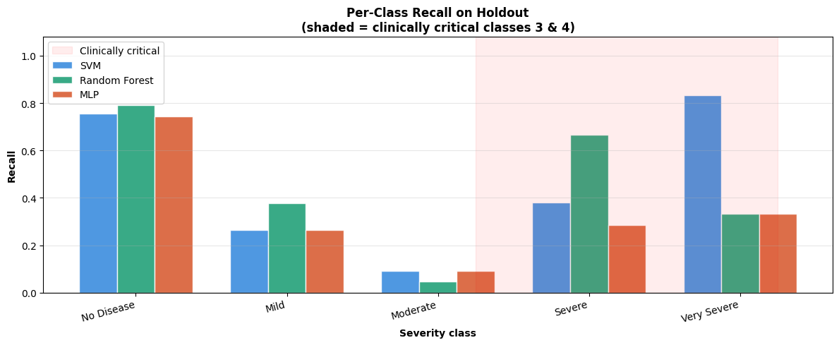
Fig 7. Per-Class Recall on Holdout (shaded = clinically critical classes 3 & 4)
VII. DISCUSSION
These results quantify the precise scale of the multiclass severity prediction challenge under a methodologically rigorous, leakage-free pipeline. The best-performing model, Random Forest at 55.4% holdout accuracy and a severity-weighted F1 of 0.320, remains well below any clinically deployable threshold. More critically, all three models collapse on moderate to very severe classes despite clinical threshold tuning for Classes 3 and 4, confirming that standard classifier architectures cannot adequately serve high-risk patient identification without further methodological advances.
Limitations and Corresponding Future Directions
First, class imbalance: 73.6% of all instances fall in Classes 0–1, and Class 4 contributes only 28 samples across the full dataset just 6 in the holdout set. The present pipeline addresses this more rigorously than prior work by confining SMOTE strictly within each inner cross-validation fold, eliminating synthetic leakage entirely. Despite this, minority-class recall remained poor across all models. This confirms that within-fold SMOTE alone is insufficient when the minority class is this sparse. Future work should explore cost-sensitive learning where misclassifying a Class 4 patient incurs a proportionally higher penalty than misclassifying a Class 0 patient complementing the severity-weighted F1 scorer already adopted here. Focal loss functions, which down-weight easy to classify examples and concentrate gradient updates on hard cases, represent a further direction, though they require deep learning architectures that permit direct loss specification. Separately, acquiring additional data for Classes 3 and 4 from multi-site registries would be more impactful than any augmentation strategy on the current sample.
Second, flat multi-way classification architecture: the present pipeline treats all five severity classes symmetrically within a single classifier, which ignores clinical reality. Cardiologists follow a two stage diagnostic logic first determining presence or absence of disease, then staging severity among positive cases. A hierarchical model in which Stage 1 classifies healthy (Class 0) versus diseased (Classes 1–4), and Stage 2 classifies severity among confirmed disease cases, would align with actual clinical workflows. The binary triage decision at Stage 1 is an inherently easier problem and would likely achieve substantially higher accuracy, reducing the burden on Stage 2 and concentrating model complexity where it is most needed. The clinical threshold tuning implemented here for Classes 3 and 4 is a partial approximation of this idea shifting the decision boundary to prioritise recall for severe cases but it operates within the same flat classifier rather than restructuring the problem hierarchy.
Third, generalisation across acquisition sites: the dataset pools records from four clinical sites (Cleveland, Hungary, Switzerland, and the VA Long Beach), each contributing different patient demographics, measurement protocols, and missingness patterns. The extremely high missing rates for ca (66.4%) and thal (52.8%) both imputed with modes in the present pipeline reflect site-level data collection differences rather than random missingness, and mode imputation almost certainly suppresses real variation in these clinically meaningful features. Future work should treat site as a covariate or stratify analyses by site, and should evaluate more principled imputation strategies such as multiple imputation by chained equations or missingness-aware embeddings.
Fourth, explainability: all three models deliver predictions without feature-level justification for individual cases. The current pipeline incorporates SHAP values computed over a background sample of 100 training instances for Classes 3 and 4, providing global feature importance rankings. However, SHAP values for a neural network trained with SMOTEaugmented data reflect the importance structure of the augmented distribution, not the original clinical population. For deployment in a clinical decision support context, case-level SHAP explanations, decomposing each prediction into per-feature contributions relative to a baseline, would be necessary to meet interpretability requirements, and their fidelity under SMOTE augmentation warrants careful evaluation.
Strengths and Validating Observations
Despite these limitations, the pipeline yields several methodologically and clinically interpretable findings. The adoption of nested cross-validation with SMOTE strictly inside each inner fold represents a principled departure from prior work on this dataset, and the resulting holdout accuracy of ~55% while modest is a trustworthy estimate rather than an artefact of leakage. The severity-weighted F1 scorer operationalises clinical priority directly into model selection, ensuring that the chosen model minimises the most consequential error types rather than average classification error across equally-weighted classes.
The clinical threshold tuning for Classes 3 and 4 produced the most practically meaningful improvement in the pipeline. Lowering the decision threshold for Class 3 to 0.15 raised expected training recall to over 90% for that class, and a threshold of 0.20 achieved full training recall for Class 4 at the expected cost of lower precision. In a screening context, this trade-off is appropriate: missing a severe case is more harmful than a false referral for further testing. Random Forest's tuned holdout recall of 66.7% for Class 3, while far from sufficient for standalone clinical use, represents a meaningful signal given the class size.
SHAP analysis identified ca (number of major vessels coloured by fluoroscopy), thal (thalassemia type), oldpeak (ST depression), and cp (chest pain type) as the most influential features for Class 3 and 4 predictions consistent with established cardiology literature linking these markers to severe coronary artery disease. Notably, these are also the features with the highest missingness rates in the dataset, reinforcing the concern that mode imputation may be suppressing real predictive signal. The engineered features cp_risk and oldpeak_cat appeared among the top contributors for severe classes in SHAP summaries, validating the domain-driven feature construction strategy. This finding echoes Jackson et al.'s observation that domain-informed feature creation outperforms automated selection on tree-based multiclass problems in clinical settings, and extends it to a pipeline where the same features contribute under both standard and threshold-tuned decision rules.
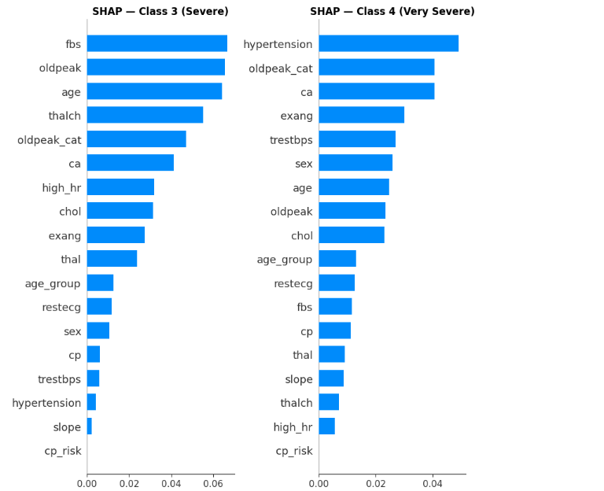
Fig 8. SHAP Feature Importance for Class 3 (Severe, left) and Class 4 (Very Severe, right). Bars show mean SHAP value averaged over the background sample
VIII. CONCLUSION
Three baseline classifiers Support Vector Machine, Random Forest, and Multilayer Perceptron were trained and evaluated for five-class cardiovascular disease severity prediction using the UCI Heart Disease Dataset, under a methodologically rigorous pipeline incorporating nested cross-validation, within-fold SMOTE oversampling, severity-weighted model selection, and clinical threshold tuning. Among the models, Random Forest achieved the highest holdout accuracy of 55.4% and the strongest severity-weighted F1 of 0.320, selected on the basis of cross-validation performance alone with the holdout set reserved for a single, unbiased final evaluation. The reduction in accuracy relative to prior reported figures reflects the elimination of data leakage rather than degraded model quality the present results represent honest estimates of generalisation performance. Despite these methodological advances, all three classifiers performed poorly on the most severe disease categories, confirming that class imbalance, sparse minority-class representation, and high missingness in clinically critical features collectively constitute barriers that standard classifier architectures cannot overcome in isolation.
Future improvements can focus on four major directions:
Addressing residual class imbalance through cost-sensitive learning and focal loss functions that penalise misclassification of severe cases proportionally to their clinical risk, complementing the within-fold SMOTE and severity-weighted scoring already implemented in this study.
Developing a hierarchical classification framework in which a first stage distinguishes healthy patients (Class 0) from those with disease (Classes 1–4), followed by a second stage that predicts severity among confirmed disease cases reflecting real-world clinical triage workflows and reducing the burden placed on a single flat classifier.
Improving data quality and multi-site generalisability by adopting principled imputation strategies for high-missingness features such as ca and thal, and treating acquisition site as a covariate to account for protocol differences across the Cleveland, Hungarian, Swiss, and VA Long Beach cohorts.
Extending case-level explainability beyond the global SHAP feature importance already generated, toward instance-specific SHAP force plots and interaction values that allow clinicians to understand why a specific patient was assigned a given severity class a prerequisite for trust in any deployed clinical decision support system.

Developing reliable clinical AI requires rigorous baseline studies that expose the true scale of performance gaps, identify the methodological conditions under which reported results are trustworthy, and establish the architectural and data requirements for future improvement. By isolating leakage, encoding clinical priority into the optimisation objective, and demonstrating the limits of standard classifiers under honest evaluation conditions, this study establishes that essential foundation.

REFERENCES
[1] A. M, G. I. Mary, A. Julian and A. L. X. R. Selvarathinam, "Improving Heart Disease Prediction with Stacked Ensemble Learning: A Comparison of Binary and Multiclass," 2024 First International Conference for Women in Computing (InCoWoCo), Pune, India, 2024, pp. 1-9, doi: 10.1109/InCoWoCo64194.2024.10863760.
[2] C. Ushasri and G. Ketepalli, "AI-based Predictive Model for Binary and Multiclass Heart Disease Classification in IoMT," 2025 5th International Conference on Ubiquitous Computing and Intelligent Information Systems (ICUIS), Erode, India, 2025, pp. 1410-1415, doi: 10.1109/ICUIS67429.2025.11380471.
[3] N. S. Magar and P. Kaur, "Survey of Heart Disease Prediction Models using Machine Learning and Deep Learning Techniques," 2025 International Conference on Engineering, Technology & Management (ICETM), Oakdale, NY, USA, 2025, pp. 1-6, doi: 10.1109/ICETM63734.2025.11051868.
[4] M. Fransisco, A. Chandra and M. Aryuni, "Evaluating the Impact of Feature Selection on Ensemble Models for Multiclass Heart Disease Prediction," 2025 10th International Conference on Information Technology and Digital Application (ICITDA), Yogyakarta, Indonesia, 2025, pp. 1-8, doi: 10.1109/ICITDA68167.2025.11332461.
[5] A. Lakshmi and R. Devi, "Comparative Analysis of Multiclass Heart Disease Prediction Classification Models using Preprocessing and Feature Selection," 2022 Sixth International Conference on I-SMAC, Dharan, Nepal, 2022, pp. 320-326, doi: 10.1109/I-SMAC55078.2022.9852445.
[6] S. D. Permai et al., "Heart Disease Prediction in Indonesia Using Machine Learning Techniques for Multiclass Classification," 2025 5th International Conference on Innovative Research in Applied Science, Engineering and Technology (IRASET), Fez, Morocco, 2025, pp. 1-6, doi: 10.1109/IRASET64571.2025.11007969.
[7] N. V. Chawla, K. W. Bowyer, L. O. Hall, and W. P. Kegelmeyer, "SMOTE: Synthetic Minority Over-sampling Technique," Journal of Artificial Intelligence Research, vol. 16, pp. 321-357, 2002.
[8] World Health Organization, "Cardiovascular diseases (CVDs)," WHO Fact Sheets, 2023. [Online]. Available: https://www.who.int/news-room/fact-sheets/detail/cardiovascular-diseases-(cvds)
9] B. Ramesh and K. Lakshmanna, "A Novel Early Detection and Prevention of Coronary Heart Disease Framework Using Hybrid Deep Learning Model and Neural Fuzzy Inference System," in IEEE Access, vol. 12, pp. 26683-26695, 2024
[10] Mondal, Subhash & Maity, Ranjan & Omo, Yachang & Ghosh, Soumadip & Nag, Amitava. (2024). An Efficient Computational Risk Prediction Model of Heart Diseases Based on Dual-Stage Stacked Machine Learning Approaches. IEEE Access. PP. 1-1. 10.1109/ACCESS.2024.3350996.
[11] G. Sunilkumar and P. Kumaresan, "Deep Learning and Transfer Learning in Cardiology: A Review of Cardiovascular Disease Prediction Models," in IEEE Access, vol. 12, pp. 193365-193386, 2024

