Day 1

Employee ID : 112916146 . Name : Priya Gumber

**Task 1**

What is SDLC?

Answer : SDLC stands for the Software development Life Cycle. It is a structured process which includes the designing, developing and testing the software to deliver the good quality product to the client.

**Task 2**

Why is SDLC required ?

Answer : SDLC helps us to create a high quality product which meets the end user’s requirement in the given timeframe and is within budget.

Some key points

Systematic Approach : Structured methodology for developing software.

Project Planning and Management : It helps in planning of various things like estimating cost , scheduling tasks and making it easier to track the progress

Quality Assurance : It ensures that software is developed to the best high standard.

**Task 3**

Steps of SDLC :

* Planning and Requirement :
* Defining Requirement
* Design
* Development : Calls -Scrum meetings-JIRA dashboard (TDL-to do list)
* Testing and Integration (Here integration means : correctness of data(integrity) check)
* Deployment and Maintenance ( To regularly check and keep updating the software for ease of users and smooth working of software after deployment)

**Task 4 :**

Types of SDLC models

Waterfall Model :

It is a liner and sequential; approach to software development. Each step must be completed before moving to the next one in the form of a waterfall model

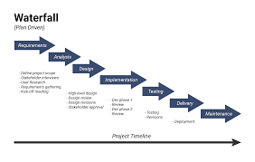

Iterative SDLC model

In this model, the Software Development Process is divided into several increments and the same phases are followed in each increment and under this model a complex project is developed in many modules or builds.

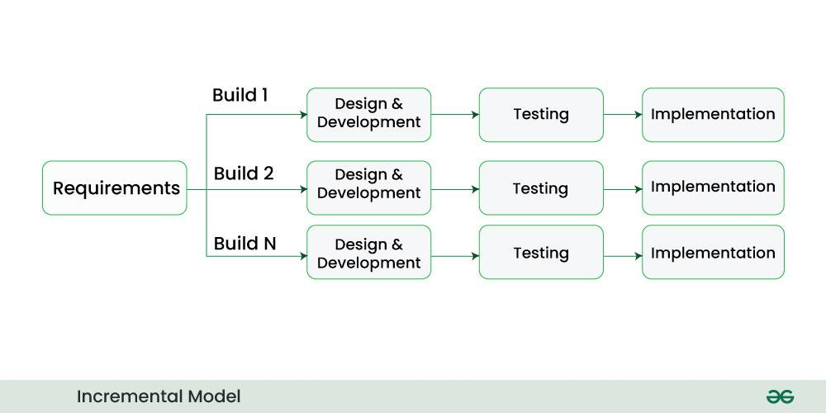

V-Model

V-Model is an SDLC model, it is also called Verification and Validation Model, which is an extension of the traditional waterfall model.

It introduces a parallel testing phase for each corresponding development stage, forming a V-shape diagram.

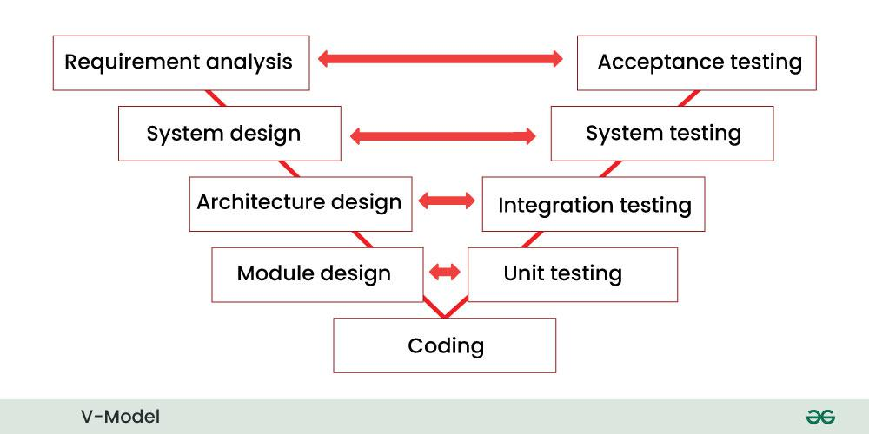

Spiral Model : It combines the idea of iterative development with the systematic aspects of the waterfall model.

The shape of the model is spiral , with each loop representing a phase in the software development process. A software project goes through these loops again and again in iterations. After each iteration a more and more complete version of the software is developed.

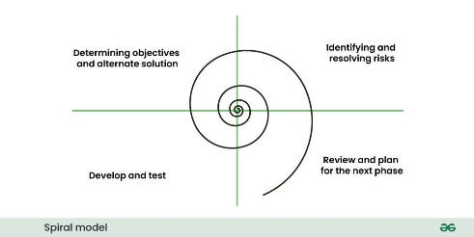

Agile SDLC Model

The Agile Model refers to a group of development processes. It is a combination of iterative and incremental process models which focus on process adaptability and customer satisfaction by rapid delivery of working software products.

This method break the product into small incremental builds. These builds are provided in iterations.

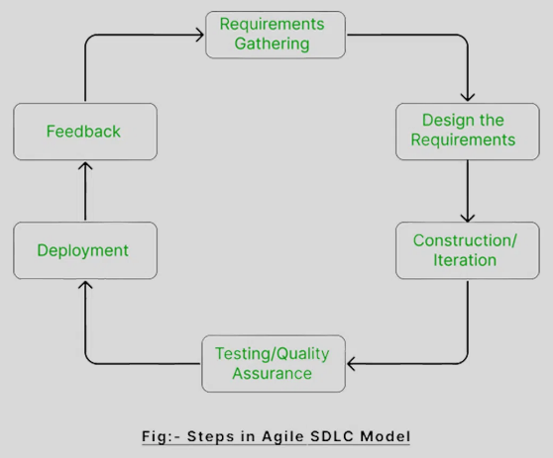

RAD Model

RAD Model stands for rapid application development model. The methodology of RAD model is similar to that of incremental or waterfall model. It is used for small projects.

The main objective of RAD model is to reuse code, components, tools, processes in project development.

If the project is large then it is divided into many small projects and these small projects are planned one by one and completed. In this way, by completing small projects, the large project gets ready quickly.

In RAD model, the project is completed within the given time and all the requirements are collected before starting the project. It is very fast and there are very less errors in it.

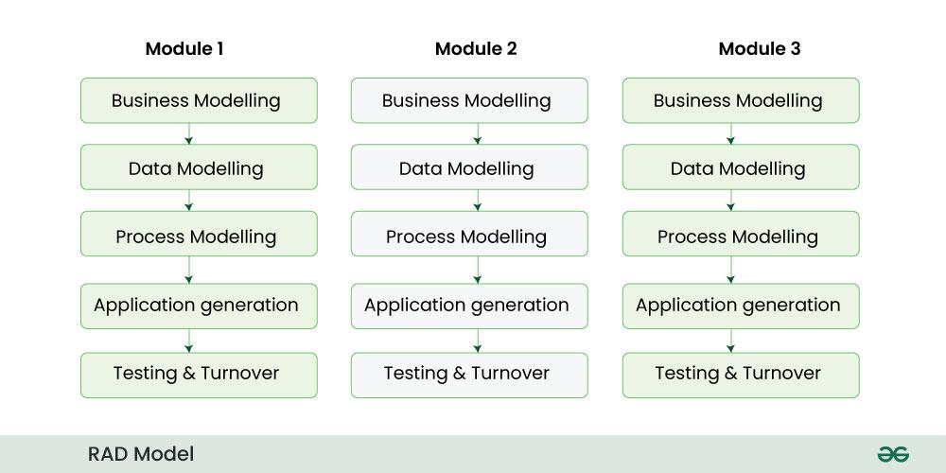

Prototype Model is an activity in which prototypes of software applications are created. First a prototype is created and then the final product is manufactured based on that prototype.

One problem in this model is that if the end users are not satisfied with the prototype model, then a new prototype model is created again, due to which this model consumes a lot of money and time.

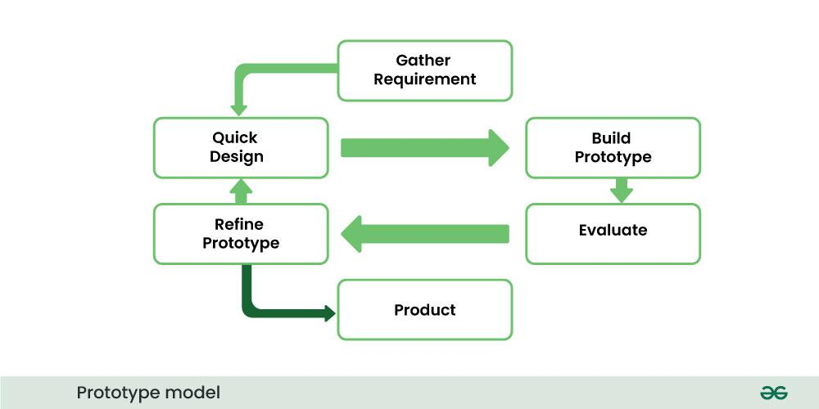

**Next TOPIC : Computer Networks**

Task 1 : What are different types of Network?

3 different types of networks are there

LAN (Local Area Network)

A LAN is a computer network that connects computers through a common communication path, contained within a limited area, that is, locally. A LAN encompasses two or more computers connected over a server. The two important technologies involved in this network are Ethernet and Wi-fi.

MAN(Metropolitan Area Network)

A MAN is larger than a LAN but smaller than a WAN. This is the type of computer network that connects computers over a geographical distance through a shared communication path over a city, town, or metropolitan area. This network mainly uses FDDI, CDDI, and ATM as the technology with a range from 5km to 50km.

WAN(Wide Area Network)

WAN is a type of computer network that connects computers over a large geographical distance through a shared communication path. It is not restrained to a single location but extends over many locations. WAN can also be defined as a group of local area networks that communicate with each other with a range above 50km.

Task 2: What are the of Servers?

A Server is a program or a device that provides functionality for called clients which are other programs or devices. This architecture is called the client-server model.

There are several types of server :

1. Application Server

These servers host web apps (computer programs that run inside a web browser) allowing users in the network to run and use them preventing the installation of a copy on their own computers.

2. Communication Server

These servers maintain an environment needed for one communication endpoint to find other endpoints and then communicate with them. These servers may or may not include a directory of communication endpoints and a presence detection service, depending on the openness and security parameters of the network. Their clients are communication endpoints.

3.  **Database Server**

These servers maintain and share any form of database over a network. A database is an organized collection of data with predefined properties that may be displayed in a table. Clients of these servers are spreadsheets, accounting sheets , asset management software, or virtually any computer program that consumes well-organized data, especially in large volumes.

4. **File Server**

Shares files and folders, storage space to hold files and folders, or both, over a network. Networked computers are the intended clients, even though local programs can be clients.

5. **Mail Server**

These servers make email communication possible in the same way as a post office makes snail mail communication possible. Clients of these servers are senders and recipients of email.

**6. Print Server**

These servers share one or more printers over a network which eliminates the hassle of physical access. Their clients are computers in need of printing something.

7. **Proxy Server**

 This server acts as an intermediary between a client and a server accepting incoming traffic from the client and sending it to the server. Reasons to use a proxy server include content control and filtering, improving traffic performance, preventing unauthorized network access, simply routing the traffic over a large and complex network. Their clients are any networked computer.

**8. Web Server**

These servers host web pages. A web server is responsible for making the World Wide Web possible. Each website has one or more web servers. Their clients are computers with a web browser.

Task : what is TCP and UDP? What is the difference?

TCP, or Transmission Control Protocol, is a fundamental networking protocol used for reliable, ordered, and error-checked delivery of data between computers.

TCP (Transmission Control Protocol) is one of the main protocols of the Internet protocol suite. It lies between the Application and Network Layers which are used in providing reliable delivery services. It is a connection-oriented protocol for communications that helps in the exchange of messages between different devices over a network. The Internet Protocol (IP), which establishes the technique for sending data packets between computers, works with TCP.

What is User Datagram Protocol (UDP)?

User Datagram Protocol (UDP) is a Transport Layer protocol. UDP is a part of the Internet Protocol suite, referred to as the UDP/IP suite. Unlike TCP, it is an unreliable and connectionless protocol. So, there is no need to establish a connection before data transfer. The UDP helps to establish low-latency and loss-tolerating connections establish over the network. The UDP enables process-to-process communication.

Where TCP is Used?

Sending Emails

Transferring Files

Web Browsing

Where UDP is Used?

Gaming

Video Streaming

Online Video Chats

Differences : 1. TCP is connection-oriented while UDP is connectionless

2. TCP leverages more error-checking mechanisms than UDP

3. TCP sends data in a particular sequence, whereas there is no fixed order for UDP protocol

4. UDP is faster and more efficient than TCP

5. Unlike UDP, TCP cannot be used for multicast or broadcast services

6. TCP leverages flow control, while UDP does not.

Task 9 : What is a Mac Address and differences between the mac address and IP address

MAC, or Media Access Control is a unique identifier that is shaped on the computer hardware to connect the system to other systems of the network address. It uses the Network Interface Controller to create a communication segment to establish communication between systems on the same network. MAC Address works for a local network.

MAC Address is represented as a group of 6 hexadecimal numbers, each group consisting of two hexadecimal numbers. It is also called a 6-byte hexadecimal number.

What is an IP Address?

IP address: Internet Protocol Address is a unique identifier for every system that has internet connectivity. The major difference between MAC address & IP address is that IP address has a global network, whereas MAC address operates only in a local network. It is used to establish a communication between networks & systems of several networks. The IP address can be used for broadcasting and multicasting.

IP address is a 32-bit, 4 group address that consists of numbers separated in a decimal format.

Difference in MAC and IP Address :

The main difference between MAC and IP address is that MAC Address is used to ensure the physical address of the computer. It uniquely identifies the devices on a network. While IP addresses are used to uniquely identifies the connection of the network with that device takes part in a network. They differ in the aspect that MAC address is a local area network address, whereas IP address is a global area network.

**Task 10 : What is OSI model?**

The OSI (Open Systems Interconnection) Model is a set of rules that explains how different computer systems communicate over a network.

It was developed by ISO. The OSI Model consists of 7 layers and each layer has specific functions and responsibilities.

This model divides the problem/issue of connecting two systems in 7 layers, and each layer has specific duties and hence this approach makes it easier for different devices and technologies to work together.

**Note :** OSI model is not a protocol but is an approach which tells how the data needs to be transferred.

**Data Flows :**

Data flows through the OSI model in a step-by-step process :

Application Layer: Applications create the data.

Presentation Layer: Data is formatted and encrypted.

Session Layer: Connections are established and managed.

Transport Layer: Data is broken into segments for reliable delivery.

Network Layer: Segments are packaged into packets and routed.

Data Link Layer: Packets are framed and sent to the next device.

Physical Layer: Frames are converted into bits and transmitted physically.

Example how data flows :

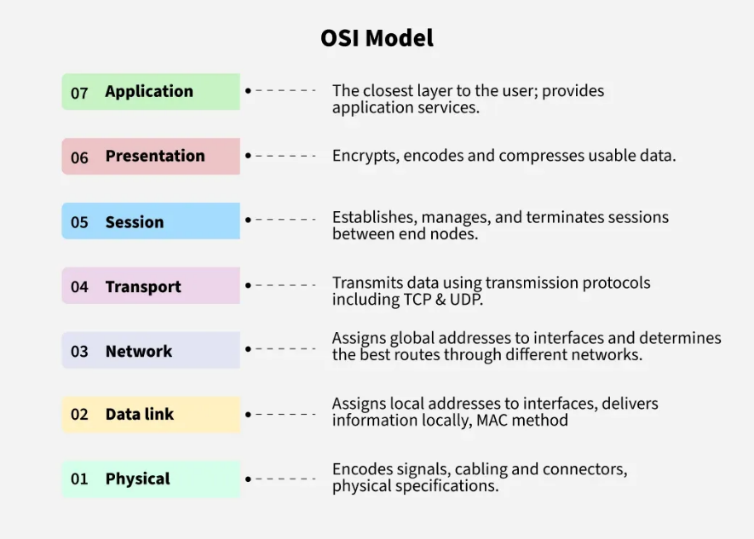Suppose Person A wants to send email to Person B

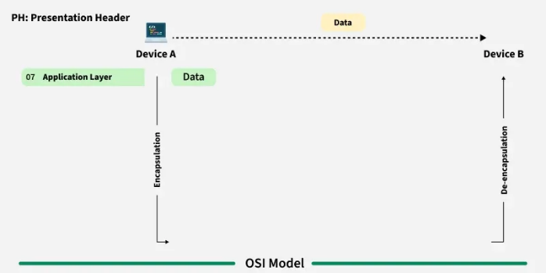

So here at Application layer ,

person A will write the mail and the person B will receive the mail.

2. Presentation layer : Mail application prepares for data transmission like encrypting data and formatting it for transmission.

3. Session Layer : Connection is established between sender and receiver

4. Transport Layer : Email is broken into smaller segments.

5. Network Layer : Addressing of packets is done in order to find the best route for transfer.

6. Data link Layer : Data packets are encapsulated into frames then MAC address is added for local devices.

7. Physical Layer : Frames are transmitted in the form of electrical/optical signals over a physical network medium like ethernet cable or WI-Fi.



After the email reaches the receiver i,e Person B , the process will reverse and decrypt the email content.

At last Person B will receive the mails.

Task 11

What is an IvP4 address?

An IP address (Internet Protocol address) is a unique identifier assigned to each device connected to a network that uses the Internet Protocol for communication. It serves two main purposes:

Identification: It uniquely identifies a device on a network.

Location Addressing: It indicates where a device is located within a network, making data routing possible.

An IPv4 address consists of series of four eight-bit binary numbers which are separated by decimal point.

Types of IPv4 Addressing

he 32-bit IP address is divided into five sub-classes. These are given below:

Class A

IP addresses belonging to class A are assigned to the networks that contain a large number of hosts.

The network ID is 8 bits long.

The host ID is 24 bits long.

Class B

IP address belonging to class B is assigned to networks that range from medium-sized to large-sized networks.

The network ID is 16 bits long.

The host ID is 16 bits long.

Class C

IP addresses belonging to class C are assigned to small-sized networks.

The network ID is 24 bits long.

The host ID is 8 bits long.

Class D

IP address belonging to class D is reserved for multi-casting. The higher-order bits of the first octet of IP addresses belonging to class D is always set to 1110. The remaining bits are for the address that interested hosts recognize.

Class E

Each of these classes has a valid range of IP addresses. Classes D and E are reserved for multicast and experimental purposes respectively. The order of bits in the first octet determines the classes of the IP address.

Task 12

Advantages of using VPN ?

Enhanced security : It Encrypts internet traffic to protect against hacking and surveillance

It helps in hiding personal data : Masks IP address to maintain anonymity online

Secure Remote Access : Enables secure access to company networks for remote workers

Task 13

Types of VPN :

**Access VPN :**

It permits a user to connect to a private network and access all its services and resources remotely. The connection between the user and the private network occurs through the Internet and the connection is secure and private.

Example : An employee of a company, while he/she is out of station, uses a VPN to connect to his/her company’s private network and remotely access files and resources on the private network.

2**. Site to Site VPN**

A Site-to-Site VPN is also called as Router-to-Router VPN and is commonly used in the large companies. Companies or organizations, with branch offices in different locations, use Site-to-site VPN to connect the network of one office location to the network at another office location.

3.**Intranet based VPN:** When several offices of the same company are connected using Site-to-Site VPN type, it is called as Intranet based VPN.

**4.Extranet based VPN:** When companies use Site-to-site VPN type to connect to the office of another company, it is called as Extranet based VPN.

Access VPN: One person → Company

Site to Site: Building → Building

Intranet VPN: Your buildings → Your other buildings

Extranet VPN: Your building → Partner's building

Task 14

Types of Topology

Mesh topology : In this every device has a dedicated P2P link to every other devices.

No. of devices = n(n-1)/2 , where n is the number of nodes.

Star Topology :Each device has a dedicated P2P link only to a central controller (hub). The devices are not directly linked to each other

Bus Topology : It is a multi point. One long cable acts as a backbone to link all the devices in a network.

Ring Topology : Each device has a dedicated P2P connection with the 2 devices on the either side of it.

Tree Topology : Combination of bus and star topology, also called as extended Bus Topology. In this multiple bus segments are connected to a backbone or main bus , extending the network’s reach and capacity.

Task 15 :

Difference between Router and Gateway :

Router : A device that connects multiple networks and routes traffic between them based on IP addresses.

Example : Home Wi-Fi.

Gateway : A device that connects network to another network or internet and performs many functions like routing , firewalling and protocol conversion is called Gateway.

Example : Company network gateway connects their internal network to the internet, while providing features like firewalling and protocol conversion.

It's like an airport:

Connects different places (networks)

Has security checks (firewall)

Has customs (protocol conversion)

Has signs directing people (routing)

Task 19

SMTP

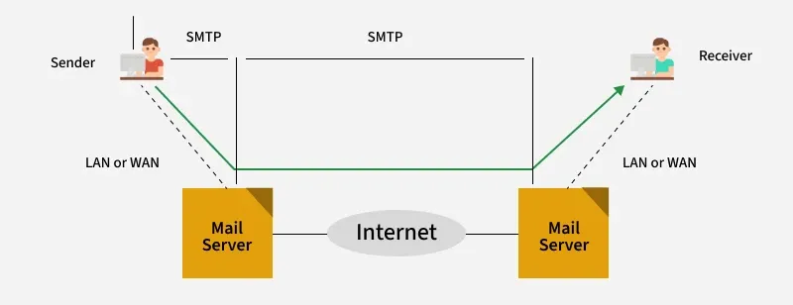

Task 20

Difference between OSI and TC/IP Model

Number of Layers:

OSI Model: 7 layers (Application, Presentation, Session, Transport, Network, Data Link, Physical)

TCP/IP Model: 4 layers (Application, Transport, Internet, Network Access)

Layer Functions: In OSI Model:

Application: End-user services (HTTP, FTP)

Presentation: Data translation & encryption

Session: Manages sessions between apps

Transport: End-to-end delivery (TCP/UDP)

Network: Routing (IP)

Data Link: Error-free delivery between nodes

Physical: Hardware transmission

TCP/IP Model:

There are many similar protocols working on various layers and hence they were clubbed together.

Application: Combines OSI's top 3 layers

Transport: Same as OSI (TCP/UDP)

Internet: Similar to OSI Network layer

Network Access: Combines OSI's bottom 2 layers (Data link layer and Physical layer)

Key Differences:

Flexibility:

OSI: More rigid, strict boundaries

TCP/IP: More flexible, protocols can cross layers

Usage:

OSI: Used as reference

TCP/IP: Actually, used in real networks

Simple Analogy:

OSI Model is like a detailed recipe with every step spelled out

TCP/IP is like a simplified version of the same recipe with practical steps combined

Note : No layer changes any data coming from any layer to another layer only header[protocol] are added to the data coming from previous layer.

Task : 21

LLD and HDD

1. Low-level Design : A detailed design document that outlines the specific implemenentation details of a system, including algorithms , Data structures and interfaces.

It is a detailed technical blueprint for implementation

1. High-level Design : A high-level design document that outlines the overall architecture and design of the system.

It is abroad overview of the system.

HLD answers "What to build?"

LLD answers "How to build it?"

Task 22

SRS with Diagram :

A Software Requirements Specification (SRS) is a comprehensive document that describes the intended purpose, features, and functionality of a software system.

These requirements can be functional as well as non-functional depending upon the type of requirement.

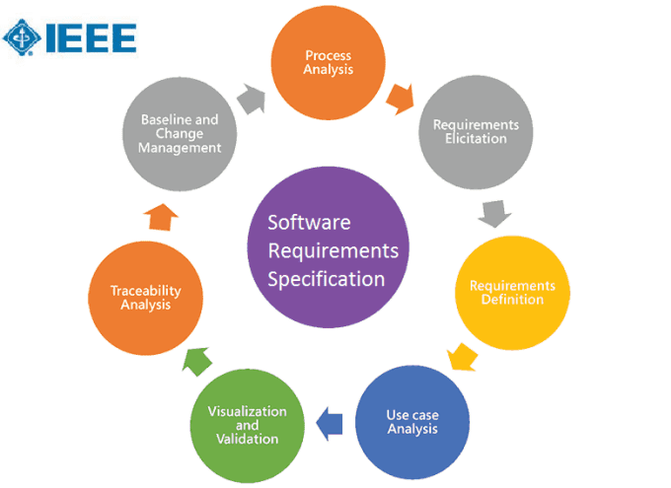

A Software Requirement Specification (SRS) is like a detailed blueprint or recipe for building software.

Example : Think of it as a master plan that explains exactly what the software should do and how it should work. It helps everyone involved in the project understand their role clearly - developers know what to build, testers know what to check, and managers know how to plan the work. It's also useful for the maintenance team who might need to fix or update the software later. The SRS helps keep everyone on the same page, much like how a building plan helps architects, construction workers, and interior designers work together smoothly. Most importantly, it helps explain to customers what they can expect from the final product. By having everything written down clearly, teams can build better software without going over budget or missing deadlines. It's like having a good map before starting a journey - you're much more likely to reach your destination successfully.

MCQs :

1.

A feasibility study using the SDLC model is conducted to

determine whether or not the project is technically possible

determine whether the proposal is financially viable

Both a and b

None of the above

2.

A well-documented life cycle model aids in the detection of what during the development phase?

Inconsistencies

Redundancies

Omission

All of the above

3.

How many lines of code does the Build & Fix Model suit for programming exercises?

100-200

300-400

600-700

Above 800+

4.

In which life cycle does regression testing play a significant role?

Waterfall model

V model

Iterative model

All of the above

5.

What determines if the project should go forward?

feasibility assessment

opportunity identification

system evaluation

program specification

6.

What is the most significant disadvantage of employing the RAD Model?

Developers/designers that are highly specialized and skilled are required.

Component reusability is improved.

Encourages client/customer input.

Increases component reusability.

7.

Which of the following developmental models is incremental?

Prototyping, V model, Agile

Prototyping, RAD, Agile, RUP

Prototyping, V model, RAD, Agile, RUP

All of the above

8.

Which of the following is an Agile development characteristic?

Shared code ownership

Test-Driven Development

Implement the simplest solution to meet today's problem

Continual feedback from customer

All of the above

9.

Which of the following steps in the SDLC framework are valid?

Requirement Gathering

Software Design

System Analysis

All of the above

10.

Who is in charge of system development, staffing, budgeting, and reporting, as well as ensuring that deadlines are met?

Project managers

Network engineers

Graphic designers

Systems analysts