29 - May - 2025, Employee ID : 112916146 (Day : 6)

Task1 :

List all regular expressions with their meanings.

1 (.) Dot character :

Meaning: Matches any single character (except newline).

Example : Input : (a.c)

Output : (abc) ectc,

2. * (Asterisk) : Matches zero or more occurrences of the preceding character.

Example : lo*l' file.txt

3. ^ (Caret)

Meaning: Matches the start of a line.

4. $ (Dollar)

Meaning: Matches the end of a line.

5. [] (Brackets)

Meaning: Matches any one character inside the brackets.

6. [^ ] (Caret inside brackets)

7. \{n\}

Meaning: Matches exactly n repetitions of the previous character.

8.\| – OR (alternation)

Meaning: Matches either of the patterns.

9.\{n,m\}

Meaning: Matches between n and m repetitions.

==================================================

Task 2 : Features of Linux

1.Open free sources

2.Is secure as it has strong built-in protection against threats.

3.Simplified updates for all installed software's.

4.Light weight (requires less RAM consumption)

5. Multiuser and Multi Tasker , as multiple users can work using one server.

6. Has multiple distribution such as Red hat , Fedora , Debian

7. Stability and Reliability as Linux systems can run for years without crashing or needing reboots.

=================================================

Task 3 : WHAT IS Kernal and can you explain its functions

Kernal is the core component of the O.S. It acts like a bridge between Hardware and Software and ensures everything works smoothly,

What does the kernel do?

Tells the CPU which program to run and when.

Manages memory so programs don’t mess with each other’s data.

Controls devices like your keyboard, screen, and printer.

Makes sure everything is safe and working without crashing.

Handles multiple programs accessing the same device (like two apps using the internet).

Its Functionalities :

Process Management – Manages processes (starting, scheduling, and stopping).

Memory Management – Allocates and frees memory for processes. Prevents one process from accessing another’s memory.

Device Management – Manages communication with hardware via drivers.

File System Management – Handles file reading, writing, and access permissions.

Network Management –Manages data transmission over networks.

Security and Access Control – Ensures only authorized users/processes can access certain resources.

System Call Interface – Provides a bridge for applications to request kernel services.

======================================================

Task 4 . What is Bash

BASH = Bourne Again SHell

BASH is a command-line shell and scripting language used in Linux and UNIX systems.

In other words : It is the command-line tool we use in Linux to communicate to our computer by typing commands.

BASH is like a translator between you and the computer.

Ex : ls

(which means "show me the files here")

BASH sends that request to the system.

The computer shows you the list of files.

Some features :

Command History and Editing : It stores all the commands which we wrote in past

Tab Completion : BASH can auto-complete file names or commands when you press the Tab key.

Shell Scripting Support : We can write scripts (small programs) using BASH to automate tasks.

==================================================================

Task 5

What is difference between and Linux and Windows

1. Linux is open-source; Windows is proprietary and closed-source.

2. Linux is free to use; Windows usually requires a paid license.

3. Linux is highly customizable; Windows has limited customization options.

4. Linux is preferred for servers and development; Windows dominates the desktop market.

5. Linux uses terminals like Bash; Windows uses Command Prompt and PowerShell.

6. Linux updates are user-controlled; Windows updates are often automatic.

7. Linux is less targeted by viruses; Windows is more vulnerable to malware.

8. Linux supports mainly open-source software; Windows supports a wide range of commercial software.

Examples include Firefox, LibreOffice, GIMP, and many free tools that users can customize or improve.

Examples include Microsoft Office, Adobe Photoshop, AutoCAD, and many popular games.

===================================================

Task 6: Is it legal to edit Kernal?

Yes, it is legal to edit the Linux kernel because it is open-source under the GNU General Public License (GPL).

Basic components of Linux

Kernel – The core part of Linux that talks to the hardware.

Example: When we open a file, the kernel helps the program read it from the hard drive.

Shell – Lets you type and run commands to control the system.

Example: You type ls to list files — the shell sends this command to the kernel.

File System – Organizes how files and folders are stored.

Example: /home/user/file.txt is a file path in the file system.

System Libraries – Help programs run by providing ready-made functions.

Example: A program uses a library to display text on the screen.

System Utilities – Small tools for tasks like copying, moving, or deleting files.

Example: cp to copy, rm to delete, top to monitor running processes.

User Space – Where user applications and programs run.

Example: Firefox, LibreOffice, VS Code run in user space.

=========================================

Task 7 : What is LILO?

LILO stands for Linux Loader.

It is a boot loader — a small program that starts Linux when you turn on your computer.LILO helps your computer choose and load the operating system (like Linux) after it's powered on.

=======================================

Task 8 : how many of you have gone through techadamy Linux plz raise ur hand

yes

=====================================

Task 9 : What is shell? How many shells are there and what are they ? can you explain.

A shell is a program that lets us communicate with the operating system by typing commands.

It takes our commands → sends it to the system → shows the result.

It acts like a translator between you and the computer.

Types of Shells :

a . Bash , Sh ,Zsh ,Ksh and Tcsh

=========================================

Task 10.What is Swap space ?

Swap space is like an extra memory area on your computer's hard drive or SSD that your system uses when it runs out of physical RAM (Random Access Memory).

========================================

Task 11 : What is Mount ? how do you mount and unmount file system in Linux?

In Linux, "mount" means connecting a storage device (like a hard drive, USB, or DVD) to a folder so we can access its files.

Think of it like this:

We plug in a USB drive to see what's inside, Linux needs to mount it (attach it to a folder).

After that, we can open it and use the files.

The folder where the device is attached is called a mount point (like /mnt or /media/usb).

How to Mount a Filesystem :

Create a mount point (a folder): (command : sudo mkdir /mnt/usb

Mount the device: sudo mount /dev/sdb1 /mnt/usb

/dev/sdb1 = our USB or disk partition

/mnt/usb = folder where it's mounted

Unmounting in Linux is the process of safely detaching a mounted filesystem from the system. This ensures that all data is written to the device, preventing potential data corruption or loss.

To detach a mounted filesystem, we use the umount command

==========================================

Task 12 :What is chmod command ? how to use it?

The chmod command in Linux stands for "change mode" and is used to modify the permissions of files and directories. Permissions determine who can read, write, or execute a file.

What Are Permissions?

Permissions control access to files and directories and are divided into three categories:

User (u): The owner of the file.

Group (g): Users who are members of the file's group.

Others (o): Everyone else.

Each category can have three types of permissions:

Read (r): View the contents of the file.

Write (w): Modify the file's contents.

Execute (x): Run the file as a program or script.

1. Using Symbolic Notation

We can modify permissions using symbolic notation:

Add permission: +

Remove permission: -

Set permission explicitly: =

2. Using Numeric (Octal) Notation

Permissions can also be represented by numbers:

Read (r): 4

Write (w): 2

Execute (x): 1

=============================

Task 13 and 14 attach pictures

==============================

Task 15 :

What is diff between Process and Thread?

A process is like a complete program running on the computer, while a thread is a smaller part of that program that performs specific tasks.

Example: When we open a web browser, it becomes a process running on your computer.

Within our web browser, one thread might handle loading a webpage, while another handles user input like clicks or typing.

Example to Illustrate

Consider a web browser:

Process: Each tab in the browser runs as a separate process, ensuring that if one tab crashes, the others remain unaffected.

Thread: Within each tab, multiple threads handle tasks like rendering the page, fetching data, and processing user input concurrently.

Note : Do all multi threads working simultaneously : No, although the difference is very minute hence not noticeable but they don't work simultaneously

================================

Task 16 -18 (ss )

16. Linux Grep commands

17. AWK commands in doc 15 Linux AWK commands..

18.How to check file access permission in Linux?

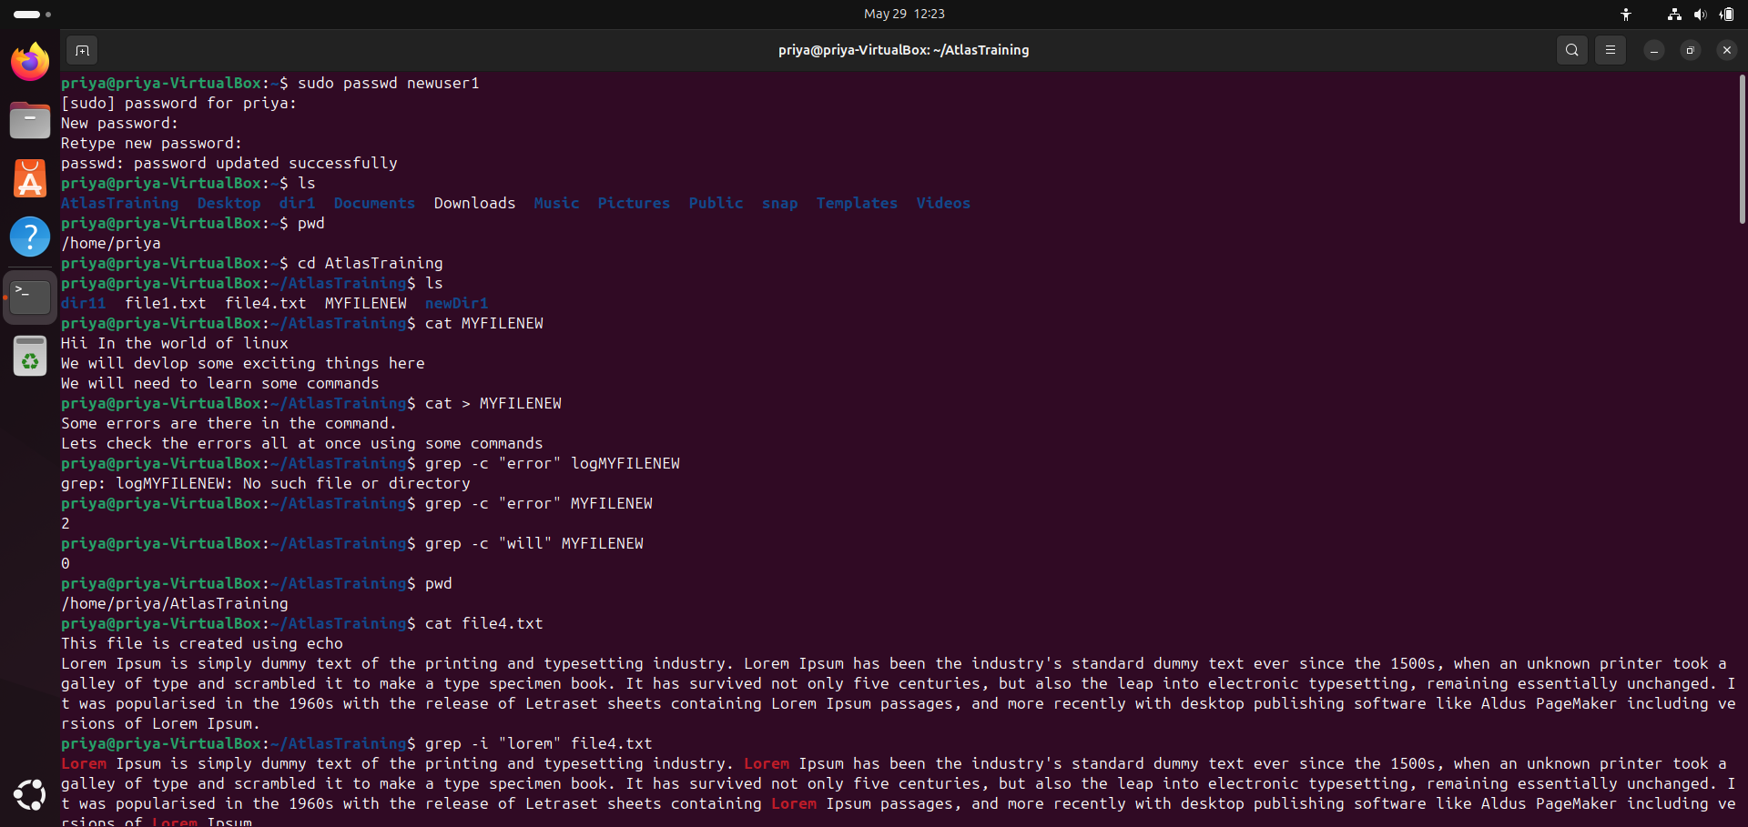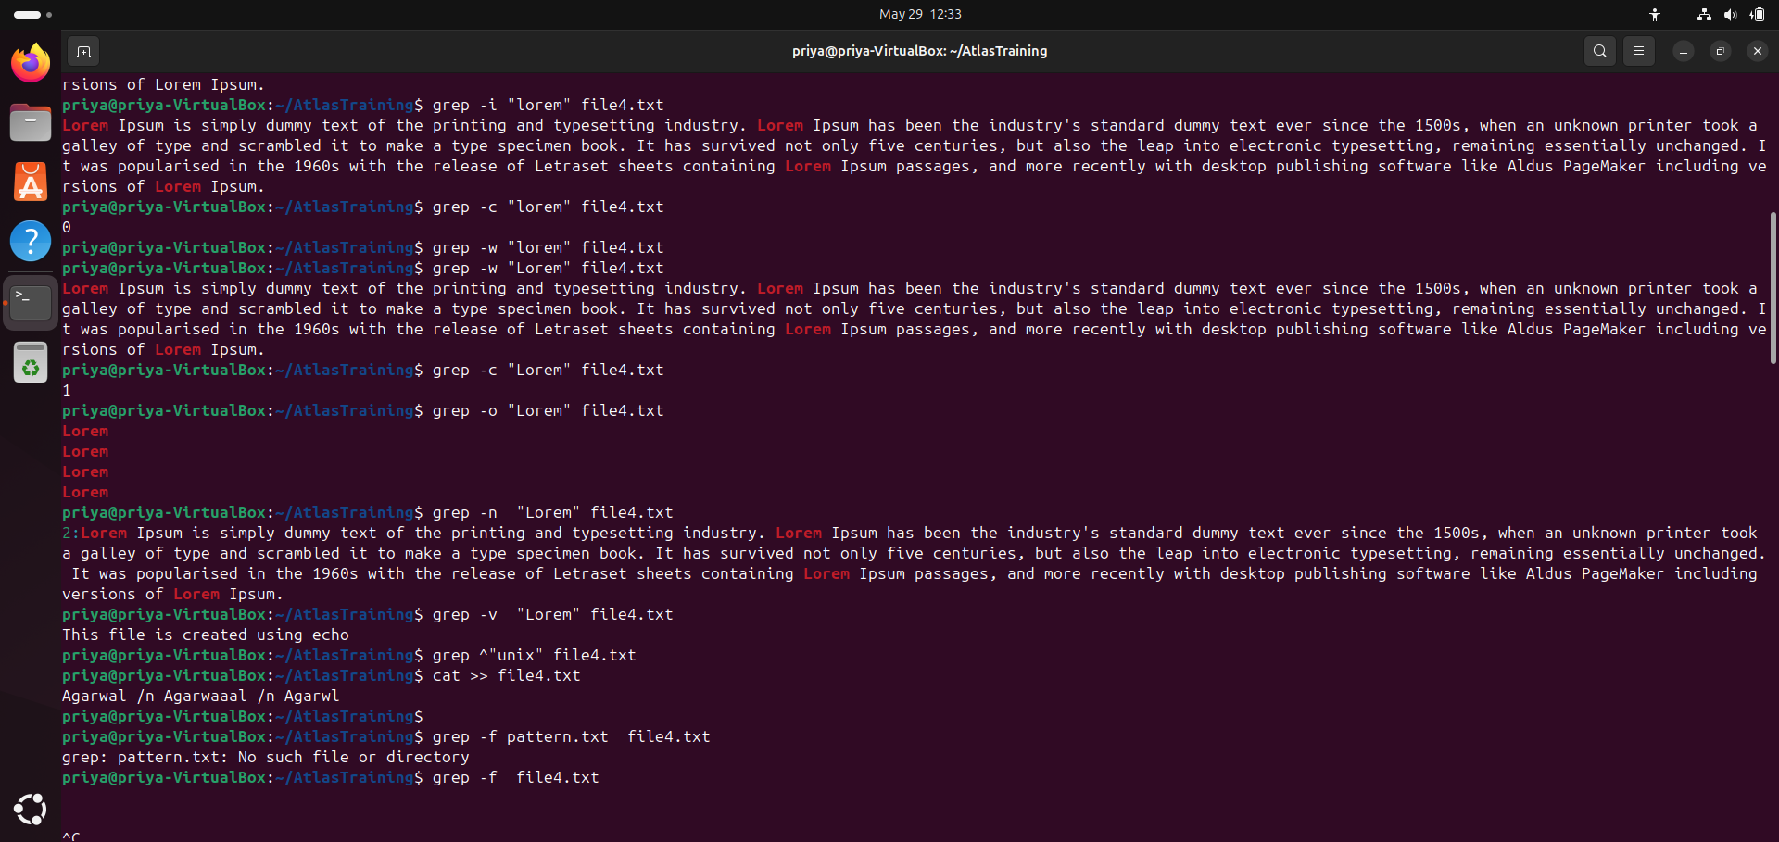

================================

Task 19 :

What are the default permissions for a new file ?

Plz find out for

Owner → ?

Group → ?

All and others → ?

Owner: Read and write permissions (rw-)

Group: Read-only permission (r--)

Others: Read-only permission (r--)

=====================

Task 20 -23 :

20. What is the command to change the permisssion to read only for the owner, group and all other users

21. Can you change the file permissions to match the following:

* owner: Read and Write
* group: Read
* other: no permissions (None)

22. What was the command for changing the file permissions to -rw-r-----?

23.Change chmod.exercises permissions to -rwxr-x--x

Change the file permissions to match the following:

owner: Read, Write and Execute

group: Read and Execute

other: Execute

Task 24:

What was the command for changing the file permissions to -rwxr-x--x

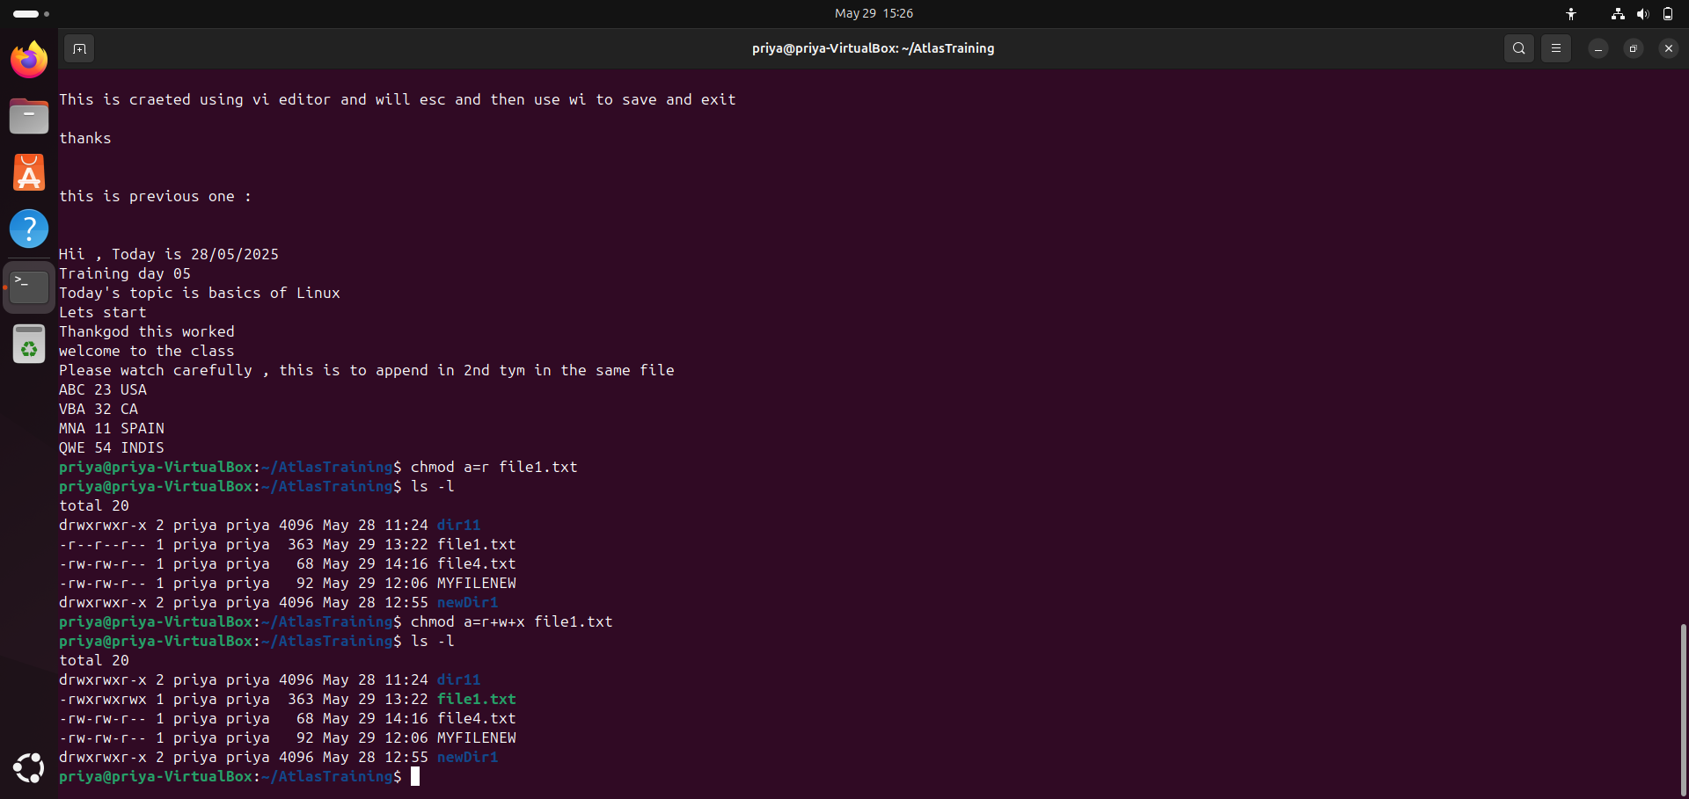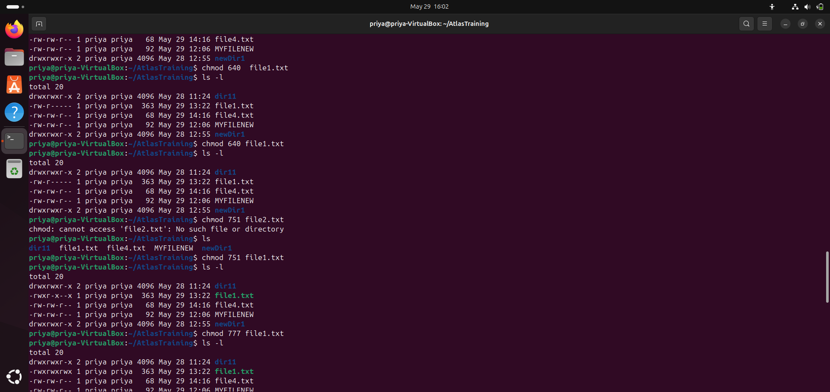

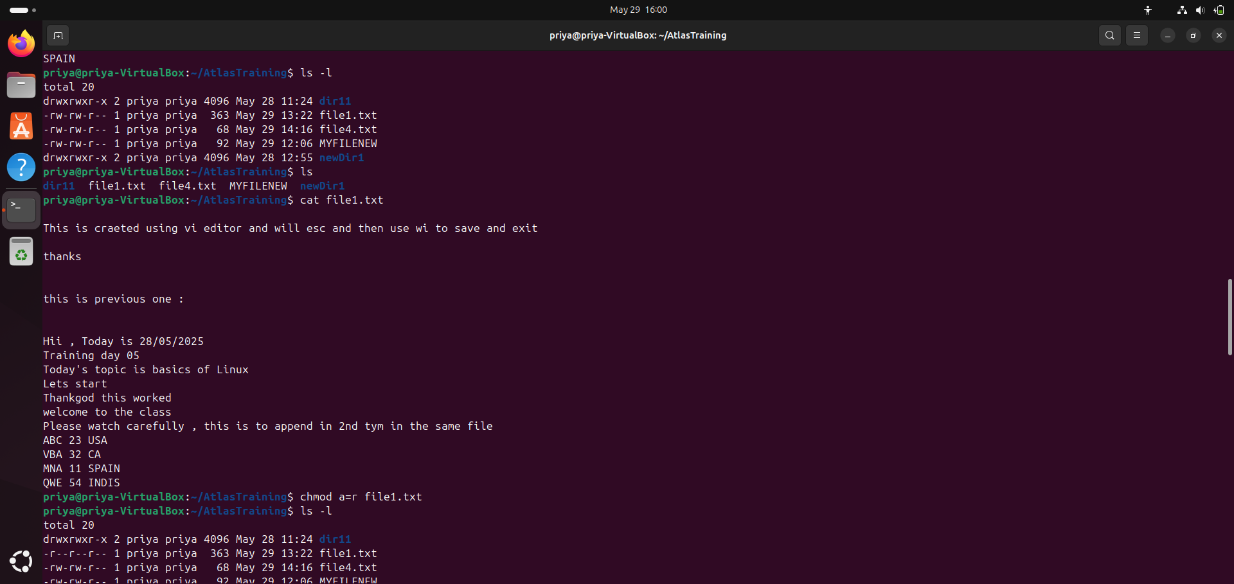

Ans of 23 : Yes(ss attached)

===================

Task 24 , 25 (SS)

=================

Task 26

Can you define what is a process

A process is a running program.

When we open an app or run a command in Linux (like ls, firefox, or python), the system creates a process to handle it.

Each process has:

A PID (Process ID)

A user who started it

Some resources (like memory, CPU)

=================================

Task 27 : What is command to check foreground process and background process

Foreground process

A foreground process runs in the terminal. We can see its output and interact with it.

Background process

A background process runs behind the scenes. It doesn't block the terminal — we can keep typing other commands.

=========================

task 28 :

ps aux

ps -ef

top

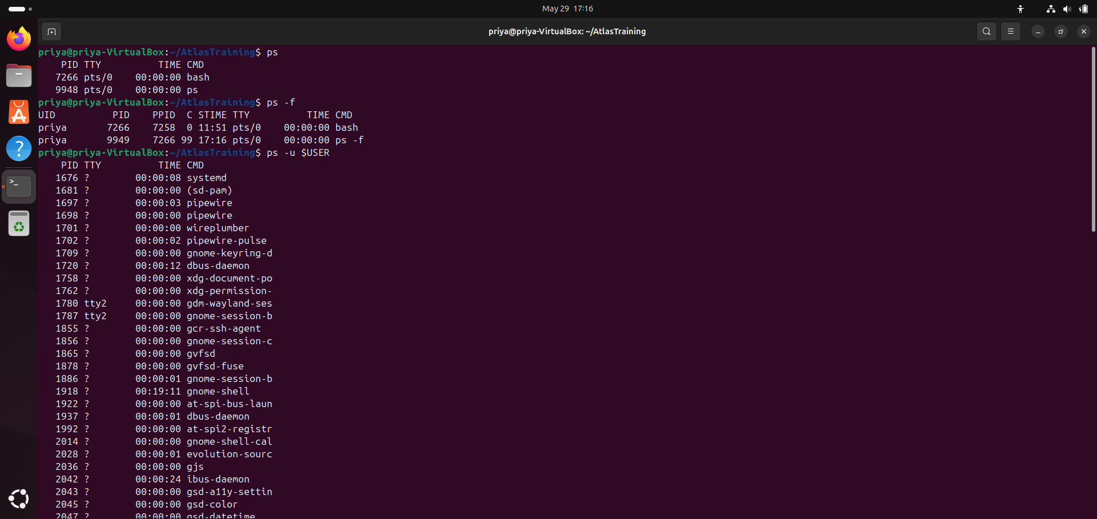

Task 29

ps -f

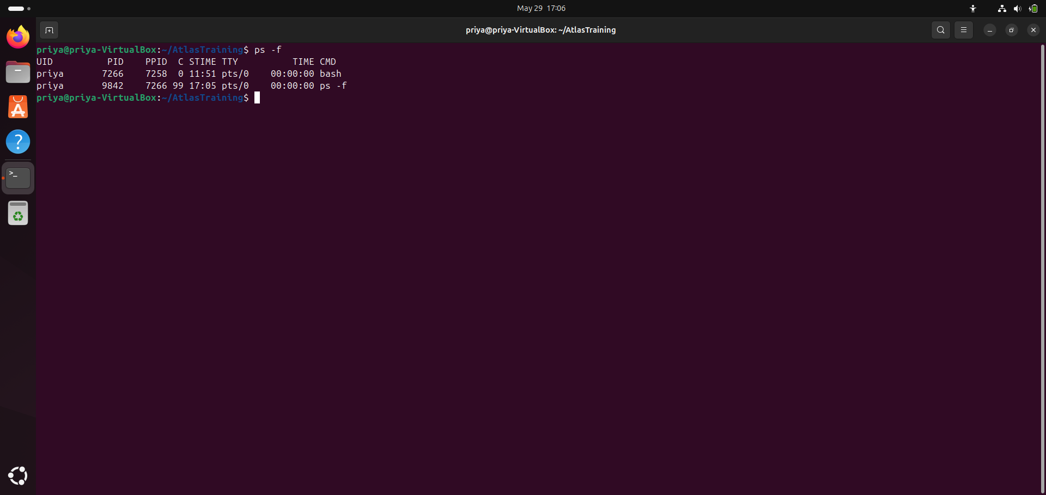

ps -f shows a full-format listing of your processes.

It includes:

UID: User ID (who owns the process)

PID: Process ID

PPID: Parent Process ID

C: CPU usage (not always used)

STIME: Start time of the process

TTY: Terminal type

TIME: CPU time used

CMD: The command that started the process

(ss )

==========================

Task30-31 (SS)

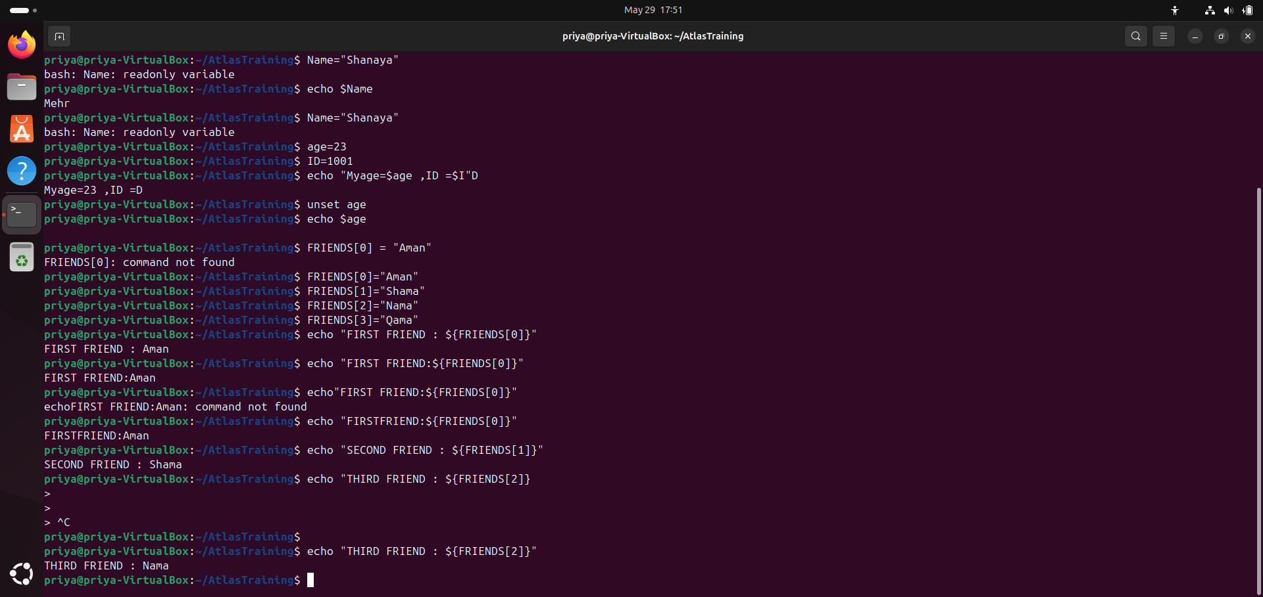

======================

Task 32

**Unset the variables**

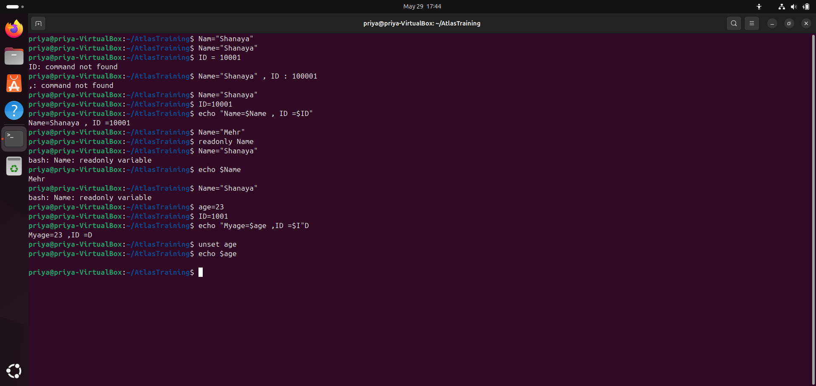

**Task 33/34:**

**Can u try to add a list of your friends names in an array and try to printout/ print full array at once**

**Ex:**

**NAME[0]="Ram"**

**NAME[1]="Sita"**

**NAME[2]="Tina"**

**NAME[3]="Veena"**

**NAME[4]="Tim"**

**echo "First Index: ${NAME[0]}"**

**echo "Second Index: ${NAME[1]}"**

**echo ${NAME[@]}**



Task 35: Plz let me know whats the output of the below snippet:

a=0

while [ "$a" -lt 10 ]    # this is loop1

do

   b="$a"

   while [ "$b" -ge 0 ]  # this is loop2

   do

      echo -n "$b "

      b=`expr $b - 1`

   done

   echo

   a=`expr $a + 1`

Done

