SCREENSHOTS OF AWS PROJECT :

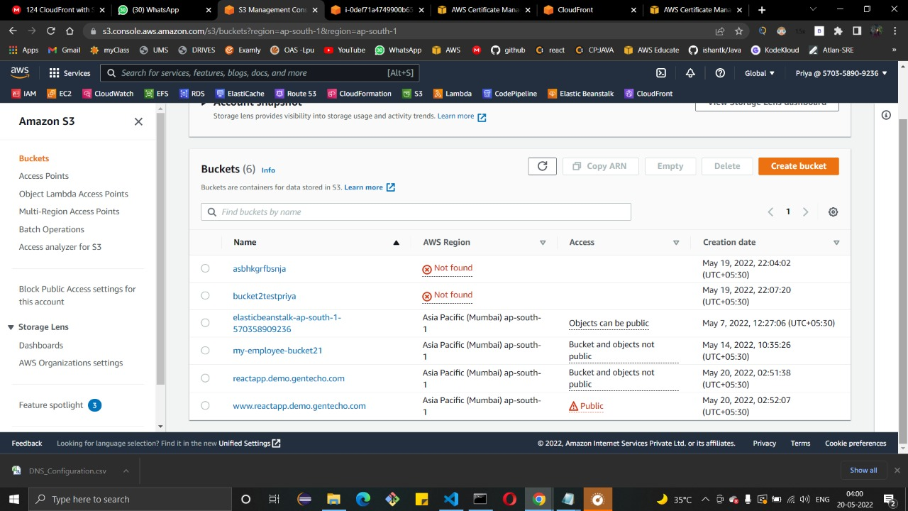

S3 BUCKETS : [www.reactapp.demo.gentecho.com](http://www.reactapp.demo.gentecho.com) and [reactapp.demo.gentecho.com](http://www.reactapp.demo.gentecho.com)

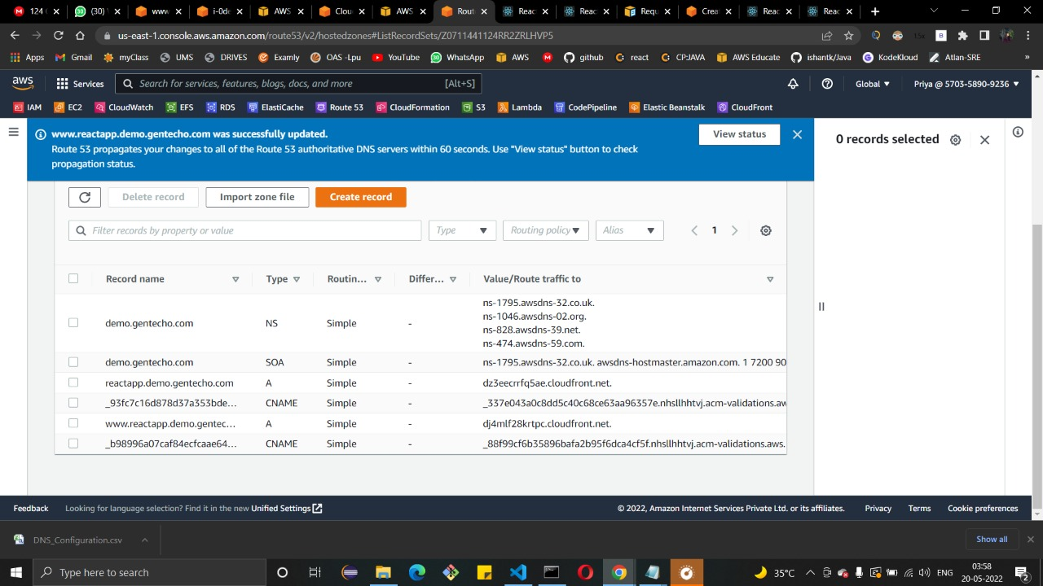

ROUTE53

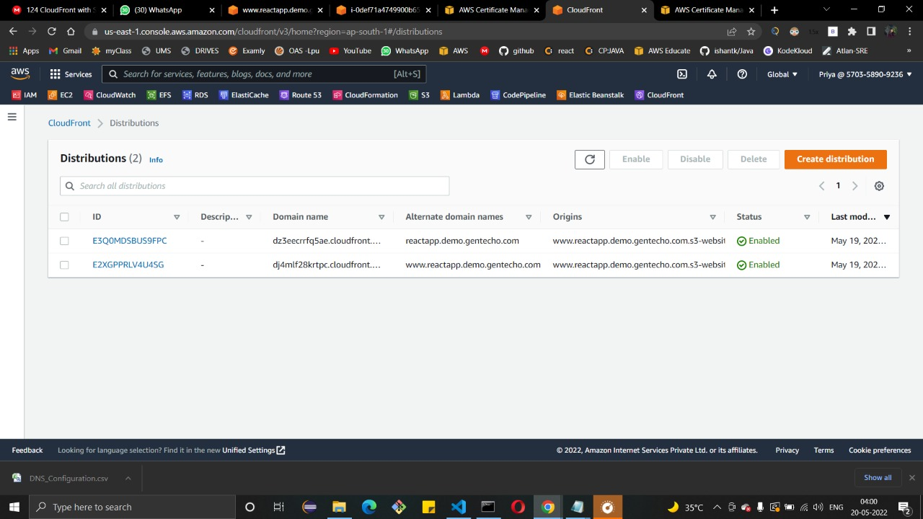

CloudFront Distributions

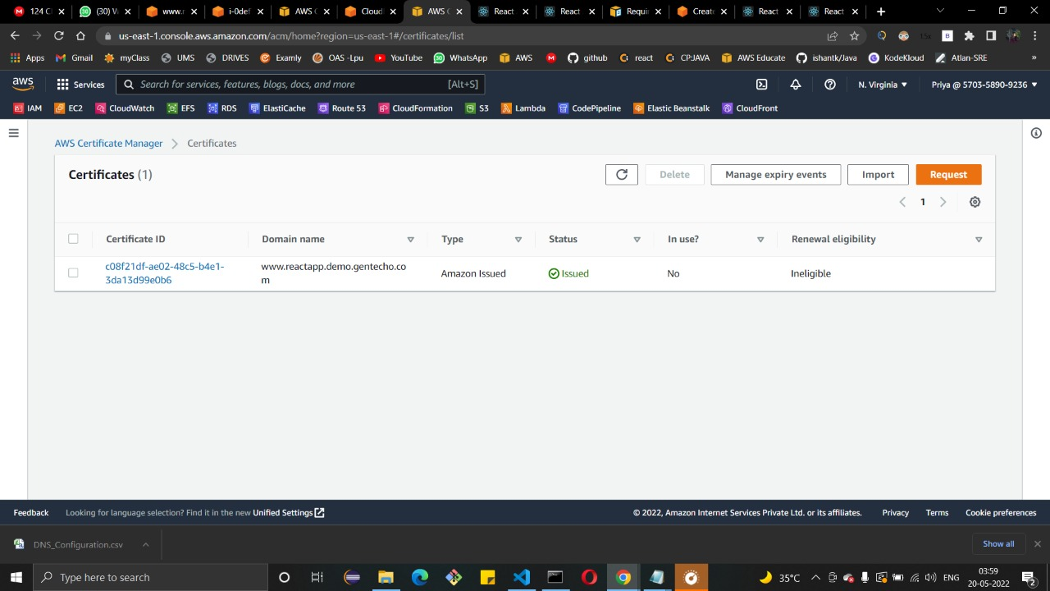

SSL Certificate

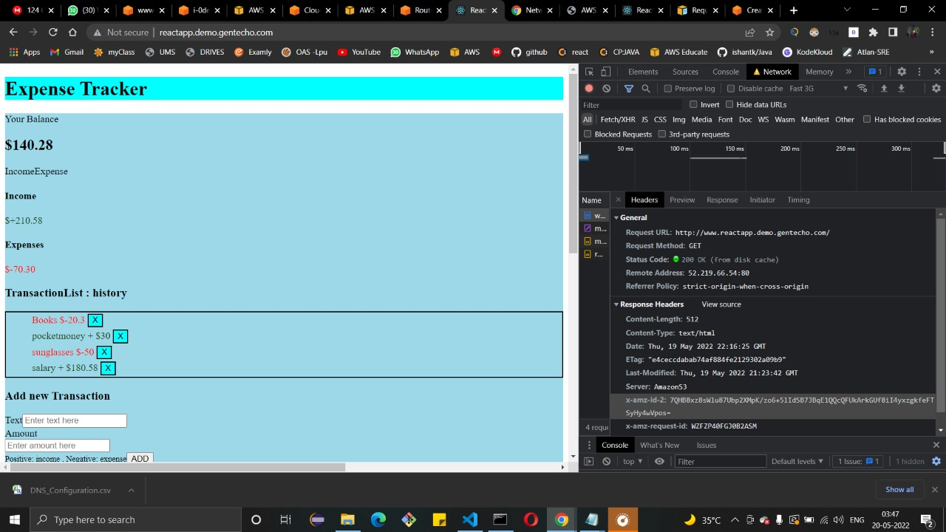

Site : Before setting up SSL and CloudFront

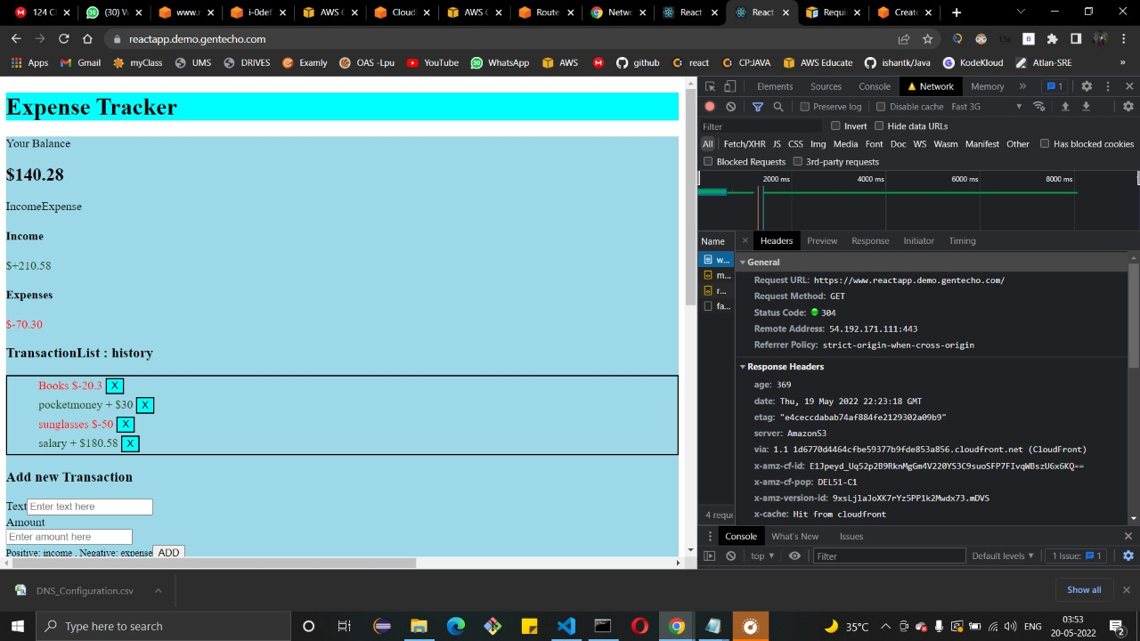

After setting up SSL and CloudFront

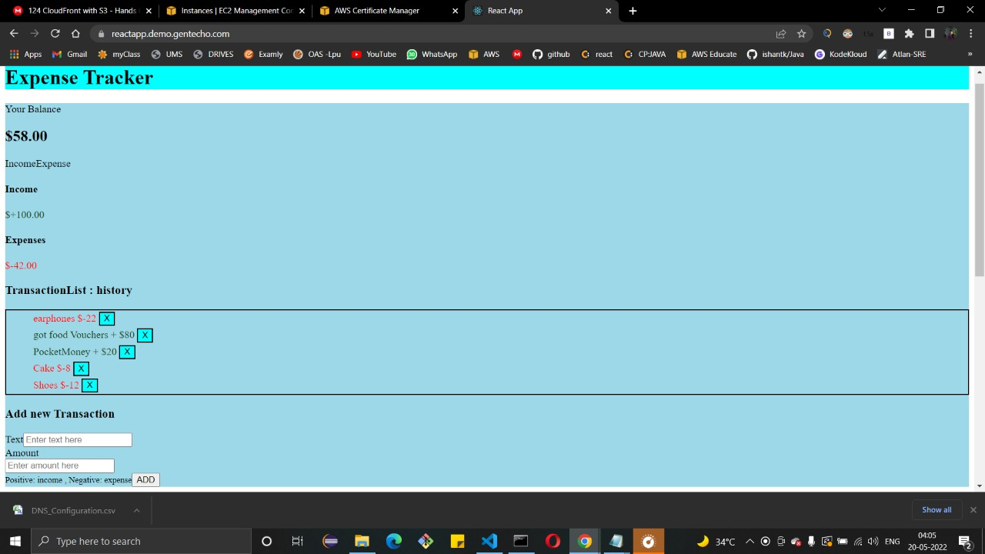

Ps: Don’t look at CSS part of the website .