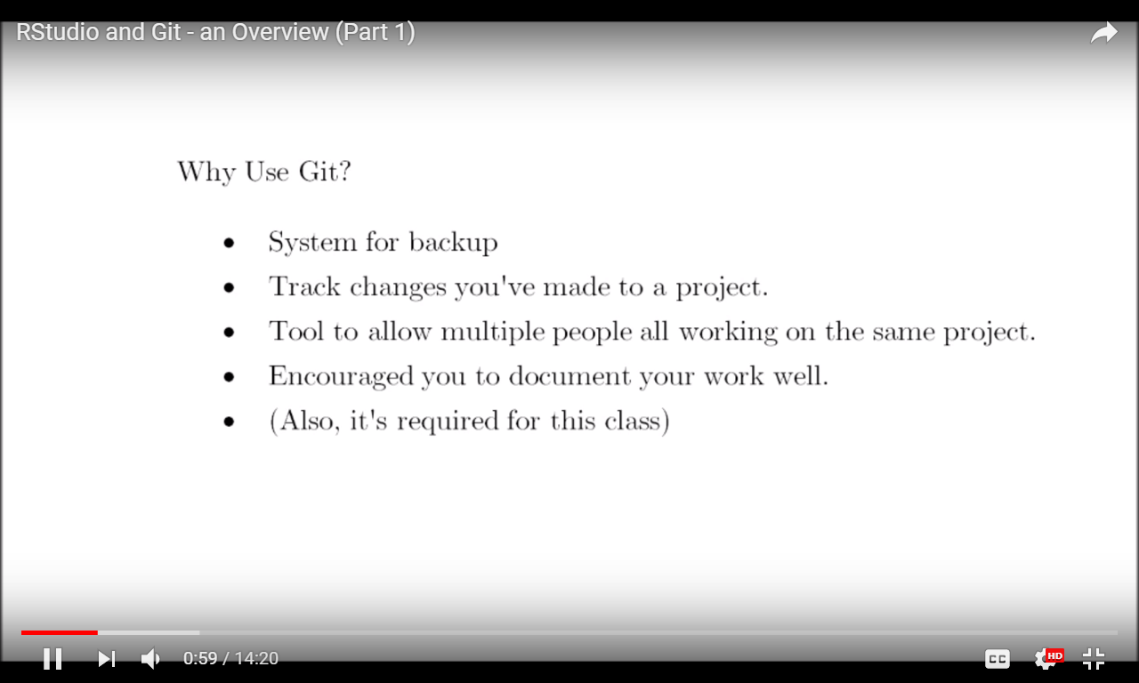

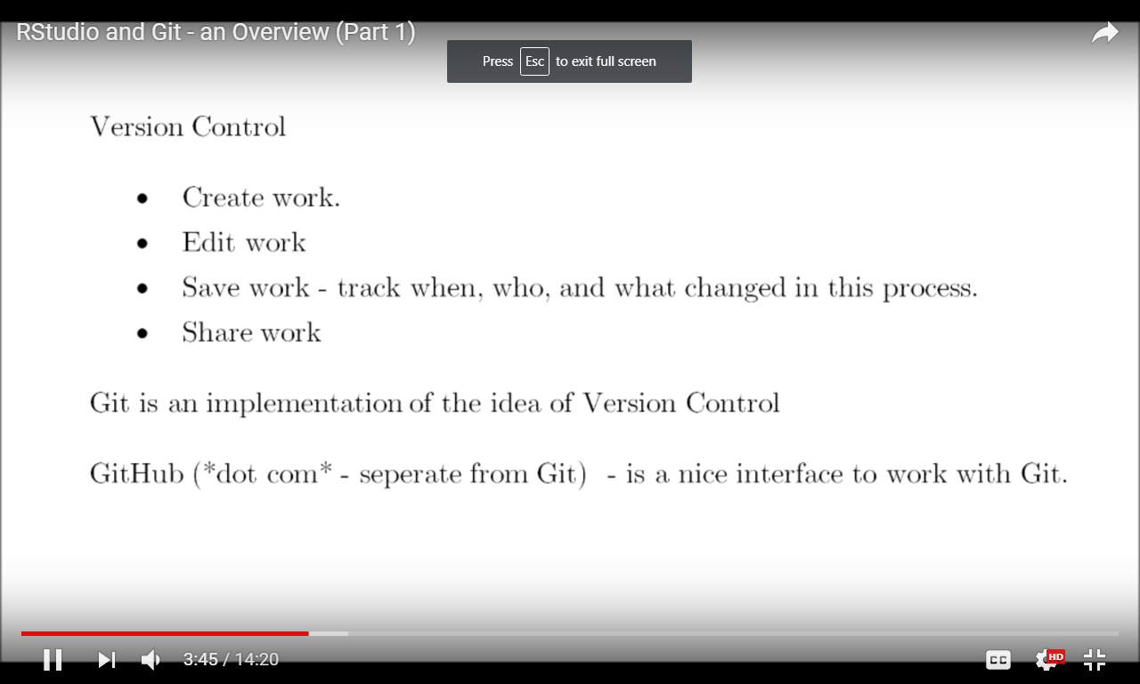

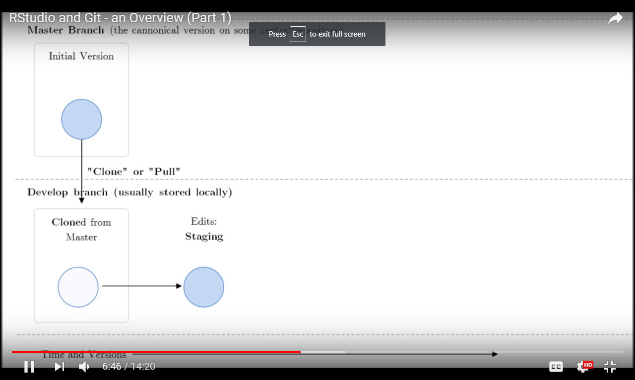

Pull: from master branch to local branch; to get the latest copy of our project.

We edit and make changes in local branch in our local machine and it doesn’t affect master branch.

Commit: commit the changes with comments. (locally)

Push: push from local to master.