# Activity 1

Design a JSON file for representing the following information:

Save the file as Actvitiy1_yourname.JSON

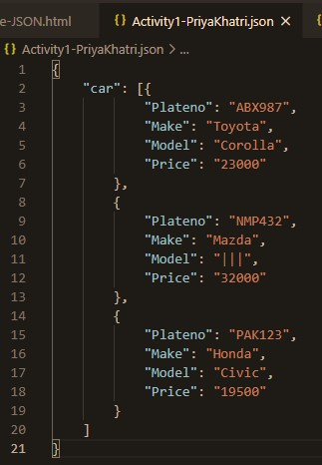

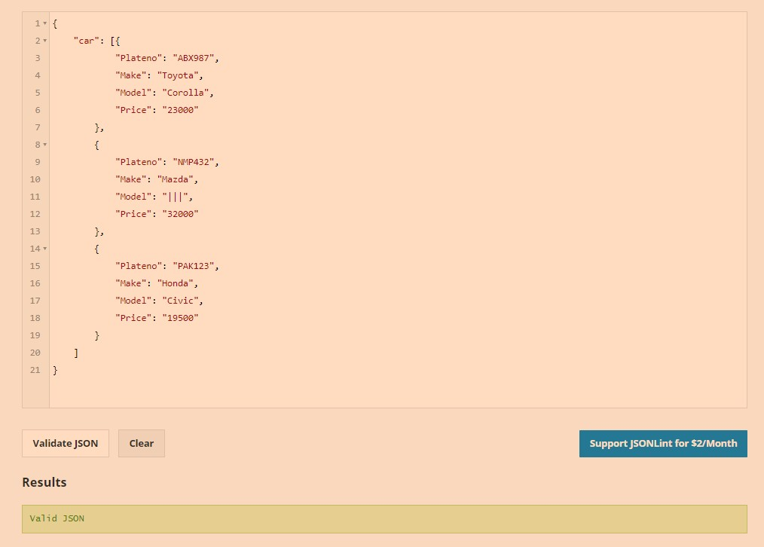

• Validate the JSON file

Using the given code in previous slide, develop a JavaScript program which

– Opens the JSON file in warm up activity 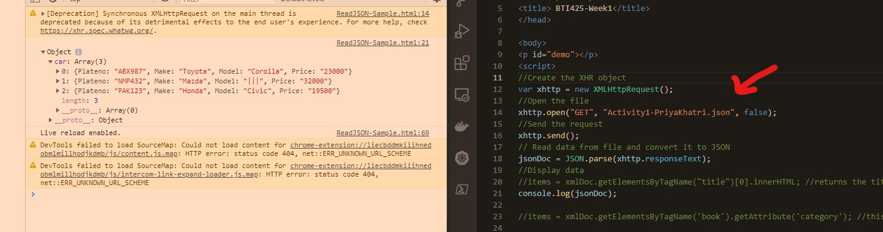

– And display all the plate-no

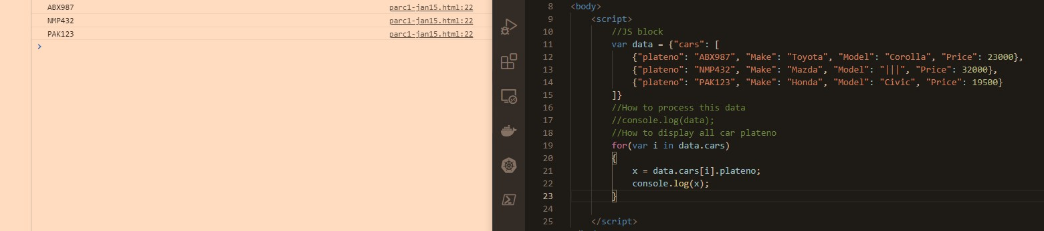

# Activity 2

– Validate the file

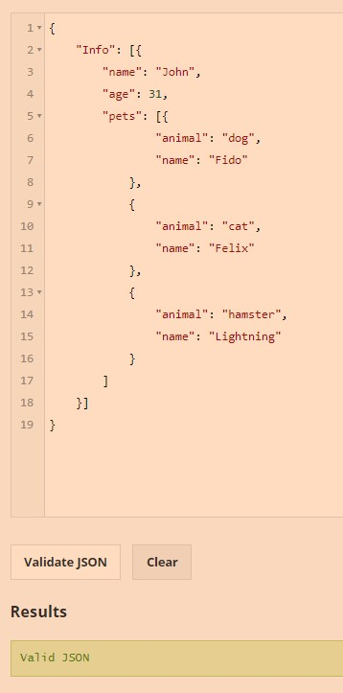

• Develop a JavaScript program (parsejson.html) which open the json file and displays the dog owner’ name and age

– John , 31

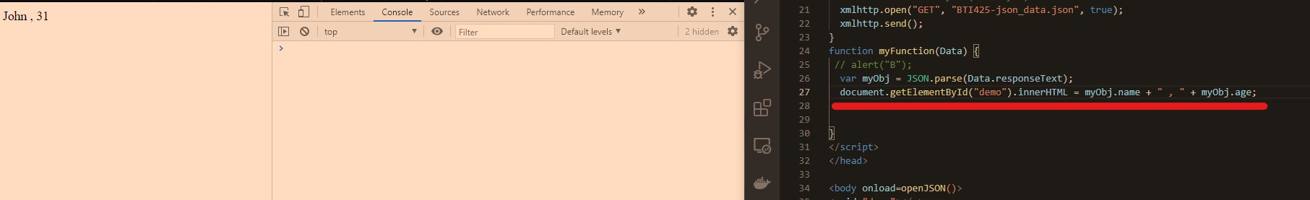

• Modify the program to display all the pets_name

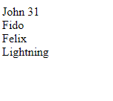

Activity 3

– Develop a program which displays the current temperature in Toronto.

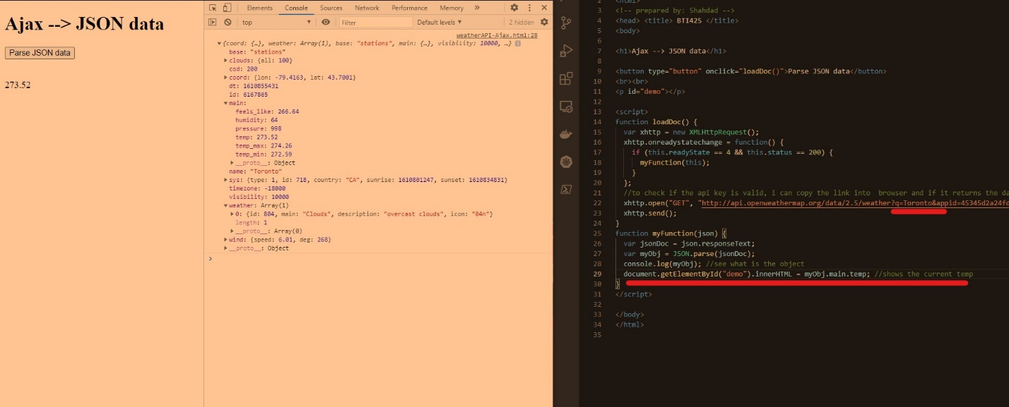

# Activity 4: Research Activity

• What are the valid range of readyState? What is the meaning of each value? What are the valid range of status? Write the three famous values and its main purpose?

When the readyState is at 4 it means the connection is successful. In the readyState property there are 0-4 status changes and it goes as follows:

0: request not initialized

1: server connection established

2: request received

3: processing request

4: request finished and response is ready

There are many codes, but the 3 famous values are:

Status code 200 which means your connection is OK and successful

Status code 403 is Forbidden and this can mean a few things but usually in API calls it can mean the access is protected or you don’t have authority for the call and will likely give you a response message letting you know the problem.

Status code 404 is Not Found means the requested site was not found on the server or it was moved without a notice.

• Read the article “XHR vs Fetch API”. Using your own word (30-60 words) compare these two.

XHR and Fetch API are different methods with API calls. Fetch API is the newer, cleaner. In the article, it mentions one of the differences is the browser support. Fetch API doesn’t work well in IE or any of the other popular browser versions before 2017. However XHR is cookieless by default and supports the timeout feature where Fetch API doesn’t.