For activity1 with the command **document.getElementsByTagName(‘title’)** it will display each collection that is in the .xml file as shown in the screenshot below along with all the details for each ‘title’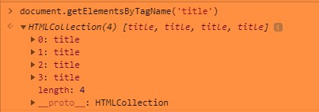

Opening the ReadXML-Sample.html in my browser and using live server it’s a blank screen until I go to the console and I saw the console and it would show what my program is doing

This is from activity 1 which was fairly simple and straightforward using the command

**items = xmlDoc.getElementsByTagName("title")[0].innerHTML;**

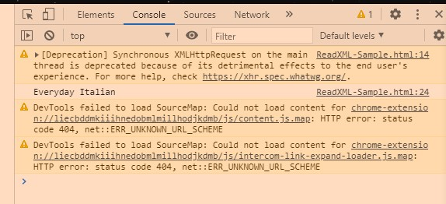

For activity2 it was a bit more complicated for me to figure out. I think I will have to practice this a bit more to figure out how exactly getAttribute() works, however I got the output.

