Activity 1 convert the code into jquery from html:

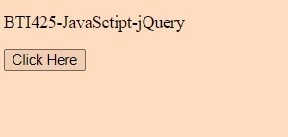

Activity 1 continued to change the colour of paragraph 2

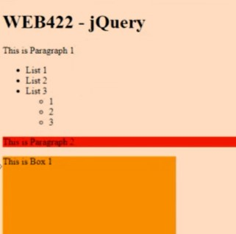

Activity 2. Running the program before changing the code gets me this popup error code with the number 10004. So we know it’s at least working.

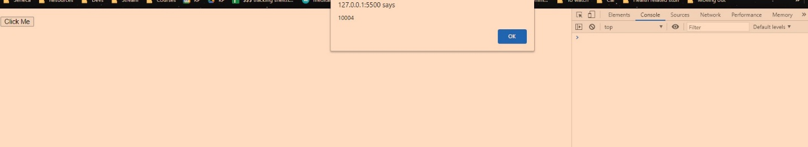

The line of code

var data = [ {"Id": 10004, "PageName": "Club"},{"Id": 10040, "PageName": "About Us"}, {"Id": 10059, "PageName": "Events"}];

alert(data[0].Id);

Is looking through the function and displaying the matching ID with an alert since that is the code we’re using on the next line.

Do some research and understand whether $.each() and $(selector).each() are two different methods or are the same.

The $.each() needs the function data and then we can display it. So the way it works is usually by looping through or iterating over JavaScript arrays and objects and gives each item a value. Whereas $(selector).each() loops through a list of jQuery objects and gives you the iterator and the jQuery object from my understanding.

Sources:

<https://stackoverflow.com/questions/6611190/what-is-the-difference-between-eachselector-and-selector-each>

<https://api.jquery.com/each/>

<https://api.jquery.com/jquery.each/>