Activity 1

You are asked to extract the current temperature of city of Toronto from the OpenWeatherMap (extract XML data)

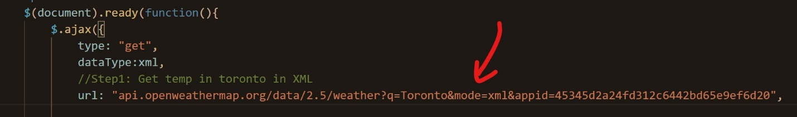

Using $.ajax(), develop a JS programs to extract the data and display it

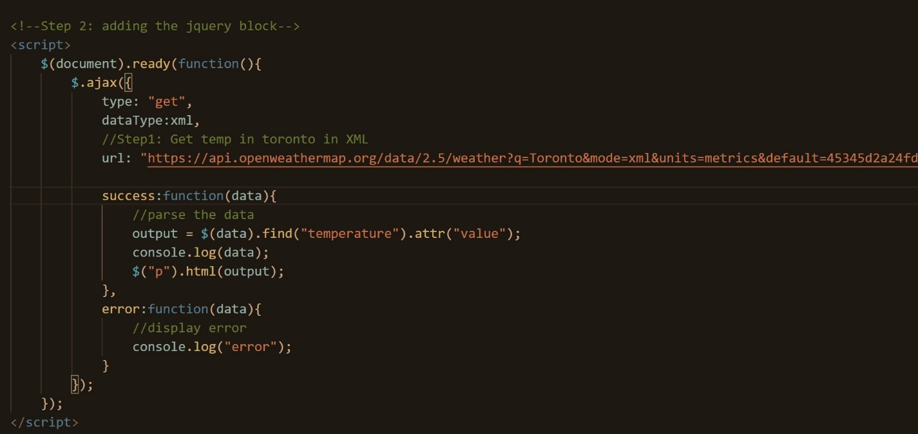

Activity 2

There are three ajax examples

* You need to explain how they work using your own word
* Run each example on your computer and take screenshot of the output

The first Example-ajax-1 doesn’t display anything it will just run the api because we’re not asking it to do anything.



The second example-ajax-2 is going to display and array of the data from a range of 99 values.

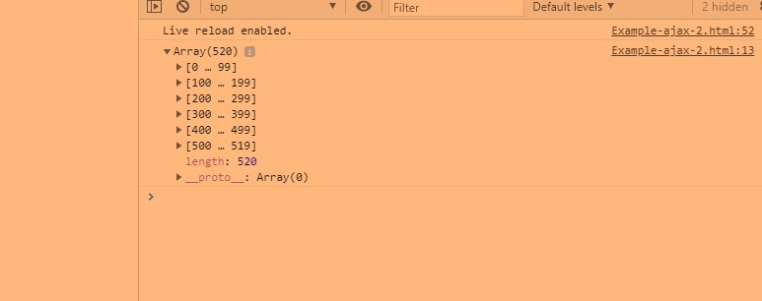

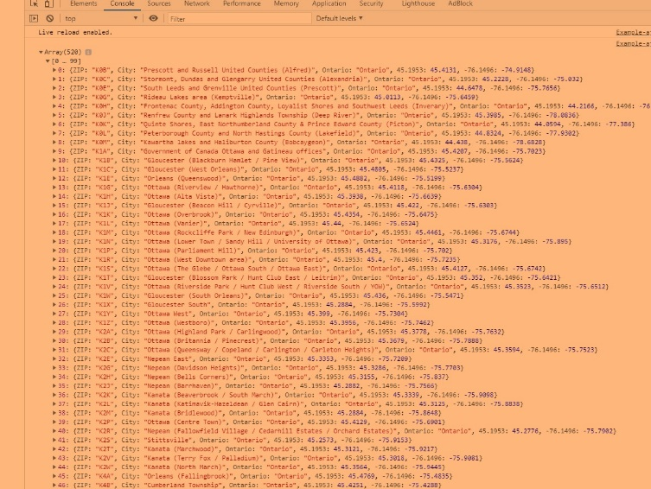

This code is requesting from the “location” of “file path” MyData.json so it will read the data and in the following lines it will display the data according to the function e.

The third example-ajax-3 will display all the code so instead of that we can narrow it down in the file data and it will display the area on the screen. As for me if I type in M3J it will show the North York location which is correct.

