Here is the link to question 1 for the add function: <https://stackblitz.com/edit/typescriptw8?file=index.ts>

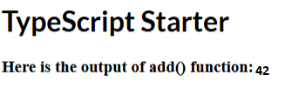

I found stackblitz very simple to use and was able to easily play around with the function while seeing the output instantly.

For question 2 updating the add function making it range from 10-50 and returning the instructed values: <https://stackblitz.com/edit/typescriptw8-wgqzt3?file=index.ts>

Return 30

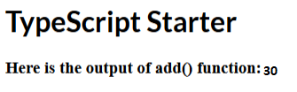

Return 50

