# **BTD210- Lab 2**

We, Monica, Muskan, Priya declare that the attached assignment is our own work in accordance with the Seneca Academic Policy. No part of this assignment has been copied manually or electronically from any other source (including web sites) **or distributed to other students.**

Please work in **groups** to complete this lab. This lab is worth 2% of the total course grade and will be evaluated through your written submission, as well as the lab demo. During the lab demo, group members are randomly selected to present the answers to each of the lab questions. Group members not present during the lab demo will lose the demo mark.

Please submit the following files through Blackboard. Only one person must submit for the team.

* Lab2.docx

## **Part I: Introduction to Databases**

1. Add this declaration on the top of your Lab1.docx file.

We, Monica, Muskan, Priya declare that the attached assignment is our own work in accordance with the Seneca Academic Policy. No part of this assignment has been copied manually or electronically from any other source (including web sites) **or distributed to other students.**

1. Specify what each member has done towards the completion of this work:

|  |  |  |
| --- | --- | --- |
|  | Name | Task(s) |
| 1 | Monica | Answers, create access table |
| 2 | Muskan | Answers, create access table |
| 3 | Priya | Answers, typing word document and submission |

1. During an interview with a small business owner, a database designer is given the following information about the two locations of the business:

|  |  |  |  |  |  |
| --- | --- | --- | --- | --- | --- |
| Location: | Phone number | Employee name | Job | Date of hire | Quality rate |
| 1234 Fine Ave. West | 416.123.1234 | John Smith | Manager | Jan 1, 2004 | 4 |
| James Jordan | Senior Engineer | Feb 12, 2005 | 4 |
| Mary McIntosh | Office Manager | May 5, 2010 | 3 |
| 999 Super Street | 905.987.9876 | Adam Array | Manager | March 3, 2003 | 3 |
| Tina Tesse | Office Manager | July 28, 2015 | 5 |

To start the data modeling process, the designer decides on the following entities:

* **Location** (information about the location)
* **Employee** (information about the employee)

What are the attributes for each of the above entities based on the above information?

* + Location table
    - Location
    - Phone number
  + Employee table
    - Employee Name
    - Job
    - Date of Hire
    - Quality Rate
    - Location

1. What type of relationship exists between **Location** and **Employee** entities? Explain your answer.
   1. 1:M because one location has many (more than one) employees.
2. Open Microsoft Access and create two new tables (**Location** and **Employee**) to store the data from above given information. (A few resources for Microsoft Access are mentioned at the end of this document.) For each table, create the fields necessary to store the data. Keep the ‘ID’ field suggested as ‘AutoNumber’. Show (paste here) a snapshot of the ‘Design view’ of the two tables. How many fields does each table have? **There are 6 field in Employee and 3 fields in Location table**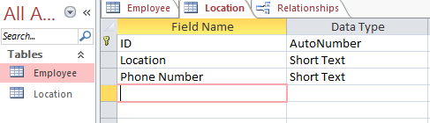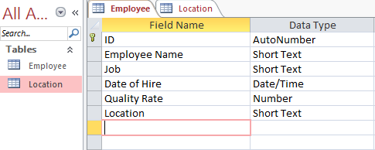
3. Store the data from the receipts in these tables. Show a snapshot of the ‘Datasheet view’ of the two tables. How many records does each table have? **In location table there are 2 records and in employee table there are 5 records.** 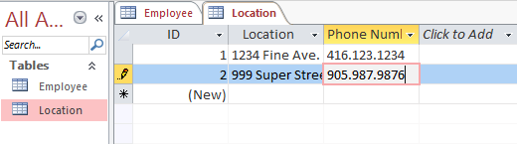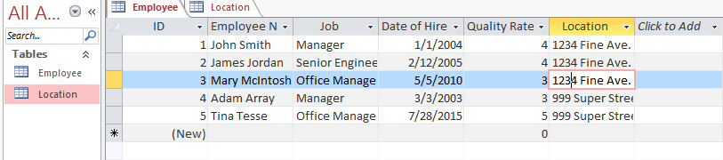
4. To build the relationship between **Location** and **Employee** entities, add a field to the **Employee** table by clicking on the drop down arrow next to ‘Click to Add’ and choose ‘Lookup & Relationship’. Choose ‘I want … another table or query’ and click ‘Next’. Then choose the **Location** table. Select ‘ID’ (to show up on the right side), choose ID to be used for sorting and then click ‘Finish’. Name this field ‘LocationID’. In the **Employee** table, set the ‘LocationID’ of each item to the ID of the related location.

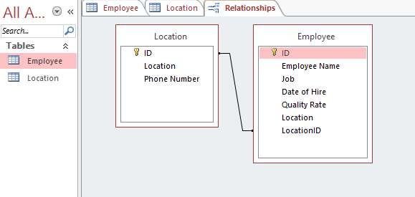

1. Use the menu item Database Tools > Relationships to see the relationship diagram. Show a snapshot of this diagram – Move the entities around for a good snapshot! What are the entities? Which attributes are linked? What does it mean?
   1. The entities are location and employee.
   2. The attributes linked are the ID from location table and the LocationID from the employee table.
   3. It means that there is a relationship between the primary key (ID) of the location table and to the foreign key of employee table (LocationID)
2. In Microsoft Access, the primary key of each table is shown by a key symbol. Which field is the primary key for each of the 2 tables above? Which field is the foreign key?
   1. The primary keys are in the location table (ID) and employee table (ID). The foreign key is LocationID in the Employee table.

**Resources for Microsoft Access:**

Access2003 Tutorial:

* <http://www.cengage.com/resource_uploads/downloads/1423901398_237258.pdf>
* <http://cws.cengage.co.uk/rcc_databases/students/accesstutorial.pdf>

Access 2013 and 2016:

* <https://support.office.com/en-us/article/Access-2013-videos-and-tutorials-a4bd10ea-d5f4-40c5-8b37-d254561f8bce>

Also on Lynda.com