# **BTD210- Lab 5**

We, Priya, Muskan, Monica, declare that the attached assignment is our own work in accordance with the Seneca Academic Policy. No part of this assignment has been copied manually or electronically from any other source (including web sites) **or distributed to other students**

Please work in **groups** to complete this lab. This lab is worth 2% of the total course grade and will be evaluated through your written submission, as well as the lab demo. During the lab demo, group members are randomly selected to present the answers to each of the lab questions. Group members not present during the lab demo will lose the demo mark.

Please submit the following files through Blackboard. Only one person must submit for the team.

* Lab5.docx

1. Add this declaration on the top of your file.
2. Specify what each member has done towards the completion of this work:

|  |  |  |
| --- | --- | --- |
|  | Name | Task(s) |
| 1 | Priya | answers, typing, submission |
| 2 | Muskan | answers |
| 3 | Monica | answers |

1. Use **Microsoft Visio** to complete and draw the ERD in worksheet 4.

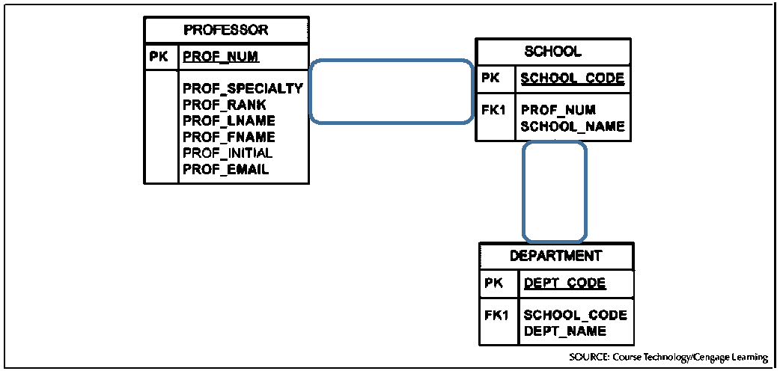

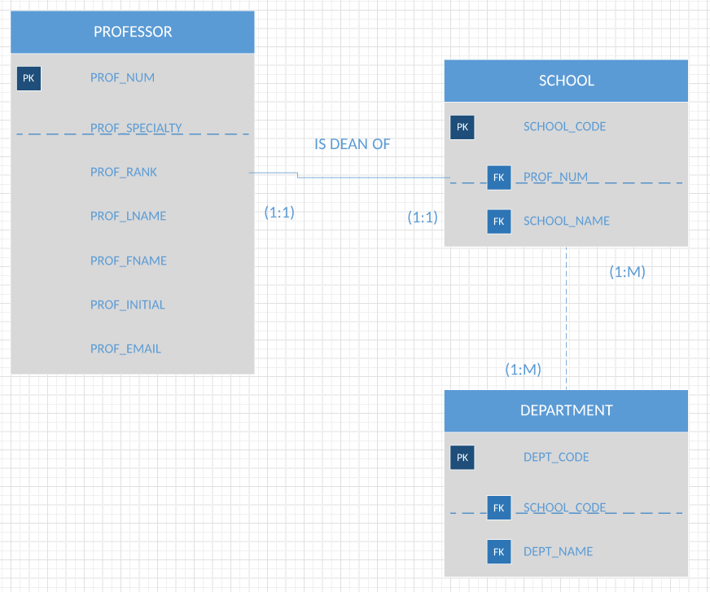

1. Download the IntroDB.SQL file [Coronel and Russel- Chapter 7 dataset]. Open **Microsoft SQL Server Management Studio** (search for SSMS in windows). Use *File > Open* to open the above SQL file and *Execute* it. Right Click on Databases in th*e Object Explorer* and click *Refresh*. Is the CH07DBINIT database created? How many tables does it have?

The database CH07DBINIT is created because it is showing in the object explorer.

For the following questions, (i) write the SQL commands and (ii) paste the output in **text format**.

1. Write a SQL command to list all data in the EMP table.

SELECT * FROM EMP;

|  |  |  |  |  |  |  |  |  |  |  |
| --- | --- | --- | --- | --- | --- | --- | --- | --- | --- | --- |
|  | EMP_NUM | EMP_TITLE | EMP_LNAME | EMP_FNAME | EMP_INITAL | EMP_DOB | EMP_HIRE_DATE | EMP_AREACODE | EMP_PHONE | EMP_MGR |
| 1 | 100 | Mr. | Kolmycz | George | D | 1942-06-15 00:00:00.000 | 1985-03-15 00:00:00.000 | 615 | 324-5456 | NULL |
| 2 | 101 | Ms. | Lewis | Rhonda | G | 1965-03-19 00:00:00.000 | 1986-04-25 00:00:00.000 | 615 | 324-4472 | 100 |
| 3 | 102 | Mr. | Vandam | Rhett | NULL | 1958-11-14 00:00:00.000 | 1990-12-20 00:00:00.000 | 901 | 675-8993 | 100 |
| 4 | 103 | Ms. | Jones | Anne | M | 1974-10-16 00:00:00.000 | 1994-08-28 00:00:00.000 | 615 | 898-3456 | 100 |
| 5 | 104 | Mr. | Lange | John | P | 1971-11-08 00:00:00.000 | 1946-10-20 00:00:00.000 | 901 | 504-4430 | 105 |
| 6 | 105 | Mr. | Williams | Robert | D | 1975-03-14 00:00:00.000 | 1998-11-08 00:00:00.000 | 615 | 890-3220 | NULL |
| 7 | 106 | Mrs. | Smith | Jeanine | K | 1968-02-12 00:00:00.000 | 1989-01-05 00:00:00.000 | 615 | 324-7883 | 105 |
| 8 | 107 | Mr. | Diante | Jorge | D | 1974-08-21 00:00:00.000 | 1994-07-02 00:00:00.000 | 615 | 890-4567 | 105 |
| 9 | 108 | Mr. | Wiesenbach | Paul | R | 1966-02-14 00:00:00.000 | 1992-11-18 00:00:00.000 | 615 | 897-4358 | NULL |
| 10 | 109 | Mr. | Smith | George | K | 1961-06-18 00:00:00.000 | 1989-04-14 00:00:00.000 | 901 | 504-3339 | 108 |
| 11 | 110 | Mrs. | Genkazi | Leighla | W | 1970-05-19 00:00:00.000 | 1990-12-01 00:00:00.000 | 901 | 569-0093 | 108 |
| 12 | 111 | Mr. | Washington | Rupert | E | 1966-01-03 00:00:00.000 | 1993-06-21 00:00:00.000 | 615 | 890-4925 | 105 |
| 13 | 112 | Mr. | Johnson | Edward | E | 1961-05-14 00:00:00.000 | 1983-12-01 00:00:00.000 | 615 | 898-4387 | 100 |
| 14 | 113 | Ms. | Smythe | Melaine | P | 1970-09-15 00:00:00.000 | 1999-05-11 00:00:00.000 | 615 | 324-9006 | 105 |
| 15 | 114 | Ms. | Brandon | Marie | G | 1956-11-02 00:00:00.000 | 1979-11-15 00:00:00.000 | 901 | 882-0845 | 108 |
| 16 | 115 | Mrs. | Saranda | Hemine | R | 1972-07-025 00:00:00.000 | 1993-04-23 00:00:00.000 | 615 | 324-2984 | 105 |
| 17 | 116 | Mr. | Smith | George | A | 1965-11-08 00:00:00.000 | 1988-12-10 00:00:00.000 | 615 | 890-2984 | 108 |

1. Start your code with *BEGIN TRANSACTION;* Then write a SQL command to change the area code to 905 for the employees with employee numbers (EMP_NUM) equal to 107 or 108. Then list the data in EMP to see the changes.

BEGIN TRANSACTION;

UPDATE EMP SET EMP_AREACODE=905 WHERE EMP_NUM IN (107,108);

SELECT * FROM EMP;

|  |  |  |  |  |  |  |  |  |  |  |
| --- | --- | --- | --- | --- | --- | --- | --- | --- | --- | --- |
|  | EMP_NUM | EMP_TITLE | EMP_LNAME | EMP_FNAME | EMP_INITAL | EMP_DOB | EMP_HIRE_DATE | EMP_AREACODE | EMP_PHONE | EMP_MGR |
| 1 | 100 | Mr. | Kolmycz | George | D | 1942-06-15 00:00:00.000 | 1985-03-15 00:00:00.000 | 615 | 324-5456 | NULL |
| 2 | 101 | Ms. | Lewis | Rhonda | G | 1965-03-19 00:00:00.000 | 1986-04-25 00:00:00.000 | 615 | 324-4472 | 100 |
| 3 | 102 | Mr. | Vandam | Rhett | NULL | 1958-11-14 00:00:00.000 | 1990-12-20 00:00:00.000 | 901 | 675-8993 | 100 |
| 4 | 103 | Ms. | Jones | Anne | M | 1974-10-16 00:00:00.000 | 1994-08-28 00:00:00.000 | 615 | 898-3456 | 100 |
| 5 | 104 | Mr. | Lange | John | P | 1971-11-08 00:00:00.000 | 1946-10-20 00:00:00.000 | 901 | 504-4430 | 105 |
| 6 | 105 | Mr. | Williams | Robert | D | 1975-03-14 00:00:00.000 | 1998-11-08 00:00:00.000 | 615 | 890-3220 | NULL |
| 7 | 106 | Mrs. | Smith | Jeanine | K | 1968-02-12 00:00:00.000 | 1989-01-05 00:00:00.000 | 615 | 324-7883 | 105 |
| 8 | 107 | Mr. | Diante | Jorge | D | 1974-08-21 00:00:00.000 | 1994-07-02 00:00:00.000 | 905 | 890-4567 | 105 |
| 9 | 108 | Mr. | Wiesenbach | Paul | R | 1966-02-14 00:00:00.000 | 1992-11-18 00:00:00.000 | 905 | 897-4358 | NULL |
| 10 | 109 | Mr. | Smith | George | K | 1961-06-18 00:00:00.000 | 1989-04-14 00:00:00.000 | 901 | 504-3339 | 108 |
| 11 | 110 | Mrs. | Genkazi | Leighla | W | 1970-05-19 00:00:00.000 | 1990-12-01 00:00:00.000 | 901 | 569-0093 | 108 |
| 12 | 111 | Mr. | Washington | Rupert | E | 1966-01-03 00:00:00.000 | 1993-06-21 00:00:00.000 | 615 | 890-4925 | 105 |
| 13 | 112 | Mr. | Johnson | Edward | E | 1961-05-14 00:00:00.000 | 1983-12-01 00:00:00.000 | 615 | 898-4387 | 100 |
| 14 | 113 | Ms. | Smythe | Melaine | P | 1970-09-15 00:00:00.000 | 1999-05-11 00:00:00.000 | 615 | 324-9006 | 105 |
| 15 | 114 | Ms. | Brandon | Marie | G | 1956-11-02 00:00:00.000 | 1979-11-15 00:00:00.000 | 901 | 882-0845 | 108 |
| 16 | 115 | Mrs. | Saranda | Hemine | R | 1972-07-025 00:00:00.000 | 1993-04-23 00:00:00.000 | 615 | 324-2984 | 105 |
| 17 | 116 | Mr. | Smith | George | A | 1965-11-08 00:00:00.000 | 1988-12-10 00:00:00.000 | 615 | 890-2984 | 108 |

1. Write the SQL command that will restore the data to its original status (before the changes in the previous question). Then list the data to check the values.

ROLLBACK;

SELECT * FROM EMP;

|  |  |  |  |  |  |  |  |  |  |  |
| --- | --- | --- | --- | --- | --- | --- | --- | --- | --- | --- |
|  | EMP_NUM | EMP_TITLE | EMP_LNAME | EMP_FNAME | EMP_INITAL | EMP_DOB | EMP_HIRE_DATE | EMP_AREACODE | EMP_PHONE | EMP_MGR |
| 1 | 100 | Mr. | Kolmycz | George | D | 1942-06-15 00:00:00.000 | 1985-03-15 00:00:00.000 | 615 | 324-5456 | NULL |
| 2 | 101 | Ms. | Lewis | Rhonda | G | 1965-03-19 00:00:00.000 | 1986-04-25 00:00:00.000 | 615 | 324-4472 | 100 |
| 3 | 102 | Mr. | Vandam | Rhett | NULL | 1958-11-14 00:00:00.000 | 1990-12-20 00:00:00.000 | 901 | 675-8993 | 100 |
| 4 | 103 | Ms. | Jones | Anne | M | 1974-10-16 00:00:00.000 | 1994-08-28 00:00:00.000 | 615 | 898-3456 | 100 |
| 5 | 104 | Mr. | Lange | John | P | 1971-11-08 00:00:00.000 | 1946-10-20 00:00:00.000 | 901 | 504-4430 | 105 |
| 6 | 105 | Mr. | Williams | Robert | D | 1975-03-14 00:00:00.000 | 1998-11-08 00:00:00.000 | 615 | 890-3220 | NULL |
| 7 | 106 | Mrs. | Smith | Jeanine | K | 1968-02-12 00:00:00.000 | 1989-01-05 00:00:00.000 | 615 | 324-7883 | 105 |
| 8 | 107 | Mr. | Diante | Jorge | D | 1974-08-21 00:00:00.000 | 1994-07-02 00:00:00.000 | 615 | 890-4567 | 105 |
| 9 | 108 | Mr. | Wiesenbach | Paul | R | 1966-02-14 00:00:00.000 | 1992-11-18 00:00:00.000 | 615 | 897-4358 | NULL |
| 10 | 109 | Mr. | Smith | George | K | 1961-06-18 00:00:00.000 | 1989-04-14 00:00:00.000 | 901 | 504-3339 | 108 |
| 11 | 110 | Mrs. | Genkazi | Leighla | W | 1970-05-19 00:00:00.000 | 1990-12-01 00:00:00.000 | 901 | 569-0093 | 108 |
| 12 | 111 | Mr. | Washington | Rupert | E | 1966-01-03 00:00:00.000 | 1993-06-21 00:00:00.000 | 615 | 890-4925 | 105 |
| 13 | 112 | Mr. | Johnson | Edward | E | 1961-05-14 00:00:00.000 | 1983-12-01 00:00:00.000 | 615 | 898-4387 | 100 |
| 14 | 113 | Ms. | Smythe | Melaine | P | 1970-09-15 00:00:00.000 | 1999-05-11 00:00:00.000 | 615 | 324-9006 | 105 |
| 15 | 114 | Ms. | Brandon | Marie | G | 1956-11-02 00:00:00.000 | 1979-11-15 00:00:00.000 | 901 | 882-0845 | 108 |
| 16 | 115 | Mrs. | Saranda | Hemine | R | 1972-07-025 00:00:00.000 | 1993-04-23 00:00:00.000 | 615 | 324-2984 | 105 |
| 17 | 116 | Mr. | Smith | George | A | 1965-11-08 00:00:00.000 | 1988-12-10 00:00:00.000 | 615 | 890-2984 | 108 |

1. Write the SQL command to list the employee number and area code of the employees whose employee number is less than 110.

SELECT EMP_NUM, EMP_AREACODE FROM EMP WHERE EMP_NUM < 110;

|  |  |  |
| --- | --- | --- |
|  | EMP_NUM | EMP_AREACODE |
| 1 | 100 | 615 |
| 2 | 101 | 615 |
| 3 | 102 | 901 |
| 4 | 103 | 615 |
| 5 | 104 | 901 |
| 6 | 105 | 615 |
| 7 | 106 | 615 |
| 8 | 107 | 615 |

1. Write the SQL command to list the employee number, last name, first name and date of birth of employees sorted from youngest to oldest.

SELECT EMP_NUM,EMP_LNAME,EMP_FNAME,EMP_DOB FROM EMP ORDER BY EMP_DOB;

|  |  |  |  |  |
| --- | --- | --- | --- | --- |
|  | EMP_NUM | EMP_LNAME | EMP_FNAME | EMP_DOB |
| 1 | 100 | Kolmycz | George | 1942-06-15 00:00:00.000 |
| 2 | 114 | Brandon | Marie | 1956-11-02 00:00:00.000 |
| 3 | 102 | Vandam | Rhett | 1958-11-14 00:00:00.000 |
| 4 | 112 | Johnson | Edward | 1961-05-14 00:00:00.000 |
| 5 | 109 | Smith | George | 1961-06-18 00:00:00.000 |
| 6 | 101 | Lewis | Rhonda | 1965-03-19 00:00:00.000 |
| 7 | 116 | Smith | George | 1965-11-08 00:00:00.000 |
| 8 | 111 | Washington | Rupert | 1966-01-03 00:00:00.000 |
| 9 | 108 | Wiesenbach | Paul | 1966-02-14 00:00:00.000 |
| 10 | 106 | Smith | Jeanine | 1968-02-12 00:00:00.000 |
| 11 | 110 | Genkazi | Leighla | 1970-05-19 00:00:00.000 |
| 12 | 113 | Smythe | Melanie | 1970-09-15 00:00:00.000 |
| 13 | 104 | Lange | John | 1971-11-08 00:00:00.000 |
| 14 | 115 | Saranda | Hermine | 1972-07-25 00:00:00.000 |
| 15 | 107 | Diante | Jorge | 1974-08-21 00:00:00.000 |
| 16 | 103 | Jones | Anne | 1974-10-16 00:00:00.000 |
| 17 | 105 | Williams | Robert | 1975-03-14 00:00:00.000 |

1. Write the SQL command to list the employee number, area code and phone number sorted by area code and phone number (i.e. sort by area code; but for those with the same area code, sort by phone number).

SELECT EMP_NUM, EMP_AREACODE, EMP_PHONE FROM EMP ORDER BY EMP_AREACODE, EMP_PHONE;

|  |  |  |  |
| --- | --- | --- | --- |
|  | EMP_NUM | EMP_AREACODE | EMP_PHONE |
| 1 | 101 | 615 | 324-4472 |
| 2 | 100 | 615 | 324-5456 |
| 3 | 115 | 615 | 324-5505 |
| 4 | 106 | 615 | 324-7883 |
| 5 | 113 | 615 | 324-9006 |
| 6 | 116 | 615 | 890-2984 |
| 7 | 105 | 615 | 890-3220 |
| 8 | 107 | 615 | 890-4567 |
| 9 | 111 | 615 | 890-4925 |
| 10 | 108 | 615 | 897-4358 |
| 11 | 103 | 615 | 898-3456 |
| 12 | 112 | 615 | 898-4387 |
| 13 | 109 | 901 | 504-3339 |
| 14 | 104 | 901 | 504-4430 |
| 15 | 110 | 901 | 569-0093 |
| 16 | 102 | 901 | 675-8993 |
| 17 | 114 | 901 | 882-0845 |

1. Write the SQL command to list all employees (all columns) that their last name starts with letter ‘S’.

SELECT * FROM EMP WHERE EMP_LNAME LIKE 'S%';

|  |  |  |  |  |  |  |  |  |  |  |
| --- | --- | --- | --- | --- | --- | --- | --- | --- | --- | --- |
|  | EMP_NUM | EMP_TITLE | EMP_LNAME | EMP_FNAME | EMP_INITIAL | EMP_DOB | EMP_HIRE_DATE | EMP_AREACODE | EMP_PHONE | EMP_MGR |
| 1 | 106 | Mrs. | Smith | Jeanine | K | 1968-02-12 00:00:00.000 | 1989-01-05 00:00:00.000 | 615 | 324-7883 | 105 |
| 2 | 109 | Mr. | Smith | George | K | 1961-06-18 00:00:00.000 | 1989-04-14 00:00:00.000 | 901 | 504-3339 | 108 |
| 3 | 113 | Ms. | Smythe | Melanie | P | 1970-09-15 00:00:00.000 | 1999-05-11 00:00:00.000 | 615 | 324-9006 | 105 |
| 4 | 115 | Mrs. | Saranda | Hermine | R | 1972-07-25 00:00:00.000 | 1993-04-23 00:00:00.000 | 615 | 324-5505 | 105 |
| 5 | 116 | Mr. | Smith | George | A | 1965-11-08 00:00:00.000 | 1988-12-10 00:00:00.000 | 615 | 890-2984 | 108 |

1. Write the SQL command to list all employees that their first name is exactly 4 letters.

SELECT * FROM EMP WHERE EMP_FNAME LIKE '____';

|  |  |  |  |  |  |  |  |  |  |  |
| --- | --- | --- | --- | --- | --- | --- | --- | --- | --- | --- |
|  | EMP_NUM | EMP_TITLE | EMP_LNAME | EMP_FNAME | EMP_INITIAL | EMP_DOB | EMP_HIRE_DATE | EMP_AREACODE | EMP_PHONE | EMP_MGR |
| 1 | 103 | Ms. | Jones | Anne | M | 1974-10-16 00:00:00.000 | 1994-08-28 00:00:00.000 | 615 | 898-3456 | 100 |
| 2 | 104 | Mr. | Lange | John | P | 1971-11-08 00:00:00.000 | 1994-10-20 00:00:00.000 | 901 | 504-4430 | 105 |
| 3 | 108 | Mr. | Wiesenbach | Paul | R | 1966-02-14 00:00:00.000 | 1992-11-18 00:00:00.000 | 615 | 897-4358 | NULL |

1. Write the SQL command to list all employees that their last name comes alphabetically before their first name.

SELECT * FROM EMP ORDER BY EMP_LNAME, EMP_FNAME;

|  |  |  |  |  |  |  |  |  |  |  |
| --- | --- | --- | --- | --- | --- | --- | --- | --- | --- | --- |
|  | EMP_NUM | EMP_TITLE | EMP_LNAME | EMP_FNAME | EMP_INITIAL | EMP_DOB | EMP_HIRE_DATE | EMP_AREACODE | EMP_PHONE | EMP_MGR |
| 1 | 114 | Ms. | Brandon | Marie | G | 1956-11-02 00:00:00.000 | 1979-11-15 00:00:00.000 | 901 | 882-0845 | 108 |
| 2 | 107 | Mr. | Diante | Jorge | D | 1974-08-21 00:00:00.000 | 1994-07-02 00:00:00.000 | 615 | 890-4567 | 105 |
| 3 | 110 | Mrs. | Genkazi | Leighla | W | 1970-05-19 00:00:00.000 | 1990-12-01 00:00:00.000 | 901 | 569-0093 | 108 |
| 4 | 112 | Mr. | Johnson | Edward | E | 1961-05-14 00:00:00.000 | 1983-12-01 00:00:00.000 | 615 | 898-4387 | 100 |
| 5 | 103 | Ms. | Jones | Anne | M | 1974-10-16 00:00:00.000 | 1994-08-28 00:00:00.000 | 615 | 898-3456 | 100 |
| 6 | 100 | Mr. | Kolmycz | George | D | 1942-06-15 00:00:00.000 | 1985-03-15 00:00:00.000 | 615 | 324-5456 | NULL |
| 7 | 104 | Mr. | Lange | John | P | 1971-11-08 00:00:00.000 | 1994-10-20 00:00:00.000 | 901 | 504-4430 | 105 |
| 8 | 101 | Ms. | Lewis | Rhonda | G | 1965-03-19 00:00:00.000 | 1986-04-25 00:00:00.000 | 615 | 324-4472 | 100 |
| 9 | 115 | Mrs. | Saranda | Hermine | R | 1972-07-25 00:00:00.000 | 1993-04-23 00:00:00.000 | 615 | 324-5505 | 105 |
| 10 | 116 | Mr. | Smith | George | A | 1965-11-08 00:00:00.000 | 1988-12-10 00:00:00.000 | 615 | 890-2984 | 108 |
| 11 | 109 | Mr. | Smith | George | K | 1961-06-18 00:00:00.000 | 1989-04-14 00:00:00.000 | 901 | 504-3339 | 108 |
| 12 | 106 | Mrs. | Smith | Jeanine | K | 1968-02-12 00:00:00.000 | 1989-01-05 00:00:00.000 | 615 | 324-7883 | 105 |
| 13 | 113 | Ms. | Smythe | Melanie | P | 1970-09-15 00:00:00.000 | 1999-05-11 00:00:00.000 | 615 | 324-9006 | 105 |
| 14 | 102 | Mr. | Vandam | Rhett | NULL | 1958-11-14 00:00:00.000 | 1990-12-20 00:00:00.000 | 901 | 675-8993 | 100 |
| 15 | 111 | Mr. | Washington | Rupert | E | 1966-01-03 00:00:00.000 | 1993-06-21 00:00:00.000 | 615 | 890-4925 | 105 |
| 16 | 108 | Mr. | Wiesenbach | Paul | R | 1966-02-14 00:00:00.000 | 1992-11-18 00:00:00.000 | 615 | 897-4358 | NULL |
| 17 | 105 | Mr. | Williams | Robert | D | 1975-03-14 00:00:00.000 | 1998-11-08 00:00:00.000 | 615 | 890-3220 | NULL |

1. Write the SQL command to list all managers (those who do not have managers).

SELECT EMP_MGR FROM EMP WHERE EMP_MGR IS NOT NULL;

|  |  |
| --- | --- |
|  | EMP_MGR |
| 1 | 100 |
| 2 | 100 |
| 3 | 100 |
| 4 | 105 |
| 5 | 105 |
| 6 | 105 |
| 7 | 108 |
| 8 | 108 |
| 9 | 105 |
| 10 | 100 |
| 11 | 105 |
| 12 | 108 |
| 13 | 105 |
| 14 | 108 |

1. Write the SQL command to calculate the total discount amount for each product in table P which has nonzero discount. The total discount for each product equals its price times the discount times the quantity-on-hand. Label the calculated column as ‘*TotDiscount’* and sort by this column, as shown in the sample below.

SELECT P_CODE, (P_PRICE*P_DISCOUNT*P_QOH) AS TOTDISCOUNT FROM P WHERE P_DISCOUNT !=0 ORDER BY TOTDISCOUNT;

P_code TotDiscount

---------- ---------------------------------------

23114-AA 5.7600

23109-HB 22.8850

2238/QPD 23.3700

13-Q2/P2 23.9840

2232/QWE 29.9610

2232/QTY 43.9680

89-WRE-Q 141.3445

WR3/TT3 215.9100

(8 row(s) affected)