# **BTD210- Lab 6**

Please work in **groups** to complete this lab. This lab is worth 2% of the total course grade and will be evaluated through your written submission, as well as the lab demo. During the lab demo, group members are randomly selected to present the answers to each of the lab questions. Group members not present during the lab demo will lose the demo mark.

Please submit the following files through Blackboard. Only one person must submit for the team.

* Lab6.docx

1. Add this declaration on the top of your file.

We, -Mukan and Priya, declare that the attached assignment is our own work in accordance with the Seneca Academic Policy. No part of this assignment has been copied manually or electronically from any other source (including web sites) **or distributed to other students.**

1. Specify what each member has done towards the completion of this work:

|  |  |  |
| --- | --- | --- |
|  | Name | Task(s) |
| 1 | Priya | answers |
| 2 | Muskan | answers, submission |
| 3 |  |  |

# Part I. Understanding the ERD

**[Adapted from Colonel and Russel- FIGURE Q4.17]**

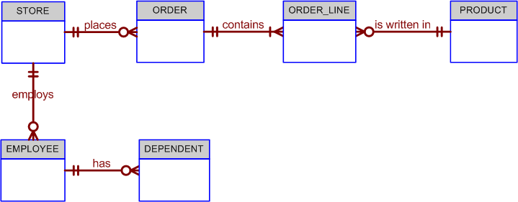

1. **Write the ten cardinalities that are appropriate for this ERD next to the entities above.**
   1. Store to order = (1,M)
   2. Order to store = (0,M)
   3. Store to employees = (1,M)
   4. Employee to store (0,M)
   5. Employee to dependent = (1,M)
   6. dependent to employee = (0,M)
   7. Order to order-line (1,M)
   8. Order-line to order (1,1)
   9. Product to order-line (1,M)
   10. Order-line to product (0,M)
2. **Write the business rules reflected in this ERD. *Write your answers below the question please.***

Hint: Use one of these words: may, must, zero, one, many, optional, mandatory

1. A store **may** (may/ must) place **_one_ to _many__** orders. The ORDERS entity is **_optional_** to the STORE entity.
2. An order **must** (may/ must) be placed by a store. STORE is **mandatory_** to ORDER.
3. An order contains at least **one** order line. ORDER_LINE is **mandatory** to ORDER, and vice-versa.
4. Each order line is contained in minimum **one**_ and maximum **_one** order.
5. Each order line has a specific product written in it. A product may be written in **one** to **many** orders. Many stores can order one or more specific products, but a product that is not in demand may never be sold to a store and will, therefore, not show up in any order line -- ORDER_LINE is **optional** to PRODUCT. Also, note that each order line may indicate more than one of a specific item. For example, the item may be “hammer” and the number sold may be 1 or 2, or 500.
6. A store **may** (may/ must) employ **many** to **many** employees. A new store may not yet have any employees, yet the database may already include the new store information … location, type, and so on. The EMPLOYEE entity is **mandatory** to STORE.
7. Each employee is employed by **one** store.
8. An employee **may** (may/ must) have **one** to **many** dependents. You cannot *require* an employee to have dependents, so DEPENDENT is **optional** to EMPLOYEE.
9. A dependent **must** (may/ must) be related to an employee. It makes no sense to keep track of dependents of people who are not even employees. Therefore, EMPLOYEE is **mandatory** to DEPENDENT.
10. may; one to many; optional
11. must; mandatory
12. one; mandatory
13. one to one
14. one to many; optional
15. may; many to many; mandatory
16. one
17. may; one to many; optional
18. must; mandatory
19. **What two attributes must b e contained in the composite entity between ORDER and PRODUCT? Use proper terminology in your answer.**
    1. The composite entity must at least include the primary keys of the entities it references. The combination of the attributes may be designated to be the composite entity's (composite) primary key. Each of the (composite) primary key's attributes is a foreign key that references the entities for which the composite entity serves as a bridge.
    2. As shown in the model in Figure Q4.17, note that an order is represented by two entities, ORDER and ORDER_LINE. Note also that the STORE’s 1:M relationship with ORDER and the ORDER’s 1:M relationship with ORDER_LINE reflect the conceptual M:N relationship between STORE and PRODUCT.
       1. The original business rules probably read:
          1. A store can order many products
          2. A product can be ordered by many stores. 112
20. **Describe precisely the composition of the DEPENDENT weak entity’s primary key. Use proper terminology in your answer.**
    1. The DEPENDENT entity will have a composite primary key that includes the EMPLOYEE entity’s primary key and one of its attributes. For example, if the EMPLOYEE entity’s primary key is EMP_NUM, the DEPENDENT entity’s primary key might be EMP_NUM + DEP_NUM.

# Part II. Designing an ERD

**[Adapted from Colonel and Russel]**

**The local city youth league needs a database system to help track children that sign up to play soccer. Data needs to be kept on each team and the children that will be playing on each team and their parents. Also, data needs to be kept on the coaches for each team.**

**Use *Microsoft Visio* to draw the data model described below.**

Entities required: Team, Player, Coach, and Parent.

Attributes required:

Team: Team ID number, Team name, and Team colors.

Player: Player ID number, Player first name, Player last name, and Player age.

Coach: Coach ID number, Coach first name, Coach last name, and Coach home phone number.

Parent: Parent ID number, Parent last name, Parent first name, Home phone number, and Home Address (Street, City, State, and ZIP Code).

The following relationships must be defined:

* Team is related to Player.
* Team is related to Coach.
* Player is related to Parent.

Connectivities and participations are defined as follows:

* A Team may or may not have a Player.
* A Player must have a Team.
* A Team may have many Players.
* A Player has only one Team.
* A Team may or may not have a Coach.
* A Coach must have a Team.
* A Team may have many Coaches.
* A Coach has only one Team.
* A Player must have a Parent.
* A Parent must have a Player.
* A Player may have many Parents.
* A Parent may have many Players.

**Hint:**

1. **Start with the above 4 entities. Choose suitable attribute names.**
2. **Identify the relationships and the connectivities. Label the relationships with a verb. Add bridges for many to many relationships.**
3. **Identify weak and strong relationships. Also Specify Primary and Foreign Keys.**
4. **The Team Colors is a multivalued attribute. Design the ERD in a way to allow for any number of colors (zero to many) to be specified for the team.**

