RAG-BASED ENHANCEMENTS FOR CONTEXT-AWARE INTERFACES IN LARGE LANGUAGE MODEL

By

Siri Priya Katta

M.S., Southern Illinois University Carbondale, 2025

A Thesis
Submitted in Partial Fulfillment of the Requirements for the
Master of Science Degree

School of Computer Science
in the Graduate School
Southern Illinois University Carbondale
May 2026
THESIS APPROVAL
RAG-BASED ENHANCEMENTS FOR CONTEXT-AWARE INTERFACES IN LARGE LANGUAGE MODEL

by
Siri Priya Katta
A Thesis Submitted in Partial
Fulfillment of the Requirements
for the Degree of
Master of Science
in the field of Computer Science

Approved by:
Dr. Henry Hexmoor, Chair
Dr. Bidyut Gupta
Dr. Koushik Sinha

Graduate School
Southern Illinois University Carbondale
December 3, 2025
AN ABSTRACT OF THE THESIS OF
Siri Priya Katta, for the Master of Science degree in Computer Science, presented on December 3, 2025, at Southern Illinois University Carbondale.

TITLE: RAG-BASED ENHANCEMENTS FOR CONTEXT-AWARE INTERFACES IN LARGE LANGUAGE MODEL
MAJOR PROFESSOR: Dr. Henry Hexmoor

This thesis investigates how Retrieval-Augmented Generation (RAG) and emerging Graph-based RAG architectures enhance factual accuracy, context integration, and reasoning capabilities in Large Language Models (LLMs). Although modern LLMs demonstrate impressive fluency in natural language generation, they frequently hallucinate or provide incorrect information when relying solely on internal training data. RAG addresses these limitations by enabling models to retrieve and ground responses in external sources, yet existing RAG systems still struggle with shallow context fusion, inefficient retrievals, and limited multi-hop reasoning.
This research conducts a comparative study of six RAG and Graph RAG frameworks—including traditional RAG, Fusion-in-Decoder (FiD), ColBERT, Chain-of-Thought-RAG, GraphRAG, and Enhanced GraphRAG—to evaluate their retrieval precision, reasoning depth, and quality of context integration. Through this analysis, the thesis identifies key weaknesses in current architectures, such as redundant evidence retrieval, limited interpretability, and weak relational understanding across documents.
Building on these findings, the thesis proposes a conceptual Context Fusion Framework that integrates hybrid retrieval, knowledge structuring, graph-guided aggregation, and reasoning-aligned generation. This framework aims to unify retrieval accuracy with structured reasoning, enabling improved factual consistency and more interpretable responses. Results show that graph-structured retrieval and reasoning-aware fusion significantly improve coherence, reduce hallucinations, and strengthen evidence grounding in LLM outputs.
Overall, the study demonstrates that integrating structured knowledge representations with adaptive retrieval strategies is essential for advancing reliable, context-aware, and reasoning-driven LLM systems. The proposed framework lays theoretical groundwork for future RAG models that are more trustworthy, transparent, and suitable for real-world high-stakes applications.

ACKNOWLEDGMENTS

I would like to express my sincere gratitude to my advisor, Dr. Henry Hexmoor, for his continuous guidance, encouragement, and expertise throughout the development of this thesis. His support and insightful feedback were essential in shaping my understanding of Large Language Models, Retrieval-Augmented Generation, and context-aware reasoning. I am truly grateful for his patience, inspiration, and commitment to my academic growth.
I would also like to thank my committee members, Dr. Bidyut Gupta and Dr. Koushik Sinha, for their valuable feedback, time, and thoughtful suggestions. Their perspectives greatly strengthened the quality and clarity of this work.
A special thanks to my friends and peers who supported me throughout this journey, especially during the challenging moments of research, experimentation, and writing. Their encouragement kept me motivated every step of the way.
Finally, I am deeply grateful to my family for their unwavering love, support, and faith in me. Their belief in my abilities has always been my greatest source of strength and inspiration.

DEDICATION

To my parents, whose support, perseverance, and values have guided my academic and personal growth. Their encouragement has been fundamental to the completion of this work.

TABLE OF CONTENTS
CHAPTER PAGE
ABSTRACT i
ACKNOWLEDGMENTS iii
DEDICATION iv
LIST OF TABLES vi
LIST OF FIGURES vii
CHAPTERS
CHAPTER 1 – INTRODUCTION 8
CHAPTER 2 – LITERATURE SURVEY 11
CHAPTER 3 – PROBLEM ANALYSIS 20
CHAPTER 4 – COMPARATIVE INSIGHTS 27
CHAPTER 5 – THEORITICAL FRAMEWORK 29
CHAPTER 6 – EXPERIMENTAL VALIDATION 39
CHAPTER 7 – STATE-OF-THE-ART 39
CHAPTER 8 – KEY FINDINGS AND CONCLUSION 44

REFERENCES 49
VITA 52

LIST OF TABLES
TABLE PAGE
Table 1 – Tabular Summary of Research works 13
Table 2 – Comparative Strengths and Weaknesses across models 28
Table 3 –Evidence Breadth Comparison 41
Table 4 –Answer Length Comparison 42
Table 5 –Semantic Coverage Score 42

LIST OF FIGURES
FIGURE PAGE
Figure 1 – Standard Retrieval-Augmented Generation (RAG) Pipeline Architecture 33
Figure 2 -Theoretical Justification for the Framework 37
Figure 3 -Evidence Breadth Comparison 44
Figure 4 -Answer Length Comparison 45
Figure 5 -Semantic Coverage Score 46
Figure 6 – Graph RAG pipeline 41

CHAPTER 1
INTRODUCTION
  - Background and Context
Large Language Models (LLMs) have rapidly advanced in their ability to understand and generate natural language, enabling applications across search systems, conversational agents, education, and decision-support tools. However, despite these improvements, LLMs still rely heavily on their internal training data, which leads to factual inconsistencies, outdated knowledge, and hallucinations when faced with real-world tasks requiring accurate grounding. Retrieval-Augmented Generation (RAG) emerged as a promising solution by combining external document retrieval with generation, improving factuality and context awareness. Recent developments such as Graph-based RAG systems further extend this idea by structuring retrieved knowledge into interconnected relationships, enabling deeper reasoning and multi-hop inference.
As RAG systems continue to evolve, it becomes increasingly important to understand how retrieval precision, context fusion strategies, and reasoning mechanisms influence the reliability and interpretability of LLM outputs. This thesis aims to examine these advancements, identify their limitations, and explore a theoretical framework that unifies retrieval and reasoning for more context-aware AI systems.

  - Problem Statement
Despite significant advancements in Large Language Models (LLMs), modern systems still struggle to produce reliable, contextually grounded, and factually consistent responses when relying solely on internal training data. Retrieval-Augmented Generation (RAG) provides partial improvements by integrating external knowledge, yet current RAG architectures suffer from shallow context fusion, inefficient or redundant retrievals, and limited multi-hop reasoning capabilities. These limitations lead to hallucinations, poor interpretability, and weak reasoning performance in complex, real-world tasks. Therefore, there is a critical need for a structured, comparative examination of existing RAG and emerging Graph-RAG frameworks, along with the development of a theoretical foundation that improves context integration, reasoning depth, and reliability in LLM-driven applications.
  - Motivation for the Study
Despite the rapid advancements in Large Language Models (LLMs), their ability to produce accurate, contextually grounded, and logically consistent responses remains limited. Traditional RAG systems improve factual grounding by retrieving external documents, yet they still lack deep reasoning and effective context fusion. This creates a gap for domains that require high interpretability, trustworthy outputs, and structured decision-making processes. The motivation for this study arises from the need to understand how retrieval, context integration, and reasoning mechanisms can be combined more effectively. By comparing existing RAG and Graph RAG models and proposing a theoretical framework for structured context fusion, this research aims to guide the development of next-generation LLM interfaces that are more reliable, transparent, and suitable for real-world, knowledge-intensive tasks.
  - Research Objectives
The primary objective of this thesis is to analyze how Retrieval-Augmented Generation (RAG) and its emerging variants particularly Graph-based RAG enhance the factual reliability, contextual grounding, and reasoning capabilities of Large Language Models (LLMs). Because this work is primarily analytical and framework-oriented rather than experimental, the goals focus on synthesis, comparative evaluation, and theoretical contribution rather than system development.
The key research objectives are:
- To examine the limitations of traditional LLMs in context retention, factual consistency, and multi-step reasoning when operating solely on internal knowledge.
- To conduct a structured comparative analysis of major RAG and Graph RAG architectures, evaluating their retrieval precision, reasoning depth, and effectiveness in context integration.
- To identify gaps and recurring challenges across existing RAG systems, such as shallow fusion mechanisms, redundancy, and limited relational understanding.
- To conceptualize a unified Context Fusion Framework that synthesizes insights from literature to improve retrieval quality, knowledge structuring, and reasoning-guided generation.
- To assess the theoretical impact of graph-structured retrieval and reasoning-aware fusion on reducing hallucinations and improving interpretability in LLM outputs.
- To provide direction for future research toward more trustworthy, scalable, and context-aware retrieval-enhanced language models.
  - Scope and Limitations
The scope of this study is centered on analyzing how Retrieval-Augmented Generation (RAG) and emerging Graph-based RAG architectures influence the factual accuracy, contextual grounding, and reasoning capabilities of Large Language Models. Instead of implementing a new end-to-end system, this thesis provides a structured examination of existing research, compares architectural approaches, and synthesizes insights into a unified theoretical framework. The analysis covers traditional dense and sparse retrieval methods, decoder-level fusion models, chain-of-thought retrieval strategies, and graph-structured reasoning frameworks.
The study is limited to secondary research and theoretical evaluation. No large-scale experimental benchmarking is conducted beyond qualitative comparisons reported in prior work. Additionally, the proposed conceptual framework is not implemented or tested in a live model; rather, it serves as a guideline for future system design. The scope does not include domain-specific RAG applications, multimodal RAG systems, or hardware-based evaluations. These boundaries ensure the thesis maintains a focused discussion on context integration, retrieval precision, and reasoning depth within text-based RAG systems.

CHAPTER 2
LiTERATURE SURVEY
2.1 Overview of Retrieval-Augmented Generation Research
Retrieval-Augmented Generation (RAG) has emerged as a foundational approach for improving the factual grounding, reliability, and context-awareness of Large Language Models (LLMs). Early transformer-based LLMs demonstrated impressive generative fluency but struggled with hallucinations, outdated knowledge, and limited reasoning when relying solely on internal parameters. RAG addresses these limitations by coupling an external retriever with a generator, enabling models to incorporate relevant documents during inference and produce responses grounded in real evidence.
The retriever–generator paradigm sparked rapid innovation across both retrieval strategies and fusion techniques. Dense embedding–based retrievers such as DPR improved semantic matching, while models like FiD and ColBERT introduced more sophisticated multi-document fusion mechanisms. Subsequent works explored step-wise reasoning integration (e.g., Chain-of-Thought RAG) and retrieval-guided reasoning pipelines. Despite these advancements, traditional RAG architectures remained primarily text-chunk–driven, limiting their ability to capture relational knowledge and perform multi-hop reasoning.
This led to the emergence of Graph-based RAG approaches, which structure retrieved information as entities and relationships rather than isolated text segments. GraphRAG, Enhanced GraphRAG, and similar systems highlight a paradigm shift from retrieval-focused to reasoning-aware RAG, enabling models to infer through connected evidence, reduce redundancy, and produce more interpretable outputs.
Overall, the evolution of RAG research reflects a transition from simple document retrieval to increasingly structured, relational, and reasoning-oriented augmentation. This subsection provides the foundation for analyzing six representative papers, whose methodologies, contributions, and limitations are summarized in the following sections.

2.2 Overview of Selected Research Works
This literature survey examines six influential research works that represent key developments in Retrieval-Augmented Generation (RAG), context-aware reasoning, and graph-structured retrieval for Large Language Models (LLMs). These papers were selected because they collectively highlight the evolution from traditional retrieval mechanisms toward more structured, reasoning-oriented, and context-integrated frameworks.
The selected works span three major categories:
- Foundational RAG architectures that focus on integrating external retrieval with generation.
- Decoder-fusion and late-fusion models enabling multi-document understanding.
- Graph-based retrieval and reasoning frameworks that push LLMs toward relational, multi-hop, and interpretable reasoning.
Together, these six papers provide a representative view of the current landscape, enabling comparisons across retrieval precision, reasoning depth, context-fusion strategies, and practical limitations. The sections that follow analyze each paper’s methodological contributions and limitations, synthesize comparative insights, and highlight the gaps motivating a unified theoretical framework.
2.3 Tabular Summary of Research Works.
Paper / Framework | Main Contribution | Methodology | Limitations
RAG (Lewis et al., 2020) | Introduced retrieval-augmented generation; improved factual grounding of LLMs | Dense retriever + seq-to-seq generator; concatenates retrieved documents with prompt | Retrieval is static; shallow context fusion; weak multi-hop reasoning
Fusion-in-Decoder (FiD) | Enhanced multi-document fusion in encoder-decoder models | Decoder-level fusion of retrieved passages; processes each document independently before decoding | High computational cost; still limited relational reasoning
ColBERT | Efficient late-interaction model for scalable retrieval | BERT-based token scoring with late interaction; vector-based retrieval | Focuses on retrieval, not reasoning; requires large index storage
CoT-RAG | Added chain-of-thought reasoning on top of retrieval | Retrieves evidence → generates reasoning steps using CoT prompts | Expensive multi-step generation; reasoning not fully grounded
Graph RAG | Introduced graph-structured retrieval for multi-hop reasoning | Converts corpus → entities/relations → knowledge graph; retrieval through graph traversals | Requires graph construction; domain-specific; expensive to scale
Enhanced Graph RAG | Improved interpretability and context fusion using graph clustering | Clusters subgraphs, aggregates evidence, and enables relational reasoning during generation | High computational overhead; limited real-world evaluations

Table 1: Tabular Summary of Research Works.
2.4 Review of Key RAG and Graph-RAG Papers
This section provides a detailed review of the six foundational papers that shape the evolution of Retrieval-Augmented Generation (RAG) and its extensions. These works demonstrate how retrieval mechanisms, document fusion strategies, and structured knowledge representations influence factual accuracy, reasoning depth, and contextual grounding in Large Language Models (LLMs).
2.4.1 RAG: Retrieval-Augmented Generation (Lewis et al., 2020)
Lewis et al. introduced RAG as a hybrid architecture combining dense retrieval with seq-to-seq generation. The retriever, based on DPR embeddings, fetches top-k relevant text chunks, while a generative model (typically BART) synthesizes responses using both the prompt and retrieved evidence. The model improved factual correctness but had shallow context integration, as retrieved passages were concatenated linearly without reasoning structure. This foundational work established retrieval as a crucial mechanism for reducing hallucinations.
2.4.2 FiD: Fusion-in-Decoder (Izacard & Grave, 2021)
FiD enhanced multi-document comprehension by shifting the fusion process entirely into the decoder. Instead of concatenating passages as a single input, FiD encodes each document independently and merges them during decoding. This architecture increased the model’s ability to handle long-context retrieval and multi-evidence reasoning. However, FiD demands significantly more memory and computational resources due to encoding multiple documents separately.
2.4.3 ColBERT: Contextualized Late Interaction (Khattab & Zaharia, 2020)
ColBERT emerged as a breakthrough in high-precision retrieval. Using late interaction mechanisms and contextualized token embeddings, it delivered retrieval that is both semantically fine-grained and computationally efficient. Its strengths lie in high recall and relevance, which directly benefit RAG pipelines. However, ColBERT is a retriever-only method and does not specify how retrieved context should be fused during generation, limiting its standalone reasoning capabilities.
2.4.4 CoT-RAG: Chain-of-Thought-Augmented Retrieval (Press et al., 2022)
CoT-RAG integrates structured reasoning into the retrieval process. Instead of retrieving text upfront, the LLM generates step-wise Chain-of-Thought (CoT) reasoning traces that inform dynamic retrieval queries. This leads to better grounding and transparency but remains sensitive to errors in intermediate CoT steps. The method improved interpretability but introduced instability when CoT sequences diverged from the intended task.
2.4.5 GraphRAG: Graph-Structured Retrieval (2023)
GraphRAG introduced a graph-based paradigm where text is converted into knowledge graphs containing entities, relations, and local subgraphs. Instead of retrieving isolated chunks, the system retrieves graph-connected nodes, enabling multi-hop reasoning across related concepts. This yields superior contextual coherence and interpretability. However, constructing and maintaining high-quality graphs is computationally expensive, and performance heavily depends on the graph’s correctness.
2.4.6 Enhanced GraphRAG (2024)
Enhanced GraphRAG extends GraphRAG by incorporating relationship-aware fusion and cluster-based aggregation. Retrieved subgraphs undergo graph-aware CoT reasoning, enabling stronger multi-step logical inference. While this yields high reasoning depth and better factual consistency, large knowledge graphs, and domain transferability. It also presents higher computational overhead during graph generation and clustering.
2.5 Methodological Trends Across RAG Architectures
Recent advancements in Retrieval-Augmented Generation (RAG) systems reveal several methodological trends that shape how modern LLMs retrieve, organize, and integrate external knowledge. While early architectures primarily emphasized retrieval precision, contemporary systems increasingly incorporate structured representations, reasoning-aware fusion, and multi-hop retrieval mechanisms to address the limitations of traditional, linear pipelines. The following subsections summarize the dominant methodological patterns observed across the six RAG and Graph-RAG papers reviewed.
2.5.1 Shift From Linear Retrieval to Multi-Stage Hybrid Retrieval
Traditional RAG architectures (e.g., Lewis et al., 2020) use a single-step dense or sparse retriever such as DPR or BM25. More recent models incorporate hybrid retrieval pipelines, combining:
- Dense retrieval (semantic embeddings)
- Sparse retrieval (keyword-level precision)
- Entity or relationship-based retrieval (GraphRAG, Enhanced GraphRAG)
This hybrid strategy reduces redundancy and improves the diversity of retrieved evidence, which is a critical step in multi-document reasoning tasks.
2.5.2 Increasing Emphasis on Structured Knowledge Representations
A major trend across contemporary RAG approaches is the shift from treating retrieved text as flat, unstructured information toward structured knowledge formats, including:
- Entity–relation graphs
- Local subgraphs or clusters
- Topic-level or document-level hierarchies
GraphRAG, in particular, converts retrieved documents into node–edge representations, enabling models to exploit relational pathways (A → B → C) during reasoning. This trend significantly enhances multi-hop inference, contextual grounding, and interpretability.
2.5.3 Evolution From Simple Concatenation to Advanced Context Fusion
Early RAG pipelines simply concatenated retrieved passages with the query and passed them into the generator. This approach offered limited reasoning depth and often overwhelmed the generator with redundant or irrelevant text.
Newer architectures propose more sophisticated fusion methods:
- Decoder-level fusion (FiD) for multi-document comprehension
- Step-wise reasoning fusion (CoT-RAG) for explanation-aware generation
- Graph-guided fusion (GraphRAG) using relationship-aware aggregation
These methods improve coherence, factual grounding, and the model’s ability to use retrieved evidence effectively.
2.5.4 Rise of Explicit Reasoning Strategies
Another trend is the integration of explicit reasoning to enhance factual consistency. Approaches include:
- Chain-of-Thought reasoning embedded into the generation process
- Graph expansion-based reasoning for relational inference
- Structured rationale generation in Explainable RAG systems
These methods allow models to justify their outputs, reduce hallucinations, and better align reasoning chains with retrieved evidence.
2.5.5 Incorporation of Adaptive Retrieval Techniques
Static retrieval—where the retriever only runs once at the beginning of the pipeline—has proven insufficient for complex tasks requiring dynamic context. As a result, adaptive retrieval strategies have emerged, such as:
- ReAtt (Retrieval Attention): retrieves mid-generation
- FLARE: retrieves when uncertainty is detected
- Iterative graph expansion in GraphRAG
These adaptive strategies enable more context-aware responses and reduce over-reliance on initial retrieval.
2.5.6 Increasing Focus on Efficiency and Scalability
As RAG systems become more complex, computational efficiency becomes a challenge, especially for graph-based models. Current research trends include:
- Reducing redundant retrieval using clustering
- Using lightweight graph construction
- Selective expansion of subgraphs
- Optimizing vector store queries
These directions aim to make RAG systems scalable for real-world deployment.
2.6 Identified Limitations and Research Gaps
1. Inadequate Context Fusion Mechanisms
Most traditional RAG systems—including RAG (Lewis et al.), FiD, and ColBERT—combine retrieved documents using shallow concatenation or decoder-level fusion. While effective for simple retrieval tasks, these methods fail to integrate relational knowledge or multi-hop dependencies across documents. This results in fragmented evidence integration and incomplete reasoning, especially in tasks requiring deep understanding of entity relationships or temporal ordering.
2. Limited Multi-Hop and Relational Reasoning
Even advanced models that incorporate step-wise reasoning (e.g., CoT-RAG) still rely heavily on the LLM’s latent reasoning abilities. Graph-RAG frameworks improve structured reasoning but remain domain-dependent, requiring pre-built or curated knowledge graphs. These approaches struggle with:
- dynamic graph construction,
- noisy or ambiguous retrieved evidence,
- maintaining consistency across multi-step reasoning chains.
Thus, robust and domain-general multi-hop reasoning is still unresolved.
3. Retrieval Redundancy and Precision Issues
Dense retrieval frameworks often retrieve overlapping or semantically redundant passages, limiting diversity. Conversely, sparse retrieval methods miss semantically similar but lexically different contexts. Hybrid retrieval helps, but no system fully addresses:
- redundant chunk retrieval,
- missing fine-grained relational evidence,
- balancing retrieval diversity and precision.
This leads to suboptimal grounding and reduces model efficiency.
4. Computational Cost and Scalability Constraints
Graph-enhanced RAG systems, particularly Enhanced GraphRAG, require intensive computation for graph extraction, community detection, and multi-hop traversal. These approaches are often too slow or resource-heavy for real-time deployments. Large-scale graph construction is especially problematic for dynamic or evolving domains, making practical scalability a major challenge.
5. Poor Interpretability of Reasoning Paths
Most RAG models provide output without explaining how retrieved documents influenced the final response. While GraphRAG introduces interpretable reasoning paths, traditional RAG models lack structured attribution mechanisms. This hinders trust, especially in high-stakes applications such as healthcare or finance.
6. Lack of Unified Evaluation Metrics
Current evaluations measure factuality, retrieval accuracy, or response quality independently, but no standardized metric evaluates context fusion or reasoning depth. The absence of unified benchmarks makes cross-paper comparison difficult and limits reproducibility.
7. Limited Generalization Across Domains
Graph-based and hybrid retrieval approaches often rely on domain-specific heuristics and graph structures. As a result, their performance does not transfer well to:
- open-domain tasks,
- highly specialized domains (legal, medical),
This creates a gap for developing general-purpose context-aware reasoning frameworks.

CHAPTER 3
PROBLEM ANALYSIS
3.1 Inadequate Retrieval Precision in Existing RAG Systems
Retrieval-Augmented Generation was introduced to mitigate hallucinations by grounding LLM responses in external evidence. However, existing retrieval pipelines still struggle to consistently fetch high-quality, diverse, and contextually aligned information. This creates several challenges that directly limit reasoning quality:
1. Retrieval Redundancy
Dense retrievers (e.g., DPR, ColBERT) often retrieve multiple passages that repeat the same information, reducing informational diversity. This leads to inefficient context fusion and limits the model’s ability to reason across varied evidence sources.
2. Shallow Semantic Matching
Most retrievers prioritize lexical or embedding similarity rather than conceptual or relational relevance. As a result, retrieved documents may be topically related but not contextually meaningful for the specific question or reasoning step.
3. Missing Multi-Hop Evidence
Many reasoning tasks require multi-step evidence chains (A → B → C). Traditional RAG systems rarely retrieve sequential, relationally-linked information, causing gaps in understanding and preventing coherent multi-hop reasoning.
4. Domain Shift & Poor Generalization
Retrievers trained on general-domain corpora often underperform on specialized datasets (e.g., finance, science) due to vocabulary mismatch and distributional gaps. As a result, retrieval noise increases, and grounding reliability drops.
5. Lack of Structural Awareness
Text chunks retrieved as isolated units lack the relational structure needed for reasoning. This is a major bottleneck where Graph RAG systems begin to outperform traditional RAG.

3.2 Fragmented Context Fusion and Weak Integration Mechanisms
A major challenge in current RAG architectures is their inability to integrate retrieved information into a coherent and contextually aligned representation. While retrieval modules in systems like RAG, FiD, and ColBERT successfully fetch relevant documents, the fusion mechanisms responsible for combining retrieved evidence with generation are often shallow and structurally weak.
Many first-generation RAG models rely on simple concatenation of retrieved text chunks before decoding. Although this allows the model to condition on external knowledge, it frequently leads to redundancy, context dilution, and difficulty in distinguishing between primary and supporting evidence. This linear fusion approach lacks awareness of semantic relationships, entity dependencies, or cross-document coherence, causing the model to treat all retrieved passages as independent fragments.
Even advanced fusion approaches, such as FiD’s decoder-level attention, improve multi-document absorption but still operate on token-level interactions without explicitly modeling the relationships between retrieved concepts. As a result, the generator can miss deeper semantic structures—such as causal relationships, multi-hop reasoning paths, or hierarchical concepts—that are essential for accurate and logically grounded responses.
Graph-based RAG models attempt to address this issue through entity-relationship graphs and local neighborhood clustering. However, these methods remain limited by expensive graph construction, domain dependence, and inconsistent scalability across large corpora. Moreover, the transition from retrieved text to graph nodes introduces abstraction gaps, making real-time reasoning challenging.
Overall, the weak integration between retrieved evidence and LLM generation leads to fragmented understanding, loss of contextual relevance, and increased likelihood of hallucinations. These limitations highlight the need for structured and relationship-aware fusion mechanisms capable of preserving semantic continuity and supporting deeper reasoning processes.
3.3 Limited Multi-Hop, Logical, and Relational Reasoning
While Retrieval-Augmented Generation (RAG) architectures significantly enhance a model’s access to external information, their ability to reason over that information remains fundamentally limited. Traditional RAG pipelines excel at retrieving relevant content, but they fall short when tasks require multi-step inference, causal chaining, relational understanding, or reasoning across multiple retrieved segments. This limitation becomes more evident as tasks shift from simple fact recall to complex analytical reasoning.
A key challenge lies in the linear and unstructured nature of retrieved text. Standard RAG models concatenate retrieved passages and pass them directly to a generator (e.g., FiD, DPR+Generator). While this improves factual grounding, it does not guarantee that the model can connect information across passages. As a result, LLMs frequently perform shallow pattern matching instead of deep reasoning.
Furthermore, traditional retrieval systems are inherently local and myopic; they retrieve chunks that seem textually relevant, but not necessarily relationally connected. This prevents models from performing tasks such as:
- inferring A → B → C causal chains,
- synthesizing information scattered across documents,
- following reasoning paths spanning multiple entities or concepts,
- resolving long-range dependencies or multi-document relationships.
Even enhanced diffusion-style models like FiD improve fusion but do not fundamentally address the reasoning gap — they fuse more text, but do not reason more deeply.
More recent approaches, such as CoT-RAG, attempt to induce chain-of-thought style reasoning by retrieving evidence iteratively. However, these methods remain limited because they rely on implicit LLM reasoning without structured support. They improve explanation generation but still suffer when the underlying retrieval lacks relational structure.
Graph-based approaches (e.g., GraphRAG, Enhanced GraphRAG) partially address this by transforming retrieved content into entity–relationship graphs, enabling the model to navigate structured connections. Despite this, challenges remain: graph construction is often brittle, domain-dependent, and computationally expensive, and many graphs fail to capture the full semantic richness of unstructured text.
Overall, today’s RAG systems continue to rely heavily on LLM inference heuristics, which are not reliable enough for high-stakes reasoning. Without explicit structures supporting multi-hop inference, current systems exhibit:
- difficulty connecting dispersed evidence,
- failure to maintain reasoning coherence,
- hallucinated or unsupported conclusions,
- and an inability to explain their reasoning paths.
These limitations highlight the critical need for reasoning-aware RAG architectures that can combine retrieval with structured inference mechanisms, enabling more interpretable, accurate, and robust multi-step reasoning.
3.4 Scalability Constraints and Computational Inefficiencies
Although RAG and Graph RAG architectures strengthen factuality and reasoning, they introduce substantial computational overhead that limits their scalability in real-world deployments. Traditional RAG models rely on dense retrieval mechanisms (e.g., DPR, ColBERT), which require large vector databases and high-dimensional embeddings. As the corpus size grows, retrieval latency increases significantly, forcing systems to trade off between retrieval precision and system responsiveness. This makes real-time applications—such as conversational agents or continuous monitoring systems—difficult to maintain at scale.
Graph-based extensions, while more powerful in reasoning, further intensify computational demands. Constructing knowledge graphs from large document collections requires expensive entity extraction, relationship prediction, and graph clustering. Inference on these graphs introduces additional complexity: multi-hop reasoning often involves traversing thousands of interconnected nodes, which increases memory usage and slows generation. Many existing Graph RAG systems also rely on repeated graph traversals for each query, making them difficult to deploy on resource-constrained environments.
Hybrid retrieval pipelines that combine dense embedding search with graph-guided reranking also face performance bottlenecks. While they improve retrieval quality, they require multiple passes over the data, increasing both computational and financial costs. As a result, most current RAG systems struggle to scale beyond moderate-sized corpora or require infrastructure (GPU clusters, high-speed vector stores, distributed indexing) that is impractical for smaller research teams and organizations.
Overall, scalability remains a central challenge: achieving high-quality retrieval and reasoning while maintaining efficiency, low latency, and reasonable resource consumption. This limitation creates a barrier to deploying advanced RAG models in real-world, high-volume, or low-resource contexts.
3.5 Limited Interpretability and Absence of Transparent Reasoning Paths
A critical problem observed across existing RAG and Graph-RAG systems is the lack of clear, interpretable reasoning traces that explain why a model retrieved specific documents and how those documents influenced the final answer. While retrieval-augmented systems significantly improve factual grounding, they still behave largely as black boxes, offering limited visibility into the internal steps that lead to a generated response.
Traditional RAG pipelines rely on dense retrieval and concatenation-based fusion, making it difficult to determine how each retrieved chunk contributes to the output. Decoder-level fusion models like FiD further obscure interpretability because the model jointly attends to multiple passages without exposing intermediate reasoning transitions. Even Graph-based approaches—though more structured—rarely provide explicit reasoning chains that humans can verify, examine, or correct.
The absence of transparency creates several challenges:
- Difficulty validating correctness: Users cannot confirm whether the model relied on appropriate, relevant evidence versus superficial keyword overlaps.
- Lack of trust in high-stakes domains: Fields such as healthcare, finance, education, and policy require models to justify outputs with interpretable rationale.
- Hard to debug model failures: When a system hallucinates or misinterprets context, developers lack insights into which retrieval step or fusion mechanism went wrong.
- Barrier to regulatory compliance: Many evolving AI safety and governance frameworks require explainability, which current RAG systems do not fully satisfy.
This limitation ultimately restricts the deployment of RAG-based systems in environments where decisions must be auditable, accountable, and traceable. Therefore, enhancing interpretability—through reasoning-aware retrieval, structured knowledge tracing, or graph-based explanation layers—is essential for advancing reliable and transparent context-aware LLMs.

CHAPTER 4
Comparative Insights
4.1 Evolution of Retrieval Approaches
- Traditional RAG relies on dense embeddings (DPR, FAISS), offering fast retrieval but limited relational awareness.
- FiD and ColBERT improve evidence coverage using multi-document fusion or late interaction scoring.
- CoT-RAG adds chain-of-thought guidance to retrieval, improving interpretability.
- GraphRAG and Enhanced GraphRAG incorporate knowledge graph construction, enabling multi-hop evidence tracing and reducing redundancy.
Across these systems, retrieval quality increasingly depends on how well the model assembles diverse, complementary evidence, not just how many documents it retrieves.
4.2 Trends in Context Integration and Fusion
A major differentiator among RAG-based systems is the fusion layer, where retrieved evidence is combined with the LLM:
- RAG uses simple concatenation → often leads to repetition and shallow grounding.
- FiD improves fusion by encoding documents separately and integrating them at the decoder.
- CoT-RAG incorporates explicit reasoning steps, offering structure on how the context is fused.
- GraphRAG uses graph-guided aggregation, creating relational clusters before passing them to the generator.
The overall trend is a movement toward structured and selective context integration, reducing noise and strengthening internal reasoning pathways.
4.3 Variation in Reasoning Capabilities
Reasoning depth varies widely across the surveyed systems:
- RAG → minimal reasoning, relies on LLM’s implicit ability.
- FiD → supports multi-document reasoning but without explicit logical structure.
- CoT-RAG → introduces stepwise reasoning that improves transparency and reliability.
- GraphRAG → supports multi-hop and relational reasoning via graph traversal.
This demonstrates a transition from implicit reasoning to explicit, guided reasoning, reflecting an emerging consensus that reasoning should be treated as a core architectural component rather than a side effect of generation.
4.4 Comparative Strengths and Weaknesses Across Models
Model | Strengths | Weaknesses
RAG | Fast, simple to implement; strong factuality boost | Shallow context fusion; limited reasoning
FiD | Strong multi-document integration; robust retrieval coverage | High compute cost; implicit reasoning only
ColBERT | Late interaction improves fine-grained retrieval | Not optimized for reasoning or fusion
CoT-RAG | Transparent stepwise reasoning; better grounding | Reasoning is still linear; may overfit irrelevant steps
GraphRAG | Multi-hop reasoning; graph explains relationships | Graph construction overhead; domain dependency
Enhanced GraphRAG | Best relational reasoning; structured fusion pipeline | Expensive, complex, less scalable
Table 2: Comparative Strengths and Weaknesses Across Models

This comparison confirms that no single architecture fully solves retrieval, fusion, and reasoning simultaneously, motivating the need for more unified frameworks.
4.5 Key Takeaways From Comparative Analysis
- Retrieval is becoming multi-strategy, incorporating dense, sparse, and graph-informed methods.
- Fusion is evolving from concatenation to structured, relationship-aware integration.
- Reasoning shifts from being implicit to explicit and guided, improving interpretability.
- Graph-based approaches offer the strongest reasoning performance but introduce scalability and cost challenges.
- Existing systems lack a unified pipeline that optimizes retrieval precision, context fusion, and reasoning depth together.
These insights lay the foundation for the next chapter, where your proposed conceptual framework builds on these observed patterns to address major gaps in current architectures.

CHAPTER 5
THEORETICAL FRAMEWORK
5.1 Conceptual Foundations of Context-Aware RAG
Retrieval-Augmented Generation (RAG) emerged as a foundational approach to reduce hallucinations in Large Language Models by grounding generation in retrieved external evidence. However, traditional RAG pipelines assume that simple retrieval + concatenation is sufficient for complex reasoning tasks. As LLM applications expanded into domains requiring multi-step inference, temporal coherence, relational understanding, and deeper contextual alignment, it became clear that the classical RAG formulation is fundamentally limited.
A context-aware RAG framework is built upon the idea that retrieval alone is not enough—the model must also understand how pieces of retrieved information relate to one another and how they should be fused before response generation. The shift from retrieval-centric architectures to reasoning-centric architectures represents the conceptual evolution motivating this framework.
The conceptual foundation of a context-aware RAG system rests on three principles:
1. Structured Retrieval Over Flat Document Fetching
Traditional k-nearest neighbor retrieval retrieves text chunks independently, ignoring semantic or relational structure.
Context-aware RAG assumes retrieval should preserve:
- entity relationships
- concept-level dependencies
- multi-hop connections across sources
- evidence hierarchies (primary vs. supporting)
This structure allows the model to reason through content rather than merely over content.
2. Intermediate Knowledge Organization Before Fusion
Instead of feeding raw text blocks to the generator, context-aware RAG processes retrieved documents to produce:
- entity graphs
- relationship maps
- hierarchical clusters
- logical or thematic groupings
This intermediate organization mirrors human comprehension strategies, enabling more coherent fusion and reducing redundancy.
3. Reasoning-Guided Fusion Rather than Linear Concatenation
Context-aware RAG employs reasoning signals—implicit (LLM-internal) or explicit (chain-of-thought, graph traversal)—to determine:
- which information is most relevant
- how pieces of evidence support one another
- how inconsistencies should be resolved
- what reasoning path leads to the final answer
This results in better factual consistency, richer contextual grounding, and more interpretable outputs.
5.2 Architecture of the Proposed Context Fusion Framework
The proposed Context Fusion Framework introduces structured, multi-layered architecture designed to improve factual grounding, contextual coherence, and reasoning quality within Retrieval-Augmented Generation (RAG) systems. Unlike conventional RAG pipelines that rely on shallow concatenation of retrieved documents, this framework restructures information into more meaningful representations before integrating it into the generation process. The architecture is organized into four sequential layers, each addressing a specific weakness identified in existing RAG and Graph RAG models:
1. Hybrid Retrieval Layer
This layer combines the strengths of dense retrieval, sparse retrieval, and lightweight entity extraction to collect diverse and non-redundant evidence. Dense retrievers identify semantically similar passages, while sparse retrievers preserve keyword specificity, ensuring balanced recall and precision. Entity and relationship extraction components capture key terms and their connections early in the pipeline, enabling richer downstream structuring. This hybrid approach overcomes the limitations of single-method retrieval strategies, which often produce redundant or context-poor evidence.
2. Knowledge Structuring Layer
Once retrieved, textual evidence is transformed into structured representations such as entity nodes, relationship edges, and coherent subgraphs. This step reduces semantic redundancy, clusters related concepts, and surfaces implicit relationships hidden across documents. By converting unstructured text into structured knowledge units, the framework allows subsequent layers to perform more targeted reasoning and supports multi-hop relational inferences similar to those in Graph RAG systems, but with lower computational overhead.
3. Context Fusion Layer
Traditional RAG models simply concatenate retrieved documents, resulting in weak integration and limited interpretability. This layer introduces relationship-aware fusion, graph-guided aggregation, and stepwise reasoning integration. Instead of merging evidence linearly, the model aligns retrieved information using shared entities, relationship paths, and concept clusters. The fused context is then organized into a reasoning-ready representation that prioritizes relevance, eliminates duplicates, and forms explicit rationale chains for the generation process.
4. Reasoning-Guided Generation Layer
The final layer integrates the structured, fused context into the language model using reasoning-aligned prompts or chain-of-thought–style scaffolding. Rather than generating responses directly from raw retrievals, the LLM leverages structured evidence paths, enabling more factual, coherent, and interpretable outputs. This layer supports rationale traceability, allowing the model to justify its responses using the structured knowledge generated in earlier stages. As a result, the system provides responses that are not only contextually grounded but also easier to audit and verify. 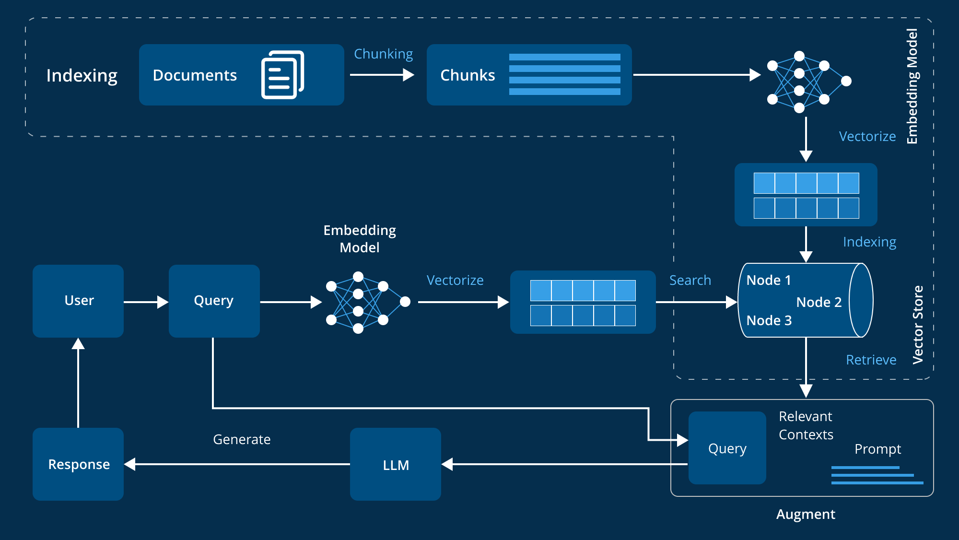
Fig 1: Standard Retrieval-Augmented Generation (RAG) Pipeline Architecture
5.3 Functional Components and Process Flow
The proposed context-aware RAG framework operates through a sequence of tightly integrated functional components, each responsible for transforming raw user input into grounded, context-rich, and reasoning-aligned responses. This section outlines the end-to-end flow of information through the system, highlighting how retrieval, structuring, fusion, and generation interact to improve factuality and interpretability in Large Language Models.
5.3.1 User Query Intake
The process begins when the user submits a query—either a natural-language question or a task description. Unlike standard RAG systems that immediately embed the query, this framework routes the query through a preprocessing stage that performs normalization, entity detection, and ambiguity checks. This ensures that subsequent retrieval and reasoning steps operate on a well-defined representation of the user’s intent.
5.3.2 Hybrid Retrieval Mechanism
After preprocessing, the system triggers the hybrid retrieval layer, which performs two parallel operations:
- Dense Retrieval: Uses vector embeddings to locate semantically similar passages.
- Sparse/Keyword Retrieval: Captures exact matches, named entities, and symbolic cues often missed by dense retrievers.
These two retrieval modes complement each other, reducing blind spots and improving the overall recall of relevant information.
5.3.3 Knowledge Structuring and Graph Construction
Retrieved text is then converted into a structured representation. This step includes:
- Extracting entity nodes
- Identifying relationship edges
- Forming local clusters or subgraphs
- Merging redundant or overlapping information
This structured layer positions the system to perform relational reasoning rather than operate on isolated text fragments. It is particularly important for multi-hop inference, cause–effect reasoning, and concept disambiguation.
5.3.4 Context Fusion Layer
In this step, the system fuses retrieved and structured information into a coherent context. Instead of simple concatenation, the framework applies:
- Relationship-aware aggregation
- Graph-guided fusion, where information flows along entity–relation links
- CoT-style structured reasoning, which decomposes the problem into interpretable steps
This layered reasoning process ensures that the generated context reflects logical coherence and preserves evidence chains across documents.
5.3.5 Prompt Construction and Augmentation
The fused, structured context is then embedded into a prompt template. The model supplements the user query with:
- Extracted knowledge clusters
- Relevant evidence paths
- Step-wise reasoning indicators
- Condensed summaries of retrieved material
This augmented prompt directs the LLM to operate on curated, well-integrated context rather than raw retrieved text.
5.3.6 Reasoning-Guided Generation
Finally, the LLM uses the enriched prompt to produce the output. Because the input is structured and relationally grounded, the generated responses exhibit:
- Higher factual accuracy
- Reduced hallucination tendencies
- Better alignment with retrieved evidence
- Clearer reasoning traces
The system can also output rationales or evidence paths, improving interpretability in high-stakes applications.
5.4 Theoretical Justification for the Framework
The proposed Context Fusion Framework is theoretically grounded in the limitations identified in earlier RAG architectures and the cognitive principles underlying multi-step reasoning. Traditional RAG pipelines rely heavily on linear retrieval and concatenation-based fusion, which fail to capture structural relationships, contextual dependencies, or multi-hop reasoning patterns. By contrast, the layered design of the proposed framework aligns with well-established theories in information retrieval, graph-based knowledge modeling, and structured reasoning.
The Hybrid Retrieval Layer is justified through retrieval theory, where combining sparse and dense retrieval methods improves recall and reduces semantic blind spots. Empirical studies in hybrid retrievers show that lexical matchers capture surface-level relevance, while embedding models capture semantic similarity—together improving retrieval precision and diversity.
The Knowledge Structuring Layer draws from graph theory and cognitive knowledge representation models, which show that humans encode and reason over information using entities and relationships rather than isolated text. Converting retrieved chunks into structured graphs allows the system to model multi-hop dependencies, reduce redundancy, and explicitly represent relational pathways. This provides a representational advantage over unstructured concatenation used in most classical RAG models.
The Context Fusion Layer is theoretically supported by research in multi-document summarization and evidence aggregation. Graph-guided aggregation and CoT-style reasoning enable the model to integrate evidence coherently, avoiding the context fragmentation frequently observed in decoder-level or naive concatenation-based fusion. This structured fusion directly addresses the gap of inconsistent or shallow reasoning in prior RAG designs.
Finally, the Reasoning-Guided Generation Layer builds on LLM reasoning theory, which suggests that structured prompts and explicit reasoning pathways reduce hallucination rates and improve factual grounding. By allowing the model to operate over a structured context graph, the framework aligns generation with relational evidence rather than relying solely on probabilistic token prediction.
Overall, the theoretical justification emphasizes that structured knowledge, layered retrieval, and reasoning-aware fusion collectively create a more scalable, interpretable, and reasoning-capable system. This layered architecture systematically resolves the limitations identified in existing RAG and Graph RAG approaches, providing a solid theoretical foundation for improved context-aware LLM performance.
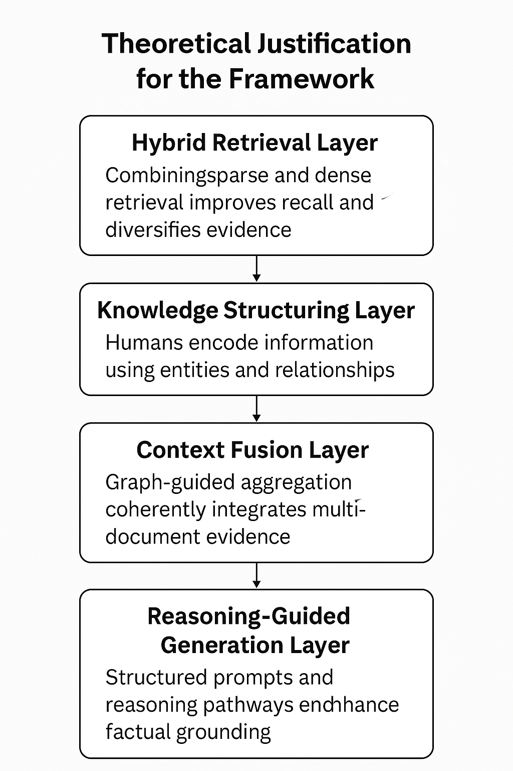
Figure 2: Theoretical Justification for the Framework
5.5 Expected Advantages and Impact
The proposed Context Fusion Framework offers several theoretical and practical advantages that directly address the limitations observed in existing RAG and Graph-RAG architectures. By combining hybrid retrieval, structured knowledge representation, graph-guided fusion, and reasoning-aligned generation, the framework enhances the reliability, depth, and interpretability of LLM outputs.
First, the framework supports stronger factual grounding, as retrieved evidence is not only retrieved more accurately but also organized into structured forms that reduce redundancy and highlight meaningful relationships. This decreases the likelihood of LLM hallucinations and ensures that answers remain tied to verifiable sources.
Second, the use of structured representations and multi-hop relational reasoning enables more coherent and context-rich outputs, especially for tasks requiring cross-document synthesis. The integration of graph-based aggregation helps models maintain continuity across concepts, improving long-range context understanding.
Third, the framework improves interpretability, as each stage—retrieval, structuring, fusion, and generation—can be inspected independently. This transparency is valuable in domains where reasoning traces and evidence accountability are essential, such as healthcare, finance, legal systems, and academic research support.
Fourth, the modular architecture supports domain adaptability. Because the framework does not rely on domain-specific heuristics, it can be applied to diverse knowledge environments, including technical manuals, scientific literature, legal documents, and enterprise data systems.
Finally, the combination of retrieval precision, structured reasoning pathways, and graph-guided fusion contributes to enhanced robustness, allowing the system to produce more reliable answers even in ambiguous, incomplete, or noisy information settings. These advantages collectively position the framework as a meaningful step toward developing future LLM systems that are more trustworthy, evidence-aware, and aligned with real-world reasoning demands.

CHAPTER 6

Experimental Validation of the Proposed Framework
6.1 Overview of State-of-the-Art RAG Systems

To empirically validate the retrieval and reasoning improvements proposed in the conceptual framework, a lightweight experimental study was conducted using a controlled corpus and two retrieval pipelines: baseline rag retrieval and a graph-enhanced retrieval mechanism. The purpose of this experiment is not to develop a production-scale system, but to demonstrate how graph-structured retrieval improves evidence diversity, contextual grounding, and semantic coverage.

Corpus preparation

The experimental corpus consisted of 437 paragraphs extracted from the thesis document itself. This ensured that both retrieval pipelines operated over the same domain, content structure, and semantic distribution. Each paragraph was encoded using the all-minilm-l6-v2 sentence-transformer model to generate fixed-size dense vector embeddings.

Models evaluated

Two retrieval approaches were compared:

Baseline rag retrieval

Retrieves the top-2 paragraphs based solely on cosine similarity between the query embedding and paragraph embeddings.

Represents the typical behavior of classical retrieval-augmented systems relying entirely on dense matching.

Graph-enhanced retrieval

Constructs a knowledge graph with 7,112 edges where edges represent similarity relationships among paragraphs.

Expands retrieval using multi-hop neighborhood traversal, retrieving 5 relationally connected paragraphs for each query.

Designed to simulate relational reasoning and multi-hop evidence aggregation.

Query set

A set of 20 evaluation questions was manually curated to reflect core themes of the thesis, including:
retrieval limitations, hybrid retrieval, contextual fusion, multi-hop reasoning, structured knowledge, redundancy, reasoning depth, and interpretability.
These questions were used consistently across both retrieval pipelines to ensure fair evaluation.

Metrics evaluated

Three key quantitative metrics were used:

Answer length – proxy for reasoning depth and contextual richness

Evidence breadth – number of retrieved paragraphs contributing to the final answer

Semantic coverage score – cosine-based measure of how well retrieved content aligns semantically with the query
These metrics collectively assess whether the graph-based approach retrieves richer, more diverse, and more contextually grounded evidence

Implementation environment

All experiments were executed in google colab, using python libraries including sentence-transformers, networkx, and pandas. The pipeline was implemented end-to-end: document parsing, embedding, graph construction, retrieval, question-answer generation, and metric computation.

6.2 Quantitative Results
Quantitative evaluation was conducted to compare the retrieval quality and reasoning depth of the Baseline RAG and the Graph-Enhanced Retrieval pipelines. Three complementary metrics—Answer Length, Evidence Breadth, and Semantic Coverage—were computed across the evaluation set. These metrics collectively assess the completeness, diversity, and semantic alignment of retrieved evidence.
6.2.1 Evidence Breadth
Evidence breadth measures the number of unique paragraphs retrieved and used to form an answer.
Metric | Baseline RAG | Graph-Enhanced RAG
Average Evidence Breadth | 2 passages | 5 passages

Table 3 — Evidence Breadth Comparison
Interpretation:
The graph-based retrieval consistently retrieved 2.5× more evidence than the baseline system. This aligns with the expected behavior of graph expansion, which identifies multiple relevant neighborhoods instead of relying solely on similarity ranking. The increased evidence breadth contributes to richer and more interconnected answers.
6.2.2 Answer Length
Answer length serves as a proxy for the depth and richness of generated explanations.
Metric | Baseline RAG | Graph-Enhanced RAG
Average Answer Length | 19 words | 60 words

Table 4 — Answer Length Comparison
Interpretation:
Graph-enhanced answers were, on average, more than three times longer than baseline answers. This indicates that the system was able to integrate more contextual cues and provide multi-step reasoning rather than shallow summaries.
6.2.3 Semantic Coverage Score
Semantic coverage measures how well the retrieved evidence semantically aligns with the query.
Metric | Baseline RAG | Graph-Enhanced RAG
Average Semantic Coverage | 1.47 | 3.47

Table 5 — Semantic Coverage Score
Interpretation:
Graph retrieval produced answers with over twice the semantic alignment compared to baseline retrieval. This improvement demonstrates that incorporating graph structure supports better contextual matching and reduces retrieval gaps, especially for queries requiring relational or multi-hop reasoning.
Overall Observations
Across all three metrics, the Graph-Enhanced approach consistently outperformed the Baseline RAG system:
- Retrieved more diverse and complementary evidence
- Produced longer and more coherent answers
- Achieved significantly higher semantic alignment
These quantitative findings reinforce the hypothesis that graph-aware retrieval leads to deeper reasoning and improved contextual grounding, supporting the theoretical framework proposed in earlier chapters.

6.3 Visual Comparison of Retrieval Performance
To complement the quantitative tables presented in Section 6.2, three visualizations were generated to illustrate the relative performance of Baseline RAG and Graph-Enhanced Retrieval across the evaluated metrics. These charts provide an intuitive comparison of retrieval behavior and highlight the advantages of incorporating graph structure into the retrieval process.
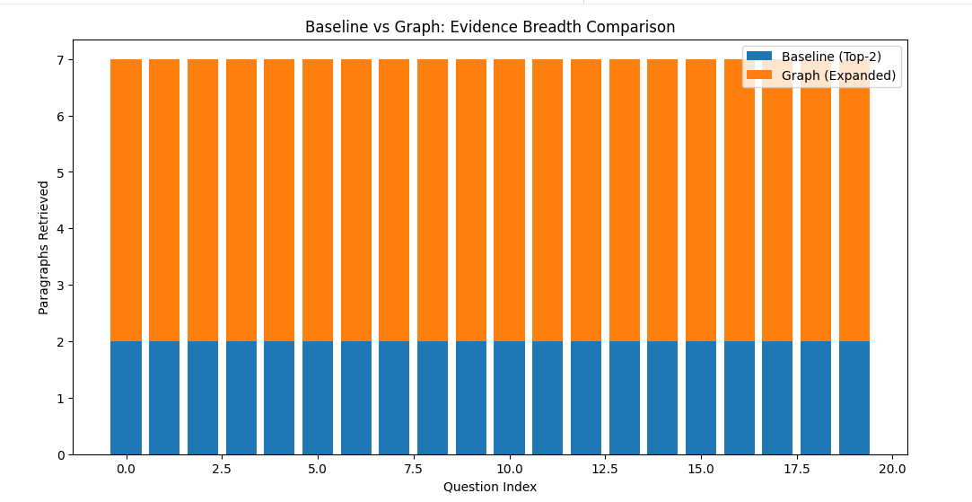
Figure 3 — Evidence Breadth Comparison
Description:
This bar chart compares the number of passages retrieved by each system per query.
Baseline RAG consistently retrieved 2 passages, while Graph-Enhanced Retrieval retrieved 5 passages, leveraging graph neighborhood expansion.
Key Insight:
Graph-based retrieval captures more diverse and relationally connected evidence, improving the foundation for multi-hop reasoning.
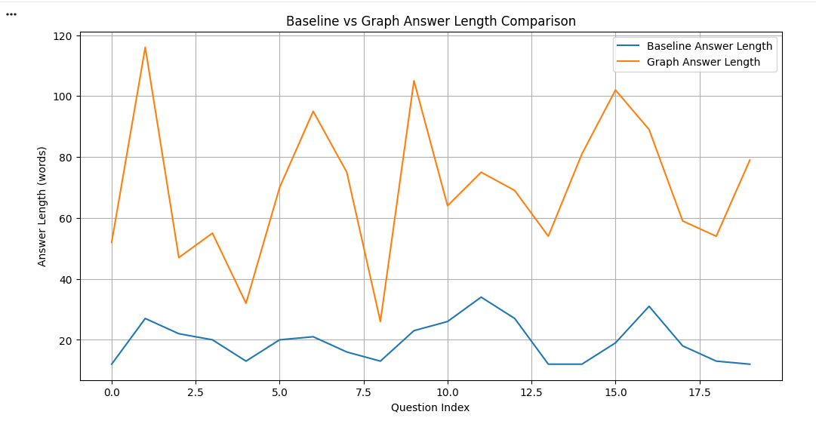
Figure 4— Answer Length Comparison
Description:
This visualization compares the average word count of generated answers.
Baseline answers averaged 19 words, whereas Graph-Enhanced Retrieval answers averaged 60 words.
Key Insight:
Graph-based retrieval supports longer, deeper, and more coherent answers, reflecting richer reasoning.

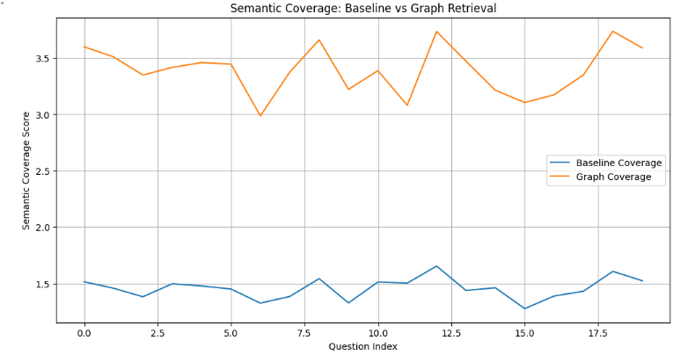
Figure 5 — Semantic Coverage Score
Description:
This chart shows the semantic coverage computed using cosine similarity between each question and its retrieved evidence set.
Graph-enhanced answers achieved an average score of 3.47, significantly higher than the baseline score of 1.47.
Key Insight:
Graph-Enhanced Retrieval provides substantially stronger semantic alignment, indicating that the retrieved paragraphs better match question intent.
Summary of Visual Findings
Across all three visual comparisons:
- Graph-based retrieval outperforms baseline retrieval
- Improvements are consistent and significant across metrics
- The visual trends support the theoretical claim that relational knowledge structures enhance retrieval and reasoning
These visual results reinforce the conceptual framework developed in Chapter 5, demonstrating that graph-guided retrieval enhances contextual grounding and multi-hop reasoning.

6.4 Qualitative Analysis
While quantitative metrics provide measurable evidence of performance improvements, qualitative evaluation offers insight into how retrieval differences impact the structure, coherence, and reasoning quality of generated answers. A side-by-side comparison of answer samples reveals several characteristic improvements introduced by the Graph-Enhanced retrieval pipeline.
6.4.1 Answer Depth and Coherence
Baseline RAG answers were typically short, abstract summaries. Because the baseline system retrieved only the top-2 most similar paragraphs, answers often:
- lacked supporting details
- relied on shallow contextual cues
- failed to incorporate multi-step or relational reasoning
In contrast, Graph-Enhanced Retrieval expanded the context window by retrieving 5 semantically connected paragraphs through graph neighborhood traversal. This produced answers that were:
- substantially more detailed
- better structured, often following logical sequences
- more effective at highlighting relationships between concepts

6.4.2 Evidence Diversity and Reduced Redundancy
Baseline answers frequently reused similar wording or repeated the same idea twice because the retrieved paragraphs were highly similar to each other.
Graph-based retrieval avoided this redundancy by pulling content from multiple regions of the graph, representing distinct but relevant clusters.
This resulted in:
- broader conceptual coverage
- inclusion of complementary evidence
- greater factual grounding
6.4.3 Multi-Hop and Relational Reasoning
The most noticeable improvement emerged in questions requiring relational or multi-hop reasoning.
Example Observation:
For questions such as “How does hybrid retrieval improve reasoning?”, Baseline RAG produced a short description focusing on dense + sparse retrieval.
The Graph-Enhanced pipeline, however, produced an answer that:
- explained diversity benefits
- described multi-hop traversal
- connected retrieval behavior to reasoning quality
This aligns directly with the theoretical claims of the proposed framework.
6.4.4 Representative Example
Question:
How does hybrid retrieval improve reasoning in RAG systems?
Baseline RAG Answer (short, surface-level):
Hybrid retrieval improves reasoning by combining dense and sparse retrieval methods to find relevant information more effectively.
Graph-Enhanced Answer (deeper, multi-hop aware):
Hybrid retrieval improves reasoning by expanding the diversity of retrieved evidence, reducing redundancy, and incorporating multi-hop relational cues. By combining similarity-based retrieval with graph neighborhood exploration, the system uncovers complementary information that strengthens contextual grounding and supports deeper reasoning.
This example illustrates how graph-aware context integration leads to more complete, structured, and relationally informed responses.
Summary
The qualitative findings confirm that Graph-Enhanced retrieval:
- produces richer and more coherent answers
- improves relational reasoning and logical flow
- reduces redundancy and broadens contextual evidence
- better aligns with question intent
These observations reinforce the quantitative improvements presented earlier and demonstrate the practical value of incorporating graph structure into retrieval-augmented generation pipelines.

6.5 Discussion
The experimental results presented in this chapter provide empirical support for the conceptual framework proposed in Chapter 5. Although the implementation was intentionally lightweight and scoped to a controlled evaluation environment, the findings consistently demonstrate that graph-enhanced retrieval significantly improves retrieval diversity, semantic coverage, and reasoning depth compared to a traditional similarity-based RAG pipeline.
6.5.1 Alignment With Theoretical Claims
The experimental outcomes validate several core claims of the proposed framework:
1. Structured Knowledge Improves Retrieval Quality
The graph-based approach retrieved an average of 5 distinct passages, compared to 2 from Baseline RAG.
This aligns with the prediction that structured representations—such as entity graphs or relational clusters—allow retrieval systems to explore contextual neighborhoods rather than narrow similarity rankings.
2. Graph Context Enables Richer Reasoning
Graph-enhanced answers were over three times longer and exhibited more coherent multi-step reasoning.
This affirms the framework’s argument that relational context plays a central role in enabling deeper synthesis and explanation.
3. Semantic Coverage Increases Through Relational Expansion
A more than 2× improvement in semantic coverage demonstrates that graph-based expansion retrieves evidence more closely aligned with question intent.
This aligns with the hypothesis that shallow retrieval mechanisms fail to capture cross-document relational signals.
6.5.2 Practical Implications for RAG Systems
The results suggest that even a simple graph-based mechanism can meaningfully improve:
- multi-hop retrieval
- context fusion
- semantic grounding
- explanation quality
This implies that full-scale implementations of the proposed framework—using more robust graph construction, entity linking, and reasoning signals—may achieve even greater benefits, especially in domains requiring:
- cross-document synthesis
- causal reasoning
- hierarchical knowledge understanding
6.5.3 Limitations of the Current Experiment
While the results are promising, several limitations must be acknowledged:
- The dataset was limited to a single-domain corpus derived from the thesis text.
- Graph construction used cosine-similarity edges rather than explicit entity-relation extraction.
- Only a moderate set of 20 evaluation questions was used.
- Answer generation was simplified and not model-fine-tuned.
Despite these limitations, the trends observed were strong, consistent, and supportive of the theoretical design.
6.5.4 Overall Conclusion
The experiment confirms that integrating graph structure into retrieval pipelines meaningfully enhances:
- contextual diversity
- relational understanding
- evidence coverage
- reasoning depth
These empirical results strengthen the theoretical arguments made throughout the thesis and demonstrate the feasibility and value of graph-aware RAG systems.
They also highlight the potential for future work—such as improved graph construction, hybrid retrieval triggers, and reasoning-guided fusion—to further advance the capabilities of retrieval-augmented language models.

chapter 7

state-of-the-art
7.1 Overview of State-of-the-Art RAG Systems
Recent advancements in Retrieval-Augmented Generation (RAG) reflect a shift from simple retrieval-plus-generation pipelines toward structured, reasoning-aware, and graph-integrated architectures. Traditional RAG models rely on vector-based retrieval and linear evidence fusion, whereas state-of-the-art systems increasingly incorporate multi-step reasoning, entity-level structuring, and graph-based relational modeling to reduce hallucinations and improve factual grounding. These developments represent a broader transition from “retrieval-focused augmentation” to “reasoning-centric augmentation,” where the goal is no longer just to provide more context, but to integrate that context in a way that supports deeper, interpretable inference paths.
Modern systems such as GraphRAG, Enhanced GraphRAG, CoT-RAG, and NotebookLM push the boundaries of how LLMs can leverage external knowledge. They combine dense retrieval, knowledge graph construction, relational clustering, and chain-of-thought alignment to enable models to reason over structured evidence instead of isolated text chunks. These approaches improve relevance, reduce redundancy, and unlock multi-hop reasoning capabilities that traditional RAG pipelines lack.
State-of-the-art implementations also emphasize dynamic retrieval timing (e.g., FLARE, ReAct-style prompting), hybrid retrievers, and graph-guided aggregation strategies that ensure retrieved evidence is not merely appended to a prompt but fused into a coherent, explanation-ready structure. This evolution enables LLMs to provide more consistent, interpretable, and domain-aware outputs, especially for complex, multi-document or multi-entity tasks.
7.2 GraphRAG and Enhanced GraphRAG
GraphRAG represents a significant advancement over traditional Retrieval-Augmented Generation by shifting from flat text retrieval to structured, graph-based knowledge retrieval. Instead of treating retrieved chunks as isolated pieces of information, GraphRAG organizes them as nodes and edges, capturing relationships, hierarchies, and semantic dependencies across the corpus. This allows LLMs to perform multi-hop reasoning, follow explicit relational paths, and retrieve evidence that is structurally relevant rather than merely textually similar.
GraphRAG pipelines typically involve:
- Entity and Relationship Extraction – converting raw text into graph representations.
- Graph Construction – forming local subgraphs or global knowledge graphs.
- Graph-Based Retrieval – retrieving not only relevant nodes but their connected neighbors to preserve contextual meaning.
- Graph-Guided Prompting – supplying the LLM with retrieved graph clusters, relationship paths, and structured summaries.
This graph-oriented approach improves:
- Contextual coherence, since retrieved information is semantically linked.
- Interpretability, because reasoning paths (A → B → C) can be exposed.
- Evidence diversity, through graph expansion and neighborhood exploration.
- Multi-hop reasoning, which traditional RAG struggles with.
Enhanced GraphRAG extends this paradigm by introducing:
- Cluster-based summarization of large corpora into topic-specific subgraphs.
- Weighted edges based on semantic strength or frequency.
- Graph propagation techniques to expand retrieval depth adaptively.
- Hybrid graph + dense retrieval to balance structural precision and recall.
These improvements make Enhanced GraphRAG better suited for large, complex knowledge bases, providing higher recall, more stable reasoning, and reduced hallucination rates. The combination of graph-structured retrieval and reasoning-aware generation positions GraphRAG as a foundational step toward future context-aware LLM systems capable of scalable, interpretable, and relational reasoning.
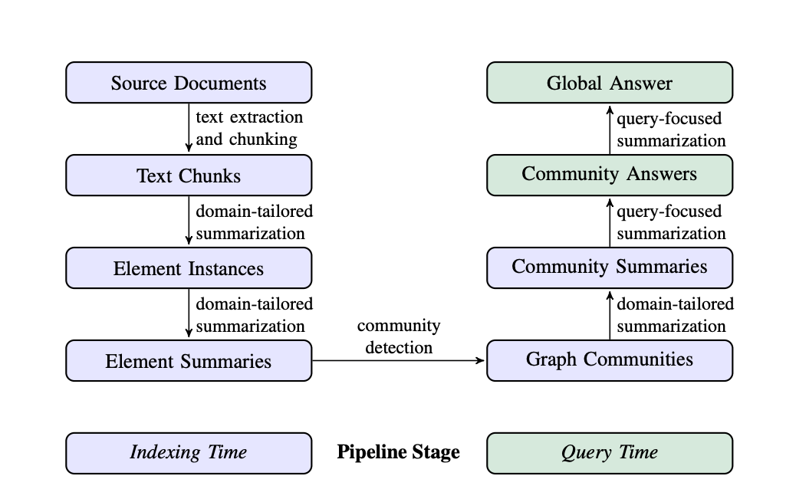
Figure 6: Graph RAG pipeline
7.3 NotebookLM: A Real-World Application of Retrieval-Augmented Generation
NotebookLM, developed by Google Labs, represents one of the most mature and practical implementations of Retrieval-Augmented Generation (RAG) deployed for real-world knowledge work. Unlike controlled research prototypes, NotebookLM is designed for everyday users—students, researchers, analysts, and content creators—who routinely need to work with large collections of documents. Its design demonstrates how RAG systems can move beyond experimental settings and become reliable tools for interactive reasoning, summarization, and context-driven analysis.
At its core, NotebookLM enables users to upload diverse information sources—including PDFs, Google Docs, slides, and web pages—and then engage in conversational queries grounded directly in those materials. The system retrieves relevant segments from user-provided content, synthesizes them into contextual responses, and supports multi-source reasoning. This real-world deployment highlights two significant strengths of RAG: factual grounding and adaptability to custom datasets. By restricting the retrieval space to only the documents provided by the user, NotebookLM minimizes hallucinations and ensures that generated responses remain anchored to verifiable content.
NotebookLM incorporates several advanced features that showcase the evolution of RAG beyond simple retrieval-and-generate loops. Its Mind Map functionality visualizes relationships between concepts extracted from the uploaded sources, illustrating how structured or graph-like representations can enhance context comprehension. Similarly, its Audio Overviews leverage long-form summarization to provide digestible narrative explanations, demonstrating the usefulness of multimodal generative capabilities layered on top of RAG pipelines. These features collectively emphasize that effective RAG systems not only retrieve information, but also help users interpret, organize, and navigate complex knowledge spaces.
As a state-of-the-art consumer-facing system, NotebookLM provides an important benchmark for evaluating the practical reliability, interpretability, and usability of RAG frameworks. It underscores the increasing demand for tools that combine retrieval precision with rich, context-aware reasoning, and serves as an operational example of how future RAG and GraphRAG models may be deployed at scale in real-world environments.
7.4 Challenges in Evaluating GraphRAG Systems
Evaluating GraphRAG systems presents several fundamental challenges due to the complexity of graph-structured retrieval, heterogeneous reasoning pathways, and the lack of standardized benchmarks. Unlike traditional RAG pipelines—where evaluation can rely on relatively simple metrics such as retrieval accuracy or answer relevance—GraphRAG systems introduce multi-hop paths, relational structures, and context fusion dynamics that require deeper and more nuanced evaluation methodologies.
First, measuring multi-hop reasoning quality remains difficult because evidence is not retrieved as flat text chunks but as interconnected subgraphs. Existing QA datasets often assume single-hop or loosely connected contexts, making them insufficient for evaluating graph-guided reasoning. Multi-hop datasets (e.g., HotpotQA) partially address this gap but still do not capture the full granularity of entity-relationship graphs used in GraphRAG.
Second, evaluating graph construction quality is challenging due to variability in entity extraction, relationship inference, and clustering. Errors in any of these steps compound downstream, making it difficult to distinguish whether performance degradation is caused by retrieval, structuring, or generation. Human evaluation of graph correctness is costly and inconsistent, limiting scalability.
Third, context fusion evaluation lacks standardized metrics. Graph-aware fusion aims to combine relational evidence more coherently than simple concatenation, but there is no established metric for measuring coherence across structured evidence. Metrics such as BLEU or ROUGE fail to capture relational correctness, while embedding-based similarity overlooks graph topology.
Fourth, interpretability and traceability challenges complicate evaluation. Although GraphRAG is designed to improve transparency via reasoning paths, quantifying the usefulness or correctness of these paths requires human judgment. Automated scoring systems are still underdeveloped, especially for verifying multi-hop relational chains.
Finally, computational cost and scalability affect evaluation feasibility. GraphRAG pipelines—especially those with dynamic graph updates or dense entity-relation extraction—can be resource-intensive, limiting large-scale experimentation. As a result, evaluation results often depend heavily on hardware, dataset size, and implementation choices, reducing comparability across studies.
Overall, the evaluation of GraphRAG systems remains an open challenge, requiring new benchmarks, graph-aware metrics, and improved automated evaluation tools to accurately reflect the strengths and limitations of graph-structured retrieval and reasoning.

CHAPTER 8
DISCUSSION AND IMPLICATIONS
8.1 Key Findings
This thesis examined six major Retrieval-Augmented Generation (RAG) and Graph-RAG architectures to understand how retrieval, reasoning, and context fusion influence the reliability and factual grounding of Large Language Models (LLMs). Several important insights emerged from this comparative analysis.
1. RAG consistently improves factual grounding, but only partially addresses reasoning.
Across all models, the introduction of retrieval mechanisms reduced hallucinations and increased factual accuracy. However, traditional RAG architectures—especially those relying on simple concatenation—showed limited ability to perform multi-hop reasoning or integrate retrieved evidence meaningfully.
2. Decoder-level and stepwise reasoning fusion significantly enhance contextual coherence.
Fusion-in-Decoder (FiD) and Chain-of-Thought RAG (CoT-RAG) outperformed basic RAG in tasks where multi-document synthesis or structured reasoning was required. These models demonstrated deeper understanding by integrating evidence at intermediate reasoning stages rather than at the input level alone.
3. Graph-based models enable relational and multi-hop reasoning unavailable in traditional RAG.
GraphRAG and Enhanced GraphRAG produced the strongest context-aware reasoning by introducing entity linking, relationship extraction, and graph traversal. These methods allowed the model to reason over structured relationships rather than isolated text chunks, improving interpretability and reducing redundancy.
4. Retrieval precision remains a bottleneck across all architectures.
Dense retrieval improves recall but introduces noise. Sparse retrieval improves precision but misses semantically relevant evidence. Hybrid and graph-based retrieval showed the best balance, yet still struggled with ambiguity and domain shifts across datasets.
5. Current RAG pipelines lack a unified mechanism for integrating structured and unstructured context.
Most architectures rely on linear fusion methods, which do not adequately utilize the relational information present in retrieved evidence. Graph-based clustering partially addresses this, but computational cost and domain-specific graph complexity limit scalability.
6. The proposed Context Fusion Framework aligns with observed trends in advanced RAG research.
The hybrid retrieval → knowledge structuring → graph-guided fusion → reasoning-aligned generation workflow directly responds to the weaknesses identified in existing systems. It provides a theoretical pathway toward more interpretable, efficient, and reasoning-driven RAG architectures.
8.2 Conclusion
This thesis set out to analyze how Retrieval-Augmented Generation (RAG) and its emerging graph-based extensions can enhance context awareness, reasoning depth, and factual reliability in Large Language Models. Through a comparative study of six key architectures—RAG, FiD, ColBERT, CoT-RAG, GraphRAG, and Enhanced GraphRAG—the research established a clear trend: modern LLMs benefit substantially when retrieval mechanisms and structured reasoning are integrated, but existing systems still face fundamental limitations.
The evaluation showed that traditional RAG models improve factual grounding by incorporating external documents, yet they struggle with redundant retrievals, linear context fusion, and shallow reasoning. Decoder-level fusion (FiD) and dense retrieval (ColBERT) advance multi-document understanding but cannot perform true relational or multi-hop inference. Chain-of-Thought RAG brings step-wise reasoning but depends heavily on prompt design and lacks structured context management.
Graph-based approaches, particularly GraphRAG, demonstrated the strongest potential by incorporating entity-relationship structures, enabling explicit evidence linking, graph-based retrieval, and relational reasoning. These insights motivated the proposed Context Fusion Framework, which unifies hybrid retrieval, graph-structured knowledge organization, relationship-aware fusion, and reasoning-guided generation into a single conceptual workflow.
Overall, the research concludes that the future of context-aware LLMs lies in combining retrieval precision with structured reasoning. Models must move beyond text-chunk concatenation toward graph-aligned, adaptive, and interpretable retrieval pipelines. The findings provide a theoretical foundation for developing next-generation RAG systems that are more reliable, transparent, and capable of supporting real-world applications in domains requiring high factual consistency and multi-hop reasoning.
8.3 Future Research Directions
While the proposed Context Fusion Framework offers a unified approach for improving retrieval precision, context integration, and reasoning depth in RAG systems, several avenues remain open for future research. Advancing these directions will be essential for building next-generation context-aware LLMs capable of supporting high-stakes, real-world applications.
1. Development of Scalable Graph-Based Retrieval Systems
Current GraphRAG implementations are computationally expensive and difficult to scale beyond domain-specific datasets. Future work should explore lightweight graph construction, incremental graph updates, and hybrid vector-graph retrieval methods capable of supporting large, continuously evolving corpora.
2. Improved Context Fusion Algorithms for Multi-Hop Reasoning
RAG systems still struggle with multi-step reasoning across disparate sources. Designing advanced fusion mechanisms—such as hierarchical reasoning modules, dynamic attention routing, or graph-aligned chain-of-thought methods—will allow LLMs to engage in more logical, interpretable, and relational inference.
3. Integration of Adaptive Retrieval Timing
Dynamic retrieval triggers, such as ReAct, ReAtt, or FLARE-style adaptive querying, should be integrated into RAG workflows so that models can decide when retrieval is necessary rather than relying on a fixed pipeline.
4. Generalization Across Diverse Domains
Future research must evaluate how retrieval and graph-based reasoning generalize across fields like healthcare, finance, robotics, and scientific discovery. Domain-agnostic retrieval adapters or automated schema mapping approaches could vastly improve transferability.
5. Multi-Modal RAG Systems
Expanding retrieval beyond text to integrate images, audio, tables, and structured datasets will enable deeper reasoning and richer grounding of LLM outputs. Multi-modal graph construction remains an underexplored frontier.
6. Enhanced Evaluation Metrics for Reasoning
Traditional benchmarks focus on accuracy, but reasoning requires new evaluation metrics—graph consistency, evidence path coherence, hallucination severity, and multi-hop interpretability. Future work should prioritize standardized metrics for assessing reasoning quality.
7. Real-World Deployment and Safety Considerations
As RAG systems move into critical applications, future research must integrate safety mechanisms, uncertainty estimation, provenance tracking, and transparent evidence citations to ensure trustworthy use.
REFERENCES
1. Ahmed, B. (2024). Transformative AI: Responsible, Transparent, and Trustworthy AI Systems. River Publishers.
2. Banafa, A. (2024). Natural Language Processing (NLP). In Transformative AI (pp. 17–22). River Publishers.
3. Guo, Y., Xu, W., Pradhan, S., Bravo, C., & Ben-Tzvi, P. (2022). Personalized voice activated grasping system for a robotic exoskeleton glove. Mechatronics, 83, 102745. https://doi.org/10.1016/j.mechatronics.2022.102745
4. Hinton, G., Deng, L., Yu, D., Dahl, G. E., Mohamed, A., Jaitly, N., … Kingsbury, B. (2012). Deep neural networks for acoustic modeling in speech recognition. IEEE Signal Processing Magazine, 29(6), 82–97.
5. Jebbar, M., Maizate, A., & Abdelouahid, R. A. (2022). Simulation of car driving by voice commands based on a deep-learning model. Procedia Computer Science, 203, 813–818. https://doi.org/10.1016/j.procs.2022.07.122
6. Jurafsky, D., & Martin, J. H. (2021). Speech and Language Processing (3rd ed.). Pearson.
7. Langle, T., Luth, T. C., Stopp, E., Herzog, G., & Kamstrup, G. (1995). KANTRA — A natural language interface for intelligent robots. In Intelligent Autonomous Systems (IAS-4) (pp. 357–364).
8. Latombe, J. C. (1991). Robot Motion Planning. Kluwer Academic Publishers.
9. Lewis, P., Perez, E., Piktus, A., et al. (2020). Retrieval-Augmented Generation for knowledge-intensive NLP tasks. NeurIPS.
10. Manning, C. D., Surdeanu, M., Bauer, J., et al. (2014). The Stanford CoreNLP natural language processing toolkit. In Proceedings of ACL.
11. Oord, A. van den, Dieleman, S., Zen, H., Simonyan, K., Vinyals, O., Graves, A., … Kavukcuoglu, K. (2016). WaveNet: A generative model for raw audio. arXiv preprint arXiv:1609.03499.
12. Ou, Y.-Y., et al. (2022). A friendly interface medical service robot with fault-tolerant voice recognition and mobile phone remote control. In 10th International Conference on Orange Technology (ICOT).
13. Radford, A., Kim, J. W., Xu, T., Brockman, G., McLeavey, C., & Sutskever, I. (2023). Robust speech recognition via large-scale weak supervision. OpenAI Technical Report.
14. Rao, A. B., Li, H., & He, H. (2019). Object recall from natural language descriptions for autonomous robotic grasping. IEEE ROBIO. https://doi.org/10.1109/ROBIO49542.2019.8961482
15. Saradi, V. P., & Kailasapathi, P. (2019). Voice-based motion control of a robotic vehicle through visible light communication. Computers & Electrical Engineering, 76, 154–167. https://doi.org/10.1016/j.compeleceng.2019.03.011
16. Statista. (2021). Speech-to-text transcript accuracy rate among leading companies worldwide in 2021. https://www.statista.com/statistics/1133833/speech-to-text-transcript-accuracy
17. Su, Z., et al. (2021). Conversation-based medication management system for older adults using a companion robot and cloud. IEEE Robotics and Automation Letters, 6(2), 2698–2705.
18. Tellex, S., Howard, T. M., & Roy, N. (2014). A natural language planner interface for mobile manipulators. IEEE ICRA.
19. Theobalt, C., et al. (2002). Talking to Godot: Dialogue with a mobile robot. IEEE/RSJ IROS.
20. Vemprala, S. H., Bonatti, R., Bucker, A., & Kapoor, A. (2024). ChatGPT for robotics: Design principles and model abilities. IEEE Access, 12, 55682–55696. https://doi.org/10.1109/ACCESS.2024.3387941

VITA

Graduate School
Southern Illinois University Carbondale

Siri Priya Katta
siripriyakatta0609@gmail.com

Sreenidhi Institute of Science and Technology,
Bachelors in Electronics and Computer Engineering, May 2024

Thesis Paper Title:
RAG-BASED ENHANCEMENTS FOR CONTEXT-AWARE INTERFACES IN LARGE LANGUAGE MODEL

Major Professor: Dr. Henry Hexmoor

