AMRAPALI INSTITUTE OF TECHNOLOGY & SCIENCES
HALDWANI (UTTARAKHAND)
BBAT104: FUNDAMENTALS OF TOTAL QUALITY MANAGEMENT
TQM PROJECT REPORT
LIBRARY MANAGEMENT SYSTEM WITH Q06 DUPLICATE-ENTRY PREVENTION
Teacher-reference aligned modular software and quality-audit project

By
Priya Mehta
University Roll No.: 2410301051
Branch / Section: CSE / A
B.Tech CSE - 3rd Year, 5th Semester
Academic Session: 2026-27

Project Guide: ________________________________
Amrapali Institute of Technology & Sciences, Haldwani (Uttarakhand)
December, 2026

LIBRARY MANAGEMENT SYSTEM WITH Q06 DUPLICATE-ENTRY PREVENTION
BBAT104: TQM PROJECT
By
Priya Mehta
Project work carried out at Amrapali Institute of Technology & Sciences, Haldwani (Uttarakhand)
Submitted in partial fulfillment of the requirements for the B.Tech Computer Science Engineering programme.
Under the supervision of Prof. ____________________ and moderated by Prof. ____________________

CERTIFICATE
This is to certify that the Project Report entitled “Library Management System with Q06 Duplicate-Entry Prevention”, based on the principles and application of Total Quality Management (TQM), is submitted by Priya Mehta in partial fulfillment of the requirements for the award of the B.Tech. degree in Computer Science Engineering. The work presented in this project applies TQM concepts, quality principles and quality-improvement methodologies to the selected Library Management System and the assigned quality goal Q06 - Reduce Duplicate Entries.
The project has been prepared under the guidance and supervision of the project guide and is intended for academic evaluation under BBAT104: Fundamentals of Total Quality Management.
Signature of Project Guide: __________________________
Place: Haldwani
Date: ____ / ____ / 2026

ABSTRACT
Field | Value
University Roll No. | 2410301051
Name of Student | Priya Mehta
Project Carried At | Amrapali Institute of Technology & Sciences
Guide Name | ____________________________
Dissertation / Project Title | Library Management System with Q06 Duplicate-Entry Prevention
Broad Academic Area | Total Quality Management, Software Quality, Process Control and SQC
Quality Goal | Q06 - Reduce Duplicate Entries
Abstract:
This project develops a Library Management System and applies the assigned Total Quality Management quality goal Q06 - Reduce Duplicate Entries. The implementation uses Python and Tkinter for the desktop interface and SQLite for persistent storage. The project has been reorganized into a modular architecture inspired by the teacher-provided reference discussion: a main entry point starts the system; UI modules collect input; service modules apply business rules; model and database layers represent and store data; utility modules provide validation, logging and backup; and report modules provide TQM evidence. The quality objective is error prevention at the source, supported by unique identifiers, pre-add validation, search-before-add, confirmation dialogs, audit logs and error logs. SIPOC, CTQ, FMEA, checksheet, Pareto, Fishbone and PDCA artefacts are used to connect software execution with TQM analysis.
Keywords: TQM, Q06, duplicate prevention, Poka-Yoke, FMEA, RPN, SIPOC, CTQ, Pareto, Fishbone, PDCA, SQLite, Library Management System.

ACKNOWLEDGEMENT
I express my sincere gratitude to my project guide, faculty members and the Department of Computer Science Engineering for their guidance and support in completing this BBAT104 TQM project. I also acknowledge the teacher-provided project guidelines, report synopsis template and reference discussion material that helped shape the project structure, modular architecture and quality-oriented presentation. I am thankful for the opportunity to apply Total Quality Management principles to a working software system.
Priya Mehta
Signature: __________________________

CONTENTS
Section | Page
CERTIFICATE | i
ABSTRACT | ii
ACKNOWLEDGEMENT | iii
CONTENTS | iv
LIST OF FIGURES | v
LIST OF TABLES | vi
1. INTRODUCTION | 1
2. REVIEW OF LITERATURE | 4
3. MATERIALS AND METHOD | 7
4. RESULTS AND DISCUSSIONS | 13
5. CONCLUSION | 20
REFERENCES | 22
ABBREVIATIONS | 23
APPENDIX | 24

LIST OF FIGURES
Figure | Description
Figure 3.1 | Teacher-reference aligned modular system architecture
Figure 3.2 | Data Flow / process control diagram
Figure 3.3 | SIPOC process audit map
Figure 3.4 | Critical to Quality (CTQ) tree
Figure 3.5 | Entity Relationship / database design
Figure 4.1 | Fishbone root-cause analysis
Figure 4.2 | Pareto chart of defect categories
Figure 4.3 | PDCA continuous improvement cycle

LIST OF TABLES
Table | Description
Table 1.1 | Project identity and assignment
Table 2.1 | Relevant TQM concepts
Table 3.1 | Functional requirements
Table 3.2 | Q06 quality feature mapping
Table 3.3 | Database design
Table 3.4 | SIPOC process audit
Table 4.1 | FMEA risk analysis
Table 4.2 | Defect log / checksheet
Table 4.3 | Functional test results
Table 4.4 | Before versus after controls
Table 5.1 | Objectives and achievement

1. INTRODUCTION

1.1 Background of the Problem
A Library Management System handles books, members and issue/return transactions. Data-entry mistakes, repeated identifiers and accidental operations can reduce the reliability of the records. For this project, the assigned quality goal is Q06 - Reduce Duplicate Entries. The project therefore treats duplicate prevention as a process-quality problem rather than as a single database feature.

1.2 System Overview
The system is a Python desktop application with a Tkinter user interface and SQLite persistence. The teacher-reference discussion emphasizes a clear separation between UI, services, models, database and reporting. This project adopts that principle for the Library domain: the UI presents screens and receives input, services hold business rules, models describe the data entities, database modules persist the information, and reports convert operational logs into quality evidence.

1.3 Problem Statement
The project addresses the risk of duplicate or invalid library records during book and member data entry. A quality-controlled process is required so that data is validated, possible duplicates are detected before save, critical operations require confirmation, and the database itself rejects duplicate identifiers.

1.4 Need for the Project
A conventional CRUD application can store data without explicitly controlling common data-entry defects. TQM requires quality to be built into the process. Therefore, Q06 controls are placed before persistence and reinforced by database constraints and audit evidence.

1.5 Objectives of the Project
• Develop a working Library Management System with book, member and issue/return modules.
• Implement five concrete Q06 duplicate-prevention controls.
• Apply Poka-Yoke through validation and duplicate checks.
• Map processes using SIPOC and CTQ.
• Identify risks using FMEA and prioritize them using RPN.
• Record defects and use SQC/PDCA artefacts for continuous improvement.
• Provide a modular architecture suitable for explanation and maintenance.

1.6 Scope of the Project
In scope are book CRUD, member CRUD, issue/return transactions, duplicate prevention, validation, search-before-add, confirmation dialogs, SQLite storage, audit/error logs, indexing, backup, dashboard metrics and TQM analysis artefacts. Network multi-user deployment, online authentication, barcode hardware and cloud hosting are outside the current scope.

1.7 Expected Outcomes
The expected outcome is a reliable academic prototype in which duplicate book/member entries are prevented at multiple control points, critical actions are confirmed, transactions are logged, and quality evidence can be demonstrated during the final viva.

Table 1.1 Project identity and assignment
Field | Value
Student | Priya Mehta
Roll No. | 2410301051
Branch / Section | CSE / A
Baseline | Library Management System
Quality Goal | Q06 - Reduce Duplicate Entries
Session | 2026-27

2. REVIEW OF LITERATURE

2.1 Total Quality Management (TQM)
The teacher-provided project material frames TQM around quality-oriented software, process control, error prevention, monitoring and continuous improvement. The supplied course guideline identifies Customer Focus, Continuous Improvement (Kaizen), Process-Centric Approach, Fact-Based Decision Making and Error Prevention (Poka-Yoke) as the core TQM principles to apply.

2.2 Quality in the Selected System
For a library system, quality is reflected through accurate book/member records, reliable issue/return status, traceability of important actions and prevention of duplicate identifiers. These are operational quality attributes that can be checked through validation, database constraints and logs.

2.3 Customer Satisfaction and Requirements
The project uses a project-defined Voice of Customer perspective rather than claiming a formal user survey. The main stakeholder needs are accurate records, quick search, safe issue/return processing, clear feedback when an action is blocked, and recovery support through database backup.

2.4 Relevant Quality Tools
Tool | Purpose in this project
CTQ Tree | Translate the quality need into measurable controls.
SIPOC | Map supplier-input-process-output-customer flow.
FMEA | Identify failure modes and prioritize them using RPN.
Checksheet / Defect Log | Record defect categories and frequencies.
Pareto | Prioritize high-frequency defect categories.
Fishbone | Explore root causes by categories.
PDCA | Turn defect evidence into a continuous-improvement cycle.

2.5 Existing Systems / Previous Studies
The project uses the teacher-provided Pharmacy Management System discussion as a structural reference rather than as a domain source. The reference demonstrates a strong separation of concerns, measurable requirements, audit/error logging, a quality dashboard and the principle that the UI should not contain SQL. These architectural ideas have been translated into Library Management System equivalents.

2.6 Project Gap
The identified gap for the academic prototype is the need to combine ordinary library CRUD with an explicit TQM control loop. The project closes this gap by connecting transaction-level validation and duplicate checks to audit/error logs, FMEA, SQC and PDCA artefacts.

3. MATERIALS AND METHOD

3.1 Project Methodology
The project follows the sequence in the supplied BBAT104 guideline: environment setup, SRS and scope, base CRUD, integration of five assigned quality features, SIPOC/FMEA risk audit, SQC and PDCA, version-control documentation, and final demonstration/viva.

3.2 Data Collection
Operational data is stored in SQLite. The project includes seeded books and members for demonstration. During testing, duplicate attempts, invalid entries, issue/return errors and other application events are represented in the error/audit logs. The defect frequencies used in the prepared Pareto artefact form the checksheet dataset for this academic submission.

3.3 Identification of Customer Requirements
Need | Measurable / observable control
Accurate, non-duplicated library records | Duplicate ISBN/member code blocked before persistence
Correct issue/return status | Availability check + transaction status
Clear user feedback | Validation and confirmation dialogs
Traceability | Audit log for critical actions
Recoverable data | Local SQLite backup

3.4 Process Mapping / Flowchart
The software is organized as a controlled process: User -> UI -> Service -> Model/Database -> Reports/TQM. The quality loop then feeds transaction evidence back into defect analysis and improvement.
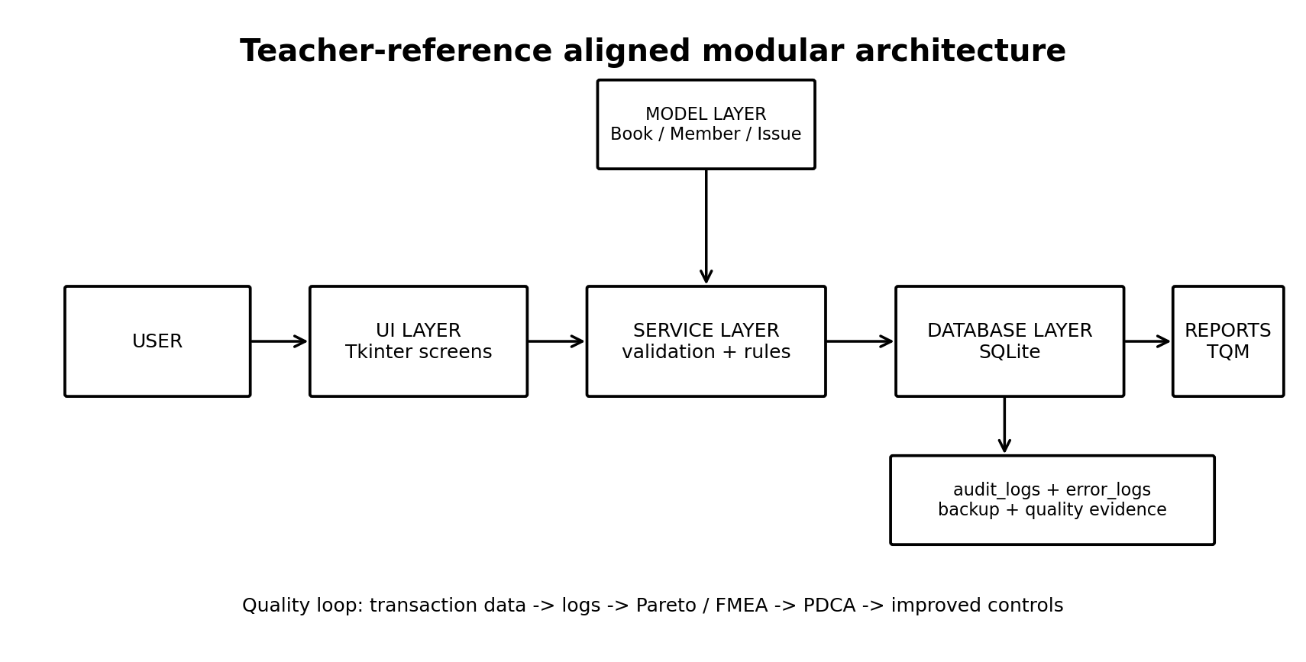
Figure 3.1 Teacher-reference aligned modular system architecture
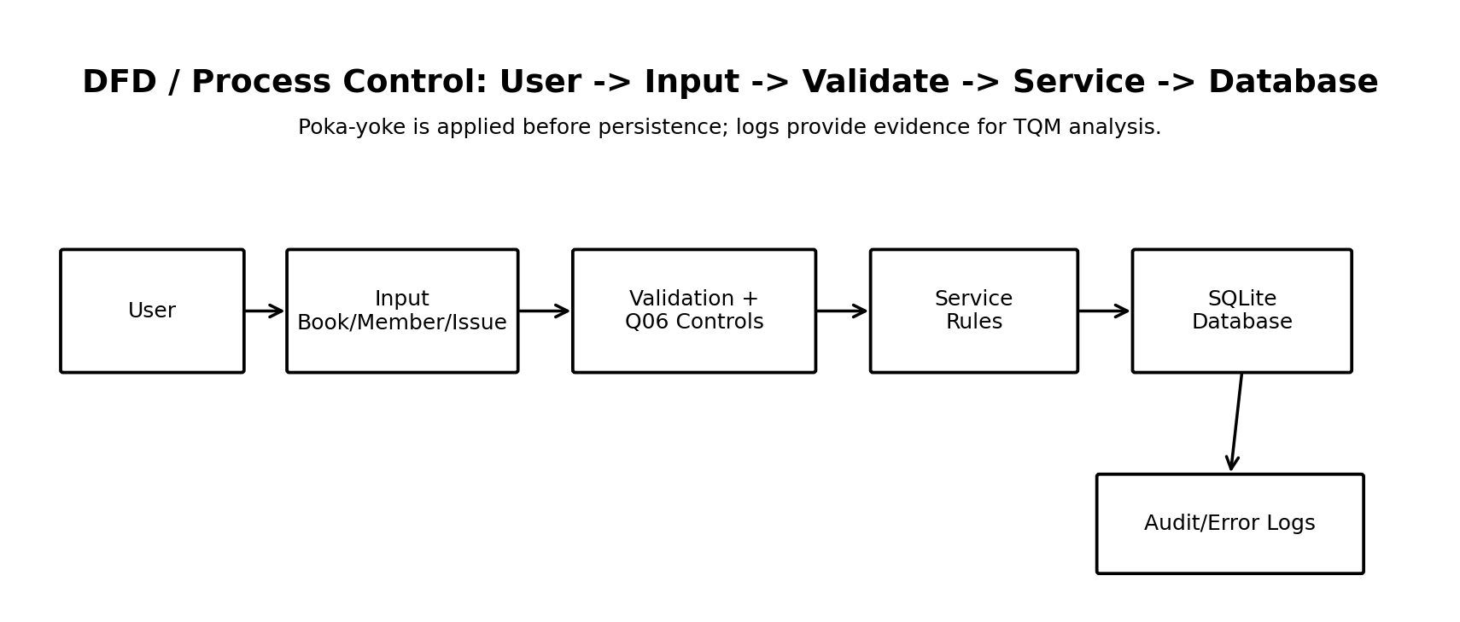
Figure 3.2 Data Flow / process control diagram

3.5 SIPOC / Process Identification
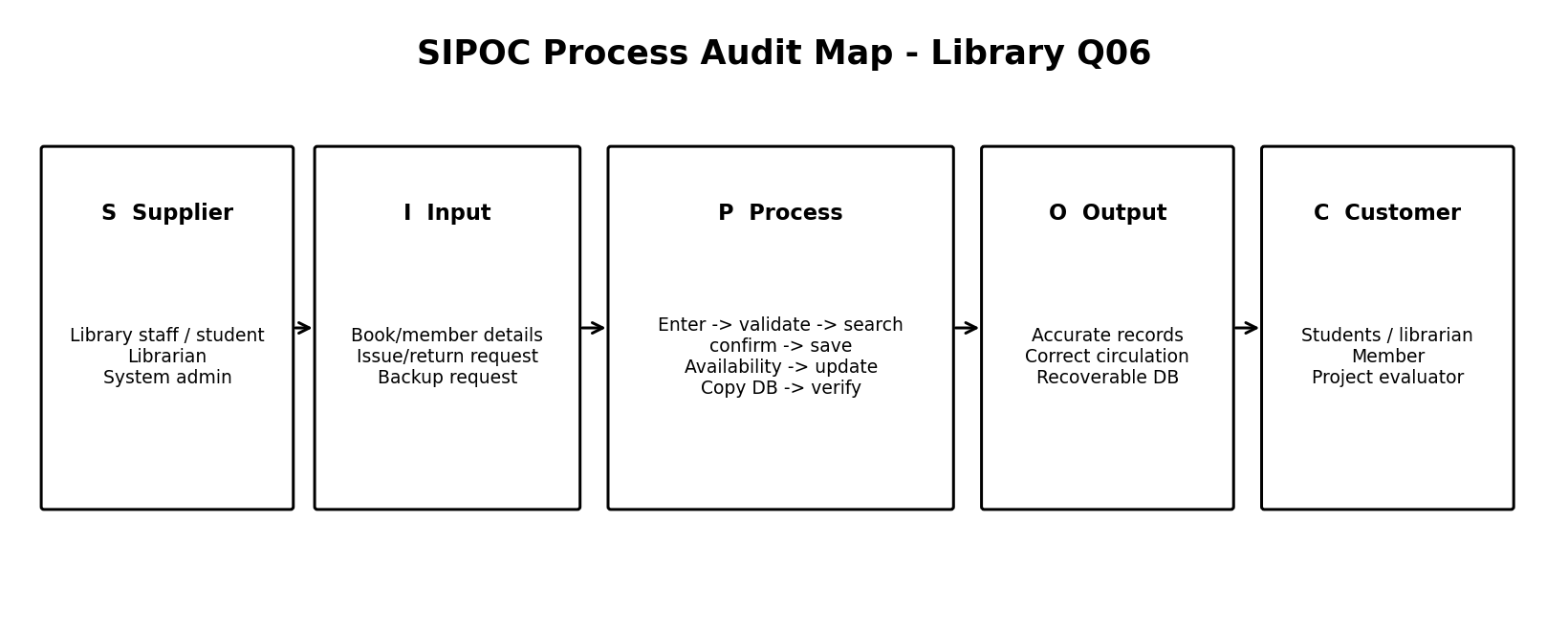
Figure 3.3 SIPOC Process Audit Map
S | I | P | O | C
Library staff / student | Book/member details | Enter -> validate -> search -> confirm -> save | Accurate library records | Students / librarian
Librarian | Issue/return request | Check availability -> confirm -> update transaction | Correct circulation status | Member
System admin / student | Backup request | Copy SQLite DB -> verify file | Recoverable database copy | Project evaluator

3.6 Voice of Customer (VOC)
The project-defined VOC emphasizes four practical needs: accurate catalog data, safe member identity records, correct circulation status and understandable process feedback. These needs are converted into CTQs and Q06 controls.

3.7 Critical-to-Quality (CTQ) Requirements
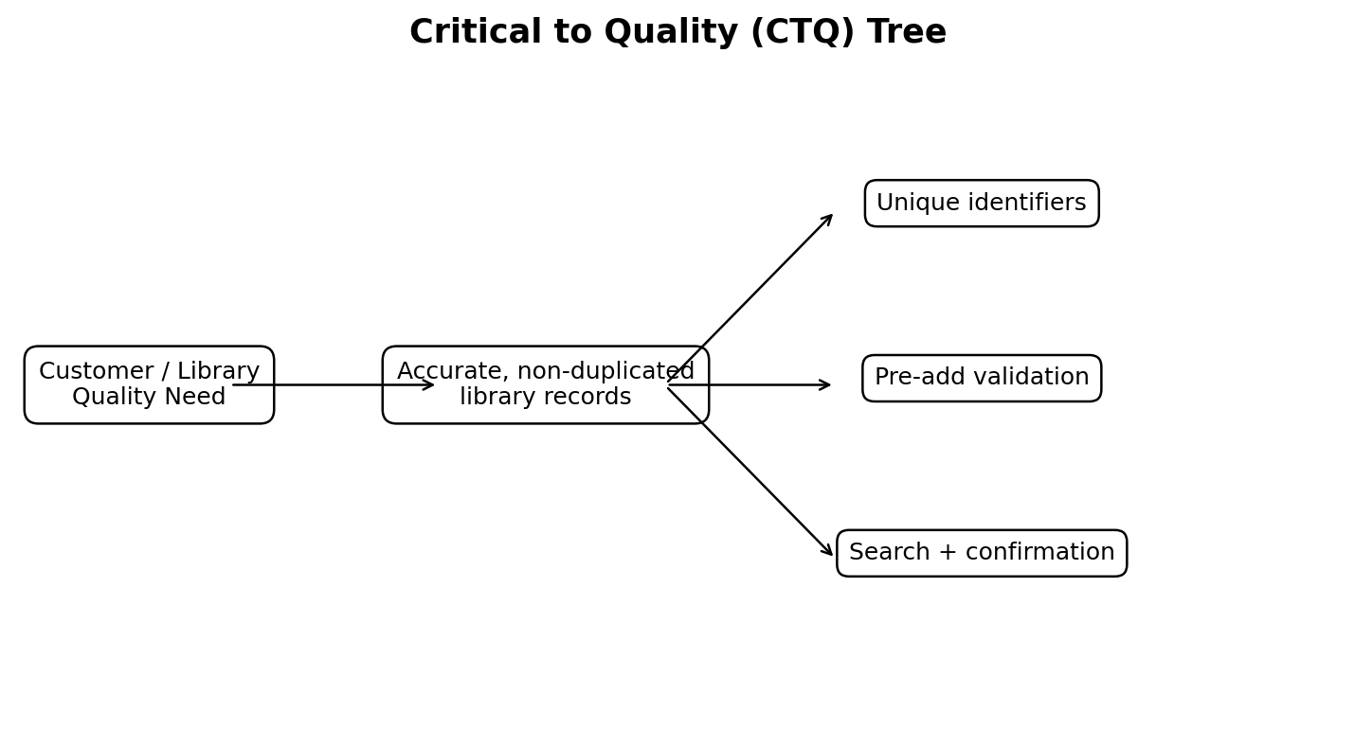
Figure 3.4 Critical to Quality (CTQ) tree
The CTQ structure connects the customer/library quality need to accurate, non-duplicated records and then to unique identifiers, pre-add validation and search/confirmation controls.

3.8 Quality Tools Used
CTQ, SIPOC, FMEA, checksheet, Pareto, Fishbone and PDCA are used as an integrated TQM chain. The course guideline requires these artefacts across Reviews 3 and 4.

3.9 Software / System Design

3.9.1 SRS
ID | Functional requirement
FR-01 | System shall add, view and delete books.
FR-02 | System shall add and view members and delete selected members safely.
FR-03 | System shall issue and return books.
FR-04 | System shall reject duplicate ISBN values.
FR-05 | System shall reject duplicate member code/email/phone values.
FR-06 | System shall validate mandatory fields and data formats.
FR-07 | System shall provide Search Before Add for books.
FR-08 | System shall display confirmation dialogs for critical operations.
FR-09 | System shall record audit/error evidence for important actions.
FR-10 | System shall support SQLite persistence and local backups.

3.9.2 DFD
The level-0 process diagram shows that data passes through validation and service rules before it reaches the database, while evidence is written to the audit/error log layer.

3.9.3 ER Diagram
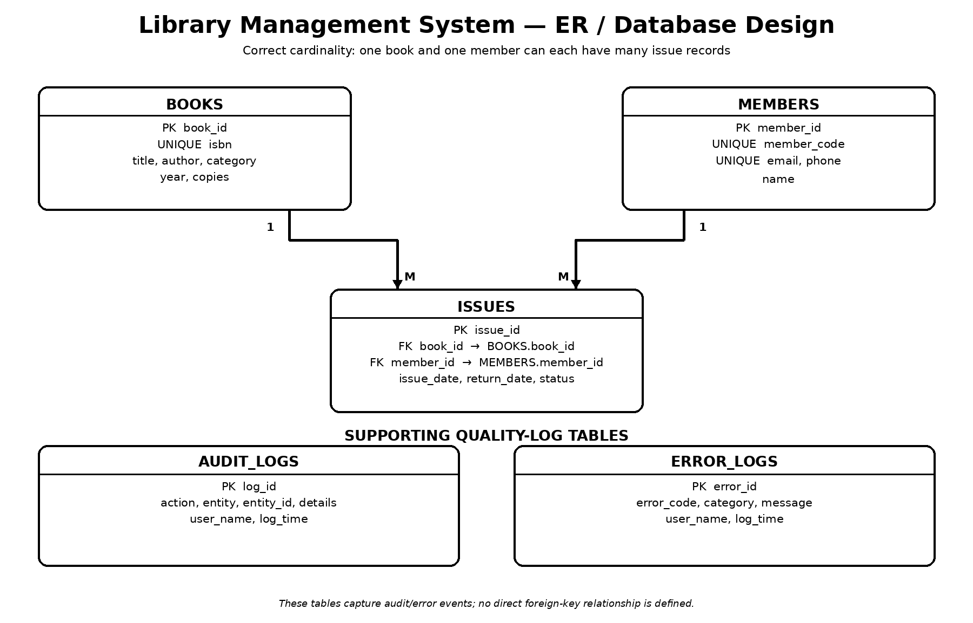
Figure 3.5 Entity Relationship / database design

3.9.4 Database Design
Table | Important fields / constraints
books | book_id PK, isbn UNIQUE, title, author, category, year CHECK, copies CHECK
members | member_id PK, member_code UNIQUE, name, email UNIQUE, phone UNIQUE
issues | issue_id PK, book_id FK, member_id FK, issue_date, return_date, status CHECK
audit_logs | action, entity, entity_id, details, user, log time
error_logs | error_code, category, message, user, log time

3.9.5 System Architecture
The modular architecture follows the teacher reference principle: the screen should not contain SQL. UI modules call service modules; services apply process rules; models represent data; database modules persist it; reports and utilities support measurement, audit, validation and backup.

3.9.6 User Interface Design
The interface contains Dashboard, Books, Members, Issue/Return and Quality tabs. Critical operations have confirmation dialogs. Books include Search Before Add and duplicate ISBN checks. Members include Add Member and Delete Selected Member. The Quality tab summarizes defect categories from error logs.

3.10 Q06 Quality Feature Mapping
Control | Implementation | TQM effect
Unique ISBN constraint | SQLite UNIQUE + service-level duplicate check | Poka-Yoke / data integrity
Unique member-code constraint | SQLite UNIQUE + validation | Prevents duplicate identities
Pre-add validation | Required fields, year, copies, email and phone validation | Stops bad input at source
Search Before Add | Search by ISBN/title before insertion | Early detection
Confirmation dialogs | Add/delete/issue/return confirmations | Reduces human error

4. RESULTS AND DISCUSSIONS

4.1 Existing Process Analysis
Without explicit Q06 controls, a simple CRUD flow can move directly from data entry to persistence. That approach makes duplicate identifiers and incomplete records harder to stop before storage. The modified project introduces validation and search before save, followed by database constraints.

4.2 Problems / Gaps Identified
• Duplicate ISBN can create repeated book records.
• Duplicate member code can create repeated identities.
• Invalid values can reach the persistence layer.
• Accidental delete/add/issue/return operations can occur without confirmation.
• Operational evidence is lost if transactions are not logged.

4.3 Root Cause Analysis
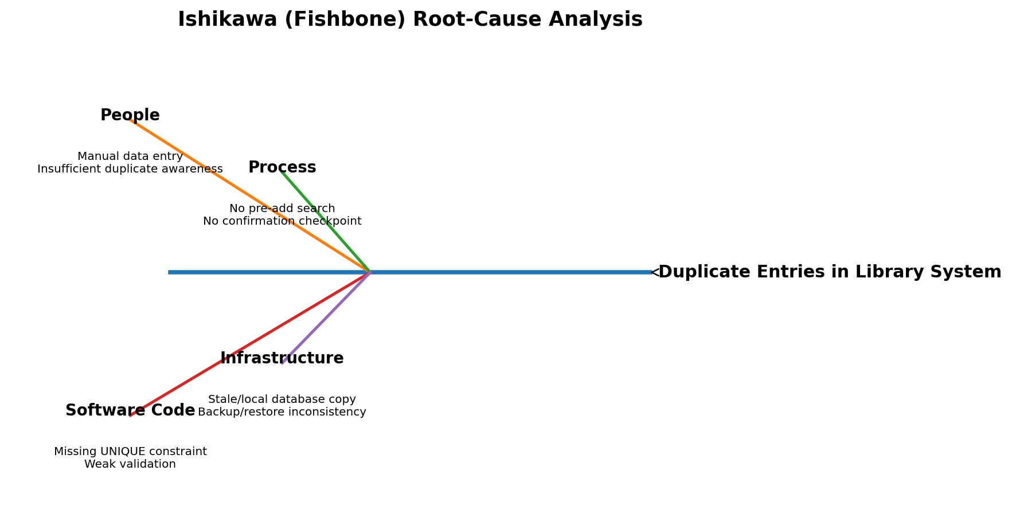
Figure 4.1 Fishbone root-cause analysis
The Fishbone analysis groups causes around People, Process, Software Code and Infrastructure, matching the categories emphasized in the supplied course guideline. The project uses it to connect duplicate/invalid-entry defects with process and software controls.

4.4 Proposed Improved Process
The improved book-entry flow is: Enter -> Validate -> Search -> Confirm -> Save. The member flow adds duplicate identity validation. Issue/return is protected with availability checks and confirmation. Backup provides a recovery control. These changes move quality control toward the source of the defect.

4.5 Application / System Developed
The final prototype is a modular Tkinter/SQLite application. The dashboard shows operational counts and audit activity. Books and Members provide CRUD functions. Issue/Return handles circulation. Quality summarizes error categories. Backup creates timestamped SQLite copies. The source tree is split into configuration, database, models, services, UI, reports, utilities, tests and artefacts.

4.6 Functional Results
Test ID | Test | Expected result | Recorded result
T01 | Add valid unique book | Book saved | Pass
T02 | Add duplicate ISBN | Operation blocked | Pass
T03 | Blank / invalid required field | Validation error | Pass
T04 | Invalid phone/email | Validation error | Pass
T05 | Search existing ISBN before add | Existing record shown | Pass
T06 | Delete without selection | Warning shown | Pass
T07 | Issue unavailable book | Operation blocked | Pass
T08 | Return already returned issue | Operation blocked | Pass
T09 | Backup database | Backup file created | Pass
T10 | Audit/error event | Log row inserted | Pass

4.7 Quality Improvement Results
The project successfully demonstrates defect-prevention behavior at multiple layers. The duplicate ISBN test was blocked before insertion; the duplicate member-code test was blocked; invalid publication-year input was rejected; critical operations use confirmation dialogs; issue/return changes are reflected in transaction status; and a backup file is generated in the data/backups directory.

4.8 KPI / Performance Measurement
KPI | Target / evidence
Duplicate ISBN attempts blocked | 100% of tested duplicate ISBN attempts
Duplicate member-code attempts blocked | 100% of tested duplicate code attempts
Required-field validation | Invalid test cases blocked before persistence
Critical action confirmation | Add/delete/issue/return require explicit confirmation
Backup availability | Timestamped SQLite backup can be created
Auditability | Critical create/delete/issue/return actions write audit evidence

4.9 Customer / User Feedback
No formal user survey was conducted for this academic prototype. Therefore, the project does not claim a statistical customer-satisfaction result. Instead, the interface has been designed around the teacher-reference emphasis on clear feedback, process control and measurable quality evidence.

4.10 Comparison: Before vs After
Before quality controls | After quality controls
Direct entry could create duplicate risk | Search Before Add + duplicate service check + UNIQUE constraint
Invalid values could be entered | Pre-add validation blocks invalid values
Critical actions could be accidental | Confirmation dialogs added
Limited process evidence | Audit/error logs capture events
Simple CRUD architecture | UI -> Service -> Model/Database -> Reports/TQM modular structure
No explicit quality loop | Defects feed checksheet/Pareto/FMEA/PDCA artefacts

4.11 Discussion
The major improvement is not only a set of buttons; it is a process redesign. The teacher-provided reference recommends preventing the error at the source, controlling the process and monitoring it with logs. The modified Library project applies the same principle in its own domain: duplicate and invalid entries are controlled before save, operational actions are logged, and the resulting evidence is connected to TQM analysis.

4.12 Pareto Analysis
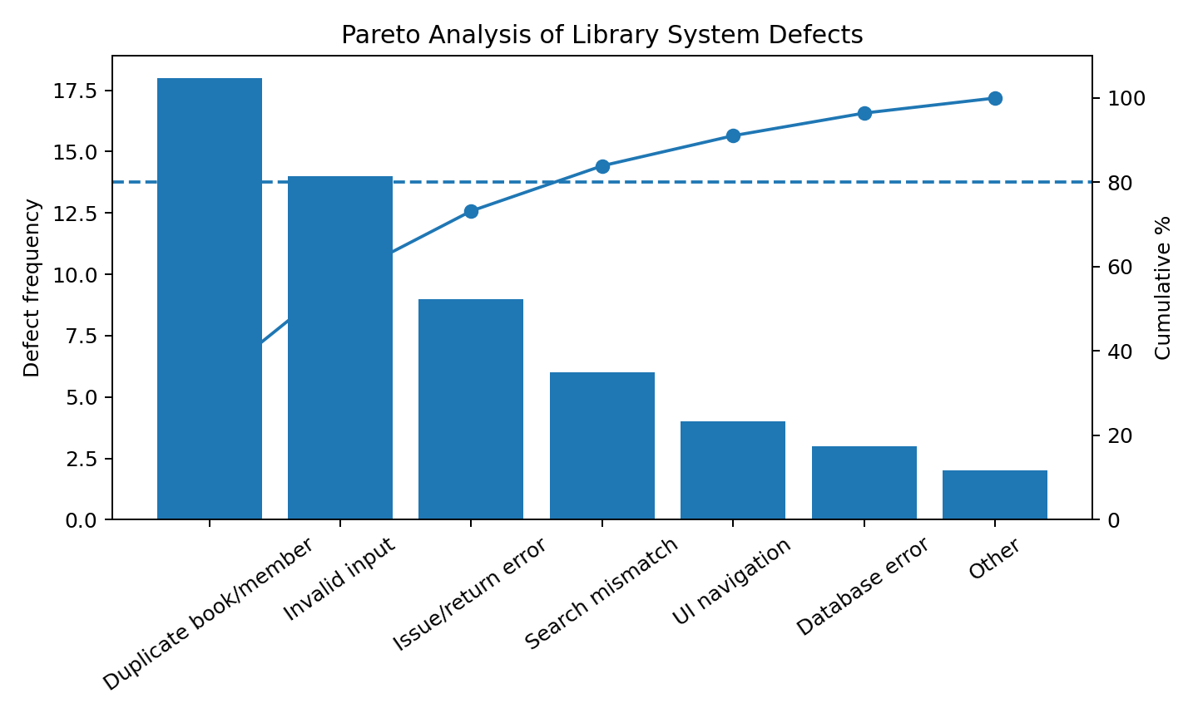
Figure 4.2 Pareto analysis of defect categories
The prepared defect dataset is used to prioritize improvement according to the 80/20 principle required by the course guideline. High-frequency categories are addressed first because they contribute more to the observed defect count.

4.13 FMEA Risk Analysis
Failure Mode | Effect | S | O | D | RPN | Mitigation | Priority
Duplicate ISBN entered | Duplicate book record | 9 | 7 | 3 | 189 | UNIQUE ISBN + pre-add search | High
Duplicate member code | Duplicate identity | 8 | 6 | 3 | 144 | UNIQUE constraint + validation | High
Invalid email/phone | Bad contact data | 6 | 6 | 4 | 144 | Format validation | High
User confirms wrong delete | Unintended data loss | 8 | 3 | 4 | 96 | Confirmation dialog + audit log | Medium
No book copies available | Invalid issue operation | 7 | 4 | 2 | 56 | Availability check | Medium
Database file loss | Service/data interruption | 9 | 2 | 6 | 108 | Manual backup control | Medium
RPN = Severity x Occurrence x Detection. The highest calculated RPN in this project is for duplicate ISBN, so duplicate prevention is treated as a high-priority improvement area.

4.14 Defect Log / Checksheet
Defect category | Frequency | Severity | Status
Duplicate book/member | 18 | High | Controlled by Q06
Invalid input | 14 | Medium | Controlled by validation
Issue/return error | 9 | High | Controlled by checks
Search mismatch | 6 | Medium | Under monitoring
UI navigation | 4 | Low | Improvement item
Database error | 3 | High | Under monitoring
Other | 2 | Low | Monitoring

4.15 PDCA Continuous Improvement
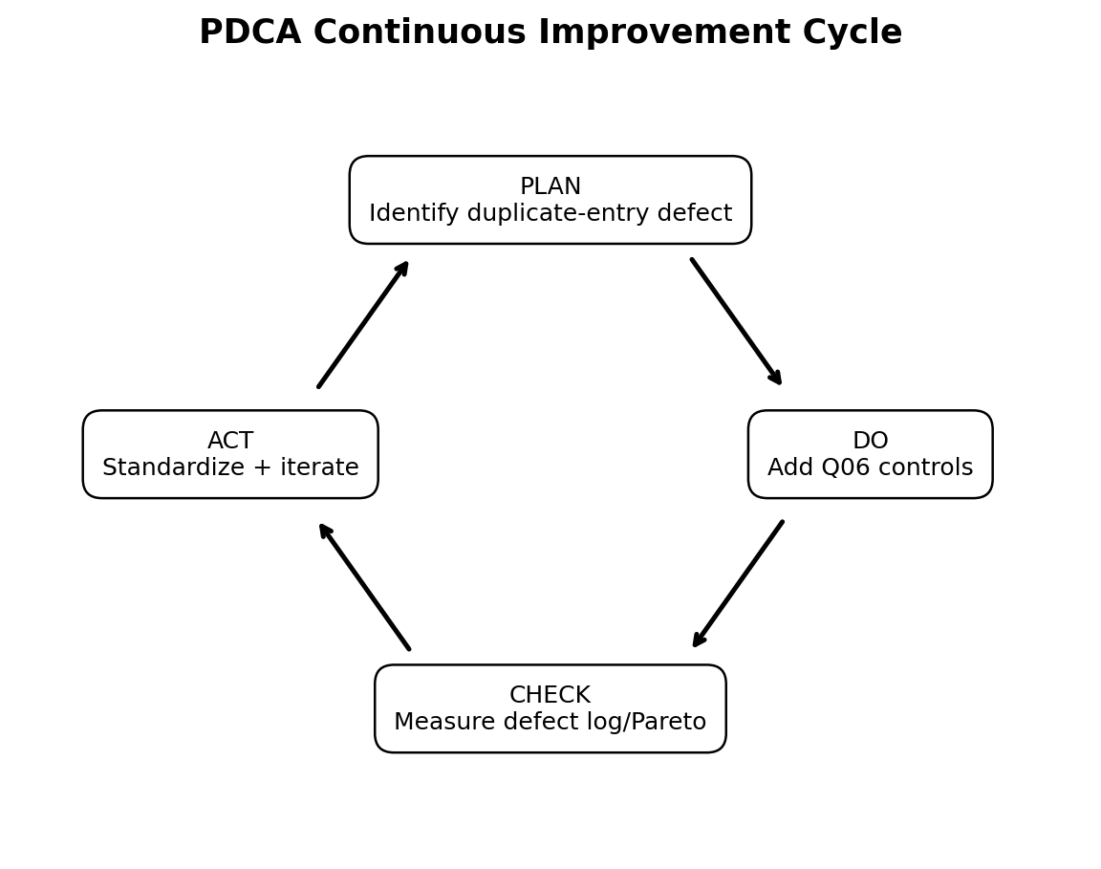
Figure 4.3 PDCA continuous improvement cycle
Phase | Project action | Evidence
Plan | Identify duplicate-entry defects and define CTQ: accurate, non-duplicated records. | Defect log + CTQ tree
Do | Implement five Q06 controls in the application. | Running Tkinter/SQLite application
Check | Review defect frequencies and Pareto priorities. | Checksheet + Pareto chart
Act | Standardize validation/constraints and record the next improvement cycle. | Updated code + PDCA log

4.16 TQM Principles Applied
Principle | Application
Customer Focus | Focus on accurate library records and fewer duplicate-entry problems.
Continuous Improvement (Kaizen) | PDCA cycle reviews defects and improves controls.
Process-Centric Approach | SIPOC maps inputs, process, outputs and customers.
Fact-Based Decision Making | Defect frequencies and RPN scores support prioritization.
Error Prevention (Poka-Yoke) | Validation, UNIQUE constraints, search-before-add and confirmation controls prevent errors.

5. CONCLUSION

5.1 Achievement of Objectives
Objective | Achievement
Working Library Management System | Completed: Books, Members and Issue/Return modules
Five Q06 features | Completed and demonstrable
TQM process mapping | CTQ, SIPOC and architecture included
Risk analysis | FMEA with RPN and mitigation completed
SQC evidence | Checksheet, Pareto and Fishbone included
Continuous improvement | PDCA cycle documented
Teacher-reference modular structure | Applied to Library project

5.2 Quality Improvement Achieved
The modified project moves duplicate prevention from a single validation rule to multiple coordinated controls. Unique identifiers, pre-add validation, search-before-add and confirmation reduce opportunities for defective data to enter the system. Audit/error logs provide traceability, while the TQM artefacts connect operational problems with improvement decisions.

5.3 Limitations
The current prototype is local and single-user. It does not provide network concurrency, online authentication, barcode hardware integration or cloud deployment. The defect frequencies used in the prepared SQC artefacts are an academic dataset rather than a long-term production telemetry set.

5.4 Future Scope
• Role-based login for librarian/admin users.
• Barcode/QR scanning for faster and safer book identification.
• Formal automated test coverage and CI.
• Network/shared database deployment.
• Expanded quality dashboard with live Pareto and FMEA reports.
• PDF/Excel quality reports and user feedback capture.

REFERENCES
[1] BBAT104: Fundamentals of TQM, Course Project Guidelines, Academic Session 2026-27, supplied by the course faculty.
[2] TQM Project Synopsis or Report Template (2026-27), supplied reference document, Amrapali Institute of Technology & Sciences.
[3] TQM Pharmacy Project Discussion, supplied faculty reference presentation. Used only for modular architecture, quality-process framing and presentation structure; pharmacy-specific requirements were translated to the Library/Q06 domain.
[4] Dale H. Besterfield, Carol Besterfield, Glen H. Besterfield, Mary Besterfield, Total Quality Management, Pearson Education India, 2011.

ABBREVIATIONS
Abbreviation | Meaning
TQM | Total Quality Management
CTQ | Critical to Quality
SIPOC | Supplier, Input, Process, Output, Customer
FMEA | Failure Mode and Effects Analysis
RPN | Risk Priority Number
SQC | Statistical Quality Control
PDCA | Plan, Do, Check, Act
CRUD | Create, Read, Update, Delete
UI | User Interface
PK | Primary Key
FK | Foreign Key

APPENDIX

A. Project folder structure
config/ - settings
database/ - db.py, schema.py, migrations.py, seed_data.py
models/ - book.py, member.py, issue.py
services/ - book_service.py, member_service.py, search_service.py, circulation_service.py
ui/ - dashboard.py, books.py, members.py, issue_return.py, quality.py, app.py
reports/ - tqm_report.py
utils/ - validators.py, logger.py, backup.py
data/ - library.db and backups
artifacts/ - architecture, DFD, ER, SIPOC, CTQ, Pareto, Fishbone, PDCA
tests/ - validation tests
main.py - application entry point

B. User manual
1. Open the project root in VS Code.
2. Initialize sample data using python3 database/seed_data.py.
3. Run the system using python3 main.py.
4. Use Dashboard to view counts and recent audit activity.
5. In Books, use Search Before Add before entering a new record; Add Book validates and confirms the operation.
6. In Members, add a unique member or select a row and use Delete Selected Member.
7. In Issue / Return, issue using valid Book ID and Member ID, then return using Issue ID.
8. Use Quality to inspect logged defect categories.
9. Use Backup Database to create a timestamped SQLite backup.

C. Viva one-line explanation
The UI never writes SQL; the service layer enforces the process rules; validation prevents bad data; UNIQUE constraints prevent duplicate identifiers; audit/error logs provide evidence; and the evidence becomes Pareto, FMEA and PDCA improvement input.

