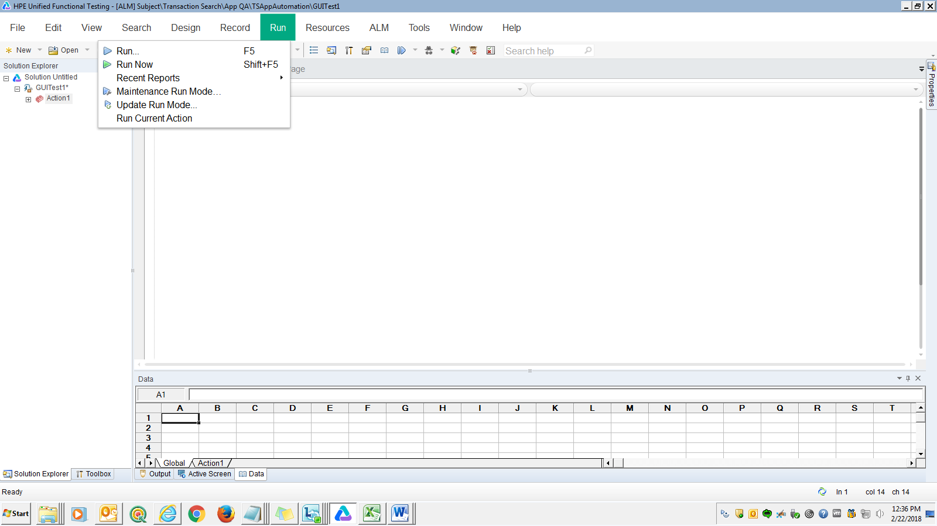

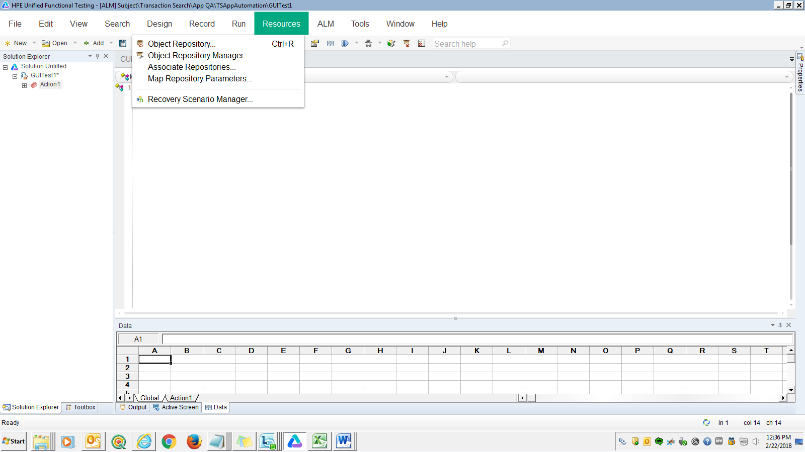

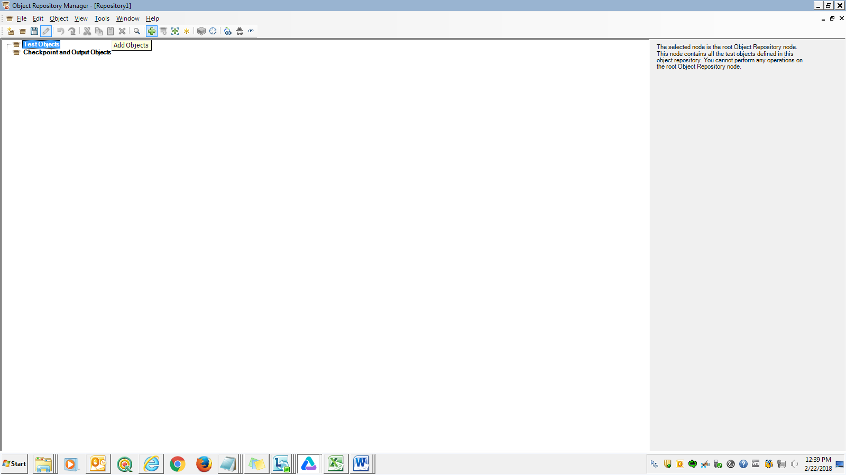

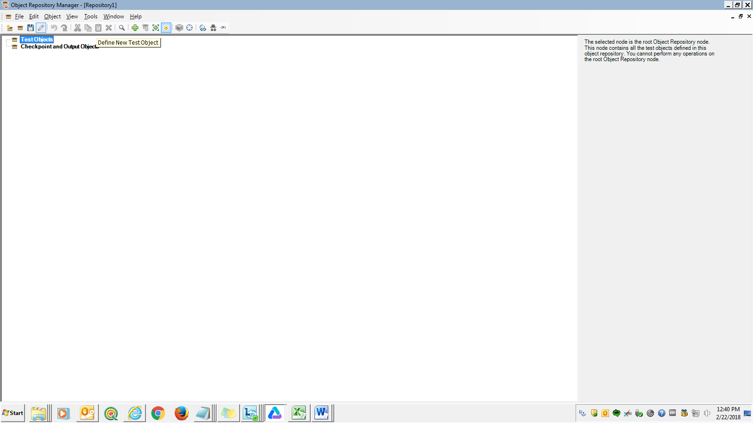

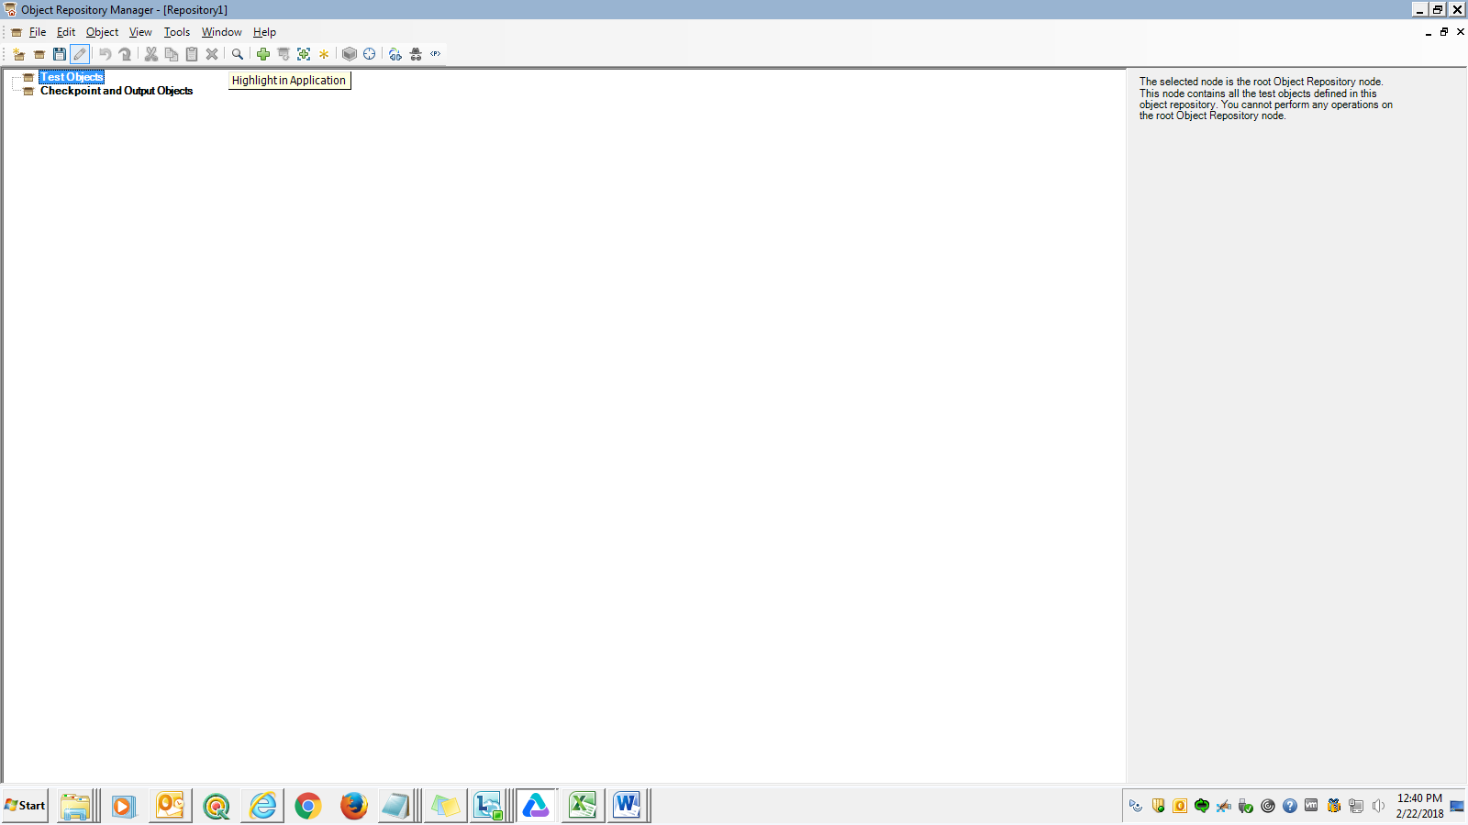

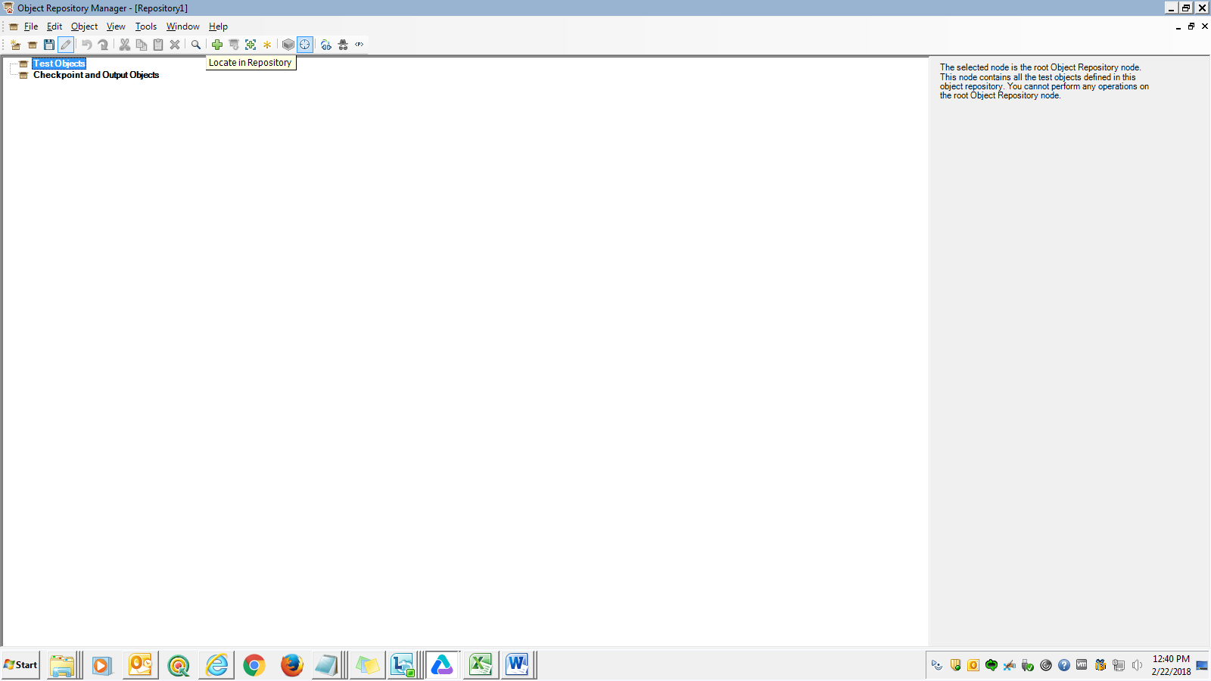

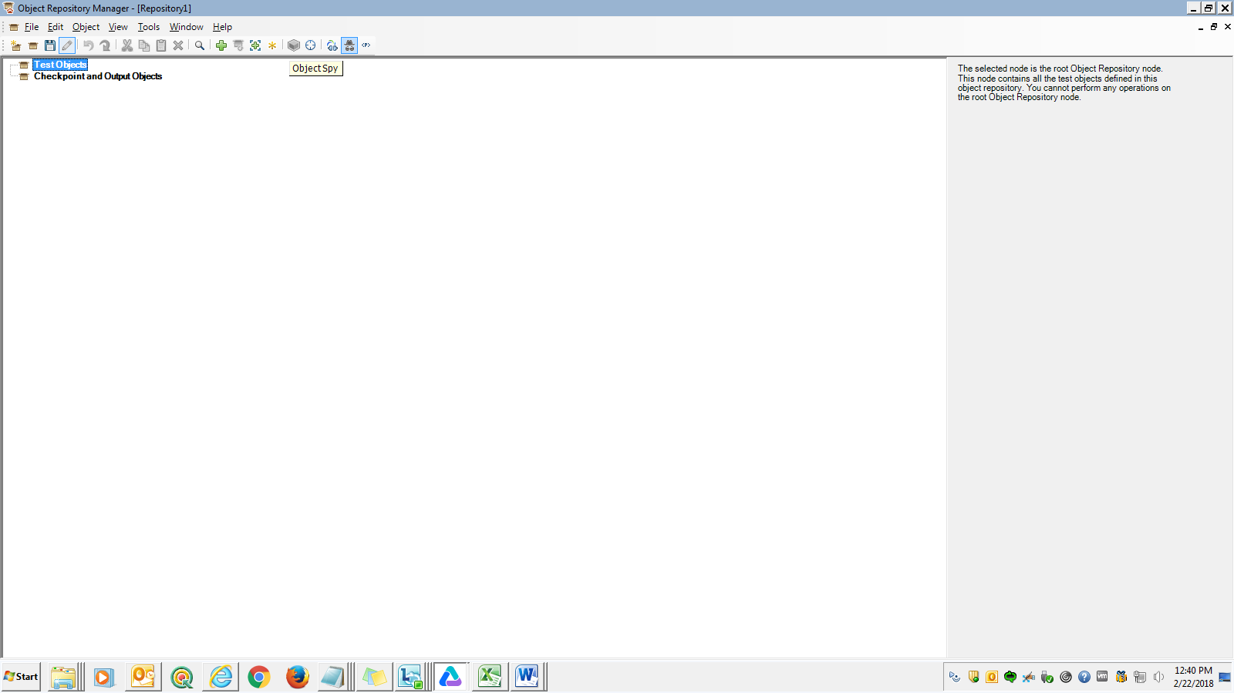

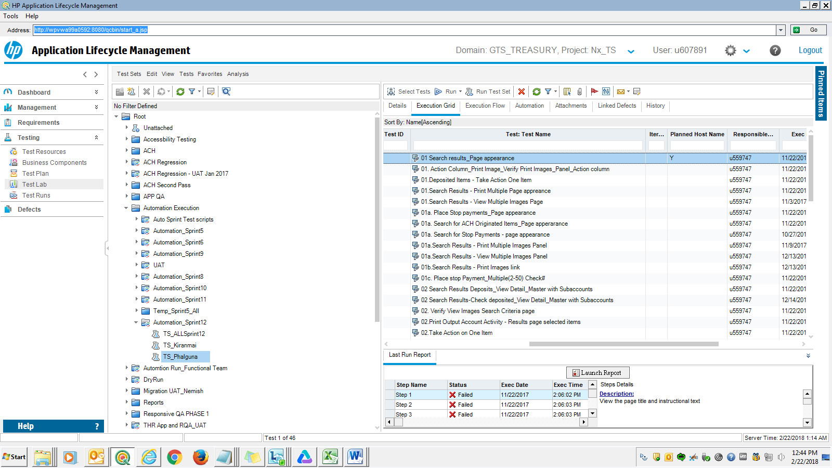

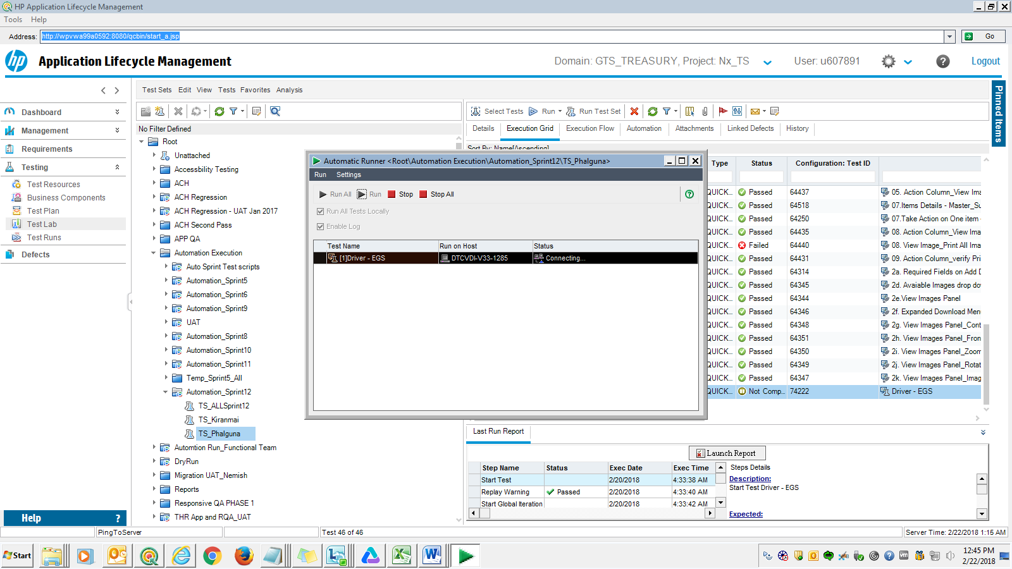

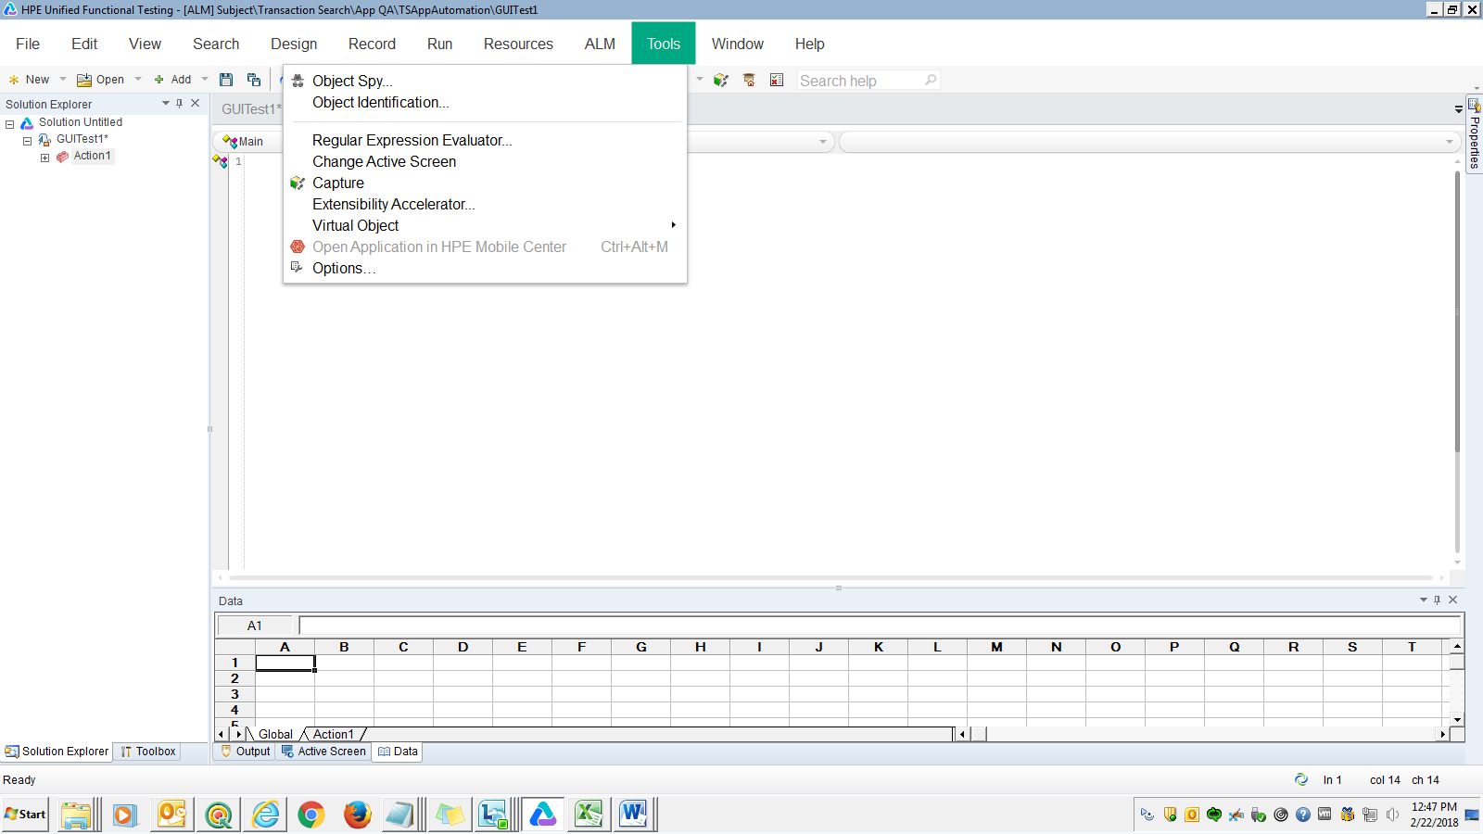

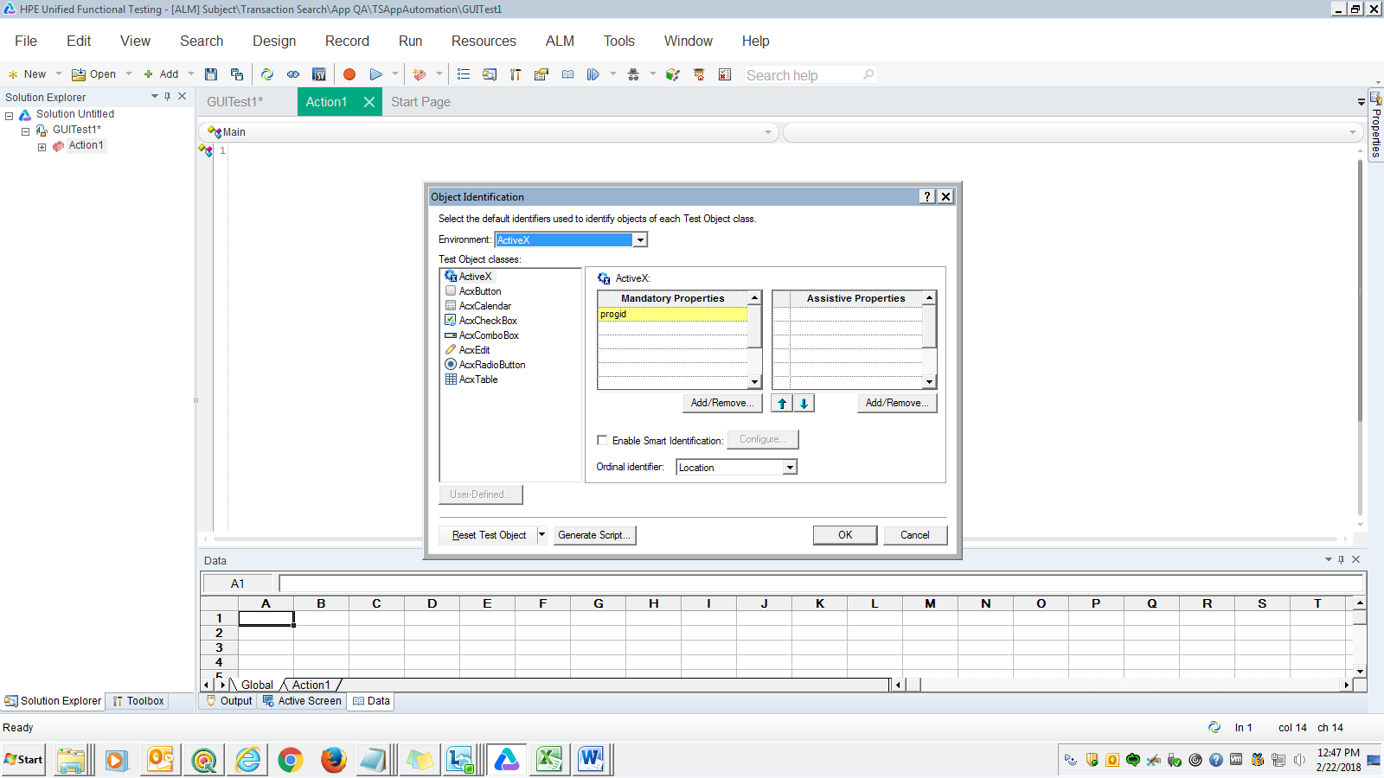

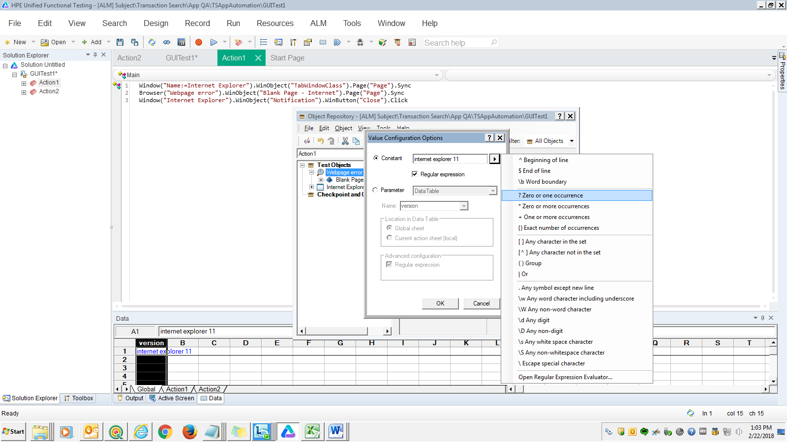

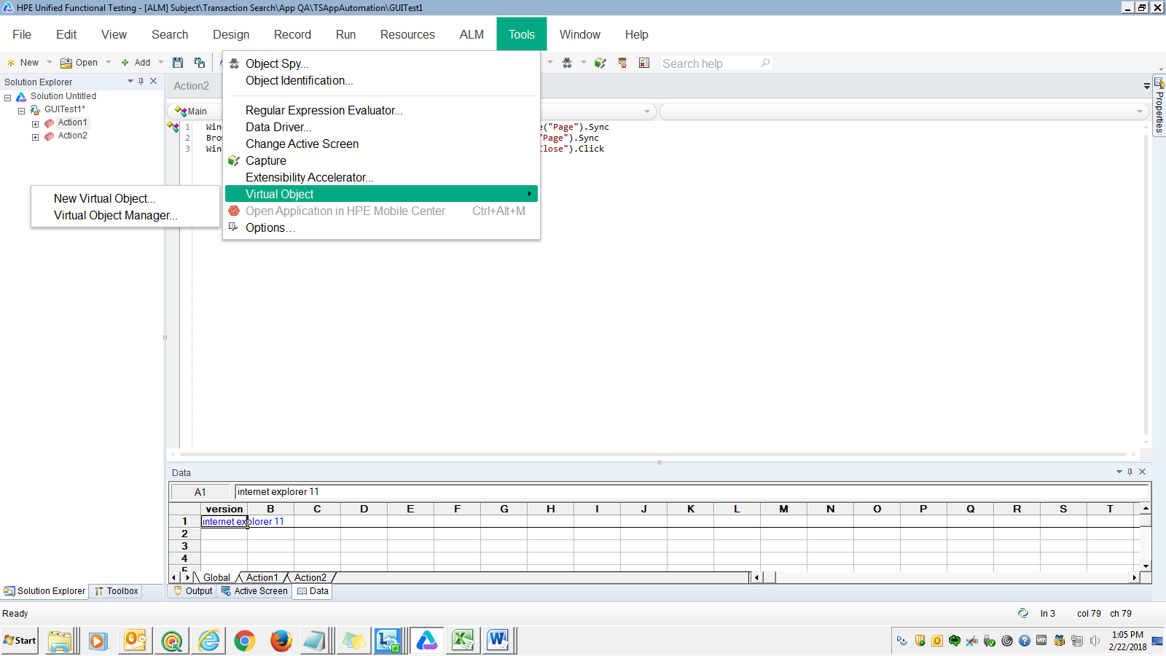

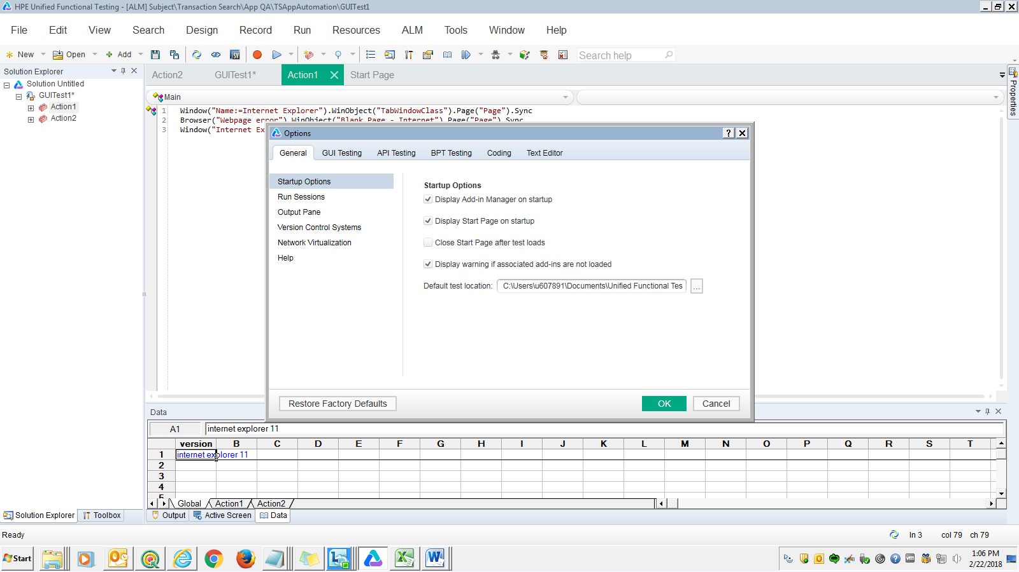

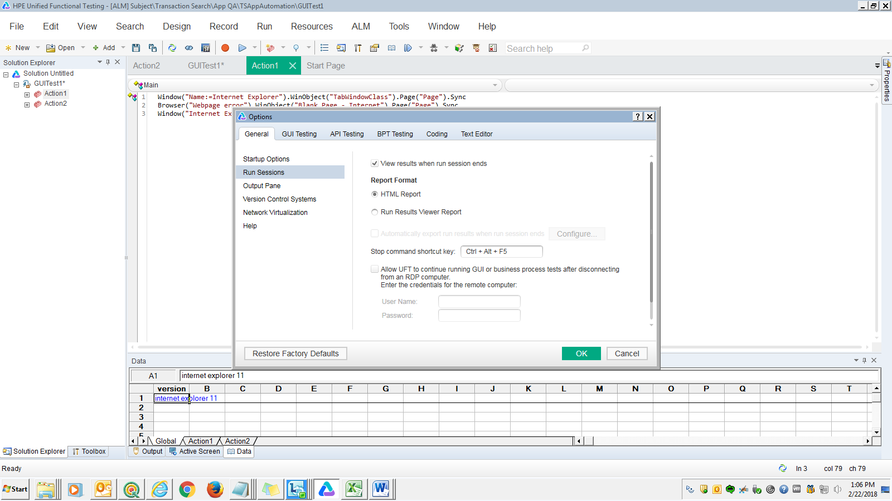

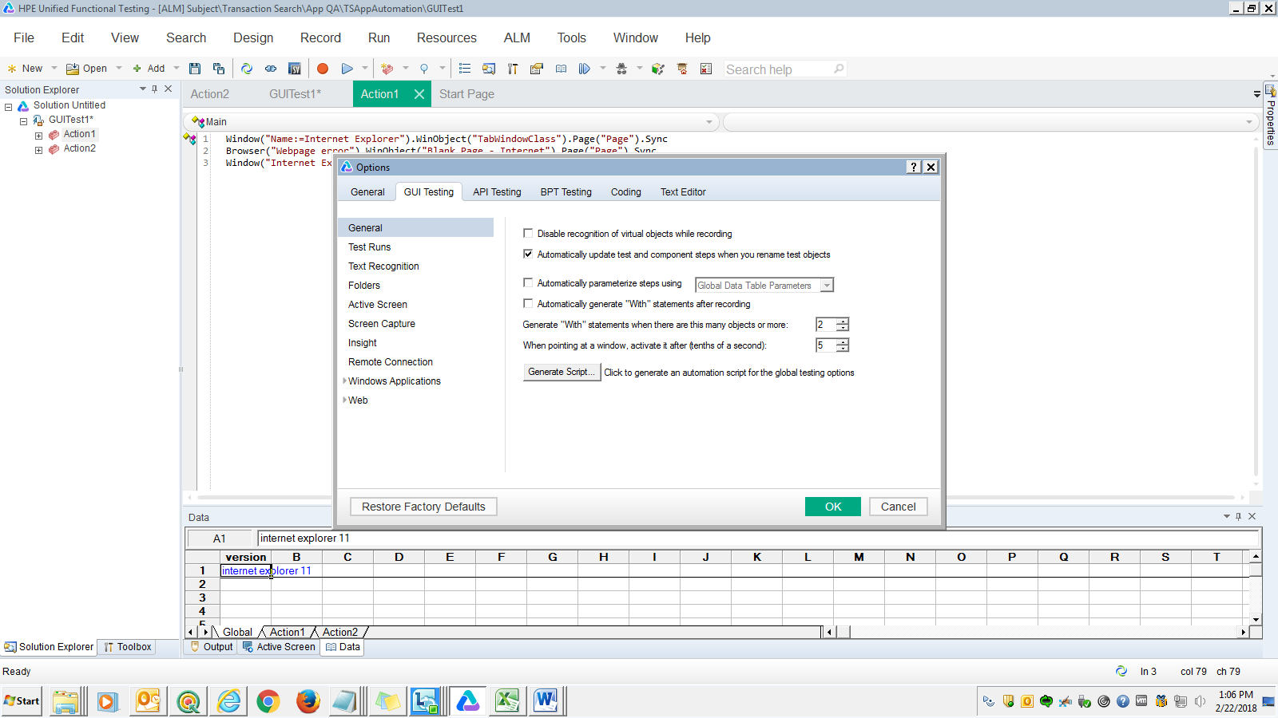

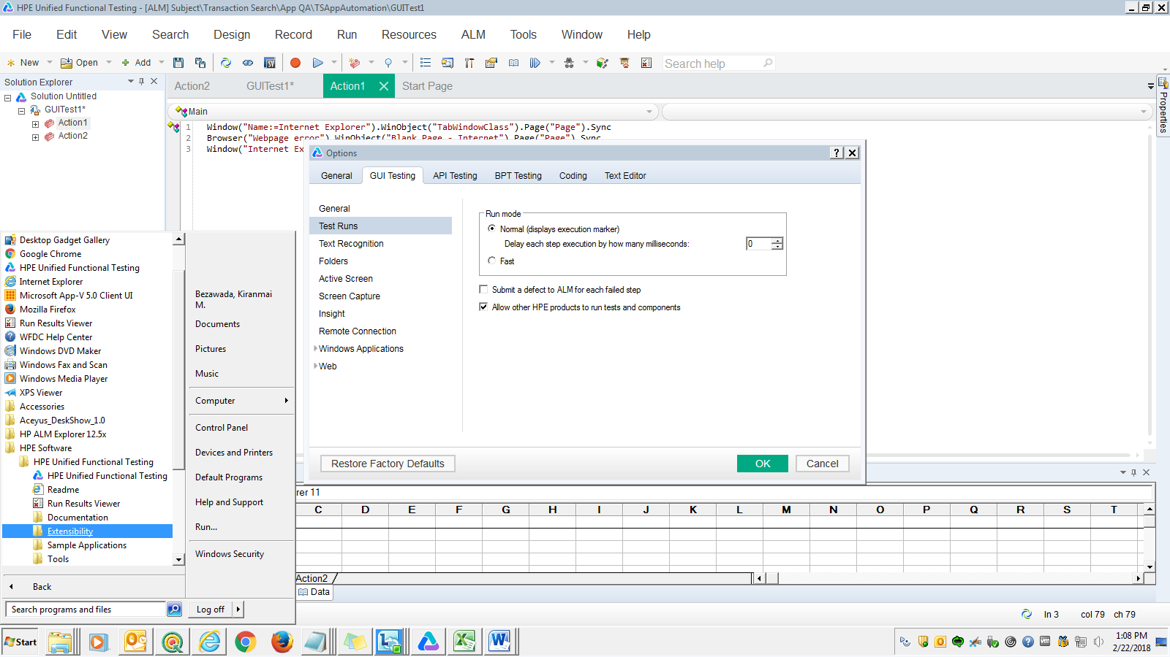

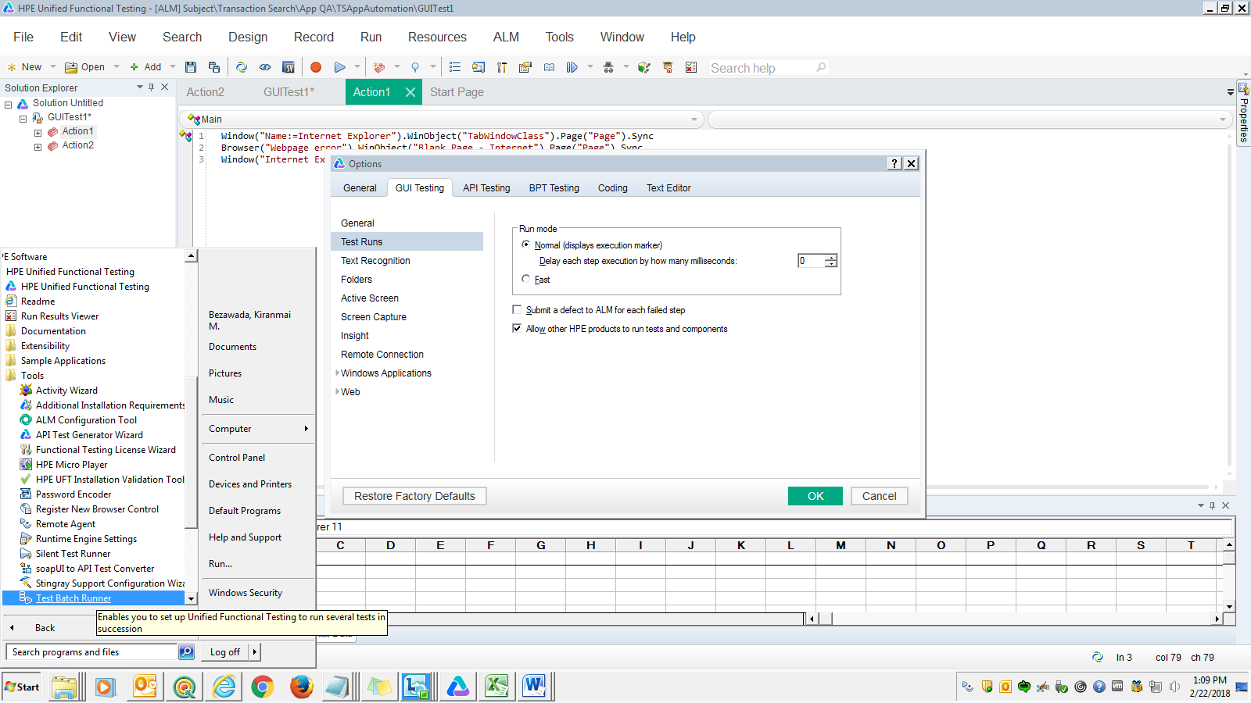

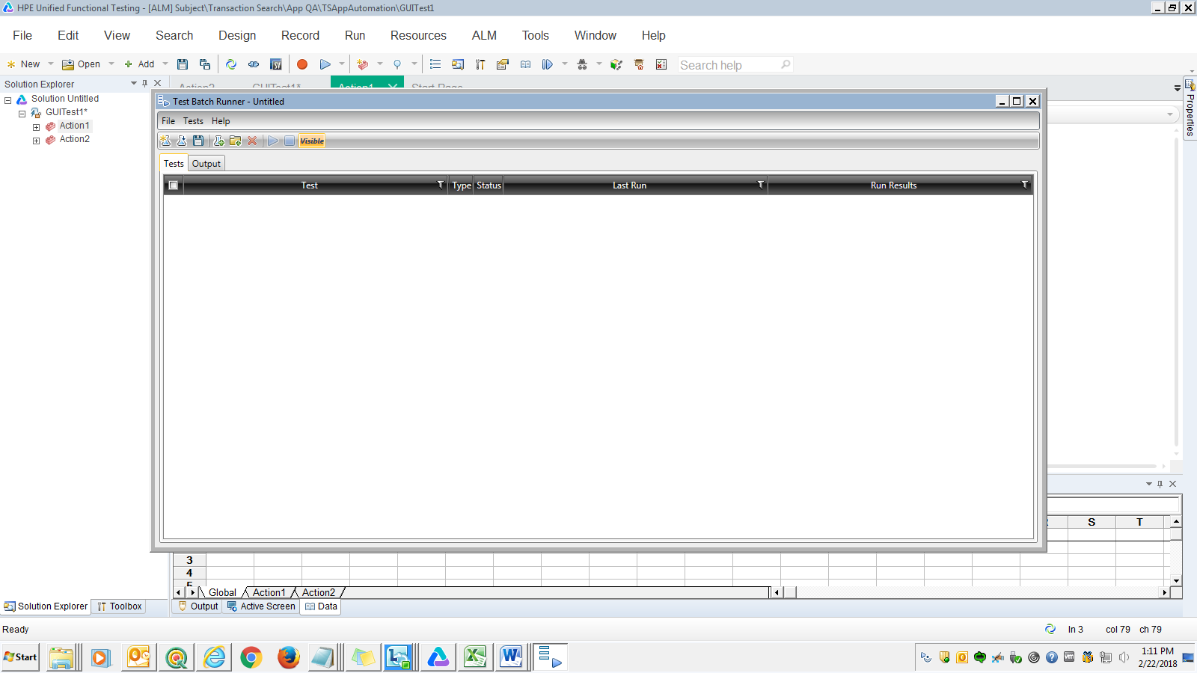

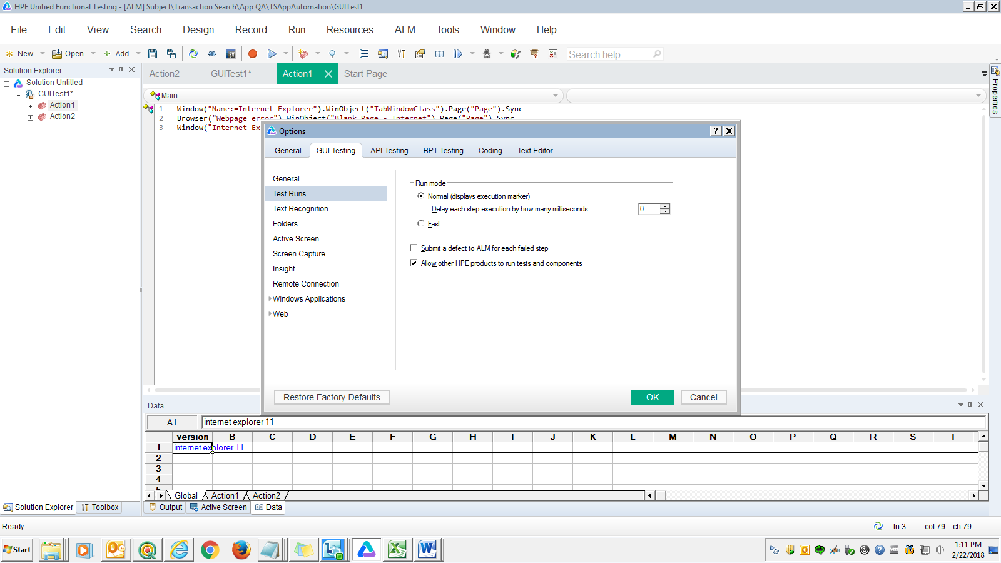

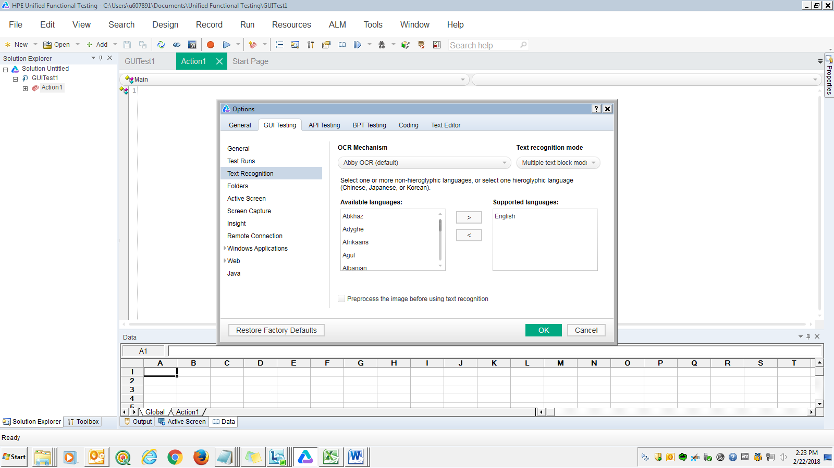

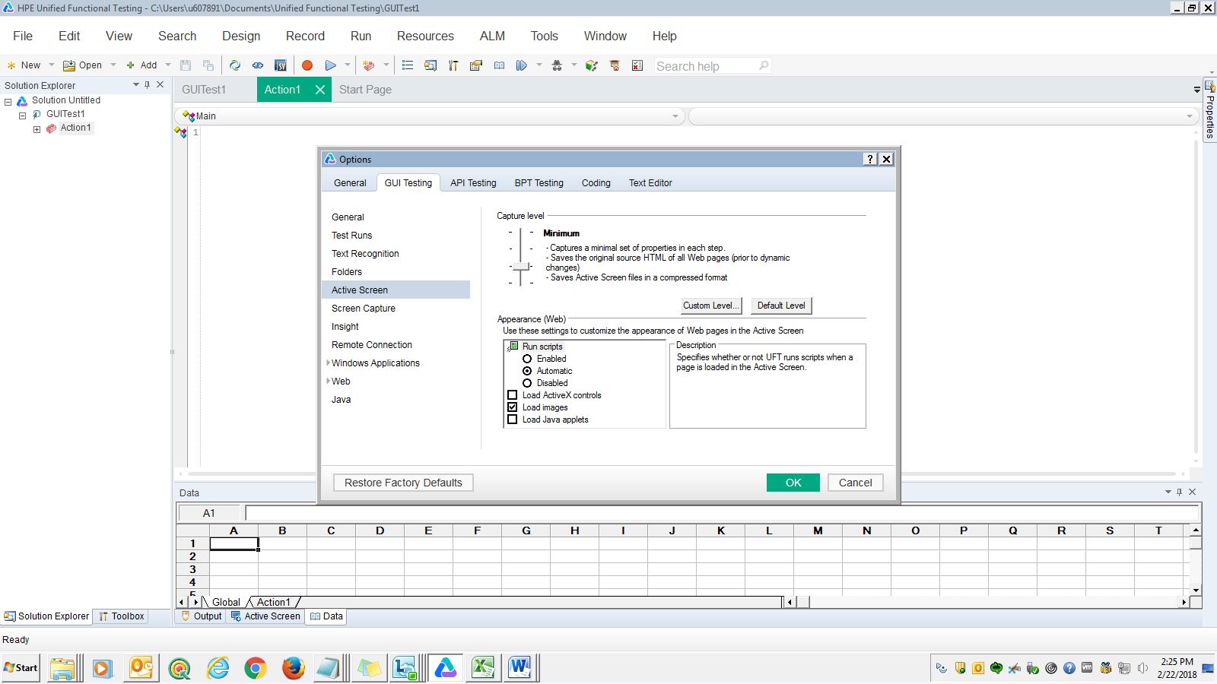

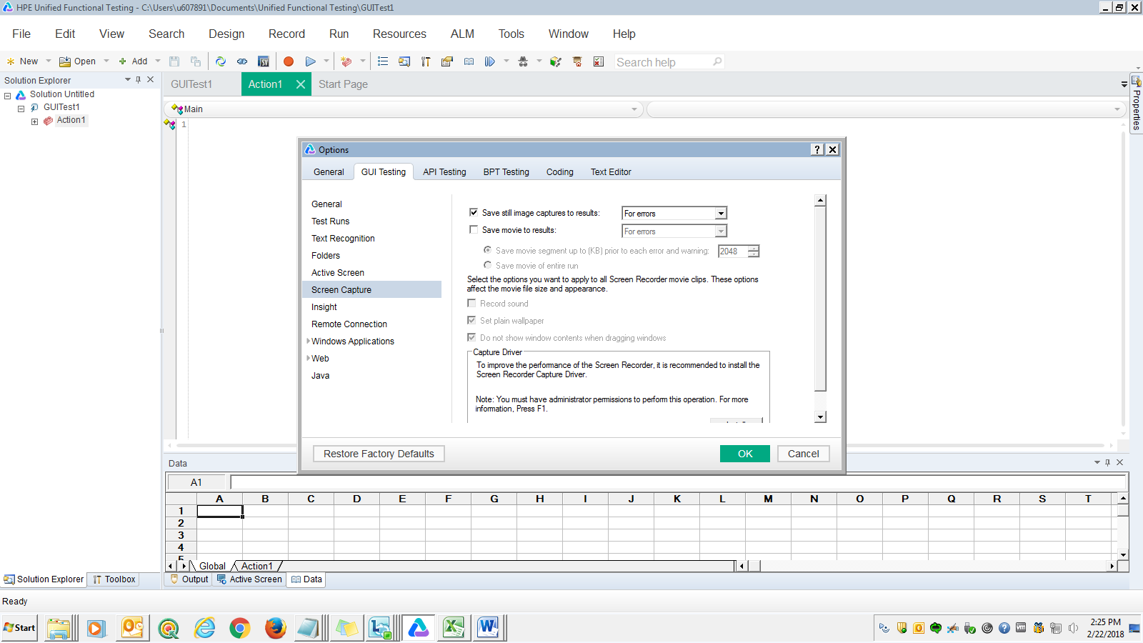

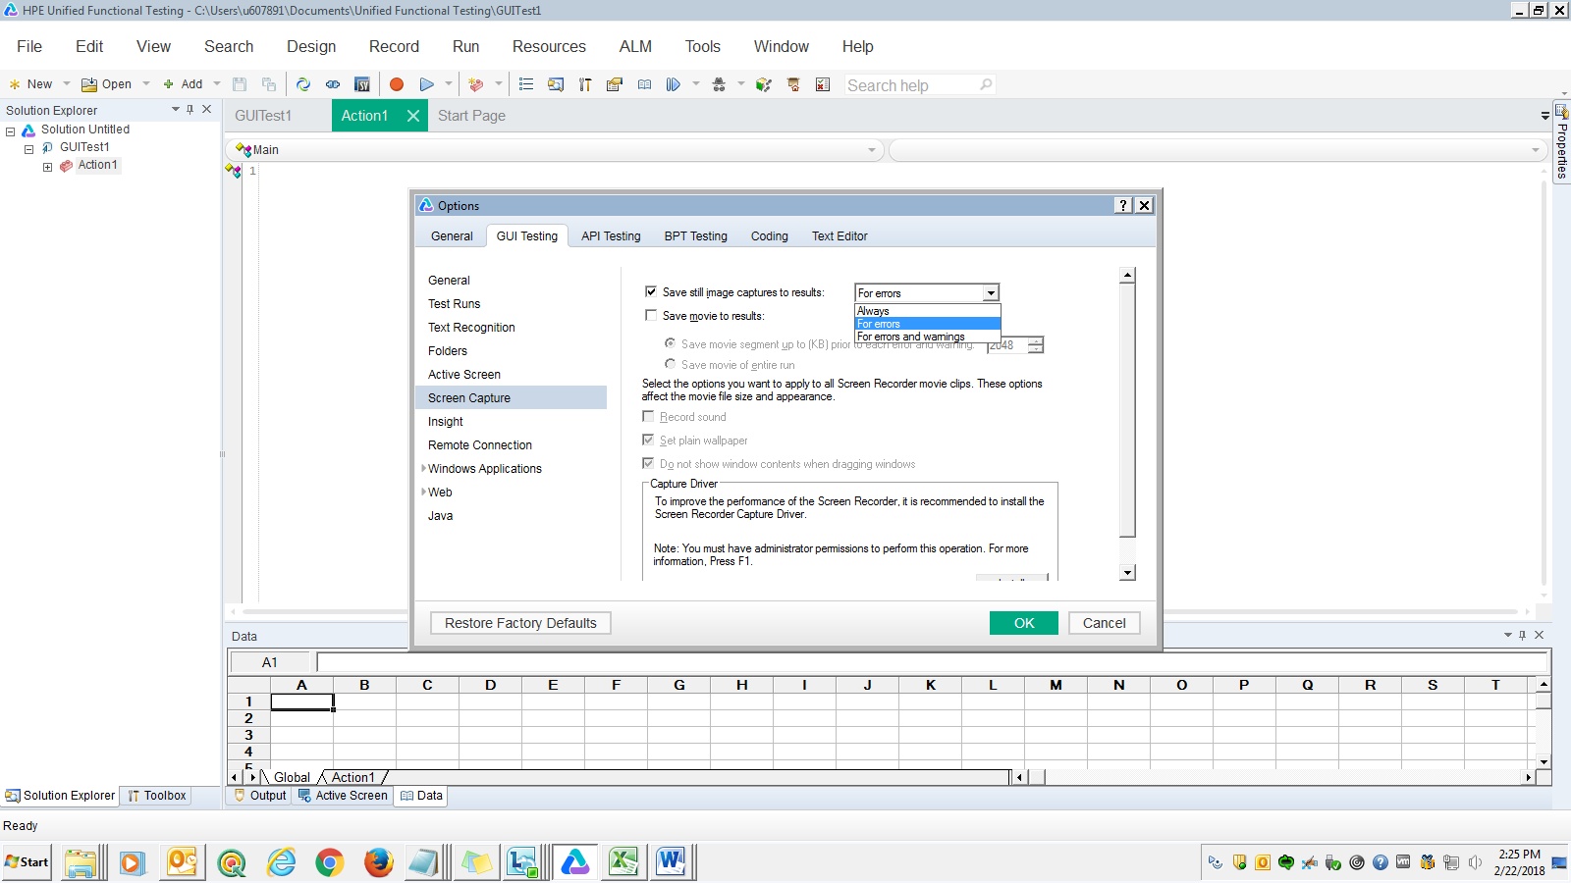

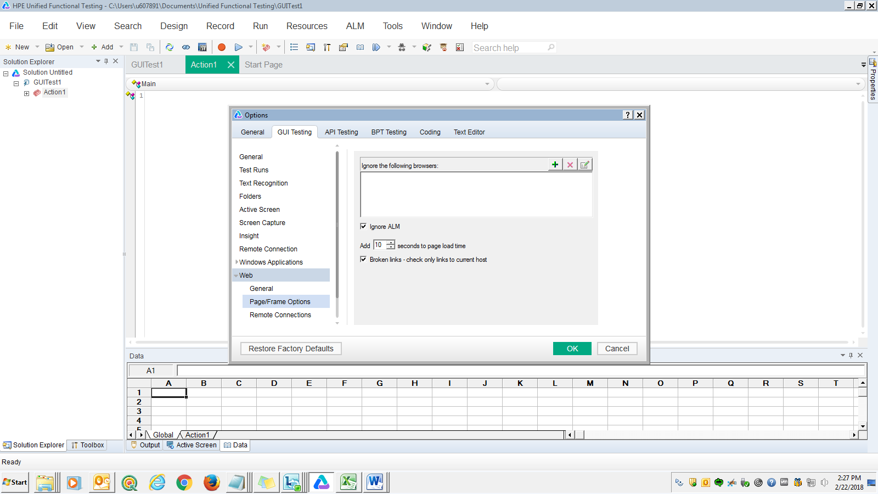

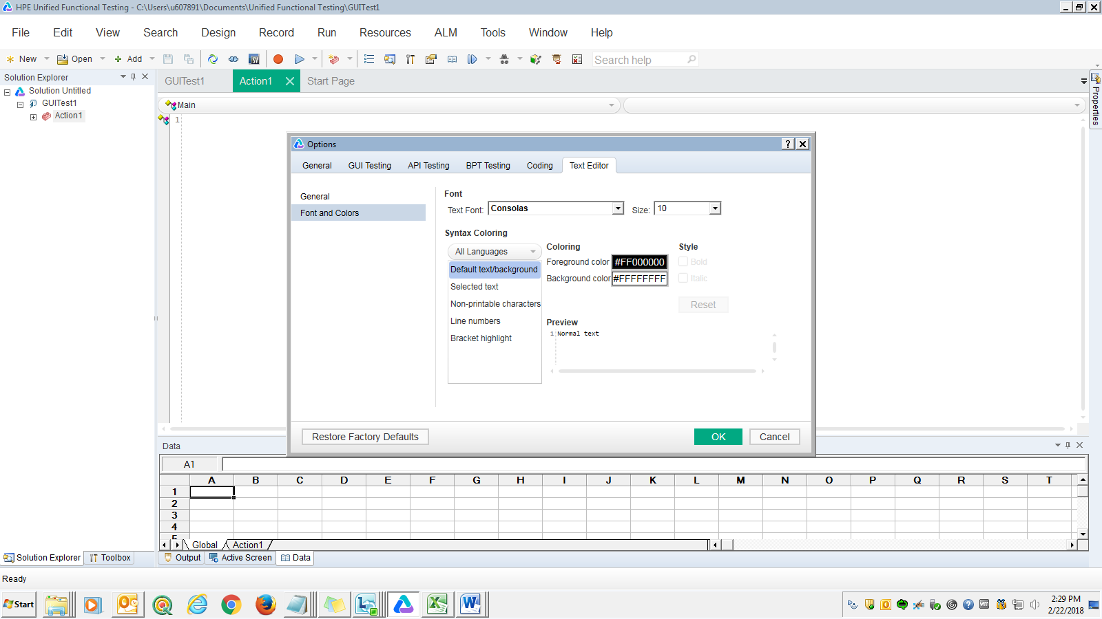

**Set** exo = **createobject**("excel.application")  
**Set** wbo = exo.workbooks.open ("C:\Users\u607891\Desktop\testdata.xlsx")  
**Set** wso = wbo.worksheets(1)  
  
Rowcount = wso.usedrange.rows.count  
**For** i = 2 **To** RowCount **Step** 1  
    a=wso.cells(i,1)  
    b=wso.cells(i,2)  
    **Call** **abs**(a,b)  
      
**Next**  
  
**Function** **abs**(a,b)  
    **If** a=b **Then**  
        wso.cells(i,3) = "Passed"  
        **else**  
        wso.cells(i,3) = "Failed"  
    **End** **If**  
**End** **Function**  
  
wbo.Save  
wbo.Close  
exo.Quit  
  
**Set** wso = **nothing**  
**Set** wbo = **nothing**  
**Set** exo = **nothing**

**Action 2:**

Datatable.AddSheet "Inputdata"  
Datatable.ImportSheet "C:\Users\u607891\Desktop\UFT\inputdata.xlsx", 1, "Inputdata"  
  
rowcount = datatable.GetSheet("Inputdata").GetRowCount  
**For** i = 1 **To** rowcount **Step** 1  
datatable.SetCurrentRow(i)      
a=datatable(1, "Inputdata")  
b=datatable(2, "Inputdata")  
**Call** abc(a,b)  
**Next**  
**Function** abc(a,b)  
    **If** a=b **Then**  
        datatable(3, "Inputdata") = "Passed"  
        **else**  
        datatable(3, "Inputdata") = "Failed"  
    **End** **If**  
**End** **Function**  
  
datatable.ExportSheet "C:\Users\u607891\Desktop\UFT\result.xlsx", 3,1