**PROJECT**

**INPUT:**

**(HTML CODE):**

<!DOCTYPE html>

<html lang="en">

<head>

    <meta charset="UTF-8">

    <meta name="viewport" content="width=device-width, initial-scale=1.0">

    <title>Complete Soil Erosion Project</title>

    <link rel="stylesheet" href="https://cdnjs.cloudflare.com/ajax/libs/font-awesome/6.5.2/css/all.min.css">

    <link rel="stylesheet" href="https://cdn.jsdelivr.net/npm/swiper@11/swiper-bundle.min.css"/>

    <link rel="stylesheet" href="style.css">

</head>

<body>

    <header>

        <div class="header-top">

            <div class="fas fa-bars" id="menu"></div>

            <div class="social">

                <a href="#" class="fab fa-facebook"></a>

                <a href="#" class="fab fa-twitter"></a>

                <a href="#" class="fab fa-pinterest"></a>

                <a href="#" class="fab fa-linkedin"></a>

            </div>

            <a href="#" class="logo"><i class="fas fa-soil"></i> Soil Erosion</a>

    </header>

    <section class="home" id="home">

        <div class="content">

            <h3>Soil Erosion</h3>

            <p>Soil erosion is the denudation or wearing away of the upper layer of soil. It is a form of soil degradation.

                This natural process is caused by the dynamic activity of erosive agents, that is, water, ice (glaciers), snow,

                air (wind), plants, and animals (including humans). In accordance with these agents, erosion is sometimes divided

                into water erosion, glacial erosion, snow erosion, wind (aeolian) erosion, zoogenic erosion and anthropogenic erosion

                such as tillage erosion. Soil erosion may be a slow process that continues relatively unnoticed, or it may occur at

                an alarming rate causing a serious loss of topsoil. The loss of soil from farmland may be reflected in reduced crop production

                potential, lower surface water quality and damaged drainage networks. Soil erosion could also cause sinkholes.

                Intensive agriculture, deforestation, roads, acid rains, anthropogenic climate change and urban sprawl

                are amongst the most significant human activities in regard to their effect on stimulating erosion.</p>

                   </div>

    </section>

    <section class="banner-container">

        <div class="banner">

            <img src="Courter.jpg" alt="">

            <div class="content">

                <h3>Contour Farming</h3>

                <span>Preparing and cultivating on slopes can be challenging and can easily

                    lead to soil erosion. However, contour farming technique, where farmers plant

                    across a slope along the contour lines can salvage the situation.

                    This farming system serves to conserve rainwater and reduce soil loss from surface erosion.

                   </span>

                    <br>

            </div>

        </div>

        <div class="banner">

            <img src="Gazing.jpg" alt="">

            <div class="content">

                <h3>Avoiding Overgrazing</h3>

                <span>Grazing too many animals in the same place over a long period of time can contribute to a poor stand of

                    vegetation. Vegetation in that condition leave soils exposed to the erosive force of water runoff.

                    You can significantly minimize these risks by employing proper pasture management practices and sustainable

                    grazing. </span>

            </div>

        </div>

        <div class="banner">

            <img src="Reforestation.jpg" alt="">

            <div class="content">

                <h3>Reforestation</h3>

                <span>Restoration of a degraded ecosystem and protection of the existing ones ensures

                    sufficient soil erosion control. A recent study shows that a properly planted and maintained

                    tree reduces erosion by 75 percent. </span>

ko

            </div>

        </div>

    </section>

    <section class="services" id="services">

        <h1 class="heading">Erosion <span>Causes</span></h1>

        <div class="box-container">

            <div class="box">

                <data class="card-number" value="01">01</data>

                <h3>Agriculture</h3>

                <p>The farming practices are the major cause of soil erosion.

                The agricultural activities disturb the ground. The trees are

                cleared and the land is ploughed to sow new seeds. Since most of

                the crops are grown during the spring season, the land lies fallow

                during winters. Most of the soil is eroded during winters.

                Also, the tyres of tractors make grooves on the land, making a natural

                pathway for water. Fine soil particles are eroded by wind.</p>

            </div>

            <div class="box">

                <data class="card-number" value="02">02</data>

                <h3>Logging and Mining</h3>

                <p>A large number of trees are cut down to carry out the logging process.

                    Trees hold the soil firmly. The canopy of the trees protects the soil

                    from heavy rainfall. The leaf litter that protects the soil from erosion,

                    is also lost during logging.

                    Mining activities also disturb the land and leave the soil more prone to erosion.</p>

            </div>

            <div class="box">

                <data class="card-number" value="03">03</data>

                <h3>Construction</h3>

                <p>The construction of roads and buildings exposes the soil to erosion. The forests and grasslands

                    are cleared for construction purposes, which exposes the soil making it vulnerable to erosion.</p>

            </div>

            <div class="box">

                <data class="card-number" value="04">04</data>

                <h3>Rivers and Storms</h3>

                <p>The flowing rivers and streams carry away the soil particles leading to a V-shaped erosion activity.</p>

            </div>

            <div class="box">

                <data class="card-number" value="05">05</data>

                <h3>Heavy Winds</h3>

                <p>During dry weather or in the semi-arid regions, the minute soil particles are carried away by

                    the wind to faraway lands. This degrades the soil and results in desertification.</p>

            </div>

            <div class="box">

                <data class="card-number" value="06">06</data>

                <h3>Grazing</h3>

                <p>The grazing animals feed on the grasses and remove the vegetation from the land.

                    Their hooves churn up the soil. They also pull out plants by their roots. This

                    loosens the soil and makes it more prone to erosion.</p>

            </div>

        </div>

    </section>

    <section class="newsletter">

        <div class="content">

            <h3>Environment</h3>

            <h6>Subscribe to Our Page</h6>

            <input type="email" class="email" placeholder="Your Email">

            <a href="#" class="btn"> Subscribe</a>

        </div>

    </section>

    <section class="footer">

        <div class="box-container">

            <div class="box">

                <h3>find us here</h3>

                <div class="share">

                    <a href="#" class="fab fa-facebook"></a>

                    <a href="#" class="fab fa-twitter"></a>

                    <a href="#" class="fab fa-linkedin"></a>

                    <a href="#" class="fab fa-pinterest"></a>

                </div>

            </div>

            <div class="box">

                <h3>newsletter</h3>

                <p>subscribe for latest updates</p>

                <input type="email" placeholder="Your Email Address" class="email">

                <input type="submit" value="subscribe" class="btn">

            </div>

        </div>

        <div class="credit">Created by <span>Project Team</span> | All rights reserved!</div>

    </section>

    <script src="https://cdn.jsdelivr.net/npm/swiper@11/swiper-bundle.min.js"></script>

    <script src="script.js"></script>

</body>

</html>

**(CSS CODE):**

@import url("https://fonts.googleapis.com/css2?family=Poppins:ital,wght@0,100;0,300;0,400;0,500;0,600;1,100;1,300&display=swap");

*{

    font-family: 'Poppins', sans-serif;

    margin: 0; padding: 0;

    outline: none; border: none;

    box-sizing: border-box;

    text-decoration: none;

    text-transform: capitalize;

    transition: .2s linear;

}

html{

    font-size: 62.5%;

    overflow-x: hidden;

    scroll-behavior: smooth;

    scroll-padding-top: 7rem;

}

html::-webkit-scrollbar{

    width: 1rem;

}

html::-webkit-scrollbar-track{

    background: #fff;

}

html::-webkit-scrollbar-thumb{

    background: #248277;

    border-radius: 5rem;

}

section{

    padding: 2rem 7%;

}

.heading{

    font-size: 4rem;

    color: #222;

    padding-bottom: 2rem;

    text-align: center;

    text-transform: uppercase;

    font-weight: bolder;

}

.heading span{

    color: #248277;

    text-transform: uppercase;

}

.btn{

    display: inline-block;

    margin-top: 1rem;

    padding: .9rem 3rem;

    border-radius: .5rem;

    color: #248277;

    border: .1rem solid #248277;

    background: none;

    font-size: 1.7rem;

    cursor: pointer;

}

.btn:hover{

    color: #fff;

    background: #248277;

}

.header-top{

    display: flex;

    align-items: center;

    justify-content: space-between;

    padding: 1.4rem 7%;

    border-bottom: .1rem solid #eee;

}

.header-top .social a{

    font-size: 1.2rem;

    padding: .5rem;

    margin-left: .25rem;

    background: #248277;

    border-radius: .5rem;

    color: #fff;

}

#menu{

    font-size: 2.5rem;

    color: #248277;

    border: .1rem solid #248277;

    padding: .8rem 1.5rem;

    border-radius: .5rem;

    cursor: pointer;

    display: none;

}

.header-top .logo{

    color: #248277;

    font-size: 3rem;

    font-weight: bolder;

}

.header-top .logo i{

    padding-right: .5rem;

    color: #222;

}

.header-top .icons .action-btn{

    position: relative;

    font-size: 2.5rem;

    margin-left: 1.5rem;

    padding: .5rem;

    background: #fff

}

.header-top .icons .action-btn a{

    color: #fff;

    -webkit-text-stroke: .1rem #222;

}

.header-top .icons .action-btn a:hover{

    -webkit-text-stroke: .1rem #248277;

}

.header-top .icons .action-btn .count{

    position: absolute;

    top: -.3rem;

    right: -.2rem;

    background: #248277;

    color: #fff;

    font-size: 1.2rem;

    font-weight: 500;

    line-height: 1;

    padding: .2rem .4rem;

    border-radius: 50%;

}

.header-main{

    display: flex;

    align-items: center;

    justify-content: center;

    padding: 2rem 7%;

    background: #fff;

    position: relative;

}

.header-main.active{

    position: fixed;

    top: 0; left: 0; right: 0;

    z-index: 1000;

    box-shadow: 0 0.5rem 1rem rgba(0,0,0,0.1);

}

.header-main .navbar a{

    margin: 0 1rem;

    font-size: 2rem;

    color: #222;

}

.header-main .navbar a:hover{

    color: #248277;

}

.home{

    min-height: 65vh;

    display: flex;

    align-items: center;

    background: url(images/home.png) no-repeat;

    background-size: cover !important;

    background-position: center !important;

}

.home .content{

    max-width: 55rem;

}

.home .content h3{

    font-size: 6rem;

    color: #248277;

}

.home .content p{

    font-size: 1.5rem;

    line-height: 2;

    color: #777;

    padding: 1rem 0;

}

.banner-container{

    display: grid;

    padding: 2rem 3%;

    grid-template-columns: repeat(auto-fit, minmax(30rem, 1fr));

    gap: 1.5rem;

}

.banner-container .banner{

    height: 45rem;

    overflow: hidden;

    position: relative;

}

.banner-container .banner img{

    height: 100%;

    width: 100%;

    object-fit: cover;

}

.banner-container .banner:hover img{

    transform: scale(1.2);

}

.banner-container .banner .content{

    position: absolute;

    top: 25%;

    left: 3rem;

    transform: translateY(-50%);

}

.banner-container .banner .content span{

    font-size: 1.7rem;

    color: black;

}

.banner-container .banner .content h3{

    color: white;

    font-size: 2.2rem;

    padding-top: .5rem;

}

.about .row{

    display: flex;

    align-items: center;

    flex-wrap: wrap;

    gap: 5rem;

}

.about .row .image{

    flex: 1 1 40rem;

}

.about .row .image img{

    width: 100%;

}

.about .row .content{

    flex: 1 1 50rem;

}

.about .row .content h3{

    font-size: 3.5rem;

    color: #248277;

    text-transform: uppercase;

}

.about .row .content p{

    font-size: 1.6rem;

    margin: .5rem 0;

    color: #777;

    line-height: 2;

}

.services .box-container{

    display: grid;

    grid-template-columns: repeat(auto-fit, minmax(30rem, 1fr));

    gap: 2rem;

}

.services .box-container .box{

    position: relative;

    background: #fff;

    padding: 2.5rem;

    border-radius: .5rem;

    padding-block-start: 4rem;

    margin-block-start: 4.4rem;

    box-shadow: 0 0.5rem 1rem rgba(0,0,0,0.1);

}

.services .box-container .box:hover{

    background: #248277;

}

.services .box-container .box .card-number{

    position: absolute;

    top: 0; left: 2.5rem;

    transform: translateY(-50%);

    background: #ededed;

    color: #666;

    font-size: 2.2rem;

    font-weight: 600;

    padding-block: .5rem;

    min-width: 5rem;

    text-align: center;

    border-radius: .5rem;

    transition: .25s ease;

}

.services .box-container .box:hover .card-number{

    color: #248277;

}

.services .box-container .box h3{

    font-size: 2rem;

    line-height: 1.3;

    color: #248277;

}

.services .box-container .box p{

    font-size: 1.5rem;

    color: #777;

    margin: .5rem 0;

}

.services .box-container .box :is(h3, p){

    transition: .25s ease;

}

.services .box-container .box:hover :is(h3, p){

    color: #fff;

}

.newsletter{

    text-align: center;

}

.newsletter .content{

    background: #248277;

    padding: 10rem 8.5rem;

    border-radius: 3rem;

}

.newsletter .content h3{

    color: #fff;

    font-size: 4rem;

    text-transform: uppercase;

}

.newsletter .content h6{

    margin: 0 auto .5rem auto;

    font-size: 3.6rem;

    color: #fff;

    text-transform: uppercase;

}

.newsletter .content p{

    font-size: 1.6rem;

    color: #fff;

    padding: 1rem 0;

    line-height: 1.8;

    margin-bottom: 2rem;

}

.newsletter .content .email{

    padding: 1.2rem;

    width: 50%;

    border: .1rem solid #fff;

    color: #fff;

    font-size: 1.2rem;

    background: none;

    border-radius: 5rem;

}

.newsletter .content .email::placeholder{

    color: #f1f1f1;

}

.newsletter .content .btn{

    border: .1rem solid #effffd;

    color: #fff;

    font-size: 1.6rem;

    border-radius: 5rem;

    margin-left: 1rem;

}

.newsletter .content .btn:hover{

    background: #f0f8f7;

    color: #248277;

}

.footer{

    background: #effffd;

}

.footer .box-container{

    display: grid;

    grid-template-columns: repeat(auto-fit, minmax(25rem, 1fr));

    gap: 2rem;

}

.footer .box-container .box h3{

    font-size: 2.2rem;

    color: #248277;

    padding: 1rem 0;

}

.footer .box-container .box p{

    font-size: 1.5rem;

    line-height: 2;

    color: #222;

    padding: 1rem 0;

}

.footer .box-container .box .share{

    margin-top: 1rem;

}

.footer .box-container .box .share a{

    height: 4.5rem;

    width: 4.5rem;

    line-height: 4.5rem;

    border: .1rem solid #248277;

    font-size: 1.7rem;

    border-radius: 30%;

    color: #248277;

    margin-right: .3rem;

    text-align: center;

}

.footer .box-container .box .share a:hover{

    background: #248277;

    color: #fff;

}

.footer .box-container .box .links{

    display: block;

    font-size: 1.4rem;

    color: #222;

    padding: 1rem 0;

}

.footer .box-container .box .links:hover{

    color: #248277;

}

.footer .box-container .box .email{

    width: 100%;

    margin: .7rem 0;

    padding: 1rem;

    border-radius: .5rem;

    background: #fffcfc;

    font-size: 1.6rem;

    color: #248277;

    border: .1rem solid #248277;

    text-transform: none;

}

.footer .credit{

    text-align: center;

    margin-top: 3rem;

    padding-top: 3rem;

    font-size: 2rem;

    color: #222;

    border-top: .1rem solid #248277;

}

.footer .credit span{

    color: #248277;

}

@media (max-width:991px){

    html{

        font-size: 55%;

    }

    .header-top{

        padding: 1.4rem;

    }

    .header-main{

        padding: 2rem;

    }

}

@media (max-width:768px){

    .header-top .social{

        display: none;

    }

    #menu{

        display: inline-block;

    }

    .header-main{

        padding: 0;

    }

    .header-main .navbar{

        position: absolute;

        top: 99%; left: 0; right: 0;

        background: #fff;

        border-top: .1rem solid rgba(0,0,0,0.3);

        box-shadow: 0 0.5rem 1rem rgba(0,0,0,0.1);

        clip-path: polygon(0 0, 100% 0, 100% 0, 0 0);

    }

    .header-main .navbar.active{

        clip-path: polygon(0 0, 100% 0, 100% 100%, 0 100%);

    }

    .header-main .navbar a{

        font-size: 2rem;

        display: block;

        margin: 2rem;

    }

    .newsletter .content{

        padding: 5rem 5.5rem;

    }

    .newsletter .content .email{

        width: 50%;

    }

}

@media (max-width:450px){

    html{

        font-size: 50%;

    }

}

**(JS CODE):**

let header = document.querySelector('.header-main');

let navbar = document.querySelector('.navbar');

document.querySelector('#menu').onclick = () =>{

    navbar.classList.toggle('active');

}

window.onscroll = () =>{

    navbar.classList.remove('active');

    if(window.scrollY > 120){

        header.classList.add('active');

    }else{

        header.classList.remove('active');

    }

}

let accordions = document.querySelectorAll('.accordion-container .accordion');

accordions.forEach(acco =>{

    acco.onclick = () =>{

        accordions.forEach(subAcco => {

            subAcco.classList.remove('active')

        });

        acco.classList.add('active');

    }

});

var swiper = new Swiper(".review-slider",{

    spaceBetween: 20,

    centeredSlides: true,

    pagination: {

        el: '.swiper-pagination',

        clickable: true,

    },

    autoplay: {

        delay: 7500,

        diableOnInteraction: false,

    },

    grabCursor: true,

    loop: true,

});

**OUTPUT:**

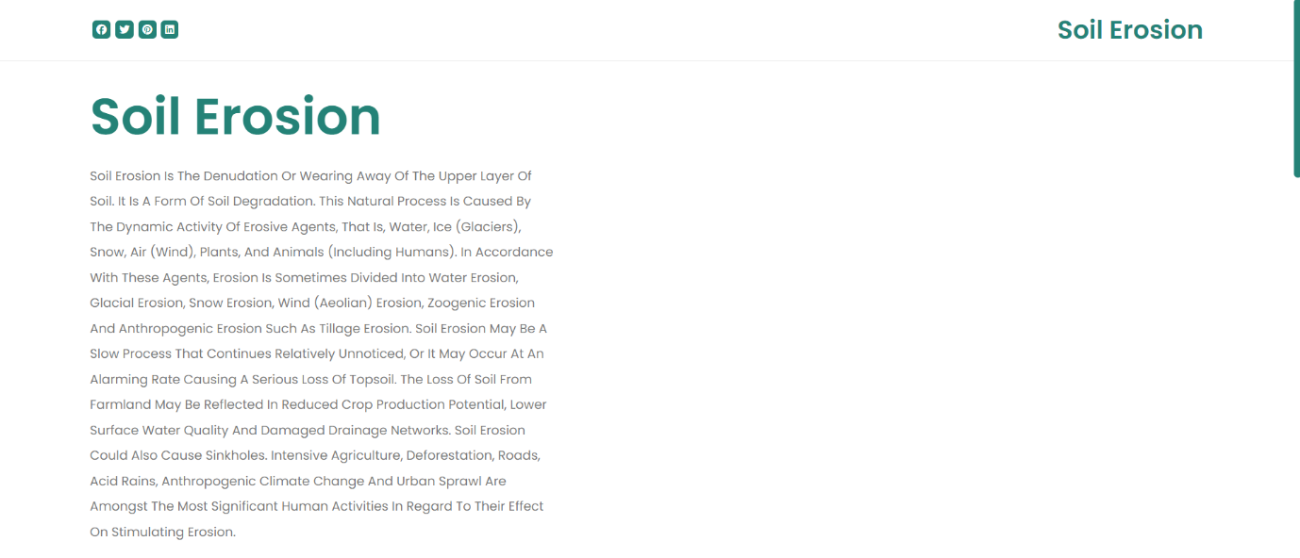

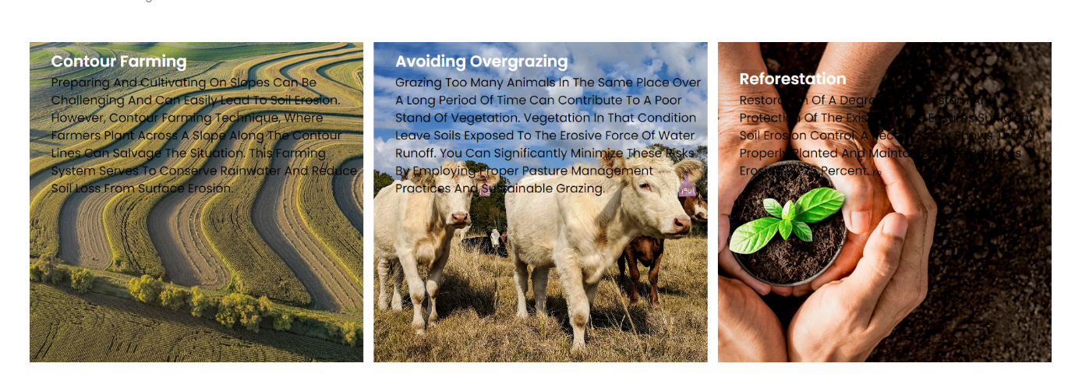

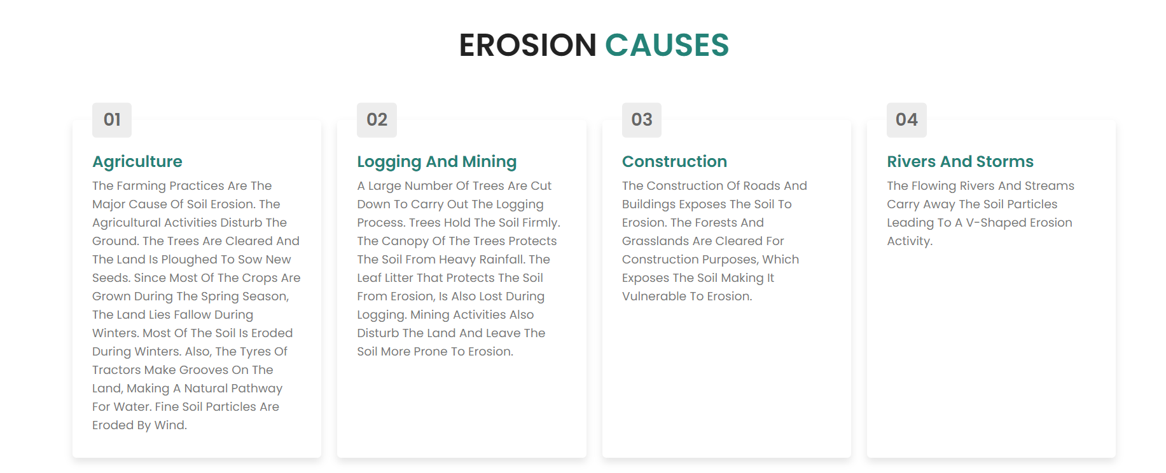





*Project done by:*

|  |  |  |  |
| --- | --- | --- | --- |
| S.NO | NAME | REGD.NO | SEC&ROLL.NO |
| 1. | P. L. N. Priya | 12408044 | K24AN (50) |
| 2. | Dhruv Pal | 12408224 | K24AN (51) |
| 3. | B. V. S. Aryan | 12408430 | K24AN (52) |