**Section 0 : Step 1:**

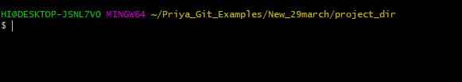

**Section 0 : Step 2:**

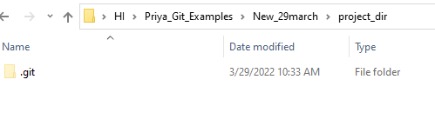

**Section 0 : Step 3:**

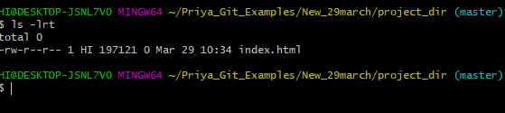

**Section 0 : Step 4:**

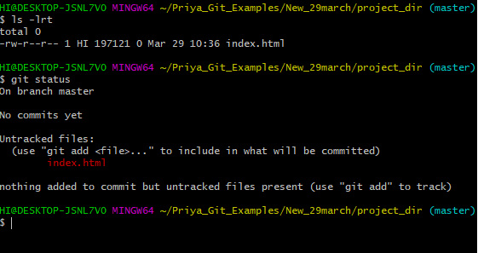

**Step 5: Stage index.html**

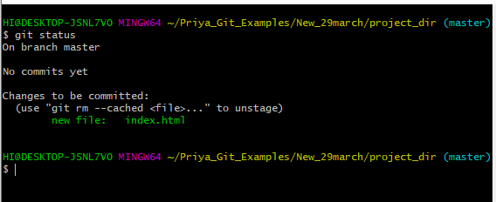

**Step 6: commit index.html**

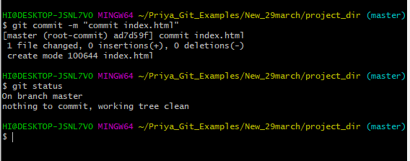

**Step 7,8 :**

**Make few changes in index .htm and new file info.txt**

**Show index.html and info.txt as Untracked**

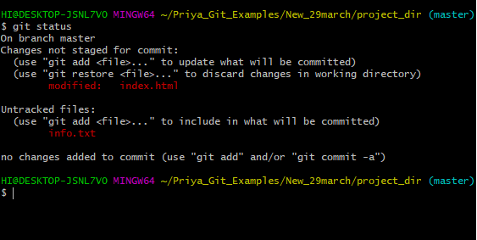

**Step 9: GIT config to ignore all txt files**

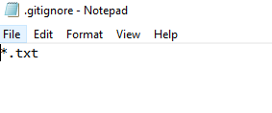

**Step 10 :Check Git Status, only html shown as untracked**

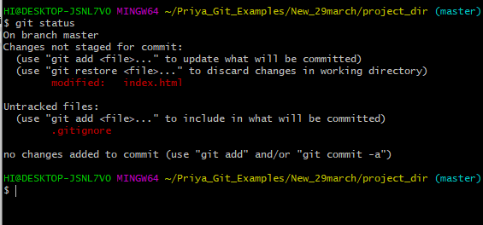

**Step :11 Stage and Commit index.html**

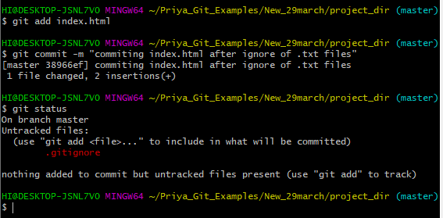

**Step 12: Log All commits so far:**

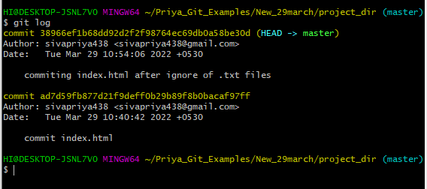

**Step 13 : Make Some changes in index.html**

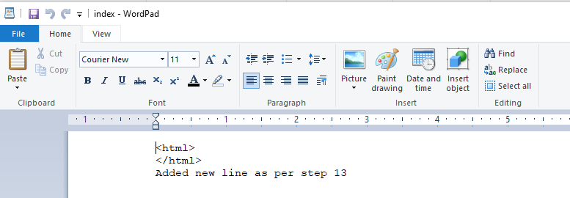

**Step 14:Revert changes in previous commit using git command**

**Commands :**

**git reflog**

**git revert <<commit ID>>**

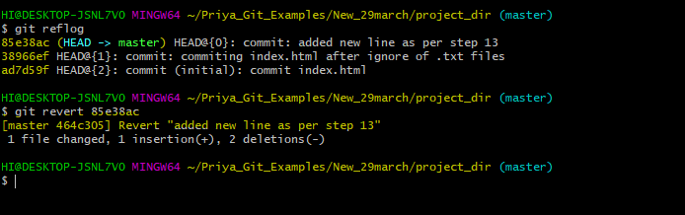

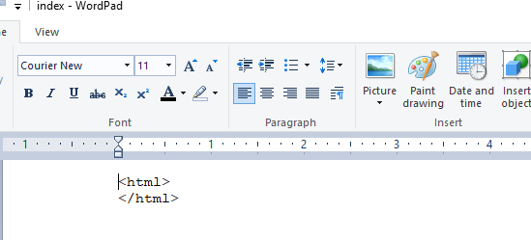

**Step 15: Again Change Index.html**

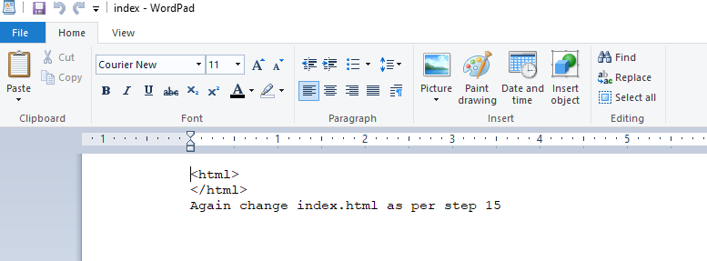

**Step 16 : Stage index.html**

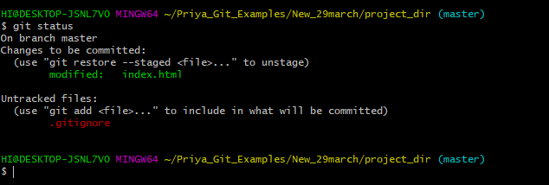

**Step 17: Revert back the last stage**

**GIT Command :** git restore --staged index.html

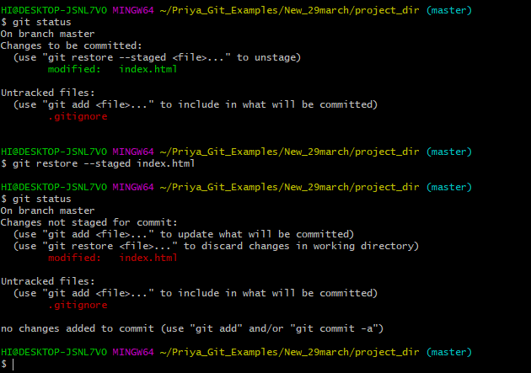

**Step 18 : Rename ‘add’ command to ‘my-add’**

git config alias.my-add add

**Step 19 : Use Custom git command ‘my-add’ to stage index.html**

S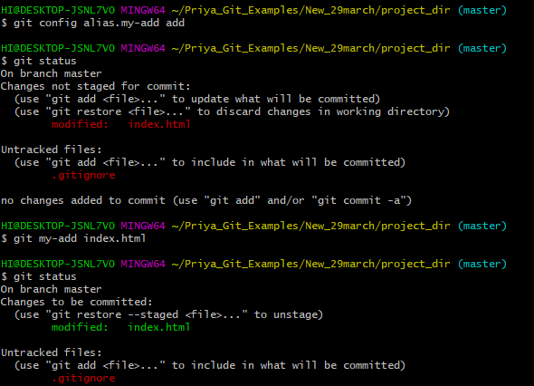

**Step : 20 Revert last commit**

**Before Revert :**

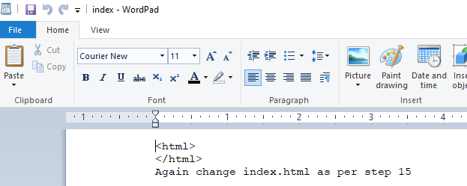

**After Revert:**

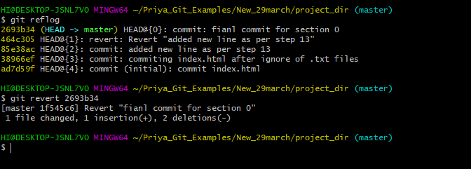

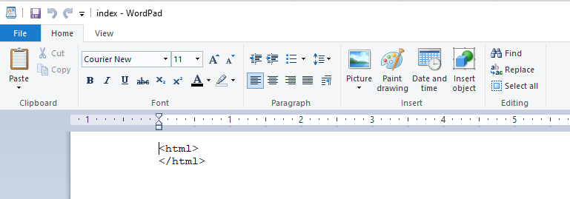

**Git Branching**

**Section 1:**

**Step 21: take Backup of current project**

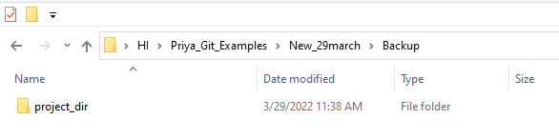

**Step 22 & 23:**

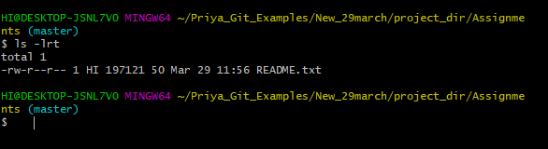

**Step 24: commit README.txt**

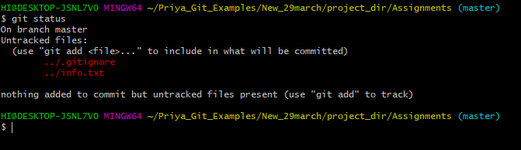

**Step 25: Create New Branch ‘html-assignments’**

**Command: git branch <<Branch Name>>**

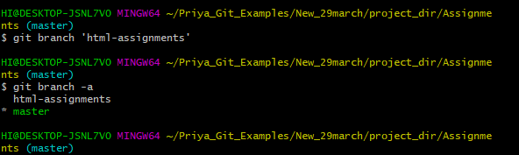

**Step 26: Switch to ‘html-assignments’**

**Command: git checkout <<Branch Name>>**

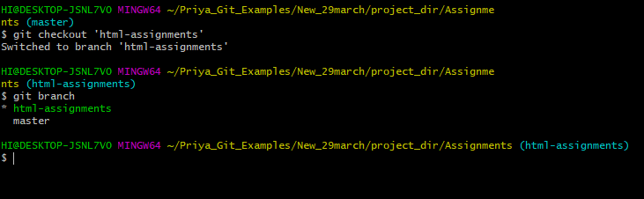

**Step: 27 Copy All HTML assignments into ‘Assignments’ folder**

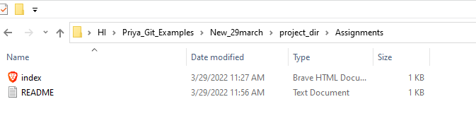

**Step 28 : Commit HTML assignments into ‘html-assignments’ branch**

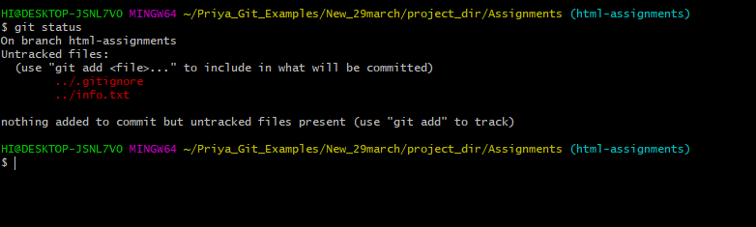

**Step 29: make minor changes in ‘html-assignments’ branch**

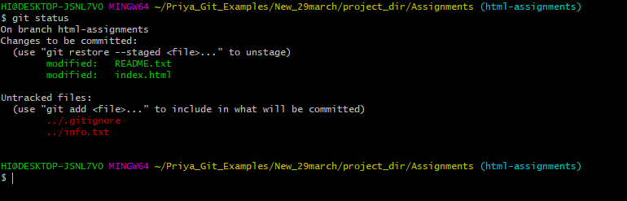

**Step 30: Commit those changed files**

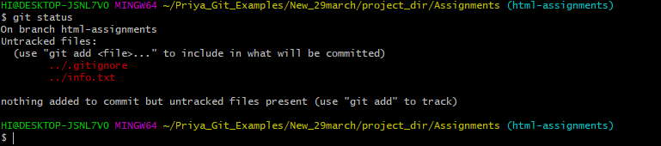

**Step 31: Switch to master**

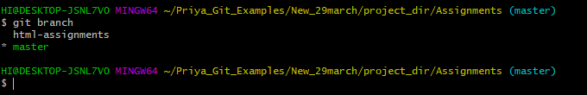

**Step 32: Make minor changes in README.txt files & commit those to master**

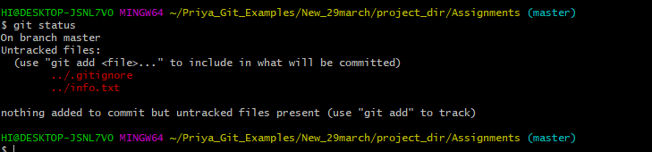

**Step 33: Again, Switch to ‘html-assignments’ branch**

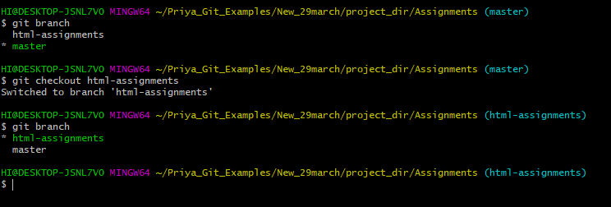

**Step 34: Make minor changes to files in ‘html-assignments’ branch**

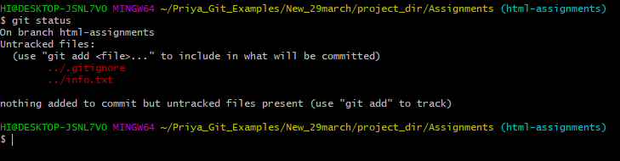

**Step 35: commit those changes**



**Step 36: Switch to master**

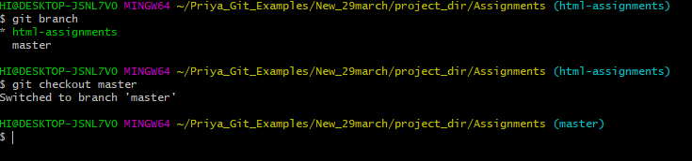

**Step 37: Merge ‘html-assignments’ branch to ‘master’ branch**

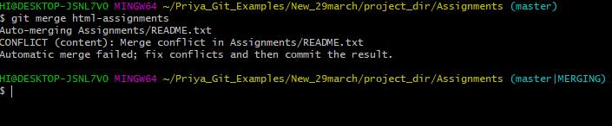

**After Merge Conflict resolved**

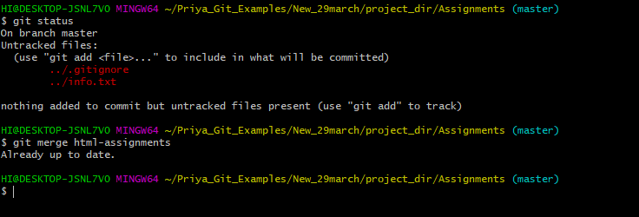

**Step 38 : finally delete ‘html-assignments’ branch**

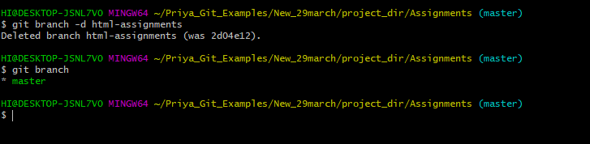

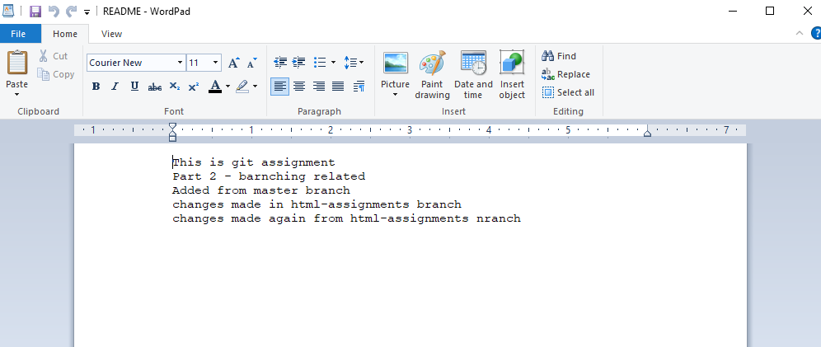

git branch -d html-assignments

**GIT Remoting**

**Step 1: Create github account**

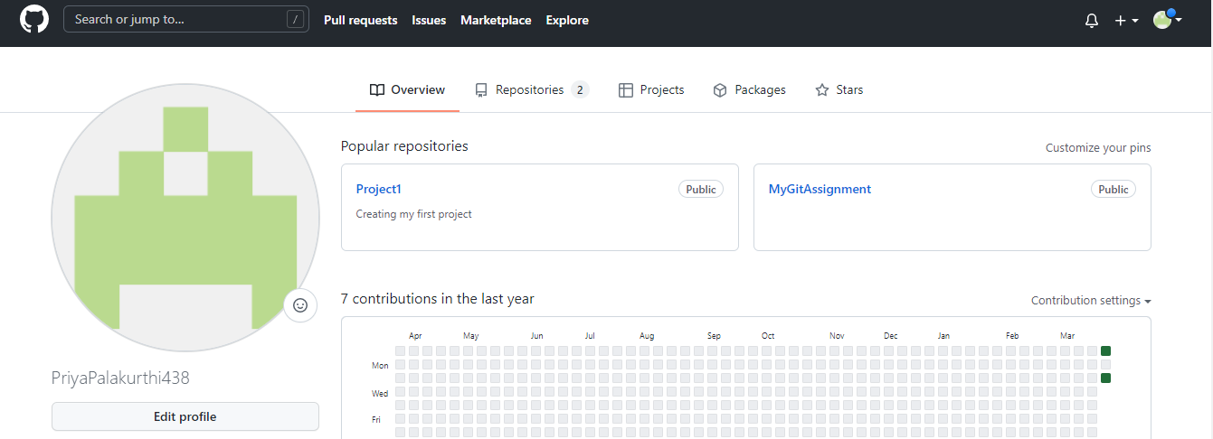

**Step 2: Login**

Refer Step screenshot

**Step 3: Create new Repository fresherbatch-oct16**

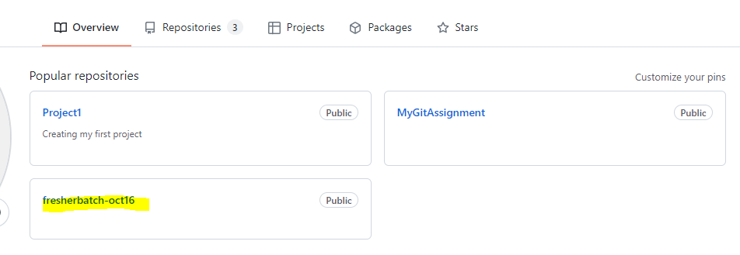

**Step 4: Commit and push code to this repository**

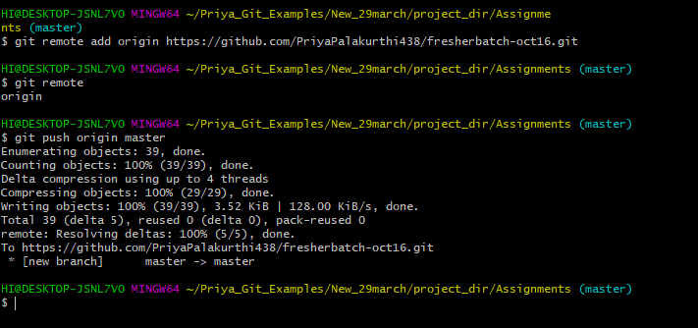

**git remote add origin <<Remote repo URL>>**

**git remote**

**git push origin <<master>>**

**<<pwd>>**

**local master to remote master**