**Section 0 : Step 1:**

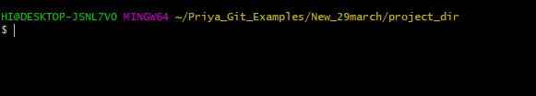

**Section 0 : Step 2:**

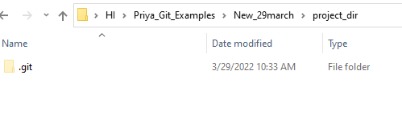

**Section 0 : Step 3:**

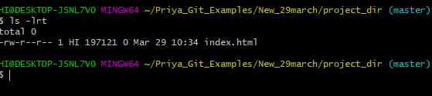

**Section 0 : Step 4:**

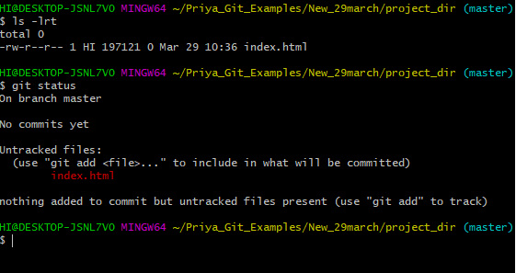

**Step 5: Stage index.html**

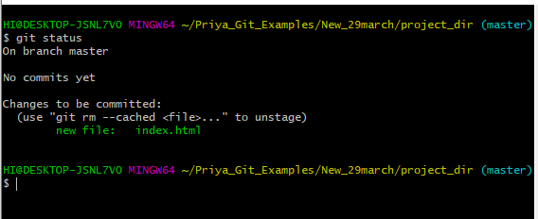

**Step 6: commit index.html**

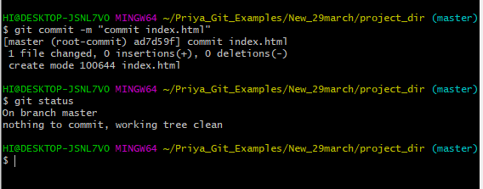

**Step 7,8 :**

**Make few changes in index .htm and new file info.txt**

**Show index.html and info.txt as Untracked**

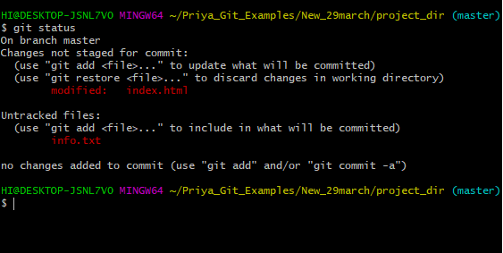

**Step 9: GIT config to ignore all txt files**

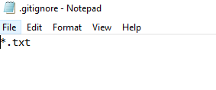

**Step 10 :Check Git Status, only html shown as untracked**

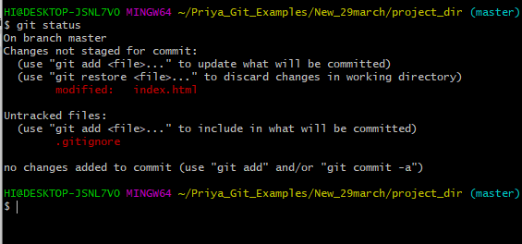

**Step :11 Stage and Commit index.html**

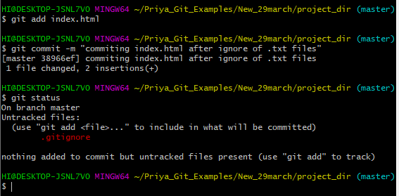

**Step 12: Log All commits so far:**

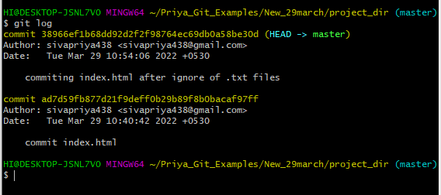

**Step 13 : Make Some changes in index.html**

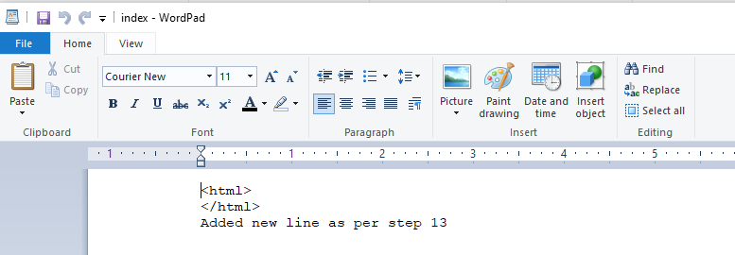

**Step 14:Revert changes in previous commit using git command**

**Commands :**

**git reflog**

**git revert <<commit ID>>**

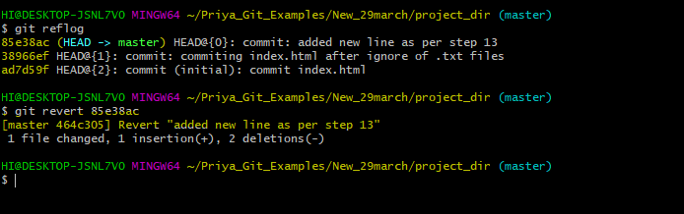

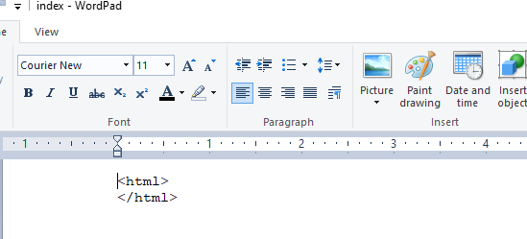

**Step 15: Again Change Index.html**

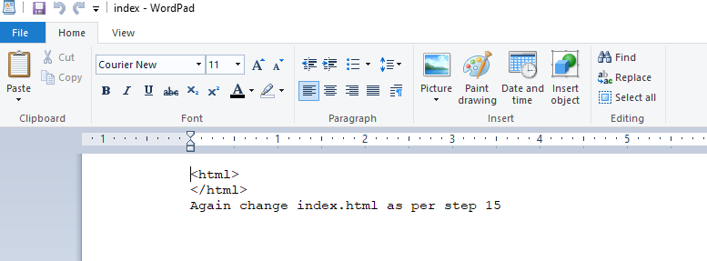

**Step 16 : Stage index.html**

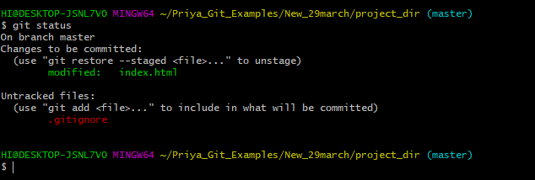

**Step 17: Revert back the last stage**

**GIT Command :** git restore --staged index.html

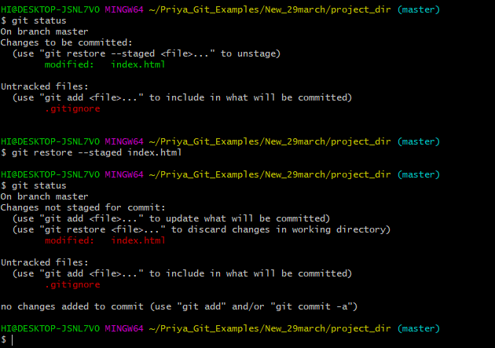

**Step 18 : Rename ‘add’ command to ‘my-add’**

git config alias.my-add add

**Step 19 : Use Custom git command ‘my-add’ to stage index.html**

S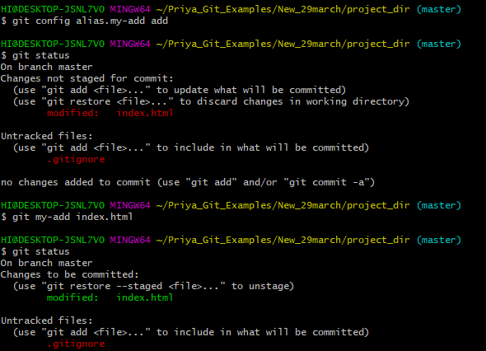

**Step : 20 Revert last commit**

**Before Revert :**

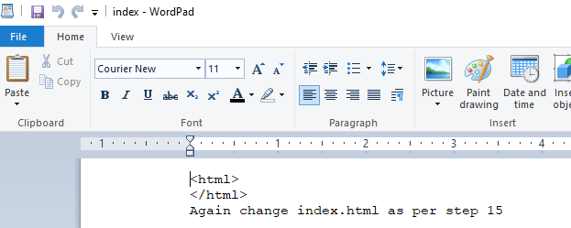

**After Revert:**

