**Assignment: 1**

We will design this laptop for higher performance and provide speed for gaming.

Components required in our Computer are listed as follow:

1. **Motherboard:**

* Name: Asus Prime Z370-A
* Manufacturer: Asus
* Maximum RAM: 64GB
* Price: $160.89
* USB- Two USB 2.0 ports

Two USB 3.1 Gen

* Video Ports-1 x DVI-D
* HDMI-1 x HDMI
* RJ45-1 x RJ45
* DisplayPort-1 x DisplayPort

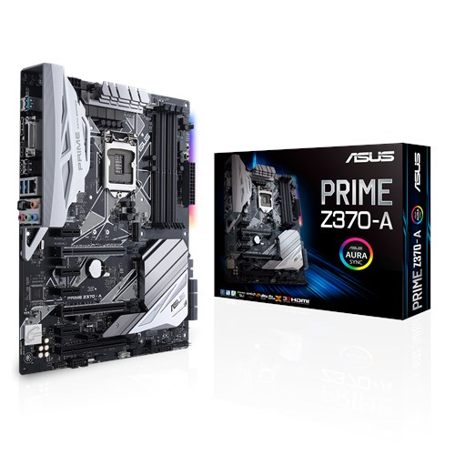

1. **Processor:**

* Name: intel core i7 8700k
* Manufacture: Intel
* Frequency: 3.7GHz
* Price: $379
* Specification: 6 cores, 12 threads, 64GB max memory

1. **RAM:**

* Name: Corsair vengeance LPX DDR4
* Manufacturer: Corsair
* Size: 16GB(2*8GB)
* Style: 3000MHz
* Price: $249.99

1. **SSD:**

* Name: Samsung 850 EVO
* Manufacturer: Samsung
* Capacity: 250GB
* Interface: SATA 6Gb/s
* Price: $109.99

1. **Graphics card:**

* Name: XFX Radeon R9 380X
* Manufacturer: Radeon
* XFX Double Dissipation Cooling Design
* 990MHz GPU Clock
* 4GB DDR5 Memory
* Price: $611.49

1. **Power supply:**

* Name: Corsair RM650
* Manufacturer: Corsair
* Size: 650W
* Style: RMX
* Price: $146.82

1. **Case:**

* Model: Crystal 570X RGB
* Manufacturer: Corsair
* Price: $169.99

1. **Monitor:**

* Name: Dell 3007WFP
* Manufacturer: Dell
* QHD upto 2560x1600
* Price: $129.99

1. **Keyboard and Mouse:**

* Name: Logitech Mk270
* Manufacturer: Logitech
* Reliable 2.4 GHz wireless connection
* Price: $30.08

1. **Cooler:**

* Name: Cooler Master Hyper 212evo
* Price: $34.99

1. **Camera:**

* Name: Logitech Brio 4K Pro Webcame
* Price: $199.99

**Conclusion:**

Estimate Cost for our laptop is: $2218.22