**Assignment 2b**

**Mobile OS**

We choose the ios operating system. following picture shows the design of our home screen.

**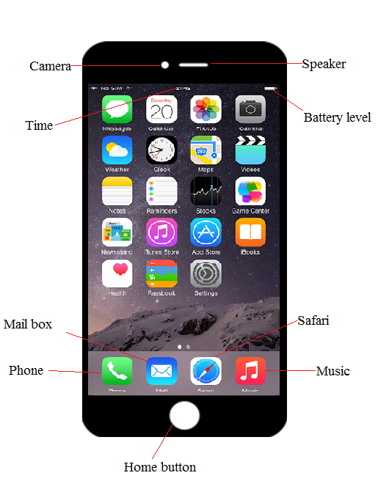**

Home Screen

* **Camera**:
* Primary : 12-megapixel,Phase detection,Autofocus
* Secondary : 5MP.
* Live photoes with stabilization.
* Features: Geo-tagging, 4K video image recording.
* **Battery** :
* Non-removable Li-Ion 1715 mAh battery.
* Stand by : Up to 240 h
* Talk Time : 14h
* **Security**:

Main Security features of IOS

1. Passcode
2. Touch ID

to unlock the iphone.

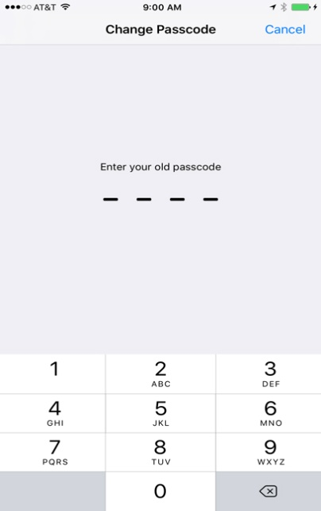 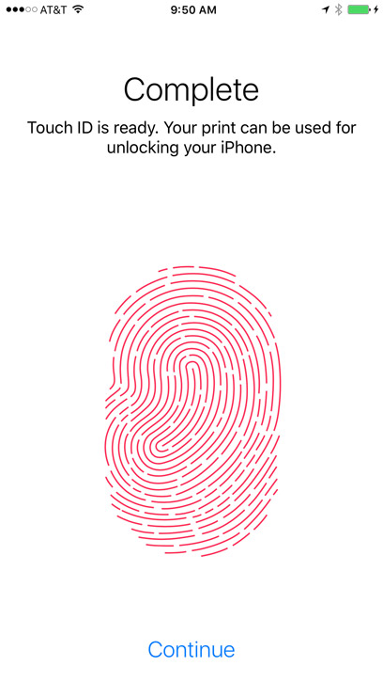

Passcode security Touch Id security

* **Notifications :**
* Swipe down from the top of any screen to interact with your notification.
* Response or see more information : Swipe left over the notification and tap view.
* **Apps**

|  |  |  |  |
| --- | --- | --- | --- |
| **Symbols** | **Description** | **Symbols** | **Description** |
| **C:\Users\hp\Pictures\Phone.png** | **-**Call anyone, anytime, from anywhere  -Store contact details | **C:\Users\hp\Pictures\galary.png** | -Store Photos and videos.  -Edit the picture as you want |
| **C:\Users\hp\Pictures\images.png** | **-**Send and receive text from anyone ,anytime. | **C:\Users\hp\Pictures\g1.png** | **-**Browse anything you want  -See update of weather, sports, news, traffic etc |
| **C:\Users\hp\Pictures\images7L166GQV.jpg** | **-**Notify us about the weather and give prediction. | **C:\Users\hp\Pictures\app_store_logo.jpg** | **-**Download apps in Appstore like Games, news app, Books ,etc |
| **C:\Users\hp\Pictures\ios9-facetime-icon.png** | **-**make both video and audio calls  -Take a live photo of the special moment during a Face time call with just a tap. | **C:\Users\hp\Pictures\Iphone-mail-app-logo.jpg** | **-**view email from cloud, Gmail, Exchange, yahoo, etc. |
| **C:\Users\hp\Pictures\iPhone-Calendar-Logo.jpg** | -keep track of your schedule  -Add special calendar for the birthdays of people in your contacts | **C:\Users\hp\Pictures\untitled.png** | -To see what friends are up to  -Share updates, photos and video |

* **Widgets :**
* News :

You can use the redesigned Apple News app to browse the most important, breaking stories of the day from almost all the publications that you want.

* Weather :

Get the weather forecast in simple ,beautiful app from apple. See the current temperature, hourly forecasts for the next 24 hours, and a 10 day forecast for cities around the world.

* **Other Feature :**
* icloud service
* imessage
* Document editor