**Assignment: 3(a)**

**Priyaben Pareshbhai Patel (8165235)**

**Upadhyay Hinali (8119158)**

**Technology Infrastructure Principles(INFO8220)**

**Q.1 What is the AODA**

* AODA stands for Accessibility for Ontarians with Disabilities, aims to identify, remove, and prevent barriers for people with disabilities.
* The AODA is made up of five standards:

1. Customer Service Standard
2. Information and Communication Standard
3. Employment Standard
4. Transportation Standard
5. Design of Public Spaces Standard

* The AODA standards are part of the Integrated Accessibility Standards Regulation (IASR). The IASR include some general requirements:

1. provide training to staff and volunteers
2. develop an accessibility policy
3. create a multi-year accessibility plan and update it every five years
4. consider accessibility in procurement and when designing or purchasing self-service kiosks

* The AODA give government authority to set monetary penalties to enforce compliance with accessibility standards. The maximum penalties under the AODA include:

1. A corporation/organization that is guilty can be fined up to $100,000 per day
2. Directors and officers of a corporation/organization that is guilty can be fined up to $50,000 per day

**Q.2 what legislations do you have in your country for people with disabilities?**

* The right to education is available to all citizens including the disabled.
* Article 45 of the Constitution directs the State to provide free and compulsory education for all children (including the disabled) until they attain the age of 14 years. No child can be denied admission into any education institution maintained by the State or receiving aid out of State funds on the ground of religion, race, caste or language.
* The health laws of India have many provisions for the disabled. Some of the Acts which make provision for health of the citizens including the disabled may be seen in the Mental Health Act, 1987
* In the Indian Succession Act, 1925 which applies in the case of intestate and testamentary succession, there is no provision which deprives the disabled from inheriting an ancestral property. For example, a person of unsound mind can make a Will during periods of sanity. Even blind persons or those who are deaf and dumb can make their Wills if they understand the import and consequence of doing it.
* Under the Designs Act, 1911 which deals with the law relating to the protection of designs any person having jurisdiction in respect of the property of a disabled person (who is incapable of making any statement or doing anything required to be done under this Act) may be appointed by the Court under Section 74, to make such statement or do such thing in the name and on behalf of the person subject to the disability. The disability may be lunacy or other disability.
* The Persons with Disabilities Act, 1995” had come into enforcement on February 7, 1996. It is a significant step which ensures equal opportunities for the people with disabilities and their full participation in the nation building.
* 3% of vacancies in government employment shall be reserved for people with disabilities, 1% each for the persons suffering from:

1. Blindness or Low Vision
2. Hearing Impairment
3. Locomotors Disabilities & Cerebral Palsy
4. Suitable Scheme shall be formulated for
5. The training and welfare of persons with disabilities
6. The relaxation of upper age limit
7. Regulating the employment

**Q.3 Accessibility features in Microsoft windows**

1) Magnifier:

* Magnifier increases the size of text or scree or makes it bigger so it helps the people who have visibility problem
* To use magnifier, go to start->setting->Ease of Access->Magnifier
* There are three options to change view full screen, lens, and docked.

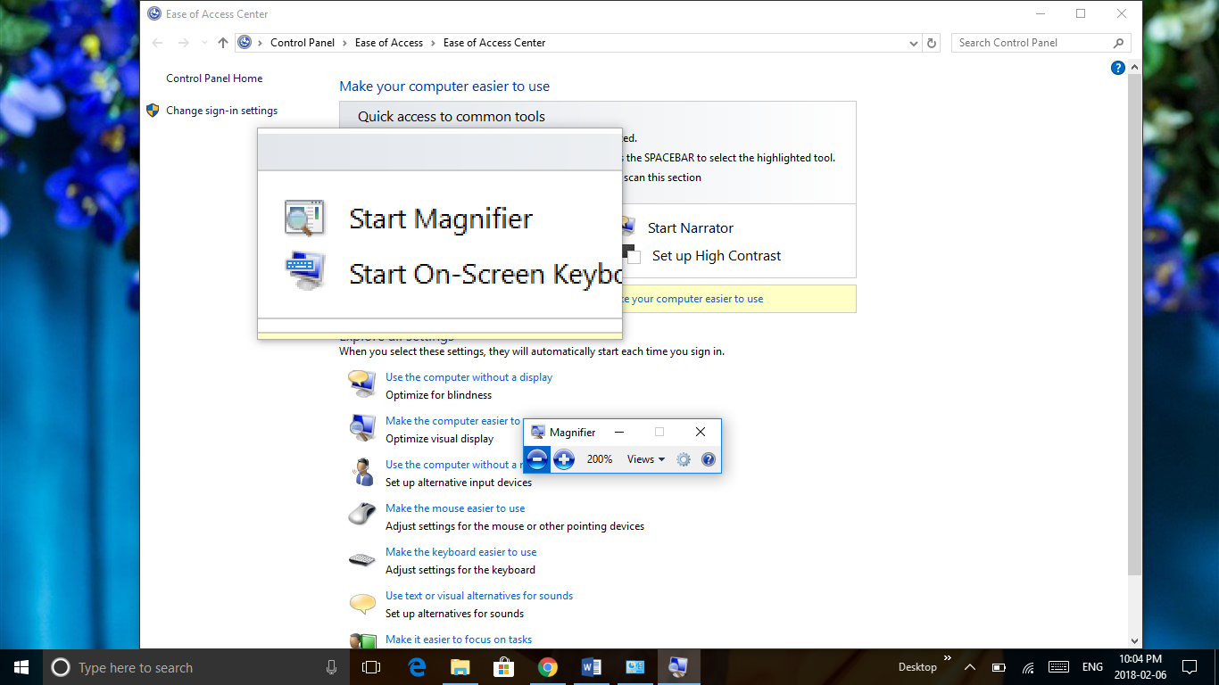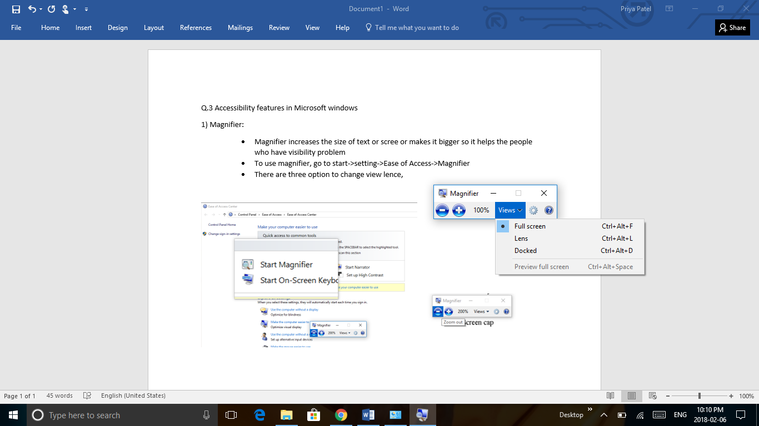

Fig 1.1 Lens view of magnifier Fig 1.2 views of magnifier

2) Cortana:

* Cortana can help blind people as well as people who can not use keyboard to search any thing in computer.
* There is search bar near windows start button is cortana.
* Cortana is like digital assistent it helps to search anything with speech or using keyboard. It can set remiders, open any apps, finds places or information, send emails and many more features are there.

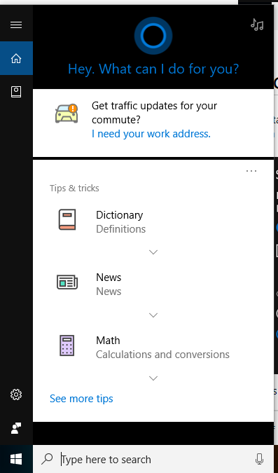

Microphone to talk with Cortana

Fig 2. Cortana

3) Cursor and Pointer size:

* It helps people who has difficulty seeing the screen.
* To use this feature, go to start->setting->Ease of Access->Ease of access center->make the mouse easier to use
* It changes the size and color of pointer or cursor for better visibility.
* It makes the pointer bigger and there is also option for dark color.

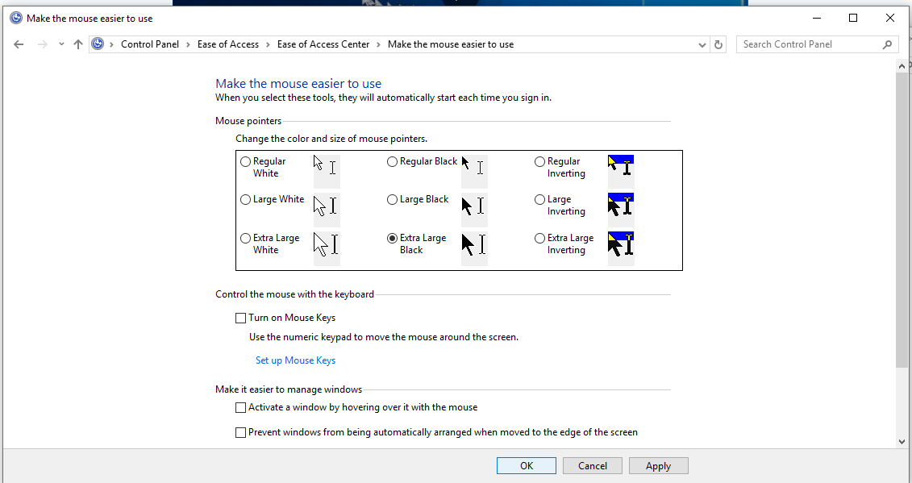

Fig.3 make the mouse easier to use

4) Narrator:

* Narrator helps the people who can not read the computer screen or blind people.
* To use narrator go to start->setting->Ease of Access->Ease of access center->

Start narrator

* Narrator is screen reading app that reads the text of screen. If audio description is available it describes what is happening in videos.

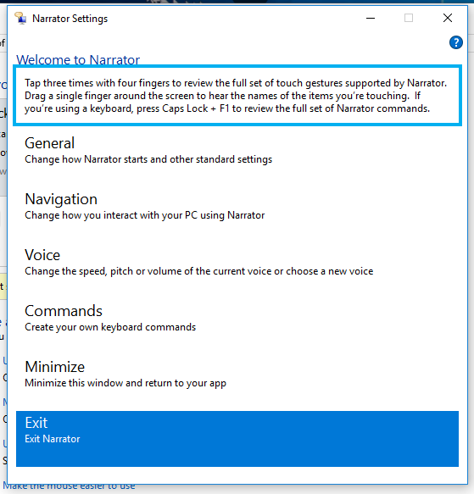

Fig.4 Narrator Setting

5) High Contrast:

* It helps people who has low vision or has color blindness.
* To use this feature go to start->setting->Ease of Access->Ease of access center->

Make the computer easier to see

* It insentify the color contras of text and images so things are easier to identify . Color filter can change the color palette make it easier to distingues items differ by color.

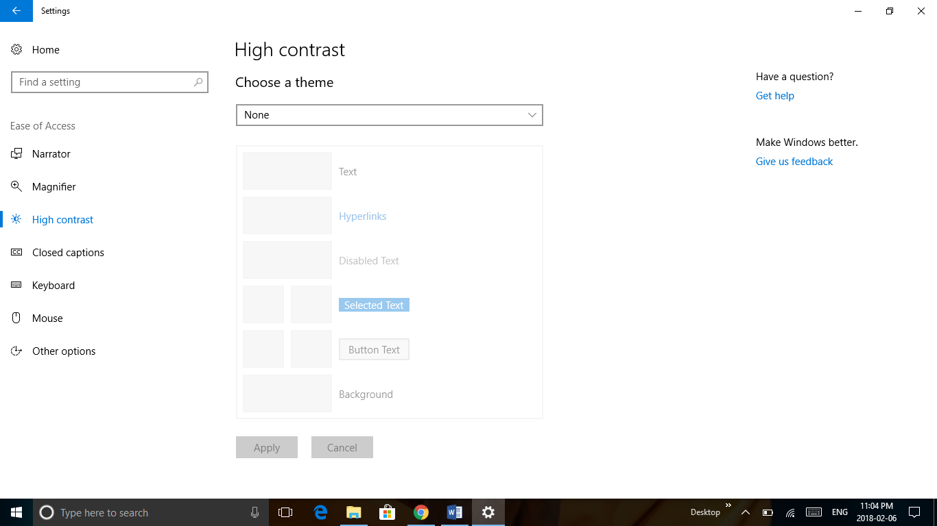

Fig 5.1 high contrast setting

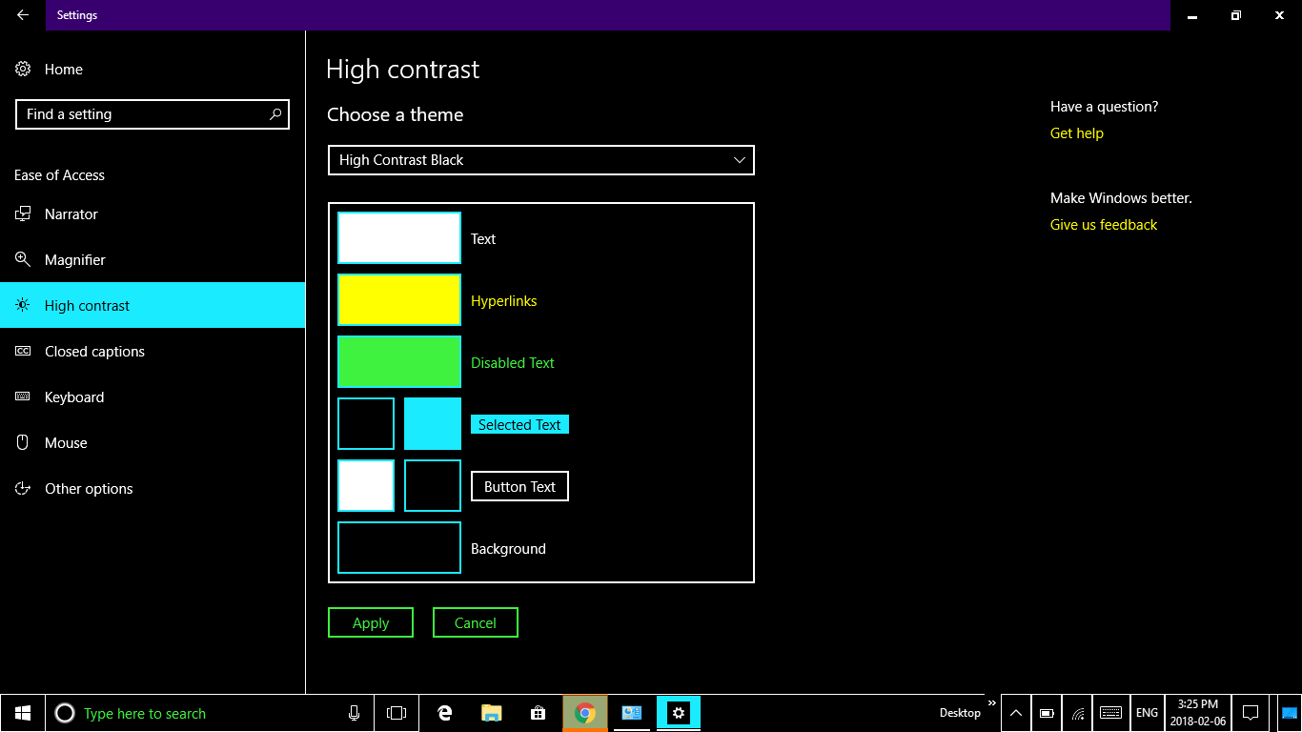

Fig 5.2 view of changed theme