# ASSIGNMENT QRC CARDS

INFO8220 – Operating Systems – **ASSIGNMENT DUE – Monday Jan. 29 end of class**

**Directions:**

Each of the groups will prepare a Quick Reference Card (QRC) on the topic of Operating Systems.

Each QRC will be two (1) page in length and made in Microsoft Word. It will include:

* A title
* Must include graphics and text
* Must be easy to read and easy to follow the instructions
* Check spelling and grammar.
* MUST BE IN YOUR OWN WORDS

**Features**

Footer with your Names and Date

Header will be “Operating System – QRC” made in Word Art

**Must include:**  
**Picture of Start Menu** – arrows pointing to: start button, named groups, live tiles, file explorer, etc.  
  
**Start menu items** (functions – to open start menu, resize app tiles, remove tile, add tile, remain tiles, search for apps or files, lock computer, signout, switch users, change acct settings) – one bullet point for each

**Apps** – launch, jump, search, view all, close, install, uninstall – one bullet point for each  
  
**Keyboard short cuts** – 12 basic commands with name – ie Copy a file Ctrl + C  
  
**Settings short cuts** – 5 – open, devices, sharing display for second screen, quick link menu and how to access help  
  
**Desktop short cuts** – (ie. Switch between apps Alt + Tab -

**File explore**

**File Explorer – use picture**  
 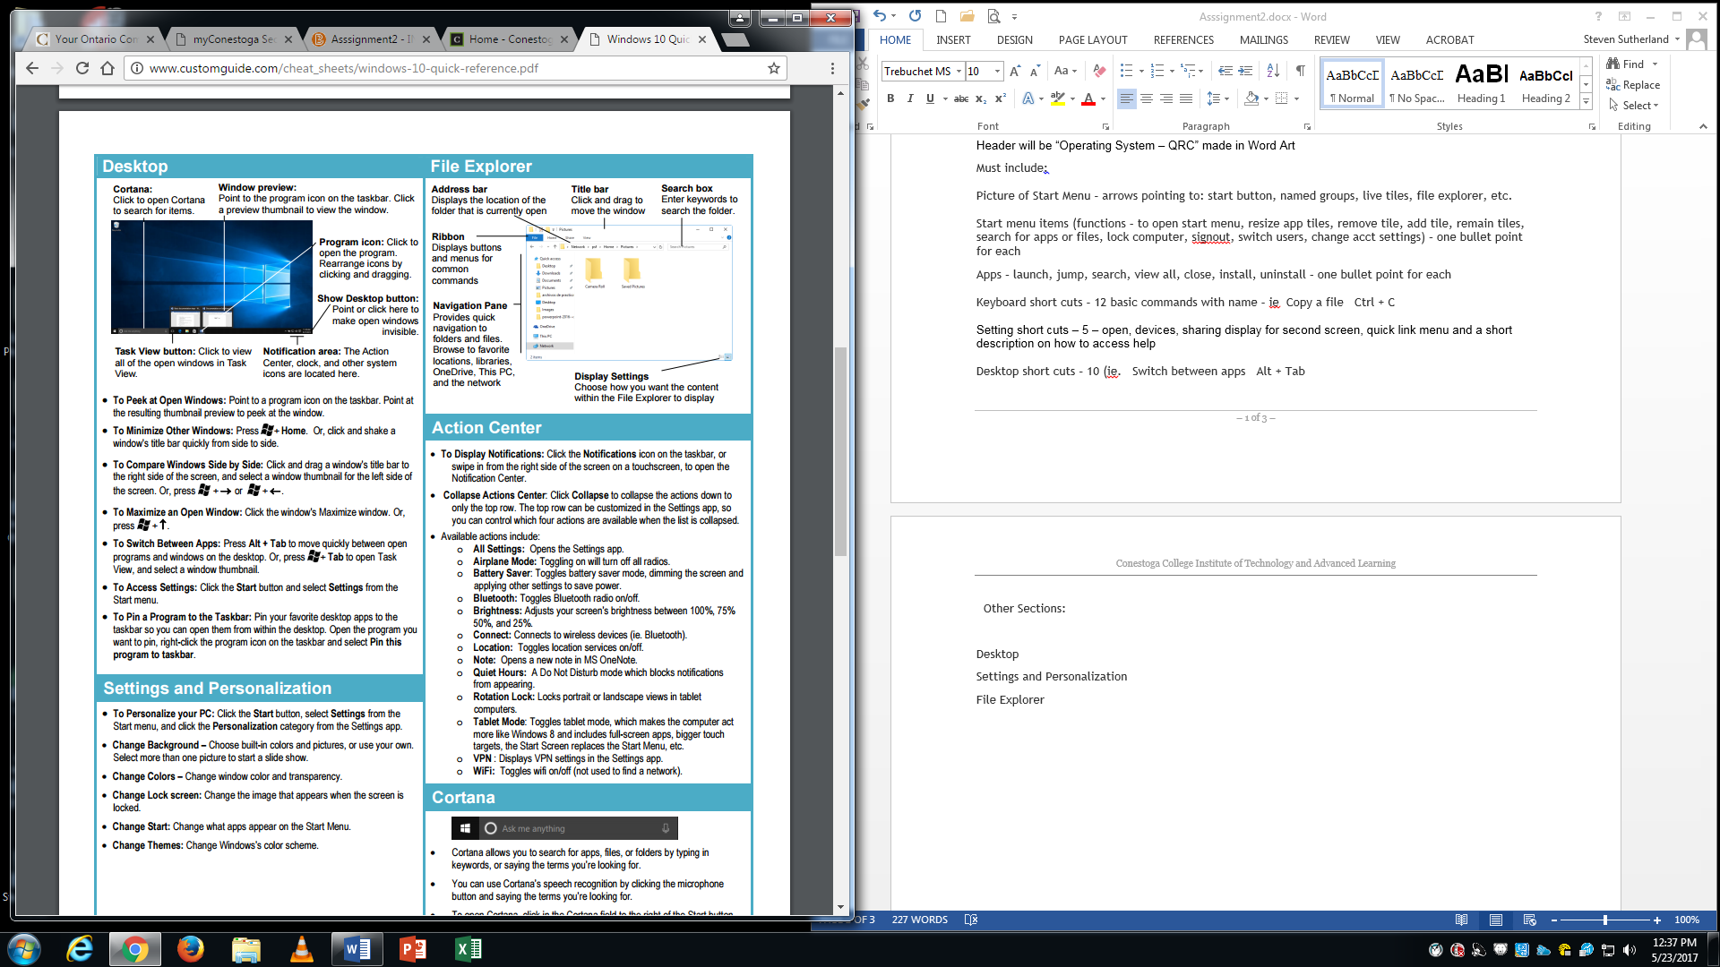

**Cortina** – explain Cortina in 5 bullet points

