**Project Report**

1. **Task Description**

Create common shared component that can handle common input like input textarea checkbox radio and use this component into one form

1. **Task Output Screenshot**

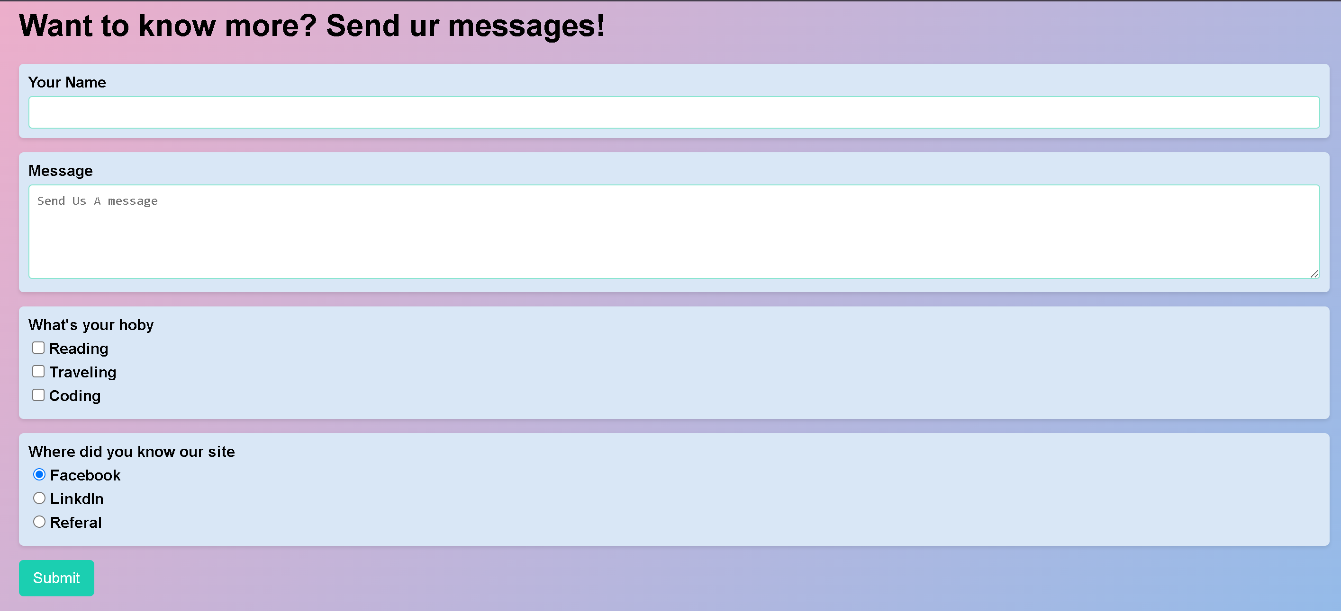

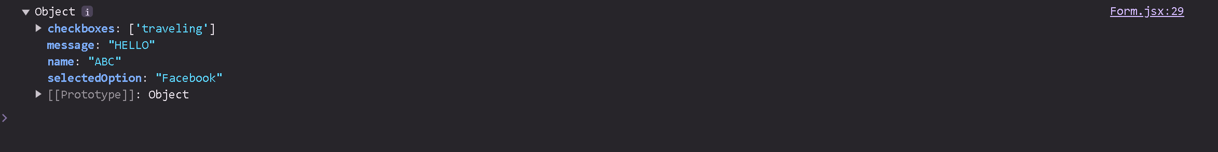

1. **Widget/Algorithm Used In Task**

* CommonField Widget:  
  Reusable component that renders different input types: text, textarea, checkbox, radio against the type prop passed
* MyForm Component:  
  It uses hooks to manipulate form state and deals with input changes by collecting values and submitting them to console.
* App Component:

This is a main application container that renders something in the root, like a header; adds MyForm there for the interaction.