**Report**

1. **Task Description**

Build a form with multiple steps or sections, with validation for each step.

1. **Task Output Screenshot**

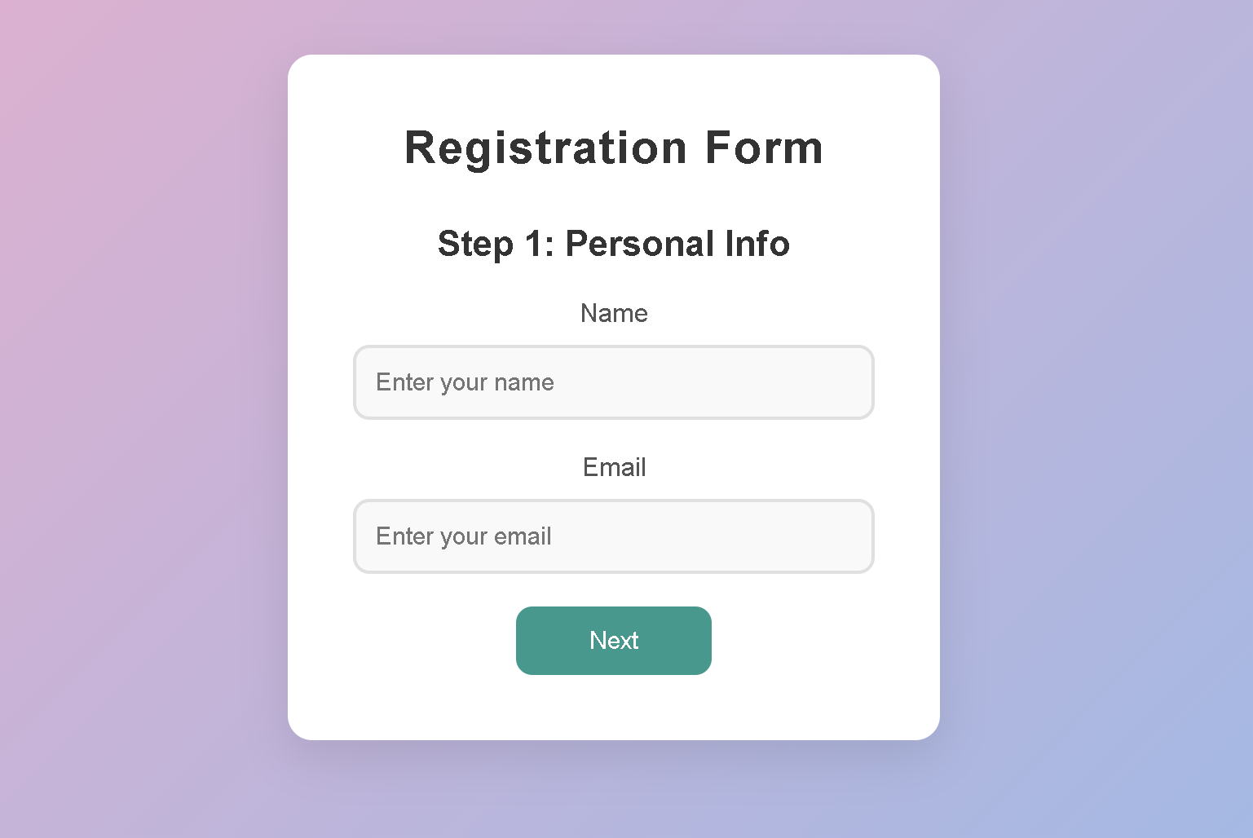

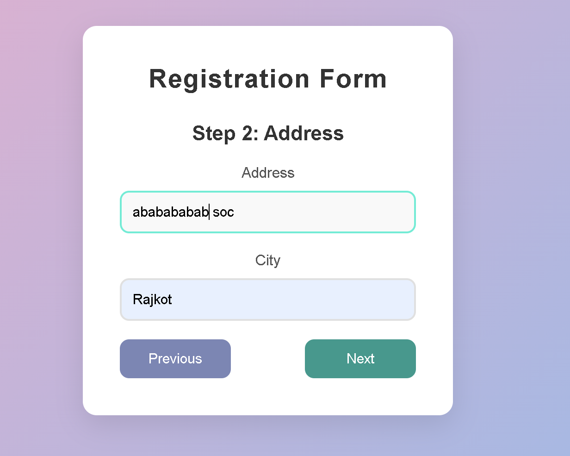

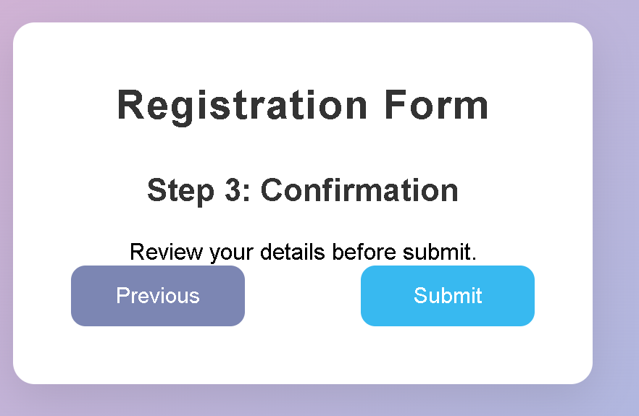

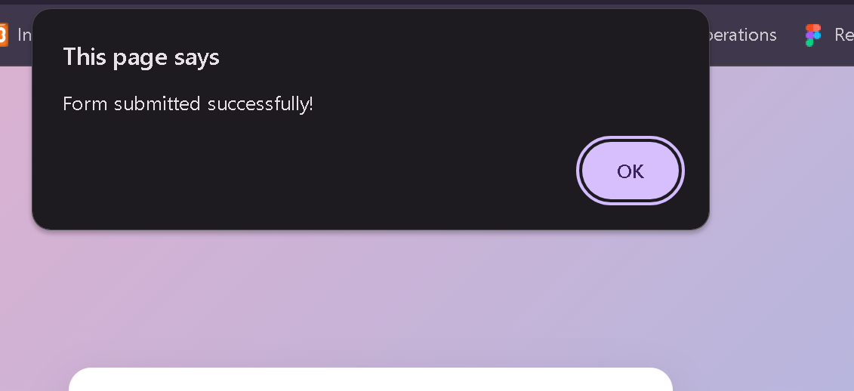

1. **Widget/Algorithm Used In Task**

* **HTML Widgets :**  
  *1. Form Elements:*- <form>: Containing the multi-step registration form.  
  - <input type="text"> & <input type="email">: The input fields are where the user has to put in their name, email address, address, and city respectively.  
  - <button>: The clickable buttons are used to transition between form steps as well as submit the form.  
  End  
    
  *2. Label Elements:*- <label> attributes: Associate with each input field, label what information is expected (like "Name,", "Email,", "Address," etc.).  
    
  *3. Container & Headers:*- <div class="container">: Wraps the entire form in a box that is designed to keep everything well-aligned and visually appealing.  
  - <h1 class="form-title"> & <h2>: Replace this with the form title and headers for the various parts of your form (like "Personal Info,", "Address,", "Confirmation,").  
  - <div class="step">: The single form sections go in separate versions of div with class step, but only one is visible at a time.
* **CSS Styling:**1. Form Layout:   
  Container is a styled box adding in some padding, border-radius, and shadow to visually draw attention.  
  Input Fields are styled with some padding, border-radius, and transitions on focus.  
  - Button customization with colors based on functionality: next, previous, submit.  
  - Buttons positioning by applying the class `.button-group` to "Next" and "Previous."  
  3. Visibility Control:  
  Step Navigation: There is a standard rule that hides all the steps by .step { display: none; }. However, the step that needs to be displayed gets shown by the .active class.  
  4. Responsive Design  
  - The page applies a meta viewport tag to ensure responsive sizing across devices.
* **JavaScript Behavior:**1. Step Navigation:   
  - showStep(step): Hide/unhide the step of choice.  
  - next Step() / prevStep(): Progress to the next/previous step depending on whether there are validation errors.  
  The form is submitted along with a confirmation message without refreshing the page