**Report**

1. **Task Description**

Build a dynamic form that adds and removes input fields based on user input.

1. **Task Output Screenshots**

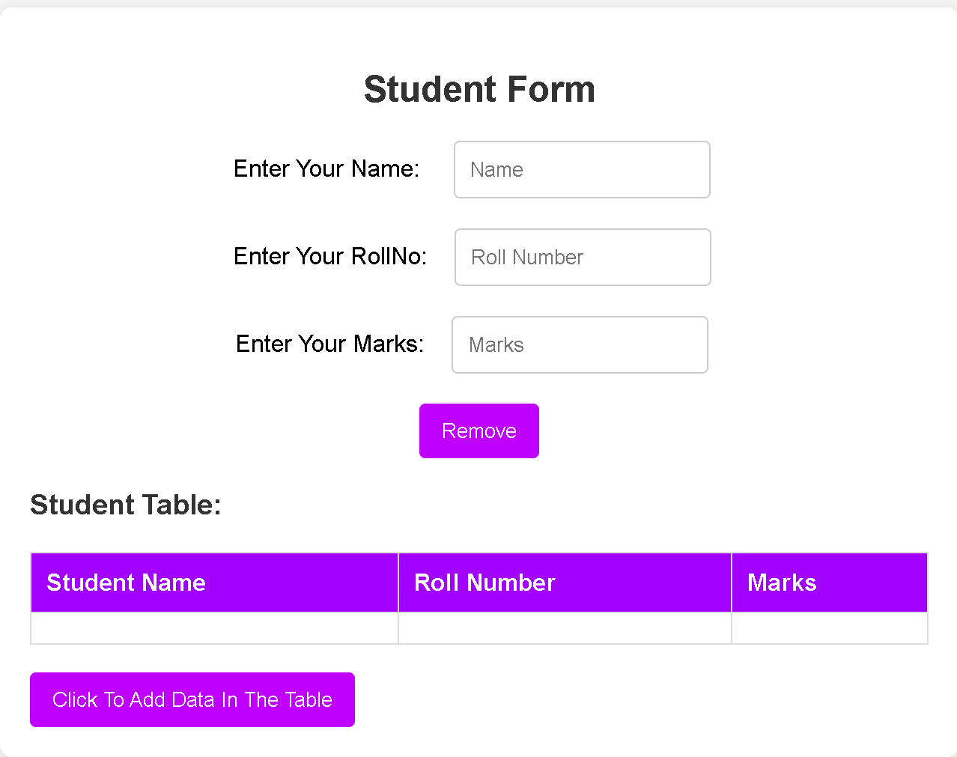

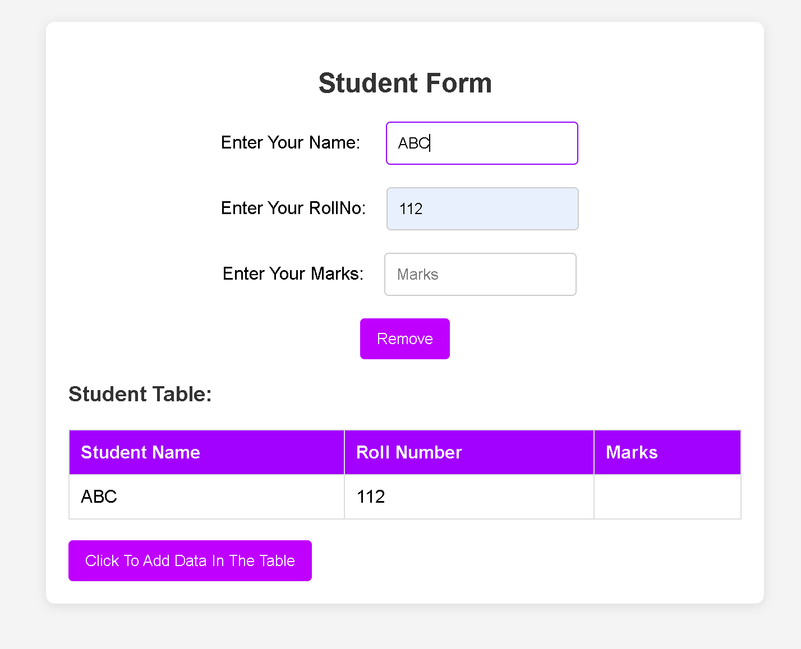

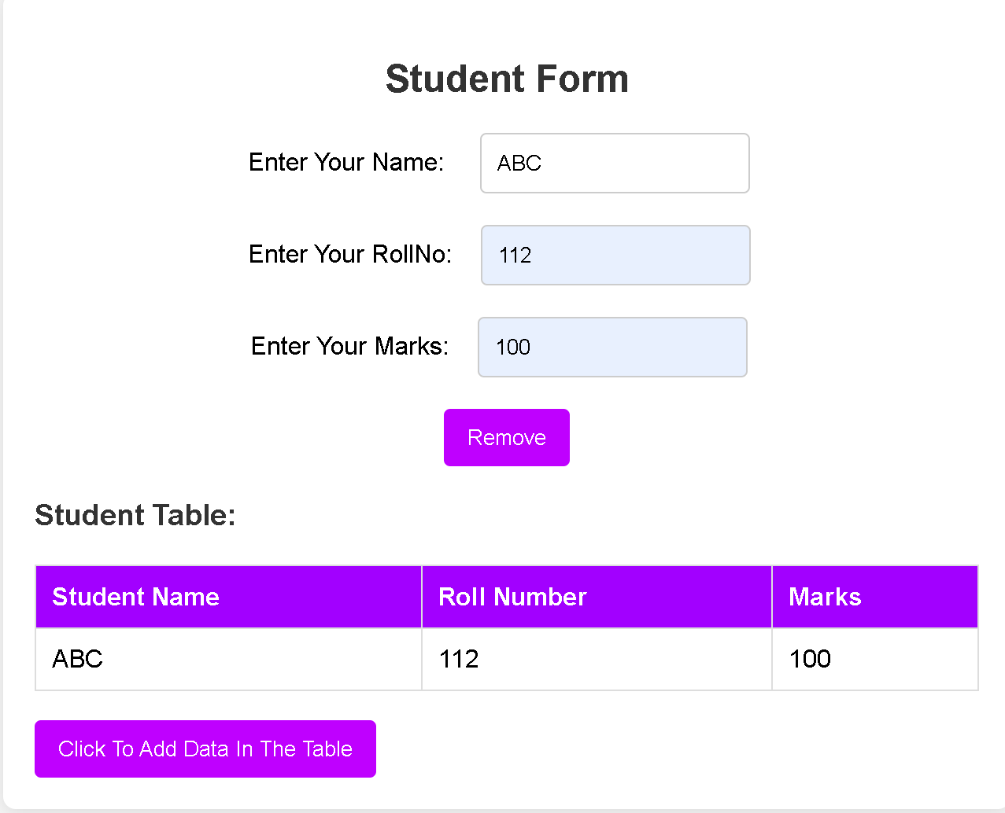

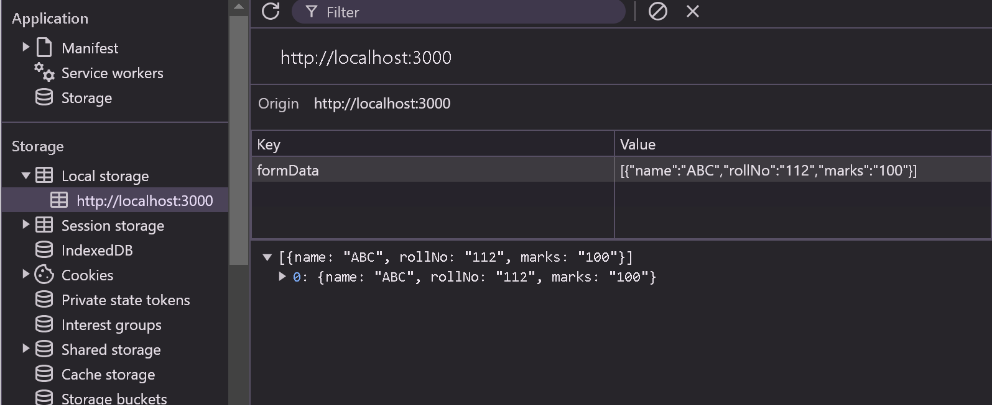

1. **Widget/Algorithm Used In Task**

* React Components:  
  1. Functional Component:  
  DynamicForm : A functional component with React hooks (`useState`, `useEffect`) to handle data dynamically of the formButton .
* React Hooks:  
  1. useState:  
   formData: The state is an array of objects containing student information; each student object has `name`, `rollNo`, and `marks`. In case data is found in local storage, then it initiated from `localStorage`.  
  - Saves the form data automatically to `localStorage` every time the `formData` state changes
* Form Functionality:

1. Input Handling:  
   - InputChange(index, event): Update the relevant form field (name, roll number, or marks) according to the user input. Every change updates the corresponding student object in the form data array.
2. AddData(): It adds a new empty student object to the `formData` array and thereby allows the user to enter details of yet another student.
3. RemoveData(index): Removes the selected student entry from `formData` array.

* Form Fields:

1. For every student, the name, roll number, and marks get generated as <input> for each student entry.  
   Labels and placeholders are used to indicate which data needs to be inputted.
2. Buttons  
   - Add Data Button: it adds a new entry for the student whenever clicked.  
   -. Remove Button: deletes the student entry corresponding to a given row.
3. Table :  
   Table: Print the current student record as rows of a table. Each row is an entry of `formData`, representing the student's name, roll number, and marks.

* CSS Layout Styles:

1. container: Main container for the form
2. form-col: Class used to lay out student input fields vertically with labels.
3. table: Shows student details in a neat and tidy tabular form so that the class list can be easily viewed.