Week 3 Report
Data Analysis and Visual Representation
An analytical framework and visualisation strategy for healthcare trends
Prepared by: Priya Kailas Rakshe | B.Tech Bioengineering, MIT-ADT University | Healthcare Data Analyst Intern

1. Introduction
Week 2 produced an integrated country-year dataset (health_integrated.csv, about 2,900 rows covering 2000-2015) that combines WHO/UN health indicators with World Bank economic and health-system data. This report sets out how that data will be analysed and visualised so that it answers the project questions and supports real healthcare decisions. It explains each method, why it was chosen, how it will be run, how results will be checked, and how each chart connects to a decision.

2. Analytical Objectives
Research question | Analytical need | Method(s)
RQ1: How has life expectancy changed, and is the developed/developing gap closing? | Describe change over time and compare groups | Trend analysis, group comparison (Welch t-test)
RQ2: Which factors are most associated with life expectancy? | Quantify relationships while controlling for other factors | Correlation analysis, multiple linear regression
RQ3: Which countries share similar health profiles? | Group countries without predefined labels | K-means clustering with PCA

3. Methodology Selection and Justification
Five methods are planned. The first three are the core (the task requires at least three); the last two add rigour and a robustness check.

3.1 Trend analysis and group comparison
- What: compute yearly mean life expectancy for Developed and Developing countries, the absolute change from 2000 to 2015, and the compound annual growth rate (CAGR = (LE2015 / LE2000)^(1/15) - 1). Fit a simple linear trend per group to obtain years gained per year.
- Why: trends are the most intuitive evidence for decision-makers and directly answer RQ1. Health planners need to know whether gains are accelerating, flat or reversing, and for whom.
- Test: a Welch two-sample t-test (does not assume equal variances) on 2015 life expectancy between groups; significance level 0.05; effect size reported as a mean difference in years with a 95% confidence interval.
- Healthcare example: in this project developing countries gained 5.1 years and developed countries 3.9 years between 2000 and 2015, so the gap narrowed from 12.2 to 11.0 years, and funders can see that catch-up is happening but slowly.
- Checks: plot residuals of the trend line; examine countries with large drops (for example HIV/AIDS-affected or conflict-affected countries) instead of treating them as noise.

3.2 Correlation analysis and multiple linear regression
- What: first a Pearson/Spearman correlation matrix of about 15 numeric variables to screen relationships; then an ordinary least squares (OLS) model of life_expectancy on selected predictors: adult mortality, HIV/AIDS, schooling, income composition, immunisation (Hepatitis B, Polio, Diphtheria), BMI, log GDP per capita, health expenditure per capita and physicians per 1,000.
- Why: regression estimates how much life expectancy changes with each factor while holding the others constant, which is exactly what RQ2 asks. Coefficients are interpretable by non-statisticians ("each extra year of schooling is associated with X more years of life expectancy").
- Preparation: standardise predictors (z-scores) so coefficients can be ranked by strength; log-transform skewed variables (GDP, population).
- Diagnostics: variance inflation factor (VIF) below 5 to control multicollinearity (infant deaths and under-five deaths are expected to be highly collinear, so only one is kept); residual-versus-fitted plot for linearity and constant variance; Q-Q plot for normality; Cook's distance to find influential countries.
- Validation: 80/20 train-test split and 5-fold cross-validation; report R-squared, adjusted R-squared and RMSE on held-out data. A held-out R-squared above 0.75 would be considered a strong explanatory model for country-level data.
- Robustness: repeat with country fixed effects (panel model) to check that results are not driven only by differences between countries.
- Healthcare example: when HIV/AIDS has the largest negative standardised coefficient, as in this project, a ministry should prioritise HIV/AIDS prevention and treatment over other levers.

3.3 Clustering (K-means) with PCA
- What: group countries (using 2015 or 2010-2015 averages) on standardised indicators: life expectancy, adult mortality, schooling, immunisation, log GDP per capita and health spending.
- Why: the Developed/Developing label is coarse. Clustering can reveal middle groups, for example middle-income countries with high immunisation but high adult mortality, which need different policies from low-income, low-coverage countries.
- Choosing k: compare k = 2 to 8 with the elbow method and the silhouette score; choose the k with a silhouette above about 0.25 that also gives clusters that are easy to interpret (planned: 3 or 4).
- Presentation: use Principal Component Analysis (PCA) to project clusters into two dimensions for plotting, and a profile table of cluster means for interpretation.
- Stability check: re-run with different random seeds (20 runs) and with hierarchical clustering; clusters that persist are trusted.
- Healthcare example: a "high spending, low outcome" cluster signals inefficiency, which is a different problem from "low spending, low outcome".

3.4 Hypothesis testing (supporting method)
To avoid reading patterns into chance variation, key claims are tested formally: (i) Welch t-test for the status gap; (ii) one-way ANOVA with Tukey post-hoc test for differences across clusters; (iii) t-test on regression coefficients (p less than 0.05). Because many tests are run, a Bonferroni or false-discovery-rate correction is applied to the p-values. Reporting confidence intervals alongside p-values keeps the focus on the size of effects, not only significance.

3.5 Feature importance with Random Forest (robustness check)
A random forest regressor (300 trees, maximum depth tuned by cross-validation) is fitted to capture non-linear effects and interactions that OLS may miss. Permutation importance ranks the predictors. If both OLS and random forest rank the same factors near the top, confidence in the findings increases; if they disagree, the disagreement is reported and investigated. The forest is used for ranking only, never as the sole basis for a recommendation, because it is harder to explain.

3.6 Method summary
Method | Question | Key output | Success criterion
Trend + t-test | RQ1 | Years gained, CAGR, gap size with 95% CI | Clear, tested difference between groups
Correlation + OLS | RQ2 | Ranked standardised coefficients | Test R-squared above 0.75; VIF below 5
K-means + PCA | RQ3 | 3-4 interpretable country profiles | Silhouette above 0.25; stable across seeds
Hypothesis tests | All | p-values (corrected) and CIs | Claims supported by tests
Random forest | RQ2 check | Permutation importance | Top predictors agree with OLS

4. Visualisation Planning

4.1 Selected visualisations
Visualisation | Variables | Insight it reveals | Tool
Line chart with confidence band | Year x mean life expectancy, split by Status | Direction and speed of change; whether the gap is closing (RQ1) | matplotlib / Power BI
Choropleth map with year slider | Country life expectancy by year | Geographic inequality and regional clusters | plotly / Power BI
Box plot by status and period | Life expectancy distributions | Spread and outliers, not only averages | seaborn
Correlation heat-map | About 15 numeric variables | Screening of relationships and multicollinearity | seaborn
Scatter plot with regression line | Schooling vs life expectancy (point size = population, colour = status) | Strength and shape of a key relationship | plotly
Horizontal bar chart of coefficients | Standardised OLS coefficients with 95% CI | Which levers matter most (RQ2) | matplotlib
Cluster scatter (PCA) and profile heat-map | PC1 vs PC2, cluster means | Country groups and their characteristics (RQ3) | plotly / seaborn
Small multiples | Immunisation coverage trends for 6-8 sample countries | Compare progress across countries on one scale | seaborn
Interactive dashboard | All of the above with filters (year, status, cluster) | Self-service exploration for non-technical users | Power BI or Tableau Public

4.2 Process for creating each visual
- Prepare tidy data: one row per country-year; filter, reshape (melt/pivot) and aggregate in pandas; save intermediate tables.
- Match the chart to the question: change over time uses lines, distributions use box plots, relationships use scatter plots, composition or rank uses bars, geography uses maps. Pie charts and 3-D charts are avoided.
- Encode carefully: position and length for precise comparison; colour only for categories (maximum 5) or one sequential variable; start bar charts at zero.
- Label for the audience: descriptive title stating the finding (for example "Developing countries gained life expectancy faster than developed ones"), axis titles with units, source note, and annotation of key points.
- Make it accessible: colour-blind-safe palettes (viridis, ColorBrewer), sufficient contrast, direct labels instead of relying on colour alone, readable font sizes.
- Review and iterate: check with a peer or mentor; test whether a person unfamiliar with the data can state the main message in 10 seconds.
- Export and document: save figures at 300 dpi in reports/figures/ and record the code that created them for reproducibility.
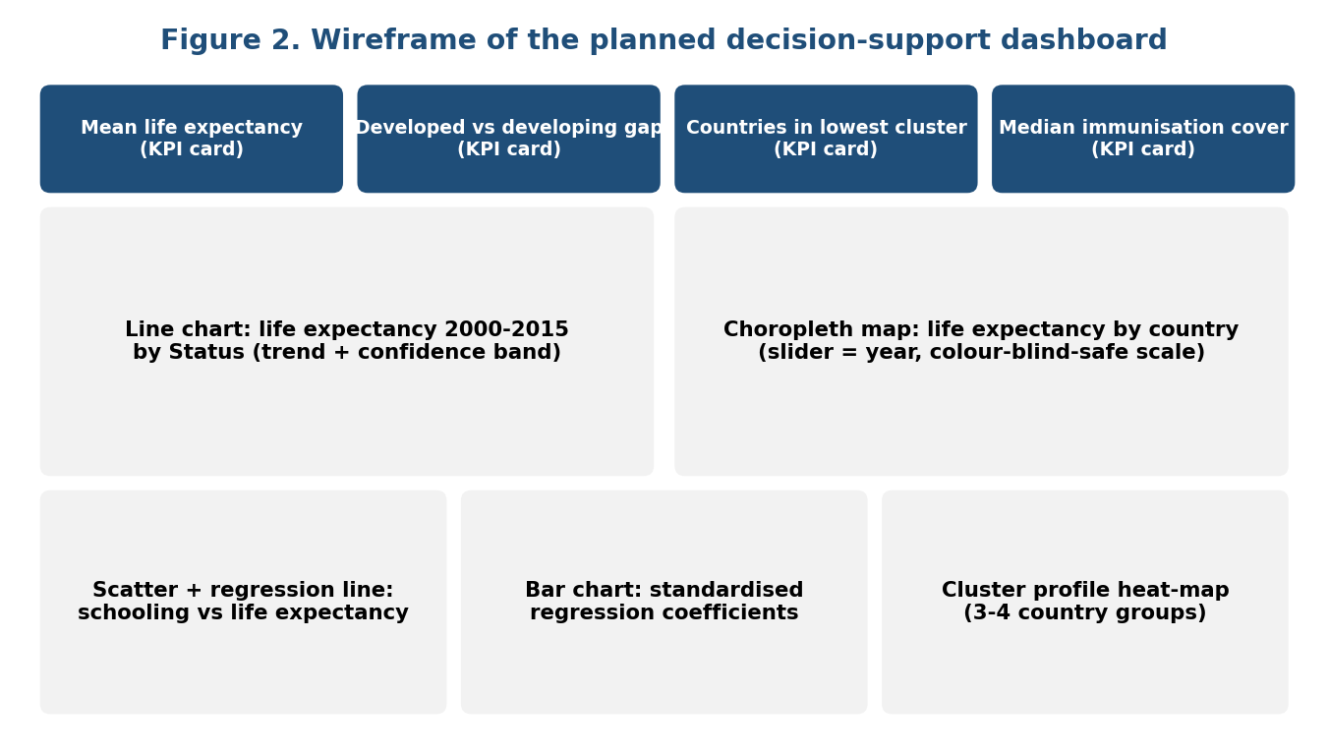
Figure 2. Planned dashboard layout: KPI cards on top, trend and map in the middle, driver and cluster analysis at the bottom.

4.3 Illustrative code outline (narrative)
# Trend by status (RQ1)
trend = df.groupby(["year", "status"])["life_expectancy"].mean().reset_index()
sns.lineplot(data=trend, x="year", y="life_expectancy", hue="status")

# Regression (RQ2)
X = sm.add_constant(df[predictors].apply(zscore))
model = sm.OLS(df["life_expectancy"], X).fit()
vif = [variance_inflation_factor(X.values, i) for i in range(X.shape[1])]

# Clustering (RQ3)
scaled = StandardScaler().fit_transform(country_2015[cluster_vars])
labels = KMeans(n_clusters=4, n_init=20, random_state=42).fit_predict(scaled)

5. Linking Analysis and Visualisation to Healthcare Decisions
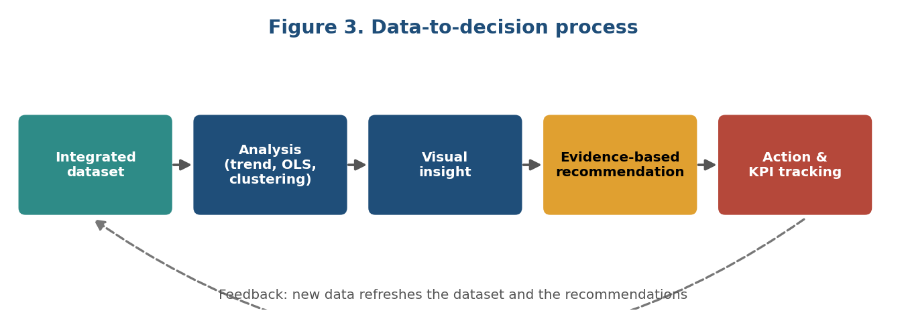
Figure 3. From integrated data to action, with a feedback loop.
Insight | Visual that communicates it | Decision-maker | Possible decision
Gap between developed and developing countries is narrowing slowly | Line chart with confidence band | Health ministry, global health funders | Continue or redirect funding to regions where the gap is not closing
HIV/AIDS has the largest negative standardised effect, and log GDP per capita the largest positive one | Coefficient bar chart | National health planners | Prioritise HIV/AIDS programmes and protect health budgets in resource allocation
One country group has very low immunisation coverage (about 35-42%) while another with similar life expectancy has about 86% | Cluster profile bar charts | Public health programme managers | Targeted immunisation drive; set a coverage target of at least 90%
Spending differs more than 40-fold between the best and the worst performing clusters | Cluster profile bar charts | Health financing teams | Raise financing where it is lowest and audit spending efficiency
A cluster with low spending, low coverage and low schooling | Choropleth and cluster table | International agencies, NGOs | Target capacity-building and primary care investment

Narrative scenario
Imagine a regional health director with a limited budget. She opens the dashboard and the map shows a belt of countries in the lowest cluster. A click shows that their immunisation coverage is below 45% and adult mortality above 230 per 1,000, while the coefficient chart shows that HIV/AIDS and national income carry the most weight in explaining life expectancy. She therefore proposes a vaccination and adult-screening package for that cluster instead of spreading money evenly, and agrees on KPIs (coverage and adult mortality) that the same dashboard will track each year. The visualisations turn statistics into a decision and a way to check whether it worked.

6. Validity, Limitations and Ethics
- Correlation is not causation: regression shows association. Recommendations are framed as "evidence suggests prioritising" and not as proof that an intervention will work.
- Ecological fallacy: the data describe countries, so conclusions must not be applied to individual patients.
- Data quality: imputed values are flagged and a sensitivity analysis repeats key models without imputed rows.
- Time window: data ends in 2015; recent shocks (such as COVID-19) are not captured, which must be stated clearly.
- Multiple comparisons: p-values are corrected; effect sizes are reported.
- Ethics: only publicly available, aggregated, non-personal data is used, so no patient privacy risk arises. Sources and licences are cited.
- Fair communication: results are presented without stigmatising countries; uncertainty is shown with intervals.

7. Implementation Plan (approximately 30-35 hours)
Activity | Hours | Output
Load integrated data, exploratory analysis, trend and group tests | 6 | Trend tables and charts
Correlation analysis, regression, diagnostics, validation | 9 | Model summary and coefficient chart
Clustering, PCA and profiling | 6 | Cluster profiles and maps
Random forest robustness check | 3 | Importance chart
Dashboard build and design review | 6 | Power BI / Tableau file or plotly app
Documentation and GitHub update | 4 | Notebook, README, figures

8. Conclusion
The plan combines trend analysis, regression and clustering, supported by hypothesis testing and a random-forest check, so every question is addressed by a method matched to it and cross-checked by another. Each visualisation is chosen for a specific decision and audience, and each analytical result is tied to an action a healthcare planner could take. This framework will be executed on the integrated dataset and its results will feed directly into the strategic recommendations in the Week 4 report.

