Week 4 Report
Insight Evaluation and Strategic Recommendations
Final report: from integrated healthcare data to actionable strategy
Prepared by: Priya Kailas Rakshe | B.Tech Bioengineering, MIT-ADT University | Healthcare Data Analyst Intern

Executive Summary
This report evaluates what an integrated analysis of WHO, UN and World Bank data reveals about the drivers of national life expectancy (193 countries, 2000-2015, 2,928 country-year observations after cleaning) and converts those insights into five strategic recommendations for a hypothetical national health improvement programme.

Key insights
- Progress is real but unequal. Mean life expectancy rose from 66.8 to 71.6 years (+4.8). Developing countries gained 5.1 years against 3.9 years for developed countries, so the gap narrowed from 12.2 to 11.0 years, but it remains large and statistically significant (95% CI 9.3-12.7 years).
- HIV/AIDS is the strongest negative factor and national income the strongest positive one. In the regression model (test R-squared 0.84), one standard deviation more HIV/AIDS burden is associated with 2.6 fewer years of life expectancy, and one standard deviation higher log GDP per capita with 2.6 more years. A random forest ranked HIV/AIDS, health spending and adult mortality as the top three predictors.
- Countries fall into four distinct profiles. The two poorest-performing groups have similar life expectancy (62.7-64.0 years) and low health spending (about US$99-118 per person), but one of them has immunisation coverage of only 35-42% compared with 86% in the other.
- Prevention and early adult health are the clearest gaps. Adult mortality is about four times higher in the high-burden groups (224-242 per 1,000) than in the high-performing group (61 per 1,000).

Strategic recommendations
- Prioritise HIV/AIDS prevention and treatment in high-burden settings.
- Close the immunisation gap in the lowest-coverage group (polio 35%, diphtheria 42%) with a target of 90% coverage.
- Reduce premature adult mortality through screening, chronic-disease care and injury services.
- Strengthen health financing and its efficiency, because income and health spending are among the strongest correlates of longer life.
- Differentiate investment by country profile and link health with education policy.

1. Introduction
Healthcare decision-makers must decide where limited resources will save the most life-years. This project asked three questions: how has life expectancy changed and is the gap between developed and developing countries closing (RQ1); which factors are most associated with life expectancy (RQ2); and which countries share similar health profiles (RQ3). Over four weeks I planned the project (Week 1), built an integrated dataset (Week 2) and designed the analytical framework (Week 3). This final report applies that framework, evaluates the findings and links them to actions.
Scope and audience. The report is written for a hypothetical national health planning team. Recommendations are strategic and evidence-informed; they are not clinical advice.

2. Methodology Summary
Stage | What was done | Result
Data gathering | WHO/UN life expectancy panel (2,938 rows x 22 columns); World Bank WDI indicators through the API (health expenditure, physicians, hospital beds, population aged 65+, GDP per capita, population) | Join key: ISO3 country code + year
Cleaning | Removed rows without life expectancy or adult mortality; within-country interpolation; group medians; plausibility rules for BMI; imputation flags | 2,938 rows reduced to 2,928
Integration | Left join of World Bank data onto the primary table; aggregates excluded | 99.0% of rows matched
Analysis | Trend analysis and Welch t-test; OLS regression (80/20 train-test split, VIF check); random forest (300 trees); K-means (k = 4) with silhouette validation and PCA | Test R-squared 0.84; maximum VIF 4.5; silhouette 0.37
Visualisation | Bar and profile charts with colour-blind-safe colours; additional figures produced by the pipeline script | See Figures 2 and 3

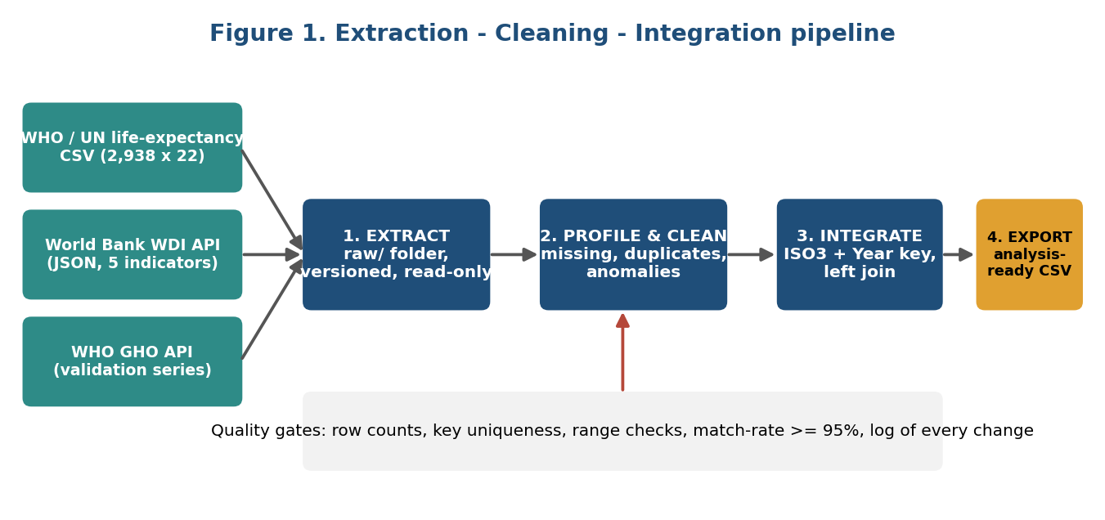
Figure 1. Data pipeline from raw sources to the analysis-ready dataset.

3. Findings and Insight Evaluation

3.1 Summary of key results
Metric | Result | Meaning
Mean life expectancy 2000 / 2015 (all countries) | 66.8 / 71.6 years (+4.8) | Global progress over 15 years
Developing countries 2000 / 2015 | 64.6 / 69.7 years (+5.1; 0.50% per year) | Faster improvement from a lower base
Developed countries 2000 / 2015 | 76.8 / 80.7 years (+3.9; 0.33% per year) | Slower improvement from a high base
Gap between groups, 2015 (Welch t-test) | 11.0 years; p < 0.001; 95% CI [9.3, 12.7] | Narrowed from 12.2 years in 2000, still significant
Regression performance (test set) | R-squared 0.84; RMSE 3.7 years | Model explains most of the variation
Multicollinearity check | Maximum VIF 4.5 (limit 5) | Coefficients are interpretable
Strongest negative predictor (OLS) | HIV/AIDS (-2.58 years per 1 SD) | Largest burden on life expectancy
Strongest positive predictor (OLS) | Log GDP per capita (+2.60 years per 1 SD) | Income and resources support longer life
Random forest top three | HIV/AIDS, health expenditure per capita, adult mortality | Confirms HIV/AIDS; adds spending and adult mortality
Clusters | k = 4; silhouette 0.37 (183 countries) | Clear, interpretable country profiles

3.2 Finding 1: Life expectancy improved and the gap is narrowing, but remains large (RQ1)
Mean life expectancy rose in both groups between 2000 and 2015. Developing countries gained 5.1 years, compared with 3.9 years for developed countries, which is consistent with catch-up from a lower baseline. The difference between the groups narrowed from 12.2 years to 11.0 years, yet the 2015 gap is still large and highly significant (Welch t-test, p < 0.001; 95% confidence interval 9.3 to 12.7 years). Because the gap narrowed by only about 1.2 years in 15 years, catch-up should not be assumed to be automatic.
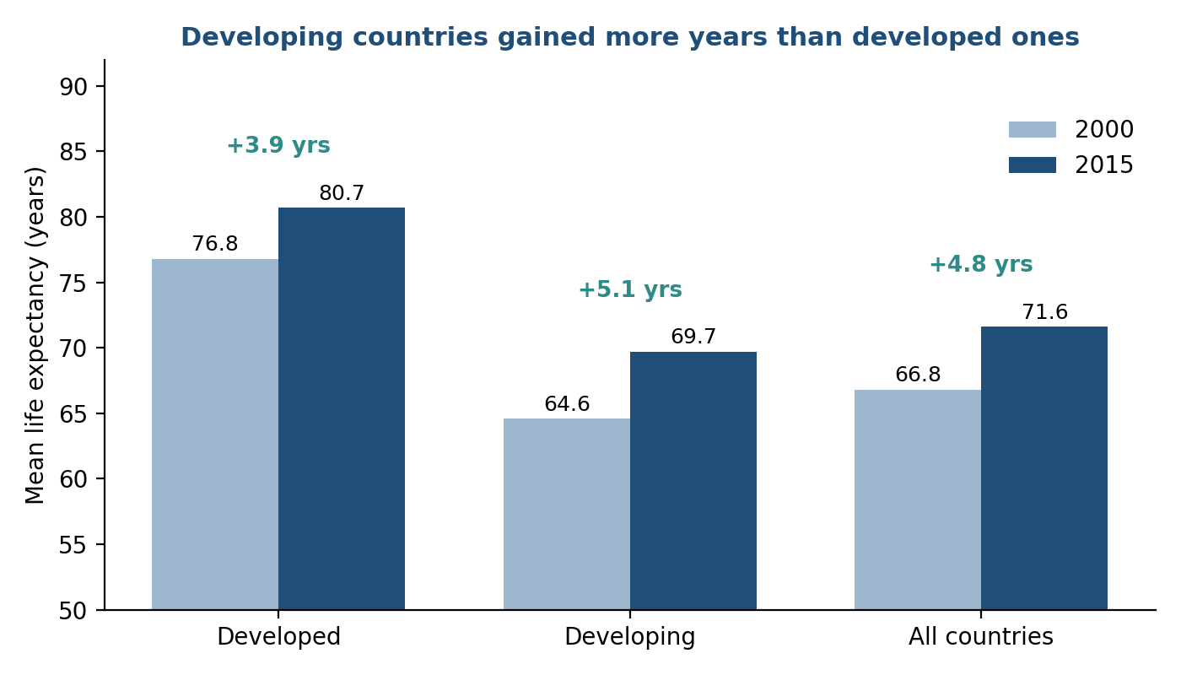
Figure 2. Mean life expectancy in 2000 and 2015 by country group (pipeline output).

3.3 Finding 2: HIV/AIDS and national income are the strongest correlates (RQ2)
The regression model explained a large share of the variation in unseen data (test R-squared 0.84, RMSE 3.7 years), and the variance inflation factors were all below 5, so the standardised coefficients can be compared. HIV/AIDS has the largest negative association (-2.58 years per standard deviation) and log GDP per capita the largest positive one (+2.60 years). The random forest, which can capture non-linear effects, also placed HIV/AIDS first and ranked health expenditure per capita and adult mortality second and third. The agreement of two different methods on HIV/AIDS makes this the most robust finding of the analysis.
The random forest achieved a higher test R-squared (0.96) than the regression. This should be read with care: because each country appears in many years, a random train-test split can place the same country in both sets, which makes predictions look better than they would for entirely new countries. The regression figure is therefore the more conservative estimate, and a split by country is listed as further work.

3.4 Finding 3: Four country profiles need different strategies (RQ3)
K-means clustering on the latest observation for each of 183 countries produced four groups (silhouette score 0.37, above the 0.25 threshold set in the Week 3 plan; k = 4 was chosen because it gave the most interpretable groups, and its score is similar to k = 3 and k = 5).
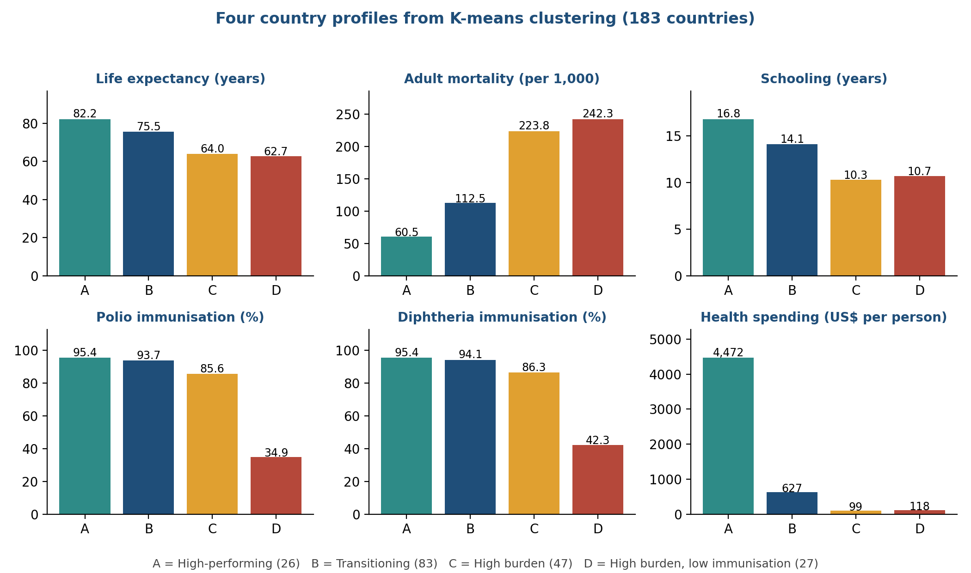
Figure 3. Profiles of the four country clusters (cluster means from the pipeline output).
Cluster | No. | Life exp. | Profile | Policy implication
A: High-performing | 26 | 82.2 | Adult mortality 61; schooling 16.8 years; immunisation about 95%; spending about US$4,470 per person | Maintain; focus on ageing and chronic disease
B: Transitioning | 83 | 75.5 | Adult mortality 113; schooling 14.1; immunisation about 94%; spending about US$630 | Invest in chronic-disease screening and primary care
C: High burden | 47 | 64.0 | Adult mortality 224; schooling 10.3; immunisation 86%; spending about US$99 | Raise financing and adult health services; protect existing coverage
D: High burden, low immunisation | 27 | 62.7 | Adult mortality 242; schooling 10.7; polio 35% and diphtheria 42%; spending about US$118 | Urgent immunisation drive and basic services

Two points stand out. First, clusters C and D have almost the same life expectancy and spending, but D's immunisation coverage is less than half that of C, so D has a distinct, fixable problem that a single "low income" label would hide. Second, spending differs more than 40-fold between clusters A and C (about US$4,470 versus US$99 per person), which shows the scale of the resource gap.

3.5 Data quality evaluation
Integration was successful: 99.0% of country-year rows matched World Bank data, and only 10 of 2,938 rows (0.3%) had to be removed because life expectancy or adult mortality was missing. Remaining gaps in slow-moving indicators were filled by within-country interpolation and flagged, so a sensitivity analysis without imputed rows can be run from the saved flag columns. Using World Bank GDP and population in place of the incomplete original columns improved completeness.
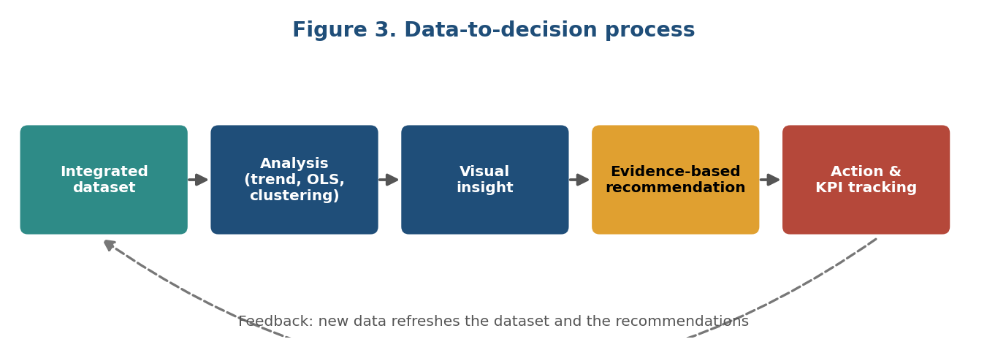
Figure 4. Process that connected the data analysis to the recommendations in this report.

4. Critical Analysis: Linking Insights to Strategy
The central lesson is that life expectancy depends on a combination of disease burden, economic resources and basic prevention, and that countries with similar life expectancy can have different underlying problems. Effective strategy therefore needs to be targeted, not uniform.
Insight | Strategic implication | Evidence strength
HIV/AIDS has the strongest negative association and ranks first in the random forest | Sustain prevention, testing and treatment where the burden is high | High: two methods agree
Income (log GDP per capita) is the strongest positive association; health spending ranks second in the random forest | Protect and make better use of health budgets; efficiency matters as much as amount | Moderate to high (association)
Adult mortality is about four times higher in high-burden clusters and ranks third in the random forest | Extend attention beyond child health to adult health | Moderate to high
One high-burden cluster has immunisation of only 35-42% | Targeted immunisation drive with a measurable coverage target | High (large, clear difference)
Schooling averages about 17 years in cluster A versus about 10 in clusters C and D | Coordinate health and education policy | Moderate (descriptive pattern, not isolated in the regression)

Limits of the evidence
- The analysis shows association, not causation; randomised or quasi-experimental evidence would be needed to prove that an intervention causes a gain.
- Results describe countries, not individuals (ecological fallacy).
- The data end in 2015; later events, including COVID-19, are not reflected, and the analysis should be re-run with newer data.
- The HIV/AIDS indicator in the source dataset is, as documented for it, a child-mortality-based measure used as a proxy for national HIV burden, so it should not be read as prevalence.
- Health spending is measured in current US$, which does not adjust for price differences between countries.
- Clusters use each country's latest observation, and cluster labels depend on the chosen method and number of groups.
- The random forest accuracy is probably optimistic because of the random split (see Section 3.3).
- Country averages hide inequality within countries.

5. Strategic Recommendations
Each recommendation is linked to a finding, with anticipated benefits, challenges and measurable indicators. Targets are hypothetical and intended for a planning discussion.

R1. Prioritise HIV/AIDS prevention and treatment
Element | Detail
Linked finding | Finding 2: strongest negative association in the regression and top-ranked predictor in the random forest
Action | In high-burden settings, scale testing, antiretroviral treatment, prevention of mother-to-child transmission and adolescent prevention programmes; integrate them with primary care.
Anticipated benefits | Largest expected life-year gain per intervention in affected countries; fewer new infections and child deaths.
Challenges and risks | Stigma, long-term drug financing, reliance on external donors, supply-chain interruptions.
Indicators / targets | At least 85% of diagnosed people on treatment; measurable fall in the national HIV/AIDS indicator within 5 years.

R2. Close the immunisation gap in the lowest-coverage group
Element | Detail
Linked finding | Finding 3: cluster D has polio coverage of 35% and diphtheria 42%, against 94-95% in clusters A and B
Action | Fund cold-chain logistics, outreach to unreached districts, community mobilisation and catch-up campaigns; track coverage on a dashboard with district alerts.
Anticipated benefits | Prevents outbreaks, among the most cost-effective health measures, strengthens basic health contact.
Challenges and risks | Insecurity and access barriers, vaccine hesitancy, shortage of health workers, funding competition.
Indicators / targets | Coverage of at least 80% within 3 years and 90% within 5 years; no district below 70%.

R3. Reduce premature adult mortality
Element | Detail
Linked finding | Findings 2 and 3: adult mortality ranks third in the random forest and is 224-242 per 1,000 in high-burden clusters versus 61 in cluster A
Action | Community screening for hypertension and diabetes, emergency and injury care, primary-care training in chronic-disease management.
Anticipated benefits | Fewer deaths between ages 15 and 60, with benefits for families and the workforce.
Challenges and risks | Needs trained staff and drug supply; screening only helps when treatment follows; benefits appear over years.
Indicators / targets | Adult mortality down 10% in 5 years; at least 70% of screened hypertensive patients under treatment.

R4. Strengthen health financing and its efficiency
Element | Detail
Linked finding | Finding 2: log GDP per capita is the strongest positive predictor and health spending ranks second in the random forest; spending ranges from about US$99 to US$4,470 across clusters
Action | Raise public health spending where it is lowest, prioritise primary care and prevention, and audit how money is used (supply chains, procurement, staffing).
Anticipated benefits | More health gain per currency unit; transparent, accountable budgets.
Challenges and risks | Limited fiscal space in low-income countries, governance weaknesses, risk of treating association as proof.
Indicators / targets | Health spending per person tracked yearly; share spent on primary care rising; audit findings acted on.

R5. Differentiate by country profile and link health with education
Element | Detail
Linked finding | Finding 3: clusters differ sharply; schooling averages about 17 years in cluster A versus about 10 in C and D
Action | Use the four profiles to allocate funds: basic services and immunisation for D, financing and adult health for C, chronic-disease care for B, maintenance for A. Add school-based health education and keep girls in school.
Anticipated benefits | Targeted resources; long-term gains from education; clear accountability by group.
Challenges and risks | Cluster labels are method-dependent; data lag; cross-ministry coordination is slow; education effect is uncertain.
Indicators / targets | Countries moving up a cluster over 5 years; improved secondary enrolment and health-literacy indicators.

5.1 Prioritisation
Recommendation | Expected impact | Feasibility | Time to effect | Priority
R2 Immunisation gap | High | High | Short-medium | 1 (quick win)
R1 HIV/AIDS | High in affected countries | Medium | Medium | 1 (core)
R3 Adult mortality | High | Medium | Medium-long | 2
R5 Profile-based targeting | Medium-high | Medium | Short (planning) | 2
R4 Financing and efficiency | High but indirect | Medium-low | Long | 3

5.2 Implementation roadmap (12 months)
Phase | Timing | Activities
Prepare | Months 1-2 | Confirm priorities, identify target districts, set baseline indicators, update the data with the latest WHO and World Bank releases
Launch | Months 3-6 | Start immunisation outreach and HIV/AIDS service scale-up; adult screening pilots; begin spending-efficiency audit
Scale | Months 7-10 | Extend successful pilots; link education and health activities; review the dashboard monthly
Evaluate | Months 11-12 | Compare indicators with baselines; adjust strategy; publish report

6. Risks, Limitations and Further Work
- Re-run the analysis with post-2015 data to test whether the relationships still hold.
- Evaluate the models with a split by country (or leave-one-country-out validation) to give a realistic accuracy estimate for new countries.
- Add district-level data to reveal inequality within countries.
- Use causal methods (difference-in-differences, instrumental variables) where policy changes can be observed.
- Include additional variables such as air pollution, sanitation, tobacco use and health-worker density.
- Build a scenario model of life expectancy under different investment options.

7. Conclusion
Integrating three public data sources made it possible to move from raw tables to decision-ready insights. Life expectancy has improved (+4.8 years on average between 2000 and 2015) and developing countries are catching up (+5.1 versus +3.9 years), but an 11-year gap remains. HIV/AIDS is the strongest negative factor and national income the strongest positive one, with health spending and adult mortality also ranking high. Four country profiles show that countries with similar life expectancy can face very different problems, such as a collapse in immunisation coverage in one group. The five recommendations form a coherent, measurable strategy, and the pipeline built in Weeks 2 and 3 allows it to be refreshed whenever new data is released. Because the findings describe associations at country level, they should guide priorities and further testing and not be treated as proof of cause.

Appendix A. Reproducibility and Sources
- Code: healthcare_pipeline.py in the GitHub repository (extract, clean, integrate, analyse, export).
- Outputs: data/processed/health_integrated.csv, reports/results_summary.csv, reports/cluster_profiles.csv, and figures in reports/figures/.
- Data sources: WHO Global Health Observatory; World Bank World Development Indicators; Kaggle "Life Expectancy (WHO)" dataset compiled from WHO and UN data.
- Software: Python (pandas, statsmodels, scikit-learn, seaborn, matplotlib).

